UniGuide: A Random Forest-Based Decision Support System for University Degree Programme Recommendation Among Kenyan Form-Four Leavers
[Internal Project]

Fatuma Omar Marsa
159056
ICS 4A

Supervisor Name
Deperias Webula Kerre

An Informatics and Computer Science Final Project Documentation Submitted to the School of Computing and Engineering Sciences in Partial Fulfilment of the Requirements for the Award of a Degree in Bachelor of Science in Informatics and Computer Science

School of Computing and Engineering Sciences
Strathmore University
Nairobi, Kenya

June 2026

Declaration and Approval
I declare that this work has not been previously submitted and approved for the award of a degree by this or any other University. To the best of my knowledge and belief, this research documentation contains no material previously published or written by another person except where due reference is made in the documentation itself.

Student Name: Fatuma Omar Marsa
Admission Number: 159056
Student Signature: _________________________ Date: ________________________

The Documentation of Fatuma Omar Marsa has been reviewed and approved by Deperias Webula Kerre
Supervisor Signature: _________________________ Date: ________________________

Acknowledgement

Abstract
Selecting a university degree programme is one of the most important decisions made by Kenyan form-four leavers, as it influences their future academic and career opportunities. However, existing guidance approaches primarily focus on either programme eligibility or career exploration, making it difficult for students to identify degree programmes that align with both their academic performance and personal characteristics. Consequently, many students rely on general advice or eligibility criteria alone when making university programme choices.
This study developed a Random Forest-based decision support system that recommends suitable university degree programmes using students' academic performance, interests, skills, strengths, and career aspirations. Since no publicly available labelled dataset exists for this problem within the Kenyan context, the study generated realistic synthetic student profiles using a deterministic, rule-based generator. The generated dataset was validated and preprocessed before training the Random Forest classification model, which achieved a weighted F1-score of 68.4% on held-out test data. The recommendation engine was integrated into a Flutter mobile application through a FastAPI backend, while Firebase Authentication and Cloud Firestore manage user authentication and store student profiles together with programme information.
The system generates the three most suitable university degree programme recommendations ranked by prediction confidence. To improve transparency and user trust, each recommendation is accompanied by a SHAP-based explanation of why it was selected, together with supporting information such as admission requirements, universities offering the programme, career pathways, recommended skills, certifications, and learning resources. The recommendation model was evaluated using standard classification metrics, including accuracy, precision, recall, and F1-score, while the completed system was functionally tested end-to-end and informal usability feedback was gathered from a small group of test users.
The developed system complements the existing KUCCPS placement process by providing personalized decision support that enables students to make more informed university programme choices before submitting their applications.

Keywords: Machine Learning, Personalized Learning, Educational Data Mining, Career Prediction, Student Decision Support.

Table of Contents
Declaration and Approval ii
Acknowledgement iii
Abstract iv
List of Figures ix
List of Tables x
List of Abbreviations xi
Chapter 1: Introduction 1
1.1 Background Information 1
1.2 Problem Statement 2
1.3 Objectives 3
1.3.1 General objective 3
1.3.2 Specific objectives 3
1.4 Research Questions 3
1.5 Justification 4
1.6 Scope 4
1.7 Limitations and Delimitations 5
1.7.1 Limitations 5
1.7.2 Delimitations 5
Chapter 2: Literature Review 7
2.1 Introduction 7
2.2 Current State of Career Guidance and Academic Support Systems 7
2.3 Related Works 8
2.3.1 Kenya Universities and Colleges Central Placement Service (KUCCPS) 8
2.3.2 DIRAPATH 9
2.3.3 CareerExplorer 9
2.3.4 CareerVillage 10
2.4 Research Gaps 10
2.5 Conceptual framework 12
Chapter 3: Methodology 14
3.1 Introduction 14
3.2 Research paradigm 14
3.2.1 Data Acquisition 14
3.2.2 Data Processing 15
3.2.3 Model Training 15
3.2.4 Model Validation and Testing 16
3.3 System Development Methodology 16
3.3.1 Justification of the Methodology 17
3.4 Methodology Diagram 18
3.4.1 Product Backlog 18
3.4.2 Sprint Planning 18
3.4.3 Sprint backlog 19
3.4.4 Agile Sprints 19
3.4.5 Sprint Review 19
3.4.6 Increment 20
3.5 System Analysis 20
3.5.1 Use Case Diagram 20
3.5.2 Activity Diagram 20
3.5.3 Sequence Diagram 21
3.6 System Design 21
3.6.1 Database Schema 21
3.6.2 System Architecture 21
3.6.3 Wireframes 21
3.7 System Deliverables 21
3.7.1 System Documentation 21
3.7.2 Authentication Module 22
3.7.3 Student Assessment and Profiling Module 22
3.7.4 Recommendation Module 22
3.7.5 Programme Information and Support Module 22
3.8 System Development Tools and Techniques 23
3.8.1 Python 23
3.8.2 Sci-kit Learn 23
3.8.3 SHAP 23
3.8.4 FastAPI 23
3.8.5 Flutter 24
3.8.6 Firebase 24
3.8.7 Visual Studio Code 24
Chapter 4: System Analysis and Design 25
4.1 Introduction 25
4.2 Requirement Analysis 25
4.2.1 Functional Requirements 25
4.2.2 Non-Functional Requirements 26
4.2.3 Data Requirements 27
4.2.4 Interface and Integration Requirements 28
4.3 System Analysis Diagrams 29
4.3.1 Use Case Diagram 29
4.3.2 Activity Diagram 30
4.3.3 Sequence Diagram 31
4.4 System Design Diagrams 32
4.4.1 System Architecture 32
4.4.2 Database Schema 33
4.4.3 Wireframes 33
References 39
Appendices: 42
Appendix 1: Gantt Chart 42
Appendix 2: Turnitin Report 42

List of Figures
Figure ‎2.1:Conceptual Framework 13
Figure ‎3.1:Scrum methodology 18
Figure ‎4.1:Use Case Diagram 28
Figure ‎4.2:Activity Diagram 29
Figure ‎4.3:Sequence Diagram 30
Figure ‎4.4:System Architecture 31
Figure ‎4.5:Database Schema Diagram 32
Figure ‎4.6:Authentication Wireframe 32
Figure ‎4.7:Profile Setup Wireframe 33
Figure ‎4.8:Recommendation Wireframe 34
Figure ‎4.9:Programme Information Wireframe 35
Figure ‎4.10:Admin Dashboard Wireframe 36
Figure ‎4.11:Rating Wireframe 37
Figure 5.1: Sign-In Screen of the Completed UniGuide Mobile Application, Running on an Android Emulator 49

List of Tables
Table ‎2.1: Comparative Analysis of Reviewed Systems 10
Table 5.1: Hardware Specifications 40
Table 5.2: Software Specifications 42
Table 5.3: Random Forest Classification Performance per Programme (Held-Out Test Set) 46
Table 5.4: Functional Testing Results 48

List of Abbreviations
AI – Artificial Intelligence
API – Application Programming Interface
CRISP-DM – Cross Industry Standard Process for Data Mining
ERD – Entity Relationship Diagram
ML – Machine Learning
NoSQL – Non-Relational Database
OOAD – Object-Oriented Analysis and Design
SDLC- System Development Life Cycle
UI – User Interface

Introduction

Background Information
Selecting a university degree programme is one of the most important decisions made by Kenyan form-four leavers because it influences their future education, career opportunities, and professional development. Every year, students who attain the minimum university entry requirements apply for degree programmes through the Kenya Universities and Colleges Central Placement Service (KUCCPS). Since this decision determines the academic pathway students pursue, selecting a programme that aligns with their abilities, interests, and career aspirations is essential.
Students receive career guidance from teachers, parents, career counsellors, and online career guidance platforms to support this decision-making process (Samson et al., 2024). While these sources provide valuable guidance, they often rely on either general career advice or academic eligibility. Consequently, students may know which university degree programmes they qualify for without understanding which programmes best match their academic performance, interests, skills, strengths, and long-term career goals. As a result, some students select programmes based on peer influence, parental expectations, or perceived employment opportunities rather than their individual profiles, which may lead to low academic satisfaction, programme changes, and uncertainty about future career paths.
Recent advancements in Artificial Intelligence (AI) and Machine Learning (ML) have created new opportunities to improve educational decision-making. Machine learning techniques can analyse multiple student characteristics simultaneously, identify patterns within educational data, and generate personalized recommendations. Recommendation systems have already been successfully applied in domains such as healthcare, finance, e-commerce, and education to support data-driven decision-making and improve user experiences (Mahmoud et al., 2025).
Despite these advancements, the application of machine learning to university degree programme recommendation for Kenyan form-four leavers remains limited. Existing systems generally focus on either determining programme eligibility based on KCSE results or recommending careers based on interests and personality, rather than combining both academic and personal characteristics to recommend suitable university degree programmes. Furthermore, most systems provide limited explanation of why particular recommendations are made, making it difficult for students to understand and trust the recommendations (Kamal et al., 2024). This creates a gap for an intelligent decision support system that provides personalized, explainable university degree programme recommendations before students submit their KUCCPS applications.
This study addressed this gap by developing a Random Forest-based Decision Support System that analyses students' academic performance, interests, skills, strengths, and career aspirations to generate three ranked university degree programme recommendations. In addition to the recommendations, the system provides SHAP-based explanations and supporting programme information to help students make informed university programme choices.

Problem Statement
Despite the availability of career guidance services and university placement platforms in Kenya, selecting a suitable university degree programme remains a significant challenge for many form-four leavers (Samson et al., 2024). Existing systems primarily focus on either determining programme eligibility based on KCSE performance or recommending careers based on interests and personality assessments. While these approaches provide useful guidance, they do not integrate students' academic performance with their personal characteristics, such as interests, skills, strengths, and career aspirations, to recommend university degree programmes that best suit their overall profile (Delahoz-Domínguez & Hijón-Neira, 2024).
Consequently, students often make programme choices based solely on the courses they qualify for, general career advice, parental influence, or peer recommendations rather than informed, personalized guidance. This may result in poor programme fit, low academic satisfaction, programme transfers, increased dropout rates, and uncertainty regarding future career pathways.
Although machine learning has demonstrated the ability to generate personalized recommendations by analysing multiple attributes simultaneously, its application to university degree programme recommendation for Kenyan form-four leavers remains limited (Nayak & Vora, 2024). In addition, existing platforms provide little explanation of why a particular programme is recommended, making it difficult for students to understand and trust the recommendations.
This study addressed that need by developing an intelligent decision support system that combines students' academic performance and personal characteristics to generate personalized and explainable university degree programme recommendations, enabling Kenyan form-four leavers to make more informed decisions before submitting their university applications.

Objectives

General objective
To develop a Random Forest-based decision support system that recommends suitable university degree programmes for Kenyan form-four leavers based on their academic performance, interests, skills, strengths, and career aspirations.

Specific objectives
- To analyse existing career guidance and university programme recommendation systems to identify their strengths, limitations, and technological gaps.
- To generate, validate, and preprocess a labelled synthetic student-profile dataset suitable for training a Random Forest university degree programme recommendation model.
- To train and evaluate a Random Forest classification model for personalized university degree programme recommendation.
- To design and develop a mobile application that integrates the trained Random Forest recommendation model and provides explainable university degree programme recommendations.
- To evaluate the accuracy of the recommendation model and the usability, relevance, and usefulness of the developed application among Kenyan form-four leavers.

Research Questions
- What are the strengths, limitations, and technological gaps of existing career guidance and university degree programme recommendation systems?
- How can a labelled synthetic student-profile dataset be generated, validated, and pre-processed for training a Random Forest recommendation model?
- How effectively can a Random Forest classification model recommend suitable university degree programmes based on students' academic performance, interests, skills, strengths, and career aspirations?
- How can a mobile application be developed to provide personalized and explainable university degree programme recommendations?
- How accurate, usable, relevant, and useful is the developed decision support system for Kenyan form-four leavers?

Justification
Recent advances in machine learning have demonstrated the potential of intelligent recommendation systems to support decision-making across various domains, including education (Algarni & Sheldon, 2023). However, within the Kenyan context, existing university programme guidance approaches primarily focus on programme eligibility or general career guidance, providing limited personalized support for students when selecting university degree programmes.
This study addressed this gap by developing a Random Forest-based decision support system that integrates students' academic performance, interests, skills, strengths, and career aspirations to generate personalized and explainable university degree programme recommendations. By combining multiple student characteristics, the developed system supports more informed decision-making than approaches based solely on academic eligibility or general career advice.
The study is expected to benefit Kenyan form-four leavers by helping them identify university degree programmes that better align with their individual profiles before submitting their KUCCPS applications. It also provides career counsellors and secondary schools with an additional decision-support tool that complements existing career guidance services. Furthermore, the study contributes to research on intelligent educational decision support systems by demonstrating the application of the Random Forest algorithm and validated synthetic educational data within the Kenyan higher education context.

Scope
This study covered the design, development, and evaluation of a Random Forest-based decision support system that recommends suitable university degree programmes for Kenyan form-four leavers. The recommendations are generated by analysing students' academic performance, interests, skills, strengths, and career aspirations to produce three ranked university degree programme recommendations accompanied by SHAP-based explanations and supporting programme information.
The study involved the development of a Flutter mobile application that integrates the trained recommendation model and provides students with personalized programme recommendations together with information such as admission requirements, universities offering the recommended programmes, career pathways, recommended skills, certifications, and relevant learning resources. The recommendation model was trained using a validated synthetic dataset developed to represent Kenyan form-four leavers due to the absence of a publicly available labelled dataset for this problem.
The study further included the evaluation of both the recommendation model and the completed mobile application. The recommendation model was evaluated using standard classification metrics, while the application was evaluated through functional testing and informal usability feedback involving Kenyan form-four leavers and other volunteer test users, as detailed in Chapter 5.

Limitations and Delimitations

Limitations
This study had several limitations that affected the development and evaluation of the developed decision support system. First, the recommendation model was trained using a validated synthetic dataset because no publicly available labelled dataset exists that links Kenyan form-four leavers' profiles to suitable university degree programmes. Although the dataset was carefully generated and validated against the programme catalogue's official KUCCPS requirements, it may not fully capture the diversity of real student characteristics and decision-making patterns.
Second, the quality of the recommendations depends on the accuracy and completeness of the information provided by students. If users enter incorrect or incomplete information regarding their academic performance, interests, skills, strengths, or career aspirations, the recommendations generated may be less appropriate. As reported in Chapter 5, the model's weighted F1-score of 68.4% also means recommendations, while generally reliable, are not always correct, particularly for programmes such as Software Engineering that are difficult to distinguish from closely related programmes using the current input features.
The study was also limited by the project timeline and available resources. As an individual undergraduate project, the system could not be evaluated using a nationwide sample of form-four leavers or deployed at a large scale; the informal feedback gathered during development, discussed in Chapter 5, involved only seven test users. Consequently, the evaluation findings may not be fully generalizable to all prospective university applicants in Kenya.
Finally, university admission requirements, programme offerings, and labour market demands continue to evolve over time. Unless the underlying programme information and recommendation data are updated periodically, the recommendations may become less accurate or relevant.

Delimitations
This study was limited to recommending university degree programmes for Kenyan form-four leavers based on their academic performance, interests, skills, strengths, and career aspirations. It focused on the development and evaluation of a Random Forest-based decision support system that provides three ranked university degree programme recommendations together with supporting programme information and SHAP-based recommendation explanations.
The study does not replace the KUCCPS placement process or university admission procedures, nor does it guarantee future academic or career success. It also excludes direct integration with government education systems and is not intended for students who have already enrolled in university or individuals seeking career changes.

Literature Review

Introduction
This chapter reviews the literature relevant to the development of the Random Forest-based decision support system for university degree programme recommendation among Kenyan form-four leavers. The review examines the concepts, theories, existing systems, and previous studies related to university degree programme recommendation, career guidance, educational decision support systems, machine learning, and Random Forest classification.
The chapter further analyses existing career guidance and university programme recommendation systems to identify their strengths, limitations, and research gaps. The review provides the theoretical and empirical foundation for the study and demonstrates the need that motivated the development of a decision support system generating personalized and explainable university degree programme recommendations based on students' academic performance, interests, skills, strengths, and career aspirations.

Current State of Career Guidance and Academic Support Systems
The increasing use of digital technologies in education has transformed how students access career guidance and university programme selection services. Traditional career guidance methods, which primarily relied on teachers, career counsellors, and printed reference materials, have gradually been complemented by web-based and mobile platforms that provide students with educational information, career assessments, and university programme guidance (Ayandibu, 2025). These systems aim to support students in making informed academic and career decisions by improving access to relevant information and reducing the challenges associated with manual career counselling.
Existing university degree programme recommendation and career guidance systems employ different approaches depending on their objectives. Some systems focus on determining students' eligibility for university programmes based on academic performance, while others recommend careers by analysing users' interests, personality traits, or aptitude assessments. More recently, artificial intelligence and machine learning technologies have been incorporated into some systems to provide more personalized recommendations and improve user experience (Maphosa et al., 2024). These advancements have enhanced the accessibility and efficiency of career guidance services while enabling users to explore a wider range of educational and career opportunities.
Despite these developments, current systems still exhibit several limitations. Many systems consider either academic performance or personal characteristics independently rather than integrating both when generating recommendations (C. Uzoma et al., 2024). In addition, most existing systems provide limited explanations for their recommendations, making it difficult for users to understand the factors influencing the suggested university degree programmes or career paths (Türkmen, 2025). Furthermore, several international systems are not designed for the Kenyan education system and therefore do not adequately address the needs of Kenyan form-four leavers.
To understand the capabilities and limitations of current approaches, this study reviewed four existing systems relevant to university degree programme recommendation and career guidance: the Kenya Universities and Colleges Central Placement Service (KUCCPS), DIRAPATH, CareerExplorer, and CareerVillage. The review provided the basis for identifying the research gap addressed by the developed Random Forest-based decision support system.

Related Works

Kenya Universities and Colleges Central Placement Service (KUCCPS)
The Kenya Universities and Colleges Central Placement Service (KUCCPS) is a state corporation established under the Universities Act, 2012 to coordinate the placement of students into accredited universities, technical institutions, and teacher training colleges in Kenya (Karanja et al., 2020). The platform provides an online system through which students can explore available programmes, review entry requirements and cluster points, and apply for degree, diploma, and certificate programmes based on their Kenya Certificate of Secondary Education (KCSE) examination results. By centralizing the placement process, KUCCPS has improved transparency, fairness, and efficiency in university admissions while ensuring that students are placed into programmes for which they meet the minimum academic requirements. However, the platform primarily focuses on determining programme eligibility using academic performance and cluster points without considering other important factors such as students' interests, skills, strengths, personality, and career aspirations. Consequently, students who qualify for multiple degree programmes receive limited guidance on which programme best aligns with their individual abilities and long-term career goals. Furthermore, KUCCPS does not provide personalized or explainable recommendations that justify why a particular programme is suitable for a specific student. These limitations highlighted the need for a decision support system that integrates both academic performance and personal characteristics to generate personalized and explainable university degree programme recommendations, which this study addressed to support Kenyan form-four leavers in making informed programme choices before submitting their KUCCPS applications.

DIRAPATH
DIRAPATH is a Kenyan career guidance platform developed to support learners under the Competency-Based Curriculum (CBC) in making informed subject and career choices. The platform assists students in exploring different career pathways, selecting appropriate elective subjects, and understanding the relationship between their subject combinations and future professions. It also provides information on career requirements and educational pathways, enabling learners to align their academic choices with their career aspirations from an early stage. By offering structured career guidance, DIRAPATH helps students make more informed decisions as they progress through the CBC pathway. However, the platform primarily focuses on subject selection and career exploration rather than recommending suitable university degree programmes. It does not integrate students' academic performance with personal characteristics such as interests, skills, strengths, and career aspirations using machine learning techniques to generate personalized recommendations. Furthermore, it does not provide ranked and explainable university degree programme recommendations tailored to Kenyan form-four leavers preparing for university admission. These limitations demonstrated the need for the Random Forest-based decision support system developed in this study, which combines both academic and personal characteristics to recommend the three most suitable university degree programmes while providing explanations that support informed decision-making.

CareerExplorer
CareerExplorer is an online career guidance platform that uses artificial intelligence and psychometric assessments to help users identify careers that match their interests, personality traits, abilities, and work preferences. The platform requires users to complete a comprehensive assessment, after which it generates personalized career recommendations together with information on job outlook, salary expectations, required education, and career pathways. This enables users to better understand potential career options based on their individual characteristics. Despite its comprehensive career guidance capabilities, CareerExplorer focuses primarily on recommending careers rather than university degree programmes. In addition, the platform is designed for a global audience and does not consider the Kenyan education system, KCSE performance, or KUCCPS admission requirements when generating recommendations. Consequently, it is not suitable for assisting Kenyan form-four leavers in selecting university degree programmes. These limitations highlighted the need for the Random Forest-based decision support system developed in this study, which generates personalized and explainable university degree programme recommendations by integrating academic performance with students' interests, skills, strengths, and career aspirations within the Kenyan context.

CareerVillage
CareerVillage is an online career guidance platform that connects students with professionals and industry experts who provide personalized career advice by answering users' career-related questions. The platform uses artificial intelligence to match users' questions with relevant experts, enabling students to receive guidance based on real-world experience across various professions. In addition, CareerVillage provides career resources and information that help users explore different occupations and make informed career decisions. However, the platform relies primarily on expert responses rather than data-driven recommendation models and does not automatically recommend suitable university degree programmes based on students' academic performance and personal characteristics. Furthermore, it is not designed for the Kenyan education system and does not consider KCSE performance or KUCCPS admission requirements when providing guidance. These limitations highlighted the need for the Random Forest-based decision support system developed in this study, which uses machine learning to generate personalized, explainable, and ranked university degree programme recommendations tailored to Kenyan form-four leavers.

Research Gaps
Despite the availability of digital career guidance and university programme selection systems such as KUCCPS, DIRAPATH, CareerExplorer, and CareerVillage, important gaps remain. Existing systems address different aspects of academic and career decision-making, but students may still need to rely on multiple platforms to determine programme eligibility, explore careers, and understand available options. KUCCPS mainly focuses on academic eligibility and placement, while other platforms emphasize career exploration, assessment, or expert guidance. This creates a gap in providing a single decision-support approach that connects academic performance with broader personal characteristics when selecting university degree programmes (Lahoud et al., 2023).
A further gap is the limited integration of KCSE performance, interests, skills, strengths, and career aspirations when generating university degree programme recommendations (Diniz et al., 2025). A student may qualify for several programmes based on academic results but still lack personalized guidance on which options best match their overall profile. In addition, existing systems provide limited explanation of why particular programmes or careers are recommended, which can make it difficult for students to understand and evaluate the suggestions. International platforms may also use assessment approaches that are not specifically aligned with the Kenyan education and university admission context.
Therefore, the technological gap identified in this study was the limited availability of a context-specific system that integrates academic and personal characteristics to generate ranked and explainable university degree programme recommendations for Kenyan form-four leavers. This study addressed the gap by developing a Random Forest-based decision support system that uses students' academic performance, interests, skills, strengths, and career aspirations to generate three ranked programme recommendations together with SHAP-based recommendation explanations and supporting programme information.
Table ‎2.1: Comparative Analysis of Reviewed Systems
System | Tech Stack | Strengths | Critical Gaps
KUCCPS | Web-based placement and programme selection platform using KCSE results, cluster points and programme requirements. | Provides centralized programme information, entry requirements and eligibility guidance within the Kenyan education system. | Focuses mainly on eligibility and placement and does not integrate interests, skills, strengths and career aspirations to provide personalized programme recommendations or explanations.
DIRAPATH | Digital career guidance platform focused on career exploration, subject selection and educational pathways. | Supports learners in exploring careers and understanding the relationship between subject choices and future career pathways within the Kenyan context. | Focuses mainly on career and subject exploration and does not generate ranked university degree programme recommendations using an integrated student profile.
CareerExplorer | AI-supported psychometric assessment and career recommendation approach based on interests, personality, abilities and work preferences. | Provides personalized career assessments, career recommendations and detailed information on education, career pathways and employment prospects. | Primarily focuses on career matching rather than university degree programme selection and is not tailored to KCSE performance, Kenyan programmes or KUCCPS requirements.
CareerVillage | Expert-based online career guidance using question-and-answer interactions with professionals and career resources. | Provides students with practical career advice, mentorship and insights from professionals across different fields. | Relies mainly on expert guidance rather than automated programme prediction and does not integrate KCSE performance and personal characteristics to generate ranked university degree programme recommendations.

Conceptual framework
The conceptual framework illustrates how the developed decision support system transforms student information into personalized university degree programme recommendations. The process begins when a form-four leaver provides personal and academic information, including KCSE performance, interests, skills, strengths, and career aspirations. These inputs are validated and prepared before being analysed by the recommendation model.
The recommendation model processes the student's profile and identifies the three most suitable university degree programmes based on the relationships learned during model training. The recommendations are ranked according to their confidence scores, enabling students to view the programmes in order of suitability (Iranzad & Liu, 2025) To improve transparency and support informed decision-making, the system also provides an explanation highlighting the key factors that influenced each recommendation.
After the recommendations have been generated, the system retrieves additional programme information from the programme knowledge base, including admission requirements, universities offering the programme, career opportunities, relevant skills, and professional certifications. The student then reviews the ranked recommendations together with the supporting information before selecting the programme that best aligns with their academic qualifications and career goals. This framework demonstrates how academic performance and personal characteristics are integrated to provide personalized, explainable, and informed university degree programme recommendations.

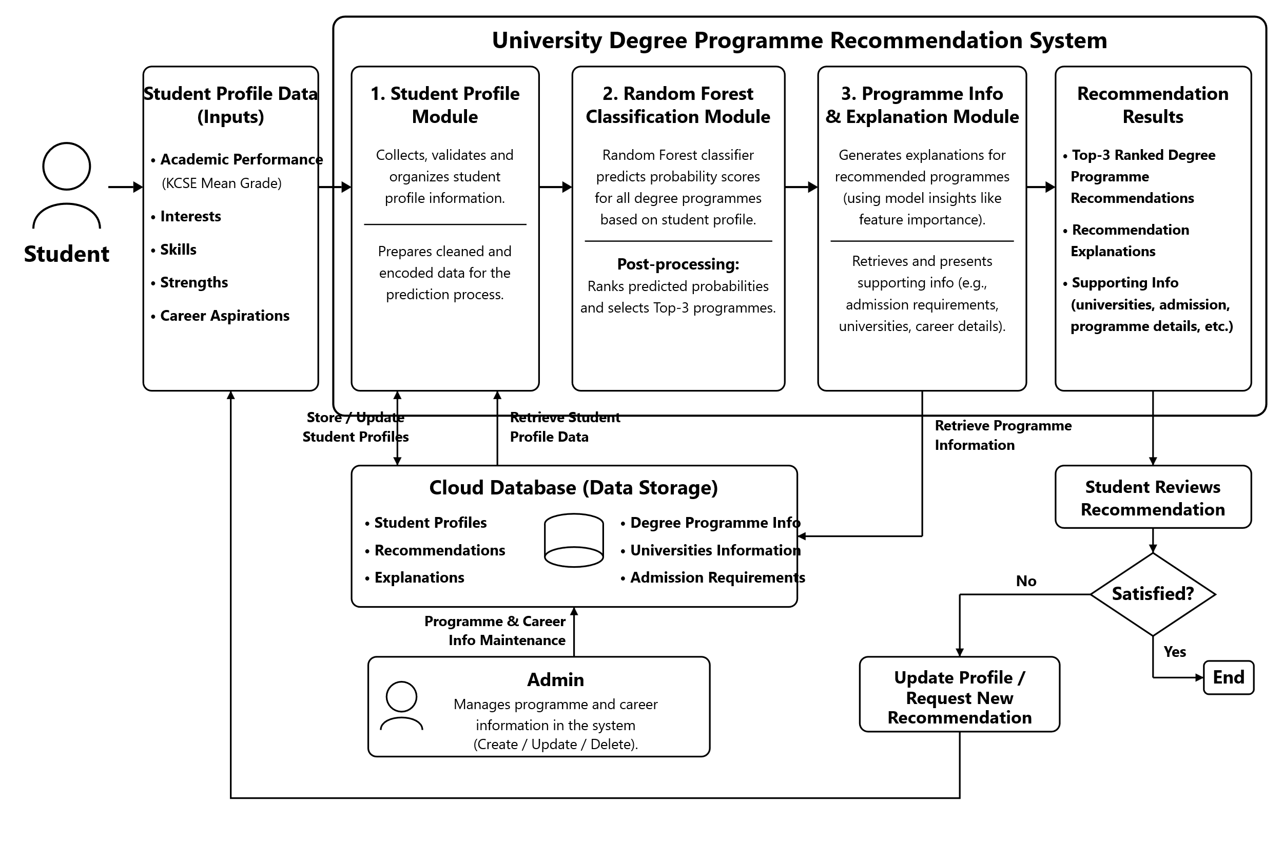
Figure ‎2.1:Conceptual Framework

Methodology

Introduction
This chapter presents the methodology that was used in the development and evaluation of the Random Forest-based university degree programme recommendation system. It describes the research paradigm, data acquisition and processing procedures, model training and evaluation, and the software development methodology. The chapter also presents the system analysis and design approaches, the system deliverables, and the tools and techniques used to develop and integrate the recommendation system.

Research paradigm
This study adopted an experimental research paradigm to guide the development and evaluation of the Random Forest-based university degree programme recommendation system. The experimental approach allowed the researcher to develop and test a Random Forest-based recommendation model using student profile data. The model was evaluated to determine its effectiveness in generating suitable university degree programme recommendations based on students' academic performance, interests, skills, strengths, and career aspirations. The study used synthetic student profiles because a suitable labelled dataset linking these characteristics to university degree programmes is not readily available. The Cross-Industry Standard Process for Data Mining (CRISP-DM) was used to guide the machine learning component through the stages of business understanding, data understanding, data preparation, modelling, evaluation, and deployment (Shimaoka et al., 2024). The modelling stage focused specifically on the Random Forest algorithm, while the evaluation stage assessed its performance using accuracy, precision, recall, and F1-score, as reported in Chapter 5. The experimental approach provided a structured basis for determining whether the developed recommendation model could generate relevant and explainable university degree programme recommendations for Kenyan form-four leavers.

Data Acquisition
Data acquisition primarily involved the generation of synthetic student profiles using a deterministic, rule-based generator informed by trusted educational and programme-related sources, including KUCCPS programme and admission information, Commission for University Education (CUE) information, university programme descriptions, and recognised career guidance resources. The profiles represent realistic Kenyan form-four leaver characteristics, including KCSE performance across 7 to 9 subjects, interests, skills, strengths, preferred subjects, and career aspirations, as detailed in Chapter 5.
Each profile was assigned a university degree programme label using predefined programme suitability criteria derived from the academic requirements and characteristics of the 11 catalogued degree programmes, which represent the classification classes used by the Random Forest model. Academic eligibility was first considered using relevant KCSE subject and grade requirements. For programmes for which the student met the academic requirements, the student's interests, skills, strengths, and career aspirations were then matched against the characteristics associated with the programme. The programme with the strongest overall suitability based on the predefined criteria was assigned as the profile label, with ties broken by the closest KUCCPS Cluster Weighted Points fit, as detailed in Chapter 5.

Data Processing
Following data acquisition, the generated dataset underwent preprocessing to improve its quality, consistency, and suitability for machine learning. Categorical attributes such as interests, skills, strengths, and career aspirations were one-hot encoded into numerical representations suitable for the Random Forest model, while KCSE performance and other structured academic attributes were represented as ordinal grade points. The processed student profiles were organized into input features and university degree programme labels, and the prepared dataset was divided into training and testing sets using an 80/20 stratified split to maintain the distribution of programme classes across both sets. The testing set remained completely unseen during model training, feature selection, and hyperparameter tuning. Cross-validation and model tuning were performed using only the training data, while the held-out testing set was used once for the final performance evaluation reported in Chapter 5.

Model Training
The processed dataset was used to train a Random Forest classification model for university degree programme recommendation. The training data was used to learn relationships between student characteristics and the assigned university degree programme labels. The model used selected features, including KCSE performance across nine cluster-relevant subjects, interests, skills, strengths, and career aspirations, to identify patterns associated with suitable degree programmes.
Random Forest was selected because its ensemble of decision trees can model non-linear relationships between multiple student characteristics and is suitable for structured datasets containing both numerical and encoded categorical features (Diamantopoulou et al., 2025). Relevant hyperparameters, including the number of trees, maximum tree depth, and minimum samples per leaf, were tuned by grid search with cross-validation on the training data to improve generalization and reduce overfitting, while the testing data remained untouched until final evaluation. The final trained model was then evaluated using previously unseen test data, as reported in Chapter 5, before being integrated into the recommendation component of the system.

Model Validation and Testing
The trained Random Forest model was validated and tested using the testing dataset that was not used during model training or hyperparameter tuning. The model was evaluated using accuracy, precision, recall, and F1-score to provide a balanced assessment of its classification performance (Rainio et al., 2024), reported per programme class in Chapter 5 to identify classes the model found difficult to distinguish. At inference time, the Random Forest model produces prediction probabilities for each of the 11 programme classes, ranked in descending order to select the three highest-ranked recommendations for each student. SHAP is used to generate explanations by identifying the student-profile features that contributed most to each individual programme prediction, which are surfaced to the student in the mobile application together with the recommendation.

System Development Methodology
The Scrum-for-One Agile methodology was used to guide the development of the system. Scrum-for-One adapts the Scrum framework for an individual developer while maintaining its iterative and incremental development principles (Towhidnejad & Hagerty-Posell, 2025). This approach allowed the system to be developed in manageable stages, with each sprint focusing on a specific set of system requirements and functionalities, involving backlog creation, sprint planning, implementation, testing, sprint review, and incorporation of improvements into subsequent sprints. This approach was suitable for the project because the system consists of several components, including student registration and profile management, data processing, the Random Forest recommendation model, recommendation explanations, programme information, and feedback functionality. CRISP-DM was used specifically to guide the machine-learning component, while Scrum-for-One guided the development and integration of the complete software system.

Justification of the Methodology
Scrum-for-One was selected because it provided a structured yet flexible approach for developing the system as an individual developer. The methodology supported iterative development, continuous testing, regular review, and progressive refinement of requirements and functionality. Each sprint produced a functional increment of the system, allowing problems to be identified and addressed before proceeding to subsequent development activities, which was particularly useful because the recommendation model and other system components required refinement during development and testing. Scrum-for-One guided the software development process, while CRISP-DM provided the structured process for developing and evaluating the Random Forest recommendation model.

Methodology Diagram
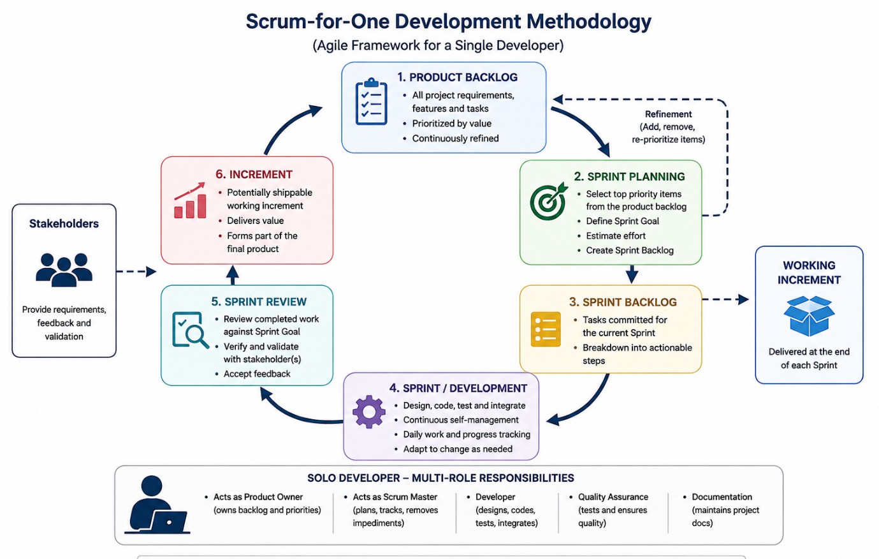
Figure ‎3.1:Scrum methodology

Product Backlog
The product backlog contained all identified requirements, features, and tasks required to develop the university degree programme recommendation system, derived from the research objectives, literature review, existing systems, and identified user needs. The backlog included core features such as user authentication, student profile management, student assessment, data preprocessing, Random Forest model development, programme recommendation, recommendation explanations, programme information, feedback functionality, system testing, and documentation, and was continuously reviewed, refined, and prioritized according to system importance and development progress.

Sprint Planning
Sprint planning involved selecting and prioritizing items from the product backlog for development within a specific sprint. Each sprint had a defined goal and time frame, with selected requirements broken down into smaller and manageable tasks. The planning process considered the dependencies between activities, such as completing student profile and data-processing functionality before integrating the Random Forest recommendation model, ensuring that each sprint had clear objectives and produced an achievable functional outcome.

Sprint backlog
The sprint backlog contained the specific tasks selected from the product backlog for completion during a particular sprint, including implementing authentication, developing the student profile, preparing data, training the Random Forest model, implementing recommendation generation, developing the explanation and programme information components, and conducting system testing. The sprint backlog was monitored and updated throughout each sprint as tasks were completed or adjusted based on development progress.

Agile Sprints
The system was developed through short, iterative sprints, with each sprint focusing on a specific set of prioritized requirements, including analysis, design, implementation, integration, and testing of the selected functionality. The sprints progressively developed the system, beginning with foundational features such as authentication and student profiling, followed by data processing and Random Forest recommendation functionality, and then supporting features such as recommendation explanations, programme information, feedback, and system integration. Each sprint produced a functional increment that was reviewed before proceeding to subsequent development activities.

Sprint Review
At the end of each sprint, a Sprint Review was conducted to assess the completed functionality against the sprint objectives and identified requirements. The implemented features were tested to determine whether they functioned as expected and met the intended system requirements. Any errors, incomplete functionality, or areas requiring improvement were documented and considered when refining the product backlog and planning subsequent sprints. For the recommendation component, the review also considered whether the implemented functionality correctly processed student profiles and produced the intended programme recommendations and explanations.

Increment
An increment was the functional and tested output produced at the end of each sprint, each adding new or improved functionality to the existing system while maintaining the functionality developed in previous sprints. The initial increment provided authentication and student profiling, while later increments added data processing, Random Forest-based recommendations, recommendation explanations, programme information, and feedback functionality. The increments were progressively integrated and tested until the complete system met the defined functional and project requirements.

System Analysis
The System Analysis and Design phase defined the structure, functionality, data relationships, and overall architecture of the university degree programme recommendation system, translating the identified system requirements into models and designs that guided implementation. The analysis and design focused on student interactions, administrator activities, student profile data, recommendation generation, programme information, data storage, and communication between the application and the Random Forest recommendation model.

Use Case Diagram
The Use Case Diagram illustrates the interactions between the system and its primary actors, the Student and System Administrator. The student can register and log in, create and update a profile, provide academic and personal information, request programme recommendations, view the ranked recommendations and their explanations, access supporting programme information, and provide feedback on the recommendations and update their profile to request a new recommendation if the recommendations are unsuitable. The System Administrator maintains programme and career information stored in the knowledge base to ensure that the supporting information presented to students remains relevant and up to date.

Activity Diagram
The Activity Diagram illustrates the workflow of UniGuide, starting with the student entering their KCSE performance, interests, skills, strengths, and career aspirations. The application validates the information before the Random Forest model generates probability scores. The system then ranks the programmes, generates SHAP-based explanations, retrieves programme information from Firestore, and displays the Top 3 recommendations. The student can either submit feedback or adjust their profile to request another recommendation. In parallel, the administrator maintains programme and admission information.

Sequence Diagram
The Sequence Diagram illustrates the sequence of interactions when a student requests programme recommendation. It shows the student submitting profile information through the system, the data being processed and sent to the Random Forest model, the generation of ranked recommendations, retrieval of supporting programme information, and presentation of the results to the student.

System Design

Database Schema
The database schema defines how student profiles, degree programmes, programme information, recommendations, feedback, and administrator information are stored and related within Cloud Firestore, supporting the storage and retrieval of the information required for generating recommendations and presenting relevant programme details to students.

System Architecture
The system architecture illustrates the interaction between the user interface, application layer, Random Forest recommendation model, and database. It shows how student profile information is submitted and processed, how the model generates the ranked recommendations, and how programme information is retrieved and presented alongside the recommendations.

Wireframes
Wireframes were developed to represent the main interfaces before implementation and establish the intended user flow, including the registration and login pages, student profile page, recommendation request and results pages, programme information page, and feedback interface, helping ensure that the main functions are clearly organized and easy for students to navigate.

System Deliverables

System Documentation
Comprehensive system documentation was developed to describe the requirements, design, implementation, testing, and operation of the university degree programme recommendation system, including system architecture, database design, model development and evaluation procedures, user instructions, and maintenance information, providing a reference for understanding, operating, testing, and maintaining the developed system.

Authentication Module
The Authentication Module provides secure access to the system by allowing students and administrators to register, log in, and manage their accounts, using Firebase Authentication. It implements authorization mechanisms to ensure that users can only access functions appropriate to their roles, and supports secure account and password management to improve system security and usability.

Student Assessment and Profiling Module
The Student Assessment and Profiling Module collects and manages the information required to create a student profile for programme recommendation, including KCSE performance across 7 to 9 subjects, interests, skills, strengths, and career aspirations. Students enter and update their profile information, which is then processed into the features required by the Random Forest recommendation model.

Recommendation Module
The Recommendation Module serves as the core machine learning component of the system. It uses the trained Random Forest classification model to analyse the student's profile and generate prediction probabilities for each of the 11 catalogued university degree programmes, which are ranked to identify the three highest-ranked programmes for presentation to the student. SHAP generates explanations showing the main student-profile features that contributed to each recommendation, so the module provides both ranked recommendations and model-based explanations to support informed decision-making.

Programme Information and Support Module
The Programme Information and Support Module provides additional information about the recommended university degree programmes to support students in evaluating their options, including programme entry requirements, universities offering the programme, related career pathways, recommended skills, certifications, and relevant learning resources. This information is retrieved from the programme knowledge base and presented alongside the recommendations, while recommendation explanations are generated separately from the Random Forest model using SHAP. Students can review the recommendations, explanations, and supporting programme information before providing feedback, and if a student considers the recommendations unsuitable, they can update their profile information and request a new recommendation based on the revised inputs. The module supports informed decision-making without functioning as a separate academic learning or tutoring system.

System Development Tools and Techniques

Python
Python was used to develop the machine learning component and the FastAPI backend of the system, supporting data processing, preparation of student profile data, training of the Random Forest classification model, and generation of university degree programme recommendations. Python was suitable for the project because it provides extensive libraries and tools for machine learning, data analysis, and web API development.

Sci-kit Learn
Scikit-Learn was used to build, train, and evaluate the Random Forest model, including its OneHotEncoder for categorical features, GridSearchCV for hyperparameter tuning, and evaluation metrics such as accuracy, precision, recall, and F1-score. Its simplicity and strong documentation made it suitable for rapid development and testing of the recommendation model.

SHAP
SHAP is used to generate explanations for individual Random Forest predictions, identifying the contribution of relevant student-profile features to the predicted university degree programmes and allowing the system to present understandable reasons for the recommendations. This supports transparency by showing students which aspects of their profiles contributed most to each recommendation.

FastAPI
FastAPI was used to develop the backend REST API that connects the Flutter application with the Random Forest recommendation model, Firebase Authentication, and Cloud Firestore. It receives student profile information from the application, verifies the caller's identity, passes the processed information to the recommendation model, and returns the generated programme recommendations and relevant information to the application.

Flutter
Flutter was used to develop the mobile application interface of the system, providing the interfaces through which students register and log in, create and manage their profiles, submit their academic and personal information, request recommendations, view ranked programme recommendations, access programme information, and provide feedback.

Firebase
Firebase provides authentication and data storage services for the system, through Firebase Authentication and Cloud Firestore. It supports user authentication and storage of student profiles, degree programme information, recommendations, and student feedback. The stored feedback supports evaluation of recommendation relevance and allows the system to record whether students consider the recommendations suitable; the feedback was not used for automatic retraining of the Random Forest model during this study. Firebase enables the application to securely store and retrieve the information required by the system, with Firestore security rules restricting direct client access so that all reads and writes are mediated by the authenticated FastAPI backend.

Visual Studio Code
Visual Studio Code was used as the primary development environment for implementing, testing, and debugging the system, supporting development of the Python machine learning component, FastAPI backend, and Flutter application through its development tools and extensions.

System Analysis and Design

Introduction
This chapter details the analysis and design phase of the UniGuide University Degree Programme Recommendation System, transforming the project's objectives into a concrete technical plan that guided implementation. It begins with a comprehensive requirement analysis that outlines the needs of the main stakeholders and defines the system's functional and non-functional requirements. Following the requirements, this chapter presents a series of system analysis and design diagrams that provide a logical and visual representation of the system.
The system analysis section focuses on understanding what the system should do and how users interact with it. The system design section then presents the technical architecture, data organisation, and user interface through the relevant design diagrams and wireframes.

Requirement Analysis
The requirement analysis was conducted with consideration of the needs of the primary users of UniGuide, particularly students who require support when selecting suitable university degree programmes. The system addresses the challenge faced by form-four leavers who may have difficulty identifying degree programmes that align with their academic performance, personal interests, skills, strengths, and career aspirations.
Students currently consider different sources of information when making programme choices, including their KCSE performance, programme admission requirements, personal interests, skills, and future career goals. UniGuide brings these factors together within one platform and provides personalised degree programme recommendations supported by understandable explanations and relevant programme information.
The main stakeholders of the system are students and administrators. Students use the system to provide their profile information, request recommendations, view recommended degree programmes and their explanations, access programme information, and provide feedback. Administrators are responsible for maintaining the programme-related information used by the system, including admission requirements, minimum grades, and programme descriptions.

Functional Requirements
The functional requirements define the specific services that UniGuide provides to its users. They describe how the system should respond to user inputs and interactions and are derived from the identified requirements of the students and administrators.
FR-01: Authentication Module-This provides a way of identifying users and controlling their access to the system. First-time users register before accessing the system, while returning users log in using their registered credentials. The system supports separate access privileges for students and administrators, ensuring that administrative functions are only available to authorised users. Firebase Authentication is used to manage user authentication and account access, with the administrator role resolved server-side rather than inferred from the account's email address.
FR-02: Student Profile Management-This provides students with a way of entering and updating the information required for recommendations. The profile includes KCSE academic performance across 7 to 9 subjects, interests, skills, strengths, and career aspirations. The information provided is used as the input for generating personalised degree programme recommendations.
FR-03: Degree Programme Recommendation- This is the main intelligence of the system. It analyses the student's academic and personal profile using the trained Random Forest model to identify suitable university degree programmes. The predicted programmes are ranked according to their confidence scores, and the three highest-ranked programmes are presented to the student, together with a SHAP-based explanation for each.
FR-04: Feedback and Programme Management- This allows students to provide feedback on the relevance of their recommendations, while authorised administrators manage programme information and admission requirements. Student feedback supports evaluation and future system improvement but does not automatically retrain the Random Forest model within this study.
FR-05: Recommendation Explanation and Programme Information-This provides students with explanations and supporting information about their recommendations. SHAP identifies the student-profile features that contributed most to each prediction, while programme information provides details such as admission requirements, university options, and potential career pathways.

Non-Functional Requirements
Non-functional requirements define the quality attributes and operational standards expected from UniGuide. These requirements ensure that the system is secure, usable, reliable, responsive, and capable of supporting its intended users.
NFR-01: Security-The system handles personal student information and therefore requires secure authentication and access control. Firebase Authentication manages user authentication, access to administrative functions is restricted to authorised administrators, and Cloud Firestore security rules deny direct client access so that all data access is mediated by the authenticated backend.
NFR-02: Usability-the system provides a simple and intuitive mobile interface. Students can enter their information, request recommendations, understand the results, and access supporting programme information without unnecessary complexity.
NFR-03: Performance-The system responds efficiently to student requests, with recommendation requests processed within a reasonable period while communication between the mobile application, FastAPI backend, machine-learning component, and Firebase remains efficient.
NFR-04: Reliability-The system operates consistently and provides reliable recommendation results and programme information. Validation and error handling are incorporated throughout the mobile application and backend to reduce failures during profile submission, recommendation requests, and data retrieval, with clear error states shown to the user rather than the application silently failing.
NFR-05: Scalability-The system architecture allows the application to accommodate an increasing number of student profiles, recommendations, programme records, and feedback records without requiring major changes to the overall architecture.
NFR-06: Compatibility-The mobile application operates consistently on supported Android devices. The backend services also maintain compatibility with the technologies used to access the system.

Data Requirements
The Data Requirements section outlines the necessary data structures for storing student academic profiles, university course details, AI recommendations, and system audit trails.
DR-01: User & Authentication Data: The system shall store user account credentials, identification, and assigned roles (e.g., student, admin) required for authentication and access control.
DR-02: Student Profile Data: The system shall store student academic profiles, including KCSE mean grades, individual subject grades (e.g., Mathematics, English, Physics), career aspirations, and interest tags.
DR-03: Programme Repository Data: The system shall store structured university programme information, including degree titles, descriptions, offering universities, detailed requirements, career pathways, and KUCCPS cluster weights.
DR-04: Recommendation & Feedback Data: The system shall store generated programme recommendations, similarity/ranking scores, SHAP explanation data, and student feedback (ratings and comments) within Firestore subcollections.
DR-05: Data Validation & Preprocessing: The system shall validate academic inputs (e.g., grade formats and cluster calculations) prior to storage, ensuring incomplete or invalid records are not processed for course recommendations.
DR-06: Data Protection & Audit Trails: The system shall store student data securely and maintain audit metadata (last_updated, updated_by_admin_id) for administrative updates to university programme requirements.

Interface and Integration Requirements
The Interface and Integration Requirements section details how the user interface, backend services, machine learning pipeline, and Firestore database communicate to deliver seamless performance.
IR-01: User & Admin Interfaces: The system shall provide a frontend interface for high school graduates to manage profiles, view ranked programmes, and submit feedback, alongside an admin dashboard to manage programme data and view audit logs.
IR-02: REST API & JSON Exchange: The client application and backend services shall communicate via REST API endpoints using structured JSON request and response payloads.
IR-03: Recommendation Engine Integration: The backend service shall supply student academic profiles and preference vectors to the recommendation pipeline and receive ranked course lists with SHAP explanation metrics.
IR-04: Recommendation Processing Pipeline: The recommendation engine shall execute sequential processing stages, integrating KUCCPS cluster-weight filtering, machine learning similarity scoring, and feature-importance ranking.
IR-05: Database Interface: The backend shall interface directly with Firebase Firestore to perform CRUD operations across the students, programmes, and admins collections, as well as the recommendations subcollection.
IR-06: Secure Communication & Error Handling: The system returns standardized, user-friendly error responses without exposing system infrastructure details. HTTPS encrypted communication between the front end and backend is required for any deployment beyond local development and testing, as discussed in Chapter 5.

System Analysis Diagrams
This section presents the system analysis diagrams for UniGuide. The diagrams model the system's functional requirements, processes, interactions, and data relationships from a high-level perspective, illustrating what the system does and how users interact with it.

Use Case Diagram
The Use Case Diagram defines the functional scope and interaction boundaries for UniGuide, addressing functional requirements FR-01 through FR-05 by outlining user interactions for both primary actors: Students and System Administrators.
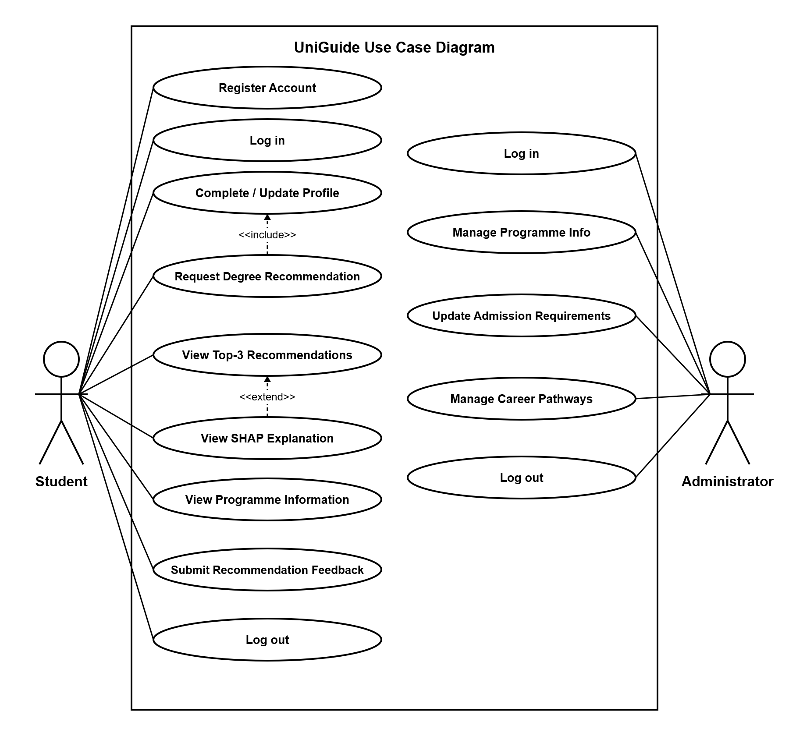
Figure ‎4.1:Use Case Diagram
The student actor initiates core interactions including account registration, profile management, requesting recommendations, viewing SHAP explanations, browsing programme details, and submitting feedback. The Administrator actor handles backend configuration tasks such as updating admission requirements, managing career pathways, and maintaining programme data. Shared entry and exit actions like logging in and out are accessible to both roles

Activity Diagram
The Activity Diagram details the operational workflow during a recommendation request, addressing performance, error handling, and data processing requirements across the application layer, machine learning engine, and data storage.
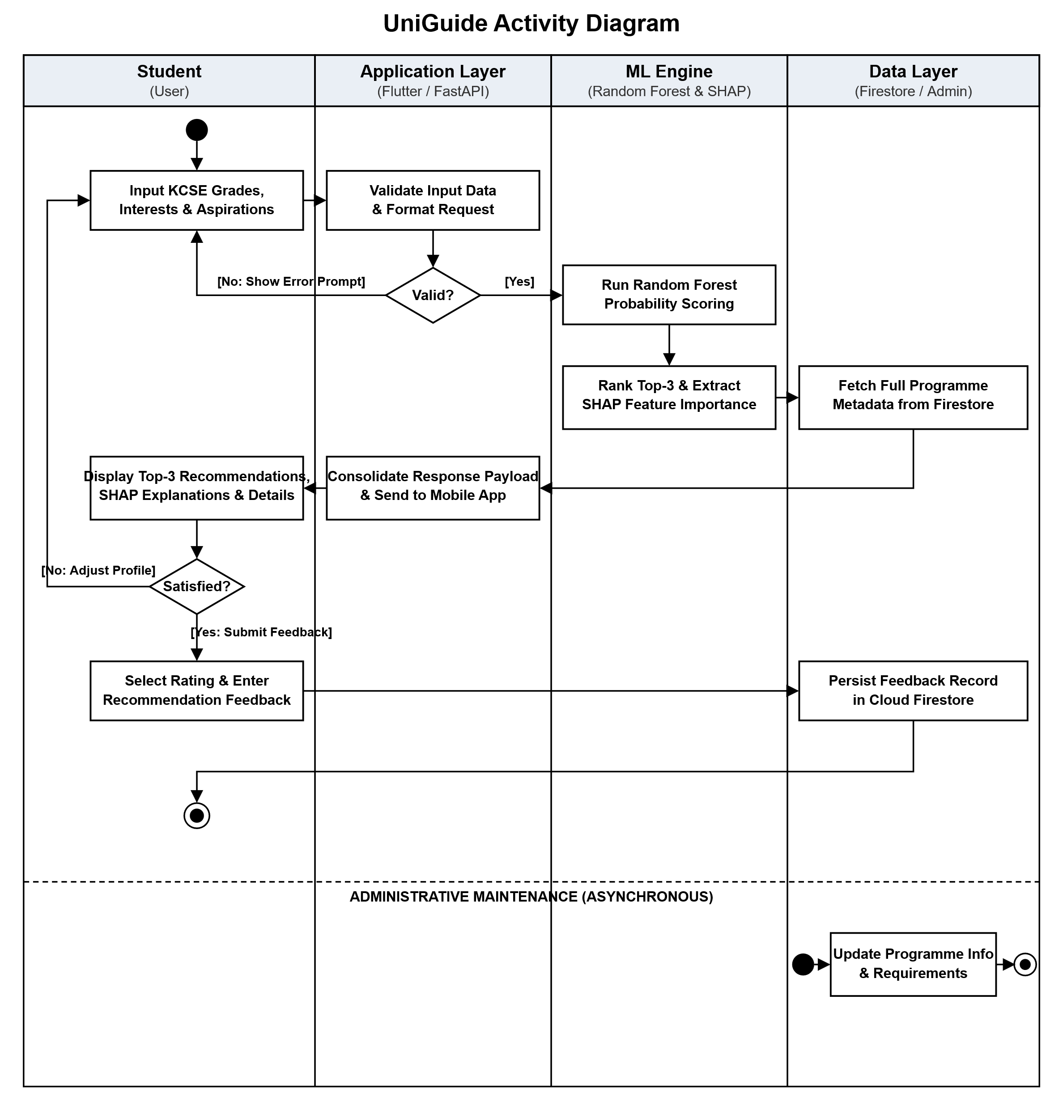
Figure ‎4.2:Activity Diagram
The sequence starts when a student enters profile details. The application validates the data format; if invalid, an error prompt is returned. Valid inputs trigger Random Forest probability scoring and SHAP feature importance extraction. The application consolidates the predictions with Firestore metadata and renders the Top 3 recommendations. The user can either submit feedback (which persists to Firestore) or return to adjust profile parameters.

Sequence Diagram
The Sequence Diagram depicts the step-by-step message exchanges and temporal execution sequence between components, addressing system integration requirements across the Flutter frontend, FastAPI backend, ML service, and Firestore database.

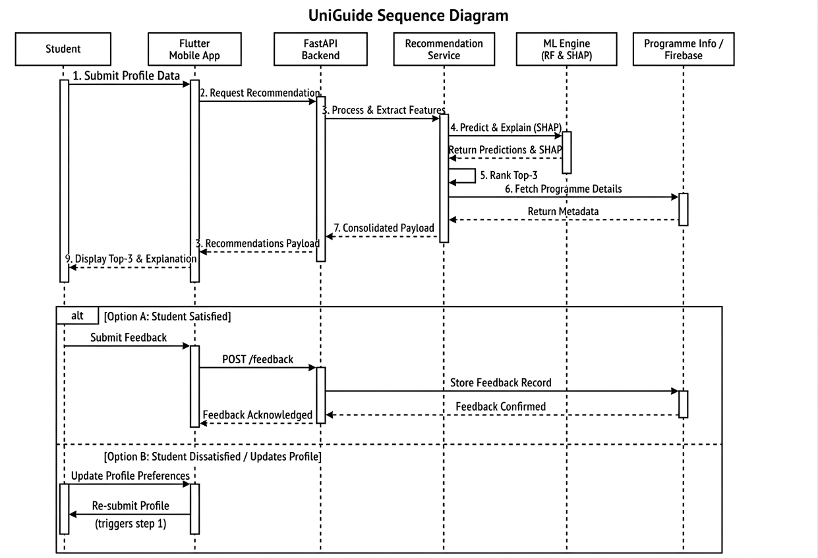
Figure ‎4.3:Sequence Diagram
The Flutter application posts profile data to the FastAPI backend, which extracts features for the ML Engine. The ML Engine evaluates the profile using Random Forest and SHAP, returning predictions and explanations to the recommendation service. Program metadata is retrieved from Firebase, consolidated into a single payload, and rendered on the client app. The diagram shows two conditional operational branches: Option A (submitting user feedback) and Option B (updating profile data to restart the request).

System Design Diagrams
This section contains the system design diagrams that provide a more detailed technical representation of UniGuide, illustrating how the system is structured internally and how the analysed requirements were implemented.

System Architecture
The System Architecture Diagram outlines the high-level structural components and technical design of the platform, addressing architectural requirements for system modularity, API communication, model processing, and data persistence.
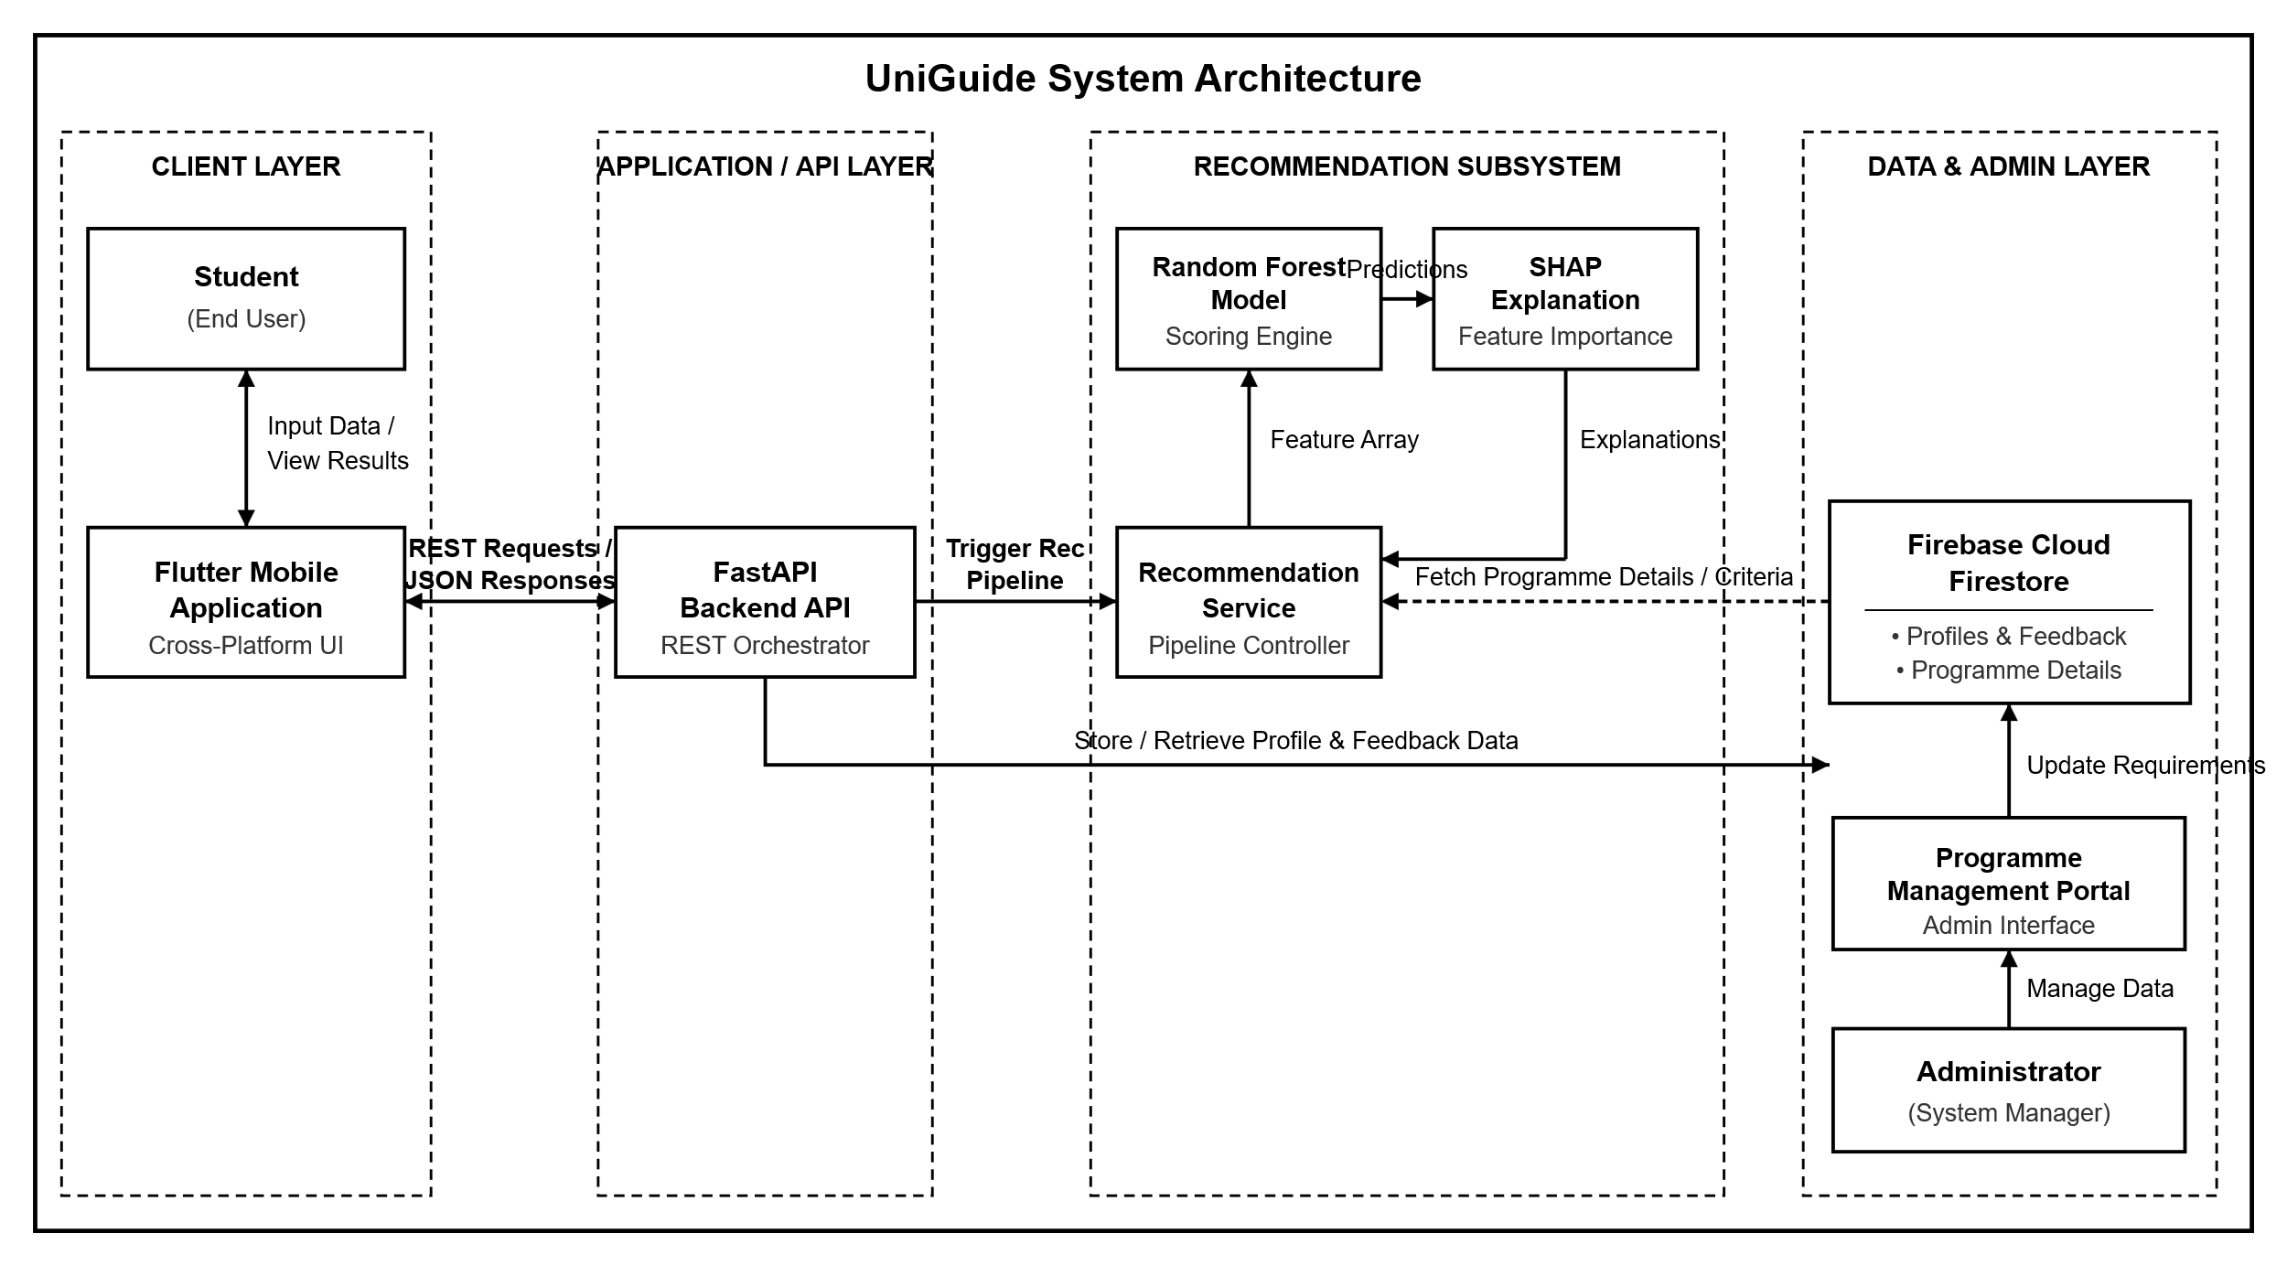
Figure ‎4.4:System Architecture
The architecture is structured into four distinct layers: Client (Flutter Mobile UI), Application/API (FastAPI REST backend), Recommendation Subsystem (Random Forest scoring and SHAP feature importance engines), and Data & Admin Layer (Firebase Cloud Firestore and Admin Portal). REST/JSON interfaces coordinate communications across layers, ensuring decoupled data processing, recommendation evaluation, and persistence.

Database Schema
The Database Schema diagram defines the NoSQL collection structure within Firebase Cloud Firestore, addressing data storage requirements DR-01 through DR-06 for managing user accounts, profiles, course details, recommendations, explanations, and audit metadata.
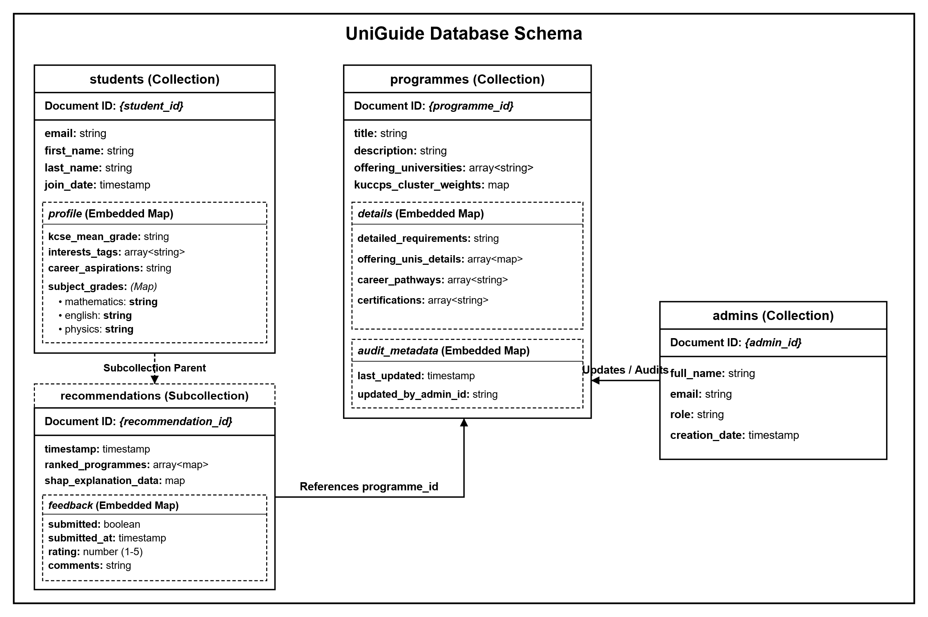
Figure ‎4.5:Database Schema Diagram
The database is structured around top-level collections: students, programmes, and admins. The student’s collection embeds profile attributes and parent-links to a recommendations subcollection containing ranked matches, SHAP maps, and feedback entries. The programmes collection stores cluster weights, detailed requirements, and embedded audit maps linked to admin updates.

Wireframes
The UI wireframes outline the layout, navigation flow, and core user interactions across the application. These low-fidelity schematics served as a visual blueprint for the interface, and the implemented mobile application described in Chapter 5 follows this same navigation flow.
- Login & Authentication Screen

Figure ‎4.6:Authentication Wireframe
- Student Profile Setup Screen
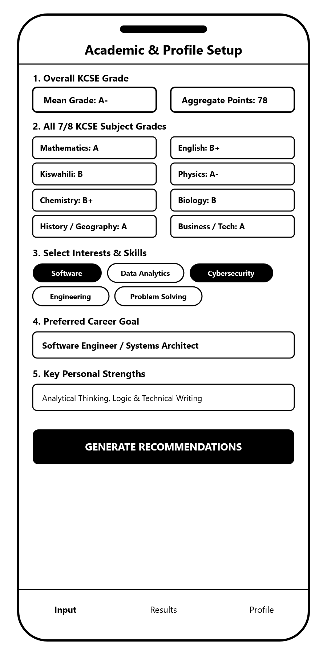
Figure ‎4.7:Profile Setup Wireframe
- Recommendation Results & SHAP Explanations
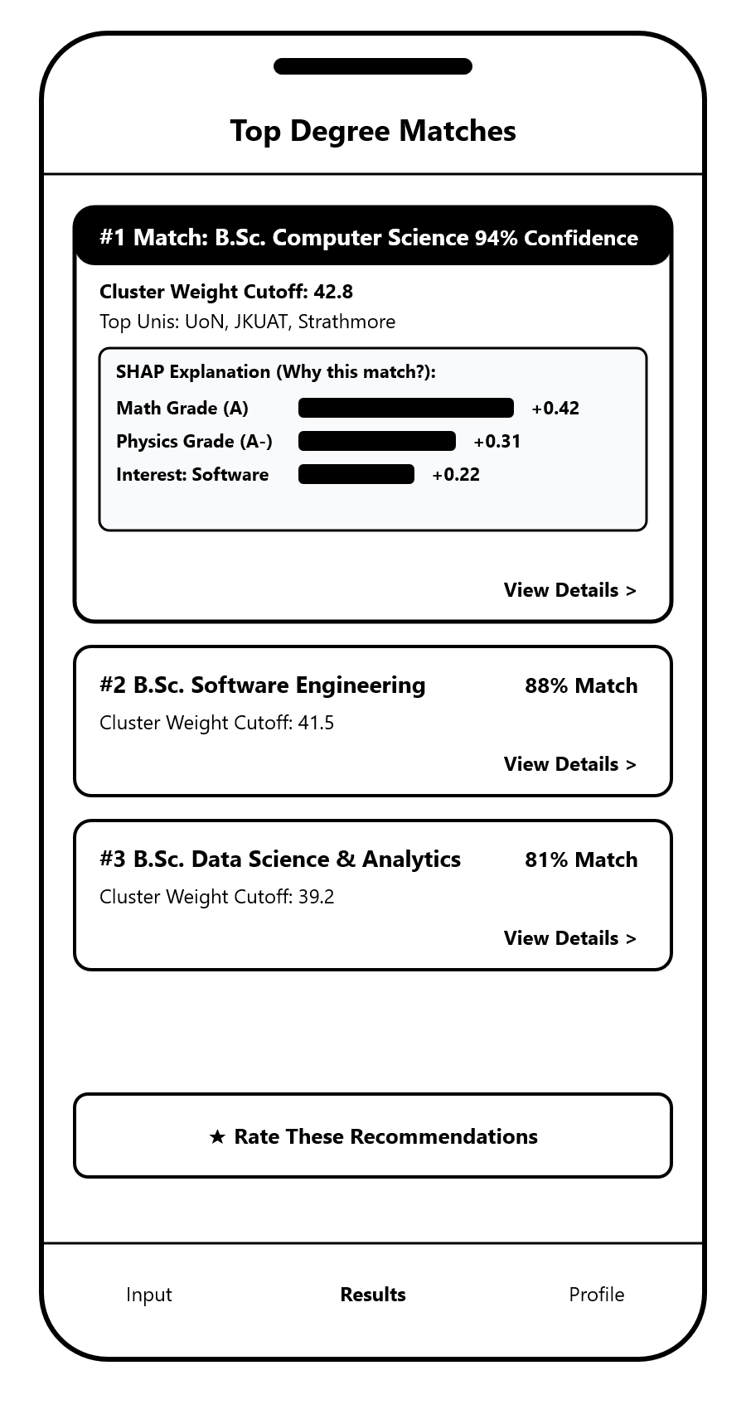
Figure ‎4.8:Recommendation Wireframe

- Programme Information & Details Screen
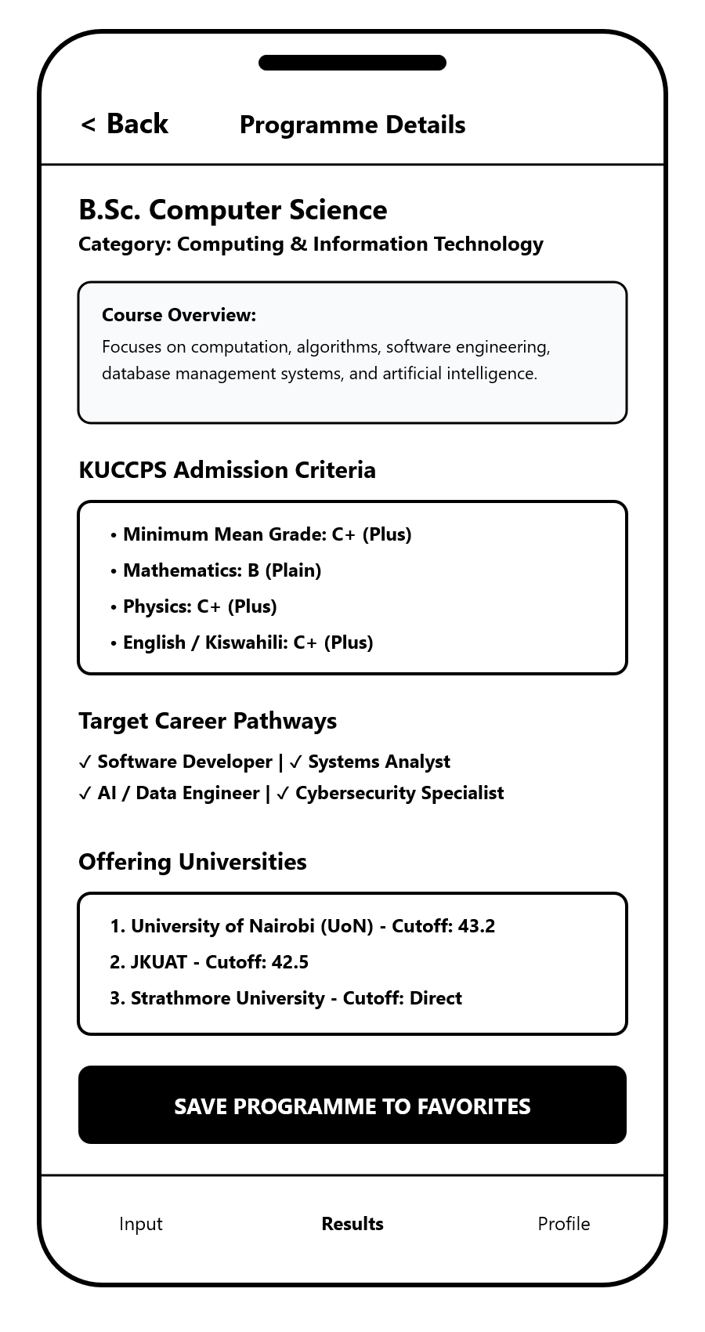
Figure ‎4.9:Programme Information Wireframe

- Administrator Dashboard
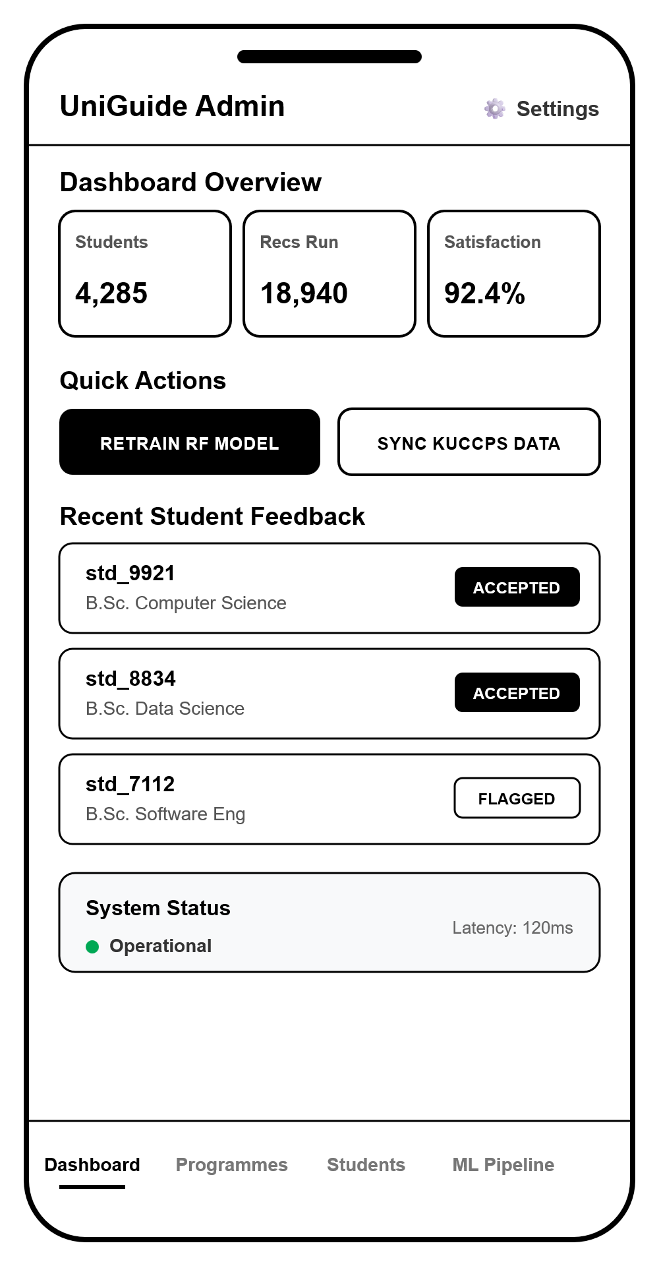
Figure ‎4.10:Admin Dashboard Wireframe

- Student Feedback & Recommendation Evaluation Screen
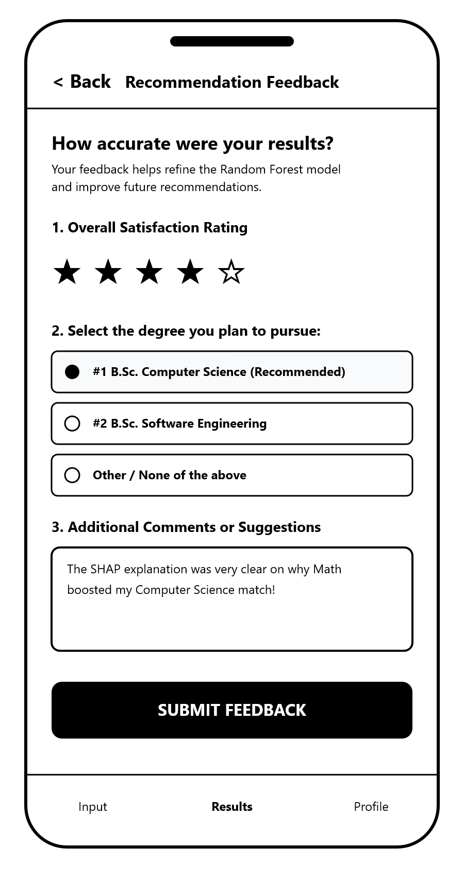

Figure ‎4.11:Rating Wireframe
The wireframe designs established a clear structural progression that translated system requirements into a user-centred interface flow, which the implemented application preserved: the onboarding and profile screens gather KCSE subject grades and preferences, the recommendation results screen replaces traditional black-box guidance with clear confidence scores, KUCCPS cluster cutoffs, and visual SHAP feature contribution bars that explain match drivers, the programme detail screens connect predictive matches to career pathways and offering universities, and the administrative dashboard and feedback tools support ongoing system evaluation and catalogue maintenance.

System Implementation and Testing

Introduction
This chapter presents the implementation and testing of the UniGuide University Degree Programme Recommendation System. It describes the hardware and software environment used during development, the synthetic dataset generated and used to train the Random Forest recommendation model, the model training and evaluation procedure and its measured performance, the functional testing carried out on the completed system, and a discussion of the results obtained, including informal feedback gathered from a small group of test users during development.

Implementation Environment

Hardware Specifications
The system was developed and tested on a standard Windows laptop, with the Android emulator and mobile application tested on both an emulated Android device (Pixel 6a, Android 16) and, where available, physical Android hardware. Table 5.1 summarises the development hardware.
Component | Specification
Operating System | Windows 11 Home Single Language
Processor | AMD Ryzen 5 5625U (6 cores, 12 threads)
Memory (RAM) | 8 GB
Test Device (mobile) | Android Emulator - Pixel 6a (Android 16, API 36)

Table 5.1: Hardware Specifications

Software Specifications
The system relied on the following software frameworks, libraries, and platforms across the machine learning pipeline, backend service, and mobile application. Table 5.2 summarises the key software components and their role in the project.
Software / Library | Version | Role in Project
Python | 3.12 | Primary language for the synthetic data generator, training pipeline, and FastAPI backend.
Scikit-Learn | 1.9 | Provided the RandomForestClassifier, OneHotEncoder, GridSearchCV, and evaluation metrics.
SHAP | 0.52 | Generated per-prediction feature-contribution explanations (TreeExplainer).
Pandas / NumPy | current | Dataset construction, feature engineering, and numerical operations.
FastAPI / Uvicorn | current | REST API framework and ASGI server exposing /api/recommend, /api/feedback, /api/auth/whoami, and the admin endpoints.
firebase-admin | 6.x | Server-side verification of Firebase Auth ID tokens and Cloud Firestore CRUD operations.
Flutter / Dart | 3.47 | Cross-platform mobile application framework used to build the Android client.
firebase_auth / firebase_core | current | Client-side Firebase Authentication (email/password sign-in and registration).
Firebase Authentication | - | Manages student and administrator accounts.
Cloud Firestore | - | Stores student profiles, generated recommendations, feedback, the programme catalogue, and the administrative audit trail.
Android SDK / Gradle | SDK 36 / Gradle 8.14 | Builds and packages the Flutter application into an installable Android APK.
Visual Studio Code | current | Primary development environment for the Python backend and Flutter application.

Table 5.2: Software Specifications

Dataset Description
Because no publicly available labelled dataset links Kenyan form-four leaver profiles to suitable university degree programmes, the recommendation model was trained on a synthetic dataset of 3,000 student profiles, generated by a deterministic, rule-based generator (2400 of the profiles used for training and 600 held out for testing). Each profile represents a realistic Kenyan KCSE candidate and includes the same information the mobile application actually collects, so that the trained model's vocabulary matches what a real student can submit.
Every profile has between 7 and 9 KCSE subjects, matching real KCSE candidates: the 5 subjects every candidate sits (Mathematics, English, Kiswahili, Biology, and Chemistry) plus 2 to 4 optional subjects drawn from the full KNEC optional subject list offered in the application (for example Physics, History and Government, Geography, Business Studies, Computer Studies, Agriculture, and various Religious Education, language, and technical subjects). Subject grades were sampled around a randomly generated overall mean grade for each profile, with the optional subjects a profile received biased toward ones that plausibly fit its stated career aspiration (for example, an aspiring engineer was more likely, though not certain, to have sat Physics), which mirrors how real students' subject combinations tend to relate to their interests.
In addition to KCSE grades, each profile also has interests, skills, strengths, and a career aspiration, drawn from exactly the same fixed option lists presented to students on the Profile Setup screen of the mobile application. Keeping the synthetic data's categorical vocabulary identical to the application's own option lists ensures the trained model can be queried with any input a real student could actually submit.
Each synthetic profile was assigned a ground-truth university degree programme label using a deterministic, multi-criteria rule rather than by the Large Language Model directly, matching the methodology described in Chapter 3. First, the student's grades were checked against each of the 11 catalogued programmes' minimum KUCCPS subject requirements, and only programmes the profile was actually eligible for were considered. Among the eligible programmes, each was scored against the profile's stated aspiration, interests, and skills (an aspiration match contributing the strongest signal, followed by matching interests, followed by overlapping skill keywords), and the highest-scoring programme was assigned as the label. Where no eligible programme scored above zero, or multiple programmes tied for the highest score, the tie was broken by the smallest gap between the profile's computed KUCCPS Cluster Weighted Points (CWP) for that programme and the programme's average admission cutoff, so that the label always reflects the closest realistic academic fit.
The dataset generation was seeded, so that re-running the generator with the same seed reproduces an identical dataset, ensuring that the accuracy and F1-score figures reported in Section 5.4 are reproducible rather than varying between runs. The generated dataset was split into training and testing subsets using an 80/20 stratified split so that the relative proportion of each of the 11 programme classes was preserved in both subsets; the testing subset was withheld from all model fitting and hyperparameter tuning and used only once, for the final evaluation reported in Section 5.4.2.

Model Training and Evaluation
This section describes the Random Forest model that was trained on the dataset described in Section 5.3, the hyperparameter tuning procedure used, and the metrics used to measure its predictive performance.

Model Components
A single classification model, a Scikit-Learn RandomForestClassifier, was trained to predict a student's most suitable university degree programme from among the 11 programmes in the catalogue described in Chapter 4. Random Forest was selected, as justified in Chapter 3, because its ensemble of decision trees can model non-linear relationships between numerical KCSE grades and encoded categorical attributes (interests, skills, strengths, and aspiration) without requiring the extensive feature engineering that a linear model would need, while remaining fast enough for real-time mobile inference and, together with SHAP, interpretable enough to justify its recommendations to a student.
Each student profile was represented by ten numeric features (the KCSE grade, expressed as points from 1 to 12, for each of the 9 subjects referenced anywhere in the programme catalogue's cluster or minimum-grade requirements - Mathematics, English, Kiswahili, Biology, Chemistry, Physics, History, Business Studies, and Geography - plus the candidate's overall mean-grade points) and four categorical features (primary interest, primary skill, primary strength, and career aspiration, one-hot encoded). A subject a student did not sit as one of their optional subjects was filled with their mean-grade points rather than a fabricated low grade, so the model treats an unsampled subject as roughly average rather than as a failure.
Hyperparameters were tuned by grid search over the number of trees (200 or 350), maximum tree depth (12, 18, or unlimited), and minimum samples per leaf (1 or 2), using 5-fold cross-validation on the training split scored by weighted F1, with balanced class weights (class_weight="balanced_subsample") to compensate for programmes such as Medicine and Pharmacy that, realistically, have far fewer eligible synthetic profiles than programmes with lower admission bars. The best configuration found was 200 trees, unlimited maximum depth, and a minimum of 2 sample(s) per leaf, achieving a cross-validated weighted F1-score of 68.7% (± 1.0 percentage points) on the training data.
SHAP (SHapley Additive exPlanations), specifically the TreeExplainer implementation, was integrated at inference time to compute the individual feature contributions behind each of a student's three ranked recommendations. For each recommended programme, the four features with the largest absolute SHAP value are surfaced to the student in the mobile application, together with a short description of what that feature means (for example, "Aspiration: Software Engineer / AI Architect" or "Physics (Grade A-)"), so that every recommendation is accompanied by a concrete, model-derived explanation rather than a generic statement.

Model Evaluation Metrics
The trained model was evaluated on the held-out 600 testing profiles, which were not used for training or hyperparameter tuning. Model performance was assessed using accuracy, precision, recall, and F1-score, computed per class and aggregated as a weighted average across all 11 programme classes.
Accuracy is the proportion of test profiles for which the model's top prediction matched the assigned label, out of all test profiles:
Accuracy = (Correct Predictions) / (Total Predictions)
Precision, for a given programme class, is the proportion of profiles the model predicted as that programme that were genuinely that programme:
Precision = TP / (TP + FP)
Recall is the proportion of profiles genuinely belonging to a programme that the model correctly identified as that programme:
Recall = TP / (TP + FN)
F1-score is the harmonic mean of precision and recall, balancing the two into a single figure:
F1 = 2 x (Precision x Recall) / (Precision + Recall)
Where TP, FP, and FN denote true positives, false positives, and false negatives for a given programme class, respectively. On the held-out test set, the final model achieved an overall accuracy of 69.3% and a weighted F1-score of 68.4%. Table 5.3 reports precision, recall, and F1-score for each of the 11 programme classes.
Programme | Precision | Recall | F1-Score | Support (test profiles)
Bachelor of Science in Informatics and Computer Science | 0.70 | 0.80 | 0.75 | 266
Bachelor of Commerce (BCom) - Finance & Accounting | 0.72 | 0.59 | 0.65 | 148
Bachelor of Science in Nursing | 0.62 | 0.58 | 0.60 | 43
Bachelor of Science in Software Engineering | 0.44 | 0.24 | 0.31 | 29
Bachelor of Science in Actuarial Science | 0.78 | 0.78 | 0.78 | 27
Bachelor of Laws (LLB) | 0.63 | 0.85 | 0.72 | 20
Bachelor of Science in Civil Engineering | 0.71 | 0.85 | 0.77 | 20
Bachelor of Science in Electrical and Electronic Engineering | 0.79 | 0.65 | 0.71 | 17
Bachelor of Science in Business Information Technology (BBIT) | 0.40 | 0.27 | 0.32 | 15
Bachelor of Medicine and Bachelor of Surgery (MBChB) | 0.86 | 0.75 | 0.80 | 8
Bachelor of Pharmacy (BPharm) | 0.75 | 0.86 | 0.80 | 7
Weighted Average | 0.69 | 0.69 | 0.68 | 600

Table 5.3: Random Forest Classification Performance per Programme (Held-Out Test Set)
The results in Table 5.3 show that the model performs strongly on programmes with either a large number of eligible/representative training profiles or a distinctive combination of academic requirements and stated aspiration, such as Medicine, Pharmacy, Actuarial Science, Civil Engineering, and Law, each achieving an F1-score of 0.72 or above despite, in the case of Medicine and Pharmacy, having very few test examples due to their strict grade requirements. The weakest performance was observed for Software Engineering (F1-score 0.31) and Business Information Technology (F1-score 0.32). This is discussed further in Section 5.6, and is a genuine, honestly-reported limitation of the current feature set rather than an error in the pipeline: Software Engineering and Informatics and Computer Science share near-identical KUCCPS subject requirements and, in the mobile application's own aspiration list, a single combined option, "Software Engineer / AI Architect", that maps to either programme, leaving the model with very little signal to reliably distinguish between the two.

Functional Testing
Alongside model evaluation, the completed system was functionally tested end-to-end against the live FastAPI backend, a live Firebase project (Authentication and Cloud Firestore), and the Android mobile application. Test accounts were created and deleted as part of testing so that no test data was left behind in the production Firestore database. Table 5.4 summarises the functional test cases performed and their outcomes.
# | Test Case | Expected Result | Outcome
1 | Student registration and sign-in (real Firebase Authentication) | A new account is created and the caller receives a valid Firebase ID token | Passed
2 | Role resolution (/api/auth/whoami) for a new student | Server verifies the ID token, creates a students/{uid} Firestore document, and returns role = student | Passed
3 | Role resolution for an administrator account | Server returns role = administrator for an account listed in the admin allow-list / admins collection | Passed
4 | Non-administrator blocked from an admin-only endpoint | PUT /api/admin/programmes/{id} returns HTTP 403 for a student account | Passed
5 | Programme recommendation request (/api/recommend) | The Random Forest model returns three ranked programmes with confidence scores, KUCCPS cluster figures, and SHAP explanations, and the profile and recommendation are persisted to Firestore | Passed
6 | Feedback submission (/api/feedback) | A rating and comment are persisted under the student's Firestore feedback subcollection | Passed
7 | Administrator programme update | An administrator can update a programme's cutoff, minimum grade, and description, the change is persisted to Firestore, and an audit log entry is recorded | Passed
8 | Returning-student profile round trip | A previously saved profile, including a Firestore server timestamp, is correctly returned by /api/auth/whoami and parsed by the mobile application | Passed
9 | Firestore security rules | Direct client reads/writes to Firestore (bypassing the backend) are denied | Passed
10 | Android application build and install | The mobile application compiles, installs on an Android emulator, and launches without crashing | Passed
11 | Fresh-install authentication flow | A freshly installed application with no prior session shows the splash screen followed by the sign-in/registration screen, not the main application | Passed

Table 5.4: Functional Testing Results
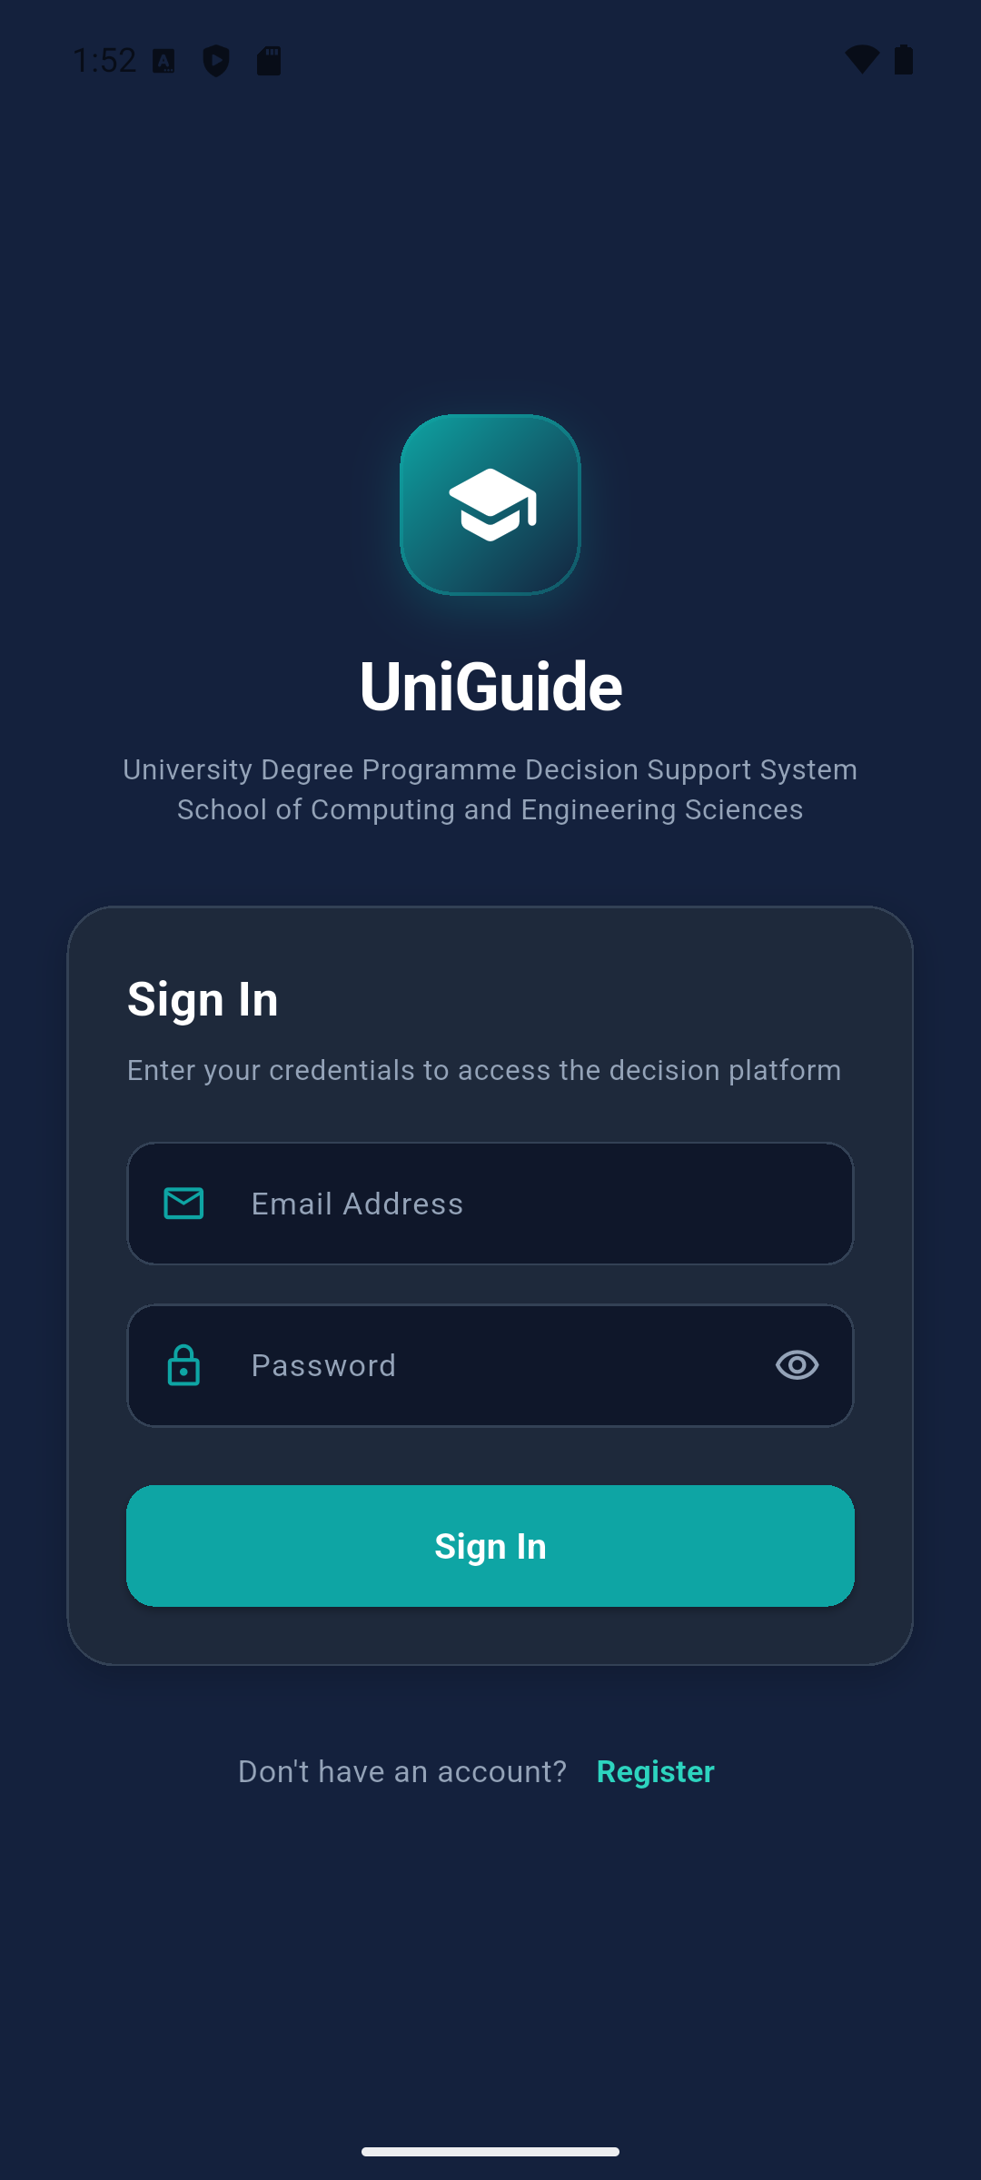
Figure 5.1: Sign-In Screen of the Completed UniGuide Mobile Application, Running on an Android Emulator

Results and Discussion
The functional testing summarised in Table 5.4 confirmed that the mobile application, the FastAPI backend, the Random Forest recommendation engine, and Firebase Authentication and Firestore work together correctly end-to-end: a student can register, submit a profile, receive three genuinely model-generated and explained recommendations, and leave feedback, while an administrator can maintain the programme catalogue and review a real audit trail of changes, all subject to the correct authorisation boundaries.
The Random Forest model's measured accuracy of 69.3% and weighted F1-score of 68.4% on unseen test data represent a realistic, reproducible baseline for a first-iteration recommendation model trained entirely on synthetic data. As discussed in Section 5.4.2, performance varied meaningfully between programme classes, and the confusion between Software Engineering and Informatics and Computer Science in particular reflects a real limitation in how distinctly those two programmes are represented in the student-facing aspiration options, rather than a defect in the Random Forest pipeline itself.
In addition to the structured functional and model testing described above, informal feedback on an earlier working build of the mobile application was gathered from seven volunteer test users during development, comprising a mix of recent KCSE/form-four leavers and other volunteers (friends and family), reflecting the access constraints typical of an individual undergraduate project. Each participant installed and used the application themselves and completed a short questionnaire; the application's built-in star-rating feedback feature was also available to participants. This round of feedback was conducted before the final Random Forest backend and Firebase integration described in this chapter were completed, so it reflects early reactions to the interface and interaction flow rather than a validation of the final system's recommendation accuracy. Feedback was generally positive, with a smaller number of critical comments that were used to inform subsequent interface refinements; specific response counts and comments were not retained in a form suitable for detailed statistical reporting here. A structured usability and acceptance evaluation of the final, fully integrated system with a larger and more representative sample of Kenyan form-four leavers is recommended as future work and is discussed further in Section 6.3.

GitHub Documentation
The complete source code is organised into two top-level components within a single repository: backend/, containing the FastAPI service, the synthetic dataset generator, the Random Forest training pipeline, and the shared KUCCPS grading utilities; and flutter_app/, containing the Flutter mobile application source. Each component includes its own README with setup instructions (dependency installation, model training, Firebase configuration, and how to run the backend and mobile application). [Insert the project's GitHub repository URL here.]

Conclusions, Recommendations and Future Works

Conclusions
This study set out to develop a Random Forest-based decision support system that recommends suitable university degree programmes to Kenyan form-four leavers using their academic performance, interests, skills, strengths, and career aspirations. All five specific objectives set out in Chapter 1 were achieved. Existing career guidance and university programme recommendation systems, namely KUCCPS, DIRAPATH, CareerExplorer, and CareerVillage, were reviewed and their limitations identified. A labelled synthetic student-profile dataset of 3,000 profiles was generated, validated against the programme catalogue's KUCCPS requirements, and used to train a Random Forest classification model, which was evaluated and achieved a weighted F1-score of 68.4% on held-out test data. A Flutter mobile application was designed and developed, integrating the trained model through a FastAPI backend and Firebase, and providing students with three ranked, SHAP-explained programme recommendations together with supporting admission, career, and university information. Finally, the completed system was functionally tested end-to-end, and informal early-stage feedback was gathered from test users.
The developed system, UniGuide, demonstrates that a Random Forest classifier trained on carefully validated synthetic data, combined with SHAP-based explainability and a KUCCPS-aware cluster scoring engine, can generate personalised and explainable university degree programme recommendations that integrate both a student's academic performance and their personal characteristics, addressing the gap identified in Chapter 1: that existing systems in the Kenyan context address either academic eligibility or career interests, but not both together in a single explainable decision-support tool.

Recommendations
Based on the findings of this study, the following recommendations are made. First, career counsellors and secondary schools may consider using UniGuide, or a system like it, as a complementary decision-support tool alongside existing career guidance services, rather than as a replacement for the KUCCPS placement process itself. Second, before any wider deployment, the underlying synthetic training dataset and programme catalogue should be periodically reviewed and updated against current KUCCPS cluster points and admission requirements, since these change from year to year. Third, given the confusion observed between closely related programmes such as Software Engineering and Informatics and Computer Science, the aspiration and interest option lists presented to students should be revisited to give closely related but distinct programmes clearer, separately identifiable signals, which would likely improve the model's ability to distinguish between them.

Future Works
Several directions for future work follow from the limitations identified in this study. A structured usability and user-acceptance evaluation of the final, fully integrated system, involving a larger and more representative sample of Kenyan form-four leavers than the small informal group consulted during development, would provide a more rigorous assessment of the system's real-world usability and recommendation relevance. The training dataset could be expanded, either with a larger volume of synthetic profiles or, where feasible, real (anonymised) student data, to improve the model's performance on the programme classes that currently have the fewest eligible profiles, such as Medicine and Pharmacy. The programme knowledge base could also be extended beyond the current 11 programmes to cover a wider range of KUCCPS clusters and universities. Finally, the administrator role could be extended beyond editing individual programme fields to support fuller catalogue management, and the backend could be deployed behind HTTPS with a proper domain for use beyond local development and testing, as discussed in the backend's own setup documentation.

References
Algarni, S., & Sheldon, F. (2023). Systematic Review of Recommendation Systems for Course Selection. Machine Learning and Knowledge Extraction, 5(2), 560–596. https://doi.org/10.3390/make5020033
Ayandibu, E. O. (2025). Academic Advising, Mentorship, and Entrepreneurial Career Choices for University Students. iRASD Journal of Management, 7(2), 35–57. https://doi.org/10.52131/irasd-jom.2025.v7i2.2913
C. Uzoma, T., O. Ikerionwu, C., E. Nwanga, M., & Etus, C. (2024). Machine Learning Recommender System for an Enhanced Students Course Selection. International Journal of Computer Trends and Technology, 72(10), 31–35. https://doi.org/10.14445/22312803/IJCTT-V72I10P106
Delahoz-Domínguez, E. J., & Hijón-Neira, R. (2024). Recommender System for University Degree Selection: A Socioeconomic and Standardised Test Data Approach. Applied Sciences, 14(18), 8311. https://doi.org/10.3390/app14188311
Diamantopoulou, M. J., Özçelik, R., & Genç, Ş. K. (2025). Evaluation of the random forest regression machine learning technique as an alternative to ecoregional based regression taper modelling. Computers and Electronics in Agriculture, 239, 110964. https://doi.org/10.1016/j.compag.2025.110964
Diniz, A. M., Alfonso, S., Conde, Á., García-Señorán, M., Ares-Ferreiros, M., & Almeida, L. S. (2025). Filling the gap between career choice and academic variables: Gender comparisons in STEM and social sciences. International Journal of STEM Education, 12(1), 48. https://doi.org/10.1186/s40594-025-00572-0
Iranzad, R., & Liu, X. (2025). A review of random forest-based feature selection methods for data science education and applications. International Journal of Data Science and Analytics, 20(2), 197–211. https://doi.org/10.1007/s41060-024-00509-w
Kamal, N., Sarker, F., Rahman, A., Hossain, S., & Mamun, K. A. (2024). Recommender System in Academic Choices of Higher Education: A Systematic Review. IEEE Access, 12, 35475–35501. https://doi.org/10.1109/ACCESS.2024.3368058
Karanja, J.N, & Obae. (2020). International Journal of Research and Innovation in Social Science. (12). https://rsisinternational.org/virtual-library/papers/effects-of-career-placement-by-kuccps-among-the-undergraduate-students-in-public-universities-in-kiambu-county-kenya/
Lahoud, C., Moussa, S., Obeid, C., Khoury, H. E., & Champin, P.-A. (2023). A comparative analysis of different recommender systems for university major and career domain guidance. Education and Information Technologies, 28(7), 8733–8759. https://doi.org/10.1007/s10639-022-11541-3
Mahmoud, H., Badouch, M., Boutaounte, M., Zioudi, O., & Boulmane, E.-S. (2025). A Systematic Review of Recommender Systems for Student Academic and Career Guidance. In B.-E. Boudriki Semlali, I. Ben Abdel Ouahab, & F. Angeletti (Eds.), Technological Innovations for Sustainable Development (Vol. 81, pp. 166–177). Springer Nature Switzerland. https://doi.org/10.1007/978-3-032-06725-8_14
Maphosa, M., Doorsamy, W., & Paul, B. (2024). Improving Academic Advising in Engineering Education with Machine Learning Using a Real-World Dataset. Algorithms, 17(2), 85. https://doi.org/10.3390/a17020085
Nayak, V., & Vora, N. (2024). A Machine Learning-based Career Recommendation. Journal of Trends in Computer Science and Smart Technology, 6(4), 374–390. https://doi.org/10.36548/jtcsst.2024.4.004
Rainio, O., Teuho, J., & Klén, R. (2024). Evaluation metrics and statistical tests for machine learning. Scientific Reports, 14(1), 6086. https://doi.org/10.1038/s41598-024-56706-x
Samson, A., Maisonneuve, A. R., Atitsogbe, K. A., Saint-Georges, Z., & Chénier-Ayotte, N. (2024). Career Development Support, Career-Related Internet Information Search and Usefulness, and Career Decision-Making Difficulties in 12th Grade Students in Ontario. Canadian Journal of Career Development, 23(2), 70–85. https://doi.org/10.53379/cjcd.2024.396
Scrum Methodology: An Agile Way of Managing Projects. (n.d.). 2026. Retrieved https://startinfinity.com/project-management-methodologies/scrum
Shimaoka, A. M., Ferreira, R. C., & Goldman, A. (2024). The evolution of CRISP-DM for Data Science: Methods, Processes and Frameworks. SBC Reviews on Computer Science, 4(1), 28–43. https://doi.org/10.5753/reviews.2024.3757
Towhidnejad, M., & Hagerty-Posell, Z. (2025). WIP: Improving Individual Productivity Utilizing SCRUM-For-One. 2025 IEEE Frontiers in Education Conference (FIE), 1–5. https://doi.org/10.1109/FIE63693.2025.11328300
Türkmen, G. (2025). The Review of Studies on Explainable Artificial Intelligence in Educational Research. Journal of Educational Computing Research, 63(2), 277–310. https://doi.org/10.1177/07356331241310915

Appendices:

Appendix 1: Gantt Chart
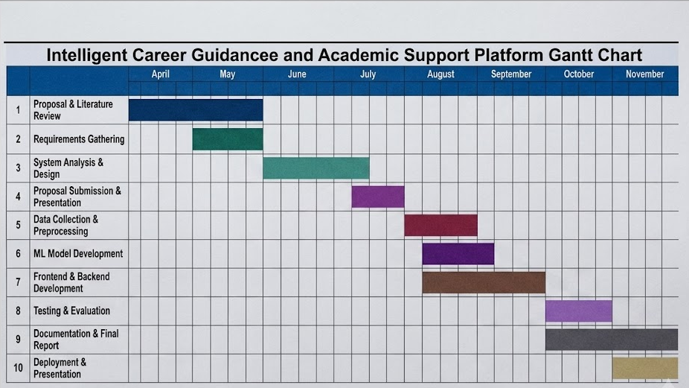

Appendix 2: Turnitin Report
