packages/apps/Bluetooth/res/values/config.xml.bak:16: error: Resource entry profile_supported_a2dp is already defined.
packages/apps/Bluetooth/res/values/config.xml:16: Originally defined here.
这个问题是由于：出现备份了，编辑器选择“不备份”
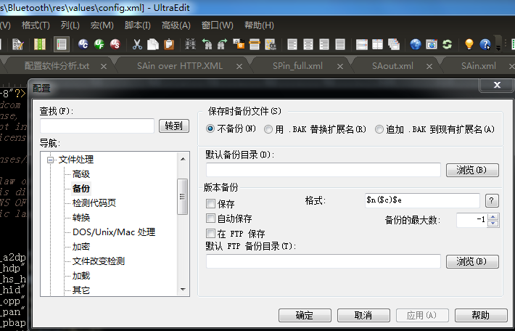
在重新编译就可以顺利编译成功
mmm packages/apps/Bluetooth –B （-B 重新更新out/里面的相对于的内容）

