- hardware\rockchip\sensor\mpu\libsensors\LightSensor.cpp 33行
修改地方：
// mPendingEvent.type = SENSOR_TYPE_LIGHT;
mPendingEvent.type = SENSOR_TYPE_PROXIMITY;
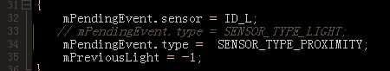
- hardware\rockchip\sensor\mpu\libsensors\sensors_mpl.cpp 149行
修改地方：
//sSensorList[LOCAL_SENSORS-1].type = SENSOR_TYPE_LIGHT;
sSensorList[LOCAL_SENSORS-1].type = SENSOR_TYPE_PROXIMITY;
- 把MySensorDemo拷贝到vr_jw\out\target\product\rk3288\system\app\

