**Running CityCAT on DAFNI**

Click on **Workflows** and click on **Global CityCat Model with extra functionality**  (at this stage do not select **Execute**)

To see the Workflow click on **View workflow** (top of screen).

Back in the Workflow click on **Create** next to **Parameters sets** to produce a parameter set to run this model.

**Inputs Model (data required)**

Click on **inputs** box which is then highlighted.

In this section the country, location, projection and boundary data are input and this feeds into the remaining models. Anything with a red star is required. Both the **Parameters** section and the **Datasets to use in Model** need to be filled.

The **country** is used in the names of the parameter files that feeds into the other models. The **location** is used in the names of the parameter files and the output files. The **projection** is the EPSG code to run CityCAT. For the UK the code is 27700 which is OSGB36 / British National Grid. If the **projection** is set to 0a UTM zones projected value is used depending on the location in the world which is located from the **Boundary file.**

The **Boundary file** needs to be in gpkg format. The **UTM Zones** file is needed to find the correct EPSG code for the location of the Boundary file.

For this example the filled in boxes should look like the following:

Note the projection is set to 27700. Additional datasets (for example a second **Boundary File**) can be removed by clicking on the rubbish bin icon on that row.

Click on the **Apply Changes** button or click on the grid at the top to exits from the **Inputs** model.

**Extract-buildings Model (data required)**

Click on **extract-buildings** box which is then highlighted.

In this section the location of the buildings is required as input as a gpkg file as below. The remaining data is automatically copied over from the **inputs** model. The buildings data is clipped to the domain specified by the boundary file and ensures it is in the correct projection.

For the UK OS buildings data is available on DAFNI. Open source data can be obtained from Open Street Map (<https://www.openstreetmap.org/>), Open Buildings (<https://sites.research.google/open-buildings/>) etc

Click on the **Apply Changes** button or click on the grid at the top to exits from the **extract-buildings** model.

**Extract -greenspaces Model (data optional)**

If nothing is input here all the domain is assumed to be impermeable.

Click on **extract -greenspaces** box which is then highlighted.

If greenspaces are available the “**Permeable areas**” parameter should be set to “**polygons”**.

In this section the location of the green spaces can be input as a gpkg file. Spatial green areas can be used in the same way. If spatial green-areas are used the polygon must have a "**Value**" parameter with the parameters associated with this value given in **infiltration.csv** file

The remaining data needed in this model is automatically copied over from the **inputs** model. The green spaces data is clipped to the domain specified by the boundary file and ensures it is in the correct projection. If no greenspaces data is added the ground is all assumed to be impermeable (worst case scenario for flooding).

Click on the grid at the top or on **Apply changes** to exit from the **extract-greenspaces** model.

**Elevation Model (data_required)**

Click on **elevation** box which is then highlighted.

In this section details of the elevation data used in CityCAT is supplied. This model accepts elevation data in .asc, .tif or .tiff format, clips the data to the selected area, and ensures all data is in the same projection. If the file sizes are too large, multiple files can be added directly, or zipped.

Under **Parameters** the **DTM Resolution** or elevation grid square size needs to be supplied. Under **Datasets to use in Model** the **5km DTM information** needs to be supplied (it does not need to be 5km data).

The remaining data is automatically copied over from the **inputs** model. The output from this model is a single elevation data file in ASC format.

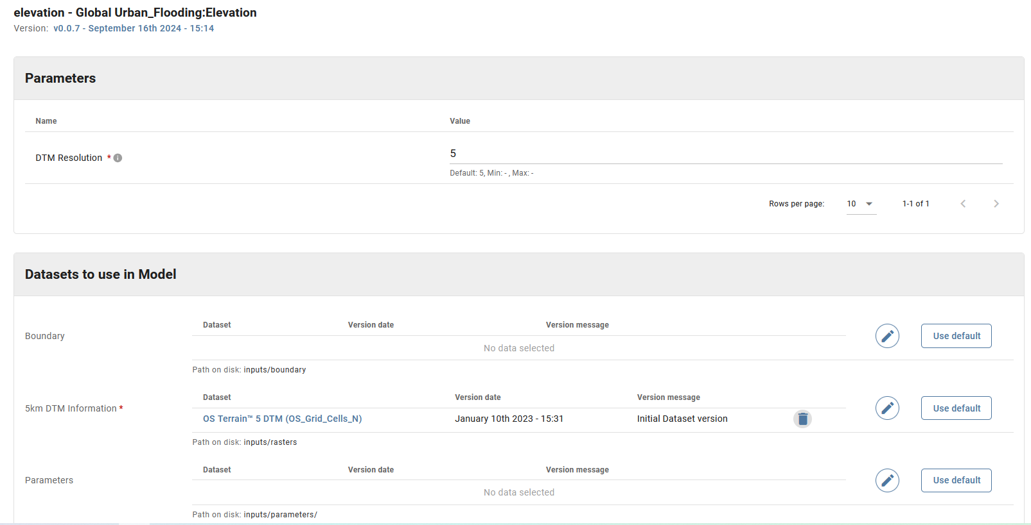

For the UK 5m grid resolution is available. The default datasets on DAFNI is for two letter grid squares starting with S. T and N datasets are also available. For the dataset here change the DTM to use the N datasets “**OS Terrain™ 5 DTM (OS_Grid_Cells_N)**”. See below for details:

Click on the grid at the top or **Apply changes** to exit from the **elevation** model.

**Add-friction-coeffs Model (data optional)**

Click on **add-friction-coeffs** box which is then highlighted. This allows for non-standard friction coefficients to be used in specified areas.

The new friction coefficient is set as "Value" in an gpkg file. The model clips the data to the selected area, and ensures all data is in the same projection. If the file sizes are too large, multiple .gpkgs can be added directly, or zipped.

Click on the grid at the top or **Apply Changes** to exit from the **friction** model.

**Add-reservoir-break Model (data optional)**

Click on **add-reservoir-break** box which is then highlighted. This allows for reservoir polygons to determine an initial reservoir elevation (m AOD) in specific locations. This is assumed to fail and the released water flows through the domain.

The reservoir water level is set as "Value" in an gpkg file. The model clips the data to the selected area, and ensures all data is in the same projection. If the file sizes are too large, multiple .gpkgs can be added directly, or zipped.

Click on the grid at the top or **Apply Changes** to exit from the **add-reservoir-break** model.

**Add-spatial-rain Model (data optional)**

Click on **add-spatial-rain** box which is then highlighted. This allows for spatial rainfall to be used (rather than have the same rainfall throughout the domain which is input as a parameter in the **citycat-extra-functionality** model and is overwritten by any data added here).

If spatial-rain is used the polygon must have a "**Value**" parameter with the parameters associated with this value given in **Rainfall_depth.txt**. The model clips the data to the selected area, and ensures all data is in the same projection. If the file sizes are too large, multiple .gpkgs can be added directly, or zipped.

Click on the grid at the top or **Apply changes** to exit from the **add-spatial-rain** model.

**Citycat-extra-functionality Model (data required)**

Click on **citycat-extra-functionality** box which is then highlighted.

This model takes all the data from the proceeding models and runs CityCAT. The **Parameter** values highlighted with a red star are used here. The other values are worth filling in as they might be used depending on the values set in the other models. Only the first 10 parameters are shown initially, the others can be seen by clicking on the arrow.

The **Datsets to use in Model** are all taken from the previous models.

Click on the grid at the top or **Apply Changes** to exit from the **citycat-extra-functionality** model.

**Running the workflow**

Click on **Continue**, just below the model grid.

Then specify the metadata. e/g

And click on **upload parameter sets**

Then in **Parameter sets** click the **Actions** for the parameter-set just specified and click on “**Execute workflow**”

In **Instances** details about the model run can be seen

Click on the **Actions** button and then **View Detailed status.**

This is what it initially looks like:

As it progresses -most models have finished. Elevation is the slow stage (so it is still in progress) as it has to extract the data for this domain from a large dataset.

When it has finished the status **changes** to **Succeeded**.

The final CityCAT output can be seen. E.g click on **publish-citycat** and **go to dataset. In the Data files** scroll to **run/max_depth.png,** select and **Download selected files.** In this case the maximum water depths are dominated by the dam break from the reservoir

There seems to be a bug where only one file (the first selected in the list) can be downloaded at a time.

The published files are also available in the **Data** catalogue. A lot can be produced and deleting them needs to be done individually (**Edit dataset** then delete **dataset** at the end of the page)

Questions:

1. Is DTM resolution in **Elevation** model used? It is output in parameters_elevation-parameters.csv but it does not then seem to be read into citycat-dafni.
2. In **Elevation** model how is the ASC file produced? I cannot see it in the code. Goes in parameters/elevation-parameters.csv but does not seem to be read into cityCAT

Note:

1. Remember citycat-dafni used here is a branch of the main version (see code in Github) <https://github.com/OpenCLIM/citycat-dafni/tree/citycatio-additional-functionality>
2. In the elevation model DTM resolution is supplied. This is not used in this workflow. If **GLobal_Urban_Flooding:Flood Impact Assessment (**[https://github.com/OpenCLIM/impact-assessment)](https://github.com/OpenCLIM/impact-assessment)%20) is added to the workflow the DTM resolution is required.