Basic Azure Set up
Computer name: (Name Relevant to its purpose for easy identification)
Windows (Windows 11 Pro)
VM generation: V2
VM Architecture: X64
Hibernation: Disabled
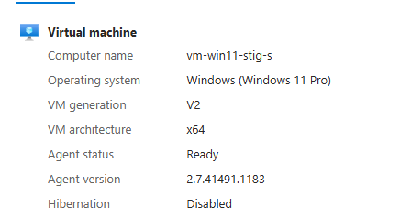

Go to the Azure Portal:
1. Search for "Virtual networks" and click "Create."
2. Provide a name, select a resource group, region, and define an address space (e.g.,10.0.0.0/16).
3. On the "IP Addresses" tab, a default subnet is usually created. You can modify its name and address range (e.g.,10.0.0.0/24) or add new subnets.
4. Review and create.

Azure CLI (example):
- az network vnet create --resource-group MyResourceGroup --name MyVNet --address-prefix 10.0.0.0/16 --location eastus

- az network vnet subnet create --resource-group MyResourceGroup --vnet-name MyVNet --name MySubnet --address-prefix 10.0.0.0/24

These commands establish the basic network infrastructure for your VMs.

VM Network & Subnet:
- Azure networks (VNets) are isolated network environments in the cloud that allow resources to communicate securely.

- Subnets are segments within a VNet, used to organize and isolate groups of resources (like VMs) and assign IP addresses from the VNet's address space.

- When creating a VM, you place it within a specific subnet of a VNet, which dictates its network access and connectivity.
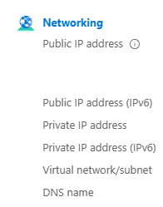

The machine was deployed successfully. You have some options to connect.
- Bastion
- Native RDP: Download the RDP file and save it in a location you'll remember.
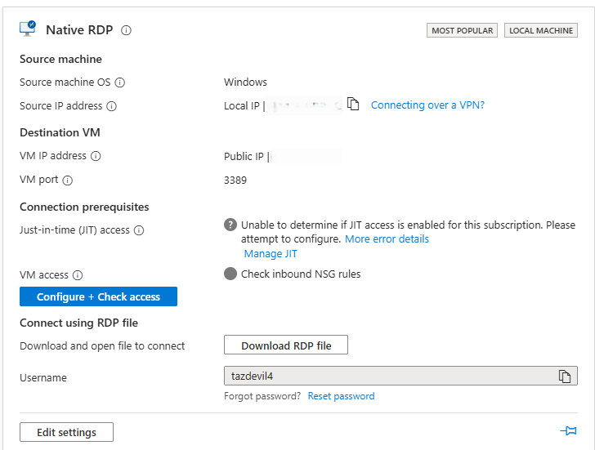
- Open RDP File: Don't worry, you will have the right IP address with it; this one is blurred for security reasons.
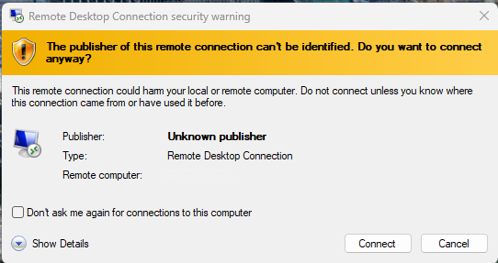
- Logging works
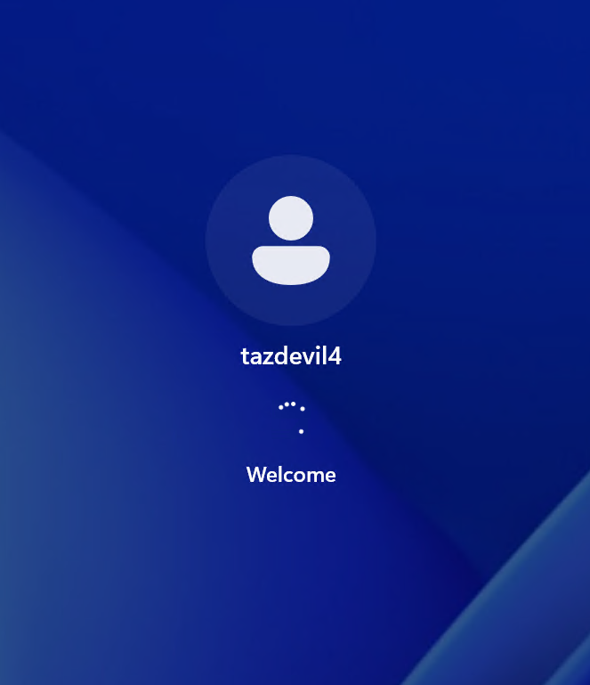
- Disable the Firewall: >>Type what is inside<<
Press the Windows key and R at the same time: Type in: >> wf.msc <<
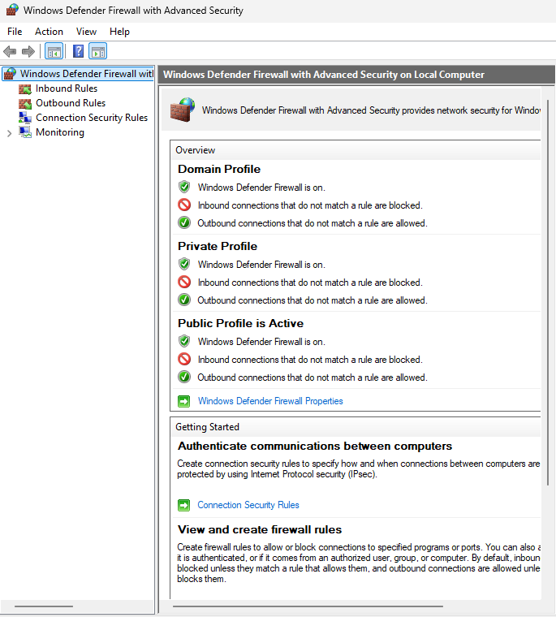
- Now that the Windows Defender firewall is open, you can disable the domain, private, and public profiles manually, or you can open a terminal and disable all three that way. Or open PowerShell in Admin mode and type >> Set-NetFirewallProfile -Profile Domain, Private, Public -Enabled False <<
- After the command executes, go to the Action tab on the firewall and press refresh, and you can see the changes from green to red
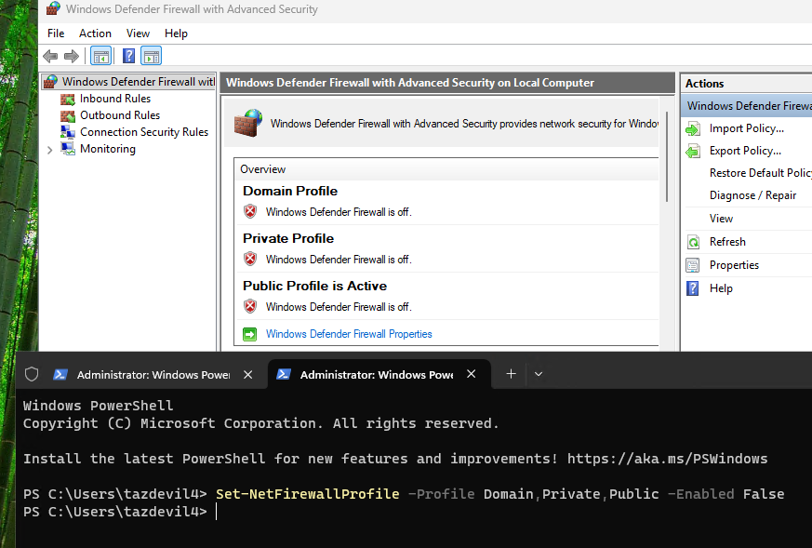

- Go to Computer Management & change settings
Create/enable administrator account
Set a blank password with no expiration
Add “administrator” account to the “administrators” group
Enable and add the “guest” account to the “administrators” group, w/no password

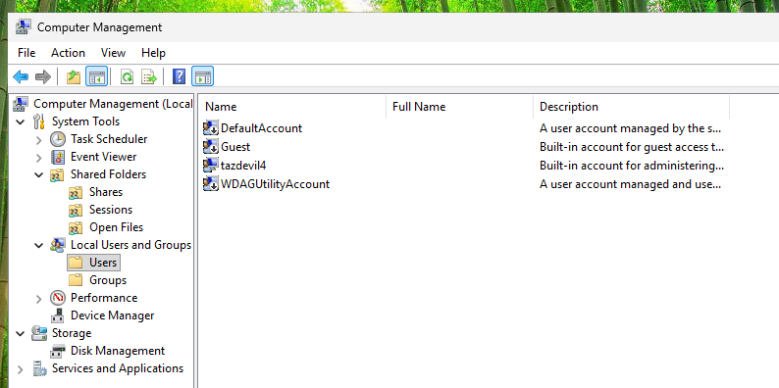

Create an "Administrator" account by leaving the credentials blank, then press "Create," and finally click “Close.”

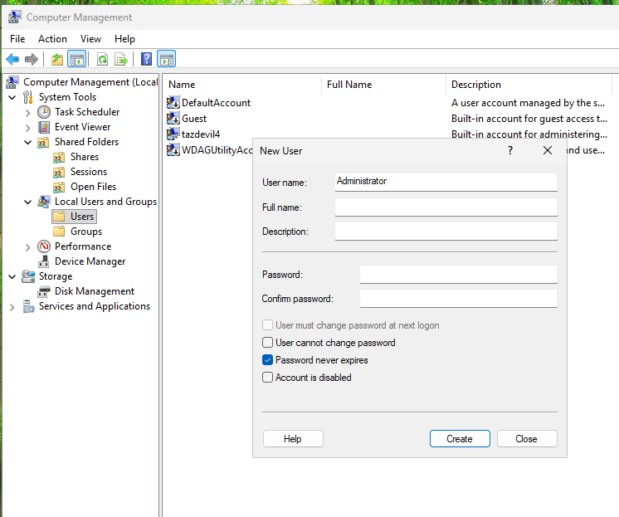

Assign “Administrator” to the Administrators Group
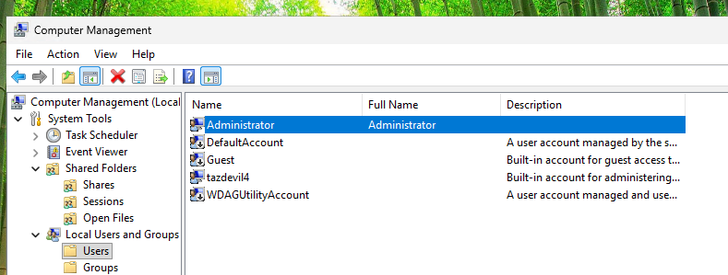
In Administrator Properties, go to the Member Of tab and add to the Administrators Group
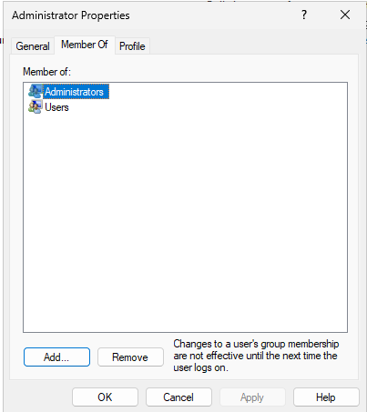

Go to Groups, select Administrators, and make sure to add “Administrator” to the group
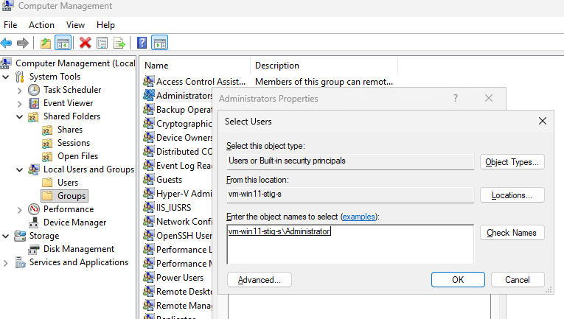

Now you see its added
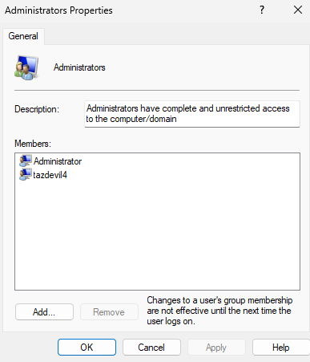
We are doing the same with the Guest ACC, checking that the password never expires, and adding to the “Administrators Group."
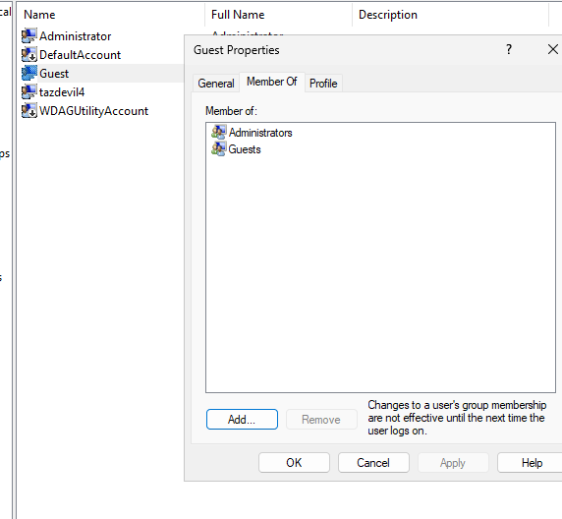
Setting a blank password to Guest ACC
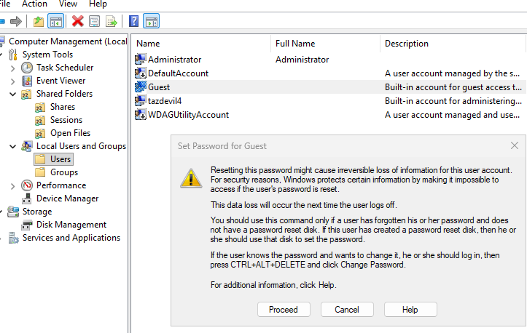
Press OK
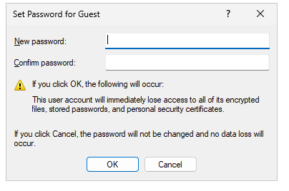

Overall Takeaway

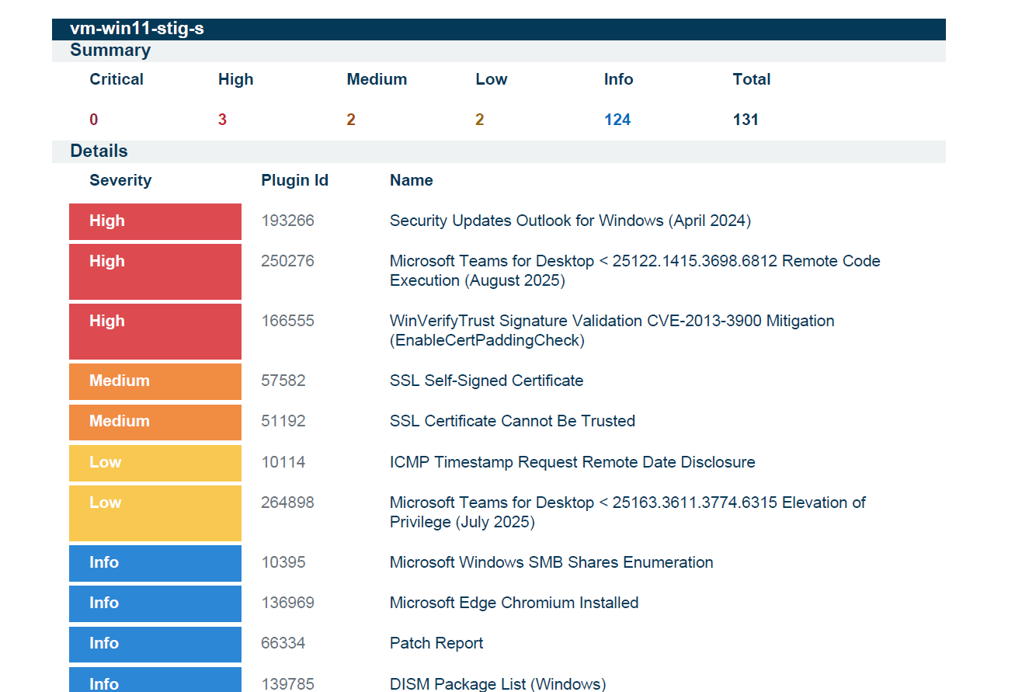

DISA STIG Scan Report
Target: vm-win11-stig-s
Operating System: Windows 11 Pro 25H2 (Build 26200.7840)
Scan Date: February 17-18, 2026
Scanner: Tenable Vulnerability Management

Executive Summary
This Hyper-V VM running Windows 11 25H2 exhibits significant DISA STIG compliance gaps across all major control categories. The system would fail a formal compliance audit and should not be considered production-ready without immediate remediation of CAT I findings.

Summary Scorecard
Severity | Count
Critical | 0
High | 3
Medium | 2
Low | 2
Info | 124
Total | 131

Critical Vulnerabilities (High Severity - CAT I)

1. Outlook for Windows - Missing Security Update
- CVE: CVE-2024-20670
- CVSS: 8.1
- Issue: Unapplied patch (KB5002574) leaves system vulnerable to Net-NTLMv2 hash theft via malicious emails
- Attack Vector: Attacker could relay the hash for lateral movement
- Current Version: 1.0.0.0 (stub)
- Required Version: 1.2023.0322.0100

2. Microsoft Teams Remote Code Execution
- CVE: CVE-2025-53783
- CVSS: 7.5
- Issue: Heap-based buffer overflow in outdated Teams stub
- Impact: Remote code execution possible
- Current Version: 1.0.0.0 (stub)
- Fixed Version: 25122.1415.3698.6812

3. WinVerifyTrust Signature Validation Bypass
- CVE: CVE-2013-3900
- Issue: EnableCertPaddingCheck mitigation not applied
- Impact: Signed malware can appear legitimate to Windows
- Status: Long-known bypass still exploitable

Medium Severity Findings

4-5. RDP TLS Certificate Issues (Port 3389)
- Issue: RDP exposed with self-signed certificate (CN=vm-win11-stig-s)
- Impact: Enables man-in-the-middle attacks on remote sessions
- Additional Risk: TLSv1.0 and TLSv1.1 (deprecated protocols) still supported
- Port: TCP/3389

Low Severity Findings
- ICMP Timestamp Disclosure (CVE-1999-0524) - System responds to ICMP timestamp requests, enabling fingerprinting
- Teams Elevation of Privilege (CVE-2025-49731) - Outdated Teams stub susceptible to local privilege escalation

DISA STIG Compliance Failures

Encryption & Boot Security (CAT I / CAT II)
STIG ID | Finding | Current State | Required State
WN11-00-000031 | BitLocker pre-boot PIN | NOT configured | Required (CAT I)
WN11-00-000032 | BitLocker PIN minimum | Not set | Must be configured
WN11-00-000020 | Secure Boot | DISABLED | ENABLED (CAT I)
WN11-CC-000070 | VBS/Secure Boot enforcement | Not enforced | Must be enforced
Drive Encryption Status:
- C: Drive - 0% encrypted, Protection OFF
- D: Drive - 0% encrypted, Protection OFF

Account & Password Policy (All CAT II)
STIG ID | Control | Current | Required
WN11-AC-000035 | Min password length | 0 | 14 characters
WN11-AC-000020 | Password history | 0 | 24 remembered
WN11-AC-000040 | Password complexity | Disabled | Enabled
WN11-AC-000030 | Min password age | 0 days | 1+ days
WN11-AC-000010 | Lockout threshold | 10 attempts | 3 or fewer
WN11-AC-000015 | Lockout reset counter | 10 minutes | 15 minutes
WN11-AC-000005 | Lockout duration | 10 minutes | 15 minutes
WN11-00-000090 | Admin/Guest password expiry | Never expires | Must expire

System Hardening Failures
STIG ID | Finding | Severity
WN11-00-000150 | SEHOP disabled - no heap overflow protection | CAT I
WN11-00-000155 | PowerShell v2 not disabled - bypass risk | CAT II
WN11-00-000175 | Secondary Logon service set to Manual vs Disabled | CAT II
WN11-00-000135 | Host-based firewall NULL on all profiles (Domain, Private, Public) | CAT II
WN11-CC-000039 | "Run as different user" available in context menus | CAT II
WN11-CC-000210 | Microsoft Defender SmartScreen not enforced | CAT II

Audit Policy Failures (All CAT II)
Critical Finding: Virtually all audit policies set to "No Auditing"
Missing audit coverage includes:
- Credential Validation (success & failure)
- User Account Management
- Process Creation
- Account Lockout
- Group Membership
- Object Access
- Privilege Use
- Registry modifications
- File System access

PKI & Certificate Findings
- DoD Root CA certificates not in Trusted Root Store
- US DOD CCEB cross-certificates not in Untrusted Store

Risk Analysis

Top 8 Critical Security Gaps
- No Drive Encryption - Data at rest is fully exposed to offline attacks
- Secure Boot Disabled - Bootkit and rootkit attacks are possible
- Extremely Weak Password Policy - No minimum length, complexity, or history requirements
- Firewall Disabled - No network perimeter defense at host level
- Credential Guard Not Enabled - NTLM hash theft risk remains
- Zero Audit Logging - No forensic visibility or incident detection capability
- Unpatched Application Stubs - Teams and Outlook CVEs rated CVSS 7.5-8.1
- Guest Account Active - Password-never-expires set on built-in accounts

Lessons Learned

1. Encryption Must Be Configured Before Deployment
What Happened: Both drives had BitLocker completely off (0% encrypted, Protection Off). Secure Boot was disabled in UEFI firmware.
Lesson: Encryption and Secure Boot must be baseline requirements, not afterthoughts. A VM deployed without these protections is fully exposed to offline data theft and bootkit attacks. In production, an attacker with physical or hypervisor-level access could extract all data with no resistance.
Action: Build a pre-deployment checklist validating BitLocker + Secure Boot before any machine goes live, even in lab/range environments.

2. Default Password Policies Are Dangerously Weak
What Happened: The local password policy was essentially non-existent - minimum length of 0, no complexity requirements, no history, and 10-attempt lockout threshold.
Lesson: Windows out-of-the-box does not enforce STIG-compliant password policies. Default settings prioritize convenience over security. Every deployed system needs Group Policy or hardening script applied immediately after provisioning.
Action: Create and apply a GPO or PowerShell hardening script as part of the OS build process, before any user accounts are created.

3. Built-In Accounts Need Immediate Attention
What Happened: Both Administrator and Guest accounts had "Password never expires" set. The Guest account was not disabled.
Lesson: Built-in accounts are high-value targets because their names are known to every attacker. Leaving Guest active and allowing passwords to never expire is an open invitation. These should be addressed in the first minutes after OS installation.
Action: Rename or disable the built-in Administrator account, disable Guest, and enforce password expiration on all accounts as part of baseline hardening.

4. No Auditing = No Forensic Visibility
What Happened: Nearly every audit policy was set to "no auditing" - credential validation, process creation, account lockout, object access, privilege use, registry changes, and more.
Lesson: If a breach, lateral movement, or privilege escalation occurs on this machine, there would be zero logs to investigate. You cannot detect what you don't log. This is one of the most dangerous gaps because it doesn't cause immediate harm but makes every other vulnerability worse.
Action: Enable the full STIG audit policy set from day one. Consider forwarding logs to a SIEM even in a lab. Auditing should be treated as non-negotiable infrastructure, not an optional add-on.

5. The Firewall Was Completely Off
What Happened: The host-based firewall returned NULL across all three profiles - Domain, Private, and Public. No rules, no enforcement.
Lesson: With RDP (TCP/3389) open and no firewall, the machine was fully reachable by anyone on the network. Even in a cyber range environment, disabling the firewall eliminates a critical layer of defense and normalizes bad habits. Defense-in-depth means every layer matters.
Action: Never disable Windows Firewall without a compensating control. If specific ports need to be open for lab work, create explicit inbound rules rather than turning the firewall off entirely.

6. Application Stubs Create Real Vulnerabilities
What Happened: Microsoft Teams and Outlook were installed as version 1.0.0.0 stubs - placeholder packages that never updated. These stubs were flagged for two CVEs rated CVSS 7.5 and 8.1, including a remote code execution vulnerability.
Lesson: Stub/placeholder app packages that ship with Windows are often ignored because they "don't look installed," but vulnerability scanners detect them. An RCE sitting in a stub package is just as dangerous as one in a fully installed application.
Action: After OS deployment, audit installed packages - including WindowsApps - and either update or remove stubs. Don't assume an app is safe because it's not actively used.

7. PowerShell v2 Being Active Is a Bypass Risk
What Happened: PowerShell version 2 was not disabled.
Lesson: PowerShell v2 has no script block logging, no AMSI (Antimalware Scan Interface), and no constrained language mode. Attackers and red teamers routinely downgrade to PS v2 to bypass modern PowerShell security controls. Leaving it enabled undoes protections you may have configured in PS v5+.
Action: Run Disable-WindowsOptionalFeature -Online -FeatureName MicrosoftWindowsPowerShellV2Root as part of every Windows hardening script.

8. Credential Guard and SEHOP Were Not Enabled
What Happened: Credential Guard registry keys were missing (not fully enabled), and SEHOP (Structured Exception Handling Overwrite Protection) was not configured - both CAT I findings.
Lesson: SEHOP protects against a class of heap/stack overflow exploits. Credential Guard prevents NTLM hash extraction from LSASS memory - a core technique in pass-the-hash attacks. Both are free, built-in Windows mitigations requiring only configuration, not additional software.
Action: Enable SEHOP via the MS Security Guide GPO template. Enable Credential Guard via Device Guard policies. These should be standard in any Windows 11 deployment.

9. RDP Exposure With Self-Signed Certificate
What Happened: RDP was open on TCP/3389 with a self-signed certificate and untrusted TLS configuration. TLSv1.0 and TLSv1.1 (both deprecated) were also supported.
Lesson: Self-signed RDP certificates cannot be validated by clients, making them susceptible to man-in-the-middle interception. Supporting legacy TLS versions makes downgrade attacks feasible. In a range environment this may be acceptable, but it builds bad habits if the same config goes to production.
Action: Deploy a certificate from a trusted internal CA for RDP. Disable TLS 1.0 and 1.1 via Group Policy or IIS Crypto tool. Restrict RDP access by IP where possible.

10. A VM Is Not a Safe Excuse to Skip Hardening
What Happened: This is a Hyper-V lab VM, and it appears hardening was deprioritized because of that context - no encryption, no firewall, weak passwords, no auditing.
Lesson: Lab VMs routinely get promoted to production, shared with others, or connected to real infrastructure. Bad security habits established in the lab carry over. More importantly, DISA STIGs apply to all systems in a DoD/government context regardless of whether they are virtual or physical.
Action: Treat every VM as if it could become production. Build a hardened base image ("gold image") with STIG controls pre-applied, and clone from that instead of starting from a raw Windows ISO each time.

Priority Remediation Plan

Priority 1: Boot & Encryption Security
Action: Enable BitLocker on C: and D: drives and re-enable Secure Boot in UEFI
Impact: Protects against offline data theft and bootkit attacks
Effort: Medium (requires reboot and BitLocker setup)

Priority 2: Password & Account Policy
Action: Apply STIG-compliant password/account lockout GPO immediately post-build
Impact: Prevents brute force attacks and enforces strong authentication
Effort: Low (GPO deployment)

Priority 3: Audit Logging
Action: Enable all DISA-required audit policies and forward logs to SIEM
Impact: Provides forensic visibility and incident detection capability
Effort: Low (GPO deployment + log forwarding config)

Priority 4: Network Protection
Action: Enable Windows Firewall on all profiles with explicit allow rules
Impact: Establishes host-based network perimeter defense
Effort: Low (GPO or PowerShell script)

Priority 5: Patch Management
Action: Apply Windows updates and remove/update all application stubs before scanning
Impact: Eliminates known CVEs rated CVSS 7.5-8.1
Effort: Medium (requires update cycle and app inventory)

Overall Takeaway
This scan reveals a system built for connectivity and convenience, not security and compliance. Almost every major STIG control category - encryption, authentication, auditing, firewall, application hardening, system integrity - had at least one significant failure.
The Good News: None of these findings require new tools or software purchases. They are all configuration gaps that can be closed with GPOs, PowerShell scripts, and a solid hardening baseline applied consistently at build time.
The Path Forward: Develop a gold image with all STIG controls pre-applied, create automated hardening scripts, and establish a mandatory pre-deployment validation checklist that includes encryption verification, password policy checks, audit logging confirmation, and firewall rule validation.

Report Generated: February 17, 2026
Next Scan Recommended: After remediation of Priority 1-3 items

