**Declaration**

We declare that this written submission represents our ideas in our own words and where others' ideas or words have been included, we have adequately cited and referenced the original sources. we also declare that we have adhered to all principles of academic honesty and integrity and have not misrepresented or fabricated or falsified any idea/data/fact/source in our submission. We understand that any violation of the above will be cause for disciplinary action by the University and can also evoke penal action from the sources which have thus not been properly cited or from whom proper permission has not been taken when needed.

Name of the Student Signature and Date

Name of the Student Signature and Date

Name of the Student Signature and Date

**Acknowledgements**

The success and final outcome of this project required a lot of guidance and assistance from many people and we are extremely privileged to have got this all along the completion of my project. All that we have done is only due to such supervision and assistance and I would not forget to thank them.

We respect and thank Mr. Karthick S, for providing us an opportunity to do the project work and giving us all support and guidance which made us complete the project duly. We are extremely thankful to him for providing such a nice support and guidance.

We are thankful to and fortunate enough to get constant encouragement, support and guidance from all Teaching staffs of Mechanical Department which helped us in successfully completing our project work. Also, we would like to extend our sincere esteems to all staff in laboratory for their timely support.

**Table of contents**

|  |  |  |
| --- | --- | --- |
| S.No | Title | Page Number |
| 1 | Declaration | 3 |
| 2 | Acknowledgement | 4 |
| 3 | Table of contents | 5 |
| 4 | List of figures | 6 |
| 5 | Abstract | 7 |
| 6 | Chapter 1: Introduction | 8 |
| 7 | Chapter 2: Fluid in a microchannel | 9 |
| 8 | Chapter 3: Simulation Set-up | 11 |
| 9 | Chapter 4: Effect of gravity | 12 |
| 10 | Chapter 5: Effect of gravity with surface Tension | 13 |
| 11 | Chapter 6: Effect of volume force with surface tension | 14 |
| 12 | Chapter 7: Results for relocation | 15 |
| 13 | Chapter 8: Droplet deformation using sound waves in microchannel: a route to acoustics based interfacial tensiometry | 16 |
| 14 | Chapter 9: Numerical simulation and observations | 18 |
| 15 | Chapter 10: Results | 20 |
| 16 | Summary and Conclusion | 21 |
| 17 | References | 22 |

**List of Figures**

1. Figure 1.1: Three different initial configurations of the dense (36% iodixanol, white) and less dense (10% iodixanol, black) solution give rise to different time evolutions.
2. Figure 3.1: Cross-section of the microchannel
3. Figure 4.1: Effect of gravity
4. Figure 5.1: Effect of gravity with Surface Tension
5. Figure 6.1: Effect of volume force when there is surface tension with passage of time
6. Figure 7.1: Energy Density required for complete relocation vs Interfacial Tension
7. Figure 8.1: Effect of sound on droplet.
8. Figure 9.1: Droplet deformation simulation of fluid droplet (radius a =100 µm and interfacial tension γ=0.5 mN/m) in acoustic field with different Eac values. a) Acoustic field of Eac = 30 J/m3 b) Acoustic field of Eac = 180 J/m3.
9. Figure 9.2: Initial configuration of droplet
10. Figure 9.3: Droplet deformation simulation of fluid droplet (radius a =100 µm, Eac = 30 J/m3 and interfacial tension γ=0.5 mN/m) in acoustic field with higher impedance fluid at the sides (density = 1000 kg/m3).
11. Figure 10.1: Droplet deformation parameter variation for different force ratio, (Fac/Fint).

**Abstract**

We present a theory for the relocation of immiscible fluids in a micro channel under acoustics fields. We demonstrate the separation of two immiscible fluids by acoustophoresis. The word "Acoustophoresis" means migration with sound. Acoustophoresis is when force, acting on micro-particles suspended in fluid medium when subjected to standing acoustic wave, relocates the micro particles. Standing wave is the result of interaction between an incident wave and a reflected wave which results in combined higher wave amplitude.

It has been observed that, when a microchannel is acted upon with sufficient acoustics force, irrespective of the initial conditions, the final configuration of the microchannel can be determined and manipulated as per requirements. This is what we aim to do with this thesis.

Also the effect of the radiation force acting on a small bubble in a liquid medium in the presence of a plane standing sound wave is largely overlooked in our work. We observe that liquid bubble of initially spherical fluid interfaces can deform into stable steady state final configuration induced by acoustic radiation stress no uniformly distributed over its surface.

The aim of our work is to provide a quantitative description of variation of geometry to applied energy and the way it can be harnessed usefully in effective assessment of interfacial tension. By doing so, we present an acoustics based equilibrium method to measure the interfacial tension of very small liquid sample

**Chapter 1: Introduction**

Relocation of fluids under acoustic field in a microchannel is a phenomenon which finds application in various aspects tumour cells isolation from white blood cells, Two dimensional patterning of cells, separation of oil and water during oil spills in ocean etc., Generally, when acoustic force is applied in a microchannel with two different fluids with different acoustic properties the fluid with higher density tends to move to the centre and lower density fluid moves to the lateral sides of the channel irrespective of its initial condition. Reason for relocation of fluids in a microchannel is the Relative mismatch in the acoustic impedance(Z) between the fluids.

(1.1)

Where ρ is the density, c is the speed of sound



**Figure1.1** Three different initial configurations of the dense (36% iodixanol, white) and less dense (10% iodixanol, black) solution give rise to different time evolutions.

The phenomenon of a travelling sound beam deforming the interface between liquids of different acoustic properties was first investigated by Hertz and Mende1 in 1939. By directing an ultrasonic beam across the interface between two immiscible liquids of different acoustic properties they showed that the direction of the deformation caused by acoustic radiation pressure was independent of the direction of propagation of the sound. For travelling plane wave incidence on a plane interface between liquids the phenomenon2 is well charted. In the regime where density and speed of sound of the two liquids are of comparable magnitude the direction and magnitude of the acoustic radiation pressure will be primarily dictated by the relative difference in speed of sound.

**Chapter 2: Fluids in a microchannel**

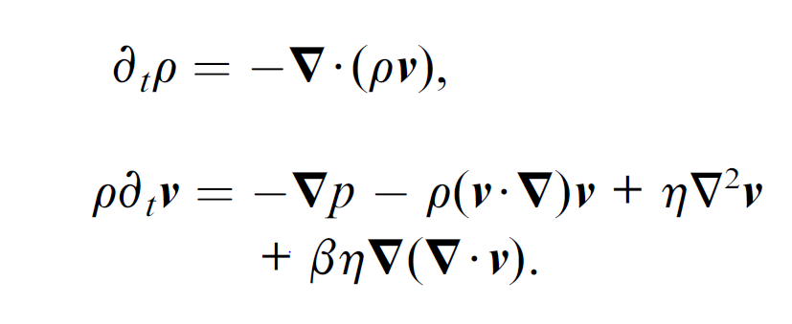Fluid flow in a microchannel is governed by two equations namely Navier-Stokes equation and continuity equation. The Navier-Stokes equation (2.1) is concerned with conservation of momentum whereas the continuity equation (2.2) gives the conservation of mass.

(2.1)

(2.2)

Let an acoustic wave constitute tiny perturbations to first and second order (subscript 1 and 2, respectively) in density ρ, pressure p, and velocity **ν**.

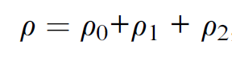 (2.3)

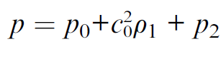 (2.4)

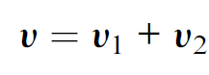 (2.5)

We assume time harmonic fields,

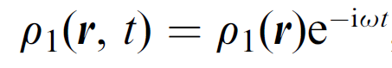 (2.6)

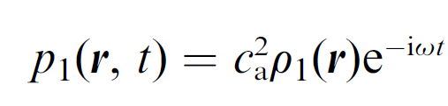 (2.7)

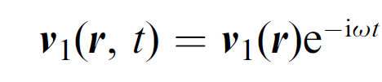 (2.8)

Neglecting β, η, the time averaged second order Navier-Strokes equation becomes

 (2.9)

Time averaged second order acoustic pressure is given by

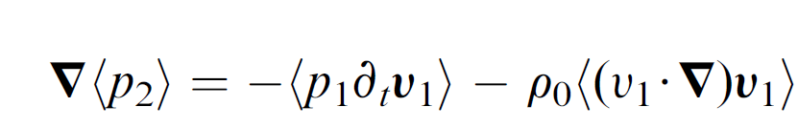 (2.10)

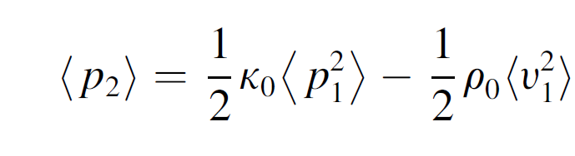 (2.11)

The time averaged acoustic momentum fluz density tensor ,

C:\Users\Dev Anand\Pictures\2018 9.PNG (2.12)

Acoustic force density *f* ac acting on a homogenous fluid is given by

C:\Users\Dev Anand\Pictures\2018 11.PNG (2.13)

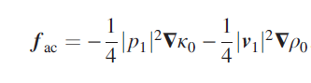 (2.14)

In our setup, acoustic half wave pressure resonance of amplitude pa, the field takes the form

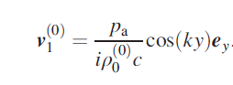 (2.15)

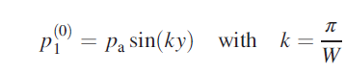 (2.16)

We arrive at our final expression for acoustic force density *f*ac acting on a inhomogenous fluid3–6 becomes

(2.17)

Where, (2.18)

(2.19)

The theoretical treatment of acoustic forces involves nonlinear models including multiple length and time scales. Steady acoustic streaming7.8 describes a steady fluid motion, spawned by fast-time-scale acoustic dissipation in either boundary layers or in the bulk. Similarly, the acoustic radiation force acting on a particle or an interface of two immiscible fluids is due to interactions between the incident and the scattered acoustic waves. This force derives from a divergence in the time-averaged momentum-flux-density tensor, which is non-zero only at the position of the particle or the interface.

**Chapter 3: Simulation setup**

The previous work in this field has been out only for combinations of miscible fluids. In this project, we are trying to extend this idea to immiscible fluids.

COMSOL MULTIPHYSICS 5.3 software is used to simulate various conditions in a microchannel. The microchannel that we have considered in these simulations is of width(w)=0.0004m and height(h)=0.0002m. The fluids used have densities ρ1=1000kg/m3 and ρ2=1100kg/m3. Laminar flow module and phase field/level set module are used to carry out the following simulations. Symmetry option has been used in the following simulation (Figure 3.1) where the line of symmetry is the y-axis. Fine mesh is used in the simulations.

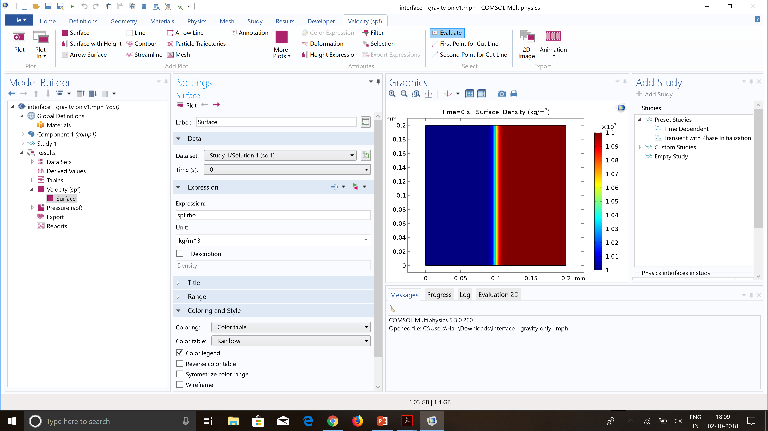

**Figure 3.1** Cross-section of the microchannel

**Chapter 4: Effect of gravity**

In this simulation, the effect of gravity in the microchannel is observed, where the surface tension between the fluids is neglected. The fluid with higher density gets sedimented at the bottom of the microchannel and the fluid with lower density floats above the higher density fluid and stabilizes with time.

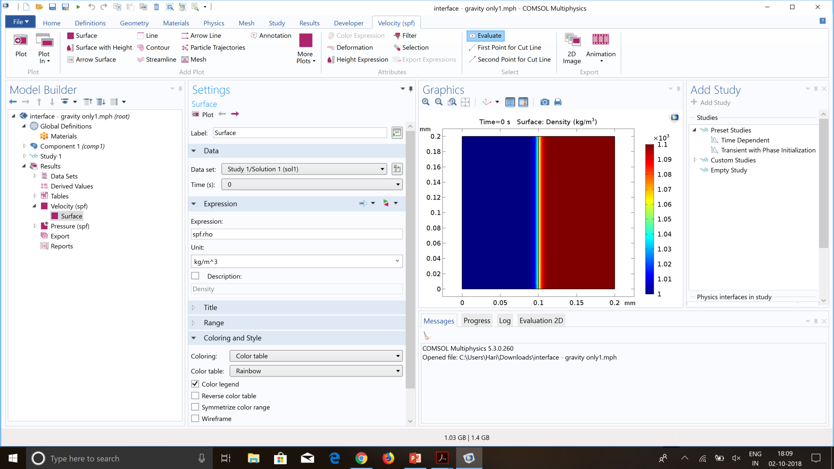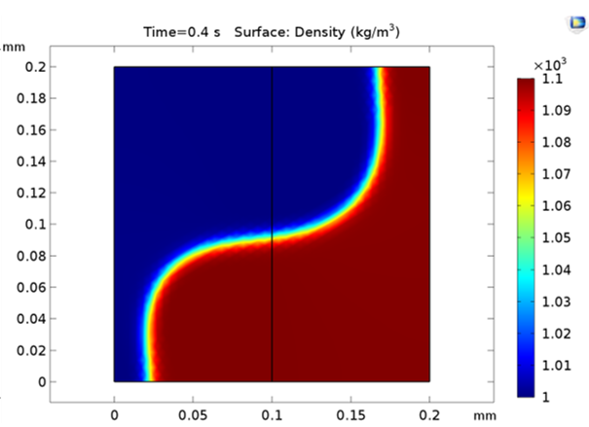

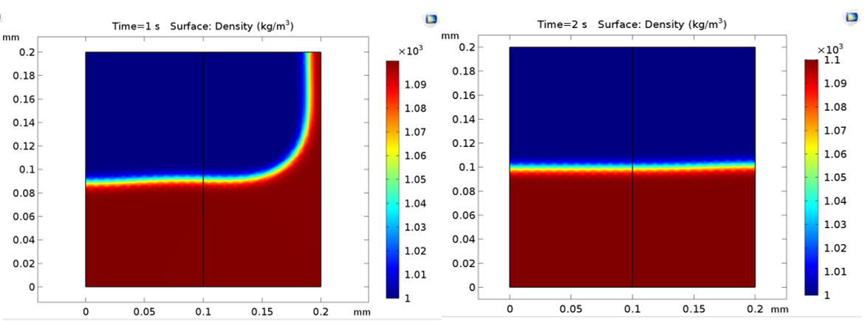

**Figure 4.1** Effect of gravity

**Chapter 5: Effect of gravity with Surface Tension**

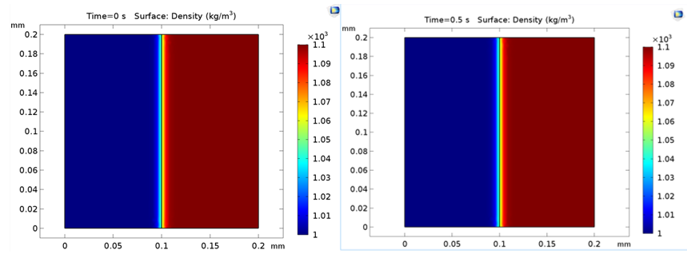

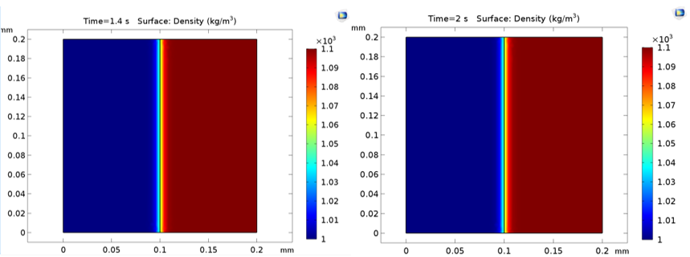

**Figure 5.1** Effect of gravity with Surface Tension

In this simulation, the effect of gravity in the microchannel is observed, where the surface tension between the fluids is0.01N/m. The gravity in this case is unable is overcome this surface tension force and disorient the interface. Thus the fluids remain in their initial orientations. But in the previous case (Fig 4.1) the force due to gravity was sufficient to disorient the interface.

* **Chapter 6: Effect of volume force with surface tension**
* 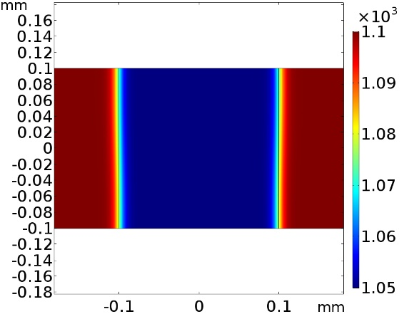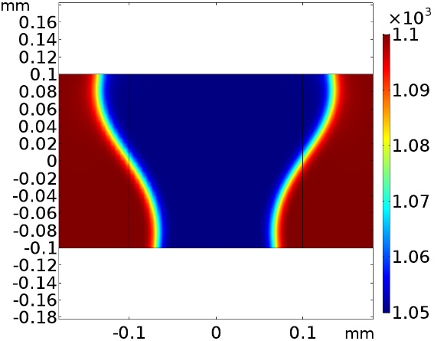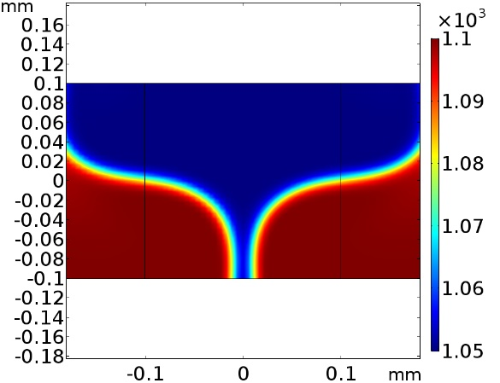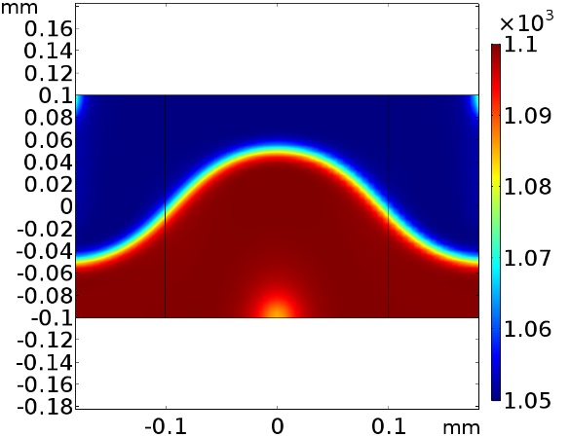
* 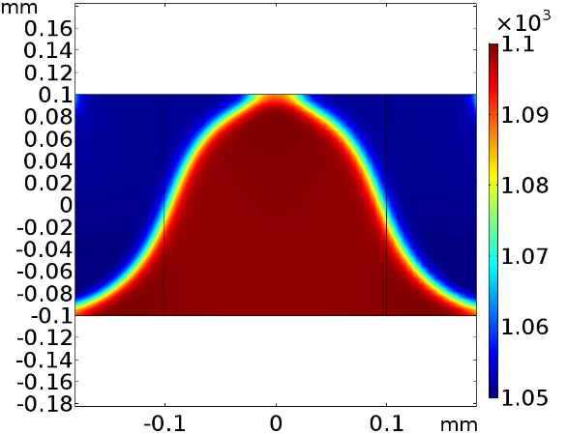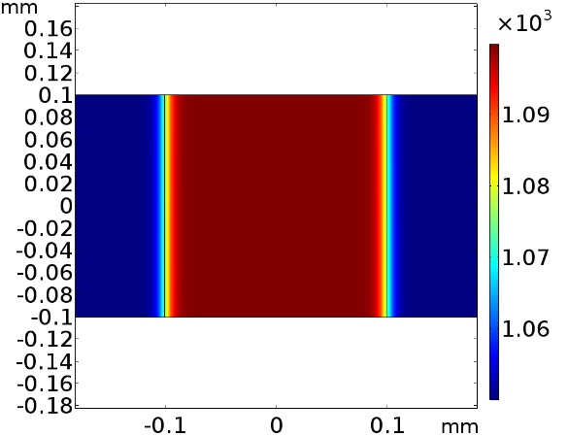

**Figure 6.1** Effect of volume force when there is surface tension with passage of time

* Relocation of fluid is observed when volume force is applied in the presence of surface tension of 0.001N/m, with Fluid 1 (density = 1000kg/m3, c = 1400 m/s) at the center, and Fluid 2 (density = 1100kg/m3 c = 1500 m/s) at the sides initially.
* **Chapter 7: Results for relocation**

**Figure 7.1** Energy Density required for complete relocation vs Interfacial Tension

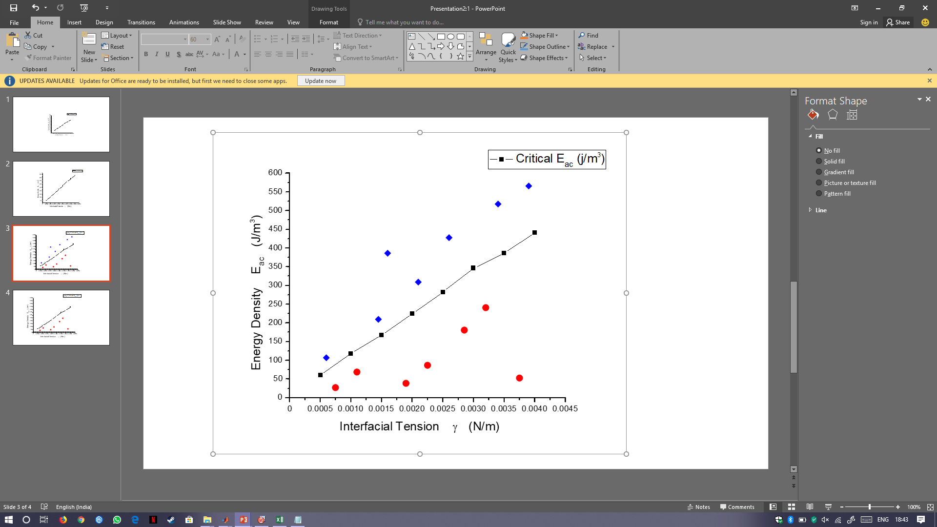

**Channel Parameters**

Channel width, b = 400 microns

Channel height, a = 200 microns

Interfacial coefficient, ɣ

Density of fluid 1, ρ1 = 1100 kg/m3

Density of fluid 2, ρ2 = 1000 kg/m3

Wavelength, Λ = 800 microns

Velocity across channel, v = 1400 + 50(1-Φ) m/s

Where Phi, Φ signifies phase field variable.

* **Chapter 8: Droplet deformation using sound waves in microchannel: a route to acoustics based interfacial tensiometry**

When a drop with initially spherical shape is put into a sound field, it scatters the incident sound wave and consequently experiences a radiation force. This force causes the distortion of the shape which, in turn, modifies the radiation stress over the drop surface.

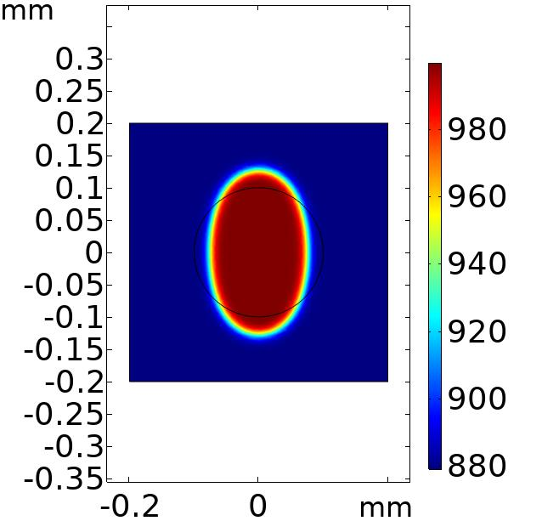

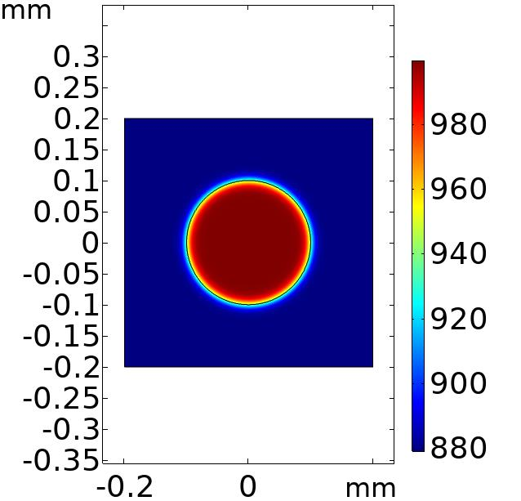

**Sound OFF Sound ON**

**Figure 8.1:** Effect of sound on droplet.

We theoretically present an equilibrium method to measure the interfacial tension between immiscible liquids using acoustics. This work may open up to a new potential acoustofluidic platform to measure interfacial tension of various combination of fluids. This paper deals with a drop of immiscible fluid surrounded by another viscous host fluid medium and we are interested in studying the mechanical response of the sphere under the influence of acoustic radiation pressure acted upon. Competition between the acoustic body force and interfacial tension is shown to be critical in droplet deformation. The dynamic response of the droplet due to acoustic standing wave is characterized by two non-dimensional parameters namely deformation parameter and ratio of acoustic body force and interfacial tension force. From this two non-dimensional parameters, the interfacial tension can be found by measuring the deformation of the droplet, acoustic energy density and from the physical properties of the two phases.

The concept of Radiation pressure has been widely studied topic and after more than a century now, after pioneering works, it has found practical applications. Acoustophoresis is a developing field and has experienced a great development in recent years. It has shown promise for several applications including study of drop dynamics and liquid interfacial phenomena. Starting with the first computation of acoustic radiation pressure by Lord Rayleigh9 and since the striking demonstration of deformations of fluid interfaces after the incidence of a sound beam on the boundary between two liquids experimentally by Hertz and Mende in 1939, this subject has been examined by many researchers. Marston10 theoretically analyzed the problem of static deformation of an acoustically levitated liquid drop in air assuming a spherical drop shape but this treatment is limited to small drop deformation. Trinh and Hsu11 conducted several experiments on acoustically levitated liquid drops in air and measured the variations of their aspect ratio versus sound pressure and drop volume.

**Chapter 9: Numerical simulation and observations**

Recently observed novel phenomena such as relocation of inhomogeneous fluids and acoustic streaming suppression in inhomogeneous fluids are explained by body force called acoustic force density. We show that the droplet deformation is induced due to second order time averaged acoustic force density which stems from theory of nonlinear acoustics. The time averaged acoustic force density can be defined as the divergence of time averaged acoustic momentum flux density tensor8,12. The acoustic energy density acting on the inhomogeneous fluid can defined in terms density and compressibility gradient which is given by [5]

(9.1)

where is the acoustic energy density inside the channel and is wave number. and are defined as and . and are the average density and velocity of sound of the fluid domain. This technique will be particularly more useful in measuring low interfacial tension.

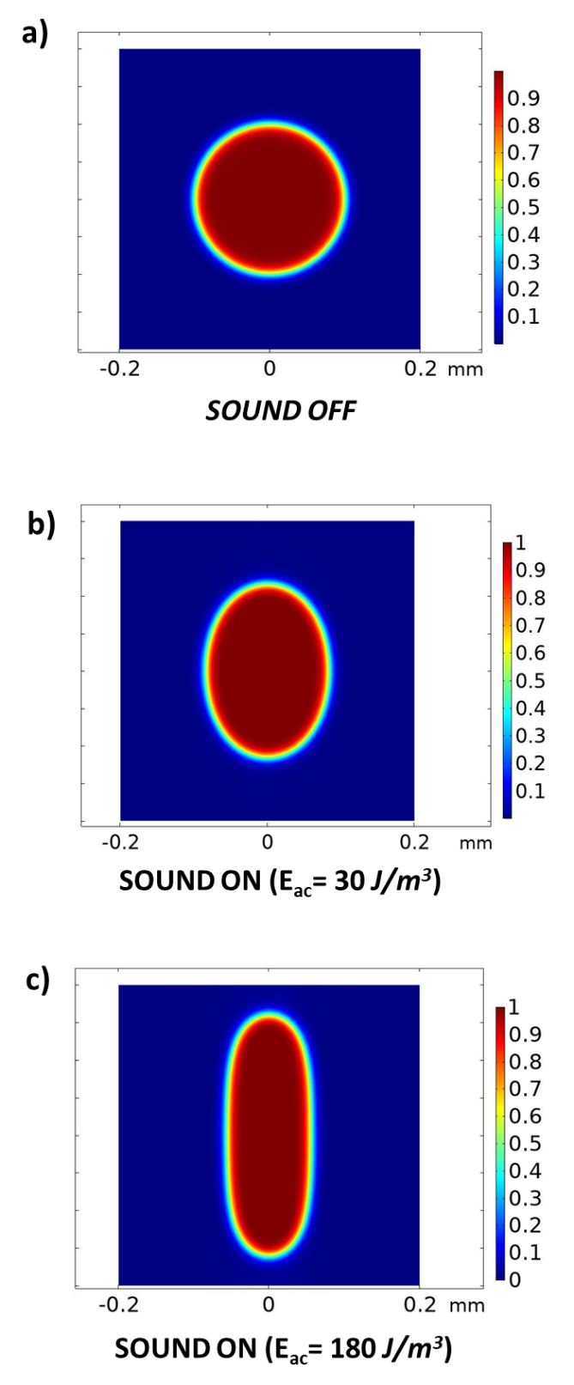

**Figure 9.1** Droplet deformation simulation of fluid droplet (radius a =100 µm and interfacial tension γ=0.5 mN/m) in acoustic field with different Eac values. a) Acoustic field of Eac = 30 J/m3 b) Acoustic field of Eac = 180 J/m3.

When fluid of higher impedance is at the sides, the droplet at the center acts like a particle with negative contrast factor and focuses to the pressure antinodes at the sidewalls.

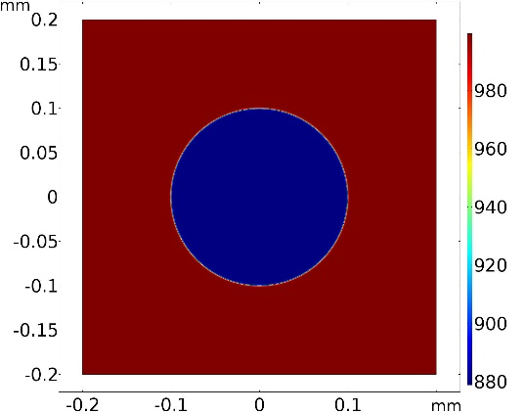

**Figure 9.2** Initial configuration of droplet

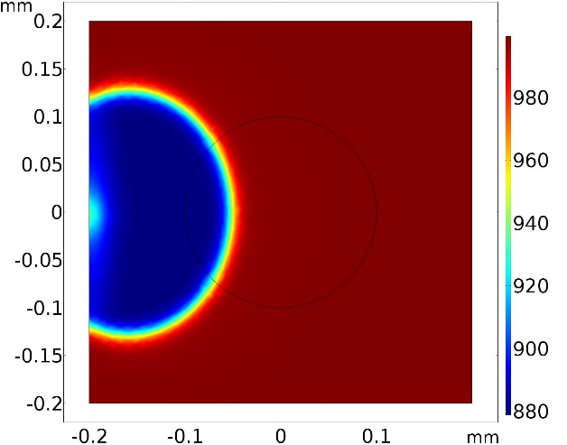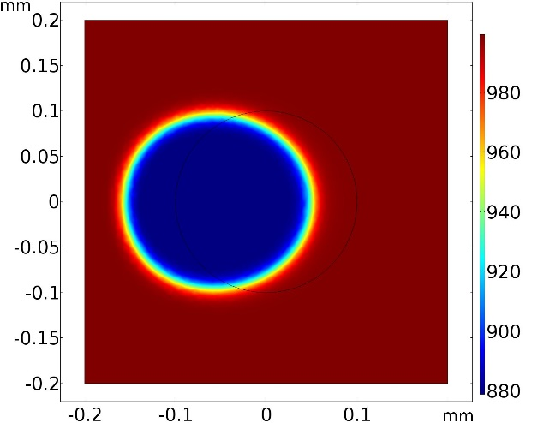 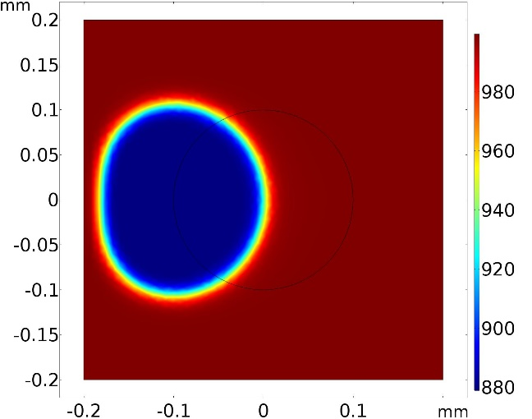

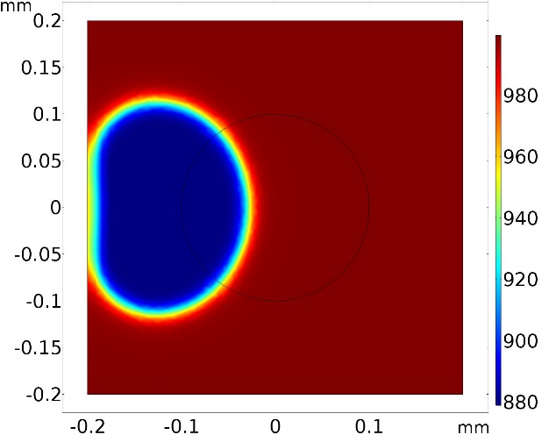

**Figure 9.3** Droplet deformation simulation of fluid droplet (radius a =100 µm, Eac = 30 J/m3 and interfacial tension γ=0.5 mN/m) in acoustic field with higher impedance fluid at the sides (density = 1000 kg/m3).

**Chapter 10: Results**

The deformation parameter( is defined as the ratio of change in drop diameter along wave direction and initial drop diameter before deformation. The variation of deformation parameter for different force ratio Fac/Fint (acoustic force and interfacial tension force) is presented.

Average acoustic force density acting on the droplet (10.1) and the force due to interfacial tension (10.2) are respectively,

(10.1)

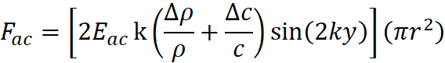

(10.2)

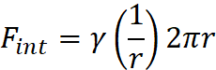



**Figure 10.1**: Droplet deformation parameter variation for different force ratio, (Fac/Fint).

**Summary and Conclusion**

In this work, by using the expression for acoustic force density *f*ac for inhomogeneous fluid using time averaged perturbation theory, we have presented theoretical evidence for the relocation of high concentration immiscible fluid in low concentration medium. The same has been studied and verified for various initial configurations in the COMSOL multi-physics software. We have found critical Eac values for different interfacial tension various differences in density and sound velocity by simulation.

We also then study the droplet deformation in an immiscible host fluid by simulations and observe the effects of acoustic radiation pressure upon the droplet surface. Finally, non-dimensionalization of droplet deformation in x axis is done, keeping acoustic force density and force due to interfacial tension in mind. This paves way route to acoustics based interfacial tensiometry, which is used for measuring interfacial tension between fluids when traditional methods would be difficult to implement.

Our thesis opens a new branch of potential application in interfacial tensiometry using manipulation with acoustic fields. This method will permit the measurement of interfacial tension when traditional methods are difficult to implement. This technique can be directly applied to measurement of interfacial tension property of liquid droplets in their stable state.

**References**

1. Hertz, G. & Mende, H. Der Schallstrahlungsdruck in Fl??ssigkeiten. *Zeitschrift f??r Phys.* **114**, 354–367 (1939).

2. Livett, A. J., Emery, E. W. & Leeman, S. Acoustic radiation pressure. *J. Sound Vib.* **76**, 1–11 (1981).

3. Bruus, H. Acoustofluidics 2: Perturbation theory and ultrasound resonance modes. *Lab Chip* **12**, 20–28 (2012).

4. Bruus, H. Acoustofluidics 7: The acoustic radiation force on small particles. *Lab on a Chip* **12**, 1014–1021 (2012).

5. Bruus, H. Acoustofluidics 1: Governing equations in microfluidics. *Lab Chip* **11**, 3742–3751 (2011).

6. Karlsen, J. T. (DTU). *Theory of nonlinear acoustic forces acting on fluids and particles in microsystems*. *Downloaded from orbit.dtu.dk on* (2018).

7. Karlsen, J. T., Qiu, W., Augustsson, P. & Bruus, H. Acoustic Streaming and Its Suppression in Inhomogeneous Fluids. *Phys. Rev. Lett.* **120**, (2018).

8. James Lighthill, S. *ACOUSTIC STREAMINGt*. *Journal ofSound and H~rution* (1978).

9. Rayleigh, Lord. XLII. On the momentum and pressure of gaseous vibrations, and on the connexion with the virial theorem . *London, Edinburgh, Dublin Philos. Mag. J. Sci.* **10**, 364–374 (2009).

10. Marston, P. L. Shape oscillation and static deformation of drops and bubbles driven by modulated radiation stresses—Theory. *J. Acoust. Soc. Am.* **67**, 15–26 (2005).

11. Trinh, E. H. & Hsu, C. Equilibrium shapes of acoustically levitated drops. *J. Acoust. Soc. Am.* **79**, 1335–1338 (2005).

12. *High-Intensity Ultrasonic Fields*. (Springer US, 1971). doi:10.1007/978-1-4757-5408-7