Food Carts and BARTs

Part 1, Introduction: A description of the problem and a discussion of the background.
Who and what? About the business: In San Francisco, an enterprising male entrepreneur is launching new food cart service, centered around snacks and non-alcoholic beverages. He envisions starting with five food carts to distribute the company's presence to make a splash effect when it enters the market. He wants to place them at high volume locations at peak times and may be open to placing one at multiple locations, or a couple at several locations, or some combination thereof. He wants to sell to BART (BART, essentially the San Francisco metro, is an acronym for Bay Area Rapid Transit) commuters who are too busy to have gotten their beverage and/or snack at home, or are beverage and/or snack enthusiasts. He wants to make efficient use of his limited food cart resources to ensure the project springs from the get-go.
Why this study? What next?: This preliminary study is to provide a foundation for a future boots-on-the-ground survey of commuters to gauge project interest, which will ask whether or not the person drinks beverages (hot/cold) around that time of day, and whether or not they already had that beverage at home or outside. This survey is out of the scope of this project, but its description serves to provide context for this project.
Where? There are four BART lines that run at regular intervals (in both directions) through the main San Francisco stops. I'll need to determine the number of trains per hour running through a given station to determine times to analyze location data around the BART station coordinates. There are 9 main stops to investigate in the San Francisco area, titled Daly City, Balboa Park, and Glen Park, 24th St Mission, 16th St Mission, Civic Center/UN Plaza, Powell St., Montgomery St, and Embarcadero. In geographic order, Daly City is the first stop and Embarcadero is the last stop in the downtown Financial District.
When? I hypothesize that finding a window in which the consumer has enough time to order and receive their request prior to boarding the BART is crucial. I'll tentatively look at location/activity data times 10 minutes prior to train arrival. If train arrival instance numbers are too high, remodeling may be needed to look only at activity over larger time chunks. Regardless, comparing specific time blocks with large time ranges will be important in determining how long mobile food carts will remain at a given location, so both scopes of data will be valuable. I hypothesize that 06:30 - 08:30 will be especially active, as well as 11:30 - 13:30 and 16:30 - 18:30, as those are common time ranges of movement (also common mealtimes). I hypothesize that lunchtime will be especially active in the main four downtown locations, as there is a dense concentration of the workforce in those areas. I also predict a wave of activity starting in the peripheral (outside of downtown) stations in the morning and moving towards downtown, and a reciprocal wave in the evening, starting at downtown stations and moving towards the periphery, due to assumed commute patterns and residential and urban geography.
How?: To obtain benchmarks for high activity times to target future survey participants, it will be important to confirm times during which cafes and/or coffee shops have the highest foot traffic around BART stations (Foursquare data), as well as other data. More on this below!

Part 2, Data Section:
A description of the data and how it will be used to solve the problem.
Foursquare API “search” searches for specific venue categories will be run to obtain the total number of businesses in the “Cafe” and “Coffee Shop” categories within the 250 meter radius of each BART station (determined by latitudes and longitudes of the stations). I hypothesize this data will be helpful for at least two purposes 1) to indicate likelihood the people buy coffee/snacks in a given area and 2) to get an understanding of the type and intensity of the competition in a given area.
This "search" data will also be used to calculate the mean frequency of occurrence of each categories and include the Cafe and Coffee Shop frequencies as data qualifiers for BART stations to give an idea of the proportion of the coffee/cafe points relative to other businesses around the BART stations. I hypothesize this data will be valuable to the entrepreneur to understand the density of the competition in a given area.
Preliminary research has shown there are too many trains per hour to select time segments for study based on train arrival, therefore 20 minute timeframes have been chosen for time segmentation. Foursquare “explore” and “trending” searches in 20 minute timeframes from 6:30 - 8:30 AM will be run to see which BART stations have high engagement (i.e. Foursquare foot traffic) with cafes/coffee shops. To determine "high engagement," at least one of the top three trending sites must be either Cafe or Coffee Shop; I'll manually record this data (logged by True or False tallies) to associate it with each BART station. There will thus be 6 timeframes: 6:30 - 6:50; 6:51 - 7:10; 7:11 - 7:30; 7:31 - 7:50; 7:51 - 8:10; 8:11 - 8:30. I hypothesize this data will be helpful to distinguish similar stations and specify which are more "engaging."
The station with the most True trending 20 minute time periods and with the most Cafe and Coffee shop locations will be recognized as the station with the highest potential/"most engaging" (assuming the entrepreneur's product is the best available and will squash all competition; should the entrepreneur's product not be the best, frequency of cafe/coffee shops can be used for determining placement strategy amongst competition).
A machine learning algorithm, titled, K-means clustering will be used to figure out how to “cluster” the potential sites for the five food carts, as the geographic separation will ensure distribution of the product as well as the brand. This clustering separation will facilitate further analysis to see the potential value of having multiple carts in individual clusters. I hypothesize it will also be valuable for the entrepreneur to understand the market trends at different types of BART stations.
In summary, each individual BART station will have the following components attributed to them based on their 250 meter radii: number of Cafe/Coffee Shops, number of Cafe/Coffee Shops relative to other shops (frequency), number of 20 minute time frames from 6:30 - 8:30 during which Cafe/Coffee Shops are trending, latitude, longitude. These components will be used to compile the k-means clustering sorting.
Addendum: The quality of the trending data was overestimated and was thus excluded from the study. Consumer rating data regarding nearby venues was substituted to give the entrepreneur an understanding of the relative power of his competition in the marketplace.

Part 3, Methodology Section:
Discussion of exploratory data analysis, statistical testing, and machine learnings and their intended purpose.
The first step was building the BART Station foundational dataframe (titled as such) which was improved upon to house all relevant data for the study. Google search was utilized to obtain all the addresses of BART Stations. Powell Street station address was not used because it generated a GPS location far from the actual location. I instead used the address of a chocolate shop across the street.
Then each station's GPS coordinates were obtained using the Nominatim package from geopy.geocoders, which converts addresses into GPS coordinates, and the coordinates were added to the foundational dataframe.
The following foundational map for the BART Stations was then built to give context for the entrepreneur, and also to prepare for a future map which summarizes similar stations at the conclusion of this study. This map was created using the folium package, which creates maps.
Image 1: San Francisco BART Stations
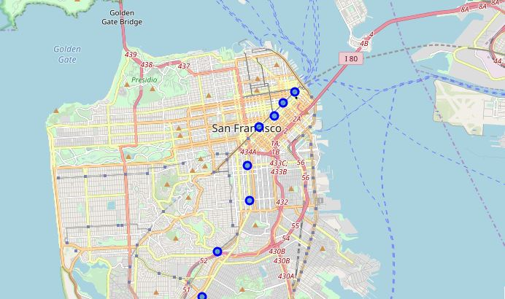
Then, a study of Foursquare API information was implemented. First, a query looking at the top 100 venues within 250 meters of Daly City Station was executed. Then a new function was built to begin to to sort these results by categories of Cafes and Coffee Shops. A new function was also built to to run the same process utilized for the Daly City station to obtain results for all BART Stations. These data were stored in a temporary dataframe (titled BVcafcof) for later manipulation.
From the results of this function, the main dataframe was expanded by performing exploratory statistical analysis of nearby restaurants. The data extracted were 1) Total numbers of coffee shops and cafes nearby stations, 2) relative frequency of the cafe/coffeshop category versus the frequency of all other businesses, i.e. cafe/coffeeshop business density, 3) the frequency's rank versus other businesses' frequency rank (i.e. first most common, third most common, etc.).
Image 2: Foundational Dataframe 1
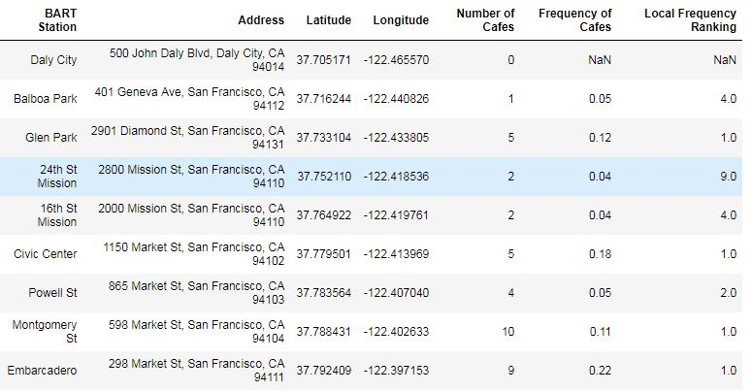
Part of the data extraction plan was getting data on trending businesses in twenty minute intervals from 6:30 - 8:30 AM, and code was created to do so. However, the trending business data was not so robust as anticipated. In fact, it was far from expected. Research at multiple times of the day showed that there was often no trending business in the entire city, let alone localized specifically around BART Stations. To create more value to the study, new data points of interest were adopted: customer ratings.
The BVcafcof dataframe, which hosted the exploratory data analysis data, was expanded to include the ratings information. An abbreviated version of the first six rows is shown below:
Image 3: BVcafcof
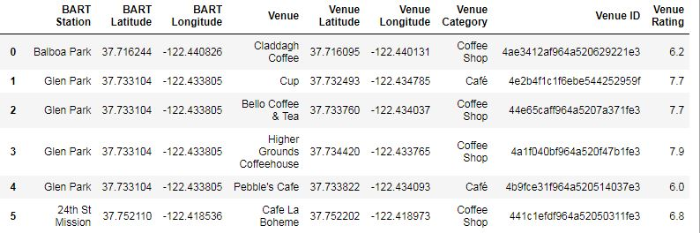
However, distilling the data from BVcafcof was important for composing the foundational dataframe, as there were only 9 stations, yet 37 coffeeshops. To do this, an average rating was taken from each chunk of station coffeshops, as well as the maximum rating. The result was the following updated foundational dataframe.
Image 4: Foundational Dataframe 2
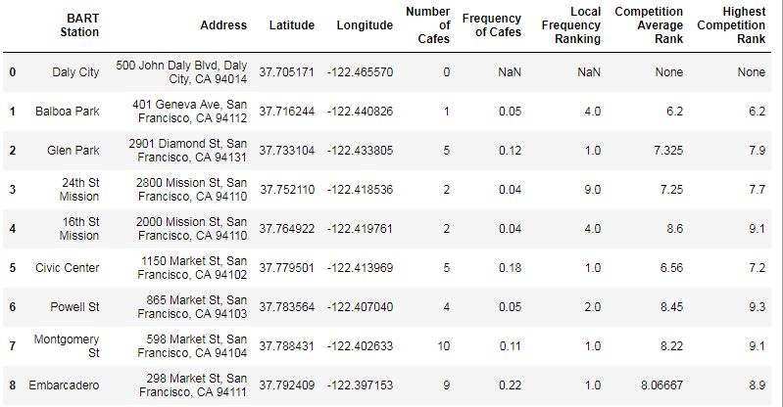
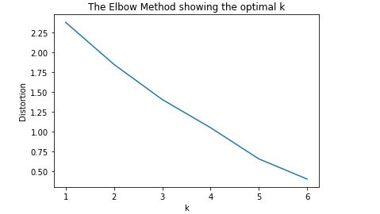
With all of the desired parameters of the study established, the preparatory steps for machine learning (via kMeans) were commenced. The numerical values were normalized, using the StandardScaler package from sklearn.preprocessing. In order to find the appropriate k (number of clusters into which the stations would be clustered), a function was built to explore the different distortions of results given different ks of the machine learning algorithm. These distortions and different ks were plotted on a graph in order to utilize the “elbow method” of finding optimal k; the elbow method looks at the part of a graph where the distortions drop to form an “elbow” in the data line. Below is the graph:

Although the graph shows a fairly consistent and steady line, 3 and 5 show sharper changes. 3 was adopted as it simplified the clustering for a data set that was already small.
Now armed with optimal k of 3, the kmeans algorithm from sklearn.cluster was used to compare the BART Stations with each other and cluster them in unique categories. These categories were added to update the foundational dataframe and generate a cluster map of the stations in San Francisco, both shown in the results section below.
Part 4, Results: Discuss the results
Below is the final result of the foundational dataframe, including all the data pertinent to this study.
Image 5: Foundational Dataframe 3
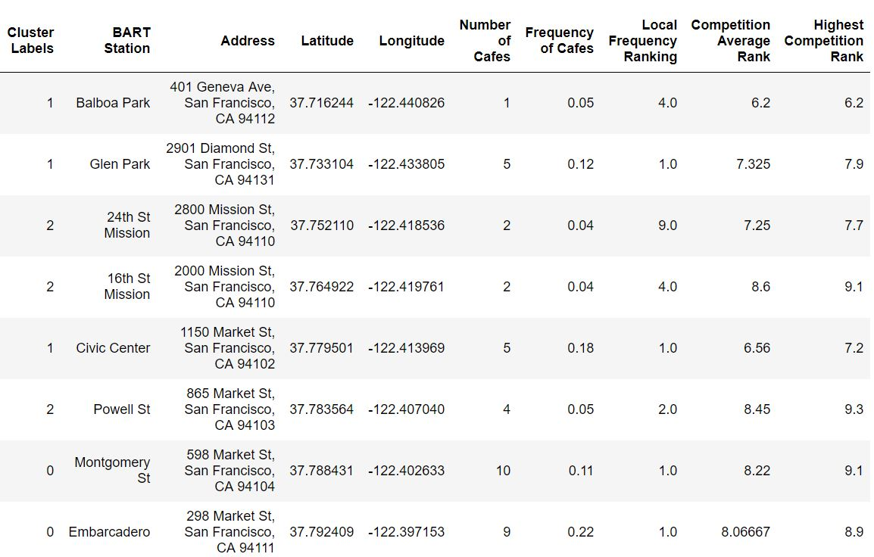

These data provide some interesting insights. Image 6, below on the next page, can be used for geo-reference.
Cluster 0 (red, in image 6, below) was occupied by two stations at the end of the line, Embarcadero and Montgomery. This is not surprising as these stations boast the highest number, and among the highest frequencies of all the stations, with nearly the highest customer ratings, and at the two closest GPS points.
In cluster 1 (purple, in image 6, below), Two stations at the other end of the line, Balboa Park and Glen Park, actually had more in common with downtown location, Civic Center, than Civic Center's nearby stations, 24th st and 16th st. Cluster 1 businesses seem to be marked bya medium number cafes with high frequency, and lower customer ratings.
Cluster 2 (mint, in image 6, below) found similiarities between downtown-peripheral stations 24th and 16th street with downtown station Powell St. Cluster 2 cafes seem to have the lowest number and frequency, while maintaining medium rankings.
Daly City BART Station presents an interesting category of its own, as there are only four businesses around it, none of which are coffeeshops.
Lastly, the ratings of all stations seem to generally trend higher when the station is closer to downtown (with the exception of Civic Center station).
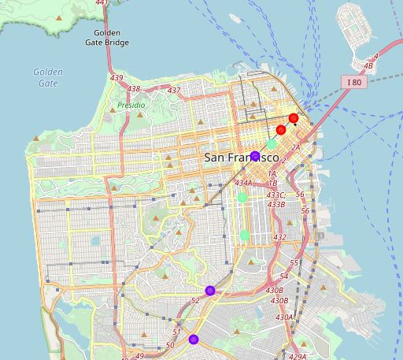
Image 6: Clustered BART Stations in San Francisco

The dataframe, BART Station Venues and Ratings, (image 7), which details the specifics of the entrepreneur's competition, demonstrates some interesting trends. Nine of the 37 coffee shops (almost 25%) within 250 meters of BART stations are corporate branded shops. A cursory review of the ratings of corporate branded shops show them to be average or higher than average, with the exception of a Civic Center Starbucks, which boasted a rating of 6.2.

Image 7: BART Station Venues & Ratings
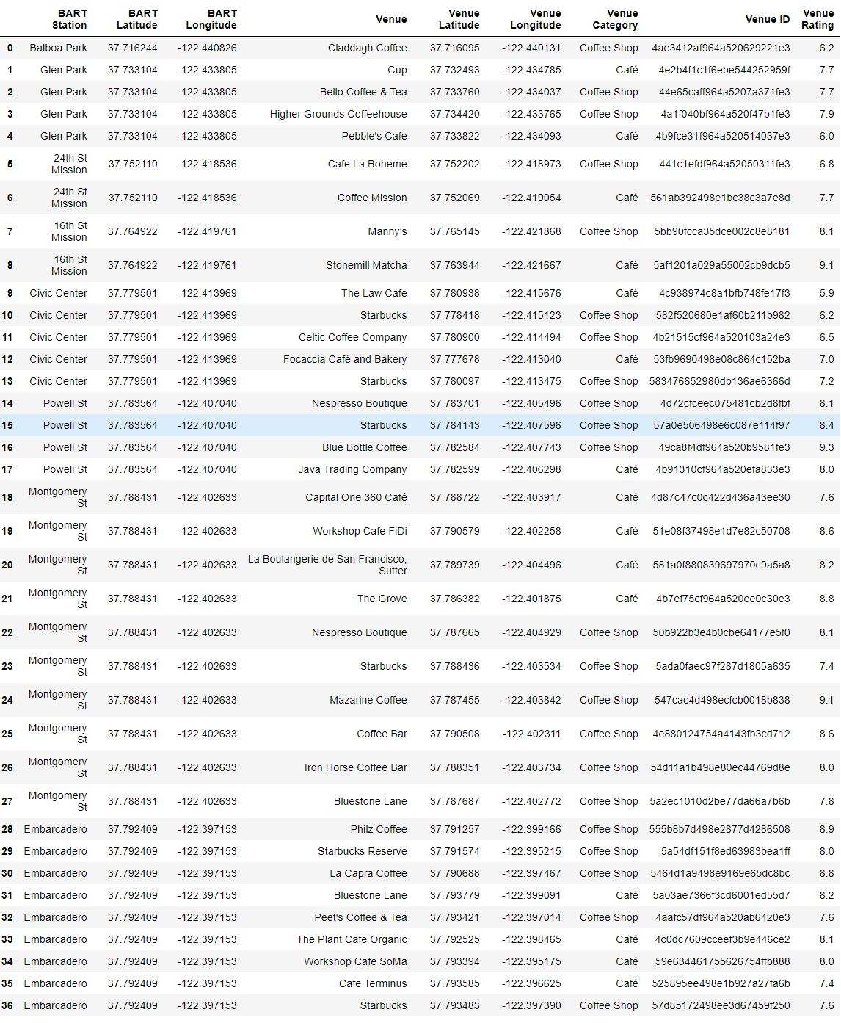

Part 5, Discussion:
Discuss observations and recommendations that can be drawn from the results.
This section is divided into three categories: unexpected developments, interpretations and recommendations, and future direction.
Unexpected developments:
At the beginning of this investigation, it was quickly discovered that BART stations have a given train arriving in either direction once every 3 or so minutes during the high activity times I wanted to explore. Therefore, specific timeslots relative to train arrival were abandoned as focal points, and instead 20 minute time intervals were chosen, or 6 data points per window. The lunchtime and evening window were abandoned as points for study due to the snacks and beverages being offered centering around “caffeine fuel-ups,” which were assumed to be most common in the morning periods. I had imagined the experiment could be replicated in the future for other timeframes as necessary. I had also imagined the experiment could also be repeated look at multiple days to see averages over time and trends for individual days.
However, the timestamped data proved to be a fruitless investigation, as Foursquare trending data (at least that which is publicly available) does not address hyperspecific GPS points in areas of a city. I found, after looking at multiple times of day and in different parts of the city, that 1) only one location tended to be trending 2) often times no locations in the entire city were trending 3) when a location was trending it was the same venue regardless of searches being conducted from various parts of the city 4) the trending location was rarely (in fact, never, during my searhes) a coffee shop. Therefore, timestamped data was abandoned as a focal point of the study, and customer ratings were instead adopted to add depth to the data.
I had originally intended to study a 400 meter radius, but upon investigation of google maps and corresponding distances around stations, it was deemed to be too large of a radius, especially at more urban stations. A radius of 250 meters was chosen to give some inclusion to more rural stations, without generating too much noise around urban stations.
The Powell St station address is listed as 899 Market, but the GPS coordinates given by geopy place the station somewhere between the 16th St Mission station and the Civic Center station. I realized this when looking through the dataframe I sorted by latitude, which showed Powell St out of order. I then went to Google maps to find the address of a business nearby the Powell St station. When using this address, 865 Market, the GPS coordinates were accurate.
The elbow method for optimal k for k-means was not as effective as I had hoped. I think this was due to a relatively small data set with similar data therein. Future studies could look at adding more data points, like ridership info, to add depth that may help starkly differentiate the k-means machine learning algorithm.
The ridership data that was publicly available from BART was interesting, but it lacked specificity. It showed monthly ridership data, which was problematic as the ideal focus of this study is for the weekday timeframe. For this reason, I did not include it in this study. However, the information shows promise, and could be included in future models, if the data are wrangled carefully.

Interpretations and Recommendations:
Looking at the data for Cluster 0, which includes Montgomery and Emarcadero, it was observed that while these stations are very busy and in densely populated areas (which are usually good indicators for placing a business, especially if your overhead is low), the coffeeshops' high customer satisfaction in a dense market with a high amount of competition makes Cluster 0 a potentially dubious place to open up shop. If the entrepreneur finds a niche, this could be a good place to exploit. The mobile aspect of the business provides a high visibility to the consumer immediately upon leaving the train. However, in the morning, these stations are destinations, not origins, and it's possible that a higher percentage of traffic at this station will have already had a caffeinated beverage and snack. Continued market research, as indicated in the "Why this study? What next?" section of the Introduction, is highly advised. As a result of the preceding evaluation, Cluster 0 has been dubbed "High Risk. High Reward?"
Cluster 1 (Glen and Balboa Park, and Civic Center) showed a surprising deviation from my expectation, which was that geographic location (regardless of whether it was included in the algorithm) would define the clusters more strongly by virtue of supply and demand that accompanies population density. But even with the inclusion of geographic data in the machine learning algorithm, distant stations had strong correlation to a downtown station. These stations really are similar. As noted in results, these stations are marked by medium number cafes with high frequency, and lower customer ratings, provide an excellent opportunity for business. There are not too many individual competitors, yet coffeeshops occupy a large corner of the market, which is comprised of unhappy customers. All three of these qualities present strong opportunities for a new business. Additionally, because these stations are further from the downtown area, they are origins, which suggests that a higher percentage of their riders will not have already gotten their morning caffeinated beverage and snack. Because of all these strong indicators, this cluster has been dubbed "The Land of Opportunity."
Cluster 2 (24th and 16th St Mission, and Powell St) is marked by the lowest number and frequency of coffeeshops, while maintaining medium rankings. It also has the lowest Local Frequency Ranking meaning there are more type of businesses that are more common than in any other cluster. At face value, this cluster presents great opportunity given how few coffeeshops there are in the areas. However, their scarceness could be due to the fact that coffeeshops are not sucessful in these locations. Additionally, customer satisfaction is in the medium range, which means that the competition that's already there would be stronger than the competition in, say, Cluster 1. However, one benefit to the stations in this cluster is that they are more similar to origin stations than those in Cluster 0, so the people who frequent them may be better potential customers. This is the second best cluster where I'd advise placing business due to its market opportunity and customer profile. Cluster 2's title is "The Middle Ground."
Daly City station presents similar advantages to those of Cluster 2, namely, its status as an origin station and its total lack of competition. However, further market research is required for this location as there are very few established businesses at this location. I would not advise placing a business here until thorough research has been done and probably until existing business locations are successful.
Looking at the detailed information on the competition in the dataframe, BART Station Venues and Ratings (image 7), about a quarter of the businesses are corporate. This indicates that there is support for independent snack and beverage shops in the marketplace, which is fantastic news for the entrepreneur. The entrepreneur could also note that 25%, while a minority, is still significant, and perhaps modeling some aspects of his business after the corporate structure would yield a larger market of consumers of his products.

Future direction:
I recommend continued data collection both prior to and after starting the business. I recommend tick counters or tallies at BART station entrances/exits to generate proprietary data on foot traffic moving in and out of BART stations at documented time intervals. I still recommend time-marked surveys of riders to gauge whether they've already had their beverages and snacks in order to confirm hypotheses about the consumer profiles at origin and destination stations. I recommend investigating BART stations across the bay in Alameda County because my preliminary review of BART rider data suggests high traffic stations exist within a couple of stops of the downtown San Francisco stations. This may complicate the initial business model preparation, but it would certainly be valuable for the future if those locations couldn't be addressed at launch.

Part 6, Conclusion:
In conclusion, I recommend placing at least two of five food carts within "The Land of Opportunity," and three if the entrepreneur decides to avoid "High Risk. High Reward?" altogether. I recommend placing another two food carts within "The Middle Ground." I recommend placing the last food cart in "High Risk. High Reward?" because there's too much potential value there to miss out on, and having a location there would allow further data collection to clarify marketplace understanding.
When choosing which station(s) within the clusters to place food carts, I'd recommend making a decision based on insights from examining nearby competition. Additionally, there could be value in rotating carts within clusters to gauge market interest and gather more data. One conclusion that can be drawn (with certainty) from this study is that the more data an entrepreneur has, the better he is equipped to determine strategy for his company.

