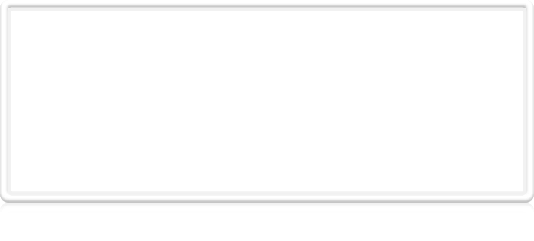
Client Worksheet

This Client Worksheet has been designed to help you gather details of your project by asking a series of simple project-related questions. The questions are generic but there is a section at then end where your team can add anything you feel is relevant that has not been mentioned. Conversely, if there is anything you think irrelevant, please skip and move on.

Project Goals

What is the name this proposed system?

"RU ITEC Agenda"

(Though, there isn't much of anything restricting it to just ITEC students, so it's open to becoming
"RU Agenda" at a later date.)

Why do you need a new software system?

In order to keep track of ITEC assignments. There are several existing products that provide calendars and task lists, but an application geared specifically to ITEC students could provide several advantages over a more generalized system.

What features would you like to see in your new system? Do you have existing documentation that will assist us develop your system more quickly?

- Easy to add assignments to your schedule
- Can input weekly class schedule / repeating due dates and app will repeat it for you
- Alerts for near deadlines
- Calendar-like views of schedule and deadlines

No existing documentation.

How will you measure the success of this project?

Minimum– manage a list of assignments, due date alerts, simple sharing mechanism
Complete– calendar views, schedule management
Extra- theming, automation using the RU academic calendar, advanced sharing

Your Market

Can you give us a description of all of the different types of people that you intend to attract with your new system?

Students. Specifically ITEC students, but students in general.
(Which is great, b/c that's what we all are…)

Is administrator access required for your system? Who will in charge of maintenance?

Administration/maintenance will not be necessary unless advanced sharing features which require
synchronization with a central server are introduced.

Your Style

What image would you like to give to your customers with the design of your new system?

Team can go ahead and make several look and feel variations, and Ryan will choose one.

Can you possibly provide a list of competitor’s websites/systems and let us know what you think works and doesn’t work for each selected?

(see 3.3)

What non-competitor’s websites/systems are there that you like the design, layout or usability of that would demonstrate your preferences?

We discussed similarities and differences with Google Calendar and mobile calendar applications.
Calendar views could draw heavily from other mobile calendar applications, but the key would be
simplification and streamlining to target our particular audience.
We can provide intelligent defaults for our target users in order to greatly simplify the addition of deadlines to one's agenda, repeating weekly schedules, and reminders/alerts for deadlines.
We can provide other (non-chronological) views of a user's assignments (by class, by priority, archived/done assignments) that add value for students beyond a simple calendar or todo app.
We can also include integration with Radford's existing systems that would keep the user from having to configure an additional account and some mechanisms for sharing between users.

Does your have an existing logo that you want to appear on your new system?

Negative.

Final Comments

Please let us know any additional information about your requirements that you think may help us achieve and understand your project more accurately.

--

