RU Agenda

*blacktie*

User’s Manual

Document

**Forrest Meade**

**Matthew Seiler**

**Danielle Paredes**

**Isaac McCraw**

**Nathan Velasquez**

**Bowtie Code**

**www.radford.edu/softeng10**

**May 1, 2014**

**USER'S MANUAL**

**TABLE OF CONTENTS**

Page #

1.0 GENERAL INFORMATION 3

1.1 System Overview 3

1.2 Project References 3

1.3 Authorized Use Permission 4

1.4 Points of Contact 4

1.4.1 Information 4

1.4.2 Coordination 4

1.4.3 Help Desk 4

2.0 SYSTEM SUMMARY 5

2.1 System Configuration 5

2.2 Data Flows 5

2.3 User Access Levels 5

3.0 QUICK START GUIDE 6

3.1 Logging On (Gaining Access to the System) 6

3.2 System Menu 6

3.2.x [System Function Name] 6

3.4 Exiting the System 6

3.5 Special Instructions for Error Correction 6

3.6 Caveats and Exceptions 6

4.0 FUTURE ENHANCEMENTS 7

4.1 Future Functionality 7

4.2 Similar Systems – Additional Functionality 7

4.3 Maintenance Capabilities 7

# GENERAL INFORMATION

## 1.1 System Overview

The RU Agenda application is designed for Radford University students that want to track their classes and assignments. The application is developed by Bowtie Code in HTML5 and JavaScript along with the use of phonegap and jquery-mobile. The user will be able to navigate through the application with button tabs and popup menus on a web based system. The application is currently under development and may contain functional issues. The system will require an android phone.

## 1.2 Project References

Lewis-Williams, Tracy. “ITEC 370 - Software Engineering I - Course Syllabus” 2014.  PDF file.

## 1.3 Authorized Use Permission

Bowtie Code prohibits the misuse or unauthorized distribution and modification of this application and any related documents.

## 1.4 Points of Contact

### 1.4.1 Information

**Bowtie Code**

Forrest Meade, Matthew Seiler, Danielle Paredes, Isaac McCraw, Nathan Velasquez

Email: softeng10@radford.edu

**ITEC 370 Professor**

Dr. Tracy Lewis-Williams

Department: Information Technology

Office: Davis Hall 229

Email: tlewis32@radford.edu

### 1.4.2 Coordination

There are no known organizations that are coordinating on this application.

### 1.4.3 Help Desk

For Assistance, email Bowtie Code at softeng10@radford.edu.

# SYSTEM SUMMARY

## 2.1 System Configuration

RU Agenda requires an android device that can hold local database storage. The system does not require Internet connectivity to function.

## 2.2 Data Flows

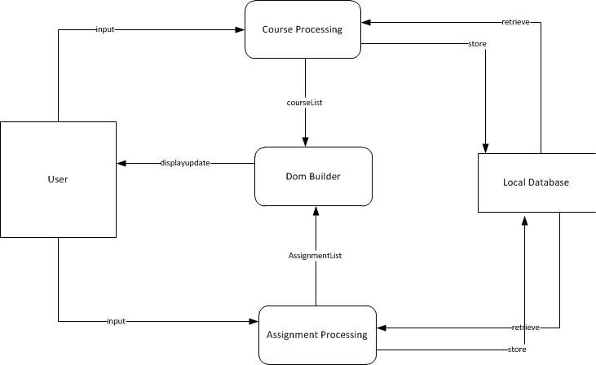

## 2.3 User Access Levels

There is a single user, the student. The student can use the application on their android device. All information stored for a single user is by device not by user account. The user will have full access to all of the applications features.

# QUICK START GUIDE

## 3.1 Logging On (Gaining Access to the System)

The user does not require a login to access the system. The user simply opens the application and begins using it. All data is relative to the device.

## 3.2 System Menu

### 3.2.1 View by Due Date

When the user launches the application, this screen will load with any existing assignments. If the user navigates to another tab, in order to get back to this one, they must click the left tab.

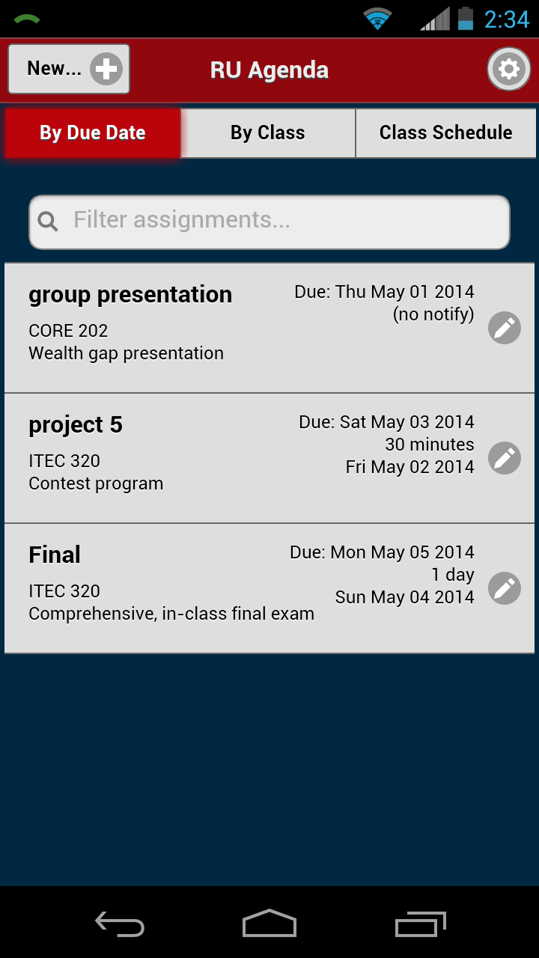

### 3.2.2 View by Class

The user must click the center tab to view this screen.

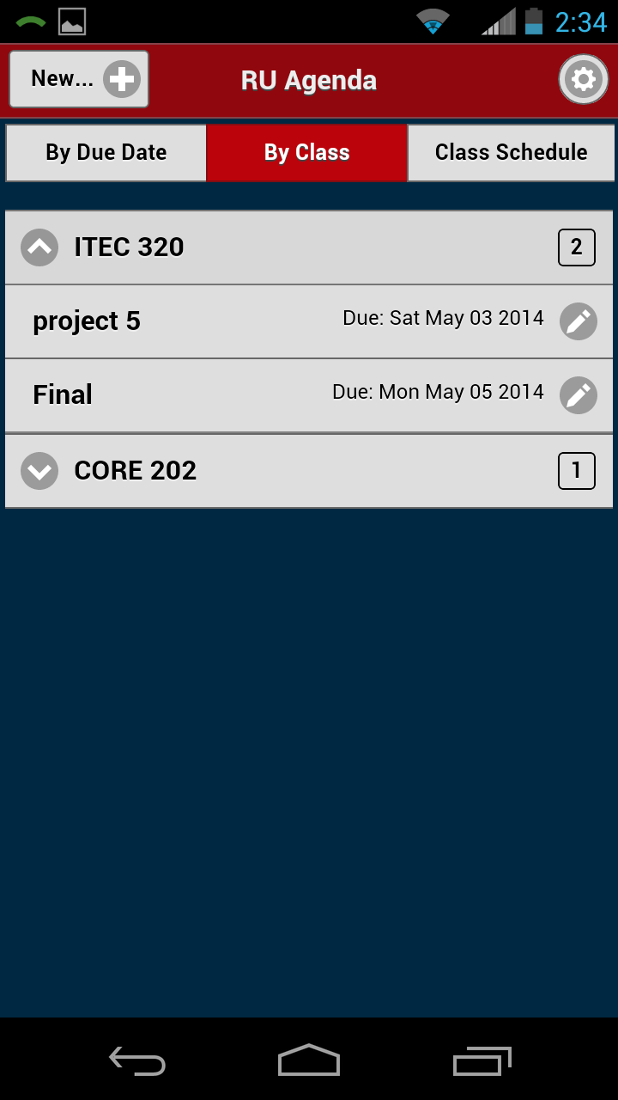

### 3.2.3 View Class Schedule

The user must click the right tab to view this screen.

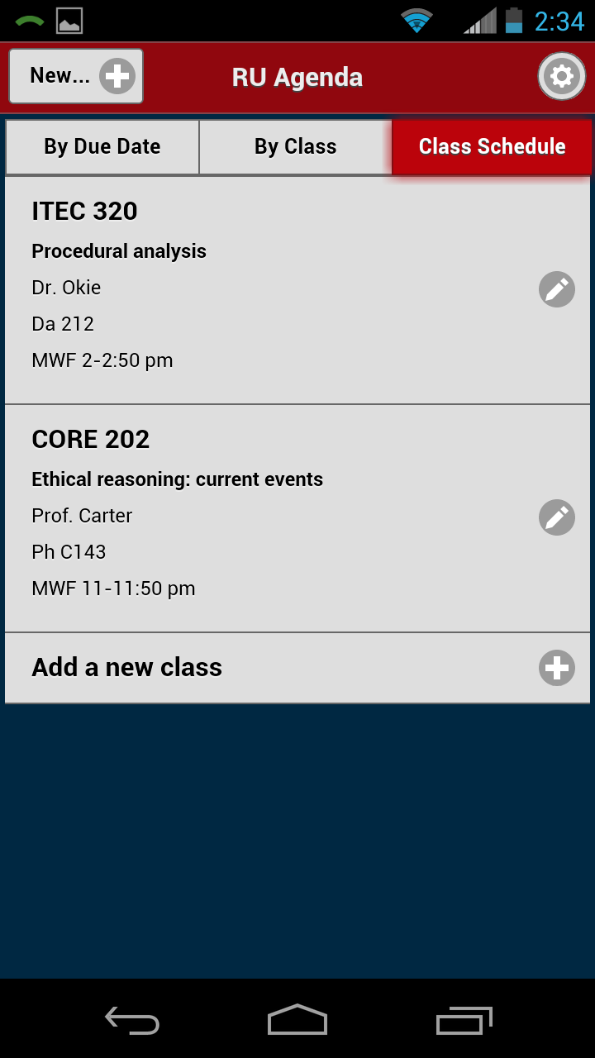

### 3.2.4 Add a class

To add a class, the user must first move to the class schedule tab. Then they click add class. A popup will appear for the user to enter class information. After they hit the save button, it will be added to their schedule.

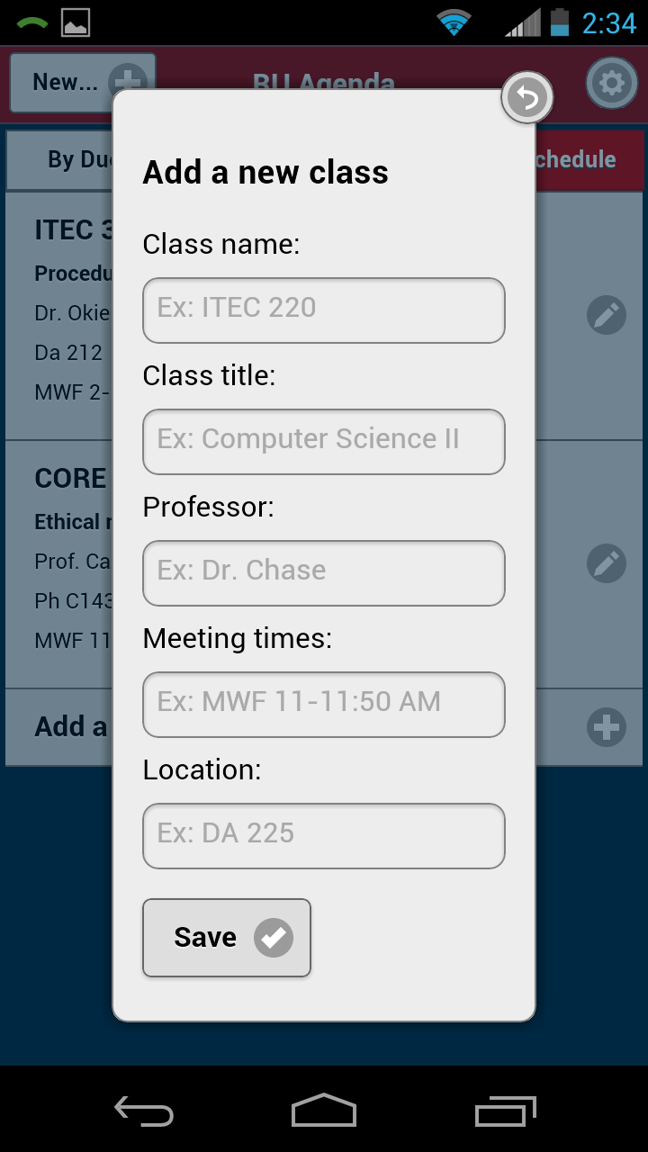

### 3.2.5 Edit a class

To edit a class, the user must first move to the class schedule tab. Then they click the class they want to edit. A popup will appear for the user to edit class information. After they edit and hit the save button, it will be updated in their schedule.

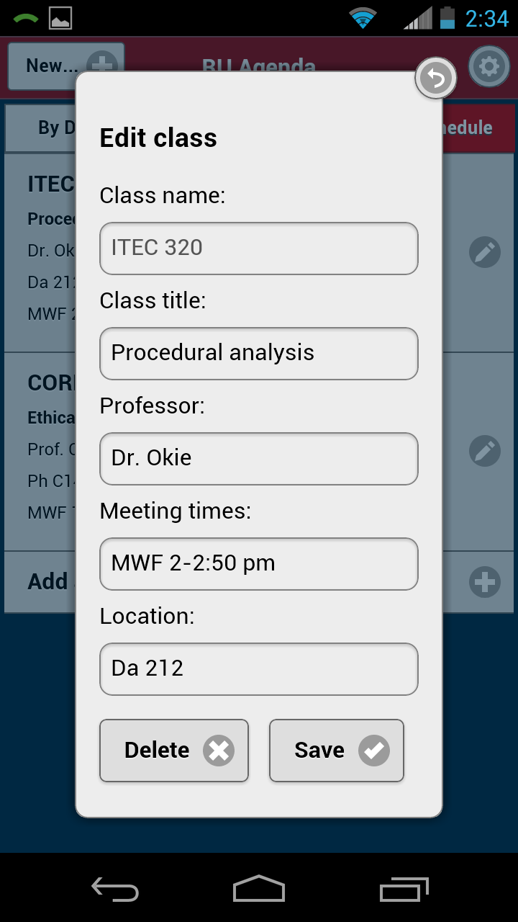

### 3.2.6 Remove a class

To remove a class, the user must first move to the class schedule tab. Then they click the class they want to remove. A popup will appear for the user to edit class information. After they hit the delete button, it will be removed from their schedule.

### 3.2.7 Add an Assignment

To add an assignment, the user will click the plus sign button in the top left corner of the system. A popup will appear for the user to enter assignment information. After they hit the save button, the assignment will be added to their assignment list.

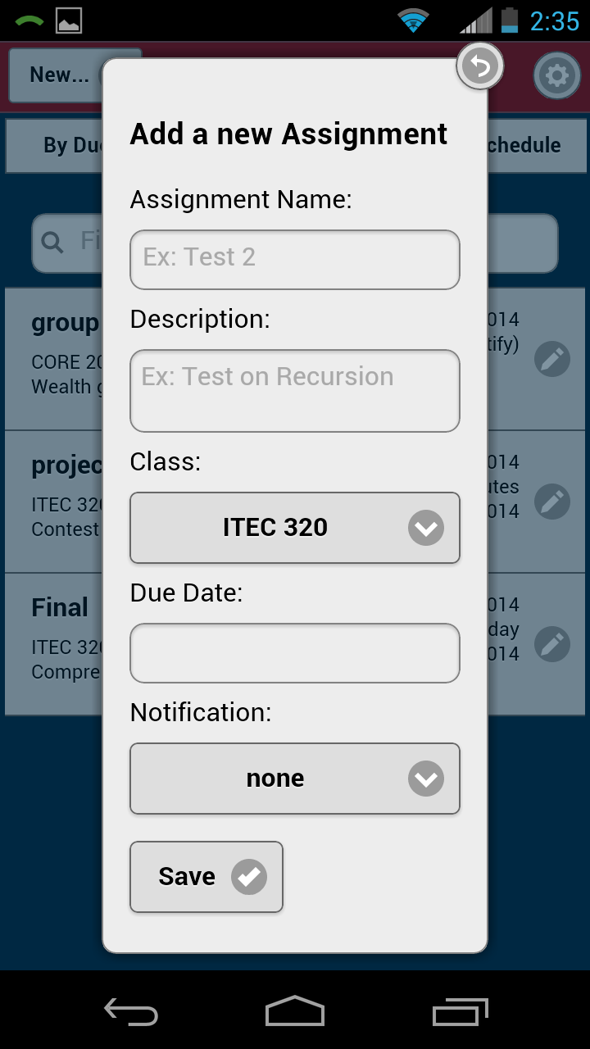

### 3.2.8 Edit an Assignment

To edit an assignment, the user must be in the by due date or by class tab. The user will click the assignment the want to edit. A popup will appear for the user to edit the assignment information. After they hit the save button, the assignment will be update in their assignment list.

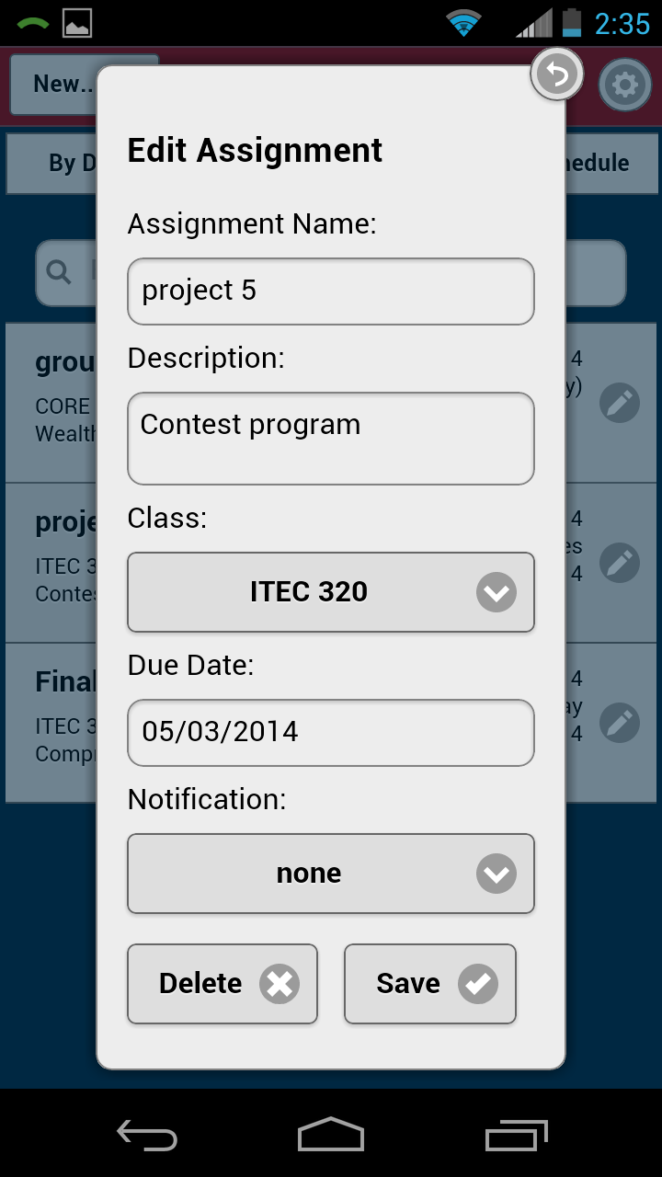

### 3.2.9 Remove an Assignment

To remove an assignment, the user must be in the by due date or by class tab. The user will click the assignment the want to edit. A popup will appear for the user to edit the assignment. After they hit the delete button, the assignment will be removed from the assignment list.

### 3.2.10 Reset Class and Assignment List

To reset the class and assignment lists; the user can click the menu button in the top right corner of the system. The user will click the reset everything button and their class and assignment list will reset.

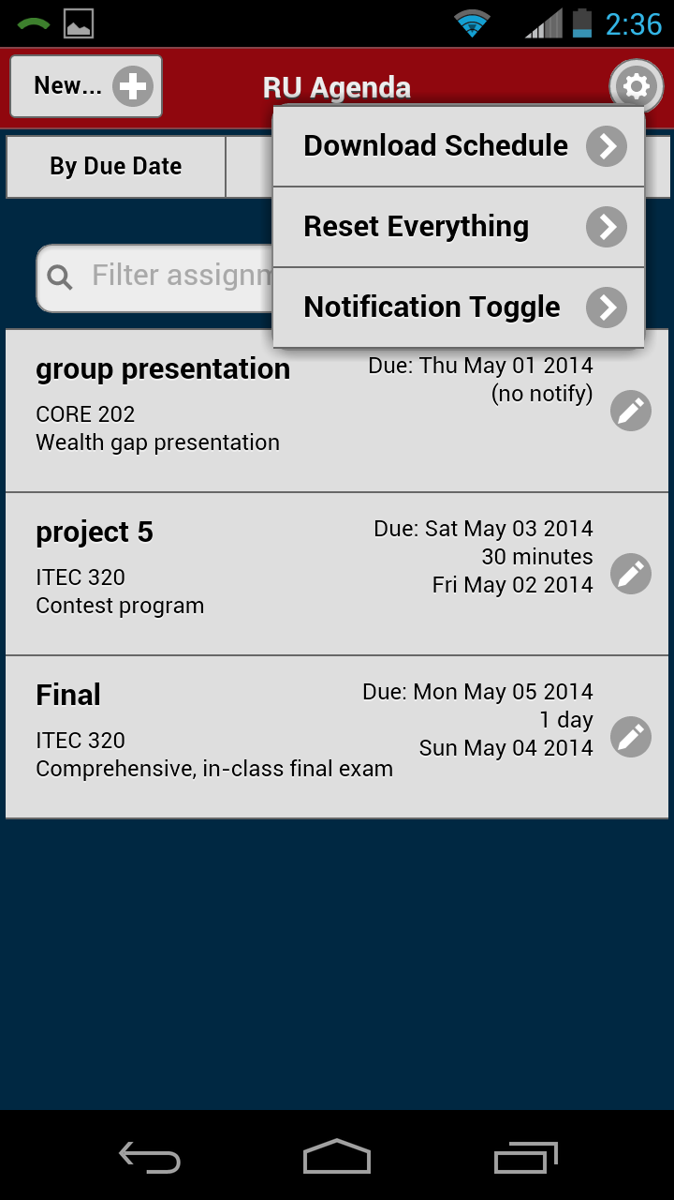

### 3.2.11 Filter Assignment List

A user can filter the assignment they are looking for by entering a title, description, due date, or course name into the search bar on the first tab.

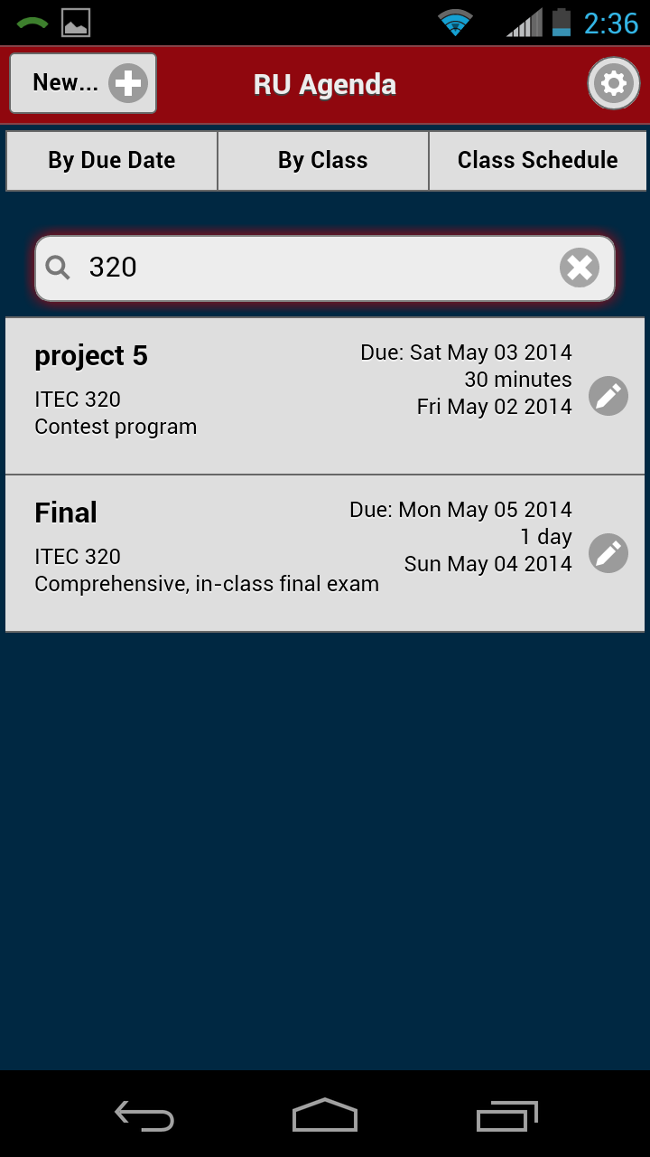

## 3.4 Exiting the System

A user can exit the system by hitting the home button on their device or turning the device off.

## 3.5 Special Instructions for Error Correction

Any errors that the application may have can be reported to Bowtie code and fixed. The user should not have any system errors involved with their information.

## 

## 3.6 Caveats and Exceptions

When adding, editing, or removing a class or assignment, the user must not close the application. There is no guarantee the information will save.

Phone-gap may crash but is not limited to the application.

# FUTURE ENHANCEMENTS

## 4.1 Future Functionality

**Login**

The user would be able to login with their RU information and it would run through the RU authentication service. This would allow the user to access their information from any android device.

**Download Schedule**

The user would be able to download the RU semester schedule straight into their class list, saving them from having to input each class manually.

**Notifications**

The user would be able to have assignment notifications.

**Notification Toggle**

The user would be able to turn off assignment notification within the application

## 4.2 Similar Systems – Additional Functionality

Apple Reminders – allows you to link your assignments or tasks to your computer. Your phone and computer sync automatically.

myHomework – The system is linked to the RU course database and it pulls information straight from there.

Google Calendar – lets you link every class time and assignment due date to a calendar view.

## 4.3 Maintenance Capabilities

All Future maintenance and responsibility will be handed over to Radford University. The RU IT department will do any and all maintenance.