Results for Project 3 – Threads

Forrest Meade

In the results, we see that by adding threads make it less time to complete the calculation. We also see that C is slightly faster, probably because of less memory being used.

Graph:

Results in C:

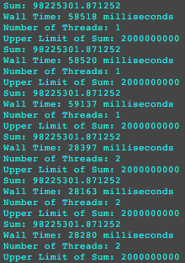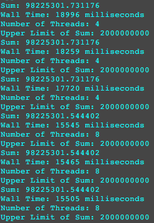

Results in Java:

