Total Covered Industries

Establishments – One lag



Establishments – One lag and change in stock of website registrations



Establishments – One lag, change in stock of website registrations, and total number of website changes.



Establishments – One lag, change in stock of website registrations, change in number of website changes.



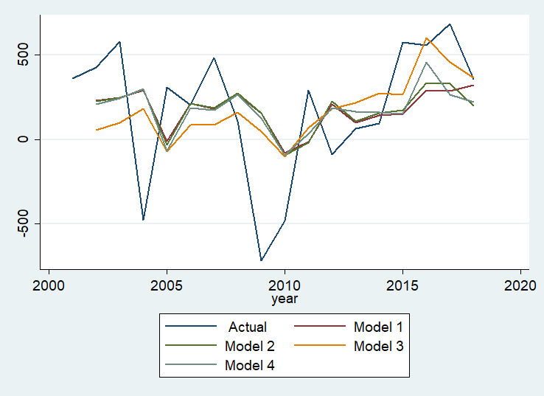

Employment – One lag



Employment – One lag and change in stock of website registrations



Employment – One lag, change in stock of website registrations, and total number of website changes.



Employment – One lag, change in stock of website registrations, change in number of website changes.



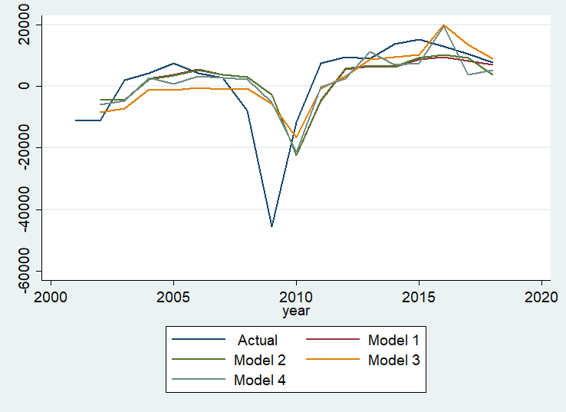

Relevant Industries









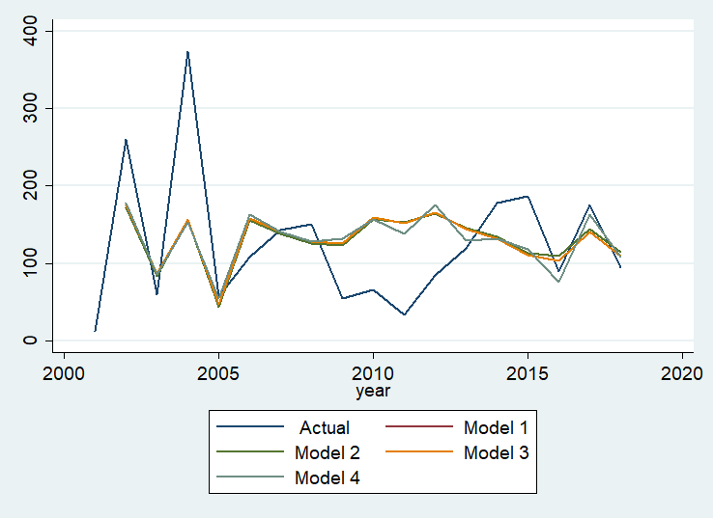

Employment in relevant industries









