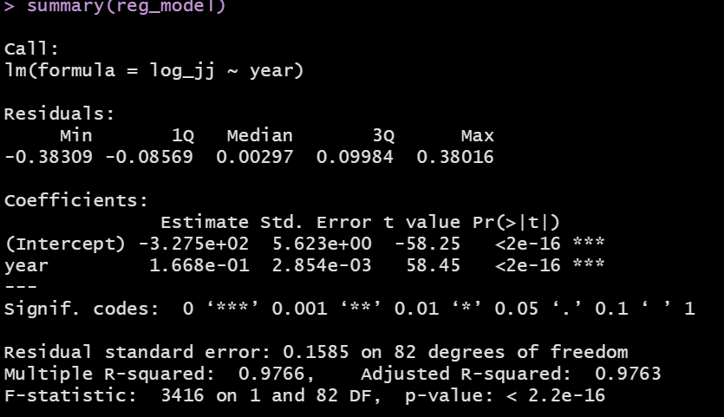
- What the regression equation based on our sample data?

$$y_{t}= -327.5+0.1668×year$$

- What is your predicted value for the EPS for Q3 of 1972?
Y_t = -327.5 + 0.1668* 1972.50 = 1.513 in logged $

To get the EPS, we will need to exponentiate the output 4.540331 in $
Note that this has a tremendous amount of rounding error since we are using the coefficients with 1 decimal place for $β_{0}$.

- What are the residuals based on the fitted values for Q3 of 1972? To make our life simpler, let us just focus on the residuals in logged EPS
$ϵ=y_{i}-1.513=$ 1.61740608 – 1.513 = ….

- I have an intercept of -327.5, which mathematically speaking is the value of the logged EPS when the year is set to 0. This is obviously meaningless in the context of this problem (there was no stock market and no J&J at Year 0).

- The slope of 0.1668, for a unit increase in year (which based on how the year was coded means increasing time by one year), the logged EPS will increase by 0.1668.

- Standard error of the slope coefficient is: 0.002854 (important since we need this to determine the significance, captures the standard deviation of the sampling distribution of the slope coefficient)

- Residual standard error: 0.1585 we want this to be small and this is essentially the square root of MSE

- Multiple R2 of 0.9766: given that this is a simple linear regression, this is essentially our R2 and it captures the proportion of variation in the logged EPS that is explained by our year predictor.

- Adjusted R2 is not useful for simple linear regression (adjusting for model size)

- t-value of 58.45 is your test statistic, which is very large. This states that we are 58.45 standard errors above the mean, which is why the predictor is significant

Test of Model Significance
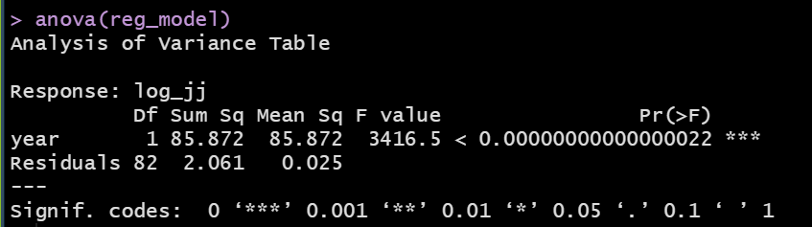
Our null hypothesis is that $β_{1}=0$and our alternate hypothesis is $β_{1}≠0$. By having a very small p_value of 0.000000, we reject the null hypothesis and conclude that year is a significant linear predictor of the logged EPS.

