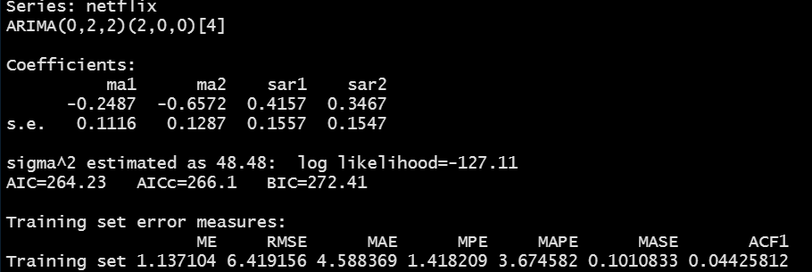
Q1: Based on the summary function (applied to your model object), please explain what are the AR lag coefficients included in the model?
- From the nonseasonal ARIMA, we only have a MA(2) applied to the second difference of the Netflix data. From the nonseasonal ARIMA, we are not using any AR lags.
- From the seasonal ARIMA, we have P = 2. What does it mean in terms of the AR lags used in model?
  - Y_{t} ~ Y_{t-4} + Y_{t-8} (Generally speaking, the seasonal ARs included will be multiple of the frequency, m, which is in the square brackets in the output).
  - Y_t ~ Y_{t-1}+ Y_{t_2} if p = 2 (since I am using lowercase p, I am referring to the nonseasonal model). Not the case based on the above output.
  - So let us say that p = 2, and P = 2. We will regress Y_{t} on Y_{t-1} + Y_{t-2} + Y_{t-4} + Y_{t-8} .

Q2: What does the seasonal ARIMA, D, parameter value indicate?
- From Last Class, we had D ≠ 0 (I think it was 1). Today, we have D = 0. What does that mean? The seasonal data/factors are stationary. Once you take the second difference of the data, no additional differences are needed for the seasonal part.
Q3: What did we learn from the non-seasonal ARIMA parameters?
- p = 0, which means that we do not have an autoregressive part.
- d = 2, two differences are needed to bring the data to stationarity.
- q = 2, this means that the error correlations are lagged by 1, and 2 quarters (MA part).

Q4: In terms of the predictive performance, do we have a reasonable model?
- The ME is relatively small compared to our data, which indicates that we do not have a biased model (i.e., we are not consistently over predicting or under predicting).
- From the MAE, we are on average 4.6 away from the true value (which given the values we had when we printed the Netflix data this is pretty good).
- The MAPE : 3.7% (our average error is about 3.7%)
- MASE: We are having ~ 90% improvement over the naïve forecast.
Overall, we have a reasonable model. improve upon it if the 3.7% error is high for your application.

Q5: In terms of the assumptions behind the ARIMA model, do we have a reasonable model?
We do have a reasonable model based on the Ljung-Box test and the plot from the checkresiduals().

