Birth Data

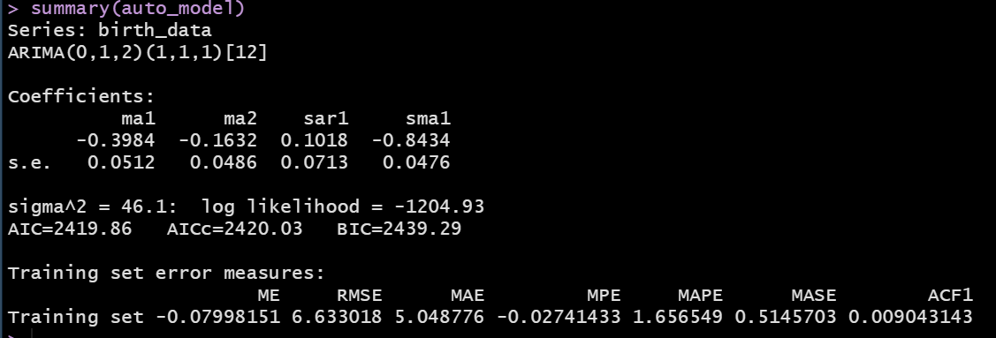

From the output above, we learned the following:
- The fitted model is an ARIMA(0, 1, 2)(1, 1, 1) [12]
  - For the nonseasonal ARIMA component, this is similar to what we have been discussing for the past 2-3 classes:
    - d = 1, which means that the first difference was applied to the nonseasonal ts, to make the data stationary
    - p = 0, which means that we do not have an AR component
    - q = 2, which means that the error correlations were lagged by 1, 2 months after taking the first difference
  - For the seasonal model:
    - [12] an input to the model, which states that the frequency of the data is 12
    - D = 1 the first seasonal difference was needed to bring the seasonal component of the ts to stationarity (first seasonal difference in the context of our data y_{t} – yt-12)
    - P = 1 Y_{t} ~ Y_{t-12} we are regressing yt as a function of y_{t-12}
    - Q = 1 we are lagging the error correlations by 12 months
  - Hypothetically speaking, let us say that we had p = 1, P =2
    - y_{t} ~ y_{t-1} + y_{t-12} + y_{t-24}
  - Hypothetically speaking, let us say that we had p = 2, P =2
    - y_{t} ~ y_{t-1}+ y_{t-2} + y_{t-12} + y_{t-24}

Netflix Data
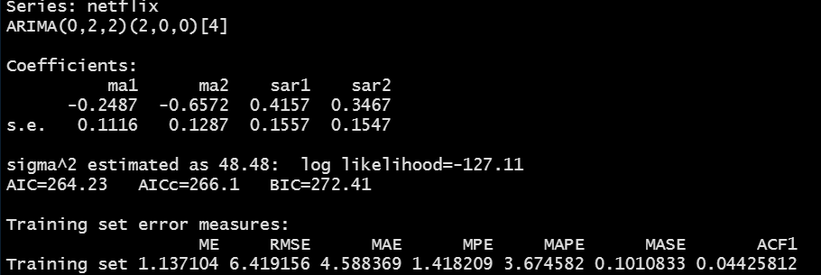
Q1: Based on the summary function (applied to your model object), please explain what are the AR lag coefficients included in the model?
- From the nonseasonal ARIMA, we only have a MA(2) applied to the second difference of the Netflix data. From the nonseasonal ARIMA, we are not using any AR lags.
- From the seasonal ARIMA, we have P = 2. What does that mean in terms of the autoregressive lags used in our model?
  - Y_t ~ Y_{t-1}+ Y_{t_2} if p = 2 (since I am using lowercase p, I am referring to the nonseasonal model). Not the case based on the above output.
  - Y_{t} ~ Y_{t-4} + Y_{t-8} (Generally speaking, the seasonal ARs included will be multiple of the frequency, m, which is in the square brackets in the output).

Q2: What does the seasonal ARIMA, D, parameter value indicate?
- We have D = 0. What does that mean? The seasonal data/factors are stationary. Once you take the second difference of the data, no additional differences are needed for the seasonal part.

Q3: What did we learn from the non-seasonal ARIMA parameters?
- p = 0, which means that we do not have an autoregressive part.
- d = 2, two differences are needed to bring the data to stationarity.
- q = 2, this means that the error correlations are lagged by 1, and 2 quarters (MA part).

Q4: In terms of the predictive performance, do we have a reasonable model?
- The ME is relatively small compared to our data, which indicates that we do not have a biased model (i.e., we are not consistently over predicting or under predicting).
- From the MAE, we are on average 4.6 away from the true value (which given the values we had when we printed the Netflix data this is pretty good).
- The MAPE : 3.7% (our average error is about 3.7%)
- MASE: We are having ~ 90% improvement over the naïve forecast.
Overall, we have a reasonable model. You may need to improve upon it if the 3.7% error is high for your application in practice.

Q5: In terms of the assumptions behind the ARIMA model, do we have a reasonable model?
We do have a reasonable model based on the Ljung-Box test and the plot from the checkresiduals().

