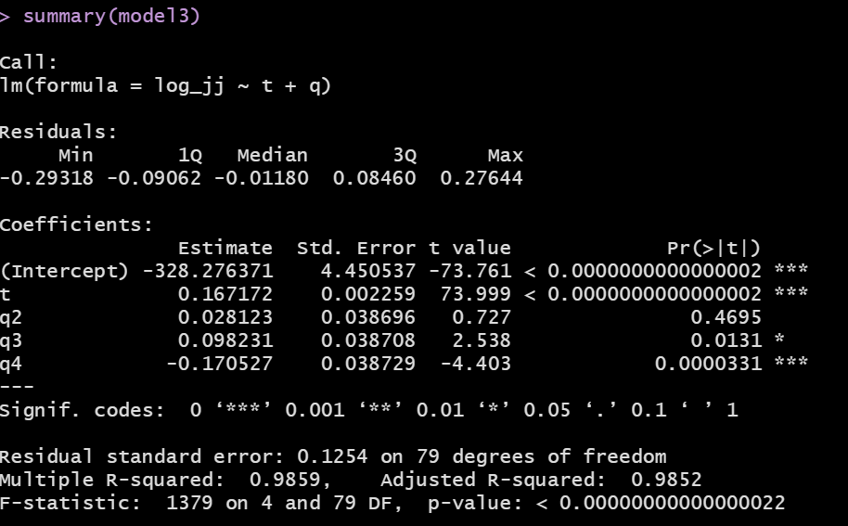

$$y_{t}= -328.276371+0.167172t+$$
0.028123q2 +
0.098231q3 +
-0.170527q4
From this equation, we can make the following observations:
- Similar to model1, the intercept of -328.276371 has no meaning since at t = 0, jj did not exist. It is only needed for the purpose of model fitting, but has no other practical value.
- At Q1 of 1964, my predicted value of the logged EPS is:
  - Y_t = $-328.276371+0.167172×1964.00= 0.049437$
- Based on the question that the decimal values in t account for some of the seasonality, what is the interpretation of the 0.028123 coefficient for q2?
  - Given that I cannot hold t constant, I cannot say that the 0.028123 value corresponds to the difference in logged EPS as I move from Q1 to Q2.
  - As we move from Q1 to Q2 of 1964, let us see what is the diff in logged EPS
    - Q1: $0.049437$
    - Q2: $-328.276371+0.167172×1964.25+0.028123= 0.119353$
    - The diff is: 0.069916 (which you could have also computed as $0.167172*0.25+0.028123$)
- The idea of the baseline means that I would compare Q3 to Q1 and not to Q2
  - As we move from Q1 to Q3 of 1964, let us see what is the diff in logged EPS
    - The diff is: 0.181817 (which you could have also computed as $0.167172*0.25+0.098231= 0.181817)$

