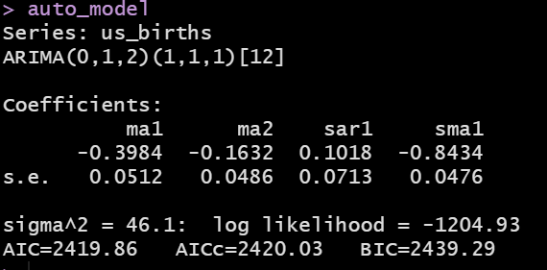

ARIMA(0,1,2)(1,1,1)[12]

* (p=0,d=**1**,q=2) this tells me that we took the first nonseasonal difference to make the nonseasonal data stationary and then we fitted a MA(2) model on that data.
* Seasonal ARIMA(P=1,D=1,Q=1)[m = 12]
  + I took the first seasonal difference (i.e., yt – yt-12)
  + AR(1) I am regressing the time-series on y_t-12
  + MA(1) – the error correlations are also lagged by 12 months
* y_t ~ t-1, t-2,t-12,  yt-12