Do Conditional Cash Transfer Programs Reduce Mortality? Ten-Year Evidence from Mexico*

Emma Aguilaª | William H. Dow^{b} | Felipe Menares^{c} | Susan W. Parker^{d}
 | Jorge Penicheª | Soomin Ryue

Abstract

This paper examines the long-term effects of Mexico’s conditional cash transfer (CCT) program (Programa de Educacion, Salud y Alimentacion - Progresa) on the mortality of adults ages 65 and older. The analysis uses vital statistics combined with administrative records on program enrollment, along with a difference-in-differences design that compares municipalities with different levels of early enrollment but similar eventual coverage. No evidence was found that earlier exposure to CCTs reduced older-adult mortality. The analysis used Progresa’s own experimental evaluation data to examine behavioral channels and found no significant effects on older adults’ labor supply and limited evidence of changes in household composition. In conclusion, there is little evidence of significant benefits in terms of mortality among older adults from Progresa’s household-based CCT program.

Keywords: mortality, conditional cash transfers, Progresa, Mexico, older adults
JEL codes: I13, I14, I15, I18

* The authors thank Victoria Barone, Tom Buchmuller, and participants in the 10th American-European Health Economics Study Group and 12th IRDES-LIRAES Workshop on Applied Health Economics and Policy Evaluation for valuable comments and suggestions for this version of the paper as well as for earlier versions presented at the 2022 PAA and LACEA-LAMES meetings. The authors also thank Pedro Bernal, Mathieu Pedemonte, and Natalia Testa for fruitful conversations. The opinions expressed in this paper are those of the authors and do not necessarily reflect the views of the Inter-American Development Bank, its Board of Directors, or the countries they represent. Nor does it represent the views of Mexico’s Instituto Nacional de Estadística y Geografía (INEGI). All data used are publicly available from INEGI. Any errors are those of the authors.
a Sol Price School of Public Policy, University of Southern California.
b School of Public Health and Department of Demography, University of California, Berkeley.
c Inter-American Development Bank.
d School of Public Policy, University of Maryland.
^{e}

Department of Public Health, University of Missouri.

Introduction

Older adults have become one of the fastest-growing population groups worldwide as fertility has declined across both developed and developing countries (United Nations, 2024). In Latin America and the Caribbean, the share of the population aged 65 and older was 9.9 percent in 2024 and is projected to nearly double to 18.9 percent by 2050 (United Nations, 2024). A growing share of this population is concentrated in low- and middle-income countries (WHO, 2024).
Population aging in Latin America and the Caribbean is unfolding against a backdrop of persistent material deprivation. According to the most recent estimates, one in five older adults in the region lives in multidimensional poverty, facing simultaneous deficits in income, healthcare access, and social support (ECLAC, 2024). Therefore, understanding how income support can improve the welfare of older adults remains paramount.
The health effects of income-support programs for older adults have attracted substantial attention, yet the evidence remains mixed. Some studies find important health benefits (Case, 2004; Barham and Rowberry, 2013; Aguila, Kapteyn, and Smith, 2015; Miglino and Navarrete, 2023; Menares et al., 2026). Others find no effects (Lloyd-Sherlock and Agrawal, 2014), and still others identify unintended adverse consequences linked to obesity and diet change (Fernald, Gertler, and Hou, 2008; Kronebusch and Damon, 2019). Most existing evidence focuses on short-term outcomes.
To study the longer-term mortality effects of a large-scale transfer program, this paper leverages Mexico’s conditional cash transfer (CCT) program launched in 1997 as the Programa de Educacion, Salud y Alimentacion (Progresa) and subsequently renamed Oportunidades and then Prospera. Progresa has served as a model for CCT programs in more than 60 countries (Fiszbein and Schady, 2009; Baird et al., 2014; Parker and Todd, 2017), and a growing literature evaluates its health impacts (Gertler, 2004; Lagarde, Haines, and Palmer, 2009; Rivera-Hernandez et al., 2016; Parker and Todd, 2017). However, the program’s long-term effects—particularly on mortality among aging adults—remain largely unstudied (Parker and Todd, 2017).
In contrast to income-support programs such as non-contributory pensions that target older adults, Progresa supports families more generally, with transfers paid to the female head of household and widely publicized conditionality features tied to children. Whether a child-focused CCT can generate mortality benefits for older adults raises a natural question: through which channels could a CCT largely designed for women and families with young children benefit the health of older adults?
Several pathways provide plausible theoretical bases to expect Progresa to potentially benefit the health of older adult household members indirectly. First, the annual health check-up conditionality requires all household members—including older adults—to go to a series of preventive visits, creating an opportunity for early detection and treatment of conditions such as infectious diseases, diabetes, and hypertension that disproportionately drive mortality in older age (Angel, Vega, and López-Ortega, 2017; Aguila et al., 2024). Second, the cash transfer raises household income by over 25 percent (Gertler, 2004; Parker and Todd, 2017), potentially improving nutrition and healthcare access for older adult members who share household resources. Third, the program could induce changes in the older adult labor supply, which could lower health risks (although it could also worsen health through decreased social interaction). Fourth, if the program induces lower labor supply or increased co-residence of other family members, this could increase the availability of informal caregiving within the household, benefiting older adults’ health through established social-support pathways (Duflo, 2000; Behrman and Parker, 2013).
Research on the effects of Progresa on older adults has focused on a narrow set of outcomes and has relatively short follow-up periods. Behrman and Parker (2013) documented improved health service use by older adult women, but not men, six years after implementation. Aguila et al. (2024) found that Progresa improved hypertension diagnosis and treatment among adults aged 50 and older but did not reduce uncontrolled blood pressure as measured by biomarkers, suggesting that CCTs can raise healthcare use without producing clinically meaningful improvements in chronic disease control. Evidence from CCTs in other settings also suggests some healthcare and morbidity benefits. For example, Contreras Suarez and Maitra (2021) found that Colombia’s Familias en Accio´n reduced reported illness among never-targeted household members aged 60 and older in the short term and hospitalization in the medium term, with effects concentrated among those in poor health at baseline. In terms of mortality, the key study in the literature has been Barham and Rowberry (2013), who found short-term reductions in mortality among older adults over the first five years of operation of Progresa. However, no study has examined whether such effects persist or accumulate over a longer time horizon.
This paper builds on Barham and Rowberry (2013) to examine longer-term effects of Progresa on older adult mortality, and in the process also replicates that paper. The analysis follows Parker and Vogl (2023) in focusing on highly marginalized municipalities, which the program most heavily targeted and were most likely to have impacts. Difference-in-difference models are estimated exploiting variation in Progresa enrollment intensity across municipalities during the program’s early phase (1997–1999) to study mortality between 1991 and 2006. Barham and Rowberry (2013) and other previous studies relied on time-varying treatment intensity, but recent developments in difference-in-differences methods have shown that this approach can produce forbidden comparisons, in which municipalities whose enrollment has already stabilized are implicitly used as controls for municipalities still increasing their enrollment. In the design for the present paper, treatment timing is common across all municipalities, so already-treated units are not compared to newly treated ones. As in Parker and Vogl (2023), the specification controls for later-phase enrollment to avoid comparing municipalities that would have ended with different total enrollment, reflecting characteristics that could themselves be correlated with mortality. Fixing early-phase intensity at a single point per municipality also allows for including interactions with year indicators and test directly for pre-trends.
The main finding of this paper is that earlier exposure to Progresa did not produce detectable reductions in older adults’ mortality during the program’s first 10 years, despite evidence from previous research of improvements in some intermediate health outcomes (Aguila et al., 2024; Behrman and Parker, 2013). This result is robust to weighting, to different sets of socioeconomic trends, to controlling for Seguro Popular (a health insurance program for informal sector workers implemented in 2002), and to alternative outcome measures (levels, logs, counts, and age adjustments). As a secondary exercise, the analysis revisited the earlier short-term mortality findings of Barham and Rowberry (2013) and found that these estimates are sensitive to weighting and sample choice: relatively small variations in the specification and sample attenuate the estimates and erode statistical significance. To examine plausible behavioral channels, Progresa’s own experimental evaluation data were used. No significant effects on health visits, labor supply, or household composition were found. Analyzing income and nutrition using the Mexican Household Expenditure and Income Survey (Encuesta Nacional de Ingresos y Gastos de los Hogares - ENIGH) similarly yielded no statistically significant results, although with limited power. The pattern of results is consistent with the Progresa’s design: the program was widely known for its conditionality related to children’s schooling, so mental accounting models may have led families to focus the cash transfer on benefits for children. This is compounded by the fact that the female heads of household receiving the benefits were often themselves not older adults. Thus, the program’s effects on co-resident older adults may well be diluted compared to the larger mortality effects of pension programs (Menares et al., 2026).
The next section of this paper describes the Progresa program, while. Section 3 presents the data, sample, and empirical strategy. Section 4 reports the main mortality results, the replication analysis, and the evidence on mechanisms. Section 5 presents the conclusions of the analysis.

- Progresa: Mexico’s Conditional Cash Transfer Program

Progresa began operations in small rural localities in 1997 to provide cash transfers to poor families conditional on children attending school and family members visiting health clinics. The program rapidly expanded to cover 6 million families—one quarter of all Mexican families—with two-thirds of beneficiaries residing in localities with fewer than 2,500 inhabitants, reaching a take-up of 97 percent in the early years (Fiszbein and Schady, 2009; Parker and Todd, 2017). Average monthly transfers reached approximately MXN$800 (US$90 in purchasing power parity), representing more than a 25 percent income increase for many poor households (Gertler, 2004; Parker and Todd, 2017). All transfers were paid to the female head of household.
The program includes two main grant types, both conditional on the household passing a poverty means test. An educational grant is paid to households with children attending school. In addition, a food and nutrition transfer is paid at a flat rate to every eligible household, conditioned only on attending appointments at health clinics. The required frequency of such appointments is age-specific: young children and pregnant or lactating women are seen several times a year, but only a single annual check-up is required for adults aged 17 and older, including older adults. Eligible households without school-age children, including many households comprised only of older adults, therefore still receive the nutrition transfer, although it is substantially less than that for households also receiving educational grants. In 2006, a pension component for adults aged 70 and older was added, fundamentally altering the program’s relevance for older adults. This paper studies impacts only until 2006 in order to focus on the original CCT design.
Most older adults in rural eligible households live in extended families (Behrman and Parker, 2013). Before Progresa, approximately 75 percent of older adults lived in households with children under 15 (Behrman and Parker, 2013). In most cases, older adults are grandparents of children receiving educational grants and thus may not directly control program expenditures, although they may benefit indirectly. Given this structure, any mortality effects on older adults would more plausibly emerge gradually through indirect channels.
Older adult mortality in Mexico has declined over time and is slightly higher in non-marginalized areas than in marginalized (poor) areas, as can be seen by comparing panel a of Figure 1, which covers highly marginalized municipalities, with Appendix Figure A.1, which covers all municipalities. Using panel data from the Mexican Health and Aging Study, Beltra´n-Sa´nchez and Wong (2025) demonstrated that this pattern is not explained by the selective migration of unhealthy people toward urban areas.

Data and Empirical Strategy

Data

Mortality Data

The analysis uses individual-level death registries derived from death certificates covering every death in Mexico between 1991 and 2006—over 3 million records. The data include cause of death, birth year, sex, and the residence of the deceased, which are used to link to population denominators and program variables. All data are publicly available from the Mexican National Institute of Statistics and Geography (Instituto Nacional de Estadística y Geografía - INEGI).
Progresa Administrative Data

End-of-year total counts of enrolled Progresa households are obtained from administrative records, which are used as the numerator to construct the treatment variable.
Population and Household Data

Census data for 1990, 2000, 2005, 2010, and 2020 on household and population counts are linearly interpolated and used as denominators for mortality rates based on the sex, geography, and age cell and treatment intensity levels.
Additional Controls

Marginalization Index data for 1990 from Mexico’s National Population Council of Mexico (Consejo Nacional de Población - CONAPO) are used to restrict the sample to highly marginalized areas, and to implement robustness checks across socioeconomic strata trends. The Marginalization Index classifies all Mexican municipalities into five categories based on household poverty indicators, including dirt floors, crowding, illiteracy, and lack of sanitation infrastructure. Enrollment data on Seguro Popular, Mexico’s public health insurance program for informal sector workers, are also used to address potential omitted variable confounding in estimates of Progresa’s mortality effects.
Progresa Experimental Survey Data

To examine short-term mechanisms, the analysis uses Progresa evaluation surveys: the baseline household survey (1997 Encuesta de Características Socioeconómicas y Demográficas de los Hogares) and follow-up rounds (Encuesta de Evaluación de los Hogares from 1998–2000). The survey data were collected in 506 treatment and 320 control localities across seven Mexican states (Guerrero, Hidalgo, Michoaca´n, Puebla, Quere´taro, San Luis Potosí, and Veracruz). Treatment localities began receiving Progresa transfers in early 1998, and control localities were enrolled in late 1999, providing an 18-month experimental window for comparison. The surveys collected individual-level information on labor supply, household composition, and income for all household members. The short-term mechanisms sample used for this analysis is restricted to older adults aged 65 and older living in eligible households, identified using Progresa’s eligibility criteria applied to the 1997 baseline.
Mexican Household Expenditure and Income Survey (ENIGH)

To examine mechanisms, the analysis used the ENIGH, a biennial survey that collects data on household income and expenditure, sociodemographic characteristics of household members, and housing characteristics.

Sample and Descriptive Statistics

Municipality-year cells are constructed by combining death counts with population denominators, as the municipality is the best geographic unit at which death records and population denominators are consistently observed across the 1991–2006 panel. Therefore, a municipality-level treatment intensity is computed as the ratio of total enrolled households to all households in a given year, defined here as Intensity_{year}. Table 1 reports summary statistics comparing marginalized and non-marginalized municipalities in the pre-program period. Panel A presents the cumulative intensity of the treatment variable in the early phase (1997–1999) and the later phase (1997–2005), and panel B presents the socioeconomic components used to compute the Marginality Index. As expected, marginalized municipalities have substantially higher Progresa enrollment rates and worse socioeconomic conditions.
Panel a of Figure 1shows a declining trend in mortality rates after the program started, in line with an increase in treatment intensity. The pattern in raw trends suggests that the subsequent increase in coverage may be driving the trend observed among females and males. Appendix Figure A.1 shows a similar but smoother trend, without a suggestive break at the beginning of program roll-out.

Empirical Strategy

The analysis uses the variation in the proportion of households enrolled in Progresa across municipalities before and after the program began in 1997. This follows Parker and Vogl (2023), who studied the long-term effects of Progresa among municipalities with the same cumulative enrollment intensity by the end of 2005, focusing on those that saw more intensity in the early phase. What varies across municipalities is the path: because the roll-out ramps up toward near-universal coverage, municipalities that enrolled heavily in 1997–1999 have less remaining enrollment to add in 2000–2005, while those that started slowly catch up later.
Panels b and c of Figure 1 document the geographic spread and temporal dynamics that motivate the two-phase design. The spatial distribution of Progresa intensity shows sufficient variation during the early phase (clearer versus darkest areas) that continued to increase by 2005 (mostly darker areas), and thus needs to be addressed using the cumulative enrollment intensity in 2005.
As mentioned in Section 2, Progresa was mean-tested using the Marginality Index and rolled out at the locality level. However, given the lack of locality-level identifiers for death records, the analysis aggregates the treatment at the municipality level. Appendix Figure A.3 shows that aggregating intensity at the municipality level replicates the locality-level patterns for both phases, revealing a more intense roll-out in more marginalized locations. The greater overlap between municipalities with similar socioeconomic conditions but different roll-out timing is helpful for the difference-in-differences design because municipalities with similar socioeconomic conditions may be more likely to follow parallel trends in potential outcomes.

Because Progresa was preferentially targeted toward more disadvantaged areas, comparing Progresa municipalities to all others could be confounded by differential trends. However, restricting the sample to highly marginalized municipalities prior to the program (1990) mitigates this concern. The
specification anchors identification to a discrete break in 1997 and controls for later-phase enrollment, refining the variation to earlier versus later cumulative exposure rather than ever versus never. Assuming mortality effects are cumulative, the following is estimated:
MR_{m,t} = β₀ Post_{t} × Intensity_{m,1999} + β₁ Post_{t} × Intensity_{m,2005} + δ_{m} + γ_{t} + χ_{m,t} + ε_{m,t}, (1)

where MR_{m,t} is the mortality rate (deaths per 1,000 persons aged 65+) in municipality m in year t. Post_{t} equals one for 1997–2006 and zero for 1991–1996. Municipality fixed effects δ_{m} control for time-invariant unobservables; year fixed effects γ_{t} absorb common time trends. χ_{m,t} is the Seguro Popular enrollment intensity. Standard errors are clustered at the municipality level. The parameter of interest is β₀, which measures the average effect of a one-unit increase in early-phase enrollment intensity (Intensity₁₉₉₉ × Post) on the mortality rate for adults aged 65 and older, conditional on later-phase intensity (Intensity₂₀₀₅ × Post). Thus, β₀ captures the effect of earlier program exposure in municipalities with comparable eventual program coverage among older Mexican adults living in highly marginalized areas. The level outcome is retained in the main analysis for three reasons: it eases interpretation (effects in deaths per 1,000 persons); it preserves comparability across outcome definitions and with prior work; and it avoids discarding municipality-year cells with zero deaths that a log transformation would require.
Event-study specifications are also estimated in order to trace dynamic effects and test for differential pre-trends:

MR_{m,t} = X
k≠1996
β_{k} 1[t = k]×Intensity_{m,1999} + X
k≠1996
θ_{k} 1[t = k]×Intensity_{m,2005} +δ_{m} +γ_{t} +χ_{m,t} +ε_{m,t}, (2)

with 1996 as the reference year. The β_{k} coefficients trace the effect of early-phase enrollment intensity on mortality in each year relative to 1996.
Identification relies on the assumption that, conditional on municipality and year fixed effects and later-phase enrollment intensity, municipalities with higher Intensity₁₉₉₉ would have followed mortality trends parallel to those with lower intensity in the absence of the program. This would be violated if the timing of early enrollment were systematically related to preexisting health infrastructure, local state capacity, or other municipality-level factors independently affecting older adult mortality trends. The event-study format of equation (2) allows for providing evidence on this assumption. In addition, population weights are applied because Progresa targeted the most isolated and impoverished communities first; unweighted estimates may overstate the average effect by giving excess weight to the highest-intensity, smallest municipalities, whose mortality rates are also more volatile. Weighting by the older adult population gives each municipality influence proportional to its contribution to total older adult deaths. The empirical strategy thus estimates the effect of earlier exposure to Progresa by comparing municipalities with different levels of enrollment during 1997–1999 but similar cumulative coverage by 2005. Among highly marginalized municipalities, average enrollment increased from 44 percent of households in 1999 to 72 percent in 2005. Enrollment patterns suggest that households entering Progresa during the initial expansion received approximately four to five additional years of exposure relative to those entering during the subsequent expansion. The estimates therefore capture the effects of these additional years of exposure rather than the effects of participation relative to the complete absence of the program. They do not rule out mortality benefits common to earlier- and later-enrolling municipalities or benefits that require longer exposure to emerge.

Results

Main Results
Table 2 reports difference-in-differences estimates of the effect of early-phase (Intensity₁₉₉₉ × Post) of Progresa enrollment intensity on the mortality rate for adults aged 65 and older. Across all specifications, the effect is small and statistically insignificant, both for the pooled sample and separately by sex. Adding a socioeconomic trend (proxied by the Marginality Index) to account for baseline differences does not materially alter the results.
Figure 2 presents the event-study estimates for the main specification in column (1) of Table 2. The pooled pre-program coefficients in panel A of the table alternate in sign rather than drifting in one direction, so they indicate year-to-year noise rather than a violation of parallel trends. In the post-program period, coefficients likewise fluctuate around zero and show no persistent decline in mortality, consistent with the null estimate documented in Table 2. Among females, panel B displays no systematic differential trend between higher- and lower-intensity municipalities, and point estimates are mostly positive and similar over the full 1991–2006 window. For males, panel C exhibits potential pre-trends and thus no credible effect after the program started. Appendix Figure A.4 shows alternative socioeconomic trend interactions, without altering the findings.

Robustness

The analysis assessed robustness to functional form and the definition of outcomes. Appendix Table A.3 presents difference-in-differences estimates under four specifications: column (1) uses the baseline mortality rate in levels; column (2) uses the natural log of the mortality rate; column (3) uses Poisson pseudo-maximum likelihood with raw death counts; and column (4) replaces the mortality rate with the age-adjusted mortality rate, which directly standardizes for the age structure of each municipality’s older adult population. Estimates remain small and statistically insignificant across all columns.

The results were then tested to determine if they are sensitive to the year at which later-phase cumulative enrollment is measured. The 2005 endpoint is not an arbitrary empirical choice: following Parker and Vogl (2023), it marks the close of the second roll-out phase, so that β₀ compares municipalities reaching the same cumulative enrollment by the end of that phase but arriving there at different speeds. However, Appendix Figure A.6 shows that the year-by-year β_{k} profile is essentially unchanged when it is replaced with the adjacent 2004 and 2006 snapshots.
Given that the results do not suggest that Progresa has reduced old-age mortality, an attempt is made to reconcile these results with the short-term results of Barham and Rowberry (2013). Those authors provided the first systematic evidence that Progresa reduced older adults’ mortality, using a design in which mortality is regressed on a two-year lagged enrollment intensity measure:

MR_{m,t} = α₀ + α₁ Intensity_{m,t−2} + δ_{m} + γ_{t} + χ_{m,t} + ε_{m,t}. (3)

Appendix Table A.4 reproduces the exercise of Barham and Rowberry (2013) as best as possible by following their article. Panel A reports their original pooled estimate, while panel B shows our close replication with a comparable coefficient. When population weights are added in panel C, the estimate attenuates by approximately 50 percent, likely reflecting the disproportionate influence of small, high-intensity municipalities in the unweighted specification. Panels D and E replace the two-year lag with a three-year and one-year lag, which continue to show lower effects. The Barham and Rowberry (2013) specification regresses mortality on a time-varying two-year lag of enrollment intensity, which is defined continuously across all years in the sample. Because there is no fixed pre-/post-program break in their design, it does not yield a set of pre-program coefficients from which to test for differential trends between higher- and lower-intensity municipalities before the program began. Applying our interaction design to their sample and window restructures the same identifying variation into a pre-/post-program framework without altering the sample composition or the underlying cross-sectional intensity variation. This yields three advantages over their original approach. First, a single common break in 1997 removes any variation in treatment timing across municipalities, so no already-treated municipality is used as a control for one whose enrollment is still rising—the forbidden comparison generated by a time-varying intensity measure combined with two-way fixed effects. Second, it enables a strong pre-trend test. Third, it allows for comparison between the short-term estimates with our long-term design, enabling validation across both samples and time horizons.
Specifically, we replace the time-varying lagged intensity with a fixed early-phase measure interacted with a post-1997 indicator:
MR_{m,t} = β₀ Post_{t} × Intensity_{m,1999} + δ_{m} + γ_{t} + ε_{m,t}. (4)
Appendix Table A.5 reports estimates under this adapted design for both the Barham and Rowberry (2013) sample and the full highly marginalized sample over 1992–2002. In the Barham and Rowberry sample, the unweighted estimate is negative and statistically significant. Adding population weights attenuates that estimate by approximately 50 percent—from roughly −4 to −1.7 deaths per 1,000 persons—consistent with the sensitivity to weighting documented in Appendix Table A.4.
When the full highly marginalized sample is used, columns (3) and (4) in Appendix Table A.5 show that the effect is not statistically significant in any specification. The short-term results are sensitive to both sample composition and weighting: the closest-weighted estimate under the adapted design is approximately -
1.660 deaths per 1,000 persons, and it does not survive extension to the relevant sample. Overall, our
replication exercises of Barham and Rowberry (2013) suggest that their estimates become smaller, depend on sample and specification choices, and are not supported by convincing event-study patterns.
Appendix Figure A.7 presents event-study estimates by sample and sex over the shorter 1992–2002 window. Unweighted and weighted results are presented. For females in the Barham and Rowberry (2013) sample, pre-trends are less pronounced, but post-program coefficients do not exhibit a consistent break from the pre-period level, and, if anything, overlap with pre-period effects. The male panels, among weighted results, display clear differential pre-trends in both the Barham and Rowberry (2013) phase-in and the highly marginalized samples over this window. In addition, in the highly marginalized sample, neither sex produces post-program coefficients distinguishable from pre-period variation. The pooled short-term estimate of -1.660 deaths per 1,000 persons is thus not corroborated by the event study: the visual evidence does not display the clean post-1997 break that would be required to credibly attribute the short-term table estimates to Progresa.
To put the magnitudes in perspective, the original estimate of Barham and Rowberry (2013) of -

6.37 translates into approximately one year of gain in life expectancy at age 65: against their sample’s pre-program mean and its mean early-phase enrollment intensity of 31.6 percent, this implies a reduction of roughly 2 deaths per 1,000 persons at the sample mean intensity. Column (2) of Appendix Table A.5 is our closest comparable replication; once population weights are added the estimate attenuates to -1.660, which translates into roughly 0.5 fewer deaths per 1,000 persons at mean intensity—a hypothetical gain of at most 0.2–0.3 years of life expectancy using a constant hazard approximation. This is around a quarter of what Barham and Rowberry (2013) report, and is not particularly supported by the event study. Our long-term design finds no statistically significant effect through 2006. It is therefore concluded here that there is little evidence that Progresa has produced meaningful and sustained reductions in older adults’ mortality.

Mechanisms: Labor Supply, Household Composition, and Income Effects
This section presents the additional steps taken to examine the behavioral channels through which Progresa could plausibly have affected older adults’ health: the annual health check-up conditionality, income and nutrition, and living arrangements. The analysis leverages the experimental design of the original Progresa evaluation. In 1997, treatment and control localities were prospectively randomized at the locality level before any program transfers were made. This randomized assignment provides a clean identification strategy that does not require additional controls: any differences in outcomes between treatment and control groups in the post-program years (1998–1999) represent the unconfounded causal effects of early Progresa enrollment on the behavior of older adults’ household members. This design is particularly valuable because older adults were not the intended direct program beneficiaries: they could benefit indirectly through household-level income changes or alterations to living arrangements, and only directly through the small food component of the program. The experimental evidence thus provides a test of whether Progresa activated the three theoretical pathways that could plausibly benefit older adults, estimated as follows:

Y_{i} _{j,t} = α + β_{t} + γ1(Treatment)_{i} + δ_{t}1(Treatment)_{i} + µ_{m} + ε_{i} _{j,t}, (5)

where Y is the outcome of interest (weekly hours worked, living alone, etc.), indexed by individual i, household j, and year t. The treatment indicator 1(Treatment)_{i} is randomized at the locality level. β_{t} represents year fixed effects (with 1997 as the omitted baseline), and γ captures the treatment indicator (with control as the omitted category). The coefficient of interest δ_{t} captures the treatment effect in each year t relative to the control group in the baseline year. Municipality fixed effects µ_{m} control for time-invariant differences across municipalities. Standard errors are clustered at the locality level. Treatment was randomized before outcome realization, so the specification requires no additional controls, and non-zero coefficients represent the causal impact of early Progresa enrollment on older adults’ household members.

Table 3 reports the results, comparing treatment and control localities within eligible households. Column (1) reports the effect on weekly hours worked by older adult individuals; columns (2)–
(4) report effects on the probability of living alone, living with children, and living exclusively with other older adult members; and column (5) reports total health facility visits. The estimates show no significant reductions in older adults’ labor hours. Limited evidence is found of changes in living arrangements, although older men were more likely to reside with children in 1999. No statistically significant increase is found in health facility visits measured over the previous four weeks. This result does not necessarily contradict earlier findings of increased healthcare use among older women or improvements in hypertension diagnosis and treatment, which examine different outcomes, populations, and follow-up periods. In particular, a four-week recall period may be insufficient to capture compliance with an annual preventive checkup. Columns (6) and (7) repeat the labor and health outcomes for older-adults-only households, which receive only the food component of the transfer and therefore isolate the response. No evidence is found that this direct component had a different effect. Appendix Table A.6 extends this analysis to household expenditure outcomes stratified by older adults’ household presence. The estimated differential effects for households with older adult members are similarly imprecise and not statistically significant.
Complementing the experimental evidence, the income and nutrition channels are examined using the ENIGH, drawing on the mechanisms framework of Menares et al. (2026) for the 70 y Más pension program. The effects of Progresa intensity are measured on labor income in households with older adults, food consumption by category, and out-of-pocket health spending. All estimated coefficients are imprecise with large standard errors, implying limited statistical power. These null ENIGH results do not contradict the experimental null from Table 3, although one must be cautious given the statistical inability to reject modest-sized effects. It is notable, however, that these data from a second independent source show limited evidence of changes in the income, nutrition, healthcare, and caregiving mechanisms examined, although imprecision in several estimates prevents ruling out smaller effects.

Conclusions

This paper has examined the long-term effects of Progresa, Mexico’s conditional cash transfer program, on the mortality of older adults. Using 16 years of vital statistics and administrative enrollment records, little evidence is found that earlier exposure to Progresa reduced mortality among adults aged 65 and older during Progresa’s first 10 years of operation. Because the design compares municipalities with similar eventual program coverage, estimates capture the effects of earlier exposure rather than the effects of program participation relative to no participation. The findings do not mean that Progresa had no benefits for older adults. Previous research documents improvements in healthcare use and in the diagnosis and treatment of conditions such as hypertension (Behrman and Parker, 2013; Aguila et al., 2024). Rather, the results indicate that these improvements did not translate into detectable reductions in mortality over the program’s first decade. Greater contact with the healthcare system or improved detection of chronic disease may be insufficient to reduce mortality without sustained treatment, effective disease management, or additional resources directed specifically toward older adults. These findings underscore the distinction between improvements in intermediate health outcomes and effects on survival. They also point to the importance of evaluating whether changes in healthcare access ultimately produce meaningful long-term health benefits.

References
Aguila, E., W.H. Dow, F. Menares, S.W. Parker, J. Peniche, and S. Ryu. 2024. Do Conditional Cash Transfers Reduce Hypertension? Economics & Human Biology 54: 101407.
Aguila, E., A. Kapteyn, and J.P. Smith. 2015. Effects of Income Supplementation on Health of the Poor Elderly: The Case of Mexico. Proceedings of the National Academy of Sciences 112(1): 70–75.
Angel, J.L., W. Vega, and M. Lo´pez-Ortega. 2017. Aging in Mexico: Population Trends and Emerging Issues. The Gerontologist 57(2): 153–162.
Baird, S., F.H.G. Ferreira, B. O¨zler, and M. Woolcock. 2014. Conditional, Unconditional and Everything in Between: A Systematic Review of the Effects of Cash Transfer Programmes on Schooling Outcomes. Journal of Development Effectiveness 6(1): 1–43.
Barham, T., and J. Rowberry. 2013. Living Longer: The Effect of the Mexican Conditional Cash Transfer Program on Elderly Mortality. Journal of Development Economics 105: 226–236.
Behrman, J.R., and S.W. Parker. 2013. Is Health of the Aging Improved by Conditional Cash Transfer Programs? Evidence from Mexico. Demography 50(4): 1363–1386.
Beltra´n-Sa´nchez, H., and R. Wong. 2025. Sociodemographic Links with Mortality and Survival in the Mexican Older Adult Population: Impact of Survey Attrition in the Mexican Health and Aging Study 2001-2015. Canadian Studies in Population 52(1): 2.
Callaway, B., and P.H.C. Sant’Anna. 2021. Difference-in-Differences with Multiple Time Periods.
Journal of Econometrics 225(2): 200–230.
Case, A. 2004. Does Money Protect Health Status? Evidence from South African Pensions. In Perspectives on the Economics of Aging, edited by D.A. Wise. Chicago: University of Chicago Press: 287–312.
Chen, J., and J. Roth. 2024. Logs with Zeros? Some Problems and Solutions. The Quarterly Journal of Economics 139(2): 891–936.
Consejo Nacional de Poblacio´n (CONAPO). 1993. Indicadores socioecono´micos e ındice de marginacio´n municipal, 1990. Technical report, CONAPO, Me´xico, D.F.
Contreras Suarez, D., and P. Maitra. 2021. Health Spillover Effects of a Conditional Cash Transfer Program. Journal of Population Economics 34: 893–928.
de Chaisemartin, C., and X. D’Haultfœuille. 2020. Two-Way Fixed Effects Estimators with Heterogeneous Treatment Effects. American Economic Review 110(9): 2964–2996.
de Chaisemartin, C., and X. D’Haultfœuille. 2026. Difference-in-Differences Estimators of Intertemporal Treatment Effects. The Review of Economics and Statistics 108(4): 863–880.

Duflo, E. 2000. Child Health and Household Resources in South Africa: Evidence from the Old Age Pension Program. American Economic Review 90(2): 393–398.
Economic Commission on Latin America and the Caribbean (ECLAC). 2024. Social Panorama of Latin America and the Caribbean 2024: The Challenges of Non-contributory Social Protection in Advancing towards Inclusive Social Development. Technical report. ECLAC, Santiago.
Fernald, L.C., P.J. Gertler, and X. Hou. 2008. Cash Component of Conditional Cash Transfer Program Is Associated with Higher Body Mass Index and Blood Pressure in Adults. The Journal of Nutrition 138(11): 2250–2257.
Fiszbein, A., and N.R. Schady. 2009. Conditional Cash Transfers: Reducing Present and Future Poverty. Washington, DC: World Bank.
Gertler, P.J. 2000. The Impact of PROGRESA on Health: Final Report. International Food Policy Research Institute, Washington, DC.
Gertler, P.J. 2004. Do Conditional Cash Transfers Improve Child Health? Evidence from Progresa’s Control Randomized Experiment. American Economic Review 94(2): 336–341.

Kronebusch, N., and A. Damon. 2019. The Impact of Conditional Cash Transfers on Nutrition Outcomes: Experimental Evidence from Mexico. Economics & Human Biology 33: 169–180.
Lagarde, M., A. Haines, and N. Palmer. 2009. The Impact of Conditional Cash Transfers on Health Outcomes and Use of Health Services in Low and Middle Income Countries. Cochrane Database of Systematic Reviews (October 7). https://doi.org/10.1002/14651858.CD008137

Lloyd-Sherlock, P., and S. Agrawal. 2014. Pensions and the Health of Older People in South Africa: Is There an Effect? The Journal of Development Studies 50(11): 1570–1586.
Mahapatra, P., K. Shibuya, A.D. Lopez, F. Coullare, F.C. Notzon, C. Rao, and S. Szreter. 2007. Civil Registration Systems and Vital Statistics: Successes and Missed Opportunities. The Lancet 370(9599): 1653–1663.
Menares, F., W.H. Dow, S.W. Parker, E. Aguila, S. Ryu, and J. Peniche. 2026. Effects of Non-contributory Pensions on Older Adult Mortality in Rural Mexico. Journal of Human Resources 61 (Supplement): S131–S161. https://doi.org/10.3368/jhr.0225-14128R1

Miglino, E., and N. Navarrete. 2023. Health Effects of Increasing Income for the Elderly: Evidence from a Chilean Pension Program. American Economic Journal: Economic Policy 15(1): 370–393.
Mikkelsen, L., D.E. Phillips, C. AbouZahr, P.W. Setel, D. De Savigny, R. Lozano, and A.D. Lopez. 2015. A Global Assessment of Civil Registration and Vital Statistics Systems: Monitoring Data Quality and Progress. The Lancet 386(10001): 1395–1406.
Organisation for Economic Co-operation and Development (OECD). 2024. Society at a Glance 2024: OECD Social Indicators. OECD Publishing, Paris.

Parker, S.W., and P.E. Todd. 2017. Conditional Cash Transfers: The Case of Progresa/Oportunidades. Journal of Economic Literature 55(3): 866–915.
Parker, S.W., and T. Vogl. 2023. Do Conditional Cash Transfers Improve Economic Outcomes in the Next Generation? Evidence from Mexico. The Economic Journal 133(655): 2775–2806.
Rivera-Hernandez, M., M. Rahman, V. Mor, and O. Galarraga. 2016. The Impact of Social Health Insurance on Diabetes and Hypertension Process Indicators among Older Adults in Mexico. Health Services Research 51(4): 1323–1346.
Skoufias, E., B. Davis, and S. de la Vega. 2001. Targeting the Poor in Mexico: An Evaluation of the Selection of Households into PROGRESA. World Development 29(10): 1769–1784.
Sun, L., and S. Abraham. 2021. Estimating Dynamic Treatment Effects in Event Studies with Heterogeneous Treatment Effects. Journal of Econometrics 225(2): 175–199.
United Nations. 2024. World Population Prospects 2024: Summary of Results. UN DESA/POP/2024/TR/NO. 9, United Nations New York. Available at https://population.un.org/wpp/assets/Files/WPP2024_Summary-of-Results.pdf
World Health Organization (WHO). 2024. Ageing and Health. Fact Sheet (October 1). Available at https://www.who.int/news-room/fact-sheets/detail/ageing-and-health

Figure 1. Progresa Enrollment Intensity and Mortality Rate Trends

Mortality rate (65+ per 1,000 persons)
80
45
Progresa intensity (percent)

60

40 40

20

35 0
1990 1995 2000 2005

All Female Male Intensity (right axis)

- Mortality and Progresa Intensity

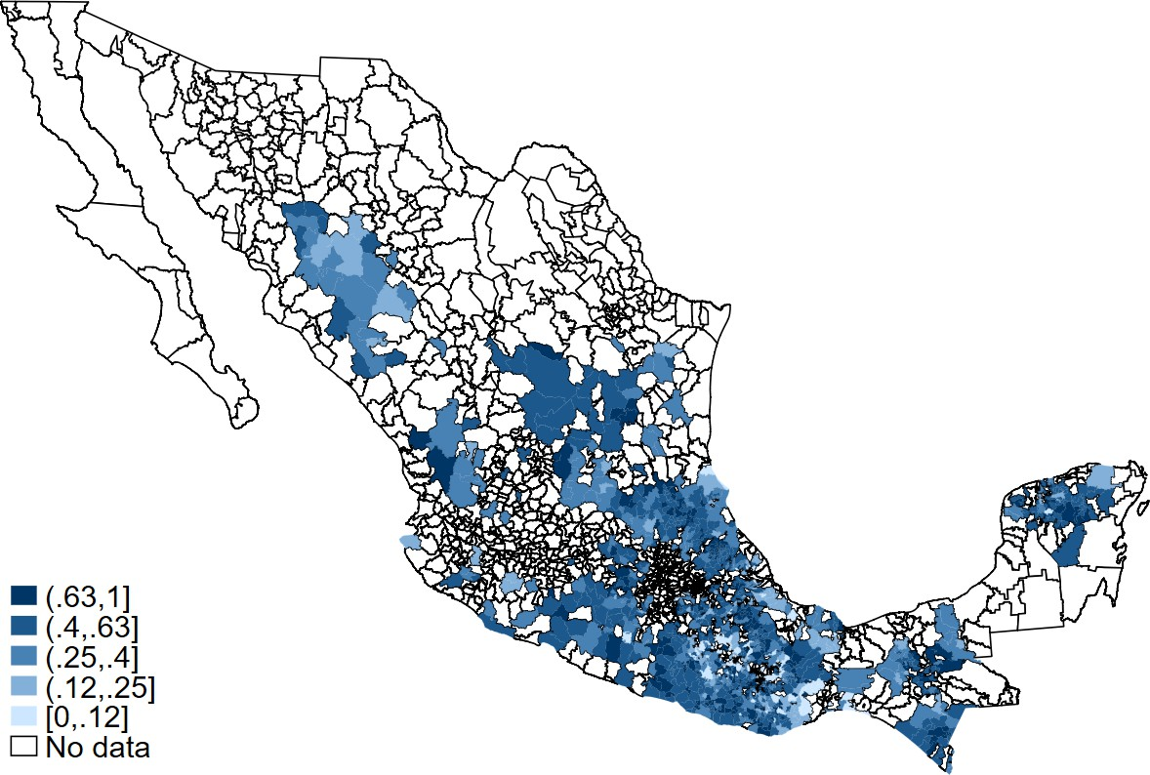
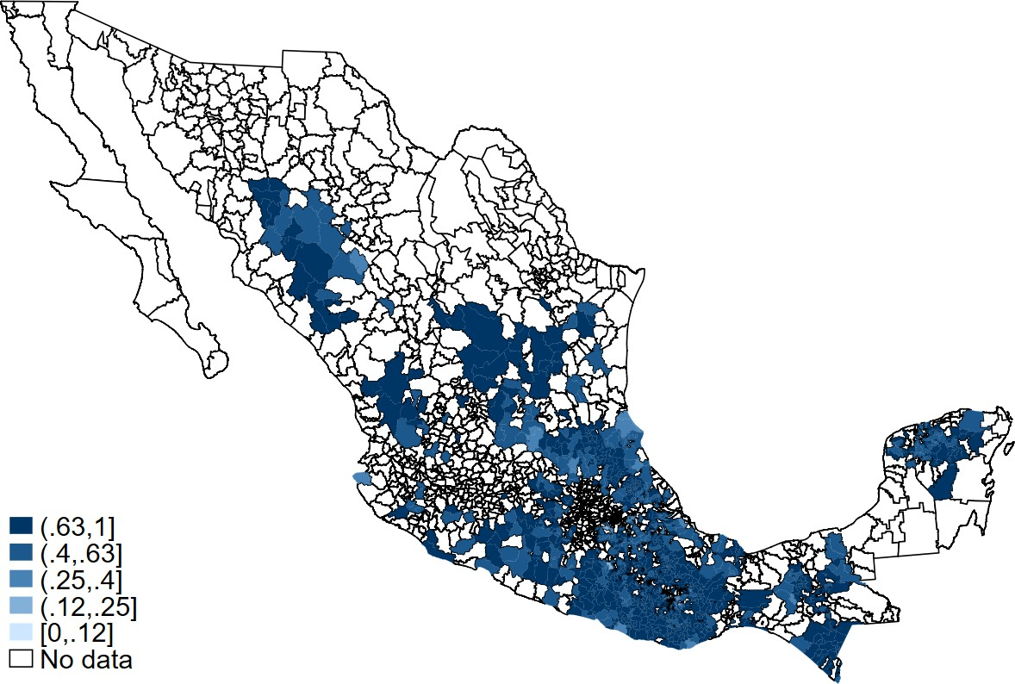
- Intensity in 1999 c. Intensity in 2005

Source: Prepared by the authors.
Note: Panel a plots the mortality rate for adults aged 65 and older—shown separately for all, male, and female—alongside Progresa intensity for highly marginalized municipalities over 1991–2006. The vertical dashed line marks 1997, the year of initial program roll-out. The left axis measures deaths per 1,000 persons aged 65 and older; the right axis measures Progresa intensity as the share of beneficiary households in total municipal households. Panels b and c display the cumulative municipality-level Progresa intensity for 1999 and 2005, respectively, among highly marginalized municipalities. Darker shading indicates higher program intensity. The sample is restricted to municipalities classified as high or very high on the 1990 Marginalization Index of the Consejo Nacional de Poblacio´n (CONAPO).

Figure 2. Event Study: Effect of Progresa Enrollment Intensity on Mortality Rate by Sex

15
Mortality rate 65+ (per 1,000 persons)

10

5

0

-5

-10

-15

-20
1991
1992
1993
1994
1995
1996
1997
1998
1999
2000
2001
2002
2003
2004
2005
2006

  - Pooled

Mortality rate 65+ (per 1,000 persons)
15
15
Mortality rate 65+ (per 1,000 persons)

10
10

5
5

0
0

-5 -5

-10

-10

-15 -15

-20 -20
1991
1992
1993
1994
1995
1996
1997
1998
1999
2000
2001
2002
2003
2004
2005
2006
1991
1992
1993
1994
1995
1996
1997
1998
1999
2000
2001
2002
2003
2004
2005
2006

  - Female c. Male

Source: Prepared by the authors.
Note: The figure shows the results obtained from estimating a difference-in-differences event-study specification. The outcome is the mortality rate for adults aged 65 and older, measured in deaths per 1,000 persons. The panels
display the interaction coefficients between Progresa intensity in 1999 and year indicators for the pooled, female, and male samples, respectively. All specifications include the Intensity2005 variable interacted with the pre- and post-period controls, but the variable is not shown because it has no stand-alone interpretation in this specification. It includes municipality
and year fixed effects, and controls for Seguro Popular intensity. Standard errors are clustered at the municipality level. The reference year is 1996. The sample is restricted to highly marginalized municipalities. Regressions are weighted by the population aged 65 and older. 95 percent confidence intervals shown.

Table 1. Summary Statistics: Marginalized and Non-Marginalized Municipalities in Mexico, Pre-Program Period

 |  |  | Highly Marginalized |  | Non-Marginalized
 |  |  | (1) |  | (2)
 | Panel A: Progresa Enrollment Intensity (percent)
 | Intensity in 1999 |  | 44.4 |  | 10.3
 |  |  | ( 21.9) |  | ( 12.7)
 | Intensity in 2005 |  | 71.7 |  | 28.5
 |  |  | ( 16.7) |  | ( 19.4)
 | Panel B: Socioeconomic Characteristics
 | Percent illiterate |  | 33.3 |  | 13.3
 |  |  | ( 13.3) |  | ( 6.6)
 | Percent without completed primary |  | 69.6 |  | 45.7
 |  |  | ( 9.7) |  | ( 12.3)
 | Percent without electricity |  | 36.4 |  | 11.8
 |  |  | ( 24.7) |  | ( 10.3)
 | Percent without piped water |  | 50.6 |  | 19.4
 |  |  | ( 24.1) |  | ( 14.9)
 | Percent with crowding |  | 74.0 |  | 59.8
 |  |  | ( 8.2) |  | ( 9.8)
 | Percent with dirt floors |  | 62.0 |  | 22.1
 |  |  | ( 21.6) |  | ( 14.2)
 | Percent without drainage |  | 60.3 |  | 25.9
 |  |  | ( 18.5) |  | ( 16.6)
 | Percent in localities <5,000 |  | 95.5 |  | 60.2
 |  |  | ( 13.5) |  | ( 36.1)
 | Percent in 2+ person households |  | 85.8 |  | 69.2
 |  |  | ( 8.6) |  | ( 11.6)
 | Municipalities |  | 1,119 |  | 1,234
Source: Prepared by the authors.
Note: Panel A reports the proportion (percent) of municipalities with Progresa beneficiaries, defined as the ratio of beneficiary households to total municipal households, with standard deviations in parentheses. Panel B presents sample means (percent) for socioeconomic characteristics, measured at the 1990 baseline (pre-program) census, with standard deviations in parentheses. Highly marginalized municipalities are those classified as high (grade 4) or very high (grade 5) on the 1990 Marginalization Index of the Consejo Nacional de Poblacio´n (CONAPO). Non-marginalized municipalities are the three remaining levels. “With crowding” is measured as the number of occupants per room.

21

Table 2. Effects of Progresa Enrollment Intensity on Older Adults’ Mortality by Sex and Age Group

Ages 65+ |  |  | Ages 65–69 |  | Ages 70+
 | (1) | (2) |  | (3) |  | (4)
Panel A: Pooled  Intensity₁₉₉₉ x Post (1997–2006) | -0.719 | 0.835 |  | 0.142 |  | -0.137
 | ( 1.464) | ( 1.487) |  | ( 1.284) |  | ( 2.032)
Mean (1991–1996) | 46.47 | 46.47 |  | 21.09 |  | 60.08
Observations | 17,904 | 17,904 |  | 17,904 |  | 17,904
Panel B: Females  Intensity₁₉₉₉ x Post (1997–2006) | 0.620 | 2.516 |  | 0.323 |  | 1.417
 | ( 1.824) | ( 1.836) |  | ( 1.566) |  | ( 2.516)
Mean (1991–1996) | 46.11 | 46.11 |  | 19.56 |  | 61.10
Observations | 17,904 | 17,904 |  | 17,821 |  | 17,821
Panel C: Males  Intensity₁₉₉₉ x Post (1997–2006) | -2.206 | -1.037 |  | -0.161 |  | -1.774
 | ( 1.735) | ( 1.773) |  | ( 1.855) |  | ( 2.402)
Mean (1991–1996) | 47.26 | 47.26 |  | 23.58 |  | 60.85
Observations | 17,904 | 17,904 |  | 17,818 |  | 17,821
Number of municipalities | 1,119 | 1,119 |  | 1,119 |  | 1,119
Socioeconomic status trend (Continuity Index) mean intensity 1999 (percent) | No 44.4 | Yes 44.4 |  | No 44.4 |  | No 44.4
Source: Prepared by the authors.
Note: The table reports difference-in-differences estimates of the effect of Progresa enrollment intensity on the mortality rate for older adults per 1,000 persons, disaggregated by age group. Columns (1) and (2) report estimates for ages 65 and older; column (2) adds a municipality-specific linear time trend interacted with the continuous 1990 Marginalization Index of the Consejo Nacional de Poblacio´n (CONAPO). Columns (3) and (4) report estimates for ages 65–69 and 70 and older, respectively.
Intensity1999 × Post captures the effect of early-phase (1997–1999) Progresa enrollment: a coefficient of one corresponds to moving from 0 to 100 percent beneficiary household coverage after 1997. Intensity2005 × Post is included in every regression as a control but is not reported, as it has no stand-alone interpretation in this specification. The post-dummy equals
one for the years 1997–2006. The sample is restricted to highly marginalized municipalities. All regressions include municipality and year fixed effects and Seguro Popular intensity, and are weighted by the population of the relevant age group. Standard errors are clustered at the municipality level and shown in parentheses. ***p < 0.01, **p < 0.05, *p < 0.1.

Table 3. Effects of Progresa on Labor Supply and Living Arrangements of Older Adults in Eligible Households

All Eligible Older Adults (65+) Older-Adults-Only Households
 | Labor |  |  | Living Arrangements |  |  | Health |  | Labor |  | Health
 | Weekly Hours |  | Live Alone | Live with Children | Only Elderly |  | Visits† |  | Weekly Hours |  | Health Visits¹
 | (1) |  | (2) | (3) | (4) |  | (5) |  | (6) |  | (7)
Panel A: Pooled  Treat × 1998 | -0.657 |  | 0.006 | -0.003 | -0.007 |  |  |  | -0.095
 | ( 1.192) |  | ( 0.006) | ( 0.009) | ( 0.007) |  |  |  | ( 2.701)
Treat × 1999 | 0.122 |  | 0.007 | 0.027* | 0.006 |  | -0.023 |  | -0.063 |  | -0.199
 | ( 1.092) |  | ( 0.009) | ( 0.016) | ( 0.013) |  | ( 0.043) |  | ( 2.733) |  | ( 0.273)
Control mean (1997)  Control mean (1999) | 14.049 |  | 0.046 | 0.693 | 0.151 |  | 0.096 |  | 13.080 |  | 0.274
Observations | 6,518 |  | 7,025 | 7,025 | 7,025 |  | 4,700 |  | 1,013 |  | 627
Panel B: Females  Treat × 1998 | 0.124 |  | 0.000 | 0.001 | -0.008 |  |  |  | -1.198
 | ( 1.136) |  | ( 0.008) | ( 0.011) | ( 0.008) |  |  |  | ( 2.539)
Treat × 1999 | 0.292 |  | 0.007 | 0.015 | 0.012 |  | 0.008 |  | -0.497 |  | 0.098
 | ( 1.070) |  | ( 0.010) | ( 0.018) | ( 0.014) |  | ( 0.027) |  | ( 2.759) |  | ( 0.135)
Control mean (1997)  Control mean (1999) | 3.923 |  | 0.044 | 0.708 | 0.145 |  | 0.090 |  | 3.529 |  | 0.178
Observations | 3,338 |  | 3,597 | 3,597 | 3,597 |  | 2,278 |  | 475 |  | 291
Panel C: Males  Treat × 1998 | -1.210 |  | 0.012 | -0.008 | -0.007 |  |  |  | 1.090
 | ( 1.895) |  | ( 0.008) | ( 0.011) | ( 0.010) |  |  |  | ( 4.409)
Treat × 1999 | 0.378 |  | 0.008 | 0.040** | -0.001 |  | -0.076 |  | -0.193 |  | -0.577
 | ( 1.872) |  | ( 0.012) | ( 0.020) | ( 0.017) |  | ( 0.103) |  | ( 4.775) |  | ( 0.585)
Control mean (1997)  Control mean (1999) | 25.288 |  | 0.049 | 0.676 | 0.159 |  | 0.105 |  | 22.912 |  | 0.367
Observations | 3,170 |  | 3,419 | 3,419 | 3,419 |  | 2,220 |  | 530 |  | 312
Source: Prepared by the authors.
Note: The table reports estimates of the short-term effect of Progresa on labor supply, living arrangements, and healthcare use of older adults aged 65 and older. In every column, the sample is restricted to eligible households and the reported coefficient compares randomized treatment to control localities; standard errors are clustered at the locality level and municipality fixed effects are included throughout. Columns (1)–(5) use the full sample of eligible older adults: column (1) reports weekly hours worked; columns (2)–(4) report living arrangement outcomes (living alone, living with children, and living only with other older adults, respectively); and column (5) reports total health facility visits in the past four weeks. Columns (6)–(7) restrict to older-adults-only households (those with no children or working-age adults present, with household composition fixed at its 1997 pre-treatment value); column (6) reports weekly hours worked and column (7) reports total health facility visits. Columns (1)–(4) and (6) are difference-in-differences estimates with 1997 as the baseline year,
reported as Treat × 1998 and Treat × 1999 against the 1997 control mean.
¹ Health facility visits (columns (5) and (7)) were not collected at baseline, so following Gertler (2000) these columns are estimated as a treatment-control cross-section rather
than a difference-in-differences: person-level records from both 1999 survey waves of the Encuesta de Evaluación de los Hogares (ENCEL) (June and November) are pooled into a single cross-section at age 65 and older, using each wave’s own contemporaneous interview age. These columns therefore report a single treatment coefficient against the 1999 control mean. ∗ p < 0.10, ∗∗ p < 0.05, ∗∗∗ p < 0.01.

Online Appendix

Figures
  - Progresa Enrollment Intensity and Mortality Rate Trends 2
  - Progresa Enrollment Intensity by Municipality Sample 3
  - Progresa Enrollment Ratio by Roll-Out Phase and Marginality Percentile: Locality
versus Municipality 4
  - Event Study: Effect of Progresa Enrollment Intensity on Older Adults’ Mortality
Rate by Sex and Socioeconomic Status Trend Specification 5
  - Event Study: Effect of Progresa Enrollment Intensity on Mortality Rate by Sex and Functional Forms 6
  - Event Study: Stability of the Early-Phase (Intensity 1999) Coefficient to the Choice
of Second-Phase Control 7
  - Event Study: Effect of Progresa Enrollment Intensity on Mortality Rate by Sex and Sample, 1992–2002 8

Tables
  - Effect of Progresa Enrollment Intensity on Older Adults’ Mortality by Age Group 9
  - Effect of Progresa Enrollment Intensity on Older Adults’ Mortality by Sex, with
  - out a Later-Phase Control 10
  - Effect of Progresa Enrollment Intensity on Older Adults’ Mortality: Functional
Form and Outcome Robustness 11
  - Effect of Progresa on Older Adults’ Mortality Rate: Replication of Barham and Rowberry (2013) 12
  - Effect of Progresa Enrollment Intensity on Older Adults’ Mortality: Sensitivity Analysis 13
  - Short-term Effects of Progresa on Household Expenditure, by Older Adult Presence
and Older-Adults-Only Household Eligibility 14

Mortality rate (65+ per 1,000 persons)
Figure A.1. Progresa Enrollment Intensity and Mortality Rate Trends



55 80
50 60
Progresa intensity (percent)
45 40
40 20

35 0
1990 1995 2000 2005
Year

Marginalized: All Marginalized: Female Marginalized: Male Non-marginalized: All Non-Marginalized: Female Non-Marginalized: Male
Intensity, marginalized (right axis) Intensity, non-Marginalized (right axis)

Source: Prepared by the authors.

Note: The figure documents trend variations in Progresa enrollment and mortality rates for older adults across all Mexican municipalities over 1991–2006. Highly marginalized municipalities are those classified as high or very high on the 1990 Marginalization Index of the Consejo Nacional de Poblacio´n (CONAPO). constructed from nine census-based indicators capturing educational attainment, housing conditions and access to basic services, low income, and residence in small localities. Non-marginalized municipalities are the three remaining levels.

Figure A.2. Progresa Enrollment Intensity by Municipality Sample
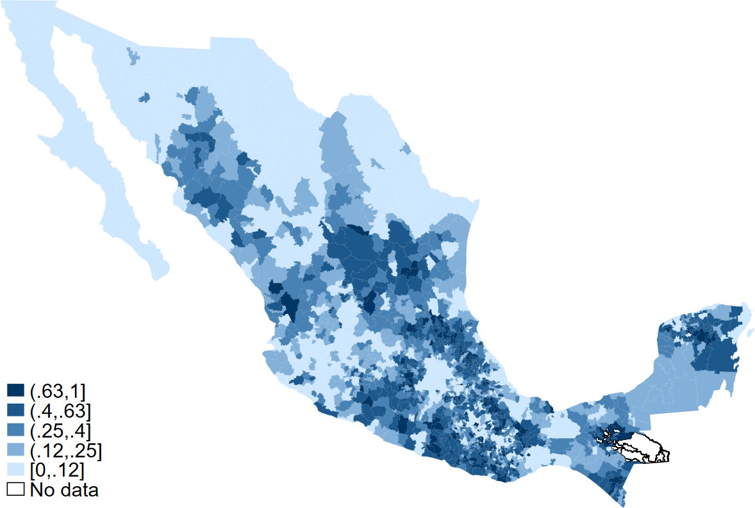
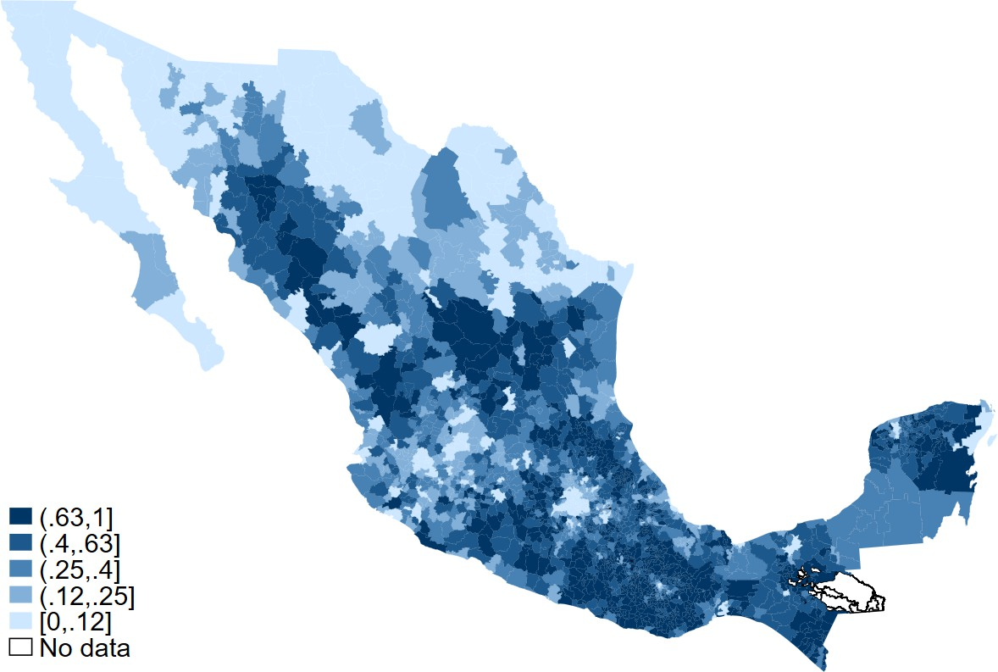
a. Intensity in 1999 - All b. Intensity in 2005 - All
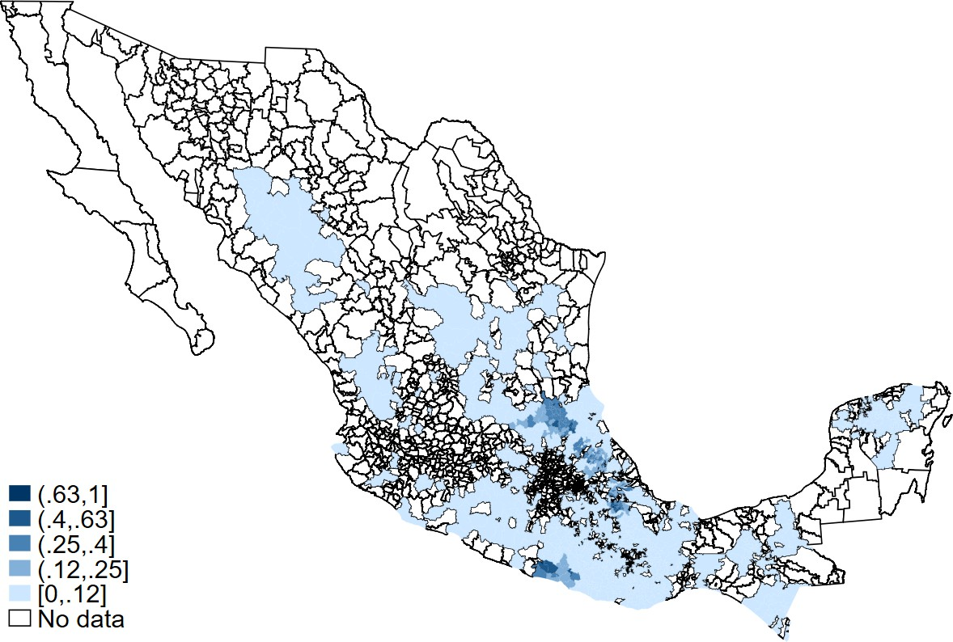
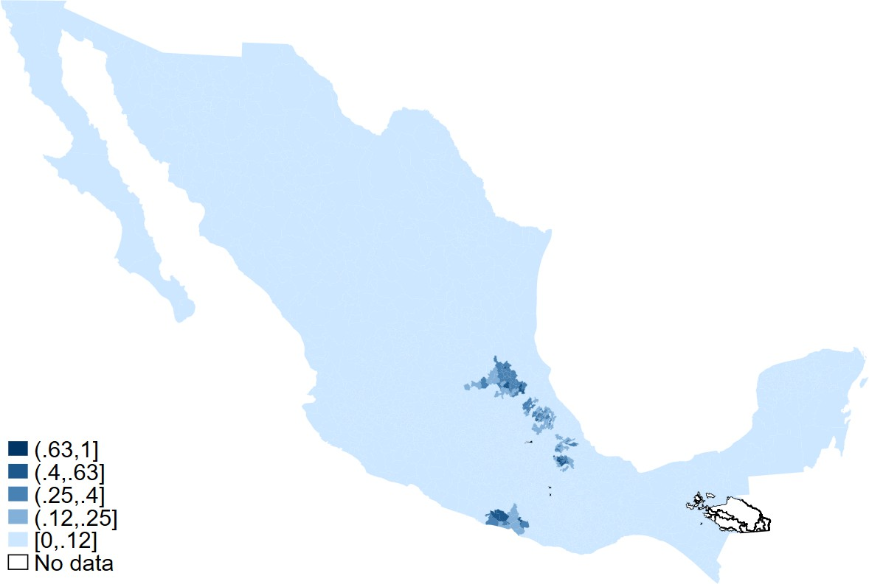
- Intensity in 1997 - Highly Marginalized d. Intensity in 1997 - All

Source: Prepared by the authors.
Note: The figure documents geographic variation in Progresa enrollment for all municipalities, complementing Figure 1 in the main text, which focuses on the highly marginalized subsample. Panels a and b map Progresa intensity across all municipalities for 1999 and 2005; panels c and d map intensity in 1997 separately for highly marginalized municipalities (the main sample) and all municipalities. Darker shading indicates higher program intensity.

Figure A.3. Progresa Enrollment Ratio by Roll-Out Phase and Marginality Percentile: Locality versus Municipality

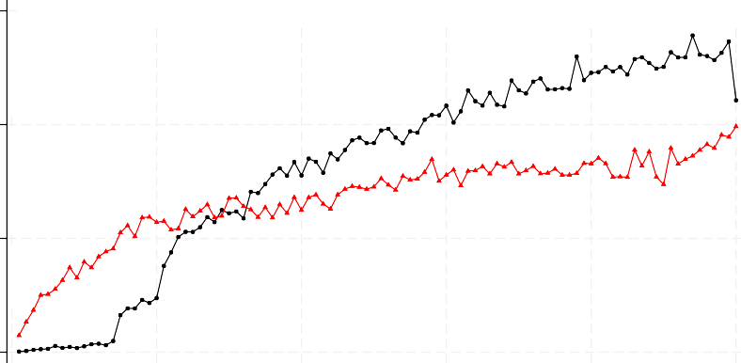
.6

.4
New enrollment ratio

.2

0
0 20 40 60 80 100
Locality marginality percentile 1997-99 2000-05

  - Locality level

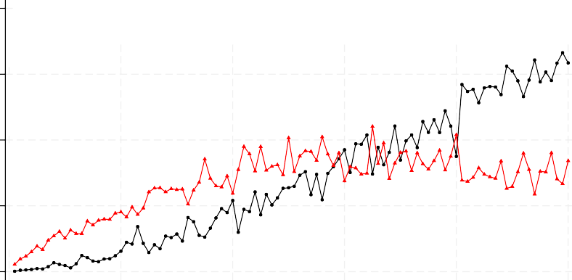
.8

.6
New enrollment ratio

.4

.2

0
0 20 40 60 80 100
Municipality marginality percentile 1997-99 2000-05

  - Municipality level

Source: Prepared by the authors.
Note: The figure shows the enrollment ratio across the marginality percentile at the locality and municipality level. The horizontal axis is a percentile rank in the national distribution of the 1995 (locality) or 1990 (municipality) Marginalization Index of the Consejo Nacional de Poblacio´n (CONAPO); each point is the mean new-enrollment ratio within a 1-point percentile bin. The black series is the early phase (1997–1999); the red series is the incremental enrollment added during the later phase (2000–2005). Both panels use all Mexican localities/municipalities (not only the highly marginalized subsample) to display the full national targeting gradient.

Figure A.4. Event Study: Effect of Progresa Enrollment Intensity on Older Adults’ Mortality Rate by Sex and Socioeconomic Status Trend Specification

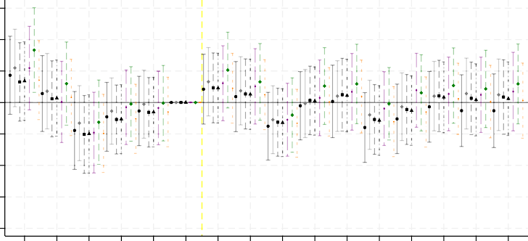
15
Mortality rate 65+ (per 1,000 persons)

10

5

0

-5

-10

-15

-20
1991
1992
1993
1994
1995
1996
1997
1998
1999
2000
2001
2002
2003
2004
2005
2006

Baseline Baseline, fixed 1997 denom. + Trend x Marg. Index (muni, linear) + Trend x Quintile (muni, linear) + Muni. marg. %-ile FE + Locality marg. %-ile shares, flexible + Locality marg. %-ile shares, linear

a. Pooled
Mortality rate 65+ (per 1,000 persons)

Mortality rate 65+ (per 1,000 persons)

15

10

5

0

-5

-10

-15

-20

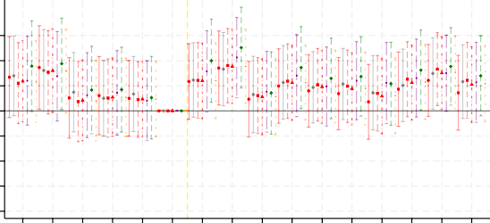
Baseline Baseline, fixed 1997 denom. + Trend x Marg. Index (muni, linear) + Trend x Quintile (muni, linear) + Muni. marg. %-ile FE + Locality marg. %-ile shares, flexible + Locality marg. %-ile shares, linear
1991
1992
1993
1994
1995
1996
1997
1998
1999
2000
2001
2002
2003
2004
2005
2006

b. Female

15

10

5

0

-5

-10

-15

-20

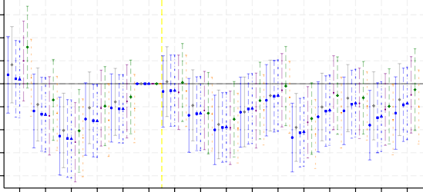
Baseline Baseline, fixed 1997 denom. + Trend x Marg. Index (muni, linear) + Trend x Quintile (muni, linear) + Muni. marg. %-ile FE + Locality marg. %-ile shares, flexible + Locality marg. %-ile shares, linear
1991
1992
1993
1994
1995
1996
1997
1998
1999
2000
2001
2002
2003
2004
2005
2006

C. Male

Source: Prepared by the authors.
Note: Panels a–c present event-study estimates of the interaction between Intensity1999 and year indicators (reference year 1996) for the pooled, female, and male older-adult (65+) mortality rate per 1,000 persons, respectively. Within each panel, seven specifications are overlaid: (i) the baseline specifications; (i-b) the same baseline but with a fixed 1997 household denominator; (ii) the baseline plus a municipality-specific linear time trend interacted with the continuous 1990 municipality Marginalization Index; (iii) the baseline plus a linear trend interacted with quintiles of the 1990 municipality Marginalization Index; (iv) the baseline plus a full set of percentile-bin indicators of the Marginalization Index (100 bins); (v) the baseline plus a locality-marginality percentile-share control—the share of each municipal-city’s population residing in localities at each percentile of the national locality-marginality distribution (five bins)—interacted with a fully flexible set of year indicators; and (vi) the same locality-marginality percentile-share control interacted with a linear year trend. All seven specifications control for Intensity2005 interaction. The vertical line marks the program’s 1997 roll-out. The sample is restricted to highly marginalized municipalities, and regressions are weighted by the population aged 65 and older. 95 percent confidence intervals shown.

Figure A.5. Event Study: Effect of Progresa Enrollment Intensity on Mortality Rate by Sex and Functional Forms

Mortality rate, 65+ (per 1,000 persons)
20

10

0

-10

-20

40
Percent change in mortality rate, 65+

20

0

-20

-40

Pooled Female Male

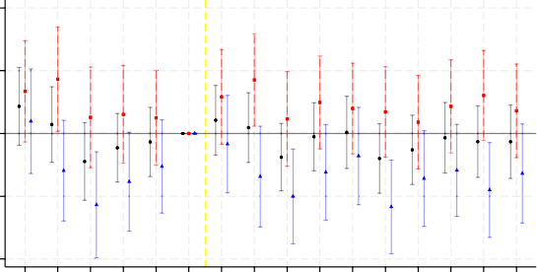
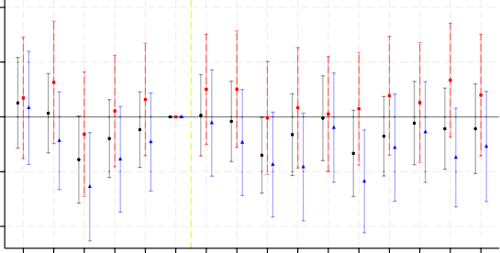
a. Levels - Weighted
1991
1992
1993
1994
1995
1996
1997
1998
1999
2000
2001
2002
2003
2004
2005
2006

Pooled Female Male
1991
1992
1993
1994
1995
1996
1997
1998
1999
2000
2001
2002
2003
2004
2005
2006

  - Logarithm

Mortality rate 65+ (per 1,000 persons)
20

10

0

-10

-20

-30

Relative change in deaths (percent)

50

0

-50

Pooled Female Male

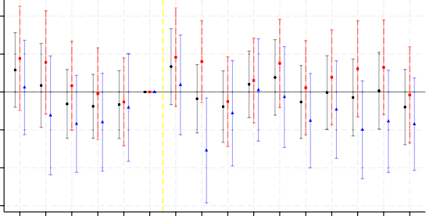
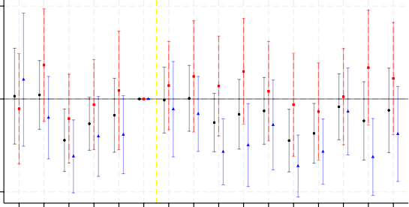
b. Levels - Unweighted
1991
1992
1993
1994
1995
1996
1997
1998
1999
2000
2001
2002
2003
2004
2005
2006

Pooled Female Male
1991
1992
1993
1994
1995
1996
1997
1998
1999
2000
2001
2002
2003
2004
2005
2006

  - Poisson

AAMR 65+ (per 1,000 persons)
20

10

0

-10

-20

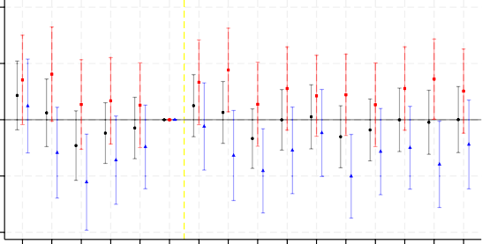
Pooled Female Male
1991
1992
1993
1994
1995
1996
1997
1998
1999
2000
2001
2002
2003
2004
2005
2006

  - AAMR

Source: Prepared by the authors.

Note: All panels display interaction coefficients between Progresa intensity in 1999, restricted to highly marginalized municipalities. 95 percent confidence intervals shown. Panel a shows the baseline specification. Panel b shows the unweighted specification. Panel c uses the natural log of the mortality rate (municipality-years with zero deaths are excluded); coefficients are multiplied by 100 and express the approximate percentage change in the mortality rate per unit increase in Progresa intensity. Panel d uses Poisson pseudo-maximum likelihood with raw death counts as the outcome; coefficients are
computed as (exp(βˆ)−1)×100 and express the percentage change in death counts per unit increase in intensity. Panel e
uses the age-adjusted mortality rate (AAMR) using each municipality’s older adult population. All specifications
include Intensity2005 and year indicators, municipality and year fixed effects, and Seguro Popular intensity controls.

Figure A.6. Event Study: Stability of the Early-Phase (Intensity 1999) Coefficient to the Choice of Second-Phase Control

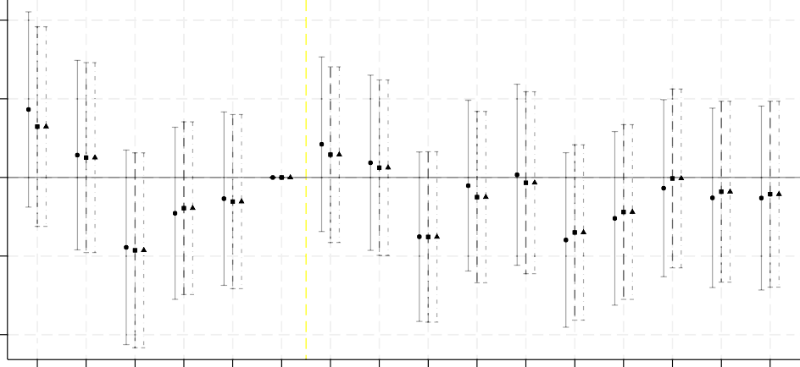
10
Mortality rate 65+ (per 1,000 persons)

5

0

-5

-10
1991
1992
1993
1994
1995
1996
1997
1998
1999
2000
2001
2002
2003
2004
2005
2006

Control: Intensity 2005 (baseline) Control: Intensity 2004
Control: Intensity 2006

Source: Prepared by the authors.
Note: The figure presents event-study estimates of the interaction between Intensity1999 and year indicators (reference year 1996) for the older-adult (65+) mortality rate per 1,000 persons, under three specifications that each add a different later-phase (cumulative enrollment) control: the baseline specification controlling for Intensity2005, and specifications replacing it with the adjacent Intensity2004 and Intensity2006 snapshots. All specifications include Seguro Popular intensity and municipality and year fixed effects, and are weighted by the population aged 65 and older. The vertical line marks the program’s 1997 roll-out. The sample is restricted to highly marginalized municipalities. 95 percent confidence intervals shown.

Figure A.7. Event Study: Effect of Progresa Enrollment Intensity on Mortality Rate by Sex and Sample, 1992–2002

Mortality rate (per 1,000 persons)
15

10

5

0

-5

-10

-15

-20

15
Mortality rate (per 1,000 persons)

10

5

0

-5

-10

-15

-20

Unweighted Weighted

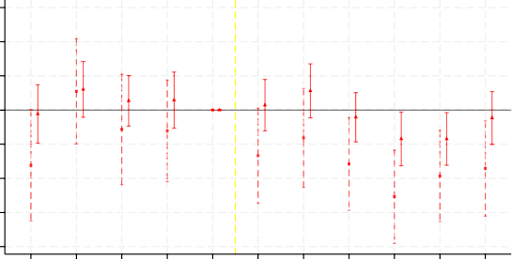
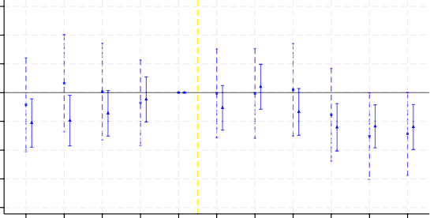
a. Phase in 1998/1999 - Females
1992
1993
1994
1995
1996
1997
1998
1999
2000
2001
2002

Unweighted Weighted
1992
1993
1994
1995
1996
1997
1998
1999
2000
2001
2002

c. Phase in 1998/1999 - Males
Mortality rate (per 1,000 persons)
15

10

5

0

-5

-10

-15

-20

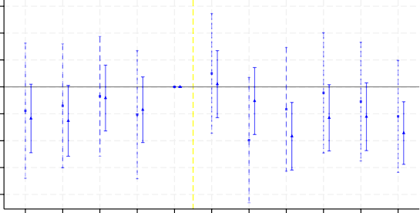
15
Mortality rate (per 1,000 persons)

10

5

0

-5

-10

-15

-20

Unweighted Weighted

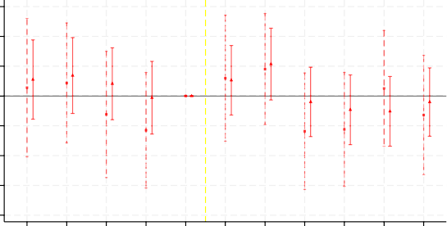
b. Highly Marginalized - Females
1992
1993
1994
1995
1996
1997
1998
1999
2000
2001
2002

Unweighted Weighted
1992
1993
1994
1995
1996
1997
1998
1999
2000
2001
2002

d. Highly Marginalized - Males

Source: Prepared by the authors.
Note: The figure compares event-study estimates across the two sample definitions used in this paper and in Barham and Rowberry (2013). Left panels (Barham and Rowberry) restrict to municipalities incorporated into Progresa in 1998 or 1999; right panels restrict to highly marginalized municipalities. All regressions include municipality and year fixed effects. The reference year is 1996 and the period is 1992–2002. 95 percent confidence intervals shown.

Table A.1. Effect of Progresa Enrollment Intensity on Older Adults’ Mortality by Age Group

 | Ages 50–64 |  | Ages 65+ |  |  | Ages 65–69 |  |  | Ages 70+
 | (1) |  | (2) |  |  | (3) |  |  | (4)
Panel A: Pooled  Intensity₁₉₉₉ x Post (1997–2006) | -0.452 |  | -0.719 |  |  | 0.142 |  |  | -0.137
 | ( 0.530) |  | ( 1.464) |  |  | ( 1.284) |  |  | ( 2.032)
Mean (1991–1996) | 10.22 |  | 46.47 |  |  | 21.09 |  |  | 60.08
Observations | 17,904 |  | 17,904 |  |  | 17,904 |  |  | 17,904
Panel B: Females  Intensity₁₉₉₉ x Post (1997–2006) | -1.069* |  | 0.620 |  |  | 0.323 |  |  | 1.417
 | ( 0.573) |  | ( 1.824) |  |  | ( 1.566) |  |  | ( 2.516)
Mean (1991–1996) | 8.39 |  | 46.11 |  |  | 19.56 |  |  | 61.10
Observations | 17,904 |  | 17,904 |  |  | 17,821 |  |  | 17,821
Panel C: Males  Intensity₁₉₉₉ x Post (1997–2006) | 0.218 |  | -2.206 |  |  | -0.161 |  |  | -1.774
 | ( 0.758) |  | ( 1.735) |  |  | ( 1.855) |  |  | ( 2.402)
Mean (1991–1996) | 12.32 |  | 47.26 |  |  | 23.58 |  |  | 60.85
Observations | 17,904 |  | 17,904 |  |  | 17,818 |  |  | 17,821
Number of municipalities  Mean intensity 1999 (percent) | 44.4 | 44.4 |  | 1,119 |  |  | 44.4 | 44.4
Source: Prepared by the authors.
Note: The table reports difference-in-differences estimates of the effect of Progresa enrollment intensity on the mortality rate for adults aged 65 and older per 1,000 persons. Columns (1)–(4) report estimates for ages 50–64, 65 and older, 65–69, and 70 and older, respectively. Intensity1999 × Post captures the effect of early-phase (1997–1999) Progresa enrollment: a coefficient of one corresponds to moving from 0 to 100 percent
beneficiary household coverage after 1997. The post-dummy equals 1 for years 1997–2006. The sample is restricted to highly marginalized municipalities. All regressions include Intensity2005 × Post, Seguro Popular intensity, and municipality and year fixed effects, and are weighted by the population of each age group of interest. Standard errors are clustered at the municipality level and shown in parentheses. ***p< 0.01, **p< 0.05,
*p< 0.1.

Table A.2. Effect of Progresa Enrollment Intensity on Older Adults’ Mortality by Sex, without a Later-Phase Control

 | Pooled |  | Female |  | Male
 | (1) |  | (2) |  | (3)
Intensity₁₉₉₉ x Post (1997–2006) | -2.255* |  | -2.466 |  | -2.095
 | ( 1.276) |  | ( 1.534) |  | ( 1.469)
Mean (1991–1996) | 46.47 |  | 46.11 |  | 47.26
Observations | 17,904 |  | 17,904 |  | 17,904
Number of municipalities | 1,119 |  | 1,119 |  | 1,119
Mean intensity 1999 (percent) | 44.4 |  | 44.4 |  | 44.4
Source: Prepared by the authors.
Note: This table reports difference-in-differences estimates of Intensity1999 × Post on the older-adult (65+) mortality rate per 1,000 persons, with no Intensity2005 × Post (or any other later-phase) control included. Columns (1)–(3) report pooled,
female, and male estimates, respectively. All regressions include municipality and year fixed effects and Seguro Popular intensity, and are weighted by the population of the relevant sex aged 65 and older. The sample is restricted to highly marginalized municipalities. Standard errors are clustered at the municipality level and shown in parentheses. ***p < 0.01, **p < 0.05, *p < 0.1.

Table A.3. Effect of Progresa Enrollment Intensity on Older Adults’ Mortality: Functional Form and Outcome Robustness

 | Levels |  | Levels (Unweighted) |  | Log |  | Poisson |  | AAMR
 | (1) |  | (2) |  | (3) |  | (4) |  | (5)
Panel A: Pooled  Intensity₁₉₉₉ x Post (1997–2006) | -0.719 |  | 0.354 |  | -1.67 |  | -2.69 |  | 0.057
 | ( 1.464) |  | ( 2.547) |  | ( 4.20) |  | ( 5.87) |  | ( 1.493)
Mean (1991 Intensity₁₉₉₉ 1996) | 46.47 |  | 46.47 |  | 3.75 |  | 23.86 |  | 46.28
Panel B: Females  Intensity₁₉₉₉ x Post (1997–2006) | 0.620 |  | 1.668 |  | 2.74 |  | 5.92 |  | 1.395
 | ( 1.824) |  | ( 2.928) |  | ( 5.49) |  | ( 7.46) |  | ( 1.850)
Mean (1991–1996) | 46.11 |  | 46.11 |  | 3.73 |  | 11.61 |  | 46.50
Panel C: Males  Intensity₁₉₉₉ x Post (1997–2006) | -2.206 |  | -1.588 |  | -2.52 |  | -10.02 |  | -1.362
 | ( 1.735) |  | ( 2.776) |  | ( 5.05) |  | ( 6.30) |  | ( 1.759)
Mean (1991–1996) | 47.26 |  | 47.26 |  | 3.78 |  | 12.25 |  | 47.50
Observations | 17,904 |  | 17,904 |  | 17,223 |  | 17,904 |  | 17,821
Number of municipalities | 1,119 |  | 1,119 |  | 1,119 |  | 1,119 |  | 1,119
Mean intensity 1999 (percent) | 44.4 |  | 44.4 |  | 44.4 |  | 44.4 |  | 44.4
Source: Prepared by the authors.
Note: The table assesses robustness of the main difference-in-differences estimates to functional form and outcome definition. Column (1) reports the baseline specification using the mortality rate in levels (weighted). Column (2) is the unweighted baseline specification. Column (3) uses the natural log of the mortality rate; reported coefficients are multiplied by 100 and express the approximate percentage change in the mortality rate per unit increase in Progresa intensity. Column (4) uses Poisson pseudo-maximum likelihood with raw death counts as the outcome
and population weights; reported coefficients are computed as (exp(βˆ) − 1) × 100 and express the percentage
change in death counts per unit increase in intensity. Column (5) replaces the mortality rate with the age-
adjusted mortality rate (AAMR), which directly standardizes for the age structure of each municipality’s older adult population. All specifications include Seguro Popular intensity and municipality and year fixed effects, and are weighted by the population aged 65 and older. The sample is restricted to highly marginalized municipalities. Standard errors are clustered at the municipality level. ***p < 0.01, **p < 0.05, *p < 0.1.

Table A.4. Effect of Progresa on Older Adults’ Mortality Rate: Replication of Barham and Rowberry (2013)

 |  |  | Pooled |  | Females |  | Males
 |  |  | (1) |  | (2) |  | (3)
 | Panel A: Barham and Rowberry (2013)
 | Two-year lagged intensity |  | -6.37*** (1.04) |  | -6.46*** (1.31) |  | -6.42*** (1.42)
 | Mean 1996 |  | 47.5 |  | 46.0 |  | 49.3
 | Observations |  | 21,571 |  | 21,571 |  | 21,571
 | Number of municipalities |  | 1,961 |  | 1,961 |  | 1,961
 | Panel B: Replication (unweighted)
 | Two-year lagged intensity |  | -7.061*** ( 1.256) |  | -7.426*** ( 1.559) |  | -6.889*** ( 1.711)
 | Panel C: Replication (weighted)
 | Two-year lagged intensity |  | -3.740*** ( 0.786) |  | -4.210*** ( 1.002) |  | -3.322*** ( 0.935)
 | Panel D: Three-year Lag (weighted)
 | Three-year lagged intensity |  | -2.071*** ( 0.772) |  | -1.830* ( 0.960) |  | -2.357** ( 0.957)
 | Panel E: One-year Lag (weighted)
 | One-year lagged intensity |  | -3.457*** ( 0.890) |  | -4.255*** ( 1.043) |  | -2.681** ( 1.072)
 | Mean 1996 |  | 48.16 |  | 47.49 |  | 48.87
 | Observations |  | 15,642 |  | 15,642 |  | 15,642
 | Number of municipalities |  | 1,422 |  | 1,422 |  | 1,422
 | Mean intensity 1999 (percent) |  | 31.6 |  | 31.6 |  | 31.6
Source: Prepared by the authors.
Note: The table replicates the main specification of Barham and Rowberry (2013) using the same sample (municipalities incorporated into Progresa in 1998 or 1999) and the same estimating equation (two-year lagged intensity, no post-interaction). The outcome is the mortality rate for adults aged 65 and older per 1,000 persons. Panel A reproduces their original unweighted estimate using a two-year lagged intensity variable and the Barham and Rowberry sample (municipalities incorporated in 1998 or 1999). Panel B reports our close replication. Panel C adds population weight. Panel D replaces the two-year lag with a three-year lag. Panel E replaces it with a one-year lag instead, as an additional sensitivity check. All regressions include municipality and year fixed effects. Standard errors are clustered at the municipality level and shown in parentheses. ***p < 0.01, **p < 0.05, *p < 0.1.

Table A.5. Effect of Progresa Enrollment Intensity on Older Adults’ Mortality: Sensitivity Analysis

 | Barham and Rowberry (2023) Sample |  |  |  | High Marginalization
 | Unweighted | Weighted |  |  | Unweighted | Weighted
 | (1) | (2) |  |  | (3) | (4)
Panel A: Pooled Intensity₁₉₉₉ x Post | -3.974*** |  | -1.660** |  | 0.225 |  | -1.563
 | ( 1.214) |  | ( 0.807) |  | ( 2.107) |  | ( 1.261)
Mean (1991–1996) | 47.45 |  | 47.45 |  | 46.65 |  | 46.65
Observations | 15,642 |  | 15,642 |  | 12,309 |  | 12,309
Number of municipalities | 1,422 |  | 1,422 |  | 1,119 |  | 1,119
Panel B: Females Intensity₁₉₉₉ x Post | -6.016*** |  | -2.343** |  | 0.063 |  | -1.492
 | ( 1.599) |  | ( 1.008) |  | ( 2.458) |  | ( 1.523)
Mean (1991–1996) | 46.69 |  | 46.69 |  | 46.45 |  | 46.45
Observations | 15,642 |  | 15,642 |  | 12,309 |  | 12,309
Number of municipalities | 1,422 |  | 1,422 |  | 1,119 |  | 1,119
Panel C: Males Intensity₁₉₉₉ x Post | -2.609 |  | -1.002 |  | -0.509 |  | -1.722
 | ( 1.681) |  | ( 1.032) |  | ( 2.621) |  | ( 1.579)
Mean (1991–1996) | 48.49 |  | 48.49 |  | 47.28 |  | 47.28
Observations | 15,642 |  | 15,642 |  | 12,309 |  | 12,309
Number of municipalities | 1,422 |  | 1,422 |  | 1,119 |  | 1,119
Mean intensity 1999, end-of-year (percent) | 31.6 |  |  |  | 44.4
Source: Prepared by the authors.
Note: The table applies the interaction design of equation (4) to both the Barham-Rowberry (2023) sample and the full highly marginalized sample, using Intensity1999 × Post as the treatment variable over a 1992–2002 window. The outcome is the mortality rate for adults aged 65 and older per 1,000 persons. Columns (1)/(3) and (2)/(4) report
unweighted and weighted estimates for the Barham-Rowberry and full highly marginalized samples, respectively. Panel A reports pooled estimates; panel B reports estimates for females; panel C reports estimates for males. All regressions include municipality and year fixed effects and Seguro Popular intensity controls. Standard errors are clustered at the municipality level and shown in parentheses. ***p < 0.01, **p < 0.05, *p < 0.1.

Table A.6. Short-term Effects of Progresa on Household Expenditure, by Older Adult Presence and Older-Adults-Only Household Eligibility

Food Health

 |  |  | Log |  | Share (percent) |  | Log |  | Share (percent)
 |  |  | (1) |  | (2) |  | (3) |  | (4)
 | Panel A: Elderly Presence
 | Treatment × 1999 (no elderly) |  | 0.121*** |  | -0.014 |  | 0.039 |  | 0.000
 |  |  | ( 0.026) |  | ( 0.014) |  | ( 0.062) |  | ( 0.005)
 | Differential (elderly households) |  | 0.007 |  | 0.021 |  | -0.012 |  | 0.004
 |  |  | ( 0.035) |  | ( 0.017) |  | ( 0.115) |  | ( 0.011)
 | Control mean (1998) |  | 4.668 |  | 0.757 |  | 0.744 |  | 0.053
 | Observations |  | 22,524 |  | 22,478 |  | 22,763 |  | 22,489
 | Panel B: Older-Adults-Only Household
 | Treatment × 1999 (ineligible) |  | -0.004 |  | 0.018 |  | -0.123 |  | -0.018
 |  |  | ( 0.055) |  | ( 0.026) |  | ( 0.189) |  | ( 0.022)
 | Differential (eligible) |  | 0.199 |  | -0.001 |  | -0.214 |  | -0.004
 |  |  | ( 0.127) |  | ( 0.053) |  | ( 0.370) |  | ( 0.045)
 | Control mean (1998) |  | 4.250 |  | 0.874 |  | 0.861 |  | 0.088
 | Observations |  | 2,307 |  | 2,297 |  | 2,452 |  | 2,297
Source: Prepared by the authors.
Note: The table reports difference-in-differences estimates of the effect of randomized assignment to Progresa on household expenditure, with 1998 as the baseline year (the 1997 baseline round is dropped prior to estimation, so the reported coefficient is Treatment × 1999 against the 1998 control mean). Columns (1)–(2) report the log of household food expenditure and food’s share of total household expenditure; columns (3)–(4) report the same for expenditure on medicine. Panel A restricts the sample to eligible households and reports the differential effect by whether a household had an older adult member (aged 65 or older) present at the 1997 baseline: the first row is the treatment effect for households without an older adult member, and the second row is the differential effect for households with one (i.e., the triple-interaction coefficient). Panel B restricts the sample to older-adults-only households (no children or working-age adults present, with household composition fixed at its 1997 pre-treatment value) and instead differentiates by household eligibility, since only eligible households received the direct food transfer (apoyo alimentario): the first row is the treatment effect for ineligible older-adults-only households, and the second row is the differential effect for eligible ones. All regressions include municipality and year fixed effects. Standard errors are clustered at the locality level and shown in parentheses. ***p < 0.01, **p < 0.05, *p < 0.1.

Sustained declines in fertility rates shrink the share of younger cohorts entering the population, while life expectancy gains keep older cohorts alive longer.
By comparison, adults aged 65 and older represent approximately 18 percent of the population on average in member countries of the Organisation for Economic Co-operation and Development (OECD, 2024), yet their income poverty rate—measured as the share living below half the national median income—stands at around 15 percent (OECD, 2024).
de Chaisemartin and D’Haultfœuille (2026) develop a continuous-treatment estimator that avoids this problem by comparing municipalities whose intensity changes from year to year (“switchers”) to municipalities whose intensity is flat (“stayers”). In our setting, treatment intensity rises across nearly all highly marginalized municipalities throughout the study period, leaving few stayers to serve as valid controls.
Our results are unchanged when 2006 is excluded.
INEGI derives mortality data from the certification system of the Mexican Ministry of Public Health. Mexico generally maintains high-quality vital statistics (Mahapatra et al., 2007; Mikkelsen et al., 2015).
The program had a staggered roll-out across municipalities beginning in May 2002 and reached 84 percent municipal coverage by 2006. However, significant proportions of the eligible population remained unenrolled throughout the period studied here.
Both measures are cumulative, so Intensity1999 and Intensity2005 are mechanically positively correlated in levels: their correlation in the sample is 0.61, weighting by the older adult population.
Our specification differs from Parker and Vogl (2023) by differentiating effects by year instead of pre-program year.
Early-phase intensity is therefore negatively related to the later-phase increment, and omitting the late-phase control would conflate overall program intensity with the timing of exposure that drives our identification.
Appendix Figure A.2 together with Figure 1 show a similar pattern between the intensities of highly marginalized municipalities and all municipalities, and they confirm that mostly highly marginalized municipalities were targeted during the early phase, as shown by the darker areas. Panels c and d of Appendix Figure A.2 show that there is not enough variation in 1997, given the program was still being rolled out, and that there is the need to focus on the 1997–1999 period in order to capture the initial roll-out.
See Parker and Vogl (2023) for more analysis on differences between locality and municipality-level intensities.
CONAPO (1993) classifies all municipalities into five categories ranging from very high marginality to very low marginality using an index constructed from nine census-based indicators capturing educational attainment, housing conditions, access to basic services, low income, and residence in small localities.
Recent developments in difference-in-differences estimators with staggered adoption using continuous time- varying treatment intensity (de Chaisemartin and D’Haultfœuille, 2026) allow us to compare municipalities whose intensity changes from year to year (“switchers”) to municipalities whose intensity is flat (“stayers”). In our setting, treatment intensity keeps rising across nearly all municipalities throughout the study period, leaving few stayers to serve as valid controls. In our design, treatment timing is common across all municipalities, so we do not compare already-treated to newly treated units, preventing forbidden comparisons (Callaway and Sant’Anna, 2021; Sun and Abraham, 2021; de Chaisemartin and D’Haultfœuille, 2020).
Because treatment is measured as municipality-level enrollment intensity rather than household-level receipt, β₀ is an intent-to-treat effect.
Chen and Roth (2024) formalize the problems that arise when taking logs in the presence of zeros and recommend count-based alternatives. This is addressed in the Appendix by estimating the same specification using raw death counts (Poisson regression) and log-transformed outcomes. Both yield qualitatively similar results to the level specification.
We do not report β₁ (Intensity2005 × Post) because it is not a causally interpretable parameter but rather a control.
Appendix Table A.1 extends the analysis to adjacent age groups and alternative age ranges, with similar findings.
Appendix Table A.2 present results using no later-phase control. The pooled results are the only significant ones, but at the 10 percent level, consistent with the null findings in our main specification.
Appendix Figure A.5 presents the corresponding event-study estimates. The pre- and post-period patterns are qualitatively similar to the baseline-level specification in all cases. Panel b shows that the unweighted event study is considerably noisier, as expected when the smallest and most volatile municipalities receive full weight, but its shape and sign track the weighted profile, and it shows no post-program decline.
Replication databases were not yet published for Journal of Development Economics articles in 2013 when the Barham and Rowberry study was published.
We also test whether our main specification is robust to the use of a fixed pre-program number of households as the denominator for the intensity of treatment, and thus address potential effects the program would have had on household counts. No evidence was found that would change our conclusions, and we maintain the time-varying denominator comparable to that used by Barham and Rowberry (2013), and in order to maintain internal consistency with the time-varying population denominator in the mortality rate.
Barham and Rowberry (2013) tested pre-trends by showing that pre-program (1992–1997) mortality levels were similar year by year between municipalities phased into Progresa in 1998 versus 1999—their preferred comparison sample. As a further check, they also report that lagging the dependent variable, three years yields a small and insignificant effect.
Using a constant-hazard (exponential) survival approximation: e₆₅ = 1/µ, where µ is the annual mortality rate. Against the pre-program mean of 47.45 deaths per 1,000 persons (µ ≈ 0.0475) in the Barham-Rowberry sample, baseline life expectancy at 65 is 1/0.0475 ≈ 21.1 years. Evaluated at that sample’s mean early-phase intensity of 31.6 percent, the −1.660 estimate implies a new rate of ≈ 0.0469, yielding e₆₅ ≈ 21.3 years—a gain of approximately 0.24 years, or 0.76 years at full intensity.
Our design has sufficient power to detect meaningful effects. At 80 percent power and two-sided 5 percent significance (MDE = 2.80 × S E), the pooled specification (Table 2, column (1); S E = 1.464) can detect effects as small as 4.10 deaths per 1,000 persons, which clears the original unweighted estimates of Barham and Rowberry (2013) of −6.37. Our null is therefore informative against the originally reported magnitude of Barham and Rowberry rather than a power artifact.
Because use was not asked about at baseline, column (5) follows Gertler (2000) and is estimated as a treatment-control cross-section pooling the two 1999 survey waves rather than as a difference-in-differences.
Difference-in-differences models using ENIGH waves from 1992 to 2006 are used to exploit variation in Progresa enrollment intensity across municipalities, following the same two-phase interaction design as in equation (1). Outcome variables include individual labor income, household food expenditure by category, and health spending.
Results not shown but available upon request to the authors.

