DaCHS for LIFE
Detailed Table of Contents
1 Motivation 1
2 GAVO DaCHS 1
2.1 Machine Requirement 2
2.2 Installation 2
2.3 DaCHS Basics 3
2.4 Database hosting 10
3 LIFE database design 10
3.1 Deriving database requirements 10
3.2 Data Model draft 12
3.3 Write Queries 18
3.4 Normalize 21
3.5 Denormalize 23
3.6 Ask for Feedback 23
4 LIFE Database implementation using DaCHS 23
4.1 LIFE prototype database 24
4.2 LIFE database full implementation 43
5 Meetings 45
5.1 Migration Planning 45
6 Open Questions 46
7 Appendix 47
7.1 Gavo feedback 47
7.2 Encountered Virtual Box challenges 47
7.3 DaCHS Debugging 49
7.4 Failed Ubuntu DaCHS implementation 50
7.5 Learn through looking at functional DaCHS databases 52
7.6 Outdated data model design 54

Motivation
Implementing a relational database with VO compatible software to ensure that the FAIR principles are met. At the IVOA webpage a list of vo compatible software is shown. They recommend DaCHS for database creation. ... at leas I thought they did, now I can't find it. ... hö and I thought uwe recommended dachs to me but cant find that email either...sind auch hauptsächlich von mir gesendete, habe ich die von ihm gelöscht? habe einige emails gefunden aber nicht dieses welches ich suchte.

GAVO DaCHS
DaCHS (acronym for Data Center Helper Suite and happens to mean “badger” in German) is a suite for publishing astronomical data to the virtual observatory (VO). It also supports services operated through the web browser. By creating a RD document as described in the tutorial at http://vo.ari.uni-heidelberg.de/docs/DaCHS/tutorial.pdf you can create the vo compatible database with the data model structure you want, ingest input data into that database and create a web interface for the database. The data itself and the database will be saved on the server you installed DaCHS on. For DaCHS to work you need a debian like OS with apt/dpkg and not rpm, the data you want to ingest into your database and an idea how the structure of your database should be.

Machine Requirement
The database will be hosted on a server. The development of the database will be easier done on a personal computer. Using a version control tool like github one can then easily connect those two systems. The storage and processing power of the server don't need to be big as my database of <1'000'000 rows is considered small.
I currently develop the code on my personal laptop where I use my ubuntu host for programming the code and a virtual debian for running the prototype database.

On ubuntu host
As my host computer is an Ubuntu and the installation tutorial specifically mentioned this as a option, though not the best one, I tried installation there. It turned out, however, that this is no longer the case as they don't provide the specific postgres package required for DaCHS. For more details on my try to implement DaCHS on Ubuntu you can find it in the Appendix.

On a virtual debian
First you need to get a software enabling virtual machines. I used virtualbox. I faced some challenges here (getting guest additions working, update failure due to disk space too full, forgot root password, sudo confusion sudo: https://forums.debian.net/viewtopic.php?t=122335). The one that finally worked was from osboxes. It provides ready to use free Unix/Linux virtual machines, so anyone can easily download and use it regardless of host OS. https://www.osboxes.org/debian/
I downloaded debian 11 bullseye, virtualbox, desktop images, 64bit.

Installation
sudo apt install gavodachs2-server

Note: I got some warning during dachs installation about home directory /nonexistent markus sais those are harmless and he will remove it so that people don't get annoyed anymore.

Some Debian distributions do not have the "release" (newest stable) part of DaCHS so there you need to manually add the DaCHS repository through:

- cd /etc/apt/trusted.gpg.d
- curl https://docs.g-vo.org/archive-key.asc | sudo tee gavo-archive.key.asc
- add the line to your /etc/apt/sources.list: deb http://vo.ari.uni-heidelberg.de/debian release main
- sudo apt update
- sudo apt upgrade

DaCHS Basics
There are multiple sources of information for DaCHS. A tutorial is available online at http://docs.g-vo.org/DaCHS/tutorial.html and can be downloaded as a pdf at https://vo.ari.uni-heidelberg.de/docs/DaCHS/tutorial.pdf. General information about DaCHS can be found at https://dachs-doc.readthedocs.io/index.html# and the explanation for individual rd elements and attributes at https://docs.g-vo.org/DaCHS/ref.html#. For a more technical view look at https://vo.ari.uni-heidelberg.de/docs/DaCHS/apidoc/gavo.rscdef.tabledef-module.html. For specific questions regarding DaCHS either contact (gavo@ari.uni-heidelberg.de), mumble (https://telco.g-vo.org/mumble-web) oder dachs support email list (http://lists.g-vo.org/cgi-bin/mailman/listinfo/dachs-support). Examples on the use of different elements and attributes can be found at http://docs.g-vo.org/DaCHS/elemref.html.

In person tutorial with Markus
I first had a short videoconference with Markus where he showed me how to work with DaCHS. For that I needed a debian environment, example data and external access for Markus. For the last part there are two options, ssh or shared screen via zoom (tunneling). I tried to get ssh working but could not manage it in time.
Markus recommended me
- to look at hsoy (hsoy is catalog combination of ppmxl and gaia dr1) and ppmxl catalogs as he did something similar there. Wenn ich kataloge wie sql zusammenfüge soll ich statement als dokumentation einfügen
- empfihlt tabellen in topcat zusammen zu suchen und dann einlesen in dachs
- benutze gencol in dachs um metadata zu erhalten, ist meist aber nicht vollständig, ist glaube ich auch auf nur auf dachs beta
- dachs info zum fehler suchen
- publish as soon as possible
- benutze skript sql editor, damit nicht zu lange kommandos z.b. vim zm.sql oder psql. danach einfach einlesen mittels psql gavo < zw.sql

DaCHS pdf tutorial
As I had to set up DaCHS on the new virtual machine I needed to go through the tutorial again. This time I used the provided one in the documentation pdf. Here is a summary:

- Using the right user account. Do everything needing sudo permissions as root and everything else using a non privileged user e.g. dachsroot. Don't try sudo in dachsroot as I don't know the password for it.
- Preparing the resource directory
  - in /var/gavo/inputs create new directory mkdir arihip
  - If needed, install subversions (sudo apt install subversions)
  - in there (cd arihip) download RD: curl -O http://svn.ari.uni-heidelberg.de/svn/gavo/hdinputs/arihip/q.rd
  - create folder for data (mkdir data)
  - in there (cd data) download tutorial data: curl -O http://dc.g-vo.org/arihip/q/cone/static/data.txt.gz
- In arihip folder create the catalog: dachs imp q
- look at catalog
  - dachs info arihip/q#main
  - (careful, not working in my dachs version) dachs limits q
  - stop previous service: service dachs stop (or if this does not work use /usr/sbin/service dachs stop)
  - then open new service: dachs serve debug (do it from dachs user to reduce permission errors later e.g. sudo -u dachsroot bash)
    - web: http://localhost:8080/arihip/q/cone/form and more detail in http://localhost:8080/browse/arihip/q
    - topcat: http://localhost:8080/tap for tap and
  - updating service: close web (ctr+c in terminal) and topcat, do service dachs stop and then dachs serve debug
open questions/remarks:
- what does shipped n/m mean?
- Tutorial sais I can use shorter url if I add arihip/q/cone/form ARIHIP to /gavo/etc/vanitynames.txt but ther is no file like that
- some issues with using dachsroot as unprivileged account because sometimes the root pwd is not enough and I don't know the one of this account

Syntax

RD and its areas
The resource descriptor (RD)
The rd document is written in xml and tells DaCHS how to create your database from the given input. The different parts of the RD are the catalog metadata, the table definition, the data ingestion, table creation, the service and the regression tests.
If you want to create an rd from scratch use dachs start template (e.g. dachs start scs) and vim (sudo apt install vim, in .vimrc put lines...to get editor to help you, that way by pressing F8 and G9 it will send you to the right place. first create vimrc (touch .vimrc , put stuff in then :w and then :source ~/.vimrc )).

xml looks hierarchical, won't that be a problem if I want to have a relational database and no hierarchical one? multiple tables are all on the same hierarchy so I can have it relational in there.

rd formatting: nicht mehr als 80 zeichen dann umbruch (einfacher zu lesen und besser für versionskontrolle), urls aber nicht umbrechen
foreign keys zusammen mit primary oben da globale eigenschaften

syntax
- comment out parts in rd not filled in yet with <macDef name="todo"><![CDATA[ at the start of the ignored area and ]]></macDef> at its end or just use <!-- text -->.
- element syntax: equivalent statements
  - <element variable="..."> ... </element>
  - <element variable="..." ... />
referencing in dachs
/ is reference for parent directory before symbol and direktory or file name after it e.g. myres/q
# is reference from file name to table e.g. q#main
. is to reference a child in the first part with name last part. e.g. main.ra
if referencing inside a rd you can leave the rd file name out e.g. main.ra instead of myres/q#main.ra
//built-in RD e.g. //tap is built in TAP RD. To inspect built-in rd use command dachs adm dumpDF //tap

Table Definition
stream instead of table: like loop an active tag replacing things inside the rd
procDef used some times to define stuff look up? definition of a procedure

To make sure the table only contains controlled vocabulary add the following lines to the column definition:
<values>
<option>term1</option>
<option>term2</option>
...
</values>

limiting input data: for the dachs parameters / data I would like to append more metadata e.g. value min, value max, progenitor, .. oh I can actually in the element param have a values element for this purpose. ah and I can also have an element meta in there. what exactly is descirbed in this document https://www.ivoa.net/documents/RM/20070302/REC-RM-1.12-20070302.html which also has a section for curation metadata (publisher, creator, ...)

foreign keys: <foreignKey dest="object_id" source="object_idref" inTable="object" />
most usual issue is that dest and source are exchanged.

type
type (a type name; the internal type system is similar to SQL's with some restrictions and extensions. The known atomic types include: smallint, integer, bigint, real, boolean, double precision, text, char, unicode, date, timestamp, time, spoint, scircle, spoly, sbox, smoc, bytea, raw, file, box, vexpr-mjd, vexpr-string, vexpr- float, vexpr-date, pql-string, pql-float, pql-int, pql-date, pql- upload, int4range; defaults to 'real') -- datatype for the column (SQL-like type system)

null values should be defined whenever a parameter is not required
<column name="n_obs" type="integer"
description="Number of
observations, NULL if interpolated data">
<values nullLiteral="-1"/>
</column>
nullLiteral needs to be of specified type
nullLiteral (unicode string; defaults to None) -- An appropriate value representing a NULL for this column in VOTables and similar places. You usually should only set it for integer types and chars. Note that rowmakers make no use of this nullLiteral, i.e., you can and should choose null values independently of your source. Again, for reals, floats and (mostly) text you probably do not want to do this.

Data ingestion
first you give a name to each different input element you make.
<data id="import_star_data">
this is what dachs imp does. if you use dachs imp --help you can see ways to only ingest some of the elements.

then you add the path to the data files.
<sources>data/simbad_main_id.fits</sources>
if you use multiple sources write
<sources>
<pattern>inp2/*.txt</pattern>
<pattern>inp1/*.txt</pattern>
</sources>

then you define the grammar they are in
<columnGrammar> for fixed width text files.
<csvGrammar> for csv files
<fitsTableGrammar> for fits files.
maybe even VOTableGrammar
You can also use direct grammars for boosters. those are for ingestion of million of rows or hundreds of columns. they use C code. see more at https://docs.g-vo.org/DaCHS/booster.html

then comes the make environment.
<make table="main">
the make brings together a table as defined in the rd with a recipe for how to fill it from the output of the grammar (called row maker). the output of grammars and thus the input to a make is a mapping from names to strings (called rawdicts).

rowmaker takes this string input and converts it into typed values (i.e. integers,...), this is called rowdict. rowmaker takes grammar output, creates rawdict and then rowdicts. rowmaker first binds var names, then applies procedures and finally performs the mappings. specific romaker functions at https://dachs-doc.readthedocs.io/ref.html#predefined-macros.
rowmaker has three kinds of children: var, map and apply

var: assignments of expression values names in the rawdict. var generates additional values in the rawdicts. So even if I have no identifiers at the start I can generate them there.
  - examples:
    - <var name="paramname">hmsToDeg(@alphaHMS, None)</var>. I think this means for the in table defined column paramname change unit of in rawdict. column alphaHMS from hms to deg and change null value into none.
    - timestamp example: <var name="processedOn">datetime.datetime.now()</var>
  - variables: name and python expression
  - children:
    - key: name of the column the value is to end up in.
    - nullExcs: Exceptions that should be caught and cause the value to be NULL, separated by commas.
    - nullExpr: python expression for a value to be mapped to null.
    - source: source key name to convert to column value (either a grammar key or a var.
what is the difference between key and name?

map: mapping expressions to values. xml suffices for simple cases, but python allowed. map changes values in the rowdict.
  - examples:
    - <map dest="star_id" src="oid"/> means the column specified as star_id should be filled with the source column called oid.
    - timestamp example: time stamp: <map dest="dateIngested">datetime.datetime.now()</map>
    - null values dealing:
      - <map dest="plx_source_idref" src="plx_source_idref" nullExpr="0" />
      - <map dest="radius">parseWithNull(@rdisk_bb,float,"None")</map>
procedure applications: manipulation using python code
examples: apply procDef bind
                - <apply procDef="//procs#dictMap">
<bind key="mapping">{
"E": "Epoch error",
"M": "Epoch missing",
"U": "Epoch uncertain"}
</bind>
<bind key="default">None</bind>
<bind key="key">"time_problem"</bind>
</apply>
what does bind exactly do? binds a parameter name (key) to a python expression in a procedure.
they reference to a built in rd called procs and the table dictMap in it. dictMap maps input values through a dictionary. Values in vars is changed, nothing changed in rowdict. found it also in the web description now. at predefined procedures for rowmaker

simple maps with rowmaker: each of the parts below leads to the same outcome
A
<rowmaker>
<map dest="evi" src="evi"/>
<map dest="av" src="av"/>
<map dest="ai" src="ai"/>
</rowmaker>
B: <rowmaker simplemaps="evi:evi,av:av,ai:ai"/>
C: <rowmaker idmaps="evi,av,ai"/>
D: <rowmaker idmaps="*"/>

special syntax @identifier , which expands to whatever value the
rawdict has for that key

examples:
q_wfpdb.rd has lots of different ingestion:
modifying ingested data: <var key="star_id">"STAR%s"%(@oid)</var> Translates into STAR+oid as identifier. note that %s is the operator for inserting the variable in the string.
The Service
- cores do the actual computation / db querying
- renderes: format input and output of client
- services: hold together core and renderer, reformat core results, are registered meaning hold the metadata ending up in the registry
Renderers: There are different renderers. The ones you select are specified in allowed="scs.xml,form". You can choose from http://docs.g-vo.org/DaCHS/ref.html#renderers-available.
Defining the service: As usual you start with metadata, then define a core and then publish render.

Tests
like python unittest
Sorted into suits (most of the time you only have one). Each test has a title, url and code. Tutorial to regression testing: https://docs.g-vo.org/DaCHS/ref.html#regression-testing. Don't overdo it (let DaCHS team do DaCHS regression tests), Don't be over-confident (test also trivial things), Be specific (test something that won't change if data is changed), Be pedantic (don't ignore failing tests), Make it fail first (write a test so that it first fails, it is only useful if it can fail), Be terse (regression tests are allowed to be computationally intensive).
Are procDefs (which are procedure applications of python code fragments. there are different types of them)
title used for reporting on test
url e.g. url="svc/form">
parSet to process for the form renderer e.g. <url RA="10" DEC="-42.3" SR="1" parSet="form">svc/form</url>
if there is service requiring authentication use
<url httpAuthKey="svc1">svc1/qp/light.txt</url>
<code>
self.assertHTTPStatus(200)
</code>

rund them by dachs val -tv ALL before committing changes into your input repository
run dachs test res2/q#test45 when developing tests
use -v to get more information about failing tests, use -d to get all the server response
Maintenance
updating
in tutorial there is a section more on importing reipes.
incremental imports (when you want not to update some sources) and a bit more detail on some grammars. though nothing about procDef stuff.

Useful elements in the RD
Loops
understanding looping:
defining items over which to iterate:
<macDef name="modes">
colname
A
B
C
</macDef>
iterating over it:
<LOOP csvItems="\modes">
<events>
<map dest="... \item in case of in data environment
<column name=... \item in case of in table environment
</events>
</LOOP>

or just define the items in the LOOP e.g.
LOOP csvItems="A B C">
<events>
<column name="\item"/> in case of in table environment
</events>
</LOOP>

indexes
indexing helps the engine to find the object quickly in a query. useful in case of very long tables to increase reading performance (querying) at the cost of writing performance (updating tables).
if you put an index on a column it is like creating an internal table
primary keys get indexed automatically to enforce the uniqueness constraint.
STREAM
element: records events as they come in
original
: simple inheritance method. occurs in apply, column, data,...
materialised views
are actual tables though they don't change if the underlying tables change.
FEED
element: takes an event stream and replays the events, possibly filling variables.

Example Data
- rawdata from which you can create the database through ingestion with the import command. this will put the data into the database and make it queryable.
  - I can acquire it from topcat, all properties that I want to be read into the database. this also means that I will need to have software in place to collect the raw data for updates. so gavo dachs is only the second step in my database implementation. the first one is getting software for data acquisition.
asked what data format best for ingestion, answer: fits though votable works too. text or csv difficult because of metadata, if then use ecsv.

Learned from already existing catalogs
Having a look at already existing catalogs can be useful. You can do so at http://svn.ari.uni-heidelberg.de/svn/gavo/hdinputs/. Examples for schemas made out of multiple tables are: the relational registry (rr) which is really complex, the wfpdb for very easy structure and the tap_schema.keys-Tabelle at http://dc.g-vo.org/tap.
primaries and foreign keys. foreign keiys cant be primaries as well. what primaries does simbad have? oidref is primary but it also says that oid is no foreign key... how does that work?
creating identifiers:
<var key="archive_id" >("%s_%s%s"%(@instr_id, @arch_part, @site_code)).strip()</var>

ingestion from multiple sources
How do I ingest data from two different sources into one column? Just trying to map both resultet in two problems: rowmaker did not know which of the two sources I wanted him to look for the identifier in and rowmaker overwrote the first ingestion. I needed it for getting the object table identifiers from the star and planet basic table identifiers and solved this problem by creating the new table through a view. I encountered some errors like "syntax error near FROM" which was due to a semicolon I forgot to delete and "subquery needing to be given an alias" which was solved by adding "as subquery" and right bracket syntax.
There are different other ways to achieve this (see email from markus). For small tables that you don't need permanently you can just pull one into memory and then fill the columns in apply-s. See fk6 as an example or wfpdb. You can also look for more examples by searching for the viewStatement in the dachs example webpage and the tutorial.
One alternative is to have the two sources joined already into one input source data.

Database hosting
I first thought I would need a separate server where I transfer my current prototype to. That way future administrators of the database will have access to it. In a meeting with Uwe we discussed the requirements of such a server and the options that ETH provides. For that I showed him the prototype and how I expect it to change in the future. A question that remained open was wether the query power will be required from the server, gavo or user machine. We therefore had a joined meeting with Markus next. There Markus offered to host the database through gavo for us as long as ETH does not have somebody working permanently on the project. We therefore won't need an additional server.
The first database implementation plan was o get the database working on a development environment, make some inqueries about server options for database publishment and then publish it. When the time arrived I found out that we can publish the database through GAVO, have a github repository with the code and develop the code further on personal machines.

LIFE database design
The sections below illustrate how one designs a database. For the first version of our database we will not go through all of it as we prefer to have a first working database for illustrative purposes, before investing more time into perfecting it.

Deriving database requirements

Content

Goal
The goal of the LIFE database is the collection of relevant data to optimize target prioritization and ultimately selection for the LIFE observation (search and characterization phase). Prior to the observation the extraction of target catalogs depending on different scenarios will allow us to make yield estimations to show the viability of the mission.
The database is for the main science case of observing the diversity and biosignatures from terrestrial planets. Secondary science cases (e.g. young planetary systems) will also be investigated with LIFE though they will have their own database or target list.

Objects and Parameters
So far we plan to include as objects stars within 20pc from SIMBAD, planets around those from ExoMercat and disks around the stars from the database of Grant Kennedy. A large part of our data will come from GAIA. The sources for the individual parameters are not all decided yet. We plan to feed the LIFE target database from other databases or archives (if possible virtual observatory compatible ones) and otherwise from the literature. Only if important data is still missing then will we calculate or observe it ourselves.
see document LIFEdbparamlistdoc.odt
basically: have some idea of which parameters I want to include, from where, and when. Have also lots of proposals to change this. For both parts the documentation still needs to be cleaned up.

Standards
The database will be a relational one following IVOA guidelines for common standards in astronomy. Relational means that it consists of multiple tables rather than a single one like a catalog. Once it is fully implemented it is planned to be updated on a regular basis rather than having a version which stays constant for a long time. First it will only be accessible via virtual observatory tools (pyvo, TOPCAT,...) and only in the end phase will we look into making it nice and user friendly accessible in a web application or GUI.
  - upper limits: current bad convention is that negative errors are upper limits. markus suggests using parameter and few fixed statistics on value e.g. plx_value, plx_1sigmaerror, plx_limit

Use Cases
Maintenance
  - Backup:
    - Python skript: Do regular backups where q.rd and data is saved on an external server. This can be done with a python skript and does not have anything to do with querying the database.
  - Ingestion & Update:
    - Python skript: downloading new data (table document) from given source. This can be done by a python skript too and does not have anything to do with querying the database.
    - DaCHS: reading in new table document then archiving existing data and replace it with updated one
Storage

  - DaCHS RD: Transform data model into rd document.
Extraction

  - bestpara: list of best parameters for given object(s) e.g. for LIFEsim
  - family: show all related objects of a given object e.g. for LIFE observer
  - objectlist: list all objects (of type star)
  - missing: show missing data (for one object / parameter)
  - moredata: show multimeasurements of one parameter and object
  - datalist: show all data of specific object
  - nondetections: Show all nondetections for a given star

Data Model draft

Data model elements
Class
Attribute
Object
Primary keys
Foreign keys (described in book p.20) are comumns representing values from another table. A foreign key is a field(s) (e.g. captain) that
refers to the primary key field(s) in some other table (e.g. it contains a value of the key field member_ID from the table Member). In this way, we establish the relationships between objects of different classes. Foreign keys are used in 1-many relationships, in the approximation of a inheritance model and in many-many relationships.
Connected to foreign keys is the concept of referential integrity. This is a constraint that says that each value e in a foreign key field must exist as values in the primary key field of the table being referred to.

First Try: Complex data model (highly normalized)
I created the first data model (later called complex data model) following the book Database Design.
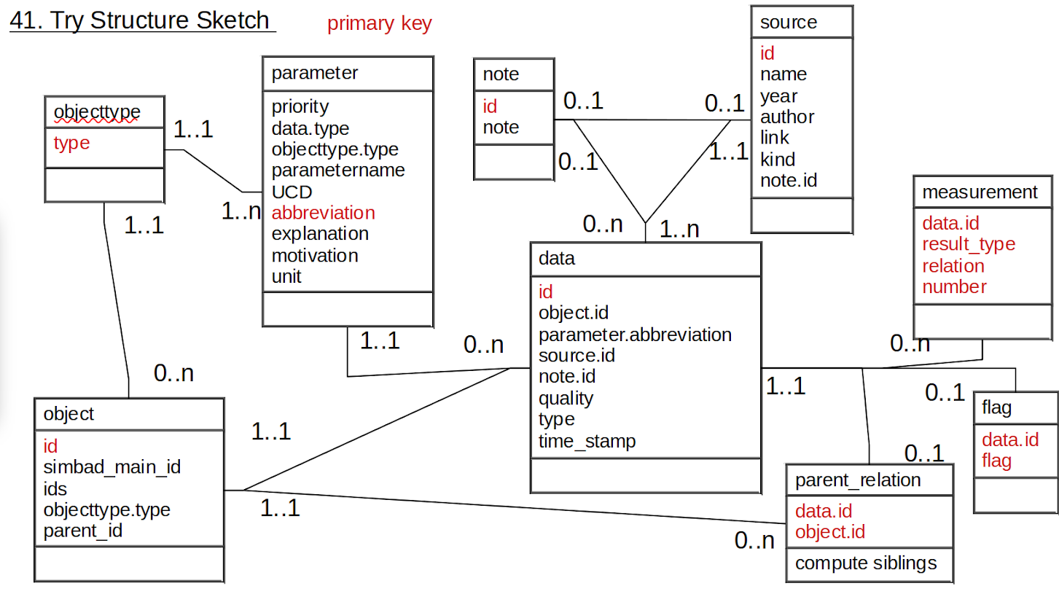

Second Try: Simplified data model based on SIMBAD DM
This data model was created after getting feedback from Markus Demleitner on the complex datamodel and finding out that it was too complex. It was highly normalized and built under the assumptions, that I would have for most parameters multiple errors, measurements and relations. High normalization, however, is not the best state, sometimes it is useful to denormalize for read performance. After looking into the actual data and discussing the multi measurement requirement with sascha it turned out that actually only a limited number of parameters will require multiple errors, measurements and relations.
Instead of denormalizing the complex one, however, the simpler data model was created to be as similar to the SIMBAD data model as possible. This path was chosen as there were some classes that Markus advised not to use (parameter, data). He also adwised to have the parent_relation only over object not additionally data.
Compared to the SIMBAD data model I including additional classes for disks and planets and leaving out classes that were irrelevant for us (e.g. bibliography, flux). I decided to use object type as argument instead of class as I don't like how SIMBAD handles it.
Compared to the complex data model I decided I did no longer need a data class as it would make queries for parameters in a specific range too difficult. I would also not need to have multiple measurements for most parameters, not need multiple error for most parameters and not for each parameter a relation attribute. I decided I would also not need a note class as I could handle it either through metadata or individual notes for parameters. Also the object type did not need to be its own class so I performed a denormalization there (object type class to star, planet, disk and h_link classes). I did decide that I wanted to have the identifier a separate class.
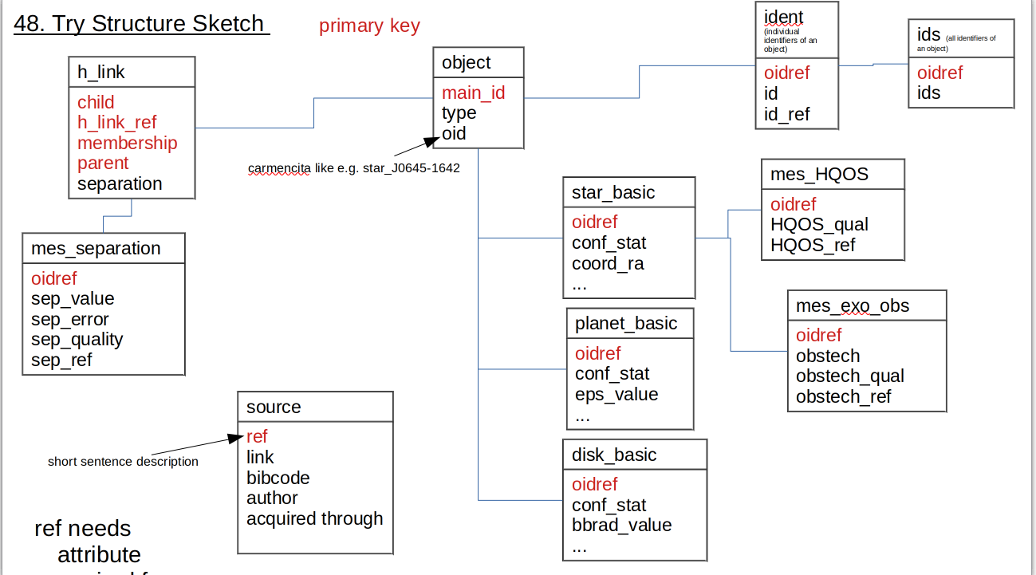
now only figure out how source is connected. each parameter has a source. therefore source is connected to each box at least once with exception of ids and object. this seems a bit strange and is difficult to draw (If I cannot draw it then I cannot do the normalization, but it is difficult not impossible). how is it done in simbad? just linked to object (because they have everything in there) through oid and oidref. but it is less for source and more for literature reference. what they have as reference is just the bibcode.
Is my h_link now my system? or would it be if I concatenated it? not really. my system is now only in object without any other table. however it is present in the h_link table as well.
still need to do: document and distinguish relation types (one, many)

object representation choice
There are three options how I can deal with the object class and the subtypes of it:
- Combining all into one class object like it is done in SIMBAD.
- Using inheritance like described in the simple data model.
- Making its own class out of parameter so that

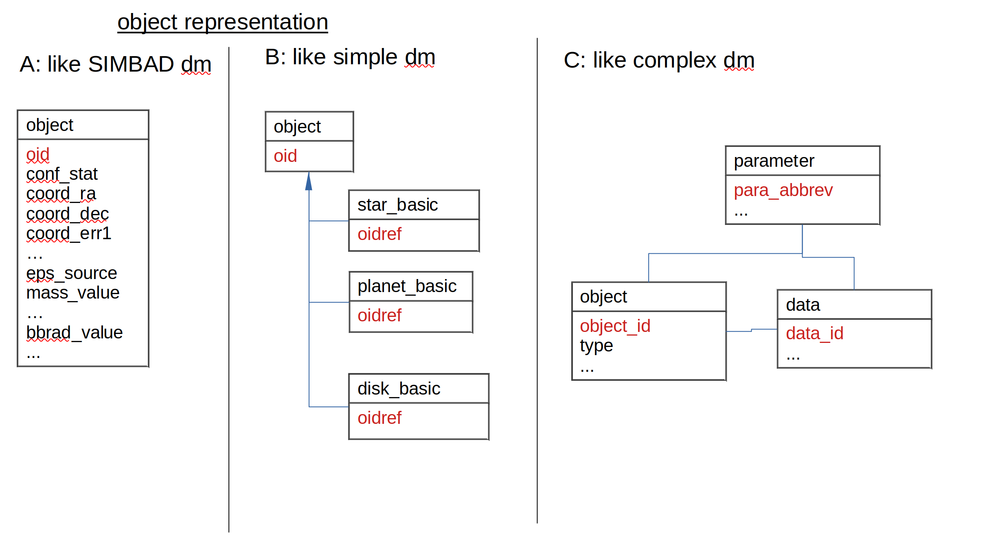
fill out this table
 | pro | contra
A | - simpel dm and queries  - adapting model easy | - many empty fields  - object type grouping more difficult
B | - can keep track of all objects and individual types easily  - object as superclass can interact with h_link instead of individual objecttypes. same is true for ident  - mutually exclusive attributes for parameters  - relationships between objects are simple | - difficult if we need to add behavoiur to our classes (not in the book)  - difficult to change model later (-> my db is small, can just copy paste and adapt)
C | - adapting model easy | - complex: queries get difficult because I need to join over the parameter class

Inheritance: book p. 79
The way I drew the simple data model I assume an inheritance relation as I want to have all objects read into one table, so that I can do the h_link and identifier relations on them. for an object with the type star, I then want there to be a star_basic table created. The decision of whether to use inheritance or not depends on how important the completeness and accuracy of the data are to the objective of the project.

Situations when inheritance is possible:
- different objects have mutually exclusive values for some attributes ->star spectrum, planet excentricity,...
- When you think this is like that except for… consider subclasses. -> The star class is like the planet class only with a different set of parameters
- When two classes have a similar relationship with another class, consider a new
generalized superclass. -> all object type classes have the similar relationships with the h_link class
-> so inheritance is possible as a data model for my project.

Before you use inheritance, make sure that:
- you have not confused objects with subclasses (e.g., Rover is probably an object, Dog or Cat could be classes). -> I am interested in planets, stars and disks as a group, though not in systems except if they are really close together. disk measurements I could also incorporate into star ones but that does not work for planet. ok if I include multistellar systems in star_basic with multiplicity flag then this should work. I can put disk to stars also later but I am sure I want stars and planets as individual groups.
- you have considered whether an association with a category class would be sufficient (e.g., Labrador and Corgi could be objects of a Breed class, and each dog could be associated with a breed). -> I need different parameters for different object types.
- it is not just the value of an attribute that is different (e.g., don’t consider inheritance because the fees for Labrador and Collie are different). -> only for some parameters (e.g. mass) but even there the source and unit are different between the object types.
Not sure about the system category but other than that everything seems to point to inheritance here.

Other considerations:
- Classes that have subclasses should be abstract, which means they will never have any
objects. This allows the problem to be more readily extended. -> solved by including multi star systems in the star_basic subclass after adding multiplicity flag.
- Consider associations with roles when you come across the my object is a member of both
these classes s dilemma. -> the parent relation is somewhat similar to this but not the object and object type challenge
- Don’t introduce the complexity of inheritance unless the specialized data in the
subclasses is important to the main objectives of the project. -> figure out if it is. stellar parameters, what planets where looked for and the parameters of those detected, what disk parameters are available and the distances between stars and (non)star objects.

The test introduced in the book turned out that it is a good candidate for inheritance.
"Is an object of SubClassA a type of SuperClass ? (always/sometimes/never)
Is an object of SuperClass a type of SubClassA ? (always/sometimes/never)
If the answer to the first question is “always” and the answer to the second is “sometimes,” the problem is a good candidate for an inheritance model."

I made sure that I was not confusing objects with subclasses:
A quick way to help decide whether something is a class or an object is to ask a question such as, “Am I likely to have several of <whatever> and am I interested in them as a group?” -> yes I am interested in star, planet and disks as a group.

Most likely both A and B would be okay for me. A might be preferable if you have many objects and are less interested in the object specific parameters. I will therefore try to use B and change it in version 2, if it turns out to be a bad decision.

different inheritance options:
  - star, planet disk as subclasses, object as superclass
  - star, system, planet, disk as subclasses, object as superclass
  - star and multi star system as one subclass, disk and planet as two others, object as superclass
  - star, multi star system and disk in one subclass, planet in another
  - composite pattern -> Checked that the composite pattern does not apply as my systems are not built out of the same base object instead have at leas two (star, planet) different building blocks.

decision why not to use 1: as superclass should not have objects of its own and for close binaries we have most of the stellar parameters. therefore including multi-star systems in star_basic is preferd.
why not use 2: because it is kind of part of h_link, we don't require specific parameters from the system object and having one more class adds complexity.

is the added complexity when choosing 3 over 4 justified?
If I consider multiple disks / disk types around same object then for sure.
If I have disk as separate subclass I can simply associate it with more than one object as parent. If, however, this is not the case I will have quite some empty fields which don't actually stand for missing data or duplicates. e.g. in the case where there are two disks would mean I need to include a multimeasurement disk object or have columns for different observations always present in star_basic which are then empty for most objects. other case is for a disk around a binary where just because you don't have data of the disk around the individual stars (or the other way round) does not mean you don't have the disk data you need for LIFE.
-> yes having a disk subclass is needed as disk data availability is important for our project.

design patterns: (useful for software developers as they deal with behavior whereas developer focus is on data)
- composites and aggregates
- others? https://en.wikipedia.org/wiki/Software_design_pattern#Structural_patterns

identifiers

internal identifiers of tables
I need the primary keys of the tables to be unique and consistent.
I would like to have some useful information encoded in them such as object type and sky position for objects and acquired through from sources.
The first could be achieved by starting the identifier with a letter (s, p, d) depending on the origin basic table. the latter could be done like in 2mass though the issue is, that the position changes with epoch and new measurement. This is not useful for a database, just for a mission.
only know how to make it unique in a python script, not how to create an unique identifyer in the rd

will the consistance be given for updates through python skript? -> not if I run a full update, maybe if I do only partial ingestion.

names of objects
do I really want to include the idents table as in simbad? would be one table for each object / very long table for all objects
taking instead only ids would be only one table and could easily be added to object
what would be the impact on the queries? can I make adql queries on ids or would I need ident for that as there is not the same concept as in python to look for things inside strings?

separation
as a parameter of h_link or better just as star parameter (sep to next star)?

Write Queries
I tried to write the queries for the complex datamodel. If I could do that and then write nice views for the complicated the data model should suffice. It turned out that already trying to write the queries was a pain.
Writing them for the simpler datamodel was easier.
- best para: is easy query after creating view.
- family: query all children of an object works. found out I need to include object table again as otherwise I can not have systems as parent. query all parents works as well. sibling query works but is difficult. a view might be needed but I am not sure how to create one. could discuss this with markus.
- object list: easy, except if you cant to filter them by parameters that are specific to a type not their own e.g. planets within certain distance. Might be easier to add that parameter to the type than to write a query using relations with other objects.
- missing: objects with low quality measureemnt works, low quality parameters of given object query is not straight foreward because I have no individual table for quality or value. I don't think this query is happening very often but if it will turn out that it does I can still write a view for it.
- moredata: stright foreward query
- datalist: easy to show what is in the individual tables and to join them with object and id if needed
- nondetections: nondetection parameters easy. show number of planetary children of object easy too. showing relations (<,>) of parameters easy too.

Concrete Queries
see Appendix for more comment
bestpara:
CREATE VIEW star_basic_values AS
SELECT object_id, coord_ra, coord_dec, pm_ra, pm_dec, sp_type, plx_value
FROM star_basic
JOIN object ON object_id=object_idref
WHERE type="st";
(works in lifetest, with the already included parameters)

GRANT SELECT ON star_basic_values TO Public;

SELECT *
FROM star_basic_values;

Family:
show all children of object with identifier '* alf Cen':
SELECT oid as Child
FROM h_link
JOIN ident as p on p.oidref=parent
JOIN object on oid=child
WHERE p.id = '* alf Cen';

show all parents of object with identifier '* alf Cen':
SELECT main_id as Parent
FROM h_link
JOIN ident as c on c.oidref=child
JOIN object on oid=parent
WHERE c.id = '* alf Cen';

show all siblings of object with identifier '* alf Cen':
SELECT DISTINCT(oid)
FROM
(SELECT parent AS oid, membership, child AS myself
FROM h_link
JOIN indent ON child=oidref
WHERE id='* alf Cen')
AS parents
JOIN h_link ON parent=parents.oid
JOIN object ON object.oid=child
WHERE (h_link.membership >=95 OR h_link.membership IS NULL) AND
(parents.membership >=95 OR parents.membership IS NULL) AND object.oid != parents.myself

objectlist:
SELECT object_id
FROM object
(WHERE type="st")
(works for lifetest)

disk query: show me the available disk data for a given stellar object / list of stellar objects
SELECT oid as Child
FROM h_link
JOIN ident as p on p.oidref=parent
JOIN disc_basic on oidref=child
WHERE p.id = '* alf Cen' ;

for multiple objects do add them via OR

missing:
SELECT object_id
FROM object
JOIN star_basic ON oid=oidref
WHERE plx.value='NULL' OR plx.quality IN ('D','E');

moredata:
SELECT *
FROM mesHQOS
JOIN ident USING(oidref)
WHERE id = ' alf Cen';

datalist:
SELECT *
FROM star_basic

SELECT *
FROM star_basic
JOIN ident USING(oidref)
WHERE id = '* alf Cen';

SELECT main_id, coord_ra, coord_dec,pm_ra, pm_dec, sp_temp, sp_lum, sp_pec,plx_value
FROM star_basic
JOIN object ON oid=oidref
WHERE type='star' AND plx_value > 50 AND sp_lum="V";

nondetections:
SELECT *
FROM mesExoObs
JOIN ident USING(oidref)
WHERE id = ' alf Cen';

SELECT HCInondec
FROM star_basic
JOIN ident USING(oidref)
WHERE id = ' alf Cen';

SELECT count(*)
FROM h_link
JOIN ident as p on p.oidref=parent
JOIN object on oid=child
WHERE p.id = '* alf Cen' and type='planet';

SELECT mass_value, mass_error, mass_relation, mass_quality, mass_source
FROM planet_basic
JOIN ident USING(oidref)
WHERE id = ' Proxima b';

Normalize
Normalization is the concept in database design on how to reduce data redundancey (e.g. having the same information save multiple times in the database) and improve data integrity (e.g. accumulations of errors occurring during data maintenance). Higher normalizations have the benefit of write performance (minimized redesign when extending the database structure, and anomaly resistance) at the cost of read performance.
Goal: Balancing user and administrator friendliness. This is done by first normalizing the database to gain writing optimization and then denormalizing it to obtain reading optimization traded against writing optimization. Writing optimization means modification, insertion and deletion problems get prevented. And the database structure can be changed relatively easy. Reading optimization means how easy it is to query the database.

Normalization makes out of one tables as many as possibly make sense. Denormalization fuses those together to as many as are useful.

Normalformen
1NF: Attribute sind nicht weiter zerkleinerbar und primärschlüssel vorhanden
<-> wiederspruch mit jetziger ids definition
2NF: jedes attribut hängt von jedem teil des zur tabelle zugehörigen primärschlüssels ab
3NF: kein Nichtschlüsselattribut von einem anderen Nichtschlüsselattribut funktional abhängig ist
BCNF: informationen können nicht doppelt vorkommen
4NF: nur noch triviale mehrwertige Abhängigkeiten (MWA) enthält
5NF: keine MWA, die voneinander abhängen

For complex dm
When I tried to check in which normal form the complex data model was so that I could denormalize it into the simpler one I found out that this was not easily done.

1NF: yes
2NF: nicht sicher bei measurements.
3NF: hm does it work with my timestamp?
BCNF: nicht sicher bei source table, does not work with my measurement table?
4NF:
5NF:

For simple dm
1NF:
attribute weiter zerkleinerbar? ->ok
- multiple data per object tables
  - multimeasurements die nicht hierarchisch sind: via oidref an objekt gekoppelt.
  - multimeasurements die hierarchisch sind z.B. bessere werte nur für einige objekte vorhanden, andere brauchen schlechtere werte als quelle. Entweder ich habe eine quelle die bereits nur die besste messung angiebt (exomercat, dann habe ich aber evt falsche einheite (mit oder ohne sin i bei masse), oder ich habe verschiedene quellen. dann möchte ich alle in den multimeasurement tabellen speichern und nur die besste anzeigen im _basic. -> an objekt geknüpft via oidref
  - an relation geknüpft (h_link) -> childoid, parentoid
    - now I can easily also add a multimeas table for H_link_ref and membership. those two attributes are also no longer keys. if I have multiple data for those for the same relation I just add a multimeas table and only include best membership in the h_link
- ids aber dafür ist ident da. brauche ich ids überhaupt? das kann man via view machen.
- oid wäre technisch aufteilbar aber ich möchte bewusst info über type und position drinnen haben.
primärschlüssel vorhanden?-> ok
2NF: jedes attribut hängt von jedem teil des primärschlüssels ab -> ok
nur bei h_link habe ich mehrere primärschlüssel teile, dort ist es aber auch nötig.
I don't think I need a main_id actually. I can use the oid for it. if people will want the main simbad it I can still include it again as id_best attribute.
3NF: kein Nichtschlüsselattribut von einem anderen Nichtschlüsselattribut funktional abhängig ist
- hier sind meine quality, error, value, relation und ref voneinander abhängig. -> die normalisierung hierbei wäre die einführung von measurement und data tabellen.
- ...TBD

BCNF: informationen können nicht doppelt vorkommen
oid type and position info, hierarchical multimeasurements (in basic and in multimeas table)
4NF: nur noch triviale mehrwertige Abhängigkeiten (MWA) enthält
könnte grund sein wieso h_link so ist wie es ist
5NF: keine MWA, die voneinander abhängen

Fragen: Soll ich mein data model bis zur 5. normalform normalisieren und danach denormalisieren bis meine use case queries einfach sind oder ist es die mühe nicht wert weil ich sowieso eine kleine datenbank habe und deshalb auch einfach bei der normalform stoppen kann, wo meine use case queries einfach sind? Kommt wahrscheinlich darauf an wie einfach ich die db anpassen können will... aber da klein ist kann ich sie einfach kopieren und neu aufsetzen.

Optionen | pro | contra
bis 5 nf normalisieren dann denormalisieren | - queries einfach  - anomalien save  - anpassungsfähigkeit hoch | - viel aufwand  - kommunikation nötig und schwierig weil nichts zum zeigen
so viel normalisieren bis queries okay | - db zum vorzeigen v1 | - anpassungsfähigkeit -> kleine db, kann einfach v2 von neuem machen  - queries langsam -> meine db klein also kaum merkbar

Fazit: db V1 nicht ganze normalisierung und denormalisierung, für V2 dies ist eine sinnvolle Möglichkeit.

Denormalize

Ask for Feedback
ask questions to simbad about things that are different to theirs to find out if they have a reason that would make sense for me too.

LIFE Database implementation using DaCHS

data model to be translated:
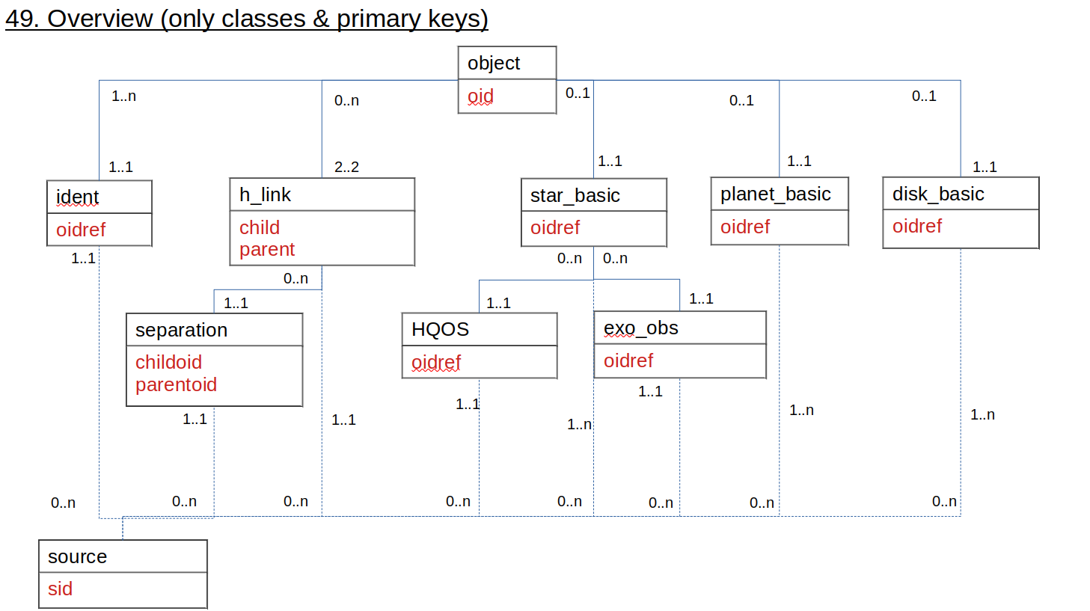
translation techniques: by book p. 94
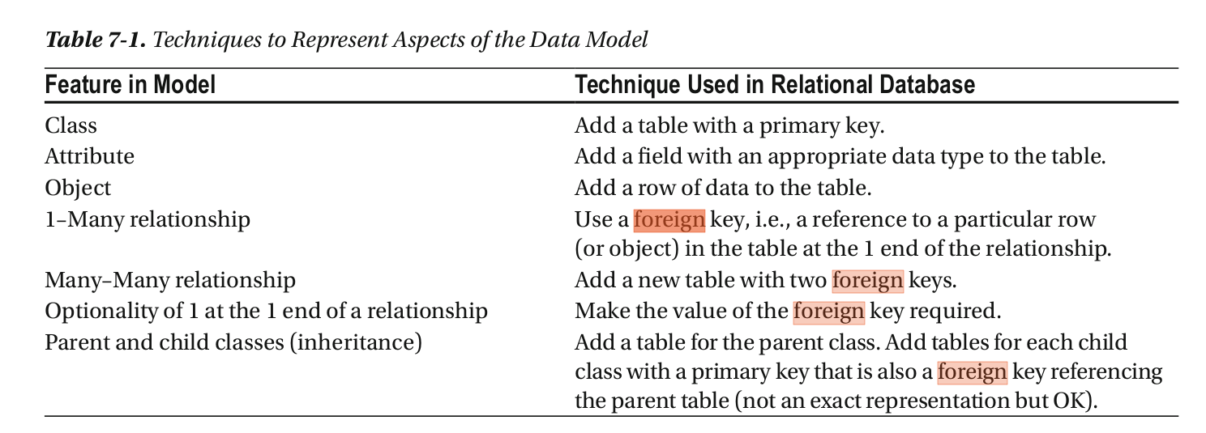
Do I really need inheritance when I actually just need an union of the object identifiers? yes because of the relations that go over all objects

LIFE prototype database

Motivation
Implementing the database structure with as few parameters as possible will let me get a better feeling for where the challenges lie and explain my project to IT people who could help me with the migration from the development environment to a server.

The data model for this minimal database is:
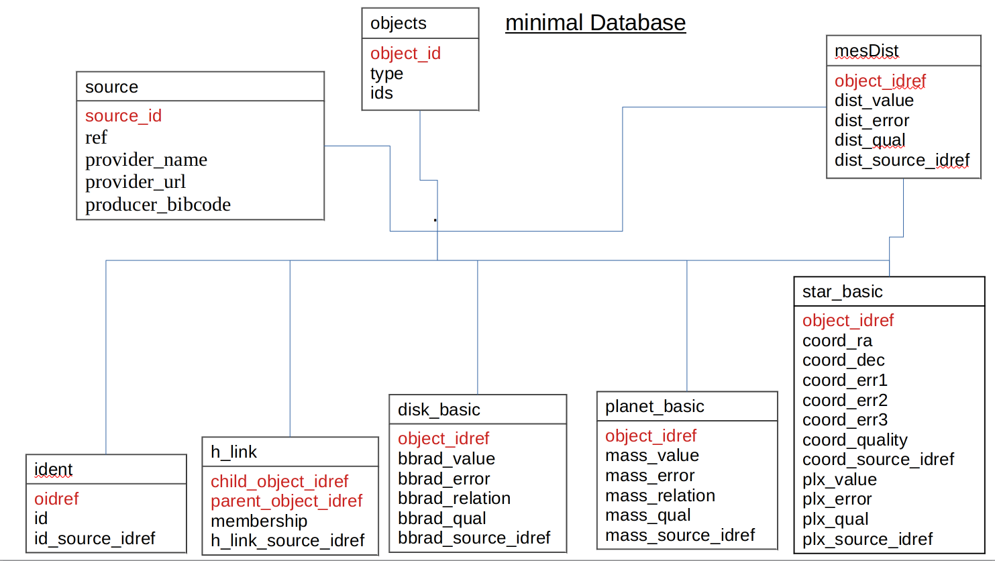
Both the sources and objects tables are connected to all the tables. They in turn only to those two. An exception is the mesDist table (example of multi measurement) which is also connected to one of the basic tables.

tour
acquisition script
virtual box: debian
dachs: rd
access: topcat, tables, queries

table overview
table | description | number of columns | number of rows | number of parameters
objects | Object parameters. | 4 | 3607 | 2
ident | Object identifiers. | 3 | 60000 | 1
h_link | Object relations. | 4 |  | 1
star_basic | Basic stellar parameters. | 16 | 1908
planet_basic | Basic planetary parameters. | 6
disk_basic | Basic disk parameters. | 6 | 33
sources | Sources for the parameters in the other tables. | 5 | 273
mesDist | Stellar distance measurements. | 5 | 6509
mesMass | Planetary mass measurements. | 6

Basic tables
objects
parameter | individual columns | provider
identifiers | ids, main_id, object_id | SIMBAD, ExoMercat, Grant, LIFE
type | type | SIMBAD, ExoMercat, Grant, LIFE

ident
parameter | individual columns | provider
identifiers | object_idref, id, id_source_idref | SIMBAD, ExoMercat, Grant, LIFE

h_link
parameter | individual columns | provider
object relation | child_object_idref, parent_object_idref, h_link_source_idref, membership | SIMBAD, ExoMercat, Grant, LIFE

star_basic
parameter | individual columns | provider
identifier | object_idref | LIFE
coordinates | coo_ra, coo_dec, coo_err_angle, coo_err_maj, coo_err_min, coo_qual, coo_source_idref | SIMBAD
parallax | plx_value, plx_err, plx_qual, plx_source_idref | SIMBAD
distance | dist_value, dist_err, dist_qual, dist_source_idref | SIMBAD

planet_basic
parameter | individual columns | provider
identifier | object_idref | LIFE
mass | mass_val, mass_err, mas_rel, mass_qual, mass_source_idref | ExoMercat

disk_basic
parameter | individual columns | provider
identifier | object_idref | LIFE
black body radius | rad_value, rad_err, rad_rel, rad_qual, rad_source_idref | ExoMercat

sources
parameter | individual columns | provider
identifier | object_idref, source_id | LIFE
provider | provider_name, provider_url, provider_bibcode | SIMBAD, ExoMercat, Grant

multimeasurement tables
mesDist
parameter | individual columns | provider
identifier | object_idref | LIFE
distance | dist_value, dist_err, dist_qual, dist_source_idref | SIMBAD

mesMass
parameter | individual columns | provider
identifier | object_idref | LIFE
mass | mass_val, mass_err, mas_rel, mass_qual, mass_source_idref | ExoMercat

What the prototype can do (queries)
- shows the structure of the database
- performs some of the queries
- give an idea of what would be changed with more implementation

issue: it is not straight forewards to get the data I want to publish in the database. I need to combine data from different sources in a consistent way and I have three different object types I want to treat differently.

Data acquisition script

Overview
First needed python modules and functions are defined. The functions are split into groups.
- The global helper functions are for saving and loading of xml files respectively votable objects. Type conversion from string <Ui to object with i a positive integer.
- There is a function for initializing the database tables.
- Helper functions for the acquisition of the data from the providers (query, sources_table, fetch_main_id).
- Then the source_provider functions.
- Finally the the building function which merges the tables from the different providers and assigns the object and source identifiers.
The code then runs the database tables initialization function, the source provider functions for simbad, the disk catalog from grant kennedy and Exo-Mercat. And then only the building functions remains to be run.

In detail

Global helper functions
save(cats,paths):
This functions saves the tables given as python list in the cats parameter.
The saving location is 'data/{path}.xml' where path is given in the paths
parameter.
:param cats: Python list of astropy table to be saved.
:param paths: Python list of paths to where to save the tables given in cats.
stringtoobject(cat,number=100):
This function changes from string to object format.
The later has the advantace of allowing strings of varying length.
:param cat: Astropy table.
:param number: Length of longest string type element in the table. Defeault is 100.
:return cat: Astropy table.
load(paths):
This function loads the tables saved in XML format at saving locations specified in paths.
:param paths: Python list of saving locations.
:return cats: Python list of loaded astropy tables.

Initialization function
This function initializes the database tables with no data in them.
:return: List of astropy tables in the order sources, objects,
ident (identifiers), h_link (relation between
objects),star_basic,planet_basic, disk_basic,
mesDist (distance measurements) and
mesMass (mass measurements).

Data acquisition helper functions
Performs a query via TAP on the service given in the link parameter.
If a list of tables is given in the catalogs parameter,
those are uploaded to the service.
:param link: Service access URL.
:param query: Query to be asked of the external database service in ADQL.
:param catalogs: List of astropy tables to be uploaded to the service.
:return cat: Astropy table containing the result of the query.

Source provider functions
general
specific differences

Building function

Testing queries

working
bestpara:
SELECT TOP 10 object_id, coo_ra, coo_dec, plx_value
FROM lifetest.star_basic
JOIN lifetest.object ON object_id=object_idref
WHERE type='st'

Family:
children of object with identifier * alf Cen
SELECT main_id as Child_main_id, object_id as child_object_id
FROM lifetest.h_link
JOIN lifetest.ident as p on p.object_idref=parent_object_idref
JOIN lifetest.object on object_id=child_object_idref
WHERE p.id = '* alf Cen'
parents of object with identifier '* alf Cen A':
SELECT main_id as arent_main_id, object_id as parent_object_id
FROM lifetest.h_link
JOIN lifetest.ident as c on c.object_idref=child_object_idref
JOIN lifetest.object on object_id=parent_object_idref
WHERE c.id = '* alf Cen A'

objectlist:
SELECT TOP 10 object_id
FROM lifetest.object
WHERE type='st'

moredata:
SELECT *
FROM lifetest.mesDist
JOIN lifetest.ident USING(object_idref)
WHERE id = 'GJ 10'

datalist:
SELECT TOP 10 *
FROM lifetest.star_basic

SELECT *
FROM lifetest.star_basic
JOIN lifetest.ident USING(object_idref)
WHERE id = '* alf Cen'

SELECT *
FROM lifetest.star_basic
JOIN lifetest.object ON object_id=object_idref
WHERE type='st' AND plx_value > 50

nondetections:

not working
siblings (membership null value bug)
show all siblings of object with identifier '* alf Cen':
SELECT DISTINCT(object_id)
FROM
(SELECT parent_object_idref AS object_id, membership, child_object_idref AS myself
FROM h_link
JOIN indent ON child_object_idref=object_idref
WHERE id='* alf Cen')
AS parents
JOIN h_link ON parent_object_idref=parents.object_id
JOIN objects ON objects.object_id=child_object_idref
WHERE (h_link.membership >=95 OR h_link.membership IS NULL) AND
(parents.membership >=95 OR parents.membership IS NULL) AND object.object_id != parents.myself

missing (null value and quantity bug):
SELECT object_id
FROM objects
JOIN star_basic ON object_id=object_idref
WHERE plx.value='NULL' OR plx.quality IN ('D','E');

nondetections:
not implemented parameter
SELECT *
FROM mesExoObs
JOIN ident USING(oidref)
WHERE id = ' alf Cen';

not implemented parameter
SELECT HCInondec
FROM star_basic
JOIN ident USING(oidref)
WHERE id = ' alf Cen';

issue giving double objects at alf cen C parent
SELECT count(*)
FROM h_link
JOIN ident as p on p.object_idref=parent_object_idref
JOIN objects on object_id=child_object_idref
WHERE p.id = '* alf Cen' and type='pl;

needs NAME in front of identifier then works
SELECT *
FROM planet_basic
JOIN ident USING(oidref)
WHERE id = ' Proxima b';

objectlist:
disk query: show me the available disk data for a given stellar object / list of stellar objects
SELECT oid as Child
FROM h_link
JOIN ident as p on p.oidref=parent
JOIN disc_basic on oidref=child
WHERE p.id = '* alf Cen' ;
-> working one in updated examplequeries.txt

for multiple objects do add them via OR

Challenges I encountered

Ressource descriptor
The first thought was to start from an already existing catalog and change its RD step by step (change metadata, add source, change column, change table) while confirming that it still works. I found out that all catalogs in /var/gavo/inputs are in your "archive" so they need to be unique. This is why I could not have two arihip and adapt one to become life. I could have kept only one of them but first wanted to try the other method, where I created a new database from scratch with as few features as possible. This meant two tables one with main id and oid, other with oidref and data. As data I used 10 objects queried from simbad for main id, ra and dec. I also change the source from csv to fits as markus recommended using that format as it is better in metadata transportation. As this worked nicely I expanded this prototype database.

From source table to acquisition script
Including more data about stars as well as adding a table for planets was straight forwards. The creation of the source table, however, wasn't. It should contain producer as well as provider references as well as a source identifier. The first is provided in the star and planet data e.g. bibcode of plx value, the later is information corresponding to which service I used to obtain the data. There are three possible ways to create the source table:
- Through creating the table through a query on the provider service. This requires me to run two nearly identical queries and uploading at least one of the tables to the service.
- By manipulating the data in DaCHS which requires helper tables and views together with finding out the order in which I have to ingest the data as the tables depend on each other.
- Creating the data table through queries on the provider services and manipulation in a python script.
I tried the first two but finally went with the last one as it leaves open the possibility to query additional source information from simbad and was the easiest to perform with my background knowledge of astropy.

Running the acquisition script

Current solution

creating skript in jupyter notebook:
- activate right environment where modules are installed (source ~/virtual/python3env2021/my_project/bin/activate)
- write jupyter notebook in terminal
- develop code
- saving as .py file

running skript in terminal:
- choose right environment where modules are installed (source ~/virtual/python3env2021/my_project/bin/activate)
- choose right python version (python if python --version returns 3..., otherwise python3)
- python file.py

optimizaiton ideas
- Embedding it into dachs: I plan to ask markus if there is an alternative e.g. using apply on how I can do it in DaCHS. I was able to write the python script but so far could only run it on the host computer. The reason is that I have neither pyvo nor python installed and I am not sure if installing them would impact the DaCHS environment.
- Using a bash script to run the acquisition and database setup together: maybe also creating environment in virtual box where the python code runs. then create bash skript that does this as well as moving the created files to the right location. but do this only after markus confirms that python skript is way to go.

Double ingestion of identifier data
For each of my tables I need to ingest the data again even if through foreign keys the elements are already ingested in another table. This first confused me but assigning foreign keys through DaCHS would otherwise not be possible.

Objects without parallax value
The query from simbad on parallax does not only get stars but also multi-star systems and planets. To make sure that no objects are missed due to lacking plx measurement e.g. for multi-star systems I performed an additional query.

Same object in multiple providers
Make sure that for each physical object I retain only one object identifier even if it is present in multiple providers. Then the identifiers are assigned to each object.

Parent relation h_link
After this preparation it is possible to create the h_link table which connects objects to their parent object, if a relation is known such as planet to its star and star to its multi-star system. Currently only SIMBAD relations with probability > 50% are included. While for the disks and Exo-MerCat sources I don't have any probability given and assumed 100%.

The object table was constructed by joining all the object identifier rows of the planet, star and disk tables. As well as the column for the simbad identifyer to facilitate the replacement of it in the h_link table.

Afterwards all the references for the data producer were matched with the source table and the corresponding source identifier attached.

simbad has four tables related to source: author, ref, keywords and has ref. I am interested in author and bibcode, the first is accessible through oid and the latter is in the ref table and the bibcode is directly the access column.

for disk I found out I also don't know the sources columns I should use. ask grant about it. I think he is the producer and I dont haven any provider service.

issue provider with no producer known
Sometimes I get data from a provider e.g. simbad plx value without a producer mentioned e.g. no bibcode. To deal with that situation in my database I have two options. I can either assign the producer as the same as the provider or leave the producer empty. In both cases it is important to communicate this. The later case has the downside, that is makes it difficult to assign the right source_idref in cases where multiple providers have this issue. A workaround would be to add a column provider to each parameter though that woud increase my number of columns dramatically. This is why I decided to use the first option.

offline modus?
I dont need offline / load option as I will only run the other thing when I want to query

object_id assignment
assigning in basic and matching with objects table or other way round? easier way would be to just assign number without type
referencing will make me need to keep the oid in the objects table. might also be useful to change that into a simbad main id at one point.

object matching
when only having simbad as provider the parameter oid works nicely for this. however, simbad does suggest against using it as it might change with time. After adding data from another provider the additional issue arrived of datatype mismatch between int and string. Therefore I decided to change not only the data type but already from oid to main_id as object matching column.

order of ingestion
I found out that I needed a specific order of ingestion meaning first the sources, then the objects and only afterwards the other tables. That made me change the code into individual functions. After encountering the problem that the code was turning so complex that I had issues understanding it let alone explaining it to others I decided to start again and only include parts of the previous code I really needed. I structured it into module ingestion, global helper functions, initialization function, provider helper functions, provider data ingestion and provider combining. The modules contain numpy, pyvo and astropy. The global helper functions are for saving and loading of multiple xml files. The initialization function creates empty tables in the defined database structure. The provider helper functions consist of one to query databases, one to combine multiple columns into a single source table, one to meth main identifiers from simbad and change from python string to object format. The provider data ingestion functions query from the individual providers (simbad, grant kennedy, exomercat) and organize the data in the database structure. Finally the provider combination function builds the actual database tables from the individual tables of the provider data ingestion functions.
At one point I thought I would create it in a way that I could have an update function which would update the database while keeping some of the data as before. It turned out this would not work as I define the source identifiers and object identifiers only when combining the tables in the provider combination function. This means checking for which data gets affected by the update would be very difficult due to uniqueness constraints. Fortunately this is also not necessary as my database will be small enough so that recreation instead of updating is a valid option.
- found out that my code might work (though is not finished yet) but is too difficult to explain. therefore I changed the code into the structure below. it still needs to get working and documented.
  - initialization
  - source data acquisition
  - updating

Null values
As one of the user cases is to find null values in the database it is important to fill the data correspondingly. This is not so easy as each provider has for each of its parameters their own set of null values. Sometimes something like 1e+20, ~, Nan, None, Null,...
---------------continue cleaning up everything that is below here into something explainable-----
#left me thinking that it would be easier to just keep ref and main_id in the first place
#that would mean I have this information double in the database though... or just in the tables and not in the actual database? but updating goes via here...
#gosh I am so confused about getting data, getting it in the format I want and then into the dachs database
###ok need to zoom out, take a pen and paper and try to find where the issue lies
#you need a certain oder for ingestion so I should give to the update function all tables at once
#this means simbad should output all tables at once with empty initialized ones if nothing available
I realized I need to treat objects like sources in that I update object_idref in all tables after updating objects.
but main_id and ref have issues why I don't use them as foreign keys (ref might come from multiple providers so not unique and main it can change and need to choose if provider not simbad) so should not use them the way I currently am. Instead of deleting old source_id(ref) I should just add new ones where needed. Also need to provider provider info into update function.
---working here. issue is, that when making unique I might delete those with source_id so maybe better instead of vstack and unique using a join? can do left join if old is on left
once I have that working I can look into objects and planet_basic again.
and then I rewrite it so that function takes all tables at once instead of one after each other.
-----------realized that the updating might not be needed. since my db will be small I should just stack, unique and assign object_id and source_id

currently working on

query bugs
- bug query ident gives 20'000 overflow instead of 60'000

streamlining data acquisition script to be easier understandable

exomercat lost objects
#issue, some objects wrongly removed because simbad does not have binary component of them
#careful should also specify that binary should be not masked
cat=removed_objects[np.where(type(removed_objects['main_id'])!=np.ma.core.MaskedConstant)]
missed_binaries=sort_out_20(cat,'main_id')
exomercat=ap.table.vstack([exomercat,missed_binaries])
print('len after missed_binary join',len(exomercat))

alternative to using sim_objects (though worse as I loose objects without plx)
#better just join sim main id and where plx...
#distance_cut(cat,colname)?
def distance_cut(cat,colname):
"""
Removes all stars not within 20 pc of the sun.
"""
TAP_service="http://simbad.u-strasbg.fr:80/simbad/sim-tap"
main_id_query="""SELECT b.plx_value,t1.*
FROM basic AS b
JOIN ident ON ident.oidref=b.oid
JOIN TAP_UPLOAD.t1 ON ident.id=t1."""+colname"""
WHERE b.plx_value >=50."""
cat=query(TAP_service,main_id_query,[cat])
return cat

implementing DaCHS using data from acquisition script
hm why for objects table shipped not all and way less than stars?

astropy computer tricks: If you write something like catalogs=[stars, disks,..] and then a for loop over it in which they get changed, this will not update the tables stars, disks,... but instead only catalogs[0],catalogs[1],...
virtualbox: if I close with save machine state then the guest does not notice that time is passing so when logging in again I need to go to time application and turn the button for sync with network on and of. That way browser should work again.
getting error when dachs implementforeign key constraing bestmass_source_idref = 0 is not present in table source
error is that that is not caught as null value
parseWithNull does not seem to work. ah that is for type conversion, I don't need that so nullExpr should work.
well now I get other error: not well-formed (invalid token)
ok so issue is nullexpression: look up at examples http://docs.g-vo.org/DaCHS/elemref.html
ok now I think issue is that foreignkey might not be allowed to be null?
temporarely excluded foreignkey statement
ok found in sources a null value from exomercat. changed that and uploading to github
current error message: parent is not unique, there is a duplicate in there so it cannot be a primary key. primary is composite then, parent, child and membership.
issue with indent not unique and thus no primary: made stars unique but found I had issue because
had twice the same star but with different source... was because plx value masked lead to empty in bibcode which got assigned source of exomercat. needed to treat null values accordingly to get no source id at all.

get null queries working
currently got error when trying to query WHERE coord_ra='NULL'

data acquisition
putting everything in functions makes that each table depends on another one. I solved that by first loading those tables and at the end saving the new table. I was worried if I would get the right idrefs this way but so far it seems to work.

null value issues
simbad plx_bibcode not masked but ' '
no plx source object in first query (alpha cen) -> what do I do with values without source? assign provider source
rest plx value is masked

#issue with null value plx in stars resulting in double rows and no primary for ident
#after querying simbad I get one entry without plx... what, why? * alf Cen ... why is it included in first query?
#I get 99 from parents without plx
#lose some in oid uniqueness
#gain them back afterwards... why?

identifier issue
print(ident[np.where(ident['id']=='NAME Proxima b')])#issue ident simbad has NAME Proxima b instead of Proxima b
#so need function that cuts away 'NAME ' from those objects

multimeas
teff from gaia? no as it needs to be attached to right object so I first start with a simbad multimeas

mesDistance from simbad as example
    - got error that object_idref is duplicated and can't be made primary from
    - start up python stuff again
    - ok issue is that mass entry is not unique because of two different mass_ref
      - short solution is to take unique on object_idref
      - long solution is to create mesMass table and to add only one value for each object to planet_basic
      - workaround: use mass_rel as part of primary to see if there is a bigger issue I need to work on first. does not work as contains null values
    - did long solution
    - now error for primary membership has null values
      - temp workaround: remove membership from primary
      - same issue with dist_err in mesDist
        - workaround would be to fill in null values
        - hm maybe I need a new identifier, like source id for multimeasurements
        - do I actually want multiple measurements with everything the same just error different?
        - removed where no error given

multiplicity
no multiples (otype **) in st type stars
11hundred multiples, 4 of them are children,
#50 are parents (of planets, disks and stars), so what of the rest? maybe hierarchy smaller 50% or moving group child?
#understanding simbad * and ** notation.
#of the single stars 40 are parents.(of planets and disks)

objects
got merging of simbad and exomercat in planet table without creating double objects working, found out instead of for loop I could just use join. can I do the same to get rid of some other for loops?
most likely for the source id ref matching and h_link creation
objects not working as stars and planets ids columns incompatible
fourn out that planet ids was wrong as alias stands for star not planet name in exomercat
found out there are some stars with no ids. those are because the upload queries did not include that yet. included it but now they are not finishing any longer. tryed changing from sync to async but no use.
seems like the uploading to simbad is not working at the moment. lets try later again.
#error TableMergeError: The 'ids' columns have incompatible types: ['str6240', 'object']
#wait why do I have 6000 digit long ids?? would have expected around 50
#The 'ids' columns have incompatible types: ['str1952', 'object']
#well 2000 is still a lot but better than before

include identifier table
ids is easy and can easily create table from already queryied stuff. can even add it directly to the objects table.
ident is one table per object and would be much more information. would need to have a routine converting to and from ids to homogenize data from different providers.
I can get name from exomercat and ids from simbad. I can split them up and give one source for each.
I can either query ident from simbad or create from ids. as I will need ids anyway creating them from ids seems simpler. for the planet ids I will need to combine the idents into unique on object_idref and id.
I need identifiers so that I can combine data from different providers. I need ident so that I can query data when only id known.
simbad has mainid in ids, uses | as separator
exomercat has name and host and alias for parent star. uses comma as separator
exomercat is my base for planets as that is where I get the parameters from. I use simbad planetary objects to add as object, if there is no match with any exomercat one and to have more ident and h_link information.

include h_link table information for exomercat
question, is it useful to create the h_link from simbad first? there will be more h_link entries coming from the exomercat and disk parent objects. yes, I can rewrite it later
oho just found out that simbad is ubdating their object type system!

so for all my objects I need to also query their parents and children, then make unique again on oid
found out that one of the parents I did not find was a moving group. I am not interested in those, only ** objects
there were different routes to obtain the missing plx objects, the one which required to search through the fewest objects was where I uploaded my objects. Otherwise I got a sample size of ten to a hundred thousend objects.
uniqueness issue, just forced it at the end though would be useful to find out where the doubles came from

informing about provenance
for acquired_through I would refer not using a simple namestring but better a bibcode too. provider_link, provider_bibcode and provider_name, producer_bibcode, producer_name, producer_publication_year
... looks like I need to look into provenance (or maybe datalink, not sure what the second does) as this looks so similar to having two tables provider and producer.

hi markus, I have a question on data provenance. Because I create an archive where I access data from other databases I want to store the provider of the data (e.g. SIMBAD) but also the producer (e.g. Gaia EDR3). What VO standards are there that I should know of?

Zunächst ist die Frage, wie weit es in deinem Fall überhaupt
*maschinenlesbare* Provenance braucht. Ich selbst habe einfach ein
README, in dem ich in der Regel reinschreibe, woher ich die Daten
habe; wann ich was gemacht habe, geht aus dem Log der
Versionskontrolle hervor (und ich kann die Wichtigkeit von
Versionskontrolle für die RDs nicht genug betonen). Dabei bin ich
manchmal etwas unruhig, weil das an die Verabeitung personenbezogener
Daten grenzen mag (und mein SVN ist ja öffentlich), aber ansonsten
hat mir das immer gereicht.

Wo die Information für NutzerInnen hilfreich ist, schreibe ich kurze
Hinweise, wo das herkommt und was ich ggf. geändert habe, auch mal in
die description oder die _longdoc.

*Wenn* du maschinenlesbare Provenance brauchst, gibt es dafür in der
Tat einen VO-Standard, nämlich
<https://ivoa.net/documents/ProvenanceDM/20200411/index.html>.
Leider ist das in den Morast der Data Model-WG gekommen und ist
insofern m.E. nicht besonders hilfreich, wenn du wirklich was basteln
willst, angefangen von der Frage, wie der Kram eigentlich zu
serialisieren sei.

Auf der positiven Seite ist der Kern der Sache ziemlich vernünftig,
es ist nämlich W3C-Prov,
<https://www.w3.org/TR/2013/REC-prov-dm-20130430/>. *Wenn* ich also
in die Verlegenheit käme, maschinenlesbare Provenance zu machen,
würde ich mir wahrscheinlich PROV-N vornehmen.

feedback from meeting with uwe
  - provider namen könnte man auch normieren, entweder durch externe tabelle oder durch dachs fixed entries.
  - server vom institut oder isg sollte kein problem sein. kostet ein wenig was aber debian mindestens via docker (lightweight virtualbox) machbar. kurt beckert ansprechperson. auch eine nachträgliche vergrösserung der maschiene sollte nicht so schwierig sein durch die IT
  - server requirements frage:
    - was uwe bisher gesehen hat sieht nicht nach viel aus, muss nur ab und zu aktualisierung der db machen
    - meeting mit markus, uwe und mir nötig um restliche requirements zu klären

meeting with markus
- show him minimal db to show what I want to have.
- show him how I get it going and ask for improvement options / alterative better ways to do things
  - data acquisition
    - how to get skript running on guest
    - alternative to get it running through DaCHs
  - provenance
  - object representation (three options simbad, simple, complex)
  - inheritance (foreign keys, origins column,...)
  - migration to server
    - options to be put on gavo?
- feedback
  - dachs warning message meta.id;meaa.main column missing can instead mean that it was doubled.

optimization potential data acquisition
- save votable as fits
- query the data I currently just give e.g. from the tab schema
- getting it running on guest machine
- doing it in dachs: wait a moment, in hpunion rd they query, I think, from the web. which is what I would like to do for most of my data.

seems there is no python in the dachs environment... didn't I find out previously that astropy was there?? yes it is, I can import it in an apply environment. so maybe I need to run the python script through an apply environment?
find out if pyvo is installed by looking if I can import it in an apply -> nope
I have this script to get query and prepare my data for ingestion. Is there a way I can run it in the rd or the same folder as the q.rd? When I tried so naively I run into the problem that I don't have pyvo installed there and that calling it in the terminal with python file.py replied that the python command was not found.
So seems like I need to install python and pyvo though I am a bit surprised as python is obviously running inside DaCHS. So maybe it is better not to install it and instead get access to the dachs one to not run into problems like influencing the dachs one?
--> first try to do ingestion and do acquisition compatible with guest machine only later

dachs options

gavo rsc module: helpers for resource creation

You should, in general, not construct the tables directly but use the tables.TableForDef factory.

getPrimaryTable -> sounds like the one used for ingestion in astropy votable.

Hi Markus

Thanks for your replay, I managed to create the table I wanted using a view. Now I am trying to create another one. This one is just a helper table where I only want to get one column from the source data and only the unique rows of it. I expect this is a good candidate to your first method. Can you explain it a bit more to me, when I look at the example in fk6 I see you use quite a bit of code. you are using a python rsc module. I also found out that astropy works in the apply. I know I can do the uniqueness through astropy so I tried: input=getPrimaryTableoutput=table.unique(input, keys='bibcode')
---I can easily test that by just putting an apply with only from gavo import rsc in my rd----
no problem importing that module in apply.
how similar is it to astropy?, is astropy in there?
well it works...astropy can be importet.

Ok I found out:
- getting the source table the way I want it is difficult with my current knowledge. I can either ask Markus to tell me the best way to do what I want. Or I can look into apply a bit more. maybe I should set up a jupiternotebook with my source data and try how I can get what I want with astropy. That would give me a better understanding of what I want to achieve.

inheritance
representing inheritance: book p. 109. object_id is primary, star_id is primary and foreign key.

How does dachs deal with foreign keys?

origin could be my solution to my foreign key problem at the moment I need to have the object table before the basic one, as it uses a foreign key on it. on the same time when reading in the object table I would like to have already the other two tables so that I can just copy in the ids.

other stuff

- add planet conf status and corresponding star relation, then add disk and corresponding star.
- add parameters one by one: start acquiring prio 1 data (examples) through simbad, then try out what I get from gaia, then from other catalogs in the sag 22 t4 one.
- found out, I should be using a version control tool so that I get changes in the rd's logged
- do I need individual data id for each table?
- find useful mixin oce I am at service creation
- look at carmencita to see how they handeled relation column, not in gavo so search for it first
- https://arxiv.org/abs/2201.03252 for stellar parameters in GAVO catalog derived from gaia and others

regression testing

reg test
run dachs test -Devidence.xml rdId#cur
then investigate evidence.xml

example queries testing
- h_link has 16959 in membership which does not make sense, is that a simbad nullvalue? I know on the webpage they have ~ . but in topcat simbad download they give null value as -32768
  - find out for one example the main_id and look what it is in topcat simbad
    - parent object id is 9 -> * 14 Her -> jup exactly where I have ~
    - try to catch it in q.rd if does not work change in acquisition script
      - turns out I get a strange error when including ~ as null expression: *** Error: Bad user expression: invalid syntax (<unknown>, line1) (At /var/gavo/inputs/lifetest/q.rd, (401,41)) -> write to markus about it. I put it in <rowmaker idmaps="*"> <map dest="membership" src="membership" nullExpr="~" />
      - oh actually, it is not ~ but masked in my data files
      - had to put the code in sim_h_link and building. now null value is -1
- mesmass has as mass?val 1e20 a few times that seems strange
  - find out for one example the main_id and look what it is in topcat exomercat
    - * 14 her b -> jep no entry there so how is it in acquisition?
    - oh found out exomercat works on topcat again. will download it on host.
    - so what null value du I want? None? is that a valid option for double precision?
    - can't do it only in the q.rd as then I have null values in mesMass which should only contain true entries
- object table ids sometimes starts with | or has two of them separating a name
  - code in merging needs an additional if statement
- star_basic has in coo_err_may 1e20 and coo err min also. same for plx and dist. one dist even has no source idref

LIFE database full implementation

What needs to be adapted from the prototype
- more parameters (about 100) (which implies more providers). This means about a hundred times 5 (value, error, source,...) columns split over the three basic tables. Also increases the sources table rows by about 100x5'000 (number of total objects).
- more multimeasurements. This means a few tens of multimeasurement tables with each containing a few 1000 rows.
- more objects from exomercat. currently I falsely loose some when applying the distance cut because of how the code works. This should give me a few thousand planetary objects. This also increases the h_link and ident tables by about that order of magnitude.
- more disk objects, a few thousand. again also increases the h_link and ident tables by about that order of magnitude.

      - migration to external accessible
      - publication
      - objects currently about 3'500, future about 5'000
      - parameters currently about 10, future about100
        - tables currently about 10, future about 30
        - columns currently about 55, future about 100x5 (split over three basic tables) and + 20x5 (multimeasurements)
      - rows
        - rows in source currently about 300, future about 100x5'000x5 (parameterxs x objects x multimeasurements)
        - rows in identifier currently 60'000, 10x5'000
        - rows in h_link currently 900

table overview
table | description | number of columns | number of rows | number of parameters
objects | Object parameters.
ident | Object identifiers.
h_link | Object relations.
star_basic | Basic stellar parameters.
planet_basic | Basic planetary parameters.
disk_basic | Basic disk parameters.
sources | Sources for the parameters in the other tables.
mesDist | Stellar distance measurements.
mesMass | Planetary mass measurements.

Basic tables
objects
parameter | individual columns | provider
identifiers | ids, main_id, object_id | SIMBAD, ExoMercat, Grant, LIFE
type | type | SIMBAD, ExoMercat, Grant, LIFE

ident
parameter | individual columns | provider
identifiers | object_idref, id, id_source_idref | SIMBAD, ExoMercat, Grant, LIFE

h_link
parameter | individual columns | provider
object relation | child_object_idref, parent_object_idref, h_link_source_idref, membership | SIMBAD, ExoMercat, Grant, LIFE

star_basic
parameter | individual columns | provider
identifier | object_idref | LIFE
coordinates | coo_ra, coo_dec, coo_err_angle, coo_err_maj, coo_err_min, coo_qual, coo_source_idref | SIMBAD
parallax | plx_value, plx_err, plx_qual, plx_source_idref | SIMBAD
distance | dist_value, dist_err, dist_qual, dist_source_idref | SIMBAD
magnitude |  | SIMBAD, GAIA, WISE
proper motion
activity | halpha, stellar rotation period, vsin i...

planet_basic
parameter | individual columns | provider
identifier | object_idref | LIFE
mass | mass_val, mass_err, mas_rel, mass_qual, mass_source_idref | ExoMercat
orbit

disk_basic
parameter | individual columns | provider
identifier | object_idref | LIFE
black body radius | rad_value, rad_err, rad_rel, rad_qual, rad_source_idref | ExoMercat
 | inclination

sources
parameter | individual columns | provider
identifier | object_idref, source_id | LIFE
provider | provider_name, provider_url, provider_bibcode | SIMBAD, ExoMercat, Grant

multimeasurement tables
mesDist
parameter | individual columns | provider
identifier | object_idref | LIFE
distance | dist_value, dist_err, dist_qual, dist_source_idref | SIMBAD

mesMass
parameter | individual columns | provider
identifier | object_idref | LIFE
mass | mass_val, mass_err, mas_rel, mass_qual, mass_source_idref | ExoMercat

Meetings

Migration Planning

meeting with uwe and markus
no migration needed as long as I can have my code on a version control e.g. github gavo can host the database and anybody can develop the code further
  - dachs requirements: debian stable, repository (trust / eth guidelines problem?), internet (eth privacy issues?), certificate
  - query leistung ist auf server der die db provided
  - gavo offers to host the db while we don't do so ourselfes -> brauchen gar keinen zusätzlichen server
  - rd versionskontrolle
  - eine maschiene wo entwicklung stattfindet, eine andere die die db hostet. verlinkt via versionskontrolle
  - nächste schritte:
    - sascha info und er soll sich an uwe wenden falls er noch fragen bezüglich technischen sachen hat
    - meeting mit uwe zum versionskontrolle gitrepository richtig zum laufen bringen
    - markus fragen ob so wie auf github gut oder noch anpassen nötig
    - meeting mit markus wenn registrierung zum metadaten / publish machen (publish code bereits in rd)
  - so why was I not able to ask markus for what he afterwards offered himself?

Open Questions

Q2: "I realized I planned parameters a bit differently than the other catalogs. They usually have a value e.g. mass and an error to it. When I created my data model I came up with another system. For each parameter e.g. stellar mass I would have a data table containing columns like source, object id, quality,.... Then I would have a table called measurement where the columns are the aforementioned data id as well as result_type (value or error), relation(=<>), number (float). Now my question is, what is the reason behind this, is it just traditional to use columns for value and error each or is there a good reason why my system would not work?
... ok this is difficult to explain, maybe better in zoom meeting where I can show him my data model and example tables
Q3: UCD for relation column?
  - source table, wie komme ich zu service metadata
  - kann ich parameter as csv einlesen z.b. mit loop um columns zu kreieren?
  - send minimal and maximal rd to markus with goal to get help getting minimal working
  - hast du jemanden z.B. einen studenten welcher mich unterstützen könnte?

Q6: welche NF ist nötig?
- What maintenance (updating, archiving, ...) will be required after the database is set up and what does the software do on itself? still need to read into this
- is there a gui that helps to create the rd without needing to know all the dachs syntax? There are multiple rd published of other catalogs. and you have helping information in the template

Appendix

Gavo feedback
gavo help issues I faced and reported back to responsibles:
- you need to be member of the dachs support list to send to it
- dachs support email list issue due to expired web certificate

Encountered Virtual Box challenges
keyboard
us layout and not all signs are as indicated in the settings keyboard map
`1234567890-=
~!@#$%^&*()_+
qwertyuiop[]QWERTYUIOP{}
asdfghjkl;’\
ASDFGHJKL:”|

bidirectional copy pasting
not working.
    - tried already usual setting method, restart, update
    - https://superuser.com/questions/1293042/bidirectional-clipboard-not-working-in-virtualbox sais you need extension pack
franziska@ipa-hit-j33-fmenti:~$ VBoxManage list extpacks
Extension Packs: 1
Pack no. 0: VNC
Version: 6.1.32
Revision: 149290
Edition:
Description: VNC plugin module
VRDE Module: VBoxVNC
Usable: true
Why unusable:
seems like I have it working already
    - the other hint is donw or upgrading the guest additions

network
Issue if I want to use guest machine internet while connected to eth cable. If I am connected to eth cable I need to change vbox settings (From wlp... which is eduroam to enxa... cable). Afterwards there is still some error. most likely it needs to accept it. so long as I use eduroam everything works.

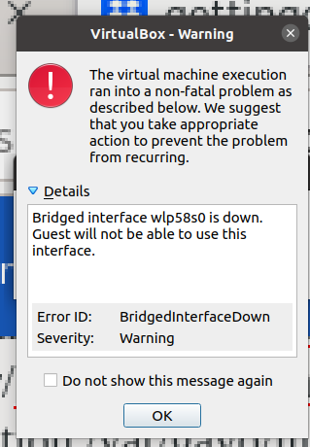
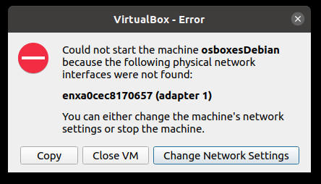

The sec_error_ocsp_future_response error is solved by:
ah I believe the problem might be, that my computer time is wrong.went to settings, date and time, unlock admin password automatic date and time off, on.

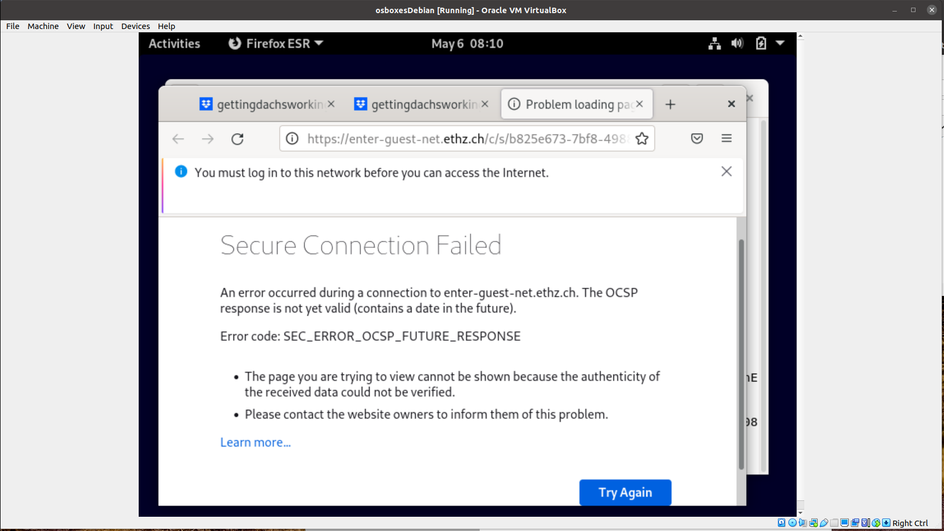

firefox dropbox sais I need to log into the network before I can access the internet.
clicked on the link I should use to log in, got:

firefox can't load this page for some reason. has a security policy called HTTP Strict Transport Security(HSTS)
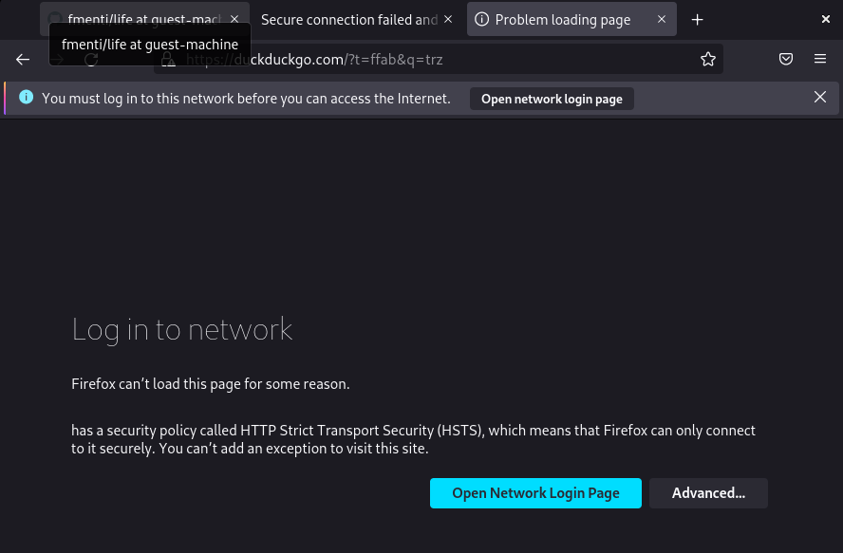
file exchange
shared folder not set up https://www.youtube.com/watch?v=ArcQtZ7kiHI
  - using dropbox web application. issue that sometimes it suddenly sais that document can't be opened in editing mode. tryed if it helps that I saved the document in word instead of odt format. if issue persists using gdrive might be a good alternative.
  - and github: You need git to upload whole folders, this does not work with github web application. I decided against it because I actually want history version control and file exchange guest-host. so first I just use githubweb for q and source files. once I have more useful things in dachs I can look again if I want to have more elaborate solution. you can access the files in raw and then copy paste the text as a download workaround.

DaCHS Debugging
- topcat localhost error message: Table Metadata Error. Error reading TAP service table metadata. java.net.ConnectException: Connection refused. Can mean that there is no dachs service running.
- dachs serve debug needs to look "frozen" meaning just a shell documenting what I am doing. I need to use another shell for opening topcat.
- need to use sudo for service dachs stop and dachs imp q
- error message can be python specific so if in doubt try in ipython console if command would work.
- foreign key issue ERROR: column "object_id" referenced in foreign key constraint does not exist might just mean your foreign key definition needs to exchange dest and source. Primary keys can be foreign keys too, you have them for example in inheritance models.
- not well-formed (invalid token)
  - xml uncorrect,, oh I forgot to end the schema
- segmentatin fault: I can not exit dachs thingy, error comes again.
  - need to include scsCore again as if it does not have position and radius it just gets normal db core and should still work
- *** Error: /var/gavo/inputs/life/qmin.rd not well-formed (invalid token): line 36, column 17 had end of column somehow not right now 62, 11.
  - regression test url error message, no ra and dec for scs -> copy pasted from gaia3light
- ** WARNING: SCS core at /var/gavo/inputs/life/q.rd, line 70: Output table has no meta.id;meta.main column. This service will be invalid.
  - changed meta in column
- ok so dachs did not give error message but topcat did. I think that is exactly why I had the colName in the viewStatement. the error was not solved by taking it away, just the error message muted in dachs
- null value error (conversion string to float) use <map dest="Vmag">parseWithNull(@VmagSrc, float, "99.99")</map>
- ingesting only part of a identifier: @identifier[0:2] takes only the first two elements
- dachs warning message meta.id;meaa.main column missing can instead mean that it was doubled.

debugging in progress
- how to use rowmaker to choose rows?
- viewStatement does not produce all the columns that I have in the table.

Failed Ubuntu DaCHS implementation
Reading package lists... Done
Building dependency tree
Reading state information... Done
E: Unable to locate package gavodachs2-server

so I do need to add the apt repository from gavo http://soft.g-vo.org/repo
install gavos archive key. id: D8C139FC . fingerprint:B199 D643 9DBB 98D7 9F4E AD09 8B6C 75C0 D8C1 39FC
quick and dirty way to do so is: cd /etc/apt/trusted.gpg.d
curl https://docs.g-vo.org/archive-key.asc \
| sudo tee gavo-archive.key.asc
output: lots of signs and -----END PGP PUBLIC KEY BLOCK-----

add the line: deb http://vo.ari.uni-heidelberg.de/debian release main
to your /etc/apt/sources.list

updating package cache: sudo aptitude update
command aptitude not found -> tried sudo apt update
install the gavodachs2-server package: sudo apt-get install gavodachs2-server
Reading package lists... Done
Building dependency tree
Reading state information... Done
Some packages could not be installed. This may mean that you have
requested an impossible situation or if you are using the unstable
distribution that some required packages have not yet been created
or been moved out of Incoming.
The following information may help to resolve the situation:

The following packages have unmet dependencies:
gavodachs2-server : Depends: postgresql-pgsphere but it is not going to be installed
E: Unable to correct problems, you have held broken packages.

google postgresql-pgsphere:
- what is it? Spherical data types, functions, operators, and indexing for PostgreSQL
- what is postgresql? open source relational database
- what does it do?
- is it possible to separately install it?
  - via ubunt: apt search postgresql-pgsphere
    - yes -> sudo apt install postgresql-pgsphere
      - The following packages have unmet dependencies:
      - postgresql-pgsphere : Depends: postgresql-11 but it is not installable
        - apt search postgresql-11
          - hm there are only extensions for it installable
          - apt search postgresql
            - lots of packages. I found postgresql-12 and postgresql
  - via own community
    - postgresql is available in all ubuntu versions by default. though only one version, others are available through the apt repository
    - find out what ubuntu version and architecture mine is: cat /etc/os-release
      - focal
    - which one is already installed? apt list--installed|postgresql
      - hm error, invalid operation list--installed
        - apt --help
        - apt list --installed | postgresql
          - postgresql command not found
          - apt list --installed | grep -i postgresql
            - this time worked but no result.
    - google postgresql-pgsphere : Depends: postgresql-11 but it is not installable
  - if not write to markus:
Hi Markus
I had some issues with my virtual machine so now I am trying to get DaCHS running on my Ubuntu. GAVO writes there: The preferred way to run DaCHS or other software provided by the GAVO data center is on Debian stable or compatible systems (this should usually cover Ubuntu; in particular, you are welcome to report installation failures on not-too-ancient Ubuntu systems). So I am now reporting that it did not work with the error message:
The following packages have unmet dependencies:
gavodachs2-server : Depends: postgresql-pgsphere but it is not going to be installed
E: Unable to correct problems, you have held broken packages.
When I tried to install the package I got the error:
postgresql-pgsphere : Depends: postgresql-11 but it is not installable
As far as I understand it your DaCHS depends on an outdated postgresql version. Do you need to change something in your code or can I do something so that it works on my computer?
Thanks!
Franziska

cd /var/gavo/
dachs,
topcat,
example data,
rd,...

not working as postgresql-11 not available
markus advice how it could work
      - for ubuntu: für 12 könnte es funktionieren, das postgres-Paket (und das postgres-dev-Paket) manuell zu installieren und dann pgsphere und q3c wie beschrieben zu bauen. Insofern wäre ich interessiert, ob die Dinge magisch klappen, wenn du die PGDG-Pakete nimmst. Das ist auf https://wiki.postgresql.org/wiki/Apt/FAQ erklärt, und die Anleitung ist auf https://www.postgresql.org/download/linux/debian/#apt.
        - researching it... sounds like hard work. try first reinstalling virtual box and another debian try this time with osboxes

Learn through looking at functional DaCHS databases
delete them in the end to have enough disk space for the life database:
dachs drop q
dachs drop -f gcns/q

10pcsample

hsoy

gcns
One that has multiple tables. Trying to use gcns.
Like what we did in tutorial or what is written in gavo quickstart tutorial.
- cd gcns
- dachs imp q (will create the database out of the rd and the source data) -> creates data in db, takes some time ... should maybe have started with the one already installed last time
  - Making data gcns/q#import
  - Starting /var/gavo/inputs/gcns/data/GCNS_cat.fits.gz
  - Shipped 5000/5000
  - Shipped 5000/10000
  - ...
  - Shipped 5000/325000
  - Shipped 5000/330000
  - Done /var/gavo/inputs/gcns/data/GCNS_cat.fits.gz, read 331312
  - Shipped 1312/331312
  - Create index Primary key on gcns.main
  - Create index main_q3c_main
  - Rows affected: 331312
  - Making data gcns/q#import-rejected
  - Create index Primary key on gcns.rejected
  - Create index rejected_q3c_rejected
  - Rows affected: 0
  - Making data gcns/q#import_rss
  - Rows affected: 0
  - Making data gcns/q#import_10mas
  - Create index missing_10mas_q3c_missing_10mas
  - Rows affected: 0
  - Making data gcns/q#import_hyacob
  - Create index gcns.hyacob:source_id -> gcns.main:source_id
  - Rows affected: 0
  - Making data gcns/q#import-maglims_5
  - Rows affected: 0
  - Making data gcns/q#import-maglims_6
  - Rows affected: 0
  - Making data gcns/q#import-maglims_7
  - Rows affected: 0
- dachs info q#main (outputs several properties (min, max, average, nulls) of nomeric columns. use dachs info q#main--sample-percent to not have to wait too long
  - could not getget percent working but went fast
  - got low space warning -> will need to delete this and the first one we tried before doing LIFE db
  - got output table of column, min, median, max fill_factor
- dachs limits q (inspect table and get colum statistics, space-time coverage and other metadata like that)
  - did it but did not give output
- dachs serve debug (trying out service, go to http://localhost:8080/gcns/q/cone/form and play around with it
  - is web interface
  - sirius, search radius 5 gave one result
- topcat, want to have a look at individual tables, what is the link to access it?
  - look at notes it you got something there (no, just found commands gencol, psql to try to use)
  - otherwise try out other links in chat/history (nope)
  - otherwise read tutorial how :
    - http://localhost:8080/arihip/q/cone/form
    - http://localhost:8080/arihip/q/cone/scs.xml
      - error reading tap service table metadata. method vosi-1.1, full detail requested, source: http://localhost:8080/gcns/q/cone/scs.xml ... table resource access failure (404 not found)
      - says I need to use scs not tap, for tap use http://localhost:8080/tap, works!
  - now look at metadata there and q to know where what goes and adapt life q.rd accordingly
    - has tables main and rejected which each has nearly all parameters, three maglim tables, one cluster table and one resolvedss table. this is not like mine which will have an object, source, parameters,... so maybe I need to discuss this with markus
    - has
      - stream instead of table: records events as they come in (so like a log?)
        - uses it for main table columns ... so like my parameter thing?
          - because in table main he then only uses <FEED source="main-table-columns"/>
          - most likely because gcns has the same parameters in two tables (main and rejected) ...
        - he also has a steam id="elements-for-import where he uses make table and rowmaker
          - then again just feeds that into the data part of the rd: <FEED source="elements-for-import" src="GCNS_cat.fits.gz" tablename="main"/>
      - column argument original: an id of an element to base the current one on -> inheritance method ... lets see if I can find out what that means in practise
      - ingesting data: learned that simplest form is: <map dest="rdcolumnname" source="sourcecolumnname"/>
      - loop listItems ...what does it mean ... ah he creates column original out of it. does he not have to define those somewhere?

maybe I will still need to download data
what is link to put in topcat for own dachs table? http://localhost:8080/

examples for archives not catalogs:
- Q1 ... maybe I can query for that... meta type = Archive -> only few results in gavo and only with max 2 tables. answer: look at them

rr
  - either complex one at <http://svn.ari.uni-heidelberg.de/svn/gavo/hdinputs/rr/>
    - lots of tables, quite clean, is how the commands that DaCHS can perform (e.g. median) are defined

wfpdb
  - or easy one at <http://svn.ari.uni-heidelberg.de/svn/gavo/hdinputs/wfpdb/>
    - two tables, one with info about photometric plate, one with info about where it is.
    - learned, make importing data after each table and not at the end of all of them
    - good example for csv import
    - they have helper tables for building main table (observer, notes, quality, availability, digitalization. as content for main table split over several files. I might need to do the same as my data tables behave similarely

tap_schema.keys Tabellen
  - mehr beispiele in den tap_schema.keys-Tabellen

Outdated data model design

Feedback from Markus to complex data model
He told me I was doing relational modelling and should have a look at normalization.
He advised me to:
Write regularly expected queries. Depending on how difficult they look:
easy -> everything ok and maybe normalize
medium -> write views,
difficult -> change data model (denormalize)

analyzing how I can simplify data model

  - less complex dm possible by not having the option for each parameter having multiple measurements, errors and limits, views/queries are much easier that way
    - multi measurements is alternative to replacing entries once new information gets available
      - hm sascha feedback ist nur activity relevante und hqos. hat die nicht die ich erwartet habe und ich habe seine nicht erwartet. muss dort noch genauer hinschauen
      - how to get "best" measurement? via view querying quality?
      - how difficult is ist to add multimeasurement table in 10 yr where currently only one parameter?
    - multi errors -> mit sascha und wg besprechen
      - unsicher: activity index S, magnitudes -> beispieldaten gaia und simbad anschauen
      - sicher:
        - ra & dec because as icrs coord parameter it has three errors from the error ellipse
        - planetary mass/eccentricity/K/period/inclination (upper and lower error not the same for some planets in exoplanet.eu/exomercat)
    - sources wie bei simbad einfach via bibcode? müsste das aber noch genauer anschauen da ich dort mal problem hatte (gaia bibcode ist 2020yCat.1350....0G aber in simbad query nicht selbes format)
    - nondetections solved via flags (relation flag, survey, observation technique) and source link
    - limits (mit sascha und wg noch besprechen)
      - limits useful for: planetary mass, planetary mass sini, planetary period, planetary radius, planetary semi mayor axis, planetary eccentricity, planetary inclination, (separation?, disk?

flag, ref, quality: exopl. obs, conf stat, chrom activity class, hqos, sTypes, parent object, id
value, error, ref, quality: activity index S, magnitude, plx, dec, ra, sep, bb radius,
value, error, ref, quality, relationflag: brightness disk, mass planet

so what about having for all value, error, ref, quality, flag and some of them nan?
prio 1 columns
this should work for singles or wide multiples, but what about circumbinary situations? treat like single but with double star flag
do I need a system class if I already have H_link? pro: measurement not linked to h_link kontra: one more class

single measurements:
parameter | value | error | flag | ref | quality | relationflag
activity index S | x | x |  | x | x
?magnitudeB | x | x |  | x | x
?rest of magnitudes | x | x |  | x | x
parallax | x | x |  | x | x
position dec | x | special |  | x | x
position ra | x | special |  | x | x
confirmation status planet |  |  | x | x | x
confirmation status star |  |  | x | x | x
confirmation status disk |  |  | x | x | x
chromospheric activity class |  |  | x | x | x
identifier |  |  | x | x
sptype (simbad does not have them separated) though on the web you can... |  |  | x | x | x
?bbradius disk | x | x |  | x | x | ?
?brightness disk | x | x |  | x | x | ?
?teff disk | x | x |  | x | x | ?
?inclination disk | x | x |  | x | x | ?
exozodi lv | x | x |  | x | x | x
?ir excess | x | x |  | x | x | x
gaia vairab | x | x |  | x | x
tess variab | x | x |  | x | x

multiple measurements:
parameter | value | error | flag | ref | quality | relationflag
exoplanet observation |  |  | x | x | x
separation | x | x |  | x | x | ?
?planet eccent | x | x |  | x | x | ?
?planet mass | x | x |  | x | x | x
?planet semimayor axis | x | x |  | x | x | ?
parent obj |  |  | x | x | x
?HQOS |  |  | ? | x | x

Writing queries
Tip von Markus, die database use cases müssen in genaue queries umformuliert werden statt abstrakt sein.

bestpara

main object name | best param1_value | best param2_value | best param3_value | ...
alpha cenA | 743 | 1.45 | ... | ...
... | ... | ... | ... | ...

complex dm:
SELECT object_main_id, star_plx_value, star_teff, star_mass
FROM ...
WHERE (star_plx BETWEEN 50 AND 100) AND (star_teff BETWEEN 6000 AND 7000)

needs defeault measurement shown = highest quality or main id

simple dm:
CREATE VIEW star_basic_values AS
SELECT main_id, coord_ra, coord_dec, pm_ra, pm_dec, sp_type, plx_value
FROM star_basic
JOIN object ON oid=oidref
WHERE type="star";

...same can be done with planets and disks though not as useful as less multiple measurements...

GRANT SELECT ON star_basic_values TO Public;

SELECT *
FROM star_basic_values;

If I now want best paras from all objects not just star then make outer join of all three tables.

family

parent object | child object | sibling object
alpha cen | - | alpha cen B

complex dm:
SELECT objectid, parent.parent, child.child, sibling
FROM object_table
WHERE object_name="alpha cenA"
LEFT JOIN objectrelation as parent
ON objectid=objectrelation.child
LEFT JOIN objectrelation as child
ON objectid=objectrelation.parent
... still more needed

simple dm:
show all children (with separation column too) of object with identifier '* alf Cen':
SELECT main_id as child, separation //which columns your output table has, rename main id into child
FROM h_link //look at h_link table
JOIN ident as p on p.oidref=parent //combine to it the ident on the columns parent and oidref
JOIN object on oid=child //combine also the object table with columns oid and child matching
WHERE p.id = '* alf Cen'; //now pick the results where the ident table id column is 3 alf Cen

show all parents of object with identifier '* alf Cen':
SELECT main_id as Parent, separation
FROM h_link
JOIN ident as c on c.oidref=child
JOIN object on oid=parent
WHERE c.id = '* alf Cen';

show all siblings of object with identifier '* alf Cen':
SELECT DISTINCT(main_id)
FROM
(SELECT parent AS oid, membership, child AS myself
FROM h_link
JOIN indent ON child=oidref
WHERE id='* alf Cen')
AS parents
JOIN h_link ON parent=parents.oid
JOIN object ON object.oid=child
WHERE (h_link.membership >=95 OR h_link.membership IS NULL) AND
(parents.membership >=95 OR parents.membership IS NULL) AND object.oid != parents.myself

should create views out of that. how does it work when I need a where c.id ='changingname'
----------------

***simbad sibling query example
-- Show Siblings from a name (eg. NGC 6928)
SELECT DISTINCT(main_id)
FROM
-- all parents
(SELECT parent AS oid, membership, child AS myself FROM h_link JOIN
ident ON child=oidref WHERE id='NGC 6928') AS parents
JOIN
-- Search all children of theses parents
h_link ON parent=parents.oid
JOIN
-- Keep all children
basic ON basic.oid=child
-- Keep only good probabilty of membership
WHERE (h_link.membership >=95 OR h_link.membership IS NULL) AND
(parents.membership >=95 OR parents.membership IS NULL)
-- exclude himself
AND basic.oid != parents.myself

objectlist

main object name
alpha cenA
...
complex dm:
SELECT *
FROM objecttable

show object "alpha cen"
SELECT *
FROM objecttable
WHERE mainid="alpha cen"

-> what if different name than main id, other id?

show all stellar objects
SELECT *
FROM objecttable
WHERE objecttype = "star"

show all stellar objects within 10pc of the Sun
SELECT *
FROM objecttable
JOIN datatable ON objectid
WHERE abbreviation = "dist"
JOIN measurementtable ON dataid
WHERE result_type = "value" AND number < 10

-> will I get multiple entries of objects for each measurement?

show all distance measurements from objects within 10pc
SELECT *
FROM datatable
WHERE abbreviation = "dist"
JOIN measurementstable ON dataid
WHERE result_type = "value" AND number < 10

... if I had instead a column dist_value

simple dm:
SELECT main_id
FROM object
(WHERE type="star")

show objects within 10 pc
this is nasty as currently only stars have distance parameter. one would need to query the stars, then include their children and parents distinctly.

missing

parameters
plx
mass
pm
complex dm:

simple dm:
objects with low quality measureemnt:

SELECT main_id
FROM object
JOIN star_basic ON oid=oidref
WHERE plx.value='NULL' OR plx.quality IN ('D','E');

if necessary multiple parameters can be queried simultaneously by adding OR (param2.value='NULL' OR param2.quality IN ('D','E'))

low quality parameters of given object:... not straight foreward because I have no individual table for quality or value. I don't think this query is happening very often but if it will turn out that it does I can still write a view for it

(SELECT *
FROM star_basic
JOIN ident USING(oidref)
WHERE id = '* alf Cen';)

    - is GROUP BY how i get my missing values? e.g. SELECT parameters, COUNT(*) FROM ... GROUP BY parameter

main object name
alpha cenA
...

moredata

value | error | quality | ref
743 | 1.3 | A | 1
742.12 | 1.40 | B | 2
754.81 | 4.11 | C | 3
complex dm:

simple dm:
SELECT *
FROM mesHQOS
JOIN ident USING(oidref)
WHERE id = ' alf Cen';

datalist
complex dm:
show system overview
SELECT *
FROM object_table

JOIN parent_relation ON object_table.id=parent_relation.oid
WHERE mainid="alpha cen"

  - show missing data (for one object / parameter)
  - show all data of specific object
  - Show all nondetections for a given star

show multimeasurements of one parameter and object
all measurements of particular object and for particular parameter
Listing multiple measurements of same object and parameter directly implicates that I need a parameter table.
(given 1 object, 1 parameter) -> two tables needed (data & source)
data table
value | error | ref
743 | 1.3 | 1
742.12 | 1.40 | 2
754.81 | 4.11 | 3

ref table
ref | author | year
1 | Hip
2 | GAIA

object alpha cenA
parameter parallax
data (simbad)

SELECT *
FROM data

(given 2 object, 1 parameter) -> three tables needed (data & source & object)

object | value | error | ref
alpha cenA | 743 | 1.3 | 1
alpha cen B | 742.12 | 1.40 | 2
alpha cenA | 754.81 | 4.11 | 3

SELECT *
FROM data
WHERE object="alpha cenA"

(given 1 object, 2 parameter) -> three tables needed (data, source, parameter)
... I am not sure if I will ever need that. why should I need multiple parameters all measurements?
plx_value | plx_error | plx_ref | dist_value | dist_err | dist_ref
743 | 1.3 | 1
742.12 | 1.40 | 2
754.81 | 4.11 | 3

wait...this table does not work, would need to have one table for each parameter

plx_value | plx_error | plx_ref
743 | 1.3 | 1
742.12 | 1.40 | 2
754.81 | 4.11 | 3

dist_value | dist_err | dist_ref

then it might be better to just have an external parameter table
parameter | value | error | ref
plx | 743 | 1.3 | 1
plx | 742.12 | 1.40 | 2
dist |  |  | 3

or

parameter | data | ref
plx_value | 743 | 1
plx_error | 1.3 | 1
plx_value | 742.12 | 2
plx_error | 1.40 | 2
dist |  | 3

but what if you have from same source multiple measurements, how do you know which value belongs to which error

SELECT *
FROM data
WHERE parameter="plx"
(given n object, n parameter) -> 4 tables needed (data, source, parameter, object)

object | parameter | value | error | ref
alpha cenA | plx | 743 | 1.3 | 1
alpha cenB | plx | 742.12 | 1.40 | 2
alpha cenA | dist |  |  | 3

SELECT *
FROM data
WHERE object="alpha cenA" AND parameter="plx"

simple dm:
SELECT *, main_id, ids
FROM star_basic
JOIN object ON oid=oidref
JOIN ids ON oid=oidref
object overview: view basic data of star(s)
all stars:

SELECT *
FROM star_basic

specific star:

SELECT *
FROM star_basic
JOIN ident USING(oidref)
WHERE id = '* alf Cen';

parameter list: view parameters in range
SELECT main_id, coord_ra, coord_dec,pm_ra, pm_dec, sp_temp, sp_lum, sp_pec,plx_value
FROM star_basic
JOIN object ON oid=oidref
WHERE type='star' AND plx_value > 50 AND sp_lum="V";

nondetections

value | error | quality | relation_flag | ref
1 | 1.3 | A | < | 1
0.5 | 1.40 | B | = | 2
2.5 | 0.11 | C | > | 3

complex dm:

simple dm:

multi measurements observation technique and survey,
SELECT *
FROM mesExoObs
JOIN ident USING(oidref)
WHERE id = ' alf Cen';

nondetections plots
SELECT HCInondec
FROM star_basic
JOIN ident USING(oidref)
WHERE id = ' alf Cen';

no planet children of star
SELECT count(*)
FROM h_link
JOIN ident as p on p.oidref=parent
JOIN object on oid=child
WHERE p.id = '* alf Cen' and type='planet';

(maybe even join planet_basic to get conf_stat in there)

relation measurements
SELECT mass_value, mass_error, mass_relation, mass_quality, mass_source
FROM planet_basic
JOIN ident USING(oidref)
WHERE id = ' Proxima b';

grouping of parameters:
    - is DISTINCT how I would do grouping? grouping will be done through views, though I could use the command in them. would I just add one column with group? what if a parameter belongs to multiple groups? most likely then group becomes a class again.

