Dear Editor,

This is to confirm that the article entitled “DETERIORATING CONDITION OF EDUCATION SYSTEM DUE TO SCIENTIFIC MISSCONDUCT-----------” submitted to the Indian Journal of Medical Ethics is original and has been authored by the undersigned.

The submission is not under consideration for publication in any other journal.

Details of sponsorship or relevant competing interests, financial or otherwise: -------NA-------

I have read the terms and conditions of authorship of IJME and accept them.

Dr. Pratibha Taneja
Senior Lecturer
Dept. of Public Health Dentistry
Sudha Rustagi College of Dental Sciences and Research, Faridabad, Haryana
Email- pratibhataneja3@gmail.com
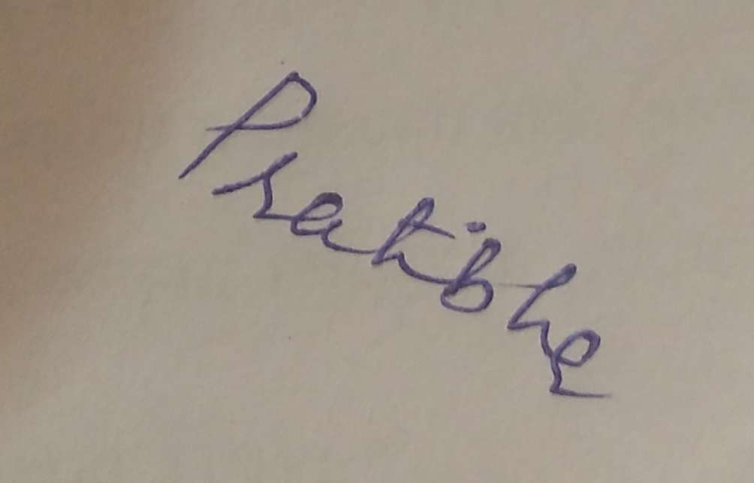
Phone no : 9654642392
07982786391
- Dr. C M Marya
Prof. and Head
Dept. of Public Health Dentistry
Sudha Rustagi College of Dental Sciences and Research, Faridabad, Haryana
Email- maryacm@yahoo.co.uk

Signatures of all authors:

