Dear Editor,

This is to confirm that the article entitled “An Afro-Communal Reflection on Justice and Rights in National Health Insurance Scheme in Nigeria” submitted to the Indian Journal of Medical Ethics is original and has been co-authored by the undersigned. All authors have participated in the work sufficiently to meet the ICMJE guidelines for authorship. All have read and approved the manuscript.

The submission is not under consideration for publication in any other journal.

We give consent to Dr Ademola Kazeem Fayemi to act as the author for correspondence.

Details of sponsorship or relevant competing interests, financial or otherwise: None

We have read the terms and conditions of authorship of IJME and accept them.

Contact details (mailing address, institutional and personal email ids) and current affiliations of all co-authors:
- (kcaristotle@yahoo.com), Postdoctoral Fellow, Department of Philosophy, University of Johannesburg, South Africa, Faculty Member, Department of Philosophy, University of Lagos, Nigeria;
- (amaraesther35@gmail.com), Department of Philosophy, University of Lagos, Akoka, Nigeria;
(3) (adeoluoyekan@gmail.com), Department of Philosophy, Lagos State University, Ojo, Nigeria.
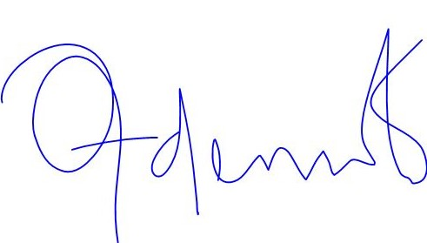
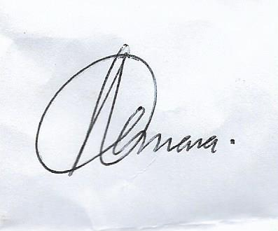
Names and signatures of all authors:
(1) Dr. Ademola Kazeem Fayemi:.....................................
(2) Amara Esther Ani

(3) Dr. Adeolu Oluwaseyi Oyekan:

