Bioethics in medical practice from the Central India Bioethics Unit at PGIMER-Dr. RML Hospital (Review Article)
Shalini Girdhar MD,* Yogesh Tyagi MD**, Smita Deshpande MD DPM***

* Associate Professor, Department of Forensic Medicine, mobile no-9873921078,drshalinirmh@gmail.com
**Prof &Head, Department of Forensic Medicine,9873552805,drtyagi..fmt@gmail.com
***Prof & Senior Consultant Department of Psychiatry ,De-addiction &Centre of Excellence in mental Health 9312654702,smitadeshp@gmail.com.
PGIMER-Dr. Ram Manohar Lohia Hospital, New Delhi 110001
Abstract
The impact of human development on this planet has been huge and often damaging. The discipline of medical bioethics addresses these and other ethical issues involving health care professionals and healthcare seekers. Bioethics thus forms the interface between medicine, law, biotechnology, health policy and philosophy. The UNESCO bioethics curriculum encompasses several principles namely-Human dignity and right, benefit and harm and individual responsibility. The UNESCO adopted the bioethics curriculum so that student learn to identify ethical issues in medicine, health care and life sciences and apply the ethical principle of universal declaration on bioethics and human rights on situation. The Department of Psychiatry at PGIMER-RML hospital was the natural choice for establishing the central India unit of the UNESCO chair at Haifa. Given the awareness of human rights the growing bioethics movement in country will help restore relationship of care and respect among patients. Let us raise hands on issues which are important to us.
Main Article
Bioethics in medical practice from the Central India Bioethics Unit at PGIMER-Dr. RML Hospital (Review Article)
Shalini Girdhar MD,* Yogesh Tyagi MD**, Smita Deshpande MD DPM***
* Associate Professor, Department of Forensic Medicine, mobile no-9873921078,drshalinirmh@gmail.com
**Prof &Head, Department of Forensic Medicine,9873552805,ytyagi.fmt@gmail.com
***Prof & Senior Consultant Department of Psychiatry ,De-addiction &Centre of Excellence in mental Health 9312654702,smitadeshp@gmail.com.
PGIMER-Dr. Ram Manohar Lohia Hospital, New Delhi 110001
Introduction
The impact of human development on this planet has been huge and often damaging. Human beings as they multiply tend to overwhelm the rest of the planet, even decimating entire species and causing irreversible damage to the physical environment. This is true of health sciences as well. Advances in health care have thrown up numerous challenges. The pace development has accelerated in the last few decades. New initiatives are now increasingly required to address ethical issues related to human health care and its impact on the environment, medical policy, practice, and research. The discipline of medical bioethics addresses these and other ethical issues involving healthcare professionals and healthcare seekers. It addresses everyday question of morals, behaviour and communication which may arise between the healthcare seeker and provider at all levels. Bioethics thus forms the interface between medicine, law, biotechnology, policy and philosophy.

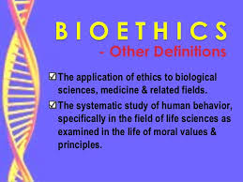

Bioethics (from the Greek bios-life an ethos- behaviour) as a term was initially coined by Fritz Jahr in 1926. A visionary, he anticipated many of the problems which bedevil medical care today. The American biochemist Van Rensselaer Potter used the term in a broader context. He wanted thinkers to consider the impact of current medical research &practices on the biosphere as a whole.

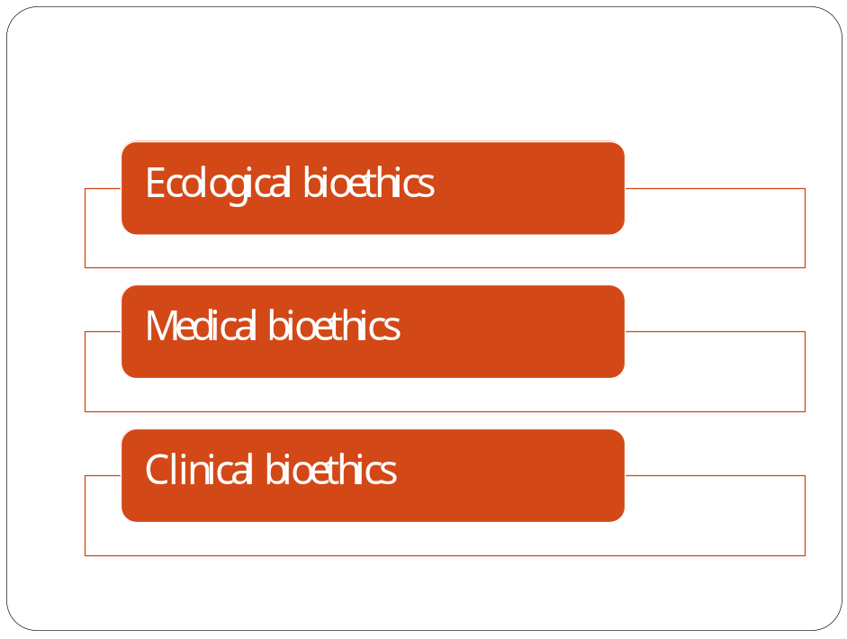

He used the term global ethics to indicate the link between biology, ecology and human values. He wanted human beings to ensure survival of human as well as animals. Hence studied bioethics in various aspects such as ecological, Medical or clinical ethics.

Bioethics as an essential prerequisite of human development and education was adopted by UNESCO on 19 Oct, 2005 at their general conference. UNESCO adopted bioethics and human rights as a Declaration. A curriculum was developed to address the role of ethics in scientific pursuits. The UNESCO Bioethics Core Curriculum sets out to introduce bioethical principles to university students. Target groups are faculty and students of medical sciences, nursing, public health care, dental and social sciences.

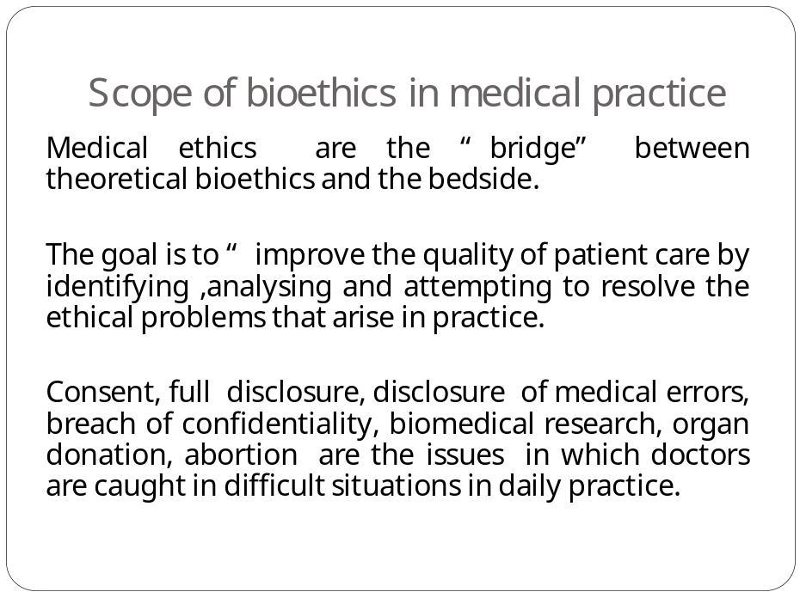

UNESCO adopted the bioethics curriculum with several objectives as follows, so that students should be able to:
- Identify ethical issues in medicine, health care and life sciences.
- Provide rational justification for ethical decisions
- Apply the ethical principles of universal declaration on bioethics and human right on situations.

The UNESCO Bioethics curriculum encompasses several Principles, namely Human dignity and human rights, Benefit and harm, Autonomy and individual responsibility, Consent and Persons without capacity to consent, Respect for vulnerable persons and personal integrity, Privacy and confidentiality, Non-discrimination and non-stigmatization, Respect for cultural diversity, Solidarity and cooperation, Social responsibility and sharing of benefit, Protection of future generations, Protection of environment, Biosphere and biodiversity and Equality justice and equity.

Here are a few case vignettes illustrating some of the issues outlined above, some from the UNESCO website for free use:

Benefit and harm: A 43 year old patient has had schizophrenia since he was 20. At the moment, he suffers from the constant presence of delusions.

The patient’s condition is known from reports by the patient’s mother because he refuses to consult a doctor. He has never been aggressive to others and has never met criteria for compulsory hospitalization. Recently, his mother has noticed a worsening in his condition, including, intensified Positive symptoms that impair his social functioning. She asked for compulsory treatment. The psychiatrist, acting in the best interests of the patient, gave Risperidone in liquid form to be added to his soup by the mother. This treatment had good result. The patient began walking his dog for the first time. The patient benefitted by his mother’s decision to take medicine. But is it ethical to add patient’s medicine without his consent?

Privacy and confidentiality: A young mother has been informed that her two year old son has leukaemia. The mother refuses the chemotherapy. Ethical principles demand respect for patient’s decision. Should the doctor try to obtain court orders for treating the child, as the child cannot consent and the mother has refused, in the best interests of the child?

Consent: A patient of multiple sclerosis has difficulty in feeding herself. She is advised tube feeds. Initially she consents and thereafter withdraws it.

What should a doctor do? Is the underlying disease impairing her decision making capacity? Should the doctor seek consent from her family or guardian/s?

Ethical issues in day to day life: A 32 year woman was admitted to trauma intensive care unit following a major road traffic accident. She suffered multiple injuries and fractures. She rapidly developed ARDS, was put on ventilator support and continuously sedated. Shortly after her admission her parents were contacted. The parents reported that the woman was one month away from having her divorce finalized. Her husband was physically and emotionally abusive to her throughout five years of marriage. The parents had not notified this man about her accident and subsequent hospitalization. Should the husband be responsible for treatment decisions which the patient cannot make? In this case if the divorce is filed then husband has no rights to take decision about wife, as he may take decision which may harm the wife. So if doctor does not know about this law, he may harm the patient by asking the husband because ethical principles state that husband has to be asked. Law and ethics are interrelated when ethics are not followed, law comes into picture and court comes into picture. So it is important for doctors to have knowledge about both ethics and law.

UNESCO discusses these and other related issues at its bioethics website: (http://www.unesco.org/new/en/social-and-human-sciences/themes/bioethics/about-bioethics/) .

Several casebooks, in pdf form, specific to each bioethics issue, are also available online for example: http://unesdoc.unesco.org/images/0019/001923/192370e.pdf.

Readers are advised to consult these free resources for further study.
Special issues in paediatrics
- consent in minor
- Conflicts of interest between parental rights
- Legal and ethical issues in case of child abuse.
- The paediatrician role in child protection

Death related issues
- The definition and diagonosis of death
- The persistent and vegetative state
- End of life care
- Legal and ethical issues in organ transplantation
- Death certification and disposal of dead bodies.
- Coroner and medico legal investigation of death
Asia Pacific Bioethics Network of the UNESCO Chair Haifa was established aiming to be the leader in the region. It was mandated to study and develop curriculum of teaching, training and research to address the changing bioethics needs of the populations of the region home to over 60% of the world population - using the network's national units of the UNESCO chair in Bioethics at Haifa.

Several bioethics units have been active all over the country since 2012. The Department of Psychiatry at PGIMER-RMLH, with its record of teaching-training-publications in the field of research ethics was the natural choice for establishing the Central India Bioethics Unit of the UNESCO Chair at Haifa. It was established in 2014 after all due permissions by the Government of India. The senior author (SND) Heads this unit with Dr. Ram Prate Benita as its Secretary. Director and Medical Superintend is its Patron. The Steering Committee was formed with participation of key Heads of Departments, Chair, Legal Member and Secretary Institutional Ethics Committee, Principal College of Nursing, and Head of the Basic Medical Sciences Unit at the Indian Council of Medical Research as members. The Steering Committee meets regularly and an interactive lecture series on bioethical issues has started. Department of forensic medicine and Deptt of pharmacology have its core committee members .They are actively involved in forming student and faculty forum for bioethics. In this forum we will discuss various bioethical issues and submit our report.

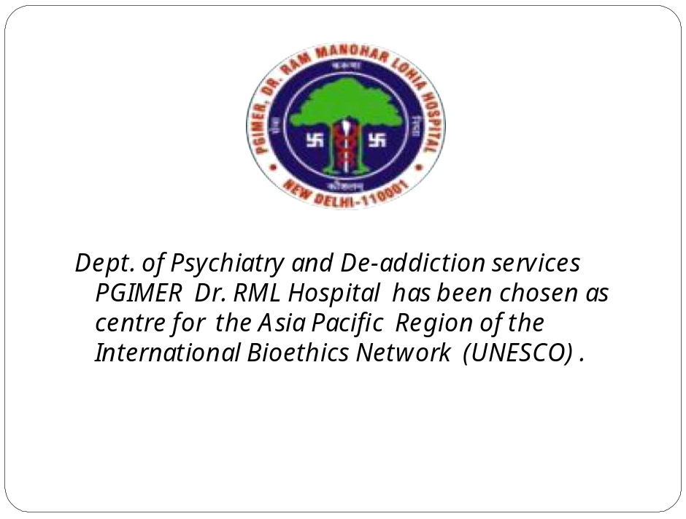

It is now proposed to expand its scope of activities by inviting like-minded members of the RMLH family to initiate a Bioethics Forum. It is also proposed to start a Student Bioethics Forum which could discuss bioethical issues. Faculty who are interested in teaching bioethics are invited to undergo training and attain membership of the International Forum of Teachers (IFT) of the UNESCO Chair in Bioethics. Let’s join hands to raise the issues which are important to all.
References
- Aulis Mark Arnold Robert younger Stout, Ethics consultation from theory to practice, Baltimore, London john hop kiln university press isbn-80018-7165-4
- Medical council of Honking ‘Professional code and conduct for guidance of registered Medical Fractioned” Hong Kong.
- Tuber Alfred(2005)Patient Autonomy and the ethics of responsibility “Cambridge MIT Press
- Doyle L Galleons R “Medical ethics and law as a core subject in medical education BMJ1998 316:1623
- Andre Judith “Bioethics as practice” Chapel Hill and London University of North Carolina Press ISBN 08078 –2733-9
- Siegler M Pellegrino ED singer PA ‘Clinical ethics “revisited BMC Medical ethics 2001.

