Magnetic Resonance Imaging findings of cervical spine derangement among working dentists

Ghassan Abdulateef Abbas Al Shammari*,Sattar Razzaq Al-Esawi **
Abbas Taher***’**** , Ammar H Albujeer*****

*,**,Diagnostic Imaging Dept,AladerTeaching Hospital,Kufa,Najaf,IRAQ
*** Dept of OMF Surgery, Faculty of Dentistry, The Islamic University, Najaf, IRAQ
*****Nabaa Alhata Foundation-Najaf-Iraq

***** Nabaa Alhayat Foundation, MOHE -Baghdad,IRAQ

Corresponding email: kufa54@gmail.com

Keywords: Work, Dentist, MSD, Cervical Spine, MRI

ABSTRACT
Objective: To assess the cervical spine derangement among working dentists using MRI in order to establish a relationship between job parameters and cervical derangement changes.
Methods: A cross-sectional study was carried out at the MRI unit of Al-Sader Medical city of Al Najaf health directorate from June, 2015 to December, 2016. This involved 43 working dentist volunteers of varying age and sex, who underwent an MRI of their cervical spine.
Results :The MRI was normal in 16 (37.3%) and abnormal in 27 (62.8%) participants. The abnormality was due to cervical spine spondylitis changes.
Conclusion: Intervertebral disc (IVD) degeneration was the most frequent finding, followed by IVD herniation.
Keywords: Dentist, Intervertebral disc degeneration, musculoskeletal disorders, cervical Spine, MRI

INTRODUCTION
Recently, many researches based on survey have suggested prevalence of musculoskeletal diseases (MSDs) in case of dental professionals, with respect to the cervical, shoulder and/or lumbar region ^{(1,2,3,4,5).} The unsuitable posture has a greater controibution in developing such muscular imbalance. ^{(5,6,7,8,9)} Work related MSDs have shown an increasing incidence among the dental professionals, and thus, proved to be one the major occupational hazards for them ^{(3,10,11,12,13,14,).} More than 86.7% of dental professionals are suffering from MSDs afecting the neck and shoulder regions. They usually complain of neck and shoulder ache ^{(3,4,11 ,12,13, 14,).}.
Development of various diagnostic techniques like MRI has been a prime encouragement for researchers to look into such cervical changes among the medical professionals. This is because MRI is very safe, non-invasive and highly sensitive for detecting changes in the skeletal structures like cervical spondylotic changes (CSC), in both symptomatic and asymptomatic patients. CSC occurs due to gradual wear and tear of the bones/cartilages in the cervical spine, affecting the spinal discs. ^{(15,16,17,18,19 ).} Thus, MRI can detect early stages of disc degeneration and has been a preferred method of choice in assessing disc integrity in the clinically symptomatic individuals.
The predisposing risk factors for cervical spine changes includes nature of work, posture of the individual, age factor, gender, any medical history of trauma in the cervical region, genetic factor, smoking, and so on. ^{( 15,16,17,18, 19,20)}

Anatomy of cervical spine:
Cervical spines constitutes the upper segment of vertebral column which extends from base of skull to the thorax. They are seven vertebrae, namely C1- C7, with primary function of skull support and brain and spinal cord maintainance in their relative positions ^{(21).}

MRI of cervical spines:

MRI is a non-invasive technique that uses non ionising electromagnetic radiation waves.⁽²²⁾

Age related changes in the intervertebral discs (IVDs):

Decrease in T2 signal of IVD is age related. It predisposes to CSC in the discs such as loss in disc height, disc herniation and annular tears as compared to normal aging discs.^{(23,24)}

Pathophsiology of CSC disease: ⁽²⁵⁾

Disc height loss causing stress on facet and neurocentral joints,

Exadurated joint motion with facet joint disease,

Instability of spine with arthritis,

Hypertrophy of joint capsule, and

Posterior ligament hypertrophy.

Thus, the study aims at assessing the cervical spine derangement among dental professionals using MRI in order to establish a relationship between job parameters and cervical derangement changes.

MATERIALS &METHODS
A cross-sectional study was carried out at the MRI unit of Al-Sader Medical city of Al Najaf health directorate during an 18 months period, i.e. June - 2015 to December -2016. This involved 43 working dentist volunteers of varying age and sex, who underwent an MRI of their cervical spine (Fig 1).
All the volunteers gave their consent to participate in this study and completed a questionnaire prior to the MRI investigation. The questionnaire included details like: their name, gender, weight, height, years of work, hours of daily work, work posture, previous medical history of trauma in the cervical region, previous MRI investigations, any systemic disease(s) or any problem(s) interfering with the MRI test (Fig , 1; Tables 1 and Appendices A and B).

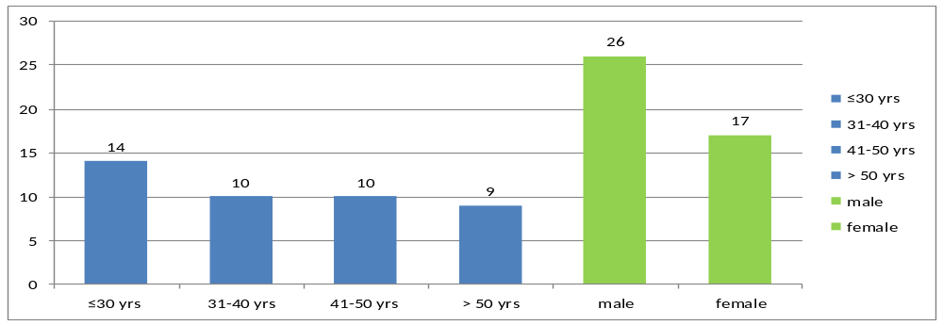Fig1 : Age and Gender distribution

Table 1. Volunteers and their medical history
Variable |  | No. | %
BMI | Normal | 8 | 18.6
BMI | Overweight | 23 | 53.5
BMI | Obese | 8 | 18.6
BMI | Morbid obesity | 4 | 9.3
Loss of sphincters control due to neurological causes | Yes | 0 | 0.0
Loss of sphincters control due to neurological causes | No | 0 | 0.0
Smoking | Yes | 2 | 4.6
Smoking | No | 41 | 95.4
Family history of cervical spine spondilytis | Yes | 9 | 20.9

Inclusion criteria:
Any working dentist were included in this study wether they had symptoms or not. The symptoms included neck pain, upper limbs radiculopathy, headache or trouble walking, etc.

Exclusion criteria:
Anyone who unerwent previous surgery or significant trauma to the cervical spine or who contraindicted to MRI reports were excluded from the study.
All volunteer dentists were examined by Philips, Acheva, 1.5 tesla model 2010 MRI machine. The examination was done in supine position with the RF coil under the neck. The protocols used were: sagittal T1W image, which is produced using spin echo (SE) sequence. This inlcuded a short echo time (TE < 30 ms), short repetition time (TR 300–700 ms), axial and Sagittal T2 weighting with repetition time (TR 2000-3000 ms) and long echo time (TE 80 ms ). All the results were reviewed by specialists in Diagnostic Radiology, experts in cervical changes and neuro-imaging.
Study Findings:
The data collected from the questionnaires stated that 13 professionals had more than 20 years of experience, followed by 9 having 16-20 years of experience, 5 having 11-15 years, 13 having 6-10 years, and 3 having <=5 years of experience. Out of this, 26 professionals worked 4-6 h per day and 5 worked more than 6 h a day. The speciality, posture of work, and other additional things have been clearly stated in Table 2. The table data stated that maximum respondents were general dental practioners (20 of them). Of 43 respondents, 33 had twisted work posture, and around 81.4% of respondents used suntem chair type.
Table 2. Speciality, posture postions, types of chaires used, and additional hobbies of the dental professionals.
Variables |  | No. | %
Specialty | General dental practitioners | 20 | 46.5
 | Surgeons | 10 | 23.3
 | Resident | 1 | 2.3
 | Other* | 12 | 27.9
Work posture | Neutral | 10 | 23.3
 | Twisted | 33 | 76.7
Type of chair | Suntem | 35 | 81.4
 | Other** | 8 | 18.6
Has a dental assistant | Yes | 17 | 39.5
Has a dental assistant | No | 18 | 41.8
Has a dental assistant | Not always | 8 | 18.6
Instrument accessibility | Easily accessible | 31 | 72
Instrument accessibility | Difficultly accessible | 12 | 28
Additional works burden neck (reading, using PC or mobile phone and sewing) | Yes | 12 | 28
 | No | 31 | 72
* Other specialty and work types include orthodontics, conservative dentistry, dental radiology, operative radiology and paediatric dentistry. **Other types of dental chairs included: CS 5001, Yaboshi, Electrica, Morita, Automatic, and Karyo types of dental chair trade marks
MRI data interpretation:
Disc degeneration was assessed in T2W images according to Lloydine J. Jacobs et al. grading system for each level alone from C2-C7 levels. Grade zero and one disc degeneration was considered to be normal while grade two and three were considered as abnormal.
Loss of disc height was assessed subjectively in comparison with higher normal levels and divided into 4 grades from 0-4 meaning 0-25%, 25-50%, 50-75% and 75-100 %.
Osteophytes were considered to be any osseous protrusion from the vertebral body outside its normal borders in anterior or posterior directions. The posterior part was divided into central or paracentral osteophytes, which were observed in T1W and T2W images in axial and sagittal views.
Disc herniation was considered as any protrusion of non-osseous disc material beyond borders of endplate of adjacent vertebral body, and classified as follows:
- Disc bulge when more than 50% of disc circumference was seen,
- Disc protrusion when less than 50% of disc circumference was seen with a wider base than tip,
- Disc extrusion when less than 50% of circumference was seen with narrower base than tip.
These protrusions were classified as central, paracentral, foraminal or extraforaminal (far lateral) according to its relationship with spinal cord in axial plane. Central protrusions were opposite to the middle third of the cord, paracentral was opposite to the lateral third, foraminal against neural foramen and extraforaminal (far lateral) protrusions lateral to the cord Some of the examples can be viewed in Figure 2.

Fig. 2: MRI images of cervical spine with cervical spine changes.

Sagittal T2W image of MRI of cervical spine of one of our participants: a 68 years old male dentist, presenting with grade 3 disc degeneration of C5-6 and grade 2 of C6-7 intervertebral discs (IVDs) with modic type endplate changes in C5-6. | 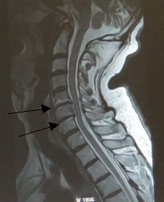
Axial T2W image with corresponding T2W sagittal scanogram of MRI of cervical spine of one of our participants: 70 year old male dentist presenting with posterior central protrusion of C5-6 IVD, causing moderate compression on the anterior thecal sac | 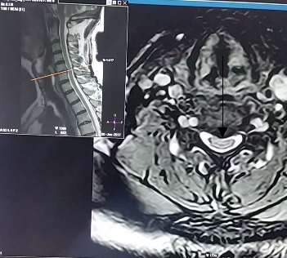
Sagittal and axial T2W image of MRI of cervical spine of a 36 year old female participant, showing normal AP diameter of spinal canal measuring 14.2 measured in sagittal plane | 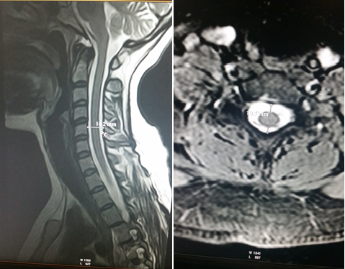
Sagittal T2W MRI views of three of our participants dentists: (A) male aged 30 years worked for 9 years/ 8 hours/day and has normal MRI and (B) male aged 41 years worked for 19 years/ 12 hours/day and has mild CSC (C) male aged 61 years worked for 38 years/ 2 hours /day and has severe CSC. | 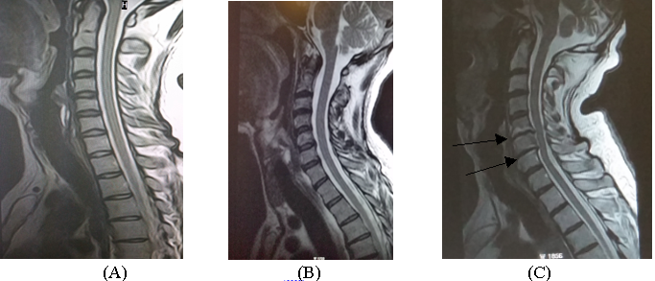

Twenty seven (62.8%) respondents showed at least single positive MRI change and 16 (37.3%) showed normal MRI. Positive MRI findings are mainly seen in males accounting for 17 (39.5%) participants, while females were 10 (23.2%). Negative findings were also more common in males than in females (Figure 3). All the findings were due to degenerative disc disease.
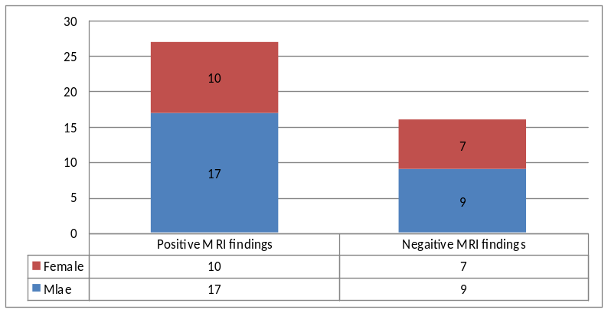

Fig 3. Details of participants with positive and negative MRI findings distributed by gender.
The most frequent MRI finding was disc degeneration seen in 27 respondents (62.8%), followed by disc herniation seen in 19 (44.2 %). Only degenerative type of spinal canal stenosis was seen. It was seen in 6 (14%) participants. The most frequently affected level was C5-6 (Table 3). C5-6 level was the most frequently affected level.
Table 3 Distribution of MRI findings by levels
Variables | No ( n = 43) | % | Most frequently level affected
IVD degeneration | 27 | 62.8 | C5-6
Disc herniation | 19 | 44.2 | C5-6
Posterior osteophyte | 27 | 62.8 | C5-6
Degenerative spinal canal stenosis and spinal cord compression | 6 | 18 | C5-6
Ligamentum flavum hypertrophy | 14 | 32.6 | C5-6

Correlation between MRI findings and demographic characteristics:
- Age was significantly correlated with CSC (P value= 0.003) (Table 4).
- Gender showed no significant correlation with CSC, although some CSCs were seen more frequently in males (8 of them showed herniation plus disc degeneration) , but it did not reach values to be statistically significant (P value= 0.6).
- Also, CSCs were seen more frequently in participants who worked in twisted posture but it did not reach values to be statistically significant.
- BMI and positive family history of CSCs showed significant correlation (Table 4).

- Also, CSCs were seen more frequently in participants who worked in twisted posture but it did not reach values to be statistically significant.
- BMI and positive family history of CSCs showed significant correlation (Table 4).

Table 4 Correlation between MRI findings and demographic characteristics
Finding |  | Age | BMI | Family history
loss of disc height level(s) | R* |  | 0.361
loss of disc height level(s) | P* |  | 0.007
Disc bulge | R | 0.377 | -0.323 | 0.304
Disc bulge | P | 0.005 | 0.017 | 0.025
Paracentral protrusion | R
Paracentral protrusion | P
foraminal protrusion | R | 1.000 | -1.000 | -1.000
foraminal protrusion | P | 0.001 | 0.001 | 0.001
Ligamentum flavum hypertrophy | R |  | 0.643
Ligamentum flavum hypertrophy |  |  | 0.013
*P= P.value, R= correlation coefficient

Table 5 Correlation between MRI changes and daily hours of work
 |  | Working hours per day |  |  |  |  |  | P.value
 |  | < 5 |  | 5 - 8 |  | > 8 |  | P.value
 |  | No. | % | No. | % | No. | % | P.value
posterior osteophytes | Yes | 2 | 40.0 | 15 | 65.2 | 11 | 73.3 | 0.40
posterior osteophytes | No | 3 | 60.0 | 8 | 34.8 | 4 | 26.7 | 0.40
Disc degeneration | Severe | 3 | 60.0 | 11 | 47.8 | 12 | 80.0 | 0.14
Disc degeneration | Mild | 2 | 40.0 | 12 | 52.2 | 3 | 20.0 | 0.14
Herniation | Yes | 4 | 80.0 | 16 | 69.6 | 13 | 86.7 | 0.47
Herniation | No | 1 | 20.0 | 7 | 30.4 | 2 | 13.3 | 0.47

There was also a significant correlation between CSC and increased years of work while there was no statistically significant correlation with increased hours of daily work (Tables 5 and 6).

Table 6 Correlation between different MRI findings and years of work

 |  | Years of work |  |  |  |  |  |  |  |  |  | P.value
 |  | < 5 |  | 6 - 10 |  | 11 - 15 |  | 16 - 20 |  | > 20 |  | P.value
 |  | No. | % | No. | % | No. | % | No. | % | No. | % | P.value
loss of disc  height | Yes | 1 | 33.3 | 1 | 7.7 | 0 | 0.0 | 1 | 11.1 | 5 | 38.5 | 0.18
loss of disc  height | No | 2 | 66.7 | 12 | 92.3 | 5 | 100 | 8 | 88.9 | 8 | 61.5 | 0.18
posterior  osteophytes | Yes | 1 | 33.3 | 5 | 38.5 | 3 | 60.0 | 7 | 77.8 | 12 | 92.3 | 0.035
posterior  osteophytes | No | 2 | 66.7 | 8 | 61.5 | 2 | 40.0 | 2 | 22.2 | 1 | 7.7 | 0.035
Disc  degeneration | Yes | 1 | 33.3 | 3 | 23.1 | 2 | 40.0 | 7 | 77.8 | 13 | 100.0 | 0.001
Disc  degeneration | No | 2 | 66.7 | 10 | 76.9 | 3 | 60.0 | 2 | 22.2 | 0 | 0.0 | 0.001
Herniation | Yes | 2 | 66.7 | 7 | 53.8 | 4 | 80.0 | 7 | 77.8 | 13 | 100.0 | 0.093
Herniation | No | 1 | 33.3 | 6 | 46.2 | 1 | 20.0 | 2 | 22.2 | 0 | 0.0 | 0.093
Foraminal  compression | Yes | 2 | 66.7 | 1 | 7.7 | 0 | 0.0 | 0 | 0.0 | 0 | 0.0 | 0.001
Foraminal  compression | No | 1 | 33.3 | 12 | 92.3 | 5 | 100.0 | 9 | 100.0 | 13 | 100.0 | 0.001
Thecal Sac  compression | Yes | 2 | 66.7 | 8 | 61.5 | 4 | 80.0 | 7 | 77.8 | 13 | 100.0 | 0.19
Thecal Sac  compression | No | 1 | 33.3 | 5 | 38.5 | 1 | 20.0 | 2 | 22.2 | 0 | 0.0 | 0.19
degenerative  spinal canal  stenosis | Yes | 1 | 33.3 | 0 | 0.0 | 0 | 0.0 | 1 | 11.1 | 5 | 38.5 | 0.061
degenerative  spinal canal  stenosis | No | 2 | 66.7 | 13 | 100.0 | 5 | 100.0 | 8 | 88.9 | 8 | 61.5 | 0.061
Spinal cord  compression | Yes | 1 | 33.3 | 0 | 0.0 | 0 | 0.0 | 1 | 11.1 | 4 | 30.8 | 0.14
Spinal cord  compression | No | 2 | 66.7 | 13 | 100.0 | 5 | 100.0 | 8 | 88.9 | 9 | 69.2 | 0.14
But after adjustment of age, gender and body mass index, there was no correlation between years of work and MRI changes, which stated that the changes could be due to the ageing process rather than dental work as shown in this study (Appendix C).. There was no statistically significant correlation between symptoms and MRI changes as shown in Table 7. No significant correlation was found between CSC and work posture, type of dental chair or presence or absence of assistants and the details have been presented in Appendices D-G.

Table 7 Correlation between MRI findings with symptomatic and asymptomatic participants.
Variables |  | Symptomatic  (n = 28) |  | Asymptomatic (n = 15) |  | P. value
 |  | No. | % | No. | % | P. value
Posterior osteophytes | Yes | 19 | 67.9 | 9 | 60.0 | 0.61
Posterior osteophytes | No | 9 | 32.1 | 6 | 40.0 | 0.61
Disc degeneration | Yes | 17 | 60.7 | 9 | 60.0 | 0.96
Disc degeneration | No | 11 | 39.3 | 6 | 40.0 | 0.96
Disc herniation | Yes | 23 | 82.1 | 10 | 66.7 | 0.25
Disc herniation | No | 5 | 17.9 | 5 | 33.3 | 0.25

Discussion
We could not find any previous similar radiological studies which did an MRI on dental professionals to compare with. However, many clinical studies revealed that MSDs are common among dentists. They have a higher incidence of work related MSDs than workers of other occupations ^{(1-7).} Neck pain and upper limb numbness are the most common symptoms and occur in more than 85% of dentists after they start working ^{(15).}
Many dentists or faciomaxillary surgeons, if not all of them, blame their routine dental work as the main cause of their neck pain and/or radiculopathy, which are relatively common symptoms among the dentists. Many of the dentists may seek for multiple sick leaves, changing job or even retirement due to ill health. In the latter case, MSDs is the most common causative factor accounting for 55% of all ill health retirements. ^{(9, 18)}

Conclusion and future recommendations:
MRI of cervical spines derangement among working dentists was found to be positive (86%) and all of the changes were related to cervical spine spondylosis. The most common finding is disc degeneration followed by disc herniation. The frequency of CSC distributed by levels, i.e. from the most to the least severe levels: C5-6, C4-5, C3-4 and C6-7. There was no statistically significant correlation between symptoms and MRI findings of CSC disc degeneration with and without disc herniation, which significantly increased with increase in the age in case of symptomatic as well as asymptomatic participants. There was no overall statistically significant correlation between gender and CSC, whether in symptomatic or asymptomatic participants.
CSC was seen to be significantly correlated with BMI and family history of CSC. No statistically significant correlation was found between years of work and daily hours of work with CSC; however this result may not reflect the reality, because of small sample size in this study, which involved more younger partiipants that responded. No significant correlation was found between CSC and work posture, type of dental chair or presence or absence of assistants.

The current study recommends the following:
- This study is considered to have the antecedent in studying MRI of cervical spine derangement among working dentists and it is considered to be an evidence-based study.
- The authors ncourage further studies with larger sample size.
- The authors also recommend preventive strategies for working dentists by adopting neutral body postures, designing the work to allow machinery to perform/assist highly repetitive tasks and early management of disorders.

REFRENCES :
- Finsen L, Christensen H, Bakke M. Musculoskeletal disorders among dentists and variation in dental work. Appl Ergon. 1998 Apr;29(2):119-25
- Tirgar A, Javanshir K, Talebian A, Amini F, Parhiz A. Musculoskeletal disorders among a group of Iranian general dental practitioners. Journal of back and musculoskeletal rehabilitation. 2015;28(4):755-9.
- Alexopoulos EC, Stathi IC, Charizani F. Prevalence of musculoskeletal disorders in dentists. BMC musculoskeletal disorders. 2004;5:16.
- Morse T, Bruneau H, Dussetschleger J. Musculoskeletal disorders of the neck and shoulder in the dental professions. Work. 2010;35(4):419-29.
- Modic M, Masaryk T, Mulopulos G, Bundschuh C, Han J, Bohlman H. Cervical radiculopathy: prospective evaluation with surface coil MR imaging, CT with metrizamide, and metrizamide myelography. Radiology. 1986;161(3):753-9.
- Dajpratham P, Ploypetch T, Kiattavorncharoen S, Boonsiriseth K. Prevalence and associated factors of musculoskeletal pain among the dental personnel in a dental school. Journal of the Medical Association of Thailand = Chotmaihet thangphaet. 2010;93(6):714-21.
- Chowanadisai S, Kukiattrakoon B, Yapong B, Kedjarune U, Leggat PA. Occupational health problems of dentists in southern Thailand. International dental journal. 2000;50(1):36-40.
- Brown J, Burke F, Macdonald E, Gilmour H, Hill K, Morris A, et al. Dental practitioners and ill health retirement: causes, outcomes and re-employment. British dental journal. 2010;209(5):E7-E.
- Rafie F, Zamani Jam A, Shahravan A, Raoof M, Eskandarizadeh A. Prevalence of upper extremity musculoskeletal disorders in dentists: Symptoms and risk factors. Journal of environmental and public health. 2015;2015.
- Muralidharan D, Fareed N, Shanthi M. Musculoskeletal disorders among dental practitioners: does it affect practice? Epidemiology Research International. 2013;2013.
- Scott E. Forseen M, Neil M. Borden, MD. Imaging Anatomy of the Human Spine: demosMEDICAL; 2016.
- Stephanie Ryan MM, Stephen Eustace. Anatomy for Diagnostic Imaging. 3rd ed: Elsevier; 2011.chapter three , P. 85-105
- Alghadir A, Zafar H, Iqbal ZA. Work-related musculoskeletal disorders among dental professionals in Saudi Arabia. Journal of physical therapy science. 2015; 27(4):1107-12.
- Ohlendorf D, Erbe C, Hauck I, Nowak J, Hermanns I, Ditchen D, et al. Kinematic analysis of work-related musculoskeletal loading of trunk among dentists in Germany. BMC musculoskeletal disorders. 2016; 17(1):427.
- Kumar VK, Kumar SP, Baliga MR. Prevalence of work-related musculoskeletal complaints among dentists in India: a national cross-sectional survey. Indian Journal of Dental Research. 2013; 24(4):428.
- Devanand G, John BD, Rajendra GK, Bushra K, Alpana K, Ankita J, et al. Use of complementary and alternative medicine for work related musculoskeletal disorders associated with job contentment in dental professionals: Indian outlook. Ethiopian journal of health sciences. 2014; 24(2):117-24.
- Hodacova L, Sustova Z, Cermakova E, Kapitan M, Smejkalova J. Self-reported risk factors related to the most frequent musculoskeletal complaints among Czech dentists. Industrial health. 2015; 53(1):48.
- Maguire M, O'Connell T. Ill-health retirement of schoolteachers in the Republic of Ireland. Occupational Medicine. 2007;57(3):191-3
- Sether L, Yu S, Haughton V, Fischer M. Intervertebral disk: normal age-related changes in MR signal intensity. Radiology. 1990; 177(2):385-8.
- Lehto IJ, Tertti MO, Komu ME, Paajanen HE, Tuominen J, Kormano MJ. Age-related MRI changes at 0.1 T in cervical discs in asymptomatic subjects. Neuroradiology. 1994; 36(1):49-53.
- Martini F OW, Garrison CW et-al. Fundamentals of anatomy & physiology. Prentice Hall College Div. ISBN. (0130172928).
- Schoenberg SO. Parallel Imaging in Clinical MR Applications. Berlin:Springer-Verlag; 2007.
- Scott E. Forseen M, Neil M. Borden, MD. Imaging Anatomy of the Human Spine: demosMEDICAL; 2016.
- Wolfgang Dahnert MD. Radiology Review Manual. Seventh Edition ed: Wolters Kluwer I Lippincott Williams & Wilkins Health; 2011,chapter two, p.206-208.
- Sether L, Yu S, Haughton V, Fischer M. Intervertebral disk: normal age-related changes in MR signal intensity. Radiology. 1990; 177(2):385-8.

Acknowldgment(s) :

We appreciate the hard work of Dr Fatimeh Shimirty for her assistance in collecting the data and reviewing the study.

Appendix A. Questionnaire and consent form
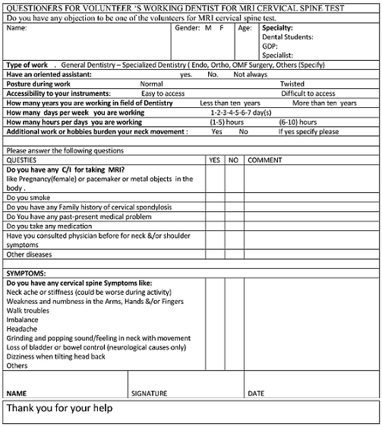

Appendix B. Medical History and related problems

Variable | No. | %
Medications use | 6 | 14
Consultations for neck problems | 10 | 23.3
Neck pain | 28 | 65.1
Upper limb numbness | 17 | 39.5
Walk troubles | 3 | 6.9
Loss of balance | 3 | 6.9
Headache | 17 | 39.5
Popping | 9 | 20.9
Loss of urine or bowel control | 0 | 0.0
Tingling | 7 | 16.2
Dizziness | 6 | 14
low back pain | 7 | 16.2

Appendix C. Correlation of MRI findings with years of work and daily dental work hours, after adjustment for age, gender and BMI, showing no significant correlations
 |  | Years of work | Working hours on chair
posterior osteophytes | R | 0.007 | -0.035
posterior osteophytes | P | 0.967 | 0.833
Herniation | R | 0.036 | 0.071
Herniation | P | 0.826 | 0.667
Degenerative spinal canal stenosis and spinal cord compression | R | -0.026 | -0.214
 | P | 0.878 | 0.191

Appendix D Correlation of work posture with CSC
 |  | Work posture |  |  |  | P
 |  | Neutral ( n = 10) |  | Twisted ( n = 33) |  | P
Posterior osteophytes | Yes | 6 | 60.0% | 22 | 66.7% | 0.70
Posterior osteophytes | No | 4 | 40.0% | 11 | 33.3% | 0.70
Disc degeneration | Yes | 6 | 60.0% | 20 | 60.6% | 0.97
Disc degeneration | No | 4 | 40.0% | 13 | 39.4% | 0.97
Herniation | Yes | 9 | 90.0% | 24 | 72.7% | 0.26
Herniation | No | 1 | 10.0% | 9 | 27.3% | 0.26

Appendix E Correlation of type of dental chair with CSC
 |  | Type of chair |  |  |  | P
 |  | Suntem ( n = 36) |  | Other ( n = 7) |  | P
Posterior osteophytes | Yes | 23 | 63.9% | 5 | 71.4% | 0.70
Posterior osteophytes | No | 13 | 36.1% | 2 | 28.6% | 0.70
Disc degeneration | Yes | 20 | 55.6% | 6 | 85.7% | 0.14
Disc degeneration | No | 16 | 44.4% | 1 | 14.3% | 0.14
Herniation | Yes | 26 | 72.2% | 7 | 100.0% | 0.63
Herniation | No | 10 | 27.8% | 0 | 0.0% | 0.63

Appendix F. Correlation of presence of dental assistant with CSC
 |  | Have an oriented assistant |  |  |  |  |  |  | P
 |  | Yes ( n = 16) |  |  | No ( n = 18) |  | Not always ( n =9) |  | P
Posterior osteophytes | Yes |  | 10 | 62.5% | 14 | 77.8% | 4 | 44.4% | 0.22
Posterior osteophytes | No |  | 6 | 37.5% | 4 | 22.2% | 5 | 55.6% | 0.22
Disc degeneration | Yes |  | 9 | 56.3% | 12 | 66.7% | 5 | 55.6% | 0.78
Disc degeneration | No |  | 7 | 43.8% | 6 | 33.3% | 4 | 44.4% | 0.78
Herniation | Yes |  | 11 | 68.8% | 13 | 72.2% | 9 | 100.0% | 0.16
Herniation | No |  | 5 | 31.3% | 5 | 27.8% | 0 | 0.0% | 0.16

Appendix G. Correlation of smoking with CSC
 |  | Smoking |  |  |  | P
 |  | Yes ( n =2) |  | No ( n =41) |  | P
Posterior osteophytes | Yes | 1 | 50.0% | 27 | 65.9% | 0.65
Posterior osteophytes | No | 1 | 50.0% | 14 | 34.1% | 0.65
Disc degeneration | Yes | 0 | 0.0% | 26 | 63.4% | 0.073
Disc degeneration | No | 2 | 100.0% | 15 | 36.6% | 0.073
Herniation | Yes | 2 | 100.0% | 31 | 75.6% | 0.43
Herniation | No | 0 | 0.0% | 10 | 24.4% | 0.43
Herniation | No | 0 | 0.0% | 9 | 22.0% | 0.43

