Title of the article: Development and Validation of the Iranian Scale of “Patient Privacy and Confidentiality”

Fatemeh Movafegh¹, Abbas Abbaszade², Maryam Rassouli³, Mohammad-Sajjad Lotfi⁴, Malihe Nasiri⁵
. Fatemeh Movafegh Master of nursing, Shahid Beheshti University of Medical Sciences, Tehran, Iran, Email: samymovafegh2015@gmail.com, Tel: +989120512109

² Abbas Abbaszade* School of Nursing and Midwifery, Shahid Beheshti University of Medical Sciences, Tehran, Iran, Email: aabaszadeh@sbmu.ac.ir, Tel:+989131444119

³. Maryam Rassouli Cancer Research center, Shahid Beheshti University of Medical Sciences, Tehran, Iran Iran, Email: rassouli.n@gmail.com, Tel: +989122494013

⁴. Mohammad-Sajjad Lotfi Iranian Research Center on Ageing, University of Social Welfare and Rehabilitation Sciences, Tehran, Iran, Email: sajjad.lotfi@yahoo.com, Tel: +989390315269

^{5.} Malihe Nasiri Faculty of Nursing and Midwifery, Shahid Beheshti University of Medical Sciences, Tehran, IR Iran AND Department of Biostatistics, Faculty of Paramedical, Shahid Beheshti University of Medical Sciences, Tehran, IR Iran, Email: malihenasiri@gmail.com, Tel: +989177204642

Corresponding Author:
Name: Abbas Abbaszade
Address: Vali Asr Ave - Prayer Crossing - Opposite Shahid Rajaee Heart Hospital - Faculty of Nursing and Midwifery Shahid Beheshti University of Medical Sciences, Tehran, Iran
Phone numbers: +989131444119
Facsimile numbers +98 21 88655363
E-mail address aabaszadeh@sbmu.ac.ir

Dear Editor,

This is to confirm that the article entitled “Development and Validation of the Iranian Scale of “Patient Privacy and Confidentiality” ” submitted to the Indian Journal of Medical Ethics is original and has been authored by the undersigned.

The submission is not under consideration for publication in any other journal.

Details of sponsorship or relevant competing interests, financial or otherwise: Shahid Beheshti School of Nursing and Midwifery

I have read the terms and conditions of authorship of IJME and accept them.

I think my paper is suitable for publication in an ethics journal because: Because our manuscript is in your journal scope and Patient Privacy and Confidentiality is

Contact details (mailing address, institutional and personal email id) and current affiliation:

Signature of author:

Name Signature Date signed
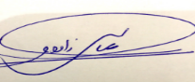
1 Abbas Abbaszade - 2019.9.11
2 Fatemeh Movafegh 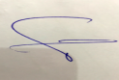--- 2019.9.12
3 Maryam Rassouli --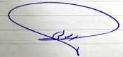------------ 2019.9.12
4 Mohammad Sajjad Lotfi -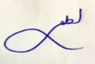-- ------------- 2019.9.12
5 -Malihe Nasiri ---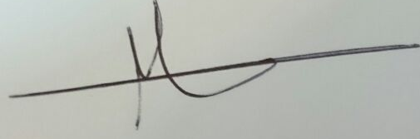---- - 2019.9.12

