02/04/2020

Dear Editor,

This is to confirm that the article entitled “Cancer treatment vis-à-vis COVID-19: The
ledge of a precipice!! ” submitted to the Indian Journal of Medical Ethics is original and has been co-authored by the undersigned. All authors have participated in the work sufficiently to meet the ICMJE guidelines for authorship. All have read and approved the manuscript.

The submission is not under consideration for publication in any other journal.
We give consent to Dr Gaurav Aggarwal to act as the author for correspondence.

We have no sponsorship or relevant competing interests, financial or otherwise.
We have read the terms and conditions of authorship of IJME and accept them.

We feel the submission is suited to a medical ethics journal because:
Considering the current pandemic of Corona virus, our write up tries to lay open in pen and paper, the ethical dilemma of both cancer patients as well as cancer care providers.

Contact details (mailing address, institutional and personal and institutional email ids) and current affiliations of all co-authors:
- Dr. Gaurav Aggarwal
Consultant,
Dept of Uro-Oncology,
Tata Medical Center,
Newtown, Kolkata,
West Bengal.
Email id: drgaurav1981@rediffmail.com
ORCID ID: https://orcid.org/0000-0002-6524-700X

- Sujoy Gupta
MS, FRCS (Urology);
Sr. Consultant, Uro-Oncology,
Tata Medical Center,
Newtown, Kolkata,
West Bengal.
Email id: sujoy.gupta@tmckolkata.com

Names and signatures of all authors:

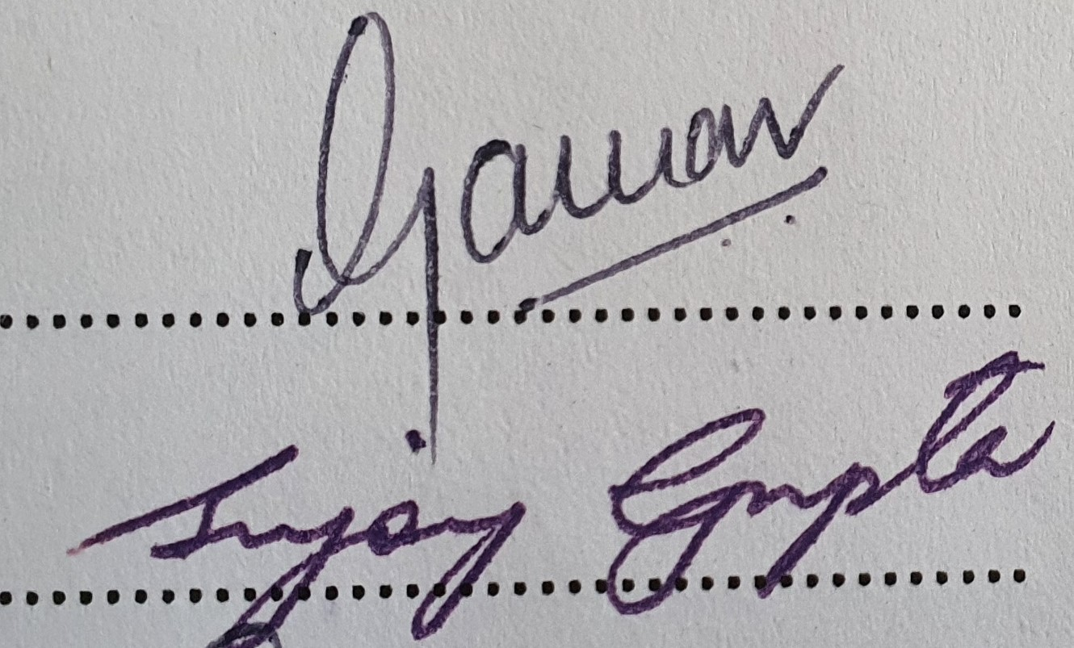
- Gaurav Aggarwal

- Sujoy Gupta

