Dear Editor,

This is to confirm that the article entitled “-Hippocratic Oath and its relevance in the COVID world-” submitted to the Indian Journal of Medical Ethics is original and has been co-authored by the undersigned. All authors have participated in the work sufficiently to meet the ICMJE guidelines for authorship. All have read and approved the manuscript.

The submission is not under consideration for publication in any other journal.

We give consent to Dr. Roopa Verghese to act as the author for correspondence.

All details of sponsorship or relevant competing interests, financial or otherwise: have been disclosed.

We have read the terms and conditions of authorship of IJME and accept them.

We feel the submission is suited to a medical ethics journal because:- Hippocratic Oath is the basis of medial ethics and to have rethought or reconsideration into the same at this pertinent pandemic time was considered formost important in my viewpoint and hence a thought to publish the same in a reouted ethical journal.----(in up to 100 words)

Contact details (mailing address, institutional and personal and institutional email ids) and current affiliations of all co-authors:
Primary Author
Dr. Roopa Verghese, MD.MA
Senior consultant (OBGYN ) and Bioethicist.
The Center for Bioethics
New Delhi.
zrverghe@gmail.com

Secondary Author
Dr. Jewel J. Jacob, MD
Senior consultant ( Anesthesia and critical Care)
Muthoot Healthcare
Kozhencherry, Kerala.
jewelz.ninan@gamil.com

Names and signatures of all authors:

Dr Roopa Verghese 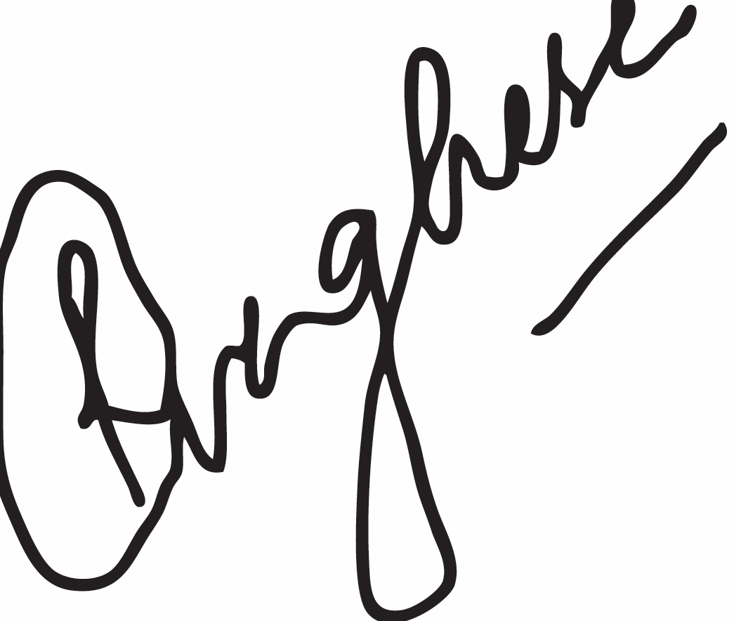
Dr.Jewel Jagan Jacob 