Dear Editor,

This is to confirm that the article entitled “An Assessment of the Public Healthcare System by Measuring Patients’ Experience about Healthcare in Alipurduar District, India” submitted to the Indian Journal of Medical Ethics is original and has been authored by the undersigned.

The submission is not under consideration for publication in any other journal.

Details of sponsorship or relevant competing interests, financial or otherwise: This study has not received any grant from any funding agency.

I have read the terms and conditions of authorship of IJME and accept them.

I think my paper is suitable for publication in an ethics journal because the topic of this paper very much related to this. This study is based on primary data where the experience of patients has given more importance and both qualitative and qualitative analysis is applied. Their experience varies among different level of healthcare system because of the variation of delivered services which is not ethical. In addition, this study shows that the behaviour of the providers is not satisfactory and not ethically correct.

Contact details (mailing address, institutional and personal email id) and current affiliation:
Name: Barnali Biswas, Research Scholar
Address: Department of Geography, Cooch Behar Panchanan Barma University, Vivekananda Street, Cooch Behar-736101, West Bengal, India
Phone numbers: +91 8346014715
E-mail address: barnalibiswas@002gmail.com

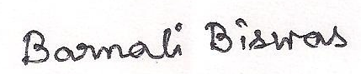

Signature of author:

