Knowledge Level on Patient rights at Selected Hospital, Puducherry
Mr. P. Prakash¹, Asst. Professor, Dept. Of Mental Health Nursing, College of Nursing, Pondicherry Institute of Medical Sciences, email: prakash.lalitha88@gmail.com, Ph:8903615913, 8015100710.
Ms. Sulu Kuruvilla², Registered Nurse. Email id - sulukuruvilla@gmail.com. Ph: 9994987622
Ms. Ranjani R³., Registered Nurse. Email id- ranjaniramesh6991@gmail.com Ph.8428658081

ABSTRACT

A study to assess the level of knowledge on patient’s rights among hospitalized patients at selected hospital, Puducherry. Descriptive design was adopted in this study. Study was conducted among hospitalized patients in medical and surgical wards of PIMS hospital, Puducherry. 68 samples were selected by simple random technique. Structured questionnaire was used to assess the level of knowledge among participants after the content validity. The data gathered were analyzed by using descriptive and inferential statistics. The present study assessed the level of knowledge on hospitalized patients and it was found that 32(47%) participants had highly adequate knowledge, 36(53%) participants had adequate knowledge on patient’s rights. There is no association between the level of knowledge with socio demographic variables such as age, gender, educational status, religion, occupational status, marital status, source of information and previous hospital admission. The majority of hospitalized patients had highly adequate knowledge on patient’s rights.

BACKGROUND OF THE STUDY
In the system of studying patient’s rights and responsibilities not only patients play the leading role, but the medical environment, medical staff that surrounds them formulate law in a system. Patient rights may be classified as either legal or human statement of desirable ethical principle. Both staff and patient should aware and understand not only the rights but also the responsibilities of each other. ¹
The patients’ rights start from the first moment he or she enters the hospital. The first thing that every patient should know –he must get a medical help regardless of his sex, race, religion and nationality. Moreover any patient can demand a copy of patient’s rights and in that way patient can acquire the necessary subsidiary information in order to be versed in his rights and responsibilities.¹
A patient is anyone who has requested to be evaluated by or who is being evaluated by a healthcare professional.²

NEED FOR THE STUDY
The low doctor –population ratio in India puts a tremendous strain on the available medical facilities and restricts the time available for doctors to interact with patients. There are thus valid reasons why doctor do not explain in detail to the patient, diagnosis, the treatment plan or expected prognosis. However, not providing such information to patients is a clear violation of their rights.³
Patient’s rights vary in different countries and in different jurisdictions, often depending upon prevailing cultural and social norms. So respecting the patient rights is a fundamental aspect of providing quality health care. Passing a regulation is not a guarantee for the protection of patient’s right. For any developing country like India to step high in the development of the quality of health care it should take over the essential part of awareness regarding patient right.⁴
The patient right charter differ from one country to another but there are main principle agreed upon universally and can be found in mast of the countries that have the legislation of
patient rights declared, which are the right to access information recorded in higher medical records and to be fully informed about the health status, the right to care and treatment, the patient has the right to make free decision, and the patient has the right privacy and confidentiality of information and socio medial data.⁴
At the same time the patient has some responsibilities or duties that she or he needs to be aware of them and implement them practically, duties towards themselves, other patients and relatives, health care personnel and society.⁴
Hence the researcher got interest to assess the level of knowledge on patient’s rights among hospitalized patients.
STATEMENT OF THE PROBLEM
A study to assess the level of knowledge on patient’s rights among hospitalized patients at PIMS hospital, Puducherry.

OBJECTIVES OF THE STUDY
- To assess the knowledge on patient rights among hospitalized patients.
- To find association between the level of knowledge and demographic variables among hospitalized patients.

OPERATIONAL DEFINITION
Knowledge on Patient’s Rights
In this study, knowledge refers to the response of patients on awareness of patient’s rights. It is assessed by using structured knowledge questionnaire on patient’s rights.
Hospitalized Patient
Male and female patients of age above 18 years who are admitted in medical and surgical wards at PIMS, Puducherry.

METHODOLOGY
Research Approach - Research approach is the most significant part of any research. The appropriate choice of the research approach depends upon the purpose of the research study which has been undertaken in order to accomplish the main objectives of the study. In this study quantitative research approach was adopted.
Reseach Design - Descriptive research design was used by the researcher in this study.
Setting - This study was conducted in medical and surgical wards of Pondicherry Institute of Medical Sciences, Puducherry.
Target population - Hospitalized patients in Pondicherry Institute of Medical Sciences, Puducherry
Accessible population - Patients admitted in medical and surgical wards at PIMS, Puducherry
Sample Size - 68 hospitalized patients who fulfilled the research criteria were included in this study.
Sampling Technique - Simple random technique was used for selecting samples.
Sampling Criteria
Inclusion Criteria
- Both male and female patients
- Hospitalized patients who are willing to participate in the study
- Patients who are able to understand and write English or Tamil
Exclusion Criteria
- Those who are below 18 years of age
- Patients who are bed ridden or terminally ill
- Those who are hospitalized less than 24 hours
- Patients who have complete sensory impairment(Hearing and visual defects)
Instrument and Tools Used - A structured knowledge questionnaire was used to assess the level of knowledge of hospitalized patients on patient’s rights.
Description of Tool
After an extensive review of literature and discussion with the experts, a self administered structured questionnaire was prepared to assess the level of knowledge of hospitalized patient on patient’s rights.
The questionnaire divided into 2 sections ‘A’ and ‘B’.

Section A
It contains demographic questions on variables which include age, gender, educational status, religion, occupation, marital status, previous hospital admission, previous OPD visit and source of information regarding patient’s rights.
Section B
It consists of 30 dichotomous questions to assess the level of knowledge on patient’s rights. Questions based on rights related to medical treatment, information, choices, privacy, complaints and healthy and safe environment.
Scoring key
Total no of questions : 30
SL.No | Category | Question number | Right answer  (score:1) | Wrong answer  (Score: 0)
1 | A | 1,2,4,9,10,11,13,17,18,19,21,22,23,26,30 | Yes | No
2 | B | 3,5,6,7,8,12,14,15,16,20,24,25,27,28,29 | No | Yes

Scoring interpretation (grading)
Knowledge | Score
Highly adequate | >25
Adequate | 15-24
Inadequate | 6-14
Highly inadequate | <5
.
VALIDITY OF TOOL
Content validity was obtained from 5 experts as their names and designation is mentioned in annexure. Their suggestions were included in this study.

ETHICAL CONSIDERATION
- Prior permission was obtained from the Dean-College of Nursing, PIMS and Nursing superintendent, Pondicherry Institute of Medical sciences.
- Informed consent was obtained from individual participants. Data collected were kept confidential.

PILOT STUDY
The pilot study was conducted to identify the feasibility of the study from 20 August 2018 to 24 August 2018 at medical ward, Pondicherry Institute of Medical Sciences. After obtaining the consent from research participants pilot study was conducted to identify the feasibility of the study among 15 hospitalized patients. Data collection was done using structured knowledge questionnaire. Anonymity and confidentiality were maintained while collecting information. The data was analyzed using SPSS-21. The results revealed that all of the participants had adequate knowledge.

DATA COLLECTION PROCESS
The level of knowledge on patient’s rights among hospitalized patients was assessed by self administered structured questionnaire method. Prior to data collection formal approval was obtained from the Dean-College of Nursing, PIMS, the Nursing Superintendent and the ward in-charges of both medical and surgical wards to conduct the study. The study was carried out during the month of September 2018 with 68 hospitalized patients selected using random sampling technique by lottery method, in medical and surgical wards, PIMS, Puducherry. Self-introduction was given by the investigator, the purpose of the study was explained to the subjects, assuring confidentiality of findings. Written consent was obtained from the participants from both medical and surgical wards to participate in the study. The data sheet consists of a structured two part questionnaire on patient’s rights, designed by the researcher was constructed in both English and local language (Tamil) for a span of 35 minutes to complete it. Research participants found inadequate in knowledge on a subtype such as right to medical treatment, right to information, right to choices, right to privacy, right related to complaint, and right related to healthy and safe environment was provided with necessary information by the researcher.

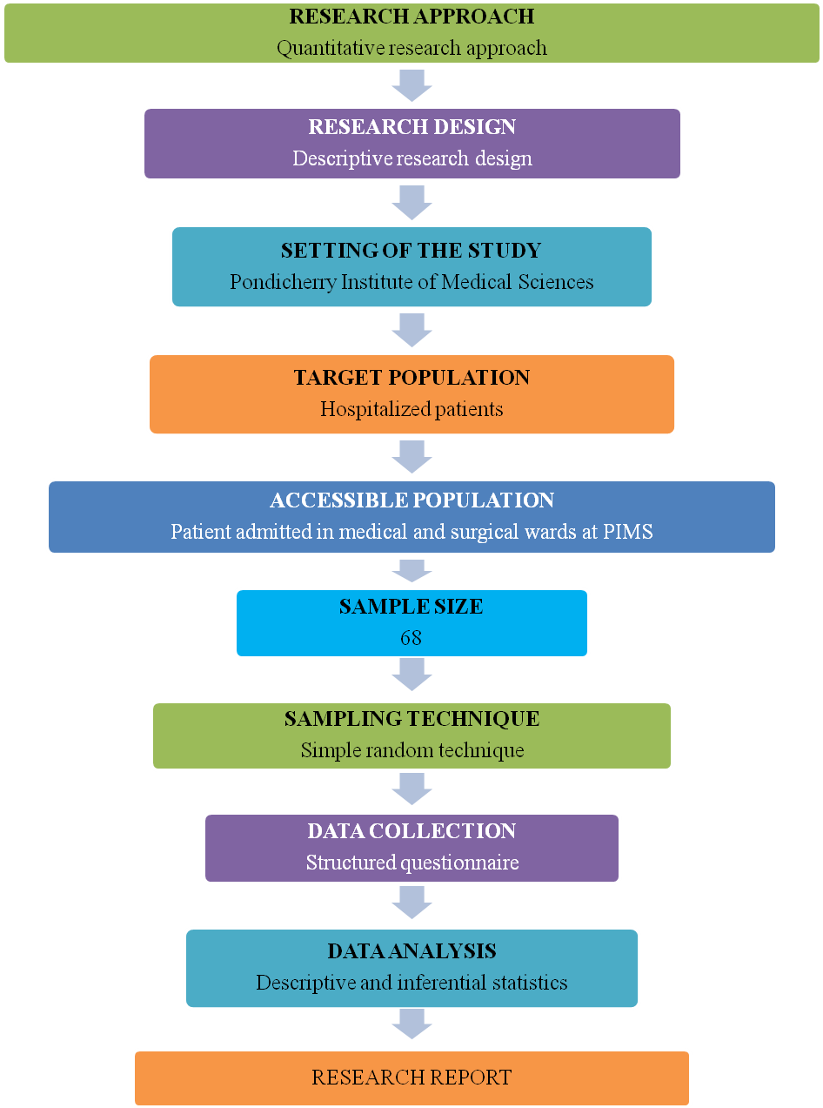
Figure 1: Schematic representation of research process

DATA ANALYSIS AND INTERPRETATION OF FINDINGS
SECTION A: DESCRIPTION OF DEMOGRAPHIC VARIABLES OF THE HOSPITALIZED PATIENTS.
n = 68
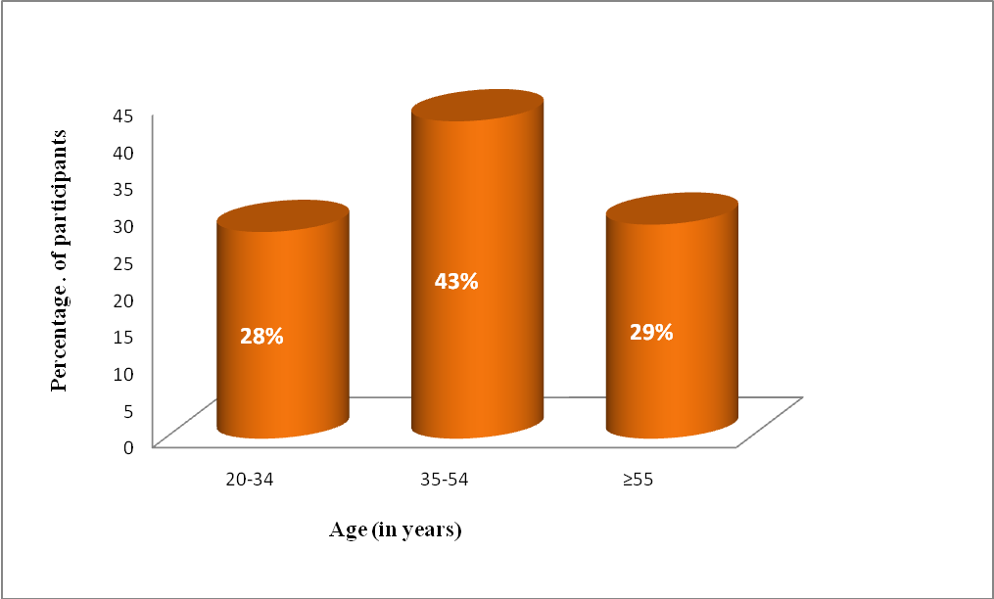
Figure 2: Distribution of hospitalized patients according to the age
Figure 2 reveals that among sixty eight participants most of them (43%) were between 35-54 years of age, 29% of participants were coming under the age group of 55 years and above. Only 28 % of participants are in 20-34 years of age.
n=68
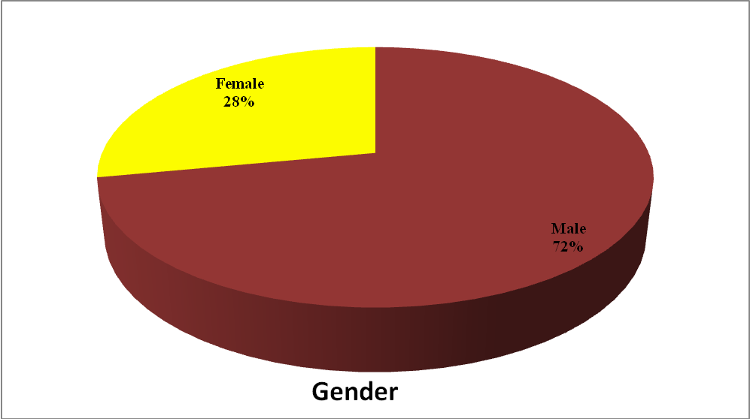

Figure 3: Distribution of hospitalized patients according to the gender
72.1%

Figure 3 reveals the distribution of participants based on gender, shows that majorities (72%) of participants were male and 28% participants were female.

n =68
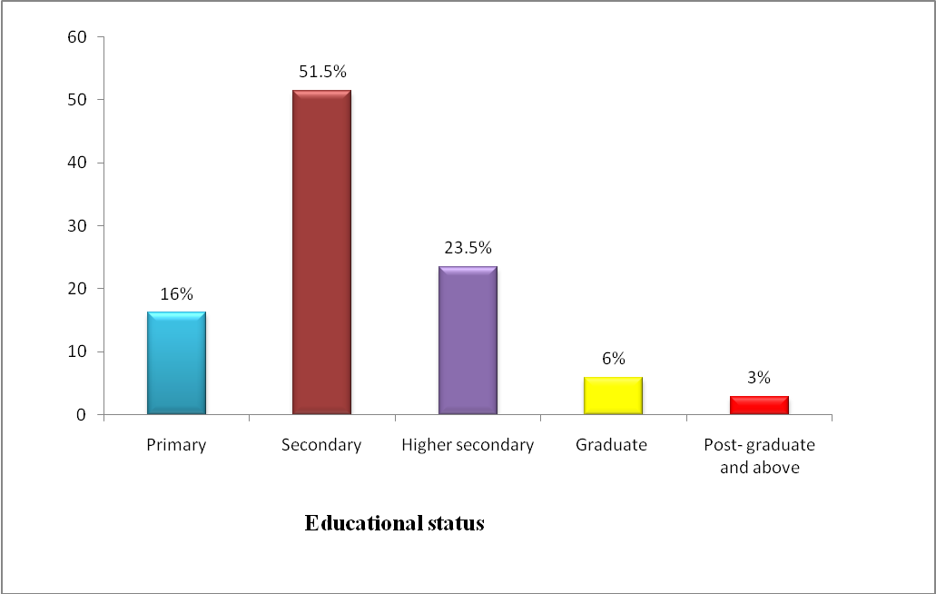 Figure 4: Distribution of hospitalized patient according to the educational status
Figure 4 reveals distribution of participants based on educational status shows that majority (51.5% )of participants were studied up to secondary classes, 23.5% participants were higher secondary, 16% participants were primary, 6% participants were graduates and only 3% of participants were post -graduate and above.
n = 68
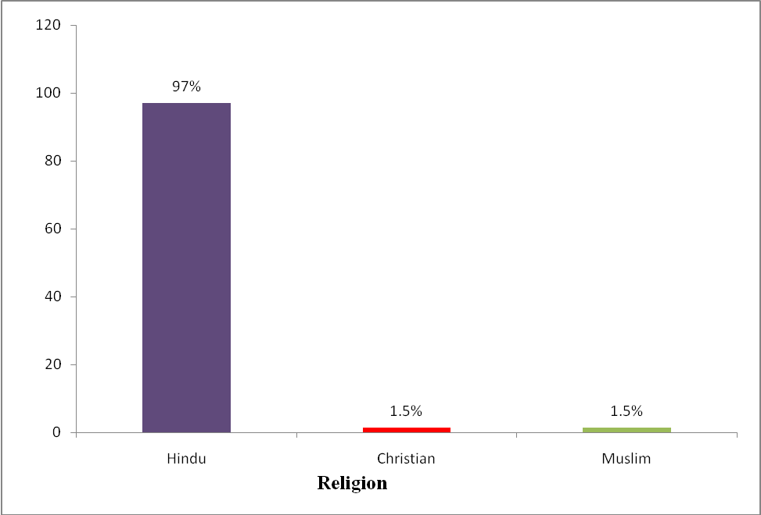
Figure 5: Distribution of hospitalized patients according to the religion
Figure 5 represents distribution of participants based on religion shows that majority (97%) of participants were Hindu. 1.5% of participants were Christian and remaining 1.5% of participants belongs to Muslim religion.

n = 68
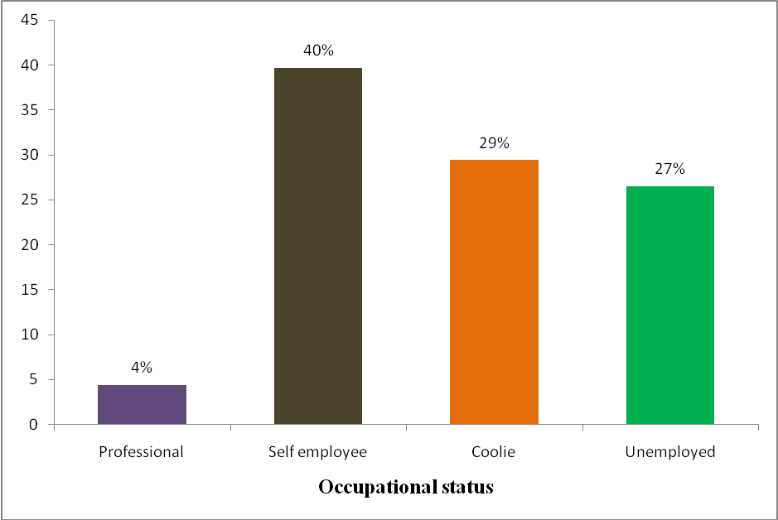

Figure 6: Distribution of hospitalized patients according to the occupational status
Figure 6 represents distribution of participants based on their occupational status shows that most (40%)of the participants were self employees, 29%participants were coolie workers, 27% participants were unemployed and only 4% of participants were professionals.
n=68
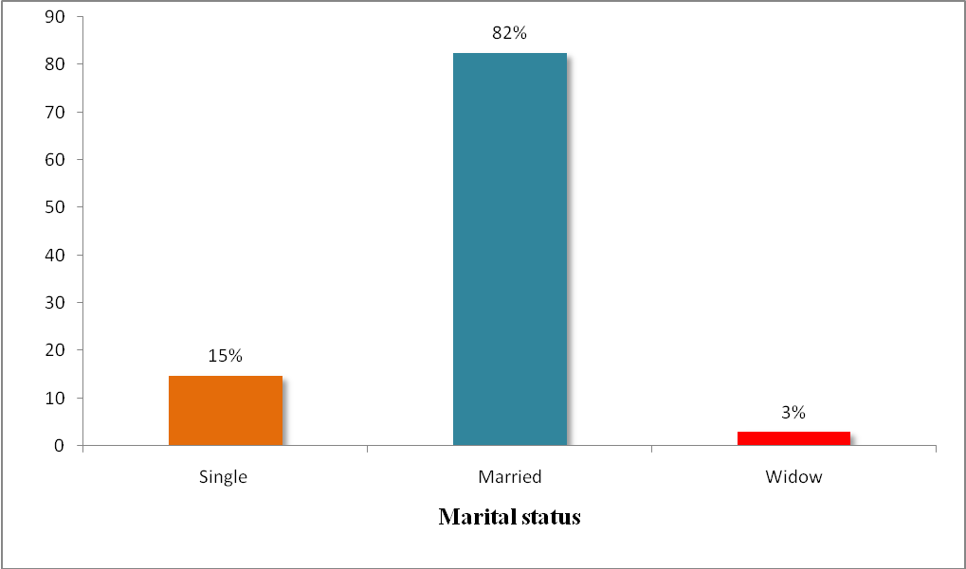
Figure 7: Distribution of hospitalized patients according to the marital status
Figure 7 represents distribution of participants based on their marital status shows that majority (82.4%) of participants were married, 14.7% participants were single and only 2.9% of participants were widow.

n= 68

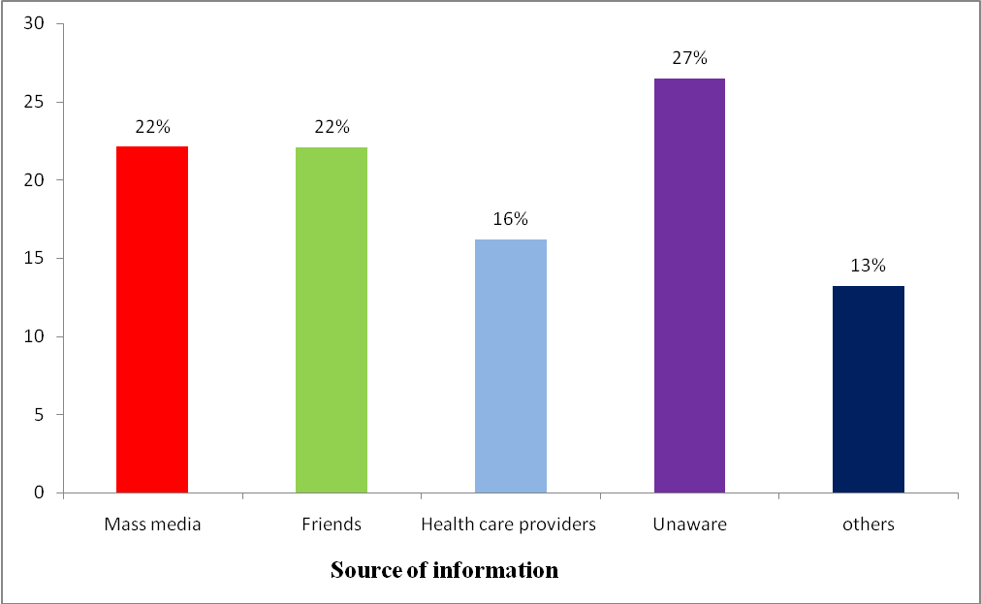
Figure 8: Distribution of hospitalized patients according to the source of information regarding patient’s rights
Figure 8 reveals distribution of participants based on source of information regarding knowledge on patient’s rights shows that majority (27%) of participants were unaware of patient’s rights. 22 % of participants were got information from mass media and friends, 16 % from health care providers, and only 13% from other sources .
n=68
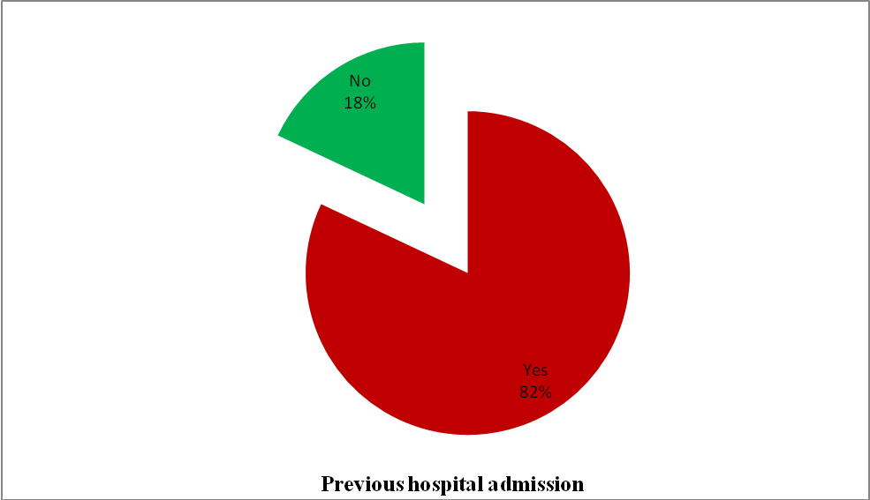
Figure: 9 Distribution of hospitalized patients according to the previous hospital admission
Figure 9 reveals distribution of participants based on their previous hospital admission shows that majority (82.4%) of participants have history of previous hospital admission and the rest (17.6%) of them have no history of hospital admission.

SECTION B: DESCRIPTION OF LEVEL OF KNOWLEDGE ON PATIENT’S RIGHTS
TABLE 1: Frequency and percentage distribution of patients according to the level of knowledge on patient’s rights
n = 68
Level of knowledge | Frequency | Percentage (%)
Highly adequate | 32 | 47
Adequate | 36 | 53
TOTAL | 68 | 100

The table 1 shows that, majority (53%) of participants had highly adequate knowledge, 47% of participants had adequate knowledge on patient’s rights.
TABLE: 2 Mean and Standard Deviation of level of knowledge on patient’s rights among hospitalized patients
Item | Mean | Standard Deviation
Knowledge | 23.94 | 3.32

The table 2 shows that, mean value and standard deviation of level of knowledge on patient’s rights among hospitalized patients was 23.94 and 3.32 respectively.

SECTION C: ASSOCIATION OF LEVEL OF KNOWLEDGE OF HOSPITALIZED PATIENTS WITH DEMOGRAPHIC VARIABLES
TABLE 3: Association of level of knowledge of hospitalized patients with demographic variables namely age, gender, educational status, religion, occupation
n =68
Sl. no | Demographic variables | Adequate knowledge |  | Highly adequate knowledge |  | P value | Table value
Sl. no | Demographic variables | No | % | No | % | P value | Table value
1 | Age(In years)
a) | 20-34 | 10 | 14.7 | 9 | 13.23 | 0.721 | NS
b) | 35-54 | 14 | 20.58 | 15 | 22.05 | 0.721 | NS
c) | ≥55 | 12 | 17.64 | 8 | 11.76 | 0.721 | NS
2 | Gender
a) | Male | 29 | 42.64 | 20 | 29.41 | 0.098 | NS
b) | Female | 7 | 10.29 | 12 | 17.64 | 0.098 | NS
3 | Educational status
a) | Primary | 6 | 8.82 | 5 | 7.35 | 0.71 | NS
b) | Secondary | 17 | 25 | 18 | 26.47 | 0.71 | NS
c) | Higher secondary | 9 | 13.23 | 7 | 10.29 | 0.71 | NS
d) | Graduate | 2 | 2.94 | 2 | 2.94 | 0.71 | NS
e) | Post graduate and above | 2 | 2.94 | 0 | 0 | 0.71 | NS
4 | Religion
a) | Hindu | 34 | 50 | 32 | 47.05 | 0.4 | NS
b) | Christian | 1 | 1.47 | 0 | 0 | 0.4 | NS
c) | Muslim | 1 | 1.47 | 0 | 0 | 0.4 | NS
5 | Occupation
a) | Professional | 3 | 4.41 | 0 | 0 | 0.386 | NS
b) | Self employee | 13 | 19.11 | 14 | 20.58 | 0.386 | NS
c) | Coolie | 10 | 14.7 | 10 | 14.7 | 0.386 | NS
d) | Unemployed | 10 | 14.7 | 8 | 11.76 | 0.386 | NS
NS= Not significant (p value>0.05)

Table no:3 shows that there is no association between level of knowledge on patient’s rights among hospitalized patients with demographic variables namely age, gender, educational status, religion and occupation.

TABLE NO: 4 Association of level of knowledge of hospitalized patients with demographic variables namely marital status, source of information and previous hospital admission
n =68
Sl.  no | Demographic variables | Adequate knowledge |  |  |  | Highly adequate knowledge |  |  |  | P value |  | Table value
Sl.  no | Demographic variables | No |  | % |  | No |  |  | % |  |  | Table value
1 | Marital status
a) | single |  | 6 |  | 8.82 |  | 4 | 5.88 |  | 0.888 | NS
b) | Married |  | 29 |  | 42.64 |  | 27 | 39.7 |  | 0.888
c) | Widow |  | 1 |  | 1.47 |  | 1 | 1.47 |  | 0.888
2 | Source of information
a) | Mass media |  | 10 |  | 14.7 |  | 5 | 7.35 |  | 0.153 | NS
b) | Friends |  | 11 |  | 16.17 |  | 4 | 5.88 |  | 0.153
c) | Health care providers |  | 5 |  | 7.35 |  | 6 | 8.82 |  | 0.153
d) | d)others |  | 3 |  | 4.41 |  | 6 | 8.822 |  | 0.153
e) | Unaware |  | 7 |  | 10.29 |  | 11 | 16.17 |  | 0.153
3 | Previous hospital admission
a) | Yes |  | 28 |  | 41.17 |  | 28 | 41.17 |  | 0.294 | NS
b) | No |  | 8 |  | 11.76 |  | 4 | 5.88 |  | 0.294
NS= Not significant (p value>0.05)

Table no: 4 shows that there is no association between level of knowledge on patient’s rights among hospitalized patients with demographic variables such as marital status, source of information and previous hospital admission.

DICUSSION, SUMMARY, IMPLICATIONS, RECOMMENDATIONS AND CONCLUSION
MAJOR FINDINGS OF THE STUDY
Among 68 participants most of them (43%) were between 35-54 years of age, 29% of participants were coming under the age group of 55 years and above. Only 28 % of participants are in 20-34 years of age. In relation to gender, majorities (72%) of the participants were male and only 28% participants were female. In relation to educational status majority of the subjects, 51.5% were studied up to secondary classes, 23.5% of participants were higher secondary, 16% were primary, 6% participants were graduates and only 3% of participants were post -graduate and above. In relation to religion majority (97%) of participants were Hindu. 1.5% of participants were Christian and remaining 1.5% of participants belongs to Muslim religion. In relation to occupational status most (40%)of the participants were self employees, 29% participants were coolie workers, 27% participants were unemployed and only 4% of participants were professionals. In relation to marital status majority (82.4%) of participants were married, 14.7% participants were single and only 2.9% of participants were widow. In relation to source of information regarding knowledge on patient’s rights majority (27%) of participants were unaware of patient’s rights. 22 % of participants were got information from mass media and friends, 16 % from health care providers, and only 13% from other sources. In relation to previous hospital admission majority (82.4%) of participants have history of previous hospital admission and the rest (17.6%) of them have no history of hospital admission.
The first objective was to assess the level of knowledge on patient’s rights among hospitalized patients.
The overall level of knowledge of hospitalized patients reveals that majority (53%) of participants had highly adequate knowledge, 47% of participants had adequate knowledge on patient’s rights. The mean score obtained for overall knowledge score was 23.94 out of 30 which shows that the subjects had highly adequate knowledge on patient’s rights.
In contrast of these study findings, study conducted by Zahra Mastaneh et.al (2013) shows a makeable difference in the result. It was a cross sectional descriptive and analytical study to evaluate patient’s awareness of their rights in two tertiary teaching hospitals affiliated with Shiraz University of Medical Sciences (SUMS) in Iran. The research sample was consisted of 200 in patients and data were collected by questionnaires during interview. The rate of awareness was measured by Likert scale. Data were analyzed by descriptive and analytical statistics. Among 200 research participants, 3.5% were found weak, 59.4% were moderate and10.1% were good. Total awareness of patient about their rights was medium⁵.
The second objective was to find association between the level of knowledge and demographic variables among hospitalized patients
The analysis was done to find the association between the level of knowledge on patient’s rights and demographic variables among hospitalized patients. There is no significant association between level of knowledge on patient’s rights and demographic variables such as age, gender, educational status, religion, occupation, marital status, source of information, previous hospital admission. As computed p-value was greater than the table value at (>0.05) level of significance.
A descriptive cross sectional study was conducted by Sumaira Masood et.al (2016), to determine the level of awareness among patients admitted in hospitals about their rights to healthcare. 140 samples were assessed by structured questionnaire. The data were entered and analyzed on SPSS version 20. Chi square test was used to find relationship of awareness with age, gender, educational status. The difference of awareness among males and females (X²=46.39, p<0.001) was statistically significant, ie. Male had better awareness as compared to females. And there was no relationship of age (p=0.153) history of previous admission (p=0.611) and entitlement (p=0.751) with level of awareness.⁸

SUMMARY
The present study was done to” assess the level of knowledge on patient’s rights among hospitalized patients at PIMS hospital, Puducherry”. The study was conducted using descriptive research design. A structured questionnaire was used to assess the level of knowledge on patient’s rights among hospitalized patients after the content validity. A pilot study was conducted to determine the feasibility of the study. The data was collected for a period of one week and was analyzed using the descriptive-inferential statistical package for social sciences for windows version SPSS 21.

IMPLICATIONS OF THE STUDY
Nursing service - Nurses play an important role in providing adequate knowledge to the patients about their rights.

Nursing education - The nursing students should be aware of the patient’s rights and its importance in nursing education. Protection of patient’s right is vital factor in a good health care setting, so the class room teaching has to be focused on patient’s rights. Teacher can motivate the students to do more project among various groups such as health care providers on patient’s rights.

Nursing Administration - The findings of the study help nurse administrator for decision making policy and protocol formulation regarding patient’s rights. So that violation of patient’s rights can be prevented.
Nursing Research - Finding of the study suggests that educators and researchers should encourage nurses to read, discuss and conduct research studies. So as to enable the nurses to make data based decision rather than intuitive decisions.
RECOMMENDATIONS
- The study can be conducted on larger samples.
- The study can be conducted among various groups (Health care providers such as doctors and nurses)
- The study can be conducted in corporative, Government and private hospitals or clinics

CONCLUSION
The present study assessed the level of knowledge on patient’s rights among hospitalized patients. Here in this study it reveals that majority (53%) of participants had highly adequate knowledge and the remaining 47% of participants had adequate knowledge on patient’s rights.
The entire right of a patient has to be protected. The violation of these rights should be prevented. So that, we can give a quality care to each of the patients.
REFERENCE
- http://www.essay.tv/patients’rights and responsibility in-a-hospital
- Agarwal Upasana et.al, Awareness of Patient’s Rights among Inpatients of a Tertiary Care Teaching Hospital-A cross- sectional study, journal of Clinical and Diagnostic research, JCDR vol.11, 2017:IC01-IC06
- R.B Ghooi, SR Deshpande, Patient’s Rights in India:An ethical perspective, Indian Journal of Medical Ethics 2012:1-7
- www.who.int>public>patientrights
- Zahra Mastaneh et.al, Patient’s awareness of their right: Insight from a Developing Country, IJHPM International Journal of Health Policy and Management 2013 July13:143-6
- Tabassum T et.al, Hospitalized patient’s Awareness of Their Rights-A Cross Sectional Survey in Public and Private Tertiary Care Hospitals of Punjab, Pakistan, Journal of Ayub Medical College Abbottabad 2016 Jul-Sep;28(3):582-6
- Unnikrishnan B.et.al, Patient’s Awareness About Their Rights: A Study from Coastal South India, Sci Eng Ethics 2017 Feb; 23(1):203-14.
- Sumaira Masood et.al, Awareness among hospitalized patients of their rights: A cross sectional survey from tertiary care hospital of Rawalpindi, Pak Armed Forces Med J. 2016; 66(5): 651-6
- Mohammed E S et.al, Awareness and practice of patient rights from a patient perspective: an insight from Upper Egypt, Int J Qual Health Care 2018 Mar 1;30(2):145-51
- Shukrya al maliki, Assessment of patient’s knowledge and awareness about their rights and duties, KUFA Journal for nursing sciences 2014 June 30
- Nowrin I , Patients awareness of Health Right: A hospital – Based pilot study from Dhaka, Epidemiology: Open Access1970 Jan 1:1-5
- Alyah M. Almoajel, Hospitalized patients awareness of their rights in Saudi Governmental hospital, Middle-East Journal of Scientific Research2012 11(3):329-35
- Alireza Parsapoor, Unsatisfied patient’s rights: A survey on the views of patients, nurses and physician, Journal of medical ethics and history of medicine, 2012 March 29;(5):4
- Alghanim SA, Assessing knowledge of the patient bill of rights in central Saudi Arabia:a survey of primary health care providers and recipients, Ann Saudi Med. 2012 Mar-Apr;32(2):151-5
- Abou Zeina H. A., Patient’s Rights: A Hospital Survey in South Egypt, Journal of Empirical Research on Human Research Ethics, 2013 July ;8(3):46-52
- D. Ducinskiene, Awareness and practice of patient’s rights law in Lithuania, World Hosp Health Serv2007;43(3):22-6
- Sonia E D’Souza et.al, Patient rights: A study on patient’s knowledge and nurse’s practice in a multispecialty teaching hospital, International Education and Research Journal 2016 October;(10):25-6
- Kiran Kumari, An exploratory study to assess the knowledge, expressed practices and barriers in protection of patient’s rights among nurses at MMIMS &R Hospital, Mullana, Ambala, IOSR-JNHS 2013 Nov- Dec;(5):55-60
- Maha Ghanem, Practice of patient’s rights among physicians and nurses in two Egyptian hospitals from patient’s perspective, Journal of Natural science research 2015 vol 5
- Alaa Abed et.al, Knowledge and attitudes towards patient’s rights among health care providers in primary care health centers in Basrah, IJMPS 2014 June;(3):7-14
- Selen Ozakar Akca, Knowledge and attitudes of nurses regarding patient rights: a corum/Turkey sample, Rev Assoc Med Bras 2015;61(5):452-7

