Dear Editor,

This is to confirm that the article entitled “A dissymmetry in the figures related to the Covid-19 pandemic in the world: what factors explain the difference between Africa and the rest of the World?” submitted to the Indian Journal of Medical Ethics is original and has been authored by the undersigned.

The submission is not under consideration for publication in any other journal.

Details of sponsorship or relevant competing interests, financial or otherwise: This study has no funding or sponsorship and has no relevant competing interests, financial or otherwise

I have read the terms and conditions of authorship of IJME and accept them.

I think my paper is suitable for publication in an ethics journal because: it enters the editorial line of the review in addition to bringing the disparate level of evolution of the Covid-19 between Africa and the rest of the world. This question remains a topical question in a world that was badly hit by the Covid-19 pandemic. In addition this review remains a review with international scope with high visibility. (in not more than 100 words)

Contact details (mailing address, institutional and personal email id) and current affiliation:
Cheikh Faye
cheikh.faye@univ-zig.sn
Assane Seck University of Ziguinchor, Sciences and Technology Faculty, Department of Geography, Ziguinchor, Senegal; e-mail:
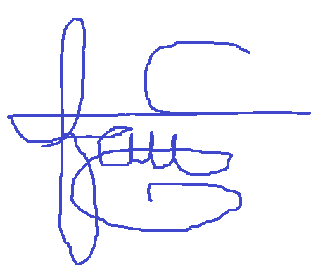
Signature of author:

