Comparison of different schemes of analgosedation in patients with severe traumatic brain injury in the postoperative period
K. Y Sharlai, Yu. V. Volkova, G. O. Syrova, K. G. Mikhnevich, V. A. Makarov, O.O. Zavada
Kharkiv National Medical University, Kharkіv, Ukraine
Purpose - to compare different methods of analgosedation with using dexmedetomidine in patients with severe traumatic brain injury (TBI).
Materials and methods. 80 patients were diagnosed with severe traumatic brain injury. In patients of the 1st group (n = 40) analgosedation were performed using morphine and sodium oxybutyrate (NaGHB), and patients in the 2nd group (n = 40) were additionally treated with dexmedetomidine. The dynamics of concentration of stress markers (insulin, cortisol, glucose), HOMA index, autoantibodies to brain antigens, restoration of consciousness by the Glasgow coma scale (GCS), duration of the artificial ventilation of lungs (AVL) were determined.
Results. It was found that in patients of the 2nd group the reduction of the intensity of stress reactions was occurred 3-4 days earlier. It was shown that analgosedation with dexmedetomidine using can reduce the peak of autoantibody concentration to S-100 protein, neurospecific enolase and total cerebral antigen (p <0.05). In patients of the 2nd group the restoration of consciousness by the GCS was 24.3% faster (p <0.05), the duration of AVL was 21.2% less (p <0.05), and the frequency of pneumonia was 14.3% less than in patients of the 1st group.
Conclusions. The use of dexmedetomidine may reduce the intensity of stress and autoimmune reactions in patients with severe traumatic brain injury, accelerate the restoration of consciousness by the GCS and reduce the duration of AVL.
Key words: severe traumatic brain injury, analgosedation, dexmedetomidine, stress reactions, autoantibody to brain antigens, restoration of consciousness by the GCS, duration of mechanical ventilation.

Actuality. The frequency of traumatic brain injury (TBI) in Ukraine in the last 10-15 years has doubled and is equal to 4-4,2 %, which is almost 200,000 injured per year [1, 2, 3, 4]. 30-50 % of injured with severe TBI are die, of which 59% in the pre-hospital phase, others - in the hospital [5]. According to other researchers, 42% of deaths from TBI occur in hospitals, 32% - at home and 26% - in the street [6]. However, even in surviving patients, the full return to satisfactory quality of life is too rarely observed [7].
It is common knowledge that artificial ventilation of the lungs (AVL) is the necessary component of intensive treatment (IT) of patients with TBI, which causes significant discomfort in the patient regardless of the level of consciousness impairment. On the other hand, there is a need for adequate anesthesia. This situation gave rise to the concept of adequate analgosedation during the postoperative period [8, 9, 10, 11]. The aim of analgosedation is to eliminate the discomfort associated with quite aggressive methods IT, successful synchronization of the patient with the respirator, transfer of metabolism to the economic regime and preservation of control over the patient, which allow to timely notice the accidental disconnection from the medical and control equipment [12].
For sedative therapy during AVL, the most common (more than 80% of patients) is applying of benzodiazepines and propofol. Unfortunately, these drugs are characterized by serious side effects that prolong the need for AVL and the time of being in the intensive care unit (ICU) [13 14, 15, 16]. In this regard, there is now a tendency to a daily periodic interruption of sedation, which promotes to reducing the duration of AVL and continuance the patient in the ICU [17, 18, 19, 20]. The modern approach to conducting of patients with AVL based on analgosedation, which gives the analgesic component a decisive role, reduces the need for a hypnotic component [21, 22]. Adequate analgosedation provides anti-stress protection during IT [23], with decreasing the depth of sedation, which keeps the circadian rhythms of the body. However, the protocols of analgosedation in different countries vary widely, which once again demonstrates the actuality of this problem [24].
The tasks that are now in the face of analgosedation, could be successfully solved by the α₂-adrenoreceptor agonists. The first drug from this group, introduced in clinical practice in the 60's of XX century, became clonidine, subsequently dexmedetomidine was synthesized [25].
Dexmedetomidine, together with the sedative and anxiolytic action, stabilizes the external breathing, which facilitates the releasing of the patient from the respirator [26]. The effect of dexmedetomidine is controlled and predicted [27, 28], it makes easy the waking of the patient after anesthesia, reduces the dose of narcotic analgesics and sedatives [29, 30, 31, 32].
In addition to the above properties of dexmedetomidine, it is characterized by cardioprotective, neuroprotective and nephroprotective action [33, 34, 35]. In particular, it reduces the severity of hypoxic-ischemic brain damage and improves functional neurological outcomes after TBI[34].
Described above dexmedetomidine’s features ensured its wide application in the practice of IT in general and in IT of neurosurgical patients in particular [28, 36]. As the side effects, only arterial hypotension and bradycardia are possible [28].
To date, the problem of the optimal method of analgosedation in patients with severe TBI remains unresolved. This causes insufficient or excessive sedation, and as a result, high risks of respiratory depression with the need for AVL, risks of hemodynamic complications and severe cognitive effects.
Currently, there were not enough tests in Ukraine to make conclusions about the efficacy of using dexmedetomidine as an analgosedative component for patients with severe TBI. Research and implementation of new approaches and algorithms for analgosedation in such patients will allow reducing the duration of treatment and improving its results.
The aim of the study was to compare different methods of analgosedation with using dexmedetomidine in patients with severe TBI.
Materials and methods. The prospective randomized controlled clinical trial has been conducted. A total of 80 patients with severe TBI (age of patients ranging from 18 to 65 (49.3 ± 17.9) years) were examined, which, after urgent craniotomy, went to the intensive care unit, as well as 20 healthy volunteers. To evaluate the effectiveness of the analgosedation schemes as a component of intensive care, all patients at the time of admission were separated by a simple fixed randomization using the random number method in 2 groups.
All patients had standard intensive therapy according to the local protocol, only the analgosedation scheme was different: analgosedation of patients in the 1st group (n = 40) were conducted with morphine and sodium oxybutyrate (NaGHB), for patients in the 2nd group (n = 40) additionally α₂-adrenomimetic dexmedetomidine was used. Morphine was given in a dose 0.03-0.04 mg/kg/h, NaGHB – 10-15 mg/kg/h, dexmedetomidine – 0.2-0.7 mg/kg/h.
The mean age in the 1st group was 53.4 ± 18.2 years, and the mean age in the 2nd group was 45.1 ± 17.4 years (Table 1).

Table 1 - Characteristics of patients by gender and age (M ± σ)
Group indices | Group 1, (n=40) | Group 2, (n=40) | Р
Gender m/f | 28/12 | 24/16 | р>0,005
Age, years | 53.4±18.2 | 45.1±17.4 | р>0,005
from 18 to 35 years | 18 (45%) | 21 (52.5%) | р>0,005
from 36 to 50 years | 13 (32.5%) | 11 (27.5%) | р>0,005
more than 50 years | 9 (22.5%) | 8 (20%) | р>0,005

Severe TBI was the result of beating in 56 cases, road accidents - in 12 cases, falling from the height of their own growth - in 12 cases (Table 2).
Table 2 – Group distribution of patients by the mechanism of getting severe TBI
Group | Mechanism of injury
Group | Beating | Road accidents | Falling from the height
1 (n = 40) | 32 (80 %) | 4 (10 %) | 4 (10 %)
2 (n = 40) | 24 (60 %) | 8 (20 %) | 8 (20 %)
Total | 56 (70 %) | 12 (15 %) | 12 (15 %)

The number of patients which were in the moderate coma (7-8 points in the Glasgow Coma Scale (GCS)) before surgery was 52 (Table 3): 27 patients (67.5% of the total number of patients in the group) in the 1st group, 25 patients (62.5% of the total number of patients in the group) in the 2nd group.

Table 3 – Group distribution of patients by level of consciousness
Coma level, GCS score | Group 1, (n=40) | Group 2, (n=40) | Р
Moderate,7-8 | 27 (67.5%) | 25 (62.5%) | р>0,005
Severe, 5-6 | 10 (25%) | 13 (32.5%) | р>0,005
Coma with 4 or less | 3 (7.5%) | 2 (5%) | р>0,005

The number of patients which were in the severe coma (5-6 points GCS) before surgery was 23 (Table 3): 10 patients (25% of the total number of patients in the group) in the 1st group, 13 patients (32.5% of the total number of patients in the group) in the 2nd group.
The number of patients which were in the coma with 4 points GCS or less before surgery was 5 (Table 3): 3 patients (7.5% of the total number of patients in the group) in the 1st group, 2 patients (5% of the total number of patients in the group) in the 2nd group.
Among patients in the 1st group the subdural hematoma was found in 19 cases, epidural, intracerebral, epidural with intracerebral and epidural with subdural - for 3, 6, 7, 5 cases, respectively. In the 2nd group subdural hematoma occurred in 22 patients, the epidural - in 4, the intracerebral - in 7, the epidural in combination with the intracerebral - in 5, the epidural and subdural - in 2 patients. The left-sided localization of the injury was observed in 26 patients in the 1st group and in 23 patients in the 2nd group, right-sided - respectively in 9 and 10 patients, bilateral localization - in 5 and 7 patients respectively (Table 4). There were no statistically significant differences between the patients of both groups according to the indicators presented.

Group | S/d | E/d | I/c | E/d+i/c | E/d+s/d | Localization
 |  |  |  |  |  | Left-sided | Right-sided | Bilateral
1 | 19 (47.5%) | 3 (7.5%) | 6 (15%) | 7 (17.5%) | 5 (12.5%) | 26 (65%) | 9 (22.5%) | 5 (12.5%)
2 | 22 (55%) | 4 (10%) | 7 (17.5%) | 5 (12.5%) | 2 (5%) | 23 (57.7%) | 10 (25%) | 7 (17.25%)
Total | 41 (51.25%) | 7 (8.75%) | 13 (16.25%) | 12 (15%) | 7 (8.75%) | 49 (61.25%) | 19 (23.75%) | 12 (15%)
Table 4 – Group distribution of patients by the nature of injury

Notice: s/d – subdural hematoma, e/d – epidural hematoma, i/c – intracerebral hematoma.

The following indicators were chosen as criteria for the effectiveness of different schemes of analgosedation: the dynamics of the stress markers concentration (insulin, cortisol, glucose), the HOMA index, which allows quantifying the intensity of stress reactions in response to analgosedation; the dynamics of the concentration of autoantibodies to brain antigens (the main protein of myelin (MPM), S-100 protein, neurospecific enolase (NSE), common cerebrospinal antigen (CCAG), which allows quantifying and tracing structural damage to both neurons and brain astrocytes, also the speed of restoration of consciousness, the duration of AVL and lethality, which allow to evaluate the functional violations of the injured brain.
Glycemia was determined using a glucose meter ONE TOUCH ULTRA, the concentration of cortisol, immunoreactive insulin (IRI) – by the immune enzyme method at 1, 3, 5, 7 days after surgery, the HOMA index was calculated according to the generally accepted formula. To determine the sedation level, the Riker Seduction-Agitation Scale (SAS) and the Richmond Seduction Agitation Scale (RASS) were used. The concentration of autoantibodies to brain antigens was determined by the immune enzyme analysis at 1, 3, 5, 7 and 14 days after surgery. Laboratory indicators were studied using unified methods. Data of all conducted studies were statistically processed. According to the method of variational analysis, the calculation of the Student's t-test reliability criterion was used to determine the reliability of deviations in indicators and mean values. The relationship between the values was estimated by correlation analysis with the calculation of the Pearson's chi-squared test.
Results of research. On the 1st day of the study, cortisol level in all patients was elevated than normal and was equal to 1028 ± 27 nmol/l in 1st group and 1036 ± 54 nmol/l in 2nd group (p> 0.05). On the 3rd day in both groups a significant decrease of this indicator occurred with 966 ± 28 nmol/l and 896 ± 26 nmol/l, respectively, but in 2nd group this decrease was significantly more marked. On the 5th day, the concentration of cortisol in the blood in all patients continued to decrease considerably (873 ± 78 and 817 ± 42 nmol/l, respectively). On the 7th day, the cortisol level continued decreasing, but without a statistically significant difference between the groups, and in 1st group was 803 ± 24 nmol/l, in 2nd – 790 ± 33 nmol/l.
The dynamics of glycemia of patients in both groups was similar, without statistically significant difference. On the 1st day, the concentration of glucose in the blood of patients in 1st group was 6.7 ± 0.6 mmol/l, 2 groups – 6.3 mmol/l. On the 3rd day the glycemic index significantly decreased in both groups with 5.7 ± 0.4 and 5.4 ± 0.4 mmol/l respectively. On the 5th day, a significant decreasing of this indicator in 1st group to 5.3 ± 0.4 mmol/l and an irrelevant reduction to 5.2 ± 0.4 mmol/l in 2nd group took place. On the 7th day the situation did not change practically: the glycemic index in patients of 1st group was 5.0 ± 0.4 mmol/l, in 2nd group – 5.0 ± 0.2 mmol/l.
Changes in the concentration of IRI in the examined groups of patients were slightly differentiated. If there were no statistically significant differences on the 1st day (1st group - 12.8 ± 3.8 μIU/ml, 2nd - 12.05 ± 4.2 μIU/ml), then on the 3rd day in 2nd group a significant decrease of the content of IRI in the blood to 9.1 ± 2.8 μIU/ml occurred, whereas in 1st group it did not significantly change (11.6 ± 4.4 μIU/ml, p <0.05 compared with 2nd group). Subsequently, in 2nd group, the concentration of IRI did not change significantly (5th day - 8.6 ± 1.8 μIU/ml, 7th day - 8.3 ± 2.0 μIU/ml). In 1st group, the level of IRI also did not significantly change on the 5th day (slightly decreased to 10.7 ± 2.6 μIU/ml), and only on the 7th day the statistically significant decreasing to 7.1 ± 2.7 μIU/ml took place.
More important than glycemic and IRI levels themselves, is their ratio, which can be expressed using the HOMA index. At the beginning of the study, this ratio was elevated to 3.8 ± 1.5 in patients of the 1st group and to 3.2 ± 1.0 in 2nd group. On the 3rd day a significant difference between the levels of this index in patients of the examined groups was observed: in 1st group, it changed irrelevantly (decreased to 2.9 ± 0.8), whereas in 2nd group it significantly decreased to 2.0 ± 0.4. On the 5th day in 1st group this index continued to decline insignificantly (to 2.5 ± 0.8) and was not essentially different from the level in 2nd group (2.1 ± 0.7). On the 7th day a significant decrease in this indicator to 1.6 ± 0.5 was occurred in 1st group, in 2nd group it changed slightly (decreased to 1.8 ± 0.7).
Consideration of the results of the study revealed that in the 2nd group of patients the reduction of the intensity of stress reactions occurred 3-4 days earlier.
The level of autoantibodies to brain antigens (MPM) during the study did not undergo significant fluctuations. Its rates did not significantly exceed the norm (26.2 ± 1.1 units) and did not differ statistically from those in healthy volunteers, and their mean values ranged from 26.2 ± 4.1 to 28.1 ± 5.3 units and did not differ statistically between groups.
A radically different situation was observed among the indicators of other neuroantibodies. On the 1st day, the level of autoantibodies to calcium binding protein (S-100) in both groups exceeded the norm (12.6 ± 0.9 units) and amounted to 14.0 ± 3.2 and 14.2 ± 2.6 units in 1st and 2nd groups respectively, but the difference between the groups was statistically unreliable. On the 3rd day the indicators increased to 18.0 ± 2.6 and 16.0 ± 2.1 units in 1st groups and 2nd, respectively, the difference between the groups was statistically significant. On the 5th, 7th day there was a gradual decreasing in the indicators in both groups, with a significant difference between them, and on the 14th day the levels of autoantibodies were within the normal range: 11.9 ± 1.6 and 12.0 ± 1.5 units in 1st and 2nd groups respectively.
The level of autoantibodies to NSE on the 1st day did not exceed the normal values (23.1 ± 1.4 units) and amounted to 24.2 ± 1.5 and 24.3 ± 2.4 units in 1st and 2nd groups, respectively. On the 3rd day the level increased to 25.9 ± 4.3 and 24.9 ± 2.6 units in 1st and 2nd groups, respectively, reaching a peak on the 5th day, when the difference between the groups was statistically significant (30.0 ± 1.5 and 28.4 ± 1.9 units). Subsequently, decreasing of the indicators took place with a statistically significant difference between the groups: on the 7th day the levels were 28.0 ± 2.5 and 25.9 ± 2.2 units; and 26.1 ± 1.3 and 24.5 ± 1.9 units on the 14th day in the 1st and 2nd groups respectively.
The levels of autoantibodies to CCAG on the 1st day exceeded the normal values in both groups (29.3 ± 1.2 units), but they did not significantly differ from the indicators of healthy volunteers and amounted to 32.5 ± 1.5 and 32.1 ± 1.8 unit in two groups respectively. Subsequently, the indicators increased in both groups and on the 3rd day they were 36.0 ± 2.9 and 34.6 ± 2.1 units respectively, reaching peak on the 5th day (38.7 ± 2.3 and 35.9 ± 1.9 units), when the difference between the groups was statistically significant. Later, decreasing of the indicators to 37.2 ± 1.3 and 34.2 ± 2.1 degrees on the 7th day and to 34.5 ± 2.7 and 31.9 ± 2.3 units on the 14th day was observed in the 1st and 2nd groups, respectively, with continuation of the statistical difference.
It was found that analgosedation with the use of dexmedetomidine does not affect the concentration of autoantibodies to the main protein of myelin (MPM), which remains within the normal values; allows to reduce the peak of the concentration of autoantibodies to S-100 protein on the 3rd day (p <0,05) and achieve the normalization of the indicators on the 7th day (p <0,05); allows to reduce the peak of the concentration of autoantibodies to the neurospecific enolase and the total cerebral antigen on the 5th day (p <0.05) and reach the limits of the donor levels on the 14th day (p < 0,05).
We selected the dynamics of the level of consciousness impairment by GCS and the duration of AVL as the main clinical markers of the effectiveness of IT of severe TBI.
The assessment of consciousness was carried out after the expiration of all drugs suppressing the function of the CNS (not earlier than 4 hours after the introducing of narcotic analgesics and sedatives).
Table 5 – The average level of consciousness impairment in the dynamics of patients in the studied groups (M ± σ)
Group | 1st day | 3rd day | 5th day | 7th day | 14th day
1st (n = 40) | 7.2 ± 1.1 | 7.8 ± 1.4 | 8.8 ± 1.6 | 9.6 ± 2.0 | 11.4 ± 1.3
2nd (n = 40) | 7.1 ± 0.9 | 8.3 ± 1.3 | 9.4 ± 1.6 | 10.5± 1.4 | 12.2 ± 1.5

The level of consciousness impairment in patients at admission was 7.2 ± 1.0 points and 7.2 ± 0.9 points in the 1st and 2nd groups respectively. As can be seen from the data in Table 5, the consciousness of patients of 1st group restored by 4.2 points and in patients of 2nd group – by 5.1 points during the study.
When comparing the transition period to full self-breathing, we found (Fig. 1) that in patients of 1st group the mean duration of AVL was 6.6 ± 1.9 days, while the ventilator-associated pneumonia was detected in 35% of cases (14 patients) (Table 6).
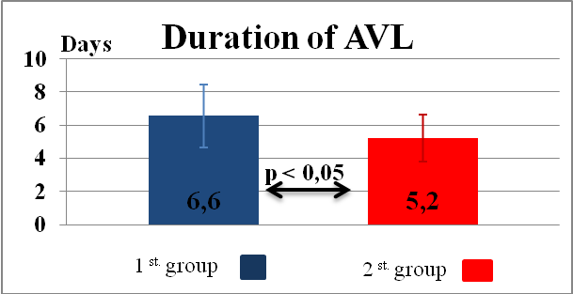
Figure 1 – Duration of AVL in patients of the studied groups
In patients of 2nd group, the average duration of AVL was 5.2 ± 1.4 days (Figure 1), ventilator-associated pneumonia was detected in 27.5% of patients (11 people) (Table 6).

Table 6 – Analysis of the duration of AVL in patients with severe TBI
Group | Number of surviving patients (on the 14th day) | Number of tracheostoma |  | Number of ventilator-associated pneumonia |  | Duration of AVL, days,  M ± σ
Group | Number of surviving patients (on the 14th day) | Number | % | Number | % | Duration of AVL, days,  M ± σ
1st (n = 40) | 30 | 14 | 35 | 14 | 35 | 6.6±1.2
2nd (n = 40) | 30 | 12 | 30 | 11 | 27.5 | 5.2±1.4

To analyze the factors that affect the duration of AVL in severe TBI, we have carried out a correlation analysis. We have found that:
- there is a strong negative relationship (r₁ = -0.74 ± 0.07 and r₂ = -0.69 ± 0.08) between the duration of AVL and the initial level of consciousness impairment in 1st group and 2nd group (Figure 2);

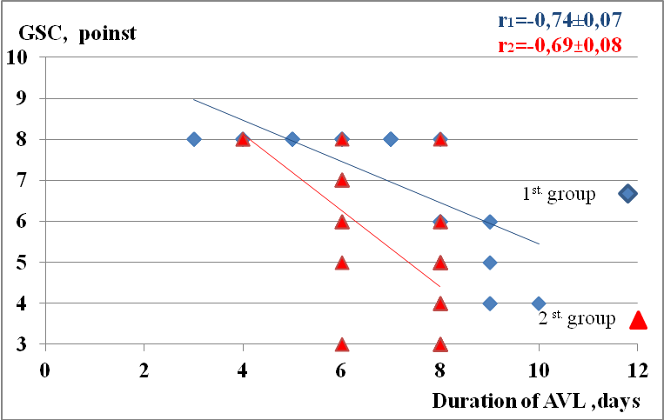
Figure 2 – Relationship between the duration of AVL and the level of consciousness impairment at admission in studied groups
- there is medium positive relationship (r₁=0.61±0.1 and r₂=0.54±0.11) between the duration of AVL and the age of patients in 1st group and 2nd group, respectively (Figure 3);
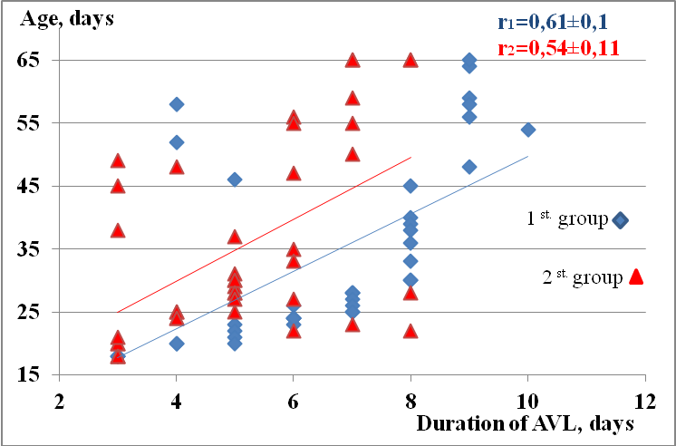
Figure 3 – Relationship between the duration of AVL and the age of patients in studied groups
- relationship between the duration of AVL and stress markers on the 1st day in 1st group and 2nd group, respectively (Figure 4):
- concentration of insulin is in medium positive relationship (r₁ = 0.47±0.12 and r₂=0.39±0.13); concentration of cortisol is in strong positive relationship (r₁=0.78±0.05 r₂=0.62±0.10); correlation between AVL duration and concentration of glucose has not found (r₁=0.12±0.16 r₂=-0.14±0.16); HOMA index is in medium positive relationship (r₁=0.43±0.13 r₂=0.27±0.15);
- correlation between the duration of AVL and concentration of autoantibodies to brain antigens on the 1st day has not found (r = 0.02 for autoantibodies to MPM, r = 0.15 for autoantibodies to S-100, r = 0.15 for autoantibodies to NSE and r = 0.15 for autoantibodies to CCAG).

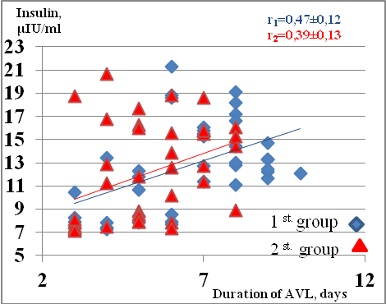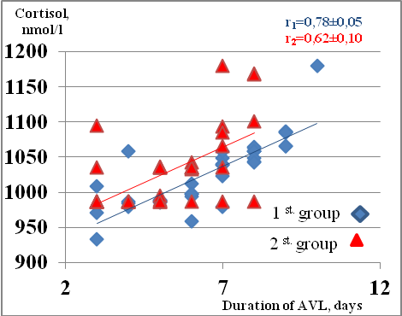
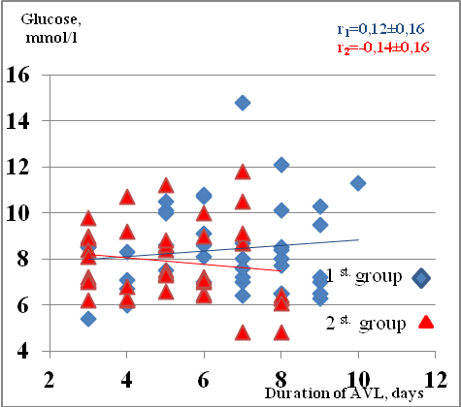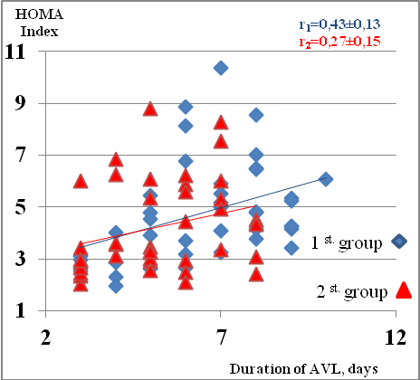
Figure 4 – Relationship between the duration of AVL and stress markers on the 1st day
Knowing that the level of consciousness impairment at admission, the age and level of stress markers of patients in groups can be compared, the duration of AVL was determined by the nature and effectiveness of the intensive care.
Thus, we found that in patients of the 2nd groups who received dexmedetomidine as an additional component of analgosedation by morphine and NaGHB, restoration of consciousness by the GCS was 24.3% faster (p <0.05), the duration of AVL was 21.2% less (p <0,05), and the frequency of pneumonia development was 14.3% less than in patients of the 1st groups who received analgosedation only by morphine and NaGHB. This suggests a greater effectiveness of the combination of morphine, NaGHB and dexmedetomidine as components of analgosedation in intensive care of patients with severe TBI.
Conclusions. The use of dexmedetomidine may reduce the intensity of stress and autoimmune reactions in patients with severe TBI, accelerate the restoration of consciousness by the GCS and reduce the duration of AVL.

References
1. Polishhuk N.E. Unifikacija ob#ema diagnostiki i medicinskoj pomoshhi bol'nym s cherepno-mozgovoj travmoj / Polishhuk N.E., Rasskazov S.Ju. // Ukr. nejrohіrurg. zhurn. – 2000. – №1. – P.1-8. [In Russian].
2. Nejrotravma: aktual'nye rekomendacii / A.I.R. Maas, M. Dearden, F. Servadei [et al.] // Medicina neotlozhnyh sostojanij. – 2008. – №2(15). – P.132-140. [In Russian].
3. Kursov S.V. Intensivnaja terapija u bol'nyh s tjazheloj cherepno-mozgovoj travmoj / S.V. Kursov, N.V. Lizogub, S.N. Skoroplet // Medicina neotlozh. sostojanij. – 2008. – №32(15). – P.44-49. [In Russian].
4. Porivnyal'na otsinka chastoty vyyavlennya cherepno-mozkovoyi travmy u velykykh mistakh Ukrayiny / M.Ye. Polishchuk M.Ye., O.V. Markov, Yu.O. Haydayev [ta in.] // Ukr. neyrokhirurh. zhurn. – 2002. – №4. – P.44-48. [In Ukrainian].
5. Cherepno-mozgovaja travma: sovremennye principy neotlozhnoj pomoshhi / E.G. Pedachenko, I.P. Shlapak, A.P. Guk, M.N. Pilipenko. – K.: ZAO “VIPOL”, 2009. – 276 p. [In Russian].
6. Ladejshhikov V.M. Analiz smertnosti postradavshih s cherepno-mozgovoj travmoj po dannym Permskogo oblastnogo bjuro sudebno-medicinskoj jekspertizy / V.M. Ladejshhikov, V.N. Korotun, L.I. Borisova // Problemy jekspertizy v medicine.– 2006.– T. 6.– № 4.– P. 70. [In Russian].
7. Chernij V.I. Cherepno-mozgovaja travma cerebroprotekcija: nejromidin v aspekte dokazatel'noj mediciny / V.I. Chernij, T.V. Ostrovaja, I.A. Andronova // Medicina neotlozh. sostojanij. – 2008. – №2(15). – P.99-105. [In Russian].
8. Tonner P.H. Sedation and analgesia in the intensive care unit / Tonner P.H., Weiler N., Paris A., Scholz J. // Curr Opin Anaesthesiol. – 2003. – Vol.16. – P. 113-121.
9. Mattia C. SIAARTI recommendations for analgo-sedation in intensive care unit. Minerva Anestesiol 2006. –72:769-805. / Mattia C., Savoia G., Paoletti F. // Minerva Anestesiol. – 2006. – Vol. 72. – P. 769-805.
10. Sessler C.N. Patient-focused sedation and analgesia in the ICU / Chest. – 2008. – Vol. 133. – P. 552-565.
11. Egerod I. Cultural changes in ICU sedation management / Egerod I. // Qual. Health Res. – 2009. – Vol. 19. – P. 687-696.
12. Rhoney D.H. National survey of the use of sedating drugs, neuromuscular blocking agents, and reversal agents in the intensive care unit / Rhoney D.H., Murry K.R. // J. Intensive Care Med. – 2003. – Vol. 18. – P. 139-145.
13. Nelsen J.L. A prospective evaluation of propylene glycol clearance and accumulation during continuous-infusion lorazepam in critically ill patients / Nelsen J.L., Haas C.E., Habtemariam B. // J. Intensive Care Med. 2008. – Vol 23. – P. 184-194.
14. Jakob M. Dexmedetomidine vs midazolamor propofol for sedation during prolonged mechanical ventilation: two randomized controlled trials / Jakob M., Ruokonen Е., Grounds М. [et al.] // JAMA. – 2012. – Vol. 307(11). – P. 1151-1160.
15. Swart E. Population pharmacodynamic modelling of lorazepam- and mid-azolam-induced sedation upon long-term continuous infusion in critically ill patients / Swart E., Zuideveld K., de Jongh J. [et al.] // Eur. J. Clin. Pharmacol. – 2006. – Vol. 62(3). P. – 185-194.
16. Barr J. Propofol dosing regimens for ICU sedation based upon an integrated pharmacokinetic-pharmacodynamic model / Barr J., Egan T., Sandoval N. [et al.] // Anesthesiology. – 2001. – Vol. 95 (2). – P. 324-333.
17. Kress J.P. Sedation in the mechanically ventilated patient / J.P. Kress, J.B.Hall // Crit. Care Med. – 2006. – Vol. 34. – P. 2541-2546.
18. Daily interruption of sedative infusions in critically ill patients undergoing mechanical ventilation / J.P. Kress, A.S. Pohlman, M.F. O’Connor, J.B. Hall // N. Engl. J. Med. – 2000. – Vol. 342. – P. 1471-1477.
19. Characteristics associated with analgesia ordering in the intensive care unit and relationships with outcome / A.X. Freire, B. Afessa, P. Cawley [et al.] // Crit. Care Med. – 2002. – Vol. 30. – P. 2468-2472.
20. Riker R.R. Adverse events associated with sedatives, analgesics, and other drugs that provide patient comfort in the intensive care unit / R.R. Riker, G.L. Fraser // Pharmacotherapy. – 2005. – Vol. 25. – P. 8-18.
21. Karabinis A. Safety and efficacy of analgesia-based sedation with remifentanil versus standard hypnoticbased regimens in intensive care unit patients with brain injuries: a randomized, controlled trial / Karabinis A., Mandragos K., Stergiopoulos S. // Crit. Care. – 2004. – Vol. 8. – R. 268-280.
22. Park G. A comparison of hypnotic and analgesic based sedation in a general intensive care unit / Park G, Lane M., Rogers S., Bassett P. // Br. J. Anaesth. – 2007. – Vol. 98. – P.76-82.
23. Kress J.P. Daily interruption of sedative infusions in critically ill patients undergoing mechanical ventilation / Kress J.P., Pohlman A.S., O’Connor M.F., Hall J.B. // N. Engl. J. Med. – 2000. – Vol. 342. – P. 1471-1477.
24. Impact of systematic evaluation of pain and agitation in an intensive care unit / G. Chanques, S. Jaber, E. Barbotte [et al.] // Crit. Care Med. – 2006. – Vol. 34. – P. 1691-1699.
25. Paris A. Dexmedetomidine in anaesthesia / Paris A., Tonner P.H. // Curr
26. Penttila J. Cardiovascular and parasympathetic effects of dexmedetomidine in healthy subjects / Penttila J., Helminen A., Anttila M. [et al.] // Cah. J. Physiol. Pharmacol. – 2004. – Vol. 82. – P. 359-362.
27. de Kruijk J.R. S-100B and neuron-specific enolase in serum of mild traumatic brain injury patients / de Kruijk J.R., Leffers P., Menheere P.P. [et al.] // Acta Neurol. Scand. 2001. – Vol. 103 (3). – P. 175-179.
28. Kobeljackij Ju.Ju. Medikamentoznaja sedacija: vybor optimal'nogo preparata. Novaja vozmozhnost' – deksmedetomidin / Ju.Ju. Kobeljackij, R.A. Tkachenko, V.A. Zhovnir // Medicine Review. – 2012. – № 3(21). – P. 20-25. [In Russian].
29. Szumita P. Sedation and analgesia in the intensive care unit. – evaluating the role of dexmedetomidine / Szumita P., Baroletti S., Anger K. [et al.] // Am. J. Health Syst. Pharm. – 2007. – Vol. 64. – P. 37-44.
30. Venn R. Comparison between dexmedetomidine and propofol for sedation in the intensive care unit. – patient and clinician perceptions / Venn R., Grounds. // Br. J. Anaesth. – 2001. – Vol. 87. – P. 684-690.
31. Triltsch A. Bispectral index-guided sedation with dexmedetomidine in intensive care. – a prospective, randomized, double blind, placebo-controlled phase II study / Triltsch A., Welte M., von Homeyer P. [et al.] // Crit. Care Med. – 2002. – Vol. 30. – P. 1007-1014.
32. Farag E. Use of alpha(2)-agonists in neuroanesthesia: An overview / Farag E., Argalious M., Sessler D.I., [et al.] // Ochsner J. – 2011. – Vol. 11(1). – P. 57-69.
33. Wallace A. Effect of clonidine on cardiovascular morbidity and mortality after noncardiac surgery / Wallace A., Galindez D., Salahieh A. [et al.] // Anesthesiology. – 2004. – Vol. 101. – P. 284-293.
34. Ma D. Dexmedetomidine produces its neuroprotective effect via the alpha2A-adrenoceptor subtype / Ma D., Hossain M., Rajakumaraswamy N. [et al.] // Eur. J. Pharmacol. – 2004. – Vol. 502. – P. 87-97.
35. Billings F. Alpha 2-adrenergic agonists protect against radiocontrast-induced nephropathy in mice / Billings F., Chen S., Kim M. [et al.] // Am. J. Physiol. Renal. – 2008. – Vol. 295. – F. 741-748.
36. Kulikov A.S. Deksmedetomidin: novye vozmozhnosti v anesteziologii / A.S. Kulikov, A.Ju. Lubnin // Anesteziologija i reanimatologija. – 2013. – № 1. – P. 37-41. [In Russian].

Authors
1. Yuliya V. Volkova, MD, PhD, Full Professor,
Head of the Department of Emergency Medicine, Anesthesiology and Intensive Care,
Kharkov National Medical University.
Address: Prospert Nauki 4, 61022, Kharkiv, Ukraine, tel.: +38 (057) 700-41-32
e-mail: dryu.volkova@gmail.com
2. Kateryna Y. Sharlai,
postgraduate Student at the Department of Emergency Medicine, Anesthesiology and Intensive Care,
Kharkov National Medical University.
Address: Prospert Nauki 4, 61022, Kharkiv, Ukraine, tel.: +38 (057) 700-41-32
E-mail: sharlaik@gmail.com
3. Konstantin G. Mіkhnevych, MD, PhD, docent,
associate Professor at the Department of Emergency Medicine, Anesthesiology and Intensive Care,
Kharkov National Medical University.
Address: Prospert Nauki 4, 61022, Kharkiv, Ukraine, tel.: +38 (057) 700-41-32
E-mail: kmikhnevich@yahoo.com
4. Anna O. Syrovaya – Doctor of Sciences (Pharmacy), Professor, Department of Medical and Bioorganic Chemistr
Address: Prospert Nauki 4, 61022, Kharkiv, Ukraine
5. Vladimir Makarov – PhD, docent, Department of Medical and Bioorganic Chemistr
Address: Prospert Nauki 4, 61022, Kharkiv, Ukrain
6. Oksana O. Zavada – PhD, Department of Medical and Bioorganic Chemistr
E-mail: o.o.zavada@ukr.net

