Permanent Pacemaker Indications and complications, a single center experience

Mohammed Hashim Al-Mayah¹, Kadhim Majdi Al-himmeirry², Ahmed Basheer³ and Falah Shaheed Al-azawi Assis⁴.

¹ Consultant Cardiologist, Al-Nasirya Heart Centre, Iraq, ² Cardiologist, Ibn-Al-bitar Cardiac Centre, Baghdad, Iraq, ³Interventional Cardiologist, College of Medicine, Wasit University, Iraq, and ⁴Interventional Cardiologist, Iraq Centre for Cardiac Diseases, Baghdad Medical City, Iraq.

Correspondence author, abalqaisi@uowasit.edu.iq

Abstract

Introduction: Pacemakers have been effectively prescribed for patients with Brady arrhythmias, and represent essential part of Cardiology skills and practice. It is usually safe procedure, but complications are possible.

Objectives: To evaluate the practice of transvenous permanent pacemaker implantation in a single tertiary cardiac center.

Methods: A group of 121 patients with different indications of permanent pacemaker implantation who have been referred to Ibn-Albitar center for cardiac surgery during the period from December 2014 to May 2018 were enrolled in this study. Case sheets of all included patients were studied carefully and their indications for permanent pacemaker implantation were re-evaluated. The implantation procedures log were reviewed and the immediate and short term complications (within two weeks of the implantation) were precisely followed.

Results: Patients at 63 ±3 years of age were enrolled in present study. Most common presentation was syncope (49.5%), dizziness (47.2%). Contrary, the lowermost common presentation was disturbed level of consciousness. Complete heart block was the most common Electrocardiogram (ECG) finding (71%). Furthermore, the most common pacing mode used was VVI (39.6%).
The indications for permanent pacemaker implantation were closely compatible with 2002 American College of Cardiology / American heart association (ACC/AHA) guidelines for permanent pacemaker implantation.
Notably, complications occurred in 10% of the procedures, whereas local haematoma formation and pacemaker infection are the most common reported complications (2.95&2.2 respectively). Additionally, Diabetes Mellitus appeared to be the strongest risk factor for pacemaker infection among all risk factors studied.

Conclusion: The standards of permanent pacemaker implantation in Ibn-Albitar Hospital approaches the international standards. Pacemaker infection is still an important problem especially in diabetic patients.

Introduction
Brady arrhythmias are generally caused by abnormalities of impulse formation in the sinus node. Alternatively, Atrioventricular (AV) conduction abnormalities would lead to the same problem. Importantly, indications for permanent pacing mainly depend on the underlying cause, as well as the presence of associated symptoms ⁽¹⁾.
Notably, pacemakers detect the slow heart rate, thereby send electrical impulses to stimulate the heart muscle to beat faster. In Iraq, the first pacemaker was implanted at mid sixties in the last century, particularly at the Medical City Teaching Hospital in Baghdad. Nowadays many centers throughout country have active pacemaker implantation programs. (personal communication).
Previous studies have shown that there are two types of implantation procedures, Transvenous (through veins), and Epicardial (next to the heart), both procedures are usually safe, however complications are possible ^{(2,3)}.

Aims of the study
Our study aimed to assess the practice of transvenous permanent pacemaker implantation in a single hospital, as well as to evaluate the indications for pacemaker implantation and short-term complications (within two weeks) following implantation.

Patients and Methods
Over a period of 3.5 years (from December 2014 to May 2018), a retrospective study was conducted at Ibn-Albitar Center for Cardiac Surgery, Baghdad, Iraq. A total number of 121 patients who underwent permanent pacemaker implantation were encompassed in the current study.
Importantly, case sheets of all patients who underwent permanent pacemaker implantation during the period of present study were precisely studied. Parameters were included are, history, clinical examination, electrocardiography traces, chest x-rays, echocardiography reports, laboratory investigations, Holters’ records and cardiac catheterization reports whenever available.
In order to confirm the obtained data, the indications for pacemaker implantation were re-evaluated using the reported history and the available ECGs with or without Holter studies. In the same line of thought, implantation procedures and the modes of pacing were reviewed thoroughly, and all the complications reported have been studied. Moreover, the reports of first follow up visit within couple weeks following implantation were studied.
Remarkably, patients who underwent triple chamber pacemaker and implantable cardioverter defibrillator (ICD) implantations, as well as patients with epicardial pacemakers were exclude. The complications reported in the current study are mainly belong patients who had it within two weeks following implantation.
In fact, an expert operator was defined according to the recommended training requirements for pacemaker implantation which include a base of core knowledge for pacemaker follow-up, participation in at least hundred pacemaker follow-up visits, participation in at least fifty initial transvenous pacemaker implantation as the primary operator (recommended that at least one half of these be dual-chamber) ⁽²⁾.

Statistical analysis:
Data are expressed as the mean value ± SD. The unpaired Student t- test was applied in order to compare the mean values between groups. Proportion were compared using the Chi- Square and Fisher exact probability tests. A P- value of < 0.05 was considered significant ⁽⁴⁾.

Results
Over a period of 3.5 years (from December 2014 to May 2018), 134 procedures of permanent pacemaker implantation have been done for 121 patients with a mean age of 63±3 years, 64 patients (52.8%) of them were males and 57 (47. 2%) were females.
Out of total number of patients, diabetes mellitus has been detected in 25 patients which represent (20,6%). Moreover, 51 patients (42.14%) has diagnosed with hypertensive, in addition, 11 patients (9.0%) were smokers (Table 1).
Indeed, most common presentation were syncope in 60 patients (49.5%) and dizziness which was present in 57 patients (47.2%), 18 patients (14.8%) have shown shortness of breath. Both palpitation and chest pain presented in 10 patients (8.2%), and 4 patients (3.3) showed cerebrovascular accident. Furthermore, two patients presented disturbed level of consciousness (1.6%), and only one patient presented convulsion (Table .1).
Among all patients, 108 patients underwent a first pacemaker implantation, 12 patients were submitted to second implantation, and only one patient had a third implantation. Notably, in those patients who underwent a second and third implant, most common presentation was syncope (8 patients), while dizziness was presenting in only five
patients.
Complete AV block (CHB) was the most common ECG finding, which was present in 86 patients (71%). Mobtiz type II second degree heart block has been noticed in 18 patients (14.8%), symptomatic first degree heart block has been diagnosed in 3 patients (2.4%), moreover, slow atrial fibrillation presented in 3 patients (2.4%) , six of the patients presented with tach-bradycardia Syndrome that accompanied with sinoatrial block proved by Holter monitoring and five patients had symptomatic trifasicular block (Table.1).
In patients who underwent a second and third implant (13 patients), the ECG displayed pacemaker malfunction (failure of capture) in 12 patients. Surprisingly, one patient showed well-functioning pacemaker on 12 leads ECG, however, Holter monitoring showed periods of non-capture. The average QRS frequency in those with complete heart block is (38 ± 1.20) bpm (Table-1).
In those with wide QRS (> 120 ms, infra-Hiss block), the QRS frequency is (38 ± 4) bpm, whereas patients with narrow QRS, the QRS frequency was (37 ± 5) bpm. In comparison with 2002 ACC/AHA guidelines for permanent pacemaker implantation, 118 patients represent class I indication, while 3 patients represent class IIa indication (Table 2) ⁽⁵⁾. In contrast, no incidence was reported of implanting a pacemaker to a patient with class III indication. For patients with complete heart block (86 patients), there was no specific reason in 77 patients (99%). However, ischemic has been determine as a main reason in 3 patients, postoperative in 3 patients, hypothyroidism in 2 patients, and congenital was the cause in only one patient (Table 1).
Among the 134 procedures of permanent pacemaker implantation, the mode of pacing was as following, (Figure 1).
- VVI mode was used in 48 patients (39.6%).
- DDD mode was used in 32 patients (23.64%).
- VDD mode was used in 15 patients (12.3%).
- DDDR mode was used in 12 patients (9.9%).
- VVIR mode was used in 10 patients (8.2%).
- VDDR mode was used in 4 patients (3.3%).

In the current study, right sided subclavian vein approach was used in 94 procedures (≈ 78%), while left sided subclavian vein approach was used in 27 procedures (≈ 22%).
We found that complications occurred in 13 procedures (10%). Pacemaker infection happened in 3 procedures (2.2%), and all responded to conservative treatment without need for device removing (Table 3).
Importantly, no attacks of bacterial endocarditis where reported due to pacemaker implantation, as well as there was no clinically evident venous thrombosis. When we compared with those without pacemaker infection, we found that patients who developed pacemaker infection tended to be older with more incidence of diabetes mellitus (Table 4).
We would also refer here that if operator experience is included in the comparison, no difference in the incidence of infection between expert versus non-expert operator was reported (Table 4).
Interestingly, among the 10 patients who presented with chest pain, 4 of them underwent coronary angiography in the peri-procedural period and the study was normal in all of them.

Table 1: Baseline characteristics of patients who underwent permanent pacemaker implantation

Character value
No. of patients 121
No. of procedures 134
Mean age (years ± SD) 63±3
Male No. (%) 64(52.8)
Female No. (%) 57(47.2)
Diabetes mellitus No. (%) 25(20.6)
Hypertension No.(%) 51 (42)
Smoking No. (%) 11 (9)
Patient presentations:
Dizziness No. (%) 57(47.10)
Syncope No. (%) 60(49.5)
Fatigue No. (%) 18(14.8)
S.O.B No. (%) 20(16.5)
Palpitation No. (%) 10 (8.2)
Chest pain No. (%) 10(8.2)
Confusion No. (%) 2 (1.6)
CVA No. (%) 4(3.3)
Convulsion No. (%) 1 (0.8)
E.C.G. findings:
CHB No. (%) 86 (71)
QRS frequency (bpm) 38±1.2
Wide QRS No. 28
Narrow QRS No. 58
2nd degree AV block No. (%) 18 (14.8)
Symptomatic 1st degree AV block No.(%) 3 (2.4)
Sinus node dysfunction No. (%) 6(4.9)
Atrial fibrillation No. (%) 3 (2.4)
Symptomatic Trifasicular block No. (%) 5 (4.4)
Etiology of heart block:
Non –specified No.(%) 112(92.2)
Ischemic (post MI)No.(%) 3 (2.4)
Post cardiac surgery No. (%) 3(2.4)
Hypothyroidism No. (%) 2 (1.6)
Congenital No. (%) 1 (0.8)

Table 2: Compliance with 2002 ACC/AHA guidelines for permanent pacemaker
Indications.

ACC/AHA Class Number of patients
Class I (indicated) 118
Class IIa (good supportive
3
evidence)
Class IIb (weak supportive
0
evidence)
Class III (not indicated) 0

Table 3: Complications of permanent pacemaker implantation within two weeks postoperatively.

Complication No.
Total No. of procedures 134
Pacemaker infection No.(%) 3 (2.2)

Treated conservatively No.(%) 3 (2.2)

Necessitate replacement 0
Local haematoma No. 4 (2.9)
CVA 1
Arrhythmia (Sustained VT) 1
Pericardial effusion 1
Apnea (drug induced) 1
Re-operation (for lead re-positioning) 1
Failed attempt to get IV access (require venous cut down) 1

Table 4: Comparison between patients who developed pacemaker infection after pacemaker implantation and those without infection within two weeks after implantation.

.
Patients
Patients p-
Variable who developed
Without infection value
Infection
Patients No. (%) 3 (2.2) 131 (97.8)
Age (years) 67±4 62±3 0.5
Sex

Male No. (%) 1 (0.8) 36 (54)

Female No.(%) 2 (1.6) 55 (46)
D.M No. (%) 3 (100) 22 (18) 0.001
Expert operator
1 (33) 47 (35) 0.5
NO. (%)

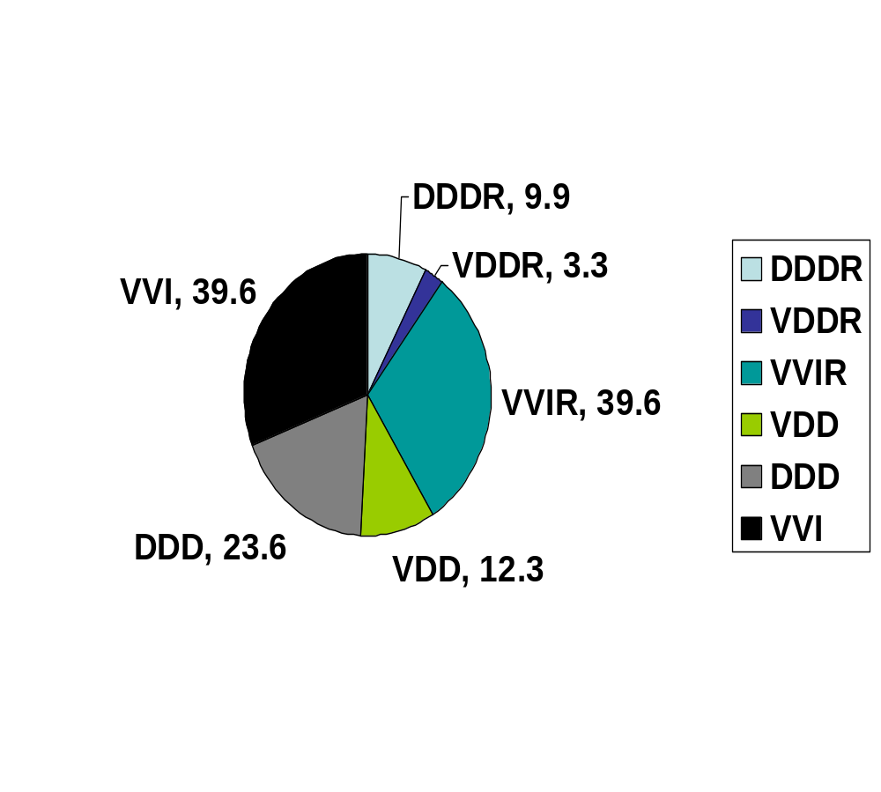
Figure 1: Pacing modes in patients who underwent permanent pacemaker implantation

DISCUSSION

Current study is intended to evaluate the practice of permanent pacemaker implantation in a single tertiary cardiac center. All patients who underwent first pacemaker implantation were symptomatic, where syncope and dizziness were the most common reported symptoms. There were no asymptomatic patients indicating the fact that the hospital in which all pacemaker implant was performed is a tertiary center not a general hospital. Moreover, all patients who underwent second pacemaker implantation were symptomatic, contrary, no asymptomatic second implant was reported. This may be due to a lack of proper follow-up of patients with pacemaker. Alternatively, this may result from the special property of our patients who seeks medical advice only when they become symptomatic. It is worthy to mention that this hospital lacks a separate electrophysiological unit.

Actually, AV block was the most common indication for implantation of a permanent pacemaker (88%), while sinus node dysfunction represents (4.9%) of the permanent pacemaker implantation indications. In the Danish pacemaker registry 2004, AV block was the indication in 40%, sick sinus syndrome in 35.5% and chronic atrial fibrillation/flutter in 17.9% of patients (6,7).

The low incidence of permanent pacing for sinus node dysfunction in this center may indicate high diagnostic threshold for sinus node dysfunction among the referring physicians and also may be due to lack of invasive electrophysiological facilities that may diagnose sinus node dysfunction in this center. The results showed that indications for all patients who underwent permanent pacemaker implantation were compliant with 2002 ACC/AHA guidelines for permanent pacemaker implantation ⁽⁵⁾.

However, if 2013 European Society of Cardiology (ESC) guidelines is applied, pacemaker implantation in 5 patients with trifascicular block and fainting attacks considered to be class IIb (8). But we used 2002 ACC/ AHA / NASPE guidelines for comparison because these guidelines are the working guidelines during the implantation time ⁽⁵⁾.

Am Greenspan et al has reported that 20 % of permanent pacemaker implantation at thirty hospitals in Philadelphia are not indicated ⁽⁹⁾. Consistently, in our study there is no incidence of unwarranted permanent pacemaker implantation and this may be due to the fact that the present study has conducted in a tertiary center which receives the referred cases and has a postgraduate teaching program.
Regarding the mode of pacing, VVI mode represents more than one third of the modes used and it is the most common mode of pacing. In the Danish pacemaker registry, physiological pacing defined as atrial based pacing, was chosen in 74% of all implants. VVI mode was used in 25.8% of patients ^{(6,7)}. Our high incidence of VVI pacing mode may be due to time shortage where VVI pacemaker implants needs less time than other modes and because of lack of a separate catheterization laboratory in the hospital for EP studies.
Interestingly, complications were reported in 10 % of the procedures and no mortality was encountered. In consistence with our observations, R Bond et al has illustrated that total complications occurred in 7.5% of patients with pacemaker implantation and the most common complications are lead dislodgement and pneumothorax ⁽¹⁰⁾. However, complication rate may increase up to 15.3% in upgrade procedures involving transvenous lead addition ⁽¹¹⁾.
Present study show that the pacemaker infection occurred in 2.2 % of the procedures and all
responded to medical treatment without removing of the device. On the other hand, it has been reported that annual incidence of pacemaker infection between 1.5 – 2.4 % ⁽¹²⁾. Among the three studied risk factors for pacemaker infection (age, DM, non-expert operator), DM seems to be associated with significant increase in the risk of pacemaker infection. It is well known that DM represents risk factor for infection anywhere in the body ^{(6, 7)}. Aforementioned studies have revealed that DM may lead to impairment at several levels of immune system. In addition, hyperglycemia impairs phagocytic function leading to reduced resistance to infection and wound healing ^{(13, 14)}.
Study by AJ Greenspon et al has reported that the occurrence of device infection was greatest in white males over 65 years of age, and the most significant associated co-morbidities were renal failure, respiratory failure, heart failure and diabetes ⁽¹⁴⁾.

Conclusion
The standards for permanent pacemaker implantation in a single center are approaching the international standards. Pacemaker infection still an important problem especially in diabetics.

Ethical approve
Our study has been approved under institutional ethical approval company. Our institutes have provided us with task facilitating requests. Consequently, ethical and legal consents have been obtained from all patients. Furthermore, we clearly explained to patients and their relatives all tests and surgical interactions.

Source of funding
Self-funded

Conflict of Interest
Nil.

References
- Pugazhendhi Vijaraman and Kenneth A Ellenbogen ; Bradyarrhythmias and Pacing , in : Richard A Walsh , James C Fang and Valentin Fuster , Hursts The Heart Manual of Cardiology 13th edition 2013 , McgrawHill Medical , New York , p 132 -143 .
- Hayes DL, Naccarelli GV, Furman S, et al . NASPE policy statement: NASPE training requirements for cardiac implantable electronic devices: selection, implantation and follow-up. Pacing Clin Electrophysiol 2003; 26: 1556-1562.
- Stamato NJ, O"Toole MFand Enger EL . Permanent Pacemaker Implantation in the cardiac catheterization laboratory versus the operating room: An analysis of hospital charges and complications. PACE 1992 ;15: 2236 - 41.
- Wayne W Daniel . Biostatistics : A foundation for analysis in the health sciences . 8th edition 2005 , John Whily and Sons Inc. , New York .
- Gregoratos G, Abrams J, Epstein AE, et al. ACC/AHA/NASPE 2002 guideline update for implantation of cardiac pacemakers and antiarrhythmia devices summery article: a report of the American College of Cardiology/American Heart Association Task Force on Practice Guidelines (ACC/AHA/NASPE Committee to update the 1998 Pacemaker Guidelines). Circulation 2002 ;106: 2145 - 2161.
- Danish Pacemaker and ICD Registry 2004 Annual Report . Odense , Denmark : Danish Pacemaker Registry ; 2004 . Available at :http://www.pacemaker.dk.
- Maisel W H . Pacemaker and ICD generator reliability ; meta- analysis of device registries . JAMA 2006 ; 295 : 1929-1934 .
- Michele Brignole , Angelo Auricchio , Gonzalo Baron – Esquivius , et al . 2013 ESC guidelines on cardiac pacing and cardiac resynchronization therapy . European Heart Journal 2013 ; 34 : 1001 – 6.
- Allan M Greenspan , Harold R Kay , Bruce C Berger , et al . Incidence of unwarranted implantation of permanent cardiac pacemakers in a large medical population . NEJM 1988 ;318 : 158 – 163 .
- Richard Bond, Daniel Augustin and Mark Dayer . Pacemaker complications in a district general Hospital. British Journal of Cardiology 2012 ; 19 : 90 – 4 .
- Jeane E Poole , Marye J Gleva , Theofanie Mela , et al . Complication rates associated with Pacemaker or Implantable Cardioverter – Defibrillator generator replacements and upgrade procedures. Circulation 2010 ; 122 : 1553 – 1561 .
- Cristian Podoleanu and Jean – Claudo Deharo . Management of Cardiac Implantable Electronic Device infection. Arrhythmia and Electrophysiology Review 2014 ; 3(3) : e pub. ahead of print – Accessed at www. AER journal.com
- B M Frier and M Fisher. Diabetes Mellitus, in : Nicki R Colledge , Brian R Walker and Stuart H Ralston . Davidsons Principles and Practice of Medicine 21st edition 2010 , Churchill Livingston Elsevier , Edinburgh , p 816.
- Greenspon A J , Patel J D , Lau E , et al . 16 – year trends in the infection burden for pacemakers and implantable cardioverter – defibrillators in the United States 1993 to 2008 . J Am Coll Cardiol. 2011 ; 58 : 1001 – 6.

