The Pandemic Notebook: The Medical-Ethics Perspective to COVID-19

Abstract
The Hindu published an e-book entitled The Pandemic Notebook in multiple languages. It is a practical, handy book on the understanding of coronavirus pandemic so to enhance medical awareness to protect ordinary people against COVID-19. R. Prasad, Bindu Shajan Perappadan, Jyoti Shelar, and Jacob Koshy have written the book. P. J. George has edited it. The Hindu has been covering the pandemic since inception, and the e-book provides most relevant, scientific information focusing on good health practices and the safety reasons to people. The present review offers the medical- ethics perspective to COVID-19.
Keywords
COVID-19, Medical-Ethics, The Hindu, Healthy Practices, Safety Reasons
Refbacks
https://www.thehindu.com/news/resources/the-hindus-e-book-on-covid-19-in-multiple-indian-languages/article31174374.ece
https://creatives.thehindu.com/covid_19_ebook.pdf
https://www.news18.com/photogallery/world/covid-19-photos-up-close-with-the-deadly-coronavirus-2532875-14.html
The medical-ethics perspective I find in the e-book underlies sufficient medical and moral reasons that it caters to the necessary expectations of an aware citizen of any country who is concerned and feels anxiety to the corona outbreak. The book offers an adequate scientific medical perspective based on the facts and reasons explaining the type, nature, characters, affective connections to other chronic diseases, and possible applications of drugs. Moreover, it provides valuable information about the screening, measures, testing, vaccination development process and treatment of COVID-19. On the other hand, the ethical perspective of the book lies in its moral reasons on care, safety, removing misinformation and myths to the pandemic. The e-book begins with introduction, origin and the fundamental question of what are the Coronaviruses. Coronaviruses cause less or severe common cold diseases like severe acute respiratory syndrome (SARS) & Middle East respiratory syndrome (MERS). The coronavirus study group has developed the official classification of the virus and is responsible for its taxa naming of the coronaviridae family as SARS-COV-2. Authors emphasized on the zoonotic specialty of the virus that it transmits from animal to human. In case of a novel coronavirus, the pieces of evidence show that it has been transmitted from the bat.
Further, it talks about the structure and how the virus enters the human body and how scientists develop the vaccine of Coronavirus discussed in the book as follows:
“Like other Coronaviruses, SARS-CoV-2 virus particles are spherical and have mushroom-shaped proteins called spikes protruding from their surface, giving the particles a crown-like appearance. The spike binds and fuses to human cells, allowing the virus to gain entry. Researchers at the University of Texas at Austin and the National Institutes of Health, U.S., have produced a 3D atomic-scale map of the protein of the SARS-CoV-2 that binds to and infects human cells. Mapping the 3D structure of the protein — spike (S) glycoprotein — will allow a better understanding of how the virus binds to the human cells. Knowing the structure of the spike protein will, in turn, allow scientists to develop vaccines and antivirals against the virus and even better diagnostics” ( The Pandemic Notebook, pp;3). The following image shows the structure of Coronavirus:
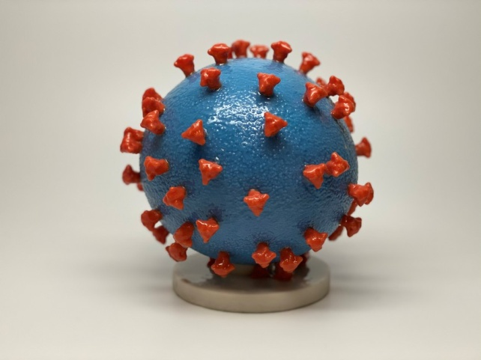
(Image-1: https://www.news18.com/photogallery/world/covid-19-photos-up-close-with-the-deadly-coronavirus-2532875-14.html)
The first two sections, from pp; 2-10 of the books:1) A closer look at SARS-COV-2, and 2) Understanding the disease, explain the medical, scientific facts. And emphasize on its high transmissibility, spike structure, genome sequencing and answer practical questions like how the disease spread, who is affected, what are the symptoms, how can it be detected, what is the treatment, and can a vaccine be developed for COVID-19? However, the last two sections, from pp; 11-17 of the book :3) Protecting yourself against COVID-19, 4) Some common queries answered, build the ethical perspective in which authors explain about the care, safety and protection of the people from the disease. The emphasis is on the use of alcohol-based sanitizers, washing hands frequently, using the mask, social distancing and practicing respiratory hygiene. Besides, the sections clarify the difference between the flue and COVID-19, the efficacy of thermal scanning, the possibility of transmission through swimming pools, meat-based eating and the link between a person’s immunity and coronavirus infection, home remedies, use of antibiotics and can a vaccine of pneumonia protect against COVID-19?
Further, it finishes off the two myths based on up to date scientific facts that coronavirus infection does not spread through a mosquito bite, and it has nothing to do with hot and humid climate zones. In the last section of the book from pp; 18-19, it provides the two new national helpline numbers: 1075/1800-112-545 & 011-23-978046 and other helpline numbers for all the states & union territories of India. Before I conclude the review, the following figure shows the medical-ethics perspective:
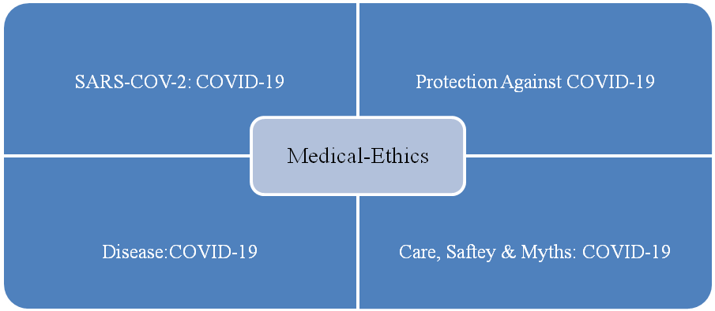
Fig: 1
The severity of the anxiety is but evident across the globe, considering up to date cases as infection count reaches to the massive number of 5937199 people and deaths to 362776. The book makes a valuable contribution to the ongoing researches as it offers a medical-ethics point of view to COVID-19 in an efficient fashion and is freely accessible to everyone in all Indian languages. Finally, it’s a must-read for all the educated people so that they can make social-community rightly informed about COVID-19 and can help people in developing coping strategies to reduce the level of social anxiety, psychological fear, and medical insecurity.

