TEACHERS’ VIEW ON ONLINE CLASSES DURING COVID-19 LOCKDOWN –
A CROSS-SECTIONAL STUDY

Andrew Thomas¹, Mohan T. Shenoy², Shenoy K. T.³, Sruthi Suresh Kumar¹, Aboobakker Sidheeque¹, C. Khovidh⁴, Jayakumar Parameshwaran Pillai⁵, Pramod Murukan Pillai⁶, Shana Sherin C. H.⁷, Anna Mathew⁸, Twinkle Zakkir⁹, Sreelakshmi Dileep¹⁰, Mekha¹¹, Sony Raju¹², Mohammed Junaid K.¹³, Sivendu P.¹⁴

CORRESPONDING AUTHOR

Andrew Thomas
Sree Gokulam Medical College and Research Foundation
Venjaramoodu, Trivandrum, Kerala, India
Pincode – 695607

Mobile - +91 7010325886
Email id - drandrewthomasj@gmail.com
ORCID id: 0000-0002-2997-4525
Running Title Covid-19 teachers view online classes

AUTHORS’ AFFILIATIONS

¹Medical student, Sree Gokulam Medical College and Research Foundation, Trivandrum, India
²Department of Endocrinology, Sree Gokulam Medical College and Research Foundation, Trivandrum, India. ORCID id: 0000-0002-2298-8852
³Department of Gastroenterology, Sree Gokulam Medical College and Research Foundation, Trivandrum, India. ORCID id: 0000-0002-2826-6869
⁴Medical student, SRM Medical College Hospital and Research Centre, Chennai, India
⁵Department of Biochemistry, Government Medical College, Trivandrum, India
⁶Medical student, Sree Narayana Institute of Medical Sciences, Ernakulam, India
⁷Medical student, Believers’ Church Medical College, Thiruvalla, India
⁸Medical student, Pushpagiri Medical College, Thiruvalla, India.
⁹Medical student, Travancore Medical College, Kollam, India
¹⁰Medical student, Government Medical College, Kannur, India
¹¹Medical student, Malabar Medical College Hospital and Research Centre, Calicut, India
¹²Medical student, Government Medical College, Thrissur, India
¹³Medical student, Al Azhar Medical College & Super Specialty Hospital, Idukki, India
¹⁴Medical student, KMCT Medical College Hospital, Calicut, India

- Sources of Funding: NIL

- Conflicts of interest: NONE

- Word count – ( 1863 ) Abstract- ( 147 )

- Number of tables - 2

- Number of figures - 3

Contributors
AT and SKT contributed the original concept and design of the study. AT, SSK, AS, CK, PMP, SSCH, AM, TZ, SD, M, SR, MJK, and S were involved in collection of data and management. AT, SKT, MTS, JPP did the data analysis and interpretation. AT and MTS drafted the paper. All the authors have critically revised this article and approved the final version to be published. We thank Dr Radhika for helping us with the English diction.

Ethics approval: Ethical approval for the study was granted by the Sree Gokulam Medical College and Research Foundation, Venjaramoodu, Trivandrum, India.

ABSTRACT

An online survey was carried out among medical teachers. We evaluated their opinions on online classes, and analyzed their views on the viability of these classes, in post COVID-19 lockdown. Respondents were 101 medical teachers from the states of Kerala and Tamil Nadu, India. Majority of the teachers took classes after intense preparation. They felt that the quality of their work would have been better with enhanced IT infrastructure. Top reason for favoring online classes was, the opportunity it gave them to access the content later. Nearly half of them faced network issues, and more felt discouraged by lack of interaction. Teachers opined that online classes were very poor, compared with regular classes. Despite experiencing problems, most participants wanted to continue online classes in the future. Online classes should be made more interactive and IT infrastructure should be improved to address the increasing need of online education.

Key Words: medical teachers, online education, attitude, COVID-19 lockdown, e-learning (Source: MeSH-NLM)

INTRODUCTION

On 31 December 2019, the World Health Organization (WHO) was notified about several cases of pneumonia with unknown aetiology in Wuhan city of Huaibei province, China¹. As of 27 June 2020, the pandemic has affected more than nine million people worldwide². Most countries around the world have closed their universities and colleges as part of lockdown in a bid to contain the spread of coronavirus infection. This has impacted almost 70% of the world’s student population³. The COVID-19 pandemic necessitated migration from regular to online classes in many countries. Technology in education was described by Peter H. Martorella, as a “sleeping giant” over two decades ago ⁴. However, developing countries like India have inadequate internet and network infrastructure, a factor that is seriously affecting the quality of online classes. Replicating pedagogic teaching is difficult in online education. Students and teachers should try to collaborate and converse in virtual discussion groups among the social media, and these interactive activities may lead to improved efficiency of online education⁵.
Student-centered approach in education, with embedded opinions from teachers, is vital to sustain the quality of education. Unfortunately, the opinions of teachers are often overlooked. Motivating the teaching staff to take up online classes seriously and improving infrastructural resources are necessary for the success of online education⁶. The use of technology is no longer unusual among teachers. Knowledge-sharing through social media networks, along with enrolment in web-based courses, will help increase interest and maximize participation in virtual teaching^{7,8}. The net result will be that teachers will be motivated to improve the quality of their online classes. As medical colleges have been actively involved in online teaching for more than month now, we hope to capture the opinions of medical teachers who have conducted online classes and assess their views on whether to continue these classes, post COVID-19 lockdown in India.

MATERIALS AND METHODS

A cross-sectional survey was conducted among medical teachers during the COVID-19 lockdown. Teachers, who conducted at least one virtual class, gave assignments or uploaded videos on social media platforms were included in the study. The survey was distributed among medical teachers currently working in the medical colleges in the states of Kerala and Tamil Nadu. The sampling was consecutive and convenient. The study was done with approval from Institutional Research Cell and Institutional Ethical Committee of Sree Gokulam Medical College and Research Foundation, Kerala, India.

QUESTIONNAIRE

The participants were asked to fill out a semi-qualitative questionnaire, comprising 26 questions. The questionnaire was pilot-tested among a group of teachers for the content and the construct. The questionnaire was self- administered in English using Google Forms (Google LLC, CA, U.S.A). WhatsApp (WhatsApp Inc, CA, U.S.A) was used to distribute the survey links. The questionnaire was online for one week (03 to 10 May 2020). The participants were informed about the aims, benefits and implications of the study, and their consent was sought before beginning the survey. Restricting the number of responses from a single mail id was to ensure there was no double entry.

The questionnaire had four sections. The first section sought information on the age, gender and area of specialization of the participant, the type of institution (government or private) he/she was affiliated to and the pin code of the institution. The second asked for details about the participants’ previous experiences in online education and training. This included questions on the characteristics of the online classes that were conducted over the last two weeks (from 18 April to 02 May 2020), specifically about the duration of online classes, the time taken for preparation, the devices, platforms and type of accounts used, the place where they conducted their classes from, and so on. The third section demanded that the participants rate their online classes. A five-point Likert’s scale was used to determine the quality of audio, video/ image/ slide quality, the content, the extent of interaction and the opportunities given to students for clearing doubts at end. Questions were also asked about how online classes compared with regular classes, and this was done on the scale of five [with ‘one’ favouring regular and ‘five’ favouring online classes]. The fourth section was on what they liked or disliked about online classes, and sought suggestions to improve online classes. Finally, they were asked whether they wished online classes to continue after COVID-19 lockdown. The participants were encouraged to select multiple answers for questions regarding experience, likes and dislikes, devices, platforms, practice and suggestions for online classes.

DATA ANALYSIS

Specialities were classified into clinical (Ophthalmology, ENT, Medical, Surgery, OBGYN, Paediatrics, Orthopaedics and Radiology) and para/non-clinical groups (Anatomy, Biochemistry, Physiology, Pharmacology, Microbiology, Pathology, Forensic medicine and Community medicine). The Likert responses were organized under five categories: very poor, poor, average, good and excellent. The data was exported from Google forms to Microsoft Excel (Microsoft Corp, WA, U.S.A). Descriptive statistics was used for data presentation because there was no prior hypothesis. The degree of association was calculated using Chi square test and p value of less than 0.05 was taken as statistically significant. SPPS v25 for windows (Statistical Package for the Social Sciences, SPSS Inc, U.S.A) was used to compare the outcomes of clinical and para/non-clinical departments.

RESULTS

Respondents’ Characteristics

A total of 101 medical teachers responded to our survey questionnaire. We excluded 12 participants from the analysis because they did not satisfy the inclusion criteria. Among them, 65% (n=58) were females and 35% (n=31) males. Those from the private sector constituted 93.3% (n=83) of the group whereas the government sector came to only 6.7% (n=6). Non-clinical teachers (Figure 1) were comparatively older than clinical teachers (p<0.05). A few of the participants – 43.8% (n=39) – had no idea about online classes before COVID-19 lockdown. Some – 46.1% (n=41) – had attended online classes earlier, and 18% (n=16) had the experience of conducting online classes before lockdown.

Figure 1. Age Distribution of Participants

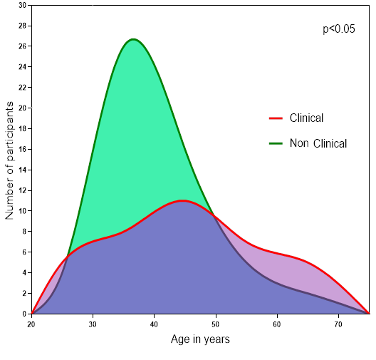
Online Class Characteristics

The respondents were asked to comment on the online classes they conducted over the past two weeks. Table 1 shows the devices and platforms used for conducting online classes. A total of 66.3% (n=59) used basic or free software, 23.6% (n=21) used premium or paid accounts and 10.1% (n=9) of the participants did not know the details. There was no significant association between time taken for preparation and duration of online classes (Figure 2). While 70.8% (n=63) conducted classes from the IT department of their institution, 58.4% (n=52) taught from home and 22.5% (n=20) from their personal office.

Table 1. Devices and Platforms used for Online Classes

 |  | Clinical (n=36) |  | Non clinical (n=53) |  | Total (n=89) |  | p
 |  | n | % | n | % | n | % | p
Devices used for online classes | Smart Phones | 16 | 44.4 | 34 | 64.2 | 50 | 56.2 | 0.066
Devices used for online classes | Tablets | 8 | 22.2 | 4 | 7.5 | 12 | 13.5 | 0.047
Devices used for online classes | PC | 32 | 88.9 | 48 | 90.6 | 80 | 89.9 | 0.797
Platforms used | Google platforms | 13 | 36.1 | 28 | 52.8 | 41 | 46.1 | 0.120
Platforms used | ZOOM | 23 | 63.9 | 29 | 54.7 | 52 | 58.4 | 0.389
Platforms used | Skype | 17 | 47.2 | 7 | 13.2 | 24 | 27 | 0.000
Platforms used | YouTube | 8 | 22.2 | 15 | 28.3 | 23 | 25.8 | 0.520
Platforms used | WhatsApp | 13 | 36.1 | 34 | 64.2 | 47 | 52.8 | 0.009
Platforms used | Others | 7 | 19.4 | 5 | 9.4 | 12 | 13.5 | 0.175

Figure 2. Duration of Classes and Time Taken for Preparation

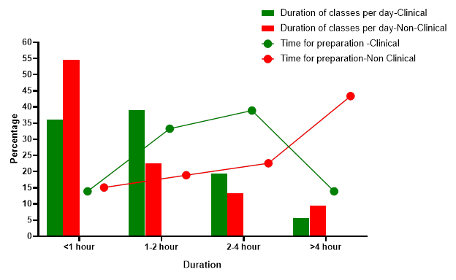

Teachers’ Opinions on Online Classes

The reasons for liking and disliking online classes are summarized in Table 2. The participants were asked to give suggestions for improving online classes. The top suggestions were: improve IT infrastructure in the educational institution [59.6% (n=53)], ensure good lighting in the environment [57.3% (n=51)]. A total of 57.3% (n=51) felt they would do better with training from peers, whereas 41.6% (n=37) felt having light refreshments would improve the online classes. The participants’ rating of online classes is summarized in Figure 3. Nearly half of the participants – 49.4% (n=44) – wanted to continue online classes after lockdown. Some – 38.2% (n=34) – were neutral whereas 12.4% (n=11) were against continuing classes.

Table 2. Likes and Dislikes of Online Classes

 |  | Clinical (n=36) |  | Non-clinical (n=53) |  | Total (n=89) |  | p
 |  | n | % | n | % | n | % | p
Likes online classes | Can access contents later | 19 | 52.8 | 31 | 58.5 | 50 | 56.2 | 0.594
Likes online classes | More relaxed/ Flexible working hours | 12 | 33.3 | 14 | 26.4 | 26 | 29.2 | 0.481
Likes online classes | Students are more regular/ attentive | 23 | 63.9 | 17 | 32.1 | 40 | 44.9 | 0.003
Likes online classes | None | 2 | 5.6 | 5 | 9.4 | 7 | 7.9 | 0.505
Dislikes online classes | Network problems | 26 | 72.2 | 30 | 56.6 | 56 | 62.9 | 0.134
Dislikes online classes | Insufficient time | 3 | 8.3 | 12 | 22.6 | 15 | 16.9 | 0.077
Dislikes online classes | Lack of expertise | 14 | 38.9 | 23 | 43.4 | 37 | 41.6 | 0.672
Dislikes online classes | Visual/ auditory fatigue | 10 | 27.8 | 14 | 26.4 | 24 | 27 | 0.887
Dislikes online classes | Lack of interaction | 21 | 58.3 | 35 | 66 | 56 | 62.9 | 0.460
Dislikes online classes | Too casual | 16 | 44.4 | 27 | 50.9 | 43 | 48.3 | 0.547
Dislikes online classes | NONE | 4 | 11.1 | 4 | 7.5 | 8 | 9 | 0.564

Figure 3. Participants’ Opinions on Online Classes

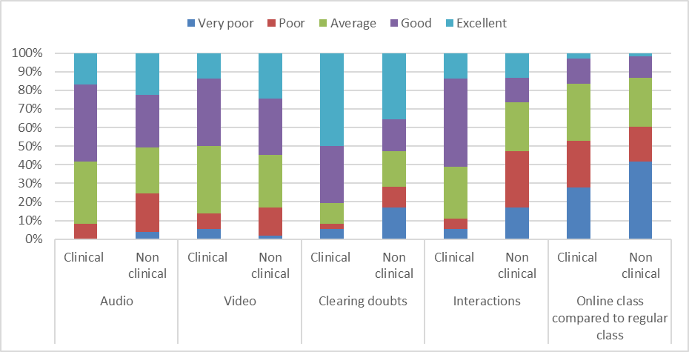

DISCUSSION

Our survey of medical teachers conducting online classes is the first of its kind during COVID-19 lockdown. A majority of the participants – 93.3% (n=83) – were from private medical colleges. This was expected because many government medical colleges have not started conducting online classes yet. The delay in starting online classes may be due to the increasing admission of COVID-19 patients in government set-ups. Even medical students have volunteered to get involved in COVID-related duties.

More than half – 56.2% (n=50) – of the participants liked online classes because it gave them an opportunity to access the contents of their class later. Network problem 62.9 % (n=56) was the top reason for disliking online classes. India is the second largest online market with over 560 million internet users. However, the internet penetration rate in 2020 is only around 50 percent⁹. This means that only half of the country’s population has access to internet. The average internet speed in India also poses a problem. India ranks 130th in mobile and 71st in broadband usage, globally¹⁰. This might be the cause of network problems experienced by the participants. Another interesting observation was that even though the participants voted ‘average’ for interactions in their class, lack of interaction, felt by 62.9 % (n=56), was also the top reason for disliking online classes, which was equal to network problem. Interaction is an essential characteristic and a critical indicator of an effective online class^{11,12}. Discussion through messages via platforms like WhatsApp, Google Classrooms, giving assignments and timely feedback may be useful. When conducting virtual classes, interacting with students personally, permitting them to ask questions or raise doubts, and encouraging them in chat participation may increase the overall effectiveness of the class.

More teachers felt online classes were very poor 36% (n=32) compared to regular classes. Medical subjects are often discussed in relation to cases, observed and studied in wards. Even theory topics are complex to understand. Add time constraints and network problems to this, and the overall efficiency of online class is reduced further. Online education is not inferior to regular classes. In a meta-analysis on undergraduate medical education, which included 16 studies, none concluded that online learning was less effective than regular learning¹³. Some aspects of online classes may not be as good as those of regular classes. However, this shortcoming can inspire students to develop self-learning capabilities through the internet^{13,14}. There is a wide disparity in the resource types and subjects. Addressing these will have good implications on online learning¹⁵. Mahadevan, a senior professor of Ophthalmology in Kerala, India writes, “online classrooms are here to stay and it has begun taking baby steps to become an integral part of education”¹⁶. His view is consistent with our findings. Almost half of the participants – 49.4% (n=44) – wanted to continue online classes after COVID-19 lockdown compared with 12.4% (n=11) who did not want to continue.

There are several limitations in our study. This is a one-sided study exploring only teachers’ opinions. There were no studies before COVID-19 lockdown to compare our findings. In a recent study, we accessed online learning among 1016 students. We calculated the sample size of teachers and students to be in the ratio of 1:10. We anticipated 108 teachers, and got 101 responses. However, we included only two states in the country because these states were the first to start online classes and secondly, they were relatively easier to access for data collection during lockdown.

No one was ready for this pandemic or its repercussions. Neither the teachers nor the students. Though India has some experience in online education, the country is not equipped to handle this sudden and massive transition. However, our survey finds that even though more participants had network problems and had to endure lack of sufficient interaction, they wanted to continue online classes after COVID-19 lockdown. But if this is to succeed, educational institutions should improve their IT infrastructure and consider training teachers in online classes. They should also try to incorporate some online classes into the curriculum. Further studies and randomized controlled trials should be conducted to evaluate the efficiency of online education in India.

REFERENCES

- Harapan H., Itoh N., Yufika A., et al. Coronavirus disease 2019 (COVID-19): A literature review. J Infect Public Health. 2020 May;13(5):667-673.

- Coronavirus disease (COVID-19) Pandemic. Retrieved 27 June 2020. https://www.who.int/emergencies/diseases/novel-coronavirus-2019

- COVID-19 Impact on education. Retrieved 27 May 2020. https://en.unesco.org/covid19/educationresponse

- Pearcy M. Student, Teacher, Professor: Three Perspectives on Online Education. The History Teacher. 2014;47(2):169–85.

- Northrup P. T. Online learners’ preferences for interaction. The Quarterly Review of Distance Education 2002;3 (2): 219–226.

- Vogelsang M., Rockenbauch K., Wrigge H., et al. Medical Education for "Generation Z": Everything online?! - An analysis of Internet-based media use by teachers in medicine. GMS J Med Educ. 2018 May 15;35(2):Doc21.

- Pscheida, Daniela, Claudia Minet, et al. “Use of Social Media and Online-Based Tools in Academia,” n.d., 101.

- Panahi S., Watson J., Partridge H. Social media and physicians: Exploring the benefits and challenges. Health Inform J. 2014:1–14

- Statista Research Department. Internet usage in India- Statistics & Facts. Retrieved 27 May 2020 https://www.statista.com/topics/2157/internet-usage-in-india/

- India's Internet Speed Is Falling Since Jan 2020, Globally Rank 130th For Mobile Data Speed. Retrieved 03 June 2020. https://www.indiatimes.com/technology/news/indias-internet-speed-is-falling-since-jan-2020-globally-rank-130th-for-mobile-data-speed-510505.html

- Kalman Y. M, Ravid G, Raban D, et al. Pauses and Response Latencies: A Chronemic Analysis of Asynchronous CMC. Journal of Computer-Mediated Communication, 2006;12(1), 1–23.

- Kuo, Y.C, Walker A. E, Schroder K. E. E, et al . Interaction, Internet self-efficacy, and self-regulated learning as predictors of student satisfaction in online education courses. The Internet and Higher Education, 2014;20, 35–50.

- Leisi Pei, Hongbin Wu. Does online learning work better than offline learning in undergraduate medical education? A systematic review and meta-analysis, Medical Education Online, 2019;24:1.

- Friedman C. P, Donaldson K. M., Vantsevich A. V. Educating medical students in the era of ubiquitous information. Med Teach. 2016;38(5):504–509

- Kim K. J, Kim G. Development of e-learning in medical education: 10 years' experience of Korean medical schools. Korean J Med Educ. 2019;31: 205-214.

- Mahadevan K. “Aftermath of Covid’s Forray into the Educational Scene.” IMA Kerala Medical Journal. 2020:13: 55–56.

