Contributors’ form (to be modified as applicable and one signed copy attached with the manuscript)
Journal Title: Indian journal of medical ethics
Manuscript Title: Awareness and Perception towards Dental Ethics and Ethical Dilemmas among Dental Professionals -A Cross-Sectional Study
Manuscript Number: ________________________________________________________________________________

I/we certify that I/we have participated sufficiently in the intellectual content, conception and design of this work or the analysis and interpretation of the data (when applicable), as well as the writing of the manuscript, to take public responsibility for it and have agreed to have my/our name listed as a contributor. I/we believe the manuscript represents valid work. Each author confirms they meet the criteria for authorship as established by the ICMJE. Neither this manuscript nor one with substantially similar content under my/our authorship has been published or is being considered for publication elsewhere, except as described in the covering letter. I/we certify that all the data collected during the study is presented in this manuscript and no data from the study has been or will be published separately. I/we attest that, if requested by the editors, I/we will provide the data/information or will cooperate fully in obtaining and providing the data/information on which the manuscript is based, for examination by the editors or their assignees. Financial interests, direct or indirect, that exist or may be perceived to exist for individual contributors in connection with the content of this paper have been disclosed in the cover letter. Sources of outside support of the project are named in the cover letter.
I/We hereby transfer(s), assign(s), or otherwise convey(s) all copyright ownership, including any and all rights incidental thereto, exclusively to the Journal, in the event that such work is published by the Journal. The Journal shall own the work, including 1) copyright; 2) the right to grant permission to republish the article in whole or in part, with or without fee; 3) the right to produce preprints or reprints and translate into languages other than English for sale or free distribution; and 4) the right to republish the work in a collection of articles in any other mechanical or electronic format.
We give the rights to the corresponding author to make necessary changes as per the request of the journal, do the rest of the correspondence on our behalf and he/she will act as the guarantor for the manuscript on our behalf.
The article will be published under the terms of the latest Creative Commons Attribution-NonCommercial-ShareAlike License, unless the journal notifies the author otherwise in writing.
All persons who have made substantial contributions to the work reported in the manuscript, but who are not contributors, are named in the Acknowledgment and have given me/us their written permission to be named. If I/we do not include an Acknowledgment that means I/we have not received substantial contributions from non-contributors and no contributor has been omitted.

Name Signature Date signed

1 Dr. Indumathy .M 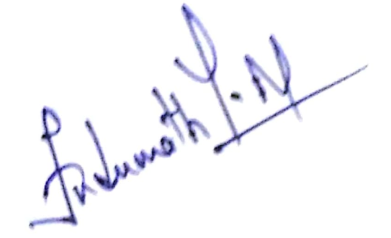 29.04.2020

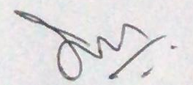
2 Dr. Meignana Armugham 29.04.2020
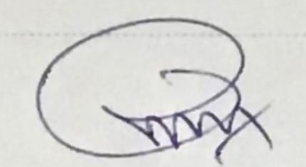
3 Dr. R. Pradeep Kumar 29.04.2020
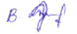
4 Dr. B. Arthi 29.04.2020

5 ———————————— ————————— —————
6 ———————————— ————————— ————— (Additional signatures may be added provided the authors meet the ICMJE criteria stated above)

