Title of the article: Effectiveness of Clinical Research Regulation and Good Clinical Practice workshop in enhancing the knowledge of University research professionals
First author-
Dr. Divya Karanth,
Research Assistant, Kasturba Medical College,
E-mail id- divya.karanth93@gmail.com
Phone no.- +918073728795
Corresponding contributor:
Dr. Veena L Karanth
Department of Surgery, Kasturba Medical College, MAHE, Manipal
E-mail - veena.karanth@manipal.edu, karanthkvl@yahoo.co.in,
Phone Number-+919845417715

Abstract:
Context: Good Clinical Practice (GCP) safeguards the privacy, confidentiality of trial subjects, and ensures the quality and integrity of the biomedical data. Training is the most critical aspect of the GCP process. The training program aims at providing clarification and sensitizing researchers on complex regulatory and academic research requirements.
Aims: The study aimed to determine the efficiency of the workshop in imparting knowledge and training to the delegates. Also, the study assessed the different levels of understanding for the various sections of the training workshop.
Settings and Design: The study retrieved 110 data from the workshop on Clinical Research Regulation (CRR) and GCP conducted for interested researchers involved in clinical research. Methods and Material: Current knowledge of CRR and GCP was tested using the pre-training questionnaire answers from the workshop.
Statistical analysis used: Wilcoxon Signed-Rank test was used for statistical analysis of pre and posttest scores of the participants answers. McNemar's test was used for the Item-wise comparison of pretest and posttest knowledge scores.
Results: This study showed an increase in the knowledge in a few questions relating to SAE (24%, p<0.001), IEC (16.3%, p=0.016) and Medical Devices Act (16.4%, p=0.008) following the training workshop, the median pretest and posttest scores were 5 and 6, respectively.
Conclusions: The study showed that with the training workshop, there was an improvement in knowledge among the participants. With further increase in intensive training in GCP and CRR, the non-compliance with GCP can be controlled, and high standard clinical trials can be achieved.
Key-words: Institutional Ethics committee, Informed consent, Serious Adverse Event, CTRI, guidelines Ethics
Key Messages: Training in good clinical practise guidelines and clinical research regulations is mandatory for effective, ethical research. Evaluation of training is equally essential. Pretest and posttest questionnaires are an effective method for its documentation. Questionnaire validation, process improvisation and long term participant evaluation is the avenue for further research.
Introduction:
Good clinical practice (GCP) is a global scientific and ethical framework for clinical research comprising of designing, planning, conducting, monitoring, documenting, and reporting biomedical studies or trials involving human subjects. ^{[1]} The primary objective is to safeguard the trial subjects, secure their privacy, confidentiality, and to ensure the quality and integrity of the created biomedical data. ^{[2] [3]}
India has been globally recognized as a nation offering unique and distinct opportunities to clinical trials due to a large patient population, well-experienced physicians, and leading medical institutions along with the advantage of low cost per patient selected, as opposed to the developed countries. ^{[3]}

However, changing times required the establishment of India's guidelines for GCP to provide a uniform standard for clinical research studies, and formulated the first recognized GCP report in 2001, customized to the Indian needs.^{[3]} ^{[1]} The Indian GCP encompasses various aspects such as informed consent (IC), community agreement, non-exploitation of study subjects, maintaining privacy and confidentiality, minimizing the risk, accountability, transparency of the investigators and sponsors and essentiality. ^{[3]}

Medical science has made fast progress at the turn of the century, with new treatment methods being developed at a remarkable pace. Clinical trials were, however, performed without adequate disclosure of intent and result. This has contributed to the need to make clinical research more transparent. ^{[3] [6]} Also, medicine has become more scientific and is less appropriate without a supported opinion and empirical data. The randomised clinical trial is the standard method for modifying diagnostic and or therapeutic methods which must bind to GCP and CRR guidelines. ^{[4]} Clinical research can only be relied upon if conducted in accordance to principles and standards of GCP. ^{[9]} Many researchers are not fully trained in the principles and practical application of GCP. ^{[8]} Due to the higher patient load along with other obligations like medical education, knowledge, and information regarding GCP lies in the grey area.^{[9]}

The introduction of an integrated approach to GCP training, which should be widely accepted by researchers, could offer a way forward in maintaining the workforce of well-trained researchers while reducing the burden of re-training. Diversity in the content and expectations of GCP training programs may have led to inefficiencies in the initiation of clinical research Understanding the GCP training goals for the research community can help to standardise GCP training practices. ^{[5]}

Conducting a clinical trial along with knowledge of GCP involves the updating of the knowledge related to the activities of biomedical research. ^{[8]}GCP training for investigators and site staff may be multiple times each year and certification is compulsory for all the members of the ethics committee and all investigators involved in clinical trials. ^{[5]}
Besides, preclinical and clinical studies are monitored under strict regulations as per international and national guidelines. Earlier, workshops were conducted merely on the GCP guidelines. The current workshop training has been improvised with addition of further presentations aimed to sensitize researchers on both clinical research regulations (CRR) and GCP guidelines. Our present study objective was to assess the knowledge of CRR and GCP among the participants before the training workshop and to demonstrate the efficacy of the training workshop in imparting the basic principles of CRR and GCP.

Subjects and Method:
This was a retrospective study conducted using the data retrieved from the CRR and GCP workshop conducted in November 2018. The centre for bioethics and KMC, KH institutional ethics committee jointly conducted a single-day workshop on CRR and GCP. The workshop included a broader range of people including clinicians, non medical and paramedical graduates, food and hospitality undergraduate students, research scholars, post graduates and in-house faculty who were interested and were concerned in the clinical research.

The workshop focused on GCP and CRR. This workshop featured several presentation slides, numerous interactive activities such as group discussions, case studies, demonstrations, and an open discussion board. The focus of the talk was on ICMR 2017 guidelines^{[16],} overview of GCP based on WHO handbook on GCP 2002, ^{[15]} informed consent, role of investigator, ethics committee and sponsor, regulations on medical device, CTRI demonstration, serious adverse effect of drugs, research process, and the essential documents. The workshop invited resource persons of national repute and who were directly involved in framing the national guidelines to conduct the training session. The training program included participants who had enrolled for the workshop. Hence, a total of 110 participants were included.

Published articles and guidelines addressing similar research and methodological issues were reviewed. The questionnaire was validated and pre-designed and contained ten multiple-choice questions. These questions were tested by getting inputs and feedback from the members of IEC. Content validation was done by the content expert.

Before starting the workshop, a pretest questionnaire was given to the participants to answer it in 15 minutes. The duration of the session was 7 hours. Once the training session was completed, the same questions were provided to the participants as posttest questionnaire to determine the efficacy of the training program. The questions for the pretest and the posttest were identical and had only one correct answer. Pre and post test answer sheets of previously conducted CRR AND GCP workshop were retrieved and analysed to know the efficacy of training programme. The data of 110participants was used for this study.

Statistical Analysis-
Each item was scored as one for the right answer, and zero for the wrong response. Shapiro-Wilk test was used to test the normality of the data. The knowledge score was not normally distributed (Sig Value- 0.001). Hence, Wilcoxon Signed Rank test was used for statistical comparison of pretest and posttest scores of the participants of non parametric data. For knowledge test questions, the responses were recorded as correct and incorrect. McNemar's test was used for the Item-wise comparison of pretest and posttest knowledge scores answered correctly. SPSS version 20.0 was used to execute the statistical analysis. The statistically significant value was determined as P-value < 0.05.

Results:
A total of 110 answers sheets were retrieved from the previously conducted workshop on the basic principles of GCP and CRR. Out of this, only 104 participants had completed both pretest and posttest questionnaires. The participant response rate was seen to be 94.5%.

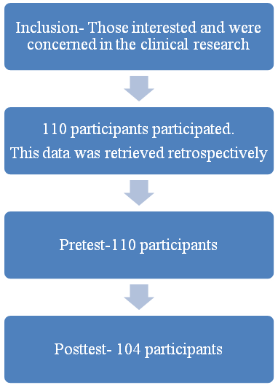
Longer training session

Figure 1: Flowchart representing the participant’s information
Wilcoxon Signed Ranks Test was used to evaluate the total pretest and posttest score of the subject on ten questions. The median pretest score was 5 and post test score was seen as 6 after the workshop. The increase in score was statistically significant (P<0.05). (Figure 2)

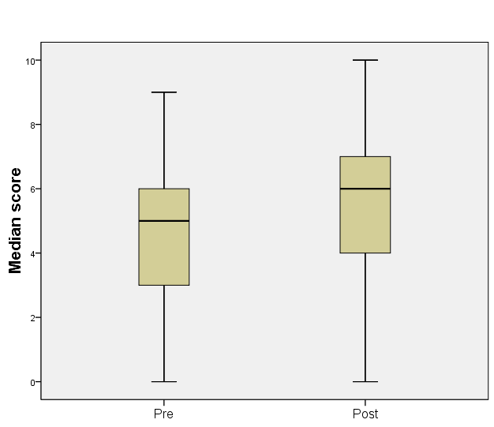
Figure 2: Represents the overall difference in the knowledge score and effectiveness of training session in pretest and posttest

McNemar's test was applied to compare the item-wise proportion answered correctly in the pretest and posttest. A significant difference, among three items in being answered correctly from pretest to posttest was seen (P<0.05). (Figure 3) The study showed that there was a significant improvement in the score of Questions 5, 6, and 9, with P-Value <0.001, 0.016, and 0.008, respectively.

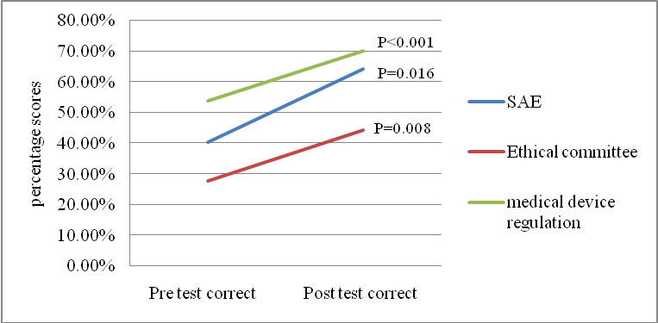

Figure 3: Graph illustrating difference and effectiveness of training workshop among participants regarding SAE, Ethics committee and Medical device regulation.

For questions related to risk categorisation (Q1), IEC oversight (Q3), and IC for vulnerable population (Q7) there was a decrease in the correct answer from pretest to posttest (Table 1) which was not statistically significant. [P-Value 0.096, 0.0839 and 0.864 for questions Q1, Q3, and Q7 respectively]
The test result showed 24% increase in with question number 5, i.e. "Condition for reporting a serious adverse event (SAE) under drugs and cosmetics act by principal investigator."

 | Topics | Pre test correct | Post test correct
Q1 | Risk categorization | 15.40% | 7.70%
Q2 | Investigator responsibility | 55.80% | 61.50%
Q3 | IEC oversight | 24.40% | 22.10%
Q4 | SAE | 71.20% | 73.10%
Q5 | SAE reporting | 40.40% | 64.40%
Q6 | IEC | 27.90% | 44.20%
Q7 | IC for vulnerable population | 75% | 73.10%
Q8 | Data management | 53.80% | 62.50%
Q9 | Regulations for Clinical trials with medical device | 53.80% | 70.20%
Q10 | CTRI | 67.30% | 74%

Table 1: Graph illustrating the percentage answered correctly in pretest and posttest
Discussion:
This retrospective study suggests that there is considerable improvement in the knowledge regarding the basics of the GCP and CRR after the training workshop, which could be considered as successful intervention. Study showed more 'positive' improvements than 'negative' changes, indicating the different understanding capacities among the participants.

In our study, it was seen that 94.5% of participants completed both the pretest and posttest questionnaire. The stated reason for non- participation to the post-test questions were they had to leave the workshop halfway due lack of personnel in their department. A study by Awatagiri et al shows an overall response rate as 83% and states the reason which coincides with our study. The other reason stated was that they attended the workshop halfway as they were keen to take part in workshop. ^{[1]} The objective assessment of the training impact using a validated questionnaire is vital for assessing the success of the training program. ^{[1]}

The workshop had several presentation, demonstration and open discussion board and was a institutional based instructor led training method. According to a study by Arango et al an online format may be most practical method to impart GCP training. ^{[5]} Further the workshop had a wide range of target population which helps to gain greater insights on the topic by looking at it from all angles. It helps to know the knowledge on GCP among different population group. Although the workshop included different population the correlation between the knowledge scores (post–pre) and selected demographic variables of research professionals could not be accomplished as the response was anonymsed. Only pre and post test questions were paired and used for the analysis.

In our study, on the question on risk categorization, it was found that 15.4% and 7.7% of the participants had correct answers in the pretest and posttest respectively. This drop might be attributed to some confusion and queries in their minds requiring further reading by them on the topics discussed. In the execution of clinical trials, research investigators face problems that are markedly different from those that they experience in daily medical practice. Some of these obstacles are the result of regulatory guidelines, the GCP, and the rigorous nature of the clinical trials. ^{[11]} The clinical investigators must fulfil all the study standards when carrying out a clinical trial. ^{[11] [12]} Study by Arango et al on training suggests that a training workshop must include the 13 elements from the investigator section of the ICH E6 Good Clinical Practice Consolidated Guidance.^{[15]} Also, depending on the nature and scope of proposed research, other topics could be included. ^{[5]}

It was also found from our study that the question regarding serious adverse event under the drugs and cosmetics act, had the highest increase in the clarification in information (24%). Documentation of all adverse effects during the clinical investigation is necessary. It is critical for a principal investigator to be aware of adverse events. Severe unexpected adverse incidents are to be identified and reported to both the institutional ethical committee and the sponsor within a limited period. ^{[11]} Training on topics outside the scope of medical practice like safety reporting is to be emphasized to all the researchers. ^{[16]}

In our study for the informed consent knowledge evaluation question, it was seen that 75 % of the participants had correctly answered in the pretest, and only 73.1% of the participants answered correctly in the posttest. It has been observed that knowledge score has decreased, which, was not statistically significant. The 7 hours one day session could have drained the participants and may be an explanation for decrease in posttest questions.

IC is a continuous process involving three key components presenting appropriate information to study participants, ensuring individual competence, ensuring the participants understand the information quickly and ensuring voluntary involvement. ^{[12]} In the study by Demour et al. about IC, 73.3% knew that engaging in research is a voluntary agreement, 87.3% knew that IC should clarify to participants the maintenance of confidentiality, and 88.7% were aware that an IC must describe the risk and benefit of the research. The result from the study by Cadman et al suggests that training on communication procedure, in addition to regulatory criteria for IC, to the clinical researcher could have a positive impact on the consent discussion. Further use of informed consent videos in training the researchers would inform both on communication process and regulatory content of IC. ^{[17][13]}

The study found that the knowledge regarding the duties and documentation for institutional ethics committee (IEC) increased substantially from 27.9% to 44.2% after the training workshop. A study by Demour et al. found that more than 50% of the study respondents had a basic knowledge of the Ethics Committee and the guidelines. ^{[13]}The Helsinki Declaration demands that all scientific work be sent to an ethics committee and be accepted to safeguard the dignity, and rights of the study participants. ^{[12]}

This study had few limitations as the workshop had the pretest questions distributed immediately, and the workshop duration was for 7 hours. Furthermore, any previous training programs attended by the participants were not accounted. Whereas, Halder in his study, has suggested that multiple training sessions and repeated assessments could improve the knowledge among participants and had the desired impact. ^{[14]}

All the involved parties, including sponsors, researchers and site personnel, contract research organizations, ethics committee, regulatory authorities, and the participants, share the responsibility of GCP. Awareness of GCP principles through training is strongly advocated as a way of ensuring the ethical, legal, and methodologically sound research involving human subjects wherever relevant. ^{[15]} It seems essential that in all the core curricula of healthcare professionals, GCP training should be considered to promote good clinical trials among the future workers in this sector. Also, GCP training is intended to support the clinical development of medicines for patients in an ethical and efficient manner. With further increase in extensive training in GCP and CRR, the non-compliance can be controlled, and clinical trials with high standards can be achieved.

The study showed participants different levels of understanding for the various sections of the training workshop. The study also pointed out that the use of presentation slides, interactive activities, and discussions with a reputed resource person helps in the significant increase in knowledge. The decrease in the posttest correct answers implies that the workshop discussion raises thought on the topic, highlighting the importance of self-reading among the researchers. Further studies must be carried out to evaluate the accomplishments of the researches in the institute by the researcher who participated in the training programme. GCP training has to become a prerequisite to be a part of a team involved in biomedical, academic research, including human participants.

References-
1. Awatagiri K, Gadgil D, Kannan S, Rane P, Bandekar B, Sawant N, et al. Effect of a planned training session on good clinical practice knowledge in research professionals: A pilot study. Perspect Clin Res 2019;10(1):20–5.
2. Switula D. Principles of Good Clinical Practice (GCP) in Clinical Research. Sci Eng Ethics 2000;6(1):71–7.
3. Castelino LJ, Narayanan VA, Fernandes SD, Kumar P, Sandeep DS. Good Clinical Practices: An Indian Perspective. Res J Pharm Technol 2018 Jul 1;11(7):3209.
4. Hellman S, Hellman D. Of Mice but Not Men: Problems of the Randomized Clinical Trial. Fac Scholarsh [Internet]. 1991 May 30 [cited 2020 Jun 17]; Available from: https://digitalcommons.law.umaryland.edu/fac_pubs/1072
5. Arango J, Chuck T, Ellenberg SS, Foltz B, Gorman C, Hinrichs H, et al. Good clinical practice training: Identifying key elements and strategies for increasing training efficiency. Vol. 50, Therapeutic Innovation and Regulatory Science. SAGE Publications Inc.; 2016. p. 480–6.
6. Vardhana Rao Mv, Maulik M, Gupta J, Panchal Y, Juneja A, Adhikari T, et al. Clinical Trials Registry – India: An overview and new developments. Indian J Pharmacol 2018 Jul 1;50(4):208.
7. Imran M, Najmi AK, Rashid MF, Tabrez S, Shah MA. Clinical research regulation in India-history, development, initiatives, challenges, and controversies: Still long way to go Journal of Pharmacy and Bioallied Sciences. Wolters Kluwer Medknow Publications 2013;5:2–9.
8. Mukesh B Vora CJS. Effectiveness of workshop training in basic principles of Good Clinical Practice among the Medical teachers - A cross-sectional study. Natl J Physiol Pharm Pharmacol 2011;1(2):92–6.
9. Pandya A, Panchal P, Kataria B, Parmar M. Evaluation of knowledge regarding good clinical practice among faculties at a tertiary care teaching hospital. Int J Clin Trials 2015;2(2):34–7.
10. Kazi AM, Khalid W. Questionnaire designing and validation. J Pak Med Assoc 2012;62(5).
11. Baer AR, Devine S, Beardmore CD, Catalano R. Clinical Investigator Responsibilities. J Oncol Pract 2011;7(2):124–8.
12. Mathur R. National ethical guidelines for biomedical and health research involving human participants, 2017. [Internet] Indian council of medical research (2017) [cited 2020 Mar 31]. Available from: www.icmr.nic.in.
13. Al Demour S, Alzoubi KH, Alabsi A, Al Abdallat S, Alzayed A. Knowledge, awareness, and attitudes about research ethics committees and informed consent among resident doctors Int J Gen Med 2019;12:141–5.
14. Haldar A, Ray S, Biswas R, Biswas B, Mukherjee D. Effectiveness of training on infant feeding practices among community influencers in a rural area of West Bengal Indian J Public Health 2001;45(2):51–6.
15. World Health Organization (‎2005)‎.Handbook for good clinical research practice (GCP) guidance for implementation. [cited 2020 Apr 8]. Available from https://apps.who.int/iris/handle/10665/43392.
16. Indian Council of Medical Research. [Internet] Government of India. [cited 2020 Mar 27]. Available from: https://www.icmr.nic.in/.
17. Cadman ME, Murphy JH, Brintnall-Karabelas J, Squires C, Whorton K, Pao M. A Training Program for Improving the Informed Consent Discussion Between Clinical Researchers and Their Subjects. Source J Empir Res Hum Res Ethics An Int J. 2014;9(4):71–5.

