Withdrawing and withholding of life support in Intensive Care Unit: An Indian stand point – A qualitative study.

Contact details (mailing address, email id) and affiliation of all authors:

Dr. Narasimhaiah Srinivasaiah, Consultant colorectal Surgeon, Apollo hospitals, Bangalore Phone: 8197088434; E mail: simha_anu@yahoo.com
Mr Nishanth Ravishankar, 3rd year medical student, Kasturba Medical College, Mangalore Phone: 7259468385; E mail: nishanth.shankar6@gmail.com

Dr. Sahana Govindaiah, Medical superintendent, Apollo hospitals, Bangalore Phone: 99025 22250; E mail: drsahana_g@apollohospitals.com

Dr. Jagadish Chikkegowda, Intensivist, Apollo hospitals, Bangalore Phone: 99809 44169; E mail: jagadishchikkegowda@yahoo.co.in

Corresponding author: Dr. Narasimhaiah Srinivasaiah
Competing interests and funding support: None
We do state that there are no previous submissions of the same work or similar.

Abstract:

Introduction: End of Life (EOL) decisions is not only complex but challenging.
Objectives: To evaluate multi-factorial nature of decision making in EOL care and undertake an exploratory analysis of the decision - making process in EOL care.
Methods: A qualitative methodology was adopted. Qualitative studies were mainly based on the concept of grounded theory utilizing focus group discussions. Study group included intensivists, surgeons, neurosurgeons, neurologists; hospital administrators, librarian and IT support network personnel (laymen). Focus group discussion was utilised.
Results: Focus group discussions suggested that decision making in EOL care is a complex process influenced by a multitude of factors. These include patient, clinician factors and circumstantial factors. Evidence based practice, resource infrastructure, translational factors, longevity, quality of life, and law. Irreversibility, Brain death and Quality of life seemed to be important factors.
Conclusions: “Decision making in EOL care” is multifactorial. It is important to individualise the decision making process.

Background:
End of life decisions are increasingly common and difficult. They get more complex, when the patients are in the Intensive Care Unit [ICU]. They are difficult for patients, families and doctors. ICNARC data (UK) shows that 15–25% of those admitted will die in the ICU . Indian overall ICU mortality varies from 18% - 36% . European data shows 70% of these deaths occur after the withholding or withdrawal of life-sustaining treatments . Withholding and withdrawing life support measures in the intensive care unit are not the same . It is important to distinguish between the two ends of life options. Their outcomes and management are significantly different.
The American Medical Association guideline (paragraph 2) states that, 'there is no ethical distinction between withdrawing and withholding life sustaining treatments'. The UK General Medical Council guideline states (Case law paragraph 4), suggests that Life prolonging treatment can lawfully be withheld or withdrawn from a patient who lacks capacity when starting or continuing treatment is not in their best interests. Both the American and the British treat withdrawing and withholding equal legally and ethically. But the GMC acknowledges that, 'it may be emotionally more difficult ... to withdraw a treatment ... than to decide not to provide a treatment in the first place.' Patient and their proxy’s autonomy, Good communication and reduction in uncertainty probably help to mitigate these difficulties.
The Indian scenario is complicated by socio-cultural diversity, faiths, and beliefs. And of course the law has a role to play. Euthanasia in any form is not permitted in India. Aruna Ramachandra Shanbaug’s case with her demise was a turning point in the history of Legislation on Euthanasia in India . Following a prolonged deliberation, The Supreme court of India on Friday, March 9, 2018 came up with a land mark judgement . A five-judge Constitution Bench (CB), chaired by Dipak Misra, the Chief Justice of India, pronounced its judgment granting, for the first time in India, legal recognition to "advanced medical directives" or "living wills", i.e., a person's decision communicated in advance on withdrawal of life-saving treatment under certain conditions, which should be respected by the treating doctor/s and the hospital. It also reiterates the legal recognition of the right to "passive euthanasia"; and draws upon Article 21 - the right to life - of the Constitution of India interpreting robustly that the "right to life" includes the "right to die with dignity". Justices Misra and Khanwilkar disposed of the writ petition filed in 2005 by Common Cause saying, "The directive and guidelines shall remain in force till the Parliament brings legislation in the field" (1: p 192) .
This still leaves with the question of withdrawal of treatment in a critically unwell ICU patient with no capacity unanswered.

In order to explore, the current understanding of the decision making process in the Intensive Care Unit w r t End Of Life care, we undertook a qualitative research project.

Aims
The aim was to explore the thoughts of care providing clinicians about “end of life care (EOL) in ICUs” and to identify factors that may have a role to play in decision-making on withdrawal and withholding treatment.

Materials and methods

Design:
It is an exploratory Qualitative study involving focus group discussions.

Participants and methods:
The study was carried out at Apollo hospitals, Bangalore. This was undertaken in association with NLSIU, Bangalore. The pilot focus group discussion was held during a dedicated research pre-lunch noon at Apollo hospitals. Care providing members of the clinical and administrative teams formed the focus group. The characteristics of participants in the focus group are as illustrated in Table 1. Qualitative methods were used based on grounded theory. The study explored the thoughts and attitudes of the care providing clinicians about “withdrawing and withholding treatment in (EOL)” and to identify factors that may have a role to play in decision-making on withdrawal and withholding treatment. The participating members were briefed in advance about the research project.

The focus group discussion was moderated by the chief investigator. Stimulus material in the form of abstracts from published papers relevant to “EOL care in Intensive care units” and decision-making on withdrawal and withholding treatment were given to the members. The stimulus material given to the participants have been listed in Appendix 1.

Table 1:
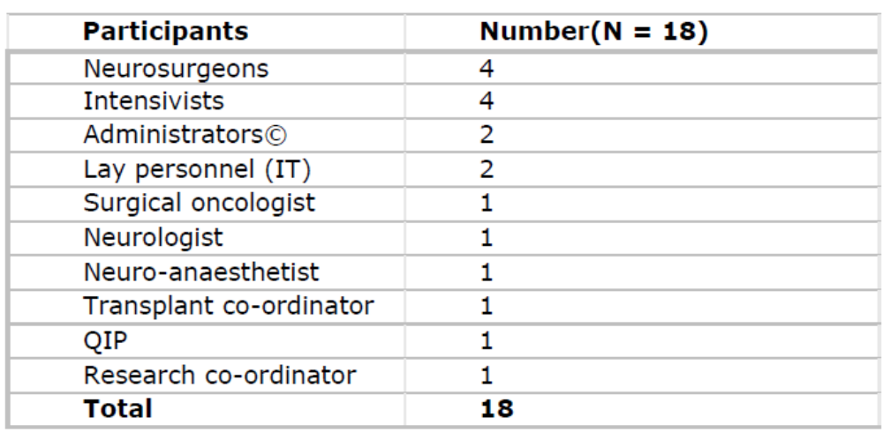

Data collection
Data was gathered from focus group discussions. The focus group discussions (Data) were audio-video taped and transcribed by the chief investigator. Quotations were anonymised for confidentiality reasons.

Analysis
Qualitative methodology was adopted for analysis. Thematic analysis of the collated data was done using the framework approach, thereby identifying themes and outcomes. Analysis of qualitative research data was carried out using a validated technique.

Results
Following the analysis of Focus group Discussion, the emerging themes and outcomes are shown in Table 2.
Table 2: Emerging themes and outcomes in EOL Care in ICU. 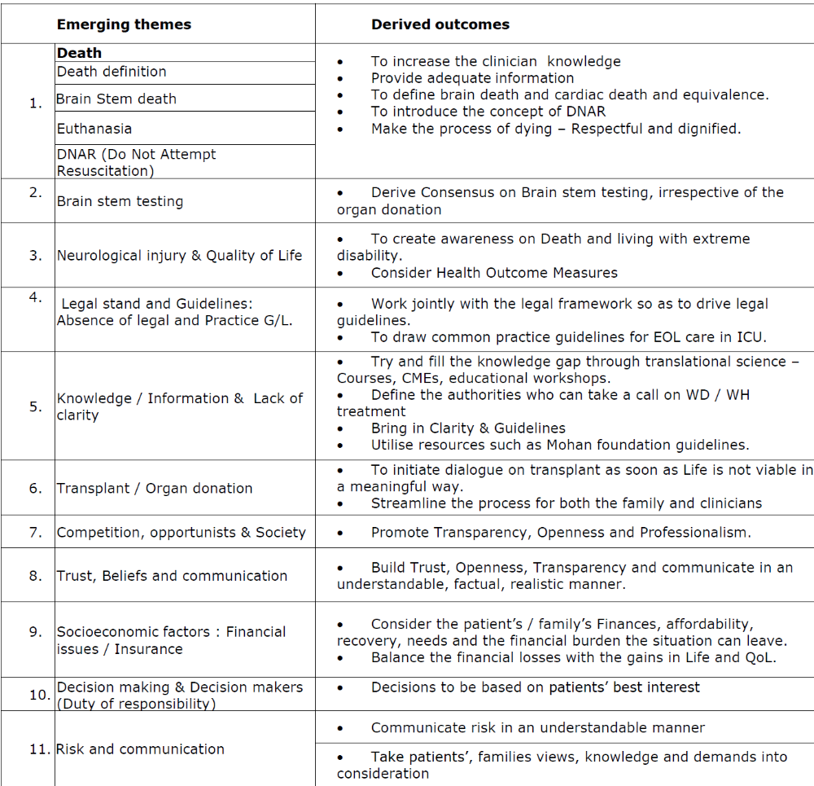

Quotations of Focus group meeting:
Detailed below, are the qualitative comments for each of the themes derived from the focus group discussion.

Withdrawal and withholding (No escalation) treatment:

Clinician knowledge, skill and communication are important aspects of being a good clinician. Even when knowledge and skill have been acquired, poor communication can lead to patient harm. Keeping up with the current knowledge, policies, guidelines and legal stand is important.

R1: “Withdrawal or No escalation” – As intensivists are concerned, we are not practicing withdrawal; no escalation is what is practiced.
R1: If (there are) no brain stem reflexes and family agrees to organ transplant, then we withdraw.
R1: At this point of time, no escalation is what is practised.
R2: We actively do not withdraw support.
R3: There is no clear cut answer – end stage to us may not be end stage to others.
R3: We do not know, whether to withdraw or withhold.
R3: Question is how far, do we go.
R3: You don’t do anything and that is OK.
R10: It is an unchartered territory.
R10: It is not a pleasant situation.
R9: There are no guidelines – Unless, I think the government actually comes up with some guidelines.
R9: And no escalation, somebody can always come back to you and say – u know u have no right “not to escalate this”.
R11: For your kind information, there is nothing called DAMA (Decision against medical advice). It is discharge on request. No DAMA, If you have done DAMA (DAMA is not legal. There is nothing called DAMA)
R2: EOL care, brain death, cardiac death defined legally – One discussion goes on.
R3: Scientifically correct, but not legally
R8: The option of withdrawal has to be attended. They have come to organ donation, but needs further
R6: No withdrawal without transplant, it is not mentioned anywhere to pull out tube.

Death:

Death can be defined biologically, philosophically, spiritually, theologically and legally. Celebrations form a part of one’s birth and rightfully so, death has to be dignified and peaceful.

R5: Indian laws define death as stoppage of heart.
R13: We should let them die peacefully
R6: legally cardiac death is considered death. In brain stem death also cross clamp time is considered death.
R13: That means you are murdering the patient.
R6: In UK- cross clamp done is the second Brain stem death time confirmation – is death.
R11: Death is defined by not brain stem death, but cardiac death
R6: Legal person has to answer
R13: That is the biggest clarity required now

Euthanasia:

The question of euthanasia both active and passive is a matter of global debate and discussion.

R2: Same euthanasia question
R13: When once death is declared legally – no more euthanasia
R13: Advanced metastatic disease
R9: who cannot survive and need for euthanasia

Do Not Attempt Resuscitation: (DNAR)

It is a vital process for resuscitation of a dying patient, if the disease process is reversible and treatable. But, has the potential to cause harm. A common status recorded in the western world – Whether to resuscitate or not, in the event of a cardio-respiratory arrest.

R10: There is no question of DNAR
R11: Cardiac arrest - Will you write DNAR / try to resuscitate
R9: Suppose a patient is metastatic, Family counselled not for ICU / not intubated. That doesn’t mean you treat. Family signs that they are not keen for ICU / Intubation and consent signed.

Brain stem testing / Brain death:

Is it the heart or the brain that ends life? The debate continues, with respect to patients with neurological injury. How does one accept or refute? What are the consequences? What is the relevance to organ transplant? So, there are more questions asked.

R5: Can be triggered when, brain stem reflexes are absent clinically.
R9: Even if you do Brain stem testing for death, it does not give any benefit.
R13: Why is that we can do brain stem death protocol except for that transplant, family gives consent for treatment. We fight among the intensivists.
R13: If patient does not consent transplant, but accept Brain stem death, we are again, creating a problem. .....says, I do not want to remove the tube and we are playing amongst ourselves.
R13: Planning a care, Cut down support, remove oxygen, we have a right along with the patient to pull out the tubes, But, when we are giving organs we are taking the tubes out.
R12: Brain stem testing done only for transplant
R13: That is what, i am saying – Do a brain stem testing. Protocol should do brain stem testing, irrespective of transplant or not. Counselling done, Transplant – Go ahead. Family – not for transplant??
R9: Why cannot .........., pull out the tube, we accept brain stem death, Please disconnect.
R2: Without consent, we cannot do brain stem testing
R9: Brain stem testing, we can do it
R2: If you disconnect the ventilator, you have to take consent. 3 minutes of disconnection – you are killing the patient.
R6: If deterioration off ventilator, connect back / drop in saturation
R13: Sir, there is no argument about doing Brain stem death testing, is a test you can do on anybody
R12: You cannot do it on anybody
R2: Patient is brain stem dead, what u do?
R12: We cannot remove the tube / legally we are not able to other than transplant, we cannot remove / pull out tube.
R2: Unless / until clear legal frame work – this will be problem
R9: Brain stem death testing done – what next.
R2: Transplant if agreed, otherwise continue treatment of take to other hospital or home
R13: Why give that option. Why other hospital will take, when brain stem death has taken place / u r coming for death certificate? Everybody will think, your focus is making money.
R6: After brain stem death there is reports, where patients have survived a maximum of 40 – 44 days, all of them die at an average of 3 – 4 days. System doesn’t work for more than 3 – 4 days. 1 week a few reports, rarely beyond 2 weeks. We report the same to patients.

Neurological Injury / QoL:

Survival and survival with a poor Quality of Life are two different processes.

R4: You are in a situation, where you have a hypoxic brain injury – those patients you have to talk to the family. Even if they survive are in a vegetative state.
R4: Once brain death is clear – family has to be explained the vegetative state.

Legal stand:

The law is above all. The legal stand over the EOL care in ICU in India is complex with lack of clarity.

R1: No escalation in the court of law is not supported.
R3: Law is against doctors and can go against you
R3: Taking consent for no escalation is against law
R3: Till the legal picture changes in this country, stay status quo
R3: Until law changes and policies change, we cannot withdraw and withhold
R8: The legal status is not very clear, that’s the problem.
R9: We refer to Joga Rao’s office constantly to see, what can be done. The response is Counsel, Counsel and Counsel. How much do you counsel? They will write, they will sign, the family counselling form, they will do all that. So that is no guarantee and they won’t come back and sue you again.
R9: We do not know, whether we are protected at al.
R11: The guidelines of society of anaesthesia and critical care have no legal stand, until and unless there is legal stand!
R12: Euthanasia, supreme court ruled
R12: EOL care – until there is a legal stand, corporate hospitals like Apollo cannot do anything.
R2: Guidelines do not stand in the court of law.
R9: We follow the western guidelines, no support of law.
R13: Lawyers have to answer

Clarity:

It is vital to have clarity over an important issue of EOL care.

R1: It is not very clear – who has the authority to say withdraw.
R9: So, there is a lot of grey area
R11: Guidelines are weak
R2: There are Mohan foundation guidelines, no government guidelines. More or less accepted in law / legal.

Transplant / Organ donation:

Organ donation is the most precious gift one can give. In this current state of increasing age, population and organ shortages, we have to have clear processes and guidelines in place.

R1: If no brain stem reflexes and family agrees to organ transplant, then we with draw.
R9: If the relatives are not willing for organ donation and you will have diagnosed a brain stem death, you will have to wait for cardiac asystole.
R9: So it is very very difficult of us on this side. Organ donation / not organ donation, when do you declare?
R4: I have commented / Moment you raise the organ donation, they don’t trust the treating team. So a different team has to trigger.
R5: The transplant team has specialists
R8: Day 1, our doctors (Transplant) will trigger, explaining the process. But the choice is given to the patient.
R2: Mohan foundation says that – Can be given option of organ donation, provided there is a clean cut evidence of brain death. Brain death declaration clinically and testing.
R13: There has to be clarity. Nothing wrong in talking about transplant. Problem comes at what point you introduce the discussion and issue that happens in many places. Brain stem death has not been confirmed and somebody has discussed about the transplant with the family. That is where the problem starts. Eg: ICU. Do a formal brain stem testing and take forward. Rumours start about lack of treatment. We should immediately institute Brain stem Death protocol.
R2: If goes to transplant legally accepted, If no transplant? Question mark – what next?
R6: If we can pull the tube for transplant / why not if not for transplant

Competition / opportunists and Society:

In a financially driven corporate healthcare system, such as ours – competition is a norm. Adds complexity is the consumer rights and legal system.

R3: Supposedly, the other corporate hospital suggested, that delay caused damage. Had he been treated early – There would have been no disability
R8: Someone who is an advocate in the family, they will try to get some money.
R8: Problem comes when he improves and somebody says care could have been better

Trust, Beliefs & Communication:

Human bonds are built on Trust, belief and communication.

R3: The moment you say no escalation, family thought process changes – You were not active in patient’s care.
R8: As long as the family and relatives are with you, there is no problem.
R8: someone puts the seed in the family’s brain that hospital did not care the first time and hence the patient is in this position
R9: You don’t know, where you cross the line
R9: You don’t know, how much you talk to them, how much you can’t
R9: It is very difficult
R10: Have a very good Rapport and then talk to them every few days. Explain the progress and then the decision is faster. If you say one day, the patient is not well, they get agitated. If you speak from day 1 what is expected, then they are more receptive.
R10: Problem is we can keep one plan, but if we do not continuously keep communicating. There is a problem.
R10: Transparency from day 1 is important
R13: Family was informed by a swamy to wait. Patient’s believe.
R13: Tomorrow, the patient’s say – u r asking DAMA, u say cannot withdraw…Kya pharak padtha hai.
R13: When we can do it for transplant, why not otherwise?

Socio-economic factors: Financial Issues / Insurance:

Socio-economic factors always play a role in decision making.

R7: Some say the cost is going up and want to go to a smaller hospital
R7: Some want to go home.
R9: Finances, affordability, recovery, how much left with family needs to be thought about
R10: The problem is if they are a cash patient. If an insurance patient, less of a problem.
R10: Financial burden is a problem
R10: It is a lot of money spent too, extra 10 days runs into 10 lakhs
R13: Sir, Summanae tube hakiddirae – Dinakkae 40 – 45, 0000 charge!
(Translates to – “It will unnecessarily cost 40,000-45,000 rupees if the tube is put”)
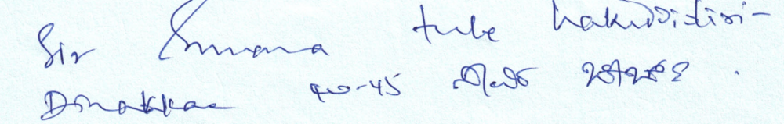

Decision making & Decision makers:
Is a complex process and is multifactorial.

R6: Salvageable / Non salvageable. Not salvageable – we all agree. Give psychological support to the family to make decision. Salvageable with Low QoL – Help with psychological support.
R9: U counsel the family, and the family buys it, it’s OK
R9: Family, cousins come along and ask a lot of questions. U open yourself to a lot of problems and complications also.
R9: It is very tricky from our point of view.
R9: We have treated on a individual case to case basis
R9: We have to do each case separately and differently and go with it
R9: as clinicians in the hospital, you primary responsibility is to treat the patient. U knows, money will come and money will go.
Risk:
There is risk both for the patient and the clinician.
R9: So, everyday – we are all taking a little bit of risk

Discussion
A guaranteed event after birth is the Death. How long one lives is the longevity. It is multifactorial based on the genetic, environmental, medical and socio-economical factors. 72.0 years was the average life expectancy at birth of the global population in 2016 .
Longevity is a marker of health both physical, physiological and reflects on the nations’ development. Much more important than the survival is the Quality of Life (QOL). Currently, Survival is overlooked. Less of an emphasis is laid on the QOL aspect in India. Tradeoffs and risks between survival and QOL will be considered when decision making in patients on EOL care and treatment.
Withdrawing and withholding - What’s the difference?
There appears to be an ethical comparison of withdrawal versus withholding of life support. Bioethical experts state that “law and medical ethics treat the withholding and the cessation of life-sustaining treatment the same” . In reality clinicians do not equate withholding and withdrawing life support measures . A study of US and British physicians and nurses attending ethics courses on death and dying believed there to be an ethical difference between withholding and withdrawal . Philosophers may argue logically that, considering the intent and outcome of withdrawing and withholding therapy, the two actions are identical; but to the individual who has to carry out the procedure, an important difference seems to exist. Shutting off a respirator, leading to the immediate death of the a patient who is not brain stem dead, may seem to be morally equivalent to active euthanasia.

There are arguments to say that if withdrawal of therapy were not to be performed, then the ICU would be full of hopelessly ill patients maintained indefinitely on life support . This is not true. ETHICUS study showed that the median time to death for patients in whom therapies were withheld was 14 hours, rather than 4 hours in those whose therapy was withdrawn.
The ETHICUS study showed that 99% of patients for whom therapies were withdrawn died, whereas 11% of patients for whom therapy was withheld survived to hospital discharge. So, when therapy appears to be failing and the prognosis looks grim, withholding therapy may be preferable to withdrawing because it allows for the limitation of potentially inappropriate therapy while not irrevocably determining outcome.
The WELPICUS consensus now provides health-care professionals with terminology for everyday purposes, thereby limiting previous confusing variations as shown in table 3.
Table: 3
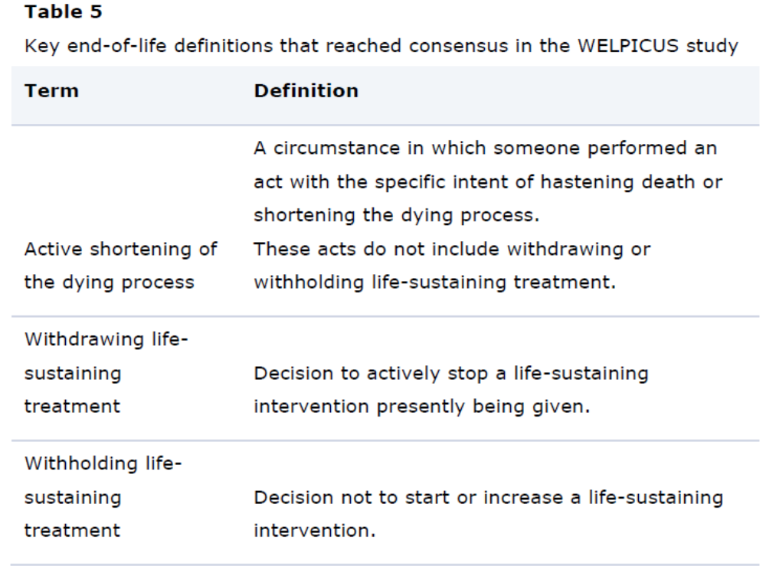

The terms ‘withholding’ and ‘withdrawal’ are ethically equivalent is debated. Equivalence implies that if a treatment, (e.g. mechanical ventilation) is disproportionately burdensome for the patient, in that it will offer no clinical improvement and/or may prolong suffering, then regardless of whether ventilation that is already ongoing is stopped (withdrawal), or not started from the outset (withheld), the principle (preventing prolonged patient suffering via a non-beneficial therapy) is regarded as the same. This is supported in the guidelines of most critical care societies and medical regulatory bodies . Nonetheless, doctors' viewpoints vary with studies showing that less than 40% of questioned intensive care physicians in >90% of the studied patients showing that both are practiced alongside each other . One study also highlighted that these differences may be primarily practical rather than conceptual as withholding is more likely to occur during on-call hour and withdrawal more likely during the working day . It argued that the withholding/withdrawal difference merely reflected the higher likelihood of consensus being achieved (among key stakeholders such as the anesthetist /intensivists, admitting physician, senior nursing staff and family) during daytime hours.
The words withholding′ and ‘withdrawal’ (when referring to ‘life-sustaining treatments’ rather than to ‘withholding/withdrawal of care’) may be negatively perceived and there has been a move away from their use. This may solve some of the terminology and ethical confusion that the two words generate.
Multiple professional organizations are moving away from the above terminologies. The GMC 2002 guidelines titled ‘Withholding and withdrawing: guidance for doctors’ were replaced in 2010 by guidelines titled ‘Treatment and care towards the end of life: good practice in decision making.’ , . The RCPCH 2004 guidelines titled ‘Withholding, withdrawal of life-sustaining treatment in children: a framework for practice’ have been replaced in 2015 by ‘Making decisions to limit treatment in life-limiting or life-threatening conditions in children: a framework for practice . Given the confusing and negative nature of this terminology, ‘withholding’ and ‘withdrawal’ would be better replaced by the more encompassing and neutral term ‘limitation’, providing that it remains clear that it relates to limitation of ‘disproportionately burdensome, life-sustaining treatments’ and not to a limitation of medical ‘care.’
World Health Organization defines palliative care as ‘an approach that improves the quality of life of patients and their families facing the problem associated with life-threatening illness, through the prevention and relief of suffering by means of early identification and impeccable assessment and treatment of pain and other problems, physical, psychosocial and spiritual’- a concept readily applicable to ICU . In this approach, while clinicians may forgo life-sustaining treatments, care is enhanced as death approaches through thoughtful, patient-centered palliative care measures. Different models are described such as palliative care medicine participation on ICU ward rounds and family meetings, didactic teaching sessions, or use of palliative care evaluation scores and questionnaires . None have been shown to be superior and the choice may be guided by resources and accommodation to local patterns of service . One approach readily applicable to everyday practice, in terms of ease of utility, is adoption of the ‘ABCDs’ of end-of-life critical care: attitudes, behaviors, Compassion and Dialogue . This approach is likely to vary as determined by specific patient-centered palliative measures.
We hope the evolution in medical terminology and the increasing incorporation of palliation into Critical Care will improve the quality of end-of-life care in ICU.

Euthanasia
It is defined as an easy or painless death. It is an act of intentional ending of the life of a person suffering from an incurable or painful disease. It is done at his or her request.
It is also called as mercy killing. There are two. Active and passive euthanasia. James Rachels informs that the distinction between active and passive euthanasia is crucial for medical ethics. The idea is that it is permissible, at least in some cases, to withhold treatment and allow a patient to die, but it is never permissible to take any direct action designed to kill the patient. Subsequent ethics literature on euthanasia has accepted active and passive forms. Active euthanasia performed by killing the patient and passive euthanasia performed by omitting to prolong the patient’s life .
Wilkinson et al in his article on passive euthanasia states that there is really no reason to abandon the category provided that it is properly and narrowly understood and provided that “euthanasia reasons” for withdrawing or withholding life-prolonging treatment are carefully distinguished from other reasons.

Policy of passive Euthanasia

The cultural belief rich Indian Society, is divided on the issue of euthanasia. There certainly have been new developments in India concerning the policy of passive euthanasia. Euthanasia and assisted dying are illegal in India according to Sections 306 and 309 of the Indian Penal Code (IPC), and Article 21 of the Constitution of India. Following the case of Aruna Shanbag, the Supreme Court requested the government to prepare a law on euthanasia. Accordingly, the 241st Report of the Law Commission of India proposed a bill to permit passive euthanasia. May 2016, saw the Ministry of Health and Family Welfare (MOHFW) issuing the draft bill for public comment in order to create an informed decision. Once such legislation is passed, passive euthanasia may, and probably will, have an enormous impact on the cultural, political, public and medical spheres of India in the near future .
Globally too the scenario is filled with debates and moral, legal righteousness w r t euthanasia. Globally, only a few countries have legislation with discreet and unambiguous guidelines on euthanasia. The Medical Treatment of Terminally Ill Patients (Protection of Patients and Medical Practitioners) Bill, once translated to law might make the process smoother .

Right to die with dignity has been put to test with the battle continuing. Legislative inadequacy coupled with judicial heterogeneity has exposed the decision making process to unwarranted ambiguity. Misapplication of moral and juristic principles is a global challenge. Kishore et al explores various dimensions of one's right to dignity in dying, in the global as well as the Indian context .

Aruna Shanbag’s case hopefully should pave way for clear cut guidelines and legislations on Euthanasia in India , , . Comparison of India on the global front is important on the issue of Euthanasia. Albania, Colombia, the Netherlands, and Switzerland permit euthanasia conditionally. Australia's legalization of euthanasia has been withdrawn. The United States permits withdrawal of life support. Mexico and Norway permit active euthanasia. India, following the Aruna Shanbag case the Supreme Court granted legal sanction to passive, but not active, euthanasia that is valid till the Parliament legislates on euthanasia .

Dying with Dignity in the Intensive Care Unit
Palliative care in the ICU is increasingly thought about. The principles are gaining significance. Ensuring that patients are helped to die with dignity begs for reflection, time, and space to create connections that are remembered by survivors long after a patient's death. It calls for humanism from all clinicians in the ICU to promote peace during the final hours or days of a patient's life and to support the bereaved family members. Ensuring death with dignity in the ICU epitomizes the art of medicine and reflects the heart of medicine. It demands the best of us .

Definition of death

Death can be defined as the end of the life of a person or organism. Sunil Shroff & Sumana Navin from the Mohan foundation talked extensively on the “Brain death and Circulatory death” and the need for a uniform definition of death in India .

In India, the definition of brain death is contained only in the Transplantation of Human Organs Act (THOA) of 1994. Doctors of ICU patients who are brain dead are unsure of what to do when the relatives refuse organ donation. However, ventilating a dead patient goes against correct medical practice and also blocks a valuable ICU bed. Delinking brain death from organ donation is essential, and this requires inclusion of “brain death” in the definition of death in The Registration of Births and Deaths Act, 1969, so that a uniform policy can be framed in the country.
In India the concept of brain death has been intimately linked with organ donation, as it is defined only in the Transplantation of Human Organs Act (THOA), 1994 which governs organ transplantation and has enabled the development of the current cadaver-based organ transplant program.
However, given that this definition exists only in THOA , there is lack of clarity in the minds of medical professionals on the appropriate steps to take when a person is suspected to be brain dead and the relatives have not consented to organ donation . It is believed that clinicians are reluctant to declare brain death in such cases . Additionally, it is believed that, because of the public’s mistrust of the healthcare system, some relatives fear that the patient has been declared brain dead for the purpose of organ donation.

Concept of brain death
The traditional definition of death in India, as in many other countries, is an “irreversible cessation of circulatory and respiratory functions.” However, death eventually resides in the brain as the nerve cells cannot be revived or regrown once they are dead. This happens due to cessation of blood circulation to the brain, which occurs about five minutes after the heart comes to a stop.
Brain death was first recognized in intensive care units in Paris, where it was found that some patients with head injury or intracranial bleed never recovered. The condition was named coma de passé [beyond coma] . In 1968, a special committee from the Harvard Medical School in the United States (US) arrived at a consensus on the definition of brain death and since then the concept of brain death has been accepted by the medical community . In 1981, the Uniform Determination of Death Act was enacted in the US. It said that “An individual who has sustained either (i) irreversible cessation of circulatory and respiratory functions, or (ii) irreversible cessation of all functions of the entire brain, including the brain stem, is dead. A determination of death must be made with accepted medical standards” . According to the 2010 guidelines of the American Academy of Neurology, to determine “cessation of all functions of the entire brain, including the brain stem,” physicians must determine the presence of irreversible coma (the cause of coma should be known), the absence of brainstem reflexes, and the absence of a breathing drive after a CO2 challenge (apnoea test). Usually one neurological examination is sufficient to pronounce brain death. However, some US state statutes require two examinations. Legally, all physicians are allowed to determine brain death in most US states, though neurologists, neurosurgeons, and intensive care specialists may have specialized expertise . The confirmation of brain death allowed the withdrawal of treatment that no longer benefitted an individual who had died. In 1976, the UK criteria for diagnosing death using neurological criteria were published and subsequently clarified in Codes of Practice. The latest Code of Practice (2008) also lays down criteria for confirming death after cardio respiratory failure. In 1977, the Australian Law Reform Commission addressed the absence of a definition of death in Australian law, recommending that a statutory definition of death should be introduced. The Commission recommended that death be defined as: a) irreversible cessation of all functions of the brain of the person; or b) irreversible cessation of circulation of blood in the body of the person . Brain death testing is carried out by two medical practitioners with specific experience and qualifications according to State and Territory laws. Two separate sets of tests are performed, with each doctor being responsible for performing one set of tests. The tests may be done consecutively but not simultaneously . These developments are based on the scientific belief that human death ultimately involves the irreversible loss of the capacity for consciousness, combined with the irreversible loss of the capacity to breathe, and this can only happen when blood circulation to the brain ceases, leading to brain death.
As the blood circulation to the rest of the body is maintained with a beating heart, and breathing is supported with the use of a ventilator, the organs (other than the brain) and tissues of a brain-dead person can be kept functional for a period and used to save multiple lives. For this reason, a brain-dead cadaver is an important source of scarce organs and tissues such as heart, lungs, liver, pancreas, kidneys, intestines, corneas, bones, heart valves and skin, to name a few. The acceptance of the Harvard criteria in 1968 led to organs being transplanted from brain dead donors subsequently. Prior to that, some organ transplants were performed from donors after circulatory death.
Brain death was defined in Indian law in 1994, through the Transplantation of Human Organs Act (and its 2011 amendment) for the purpose of organ donation and transplantation in India, as evidenced by the insertion of clauses pertaining to this in the brain stem death certificate – Form 8/Form 10 , . In 2011, a further amendment to the transplant law in India required the registered medical practitioner of the hospital having an Intensive Care Unit facility, in consultation with the transplant coordinator, to make the family aware of the option to authorize or decline organ and tissue donation . This is popularly known as “required request”.
While only one doctor is required to certify death according to the traditional definition of death, four doctors are required for certification of brain death, and this certification is to be done twice, six hours apart, as per the THOA .

When the patient is brain dead and the family says no to donation.
Twenty-three years after it was described in the Indian law, brain death as a concept has still not been fully accepted by the medical fraternity and the public in India.
If the family of a person declared brain dead agrees to donation of any of the person’s organs, the steps outlined in THOA for declaration of brain death are followed , organs are retrieved, after which the ventilator is turned off. But if they say “No” to donation, there is no standard of care.
Often a peculiar situation crops up in ICUs, where intensivists will not switch off the ventilator if the family says “No” to donation. Furthermore, while the diagnosis of brain death is first suspected when an MRI or CT of the brain shows extensive brain injury and there are clinical signs such as lack of pupillary response, corneal reflex, or cough reflex to substantiate this diagnosis, the gold standard test for certifying brain death is to establish the lack of spontaneous breathing through an apnoea test. The apnoea test is done twice and if there is no spontaneous breathing, the patient is certified brain dead by the panel of four doctors as required by the THOA. Currently, it is known that in some units, clinicians will perform the second apnoea test only when the relatives agree to donation, since the understanding is that brain death certification is for the purpose of organ donation only. This is because there have been situations where after the second apnoea test has been done and brain death has been certified (this is the official time of death), the family has said “No” to organ donation and asked the doctors to keep the patient on the ventilator till circulatory death occurs. The doctors comply because they do not want to escalate the grief of the family, and they also say that there are no guidelines about disconnecting the ventilator in a situation when organ donation is not authorized by the family. This means many such patients will continue to be ventilated despite being brain dead. The second apnoea test and certification of brain death is not taken into account, and the time of death is when circulatory arrest occurs. For this reason and because of the resource intensive protocol in brain death certification, ICU doctors do not want to venture into testing for the second time if the family does not verbally consent to organ donation after the first apnoea test is done.
Brain death is not mentioned on the death certificate as there is no provision for it, and death is always mentioned as cardiopulmonary death, which is universally acceptable for cremation, burial or for insurance claims.
Many doctors are also of the opinion that consent is required to withdraw ventilation from a person certified brain dead. False and misleading stories in the media of a person making a “miraculous recovery” from coma or a “dead person coming alive” , may have led to these doctors taking a defensive stand. The public has difficulty in understanding and accepting that brain death is, in fact, death, since the heart is still beating and the body is warm to the touch with occasional spinal reflexes. This can make a doctor reluctant to withdraw ventilation. There are situations in which the family of a brain-dead person demands continuation of the ventilator, hoping for a “miracle”, and becomes belligerent if doctors advise turning it off. Hospitals, in such situations, have often yielded to the wishes of relatives. Continuing the ventilation of a brain-dead patient also prevents care of another critical patient when ICU beds are full, and leads to ethical dilemmas among clinicians .
In this context, there is an urgent need to delink brain death from organ donation .

Laws determining death in India
The common universal legal definition of death is cessation of all vital functions, traditionally demonstrated by an “absence of spontaneous respiratory and cardiac functions”.
At present, death is an important component of three different laws in India: The Registration of Births and Deaths Act, 1969 (RBDA); The Indian Penal Code, 1862 (IPC) (Section 46); and The Transplantation of Human Organs Act of 1994 (THOA).
Under Section 2 (e) of The Transplantation of Human Organs Act, 1994, a deceased person is a person in whom there is a “permanent disappearance of all evidence of life, by reason of brain stem death or in a cardio-pulmonary sense at any time after live birth has taken place” . However, the other two Indian laws which were framed prior to THOA do not mention brain death in their definition of death and hence the universal acceptance of brain death has been absent in India. According to Section 46 of the IPC, the word death “denotes death of a human being unless the contrary appears from the context” , whereas Section 2 (b) of the Registration of Births and Deaths Act (RBDA), 1969, defines death as “the permanent disappearance of all evidence of life at any time after live-birth has taken place” . Neither definition makes brain stem death a criterion for death (both definitions should also mention death as irreversible cessation of circulatory function). As a result, a person whose brain stem is dead and whose breathing is supported by a ventilator and heart is beating, could be considered to be alive under the RBDA, as not all “evidence of life has been lost”.

Requirement of uniform definition of death
To tackle these issues, it is essential that the Government of India state a policy for a “uniform definition of death” that includes both the circulatory and neurological criteria of death. Delinking brain death from organ donation by removing the offending clause in the brain stem death certificate form given in the THOA Rules would be a good start to help avoid ambiguities in interpretation of the law. It would also help to free ventilator beds in difficult situations and prevent ethical challenges as described earlier. Uniform legislation on death has been incorporated in many other countries including the USA, UK and Australia, as mentioned above, that have faced similar problems in the past , , .
Uniform legislation on death will require inclusion of brain death as a form of death in the Registration of Births and Deaths Act, and it will need to be included in the death certificate as well. The Act can define death as “death of an individual who has sustained either (a) irreversible cessation of circulatory and respiratory functions, or (b) irreversible cessation of all functions of the brain stem”.

Conclusions

In conclusion, the results from our studies have led to say that “Decision making process in end of life care is multifactorial”. It is vital that qualitative data, nursing factors, patient factors, translational research, health outcome measures, infrastructure and resources, socio-economic, cultural factors, patient and family knowledge, views, preferences, demands in addition to legal standpoint all need to be considered in the EOL care.

Quality of life and its measurements is a relatively old concept, only though about recently in the developing world such as ours, whilst decision making. Tradeoffs and risks between survival and quality of life have to be considered. The background knowledge about health outcome measures (HOM) and their applications in various sub-specialities of medicine and critical care have shown their importance in the decision making process in EOL care. They influence the care providing clinicians as well as the patients / family in the decision making process.

There exists perceptional difference between withdrawing life support and Withholding Life support with ethical implications. The need for the hour seems to be the legal content and clarity over “Withdrawal and Withholding” treatment in the critically unwell patients. This will pave way for better patient care and a better value for life. After all – we all deserve a right to “Die with Dignity”

Appendix 1:
Stimulus material for focus group discussions (Abstracts of publications)
- Aruna Shanbag: Is Her Demise the End of the Road for Legislation on Euthanasia in India? PMID: 26276161
- The Medical treatment of Terminally Ill patients Bill
- New developments in India concerning the policy of passive euthanasia.

References

