Conceptional Framework to Support Struggling Students During Crisis, A Real Learning Experience During Covid-19 Pandemic
Alrefaie Z
Physiology Department, Faculty of Medicine, Cairo University, Cairo, Egypt

Corresponding author
Zienab Alrefaie
z_elrefay@yahoo.com

002 01278659250
Orchid ID: 0000-0002-9050-9198
RG: https://www.researchgate.net/profile/Zienab_Alrefaie

Abstract
Coronavirus COVID-19 pandemic has caused psychological burden in terms of fear of the infection, anxiety and stress because of the spreading news about cases and deaths and even loneliness of the quarantine and curfew measures. This brief describes a framework to support vulnerable students during times of crisis based on a learning experience with a postgraduate medical student who suffered loss of a family member in coincidence with the pandemic curfew measures just before being enrolled in the course. The student was extremely irritable, distressed and worried about the running and assessment of the course and felt scared of doing online presentation for the department at the end of the course. The current framework was implemented and effectively helped the candidate to overcome worries and stress with a fruitful end of the learning experience.
Key Words
COVID-19, vulnerable student, conceptional framework, online education

Introduction
As the WHO declared COVID-19 epidemic as a pandemic (1), massive disruption in the educational process all over the world has occurred. Universities suspended all in-campus activities for the safety of students, faculty and employees, and online learning was totally implemented to resume all educational activities.
Anxiety and worry have affected everybody because of the escalating numbers of COVID-19 outbreak cases and deaths all over the world (2) and psychological well-being became a major concern as aggressive distancing and isolation measures have been taken for indefinite time. As the pandemic will occur in waves and distancing measures are still taken and moreover, the curfew measure might be resumed anytime and anyplace, emotional and social wellbeing would always be of great concern.
Based on a real experience with a student who unfortunately was suffering depression and grief caused by loss of a family member that was concomitant with the onset of the lock down measures caused by the COVID-19 pandemic, this framework emerged. The two overwhelming circumstances accidentally happened at the beginning of the first course in the master degree of my student, creating a huge dilemma that needed a specifically tailored approach. Figure 1 summarizes the scheme implemented in this learning experience including the communications and course progress.
For myself, it definitely wasn’t a good time to go through that experience, having many academic and administrative responsibilities, being worried about my son studying overseas who also got locked because of the pandemic besides to my personal worries regarding the pandemic and the distancing and protective measures.
It was really difficult time for everyone, but the commitment and felling responsible for my student helped making a wonderful end for the story

Conceptional Framework used for offering support
Understanding
Educationalist should consider the complexity of the situation and candidate’s emotional status and plan to go beyond the educational practice, not only to stick to predetermined learning objectives but also give the space to emergent plans and outcomes. empathy and support would be as important as the scientific value of the course.
Support and passion
Acknowledge the stressful event and student’s concern and let them explicitly express their fears and worries. Show compassion to how your student feels and acknowledge those feelings and be careful about your wording to maintain positivity and enthusiasm.
Regular communications
Face to face communication would be ideal during overwhelming stressful circumstances, but because it is not possible in COVID-19 times, contact over personal phone, whats app and zoom or any available platform is the mean to sustain communication. Reach out if your student is not showing up or finds it easier to hide. Make the first couple of communications for socializing and let your candidate talk about his/ her plans and preferences. Do not mind having further non-scheduled meetings to help your candidate finalize his/her task
Tolerance and accepting errors
Frustration is expected in crisis and emergency and shouldn’t be considered as overly emotional response. Cognitive and intellectual functions would be compromised so give room for errors and accept it
Pursue contribution and engagement
My student was inspired to relate the pandemic to the course, it was successful and feeling of contribution and engagement did work to minimize the fears. The accomplished review explained the comorbidities of COVID-19 in a way that relate to our specialty and was submitted for publication. The candidate felt offering a hand in the scientific discussions related to the pandemic. Furthermore, feeling the interest of department staff helped my student present the topic in the departmental scientific meeting, an idea which initially looked frightening and impossible to my student
Costumed strategies
People struggle many battles throughout life and respond differently to stress. My student lost a family member just prior to the emerging pandemic. For each vulnerable student, mentors and facilitators must tailor specific measures concerning both communication and education to help overcome these battles
Avoiding deadlines
Loosening usual rules about submission deadlines at least at the beginning seemed very helpful in our case, and probably when trust and bonding develops your student would be motivated to compensate for the delay
Praise minor achievements
Emphasize whatever your student achieves pointing to his/her strengths. Praise their literature preferences, scientific writing, presentation, addressing question and concerns and even the acceptable plagiarism incidence or whatever related to their required task.
Being a role model
Show self-control and explain any related personal experience, this would help your candidate to acquire similar attitude
Allocating time for reflection
Allocate time at the beginning of each communication for your student to reflect about communication and learning issues, what is good or unlikely. This would enable the experience to become more dynamic and in the favor of your student

Message
As faculty, we experience a lot of challenges with our students and appreciate the need to take adaptive measures specially in such exceptional situations. The little story started with the lonely anxious and worried student but ended with a pleasant moment; my student is feeling appreciated and motivated and the presentation was fruitful and engaging for all attending staff members.

To support struggling students during stressful emergent situation, consider:
Understanding and passion
Effective communication
Tolerance towards errors and deadlines
Relating to the problem might help faacing it
Tailored strategies to individual experience
Praising minor achievements
Being a role model
Allowing room for reflections
Professional help should be considered if needed
Counselling training for faculty is crucial

Figure 1: Summary of the learning experience
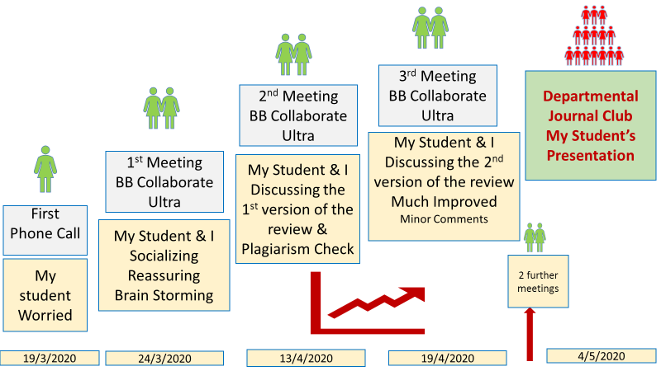

Conflict of interest
The author declares no conflict of interest
References
1- WHO. Coronavirus disease (COVID-19) pandemic. (2020). Accessed: March 20, 2020: https://www.who.int/emergencies/diseases/novel-coronavirus-2019
2- Sahu P. Closure of Universities Due to Coronavirus Disease 2019 (COVID-19): Impact on Education and Mental Health of Students and Academic Staff. Cureus 2020 12(4): e7541.

