AUTHORSHIP LETTER FORMAT: INDIVIDUAL

Dear Editor,

This is to confirm that the article entitled “The Killing of a Male Child of the Jarawa Tribe in the Andaman Islands, India: An Ethical Deliberation” submitted to the Indian Journal of Medical Ethics is original and has been authored by the undersigned.

The submission is not under consideration for publication in any other journal.

Details of sponsorship or relevant competing interests, financial or otherwise: None

I have read the terms and conditions of authorship of IJME and accept them.

I think my paper is suitable for publication in an ethics journal because: I have used an ethical framework in order to ethically deliberate upon the decision of government of India to not prosecute the elder of the Jarawa tribe, who killed a 5-month old baby boy in order to save his tribe from the admixture of the gene pool of his tribe, in order to save the dwindling number of his tribal group. (in not more than 100 words)

Contact details (mailing address, institutional and personal email id) and current affiliation:

Roshani M S Babu
Fogarty International Fellow, 2nd Semester
Yenepoya University’s Fogarty International Center for Ethics (YU-FIC),
3rd Floor, Yenepoya University,
Derlakatte, Mangalore,
Karnataka 575018
India
Email id: robabu@gmail.com

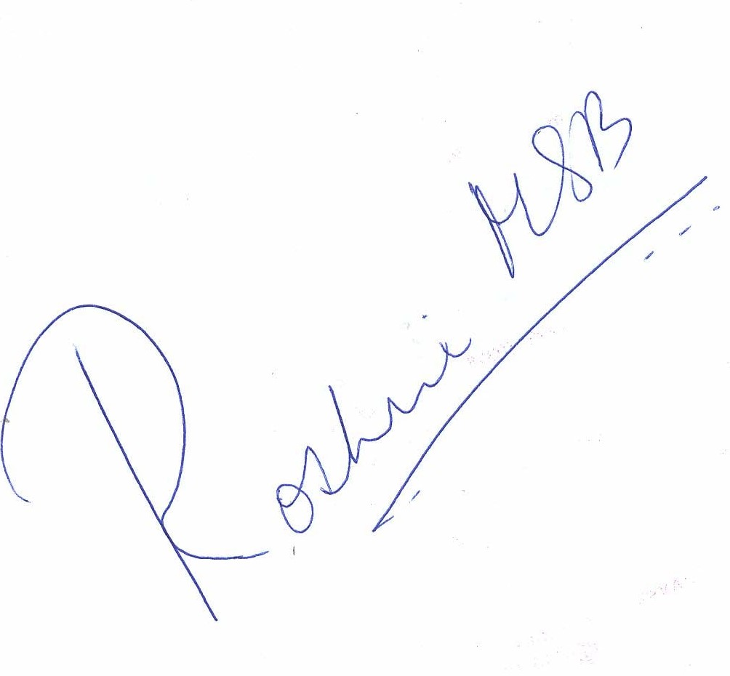
Signature of author:

