From:
Dr Swarup Sarkar

Date: 19 May 2021

Dear Editor,

This is to confirm that the article entitled “Dr Smarajit Jana (1951-2021): An obituary” submitted to the Indian Journal of Medical Ethics is original and has been co-authored by the undersigned.

All authors have participated in the work sufficiently to meet the ICMJE guidelines for authorship. All have read and approved the manuscript. Details of each author’s contribution to the paper are given below.

The submission is not under consideration for publication in any other journal.

Details of any papers on a related topic published/ or submitted elsewhere:

If research paper, whether IEC approval obtained, with details:

All details of sponsorship or relevant competing interests, financial or otherwise:
No sponsorship or competing interests to be declared

We have read the terms and conditions of authorship of IJME and accept them.

We feel the submission is suited to a medical ethics journal because:
Dr Smarajit Jana, in his life, work and approach set the highest standards of ethics in medical interventions and research and was an inspiration for many health professionals and health workers.

-(in up to 100 words)

Specific contribution of each author to the study/article:
Dr Swarup Sarkar: Conceived the article, provided relevant information
Satya Sivaraman: Did background research and wrote the article
Siddharth Dube: Provided relevant information and edited the article

Declaration that all authors are equally accountable for the contents of the paper.

We give consent to Satya Sivaraman to act as the author for correspondence.

Names and signatures of all authors:

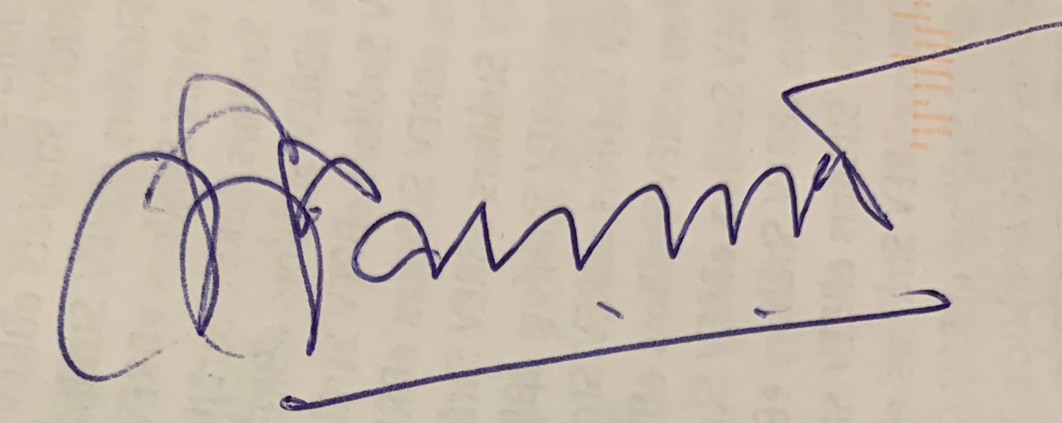

Dr Swarup Sarkar

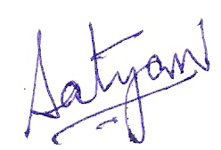
Satya Sivaraman

Siddharth Dube (please treat this as my signature)
Siddharth Dube

Contact details (mailing address, personal and institutional email ids) and current affiliations of all co-authors:

Dr Swarup Sarkar: Former CG Pandit National Chair, Indian Council of Medical Research and Ex-Director, UNAIDS/ WHO. sarkar.swarup@gmail.com

Satya Sivaraman; Communications Coordinator for ReAct Asia-Pacific; No.17, 2nd Cross Road, R.A.Puram, Chennai, 600028, Tamil Nadu. satyasagar@gmail.com

Siddharth Dube: Senior Fellow, World Policy Institute, New York City, USA. siddharthdube@gmail.com

---------------------------------------

