From: Dr Gaurav Aggarwal

Date: 22-05-2021

Dear Editor,

This is to confirm that the article entitled “Ureteric Colic Management : A KAP Survey,
to assess whether Indian Urologists are Evidence-based or biased ? ” submitted to the Indian Journal of Medical Ethics is original and has been co-authored by the undersigned.

All authors have participated in the work sufficiently to meet the ICMJE guidelines for authorship. All have read and approved the manuscript. Details of each author’s contribution to the paper are given below.

The submission is not under consideration for publication in any other journal.

Details of any papers on a related topic published/ or submitted elsewhere: Nil

If research paper, whether IEC approval obtained, with details: NA

All details of sponsorship or relevant competing interests, financial or otherwise: Nil

We have read the terms and conditions of authorship of IJME and accept them.

We feel the submission is suited to a medical ethics journal because:--(in up to 100 words)

Ureteric-colic/ Ureteric stone disease is an extremely painful and commonly encountered condition in the population, with a high recurrence rate. Hence, the diagnosis and management of such patients is of utmost importance. European association of urology(EAU)and American urological association(AUA) guidelines are well established, with regards to ureteric-colic management. However,are Indian urologists actually practicing this “Evidence based management”or is it “experience based”. This is an interesting survey to assess the Knowledge, aptitude and practices of the Indian Medical fraternity, vis-a-vis internationally accepted guidelines. Whether we need to and are blindly following them, is the Ethical question, and do we need to customise guidelines for our Indian population.
Specific contribution of each author to the study/article:

Both authors have done the survey, read and approved the manuscript.
Both the authors are equally accountable for the contents of the paper.

We give consent to Dr Gaurav Aggarwal to act as the author for correspondence.

Names and signatures of all authors:

Gaurav Aggarwal 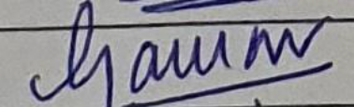

Samiran Das Adhikary 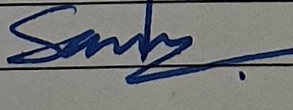

Contact details (mailing address, personal and institutional email ids) and current affiliations of all co-authors:
- Dr. Gaurav Aggarwal
MS; DNB (Urology)
Consultant,
Dept of Uro-Oncology,
Tata Medical Center,
Newtown, Kolkata,
West Bengal.
Email:
drgaurav1981@rediffmail.com
gaurav.aggarwal@tmckolkata.com

- Samiran Das Adhikary
MS, Mch(Urology);
Sr. Consultant, Urology,
Apollo Hospital,
Bhubaneswar,
Odisha.
Email: drsamiran@gmail.com

