***Original Article***

**ASSOCIATION OF VITAMIN B12, FOLATE AND FERRITIN WITH THYROID HORMONES IN HYPOTHYROIDISM**

**Prashant Tripathi, Nivedita Saxena, Manish Kumar Verma, Anand Narayan Singh\***

**Department of Biochemistry, G.S.V.M. Medical College Kanpur, India**

***\*Corresponding Address***

***Dr. Anand Narayan Singh***

***Associate Professor & Head***

***Department of Biochemistry***

***G.S.V.M. Medical College Kanpur, India***

***Email ID: anandnarayansingh@gmail.com***

**ABSTRACT**

**BACKGROUND:** Thyroid hormones are required for normal development as well as regulating metabolism in the adult. Thyroid gland disorders are the second most abundant endocrinal disorders after diabetes. A decreased thyroid hormone adversely affects erythropoietic system causes anaemia.

**AIM:** The Aim and objective of the study was to compare the vitamin B**12**, Folate and Ferritin with thyroid hormones in hypothyroidism

**MATERIALS AND METHODS:** In the present study, total 350 samples were included in which 175 were hypothyroid patients and 175 were normal individuals of age group between 15-65 years. Measurements of serum concentrations of Total T3, Total T4, TSH, Vitamin B12, Folate and Ferritin were done using Chemiluminiscence Immunosorbant Assay.

**RESULTS:** Serum TSH levels were significantly increased in Hypothyroidism as compared to normal individual (7.42±1.75 vs 2.72±1.28, p<0.0001*). The total T3 level was significantly decreased in Hypothyroidism in comparison to normal individual (0.43±0.41 vs 1.30±0.29, p<0.0001*). Similarly, total T4 level was significantly decrease in Hypothyroidism in comparison to normal individual (3.60±1.38 vs. 6.62±1.11, p<0.0001*). Level of Vitamin B12 was significantly decreased in Hypothyroidism in comparison to normal individual (210.45±129.30 vs 483.93±264.74, p<0.0001*). Folate was significantly decreased in Hypothyroidism as compared to normal (2.51±0.99 vs 6.67±0.83, p<0.0001*). Ferritin was also observed significantly decreased in Hypothyroidism in comparison to normal (23.08±1.18 vs 63.43±3.30, p<0.0001*). TSH was observed significantly correlated with Folate (r=0.187* p=0.013).

**CONCLUSION:** Lower values of above these parameters in hypothyroidism interpret that thyroid hormones are metabolic hormones and produce impact on our metabolic and hormonal balance in which hemopoetic system is highly effected.

**Key Word:** Hypothyroidism, Thyroid Profile, Vitamin B12, Folate and Ferritin

**INTRODUCTION**

Hypothyroidism is a common endocrine disorder with reduced production of thyroid hormones. It is a common disease with different frequency in different countries. It is characterized biochemically by a reduction in serum T3 and T4 levels that result in an increase in serum thyroid stimulating hormone (TSH) concentration (1, 2). Primary hypothyroidism is the principal manifestation of the hypothyroidism which is marked by elevated thyroid stimulating hormone levels and reduced thyroid hormones including tri-iodothyronine and thyroxin.

Thyroid hormones regulate blood cells metabolism and proliferation as regulate metabolism of all cells in the human body. There is a metabolic deceleration in hypothyroidism. All organ systems are affected. Anemia is defined in 20-60% of the patients with hypothyroidism (3, 4). Anemia in hypothyroidism can be normocytic normochromic, hypo-chromic microcytic, and macrocytic.

Prevalence of vitamin B12 deficiency increases along with the age (5). Patients with deficiency of vitamin B12 and hypothyroidism usually have symptoms of fatigue, weakness, poor memory retention, itching and loss of sensation (6, 7).

Folic acid is another vitamin with impaired intestinal absorption, and causing macrocytic anemia in hypothyroidism (8). Folate deficiency is related mainly to a low intake of green leafy vegetables and legumes and meat (9). As humans cannot produce folate, it must be supplied by dietary sources like fresh and frozen green leafy vegetables, citrus fruits and juices, wheat bread and legumes, such as beans. It was reported that, folate prevents degeneration of neurons in adults (10) and also improves cognitive functions and decreases depression (11). Vitamin B12 deficiency may also lead to the decrease in folate level because the available tetrahydrofolate is not utilized due to folate trap.

Ferritin is the storage form of iron present in the body. Iron deficiency impairs thyroid hormones synthesis. Low serum ferritin is one of the most overlooked causes of low thyroid function (12). The current study cross-sectional study was performed to observe the association of vitamin B12, folic acid and ferritin with thyroid hormones in hypothyroidism.

**MATERIALS AND METHODS**

The study was carried out in the Department of Biochemistry, G.S.V.M. Medical College, Kanpur. Total 350 persons were included in the study in which 175 individuals were normal and 175 were hypothyroid patients.

**Inclusion criteria**

* Age between 15-65 years
* Normal group and hypothyroid group

**Exclusion criteria**

* Hypertension, Diabetes Mellitus
* Secondary hypothyroidism

**Sample collection**

Overnight fasting 5ml venous blood samples were collected from each subject. These blood samples were allowed to stand for complete clot formation at room temperature and subsequently centrifuged for 10 minutes at approximately 3500 rpm.

**Biochemical Analysis**

**Determination of Total T3, Total T4, TSH, Vitamin B12, Folate and Ferritin**

Measurements of serum concentrations of Total T3, Total T4, TSH, Vitamin B12, Folate and Ferritin were done using Chemiluminiscence Immunosorbant Assay.

**Statistical Analysis**

The results are presented in mean±SD and percentage. Chi-square test was used to compare the categorical variables between hypothyroid and normal. Unpaired t-test was used to compare the study parameters between cases and controls. The Pearson correlation coefficient was calculated among the study parameters. The p-value<0.05 was considered significant. All the analysis was carried out by using SPSS 21.0 version (Chicago, Inc., USA).

**RESULTS**

Total 350 samples were included in the study out of which 175 were hypothyroid patients and 175 were normal individuals.

|  |  |  |  |
| --- | --- | --- | --- |
| **HYPOTHYROID**  **(n=175)** | | **NORMAL**  **(n=175)** | |
| **Minimum age** | **Maximum age** | **Minimum age** | **Maximum age** |
| 15 | 65 | 15 | 65 |
| Mean ± SD 33.78±13.9 | | Mean ± SD 34.28±14.0 | |

**TABLE 1: AGE DISTRIBUTION OF HYPOTHYROID GROUP & NORMAL GROUP**

**p-value= 0.257 t value=1.135**

**Table 1:** Mean age for both groups i.e. hypothyroid and normal was 33.78± 13.9 and 34.28±14.0 respectively.

**TABLE2: FREQUENCY DISTRIBUTION AMONG MALE AND FEMALE IN HYPOTHYROID GROUP & NORMAL GROUP**

|  |  |  |  |  |  |  |  |
| --- | --- | --- | --- | --- | --- | --- | --- |
| **HYPOTHYROID** | | | | **NORMAL** | | | |
| **Gender** | **Frequency** | **Percent** | **Valid Percent** | **Gender** | **Frequency** | **Percent** | **Valid Percent** |
| **Female** | 105 | 60.0 | 60.0 | **Female** | 109 | 62.2 | 62.2 |
| **Male** | 70 | 40.0 | 40.0 | **Male** | 66 | 37.8 | 37.8 |
| **Total** | 175 | 100.0 | 100.0 | **Total** | 175 | 100.0 | 100.0 |

**Chi square test* p-value: 0.66 Chi-square:0.19**

**Table 2:** Inhypothyroid group**,** 105 (60%) patients were female and 70 (40%) were male whereas in normal group, there were 109 (62.2%) female and 66 (37.8%) were male persons

**TABLE 3: LABORATORY FINDINGS OF HYPOTHYROID GROUP & NORMAL GROUP**

|  |  |  |  |  |
| --- | --- | --- | --- | --- |
|  | **HYPOTHYROID**  **Mean ±SD (n=175)** | **NORMAL**  **Mean ±SD (n=175)** | **p- VALUE** | **t- VALUE** |
| **AGE** | 33.78±13.9 | 34.28±14.0 | 0.737 | 0.3353 |
| **TSH** | 7.42±1.75 | 2.72±1.28 | 0.0001* | 28.6765 |
| **TOTAL**  **T3** | 0.43±0.41 | 1.30±0.29 | 0.0001* | 22.9174 |
| **TOTAL**  **T4** | 3.60±1.38 | 6.62±1.11 | 0.0001* | 22.5581 |
| **VITAMIN B12** | 210.45±129.30 | 483.93±264.74 | 0.0001* | 12.2792 |
| **FOLATE** | 2.51±0.99 | 6.67±0.83 | 0.0001* | 42.5975 |
| **FERRITIN** | 23.08±1.18 | 63.43±3.30 | 0.0001* | 152.3074 |

**Unpaired t-test, * statistically significant**

**Table3:** In normal individual group, all the serum values were in normal range. The levels of TSH of hypothyroid patients show a significant increase in comparison to normal individuals (p<0.0001). Hypothyroid patients also had significantly lower levels of serum total T3 and total T4 (p<0.0001). The mean serum vitamin B12 and folate levels were also significantly (p<0.0001) decreased as compared to normal. In case of serum ferritin, the level was observed lower in comparison to normal and it was significant.

**TABLE 4: PEARSON CORRELATION COEFFICIENT AMONG THE VITAMIN B12, FOLIC ACID AND FERRITIN WITH TSH IN HYPOTHYROID**

|  |  |  |  |  |  |
| --- | --- | --- | --- | --- | --- |
| **Correlations** | | | | | |
|  | | **TSH** | **VITAMIN B12** | **FOLATE** | **FERRITIN** |
| **TSH** | Pearson Correlation | 1 | .006 | .187* | .035 |
| Sig. (2-tailed) |  | .935 | .013 | .641 |
| N | 175 | 175 | 175 | 175 |
| **VITAMINB12** | Pearson Correlation | .006 | 1 | .004 | -.010 |
| Sig. (2-tailed) | .935 |  | .955 | .897 |
| N | 175 | 175 | 175 | 175 |
| **FOLATE** | Pearson Correlation | .187* | .004 | 1 | .115 |
| Sig. (2-tailed) | .013 | .955 |  | .129 |
| N | 175 | 175 | 175 | 175 |
| **FERRITIN** | Pearson Correlation | .035 | -.010 | .115 | 1 |
| Sig. (2-tailed) | .641 | .897 | .129 |  |
| N | 175 | 175 | 175 | 175 |
| **\*. Correlation is significant at the 0.05 level (2-tailed).** | | | | | |

**Table 4:** TSH was observed significantly correlated with folate (r=0.187* p= 0.013). There was no correlation found of TSH with vitamin B12 (r=0.006 p= 0.935) and ferritin (r=0.035 p= 0.641).

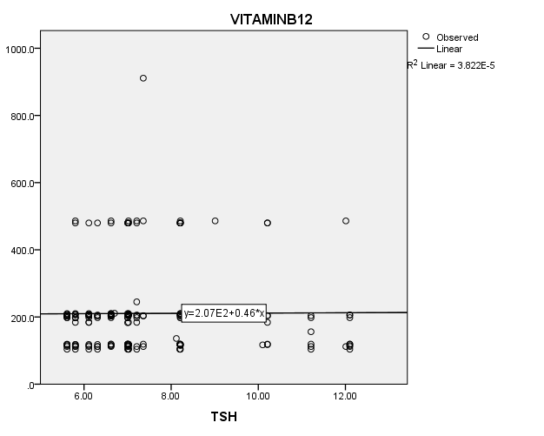

**FIG. 1: SCATTER DIAGRAM SHOWING ASSOCIATION BETWEEN TSH AND VITAMIN B12 IN HYPOTHYROID GROUP**

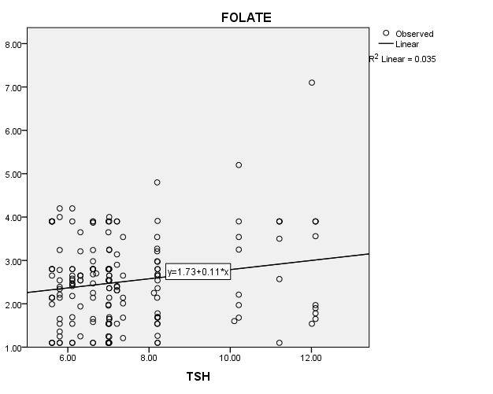

**FIG. 2: SCATTER DIAGRAM SHOWING ASSOCIATION BETWEEN TSH AND FOLATE IN HYPOTHYROID GROUP**

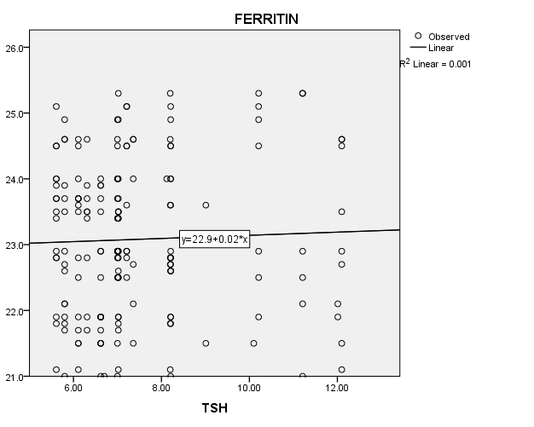

**FIG. 3: SCATTER DIAGRAM SHOWING ASSOCIATION BETWEEN TSH AND** **FERRITIN IN HYPOTHYROID GROUP**

**TABLE 5: PEARSON CORRELATION COEFFICIENT AMONG VITAMIN B12, FOLIC ACID & FERRITIN WITH TOTAL T3 IN HYPOTHYROID GROUP**

|  |  |  |  |  |  |
| --- | --- | --- | --- | --- | --- |
| **Correlations** | | | | | |
|  | | **TOTAL T3** | **VITAMIN**  **B12** | **FOLATE** | **FERRITIN** |
| **TOTAL T3** | Pearson Correlation | 1 | .124 | -.041 | .076 |
| Sig. (2-tailed) |  | .103 | .587 | .316 |
| N | 175 | 175 | 175 | 175 |
| **VITAMIN B12** | Pearson Correlation | .124 | 1 | .004 | -.010 |
| Sig. (2-tailed) | .103 |  | .955 | .897 |
| N | 175 | 175 | 175 | 175 |
| **FOLATE** | Pearson Correlation | -.041 | .004 | 1 | .115 |
| Sig. (2-tailed) | .587 | .955 |  | .129 |
| N | 175 | 175 | 175 | 175 |
| **FERRITIN** | Pearson Correlation | .076 | -.010 | .115 | 1 |
| Sig. (2-tailed) | .316 | .897 | .129 |  |
| N | 175 | 175 | 175 | 175 |

**Table 5:** There was no correlation found between total T3 and Vitamin B12 (r=0.124 p= 0.103). A negative correlation was observed between total T3 and folate but it was not significant (r=-0.041 p= 0.587). No association was found between total T3 and ferritin (r=0.076 p= 0.316).

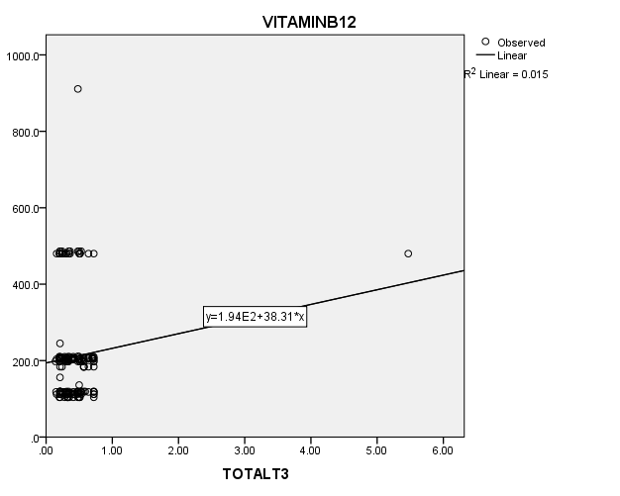

**FIG. 4: SCATTER DIAGRAM SHOWING ASSOCIATION BETWEEN TOTAL T3****AND VITAMIN B12 IN HYPOTHYROID GROUP**

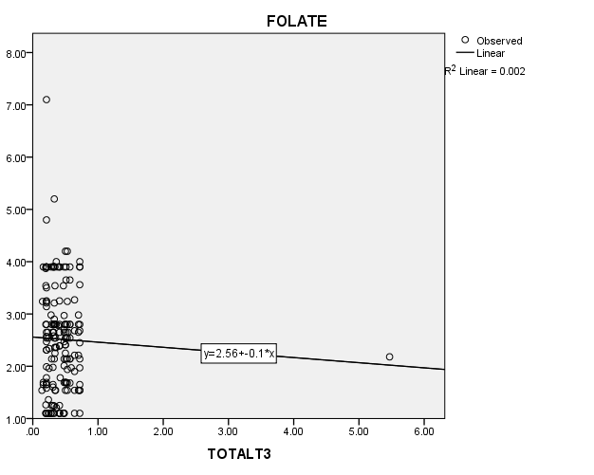

**FIG. 5: SCATTER DIAGRAM SHOWING ASSOCIATION BETWEEN TOTAL T3 AND FOLATE IN HYPOTHYROID GROUP**

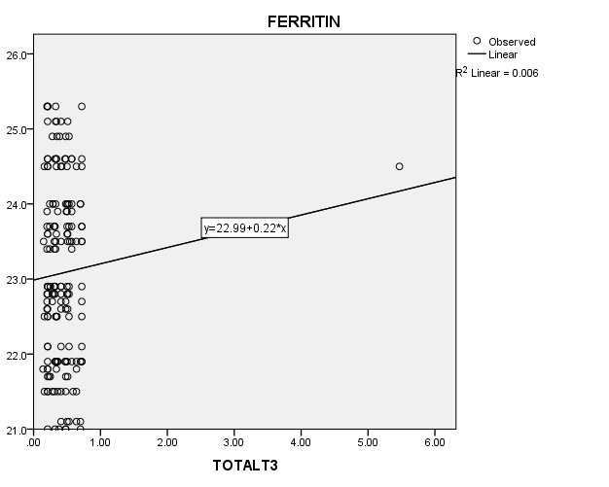

**FIG. 6: SCATTER DIAGRAM SHOWING ASSOCIATION BETWEEN TOTAL** **T3 AND FERRITIN IN HYPOTHYROID GROUP**

**TABLE 6: PEARSON CORRELATION COEFFICIENT AMONG THE VITAMIN B12, FOLIC ACID AND FERRITIN WITH TOTAL T4 IN HYPOTHYROID GROUP**

|  |  |  |  |  |  |
| --- | --- | --- | --- | --- | --- |
| **Correlations** | | | | | |
|  | | **TOTAL**  **T4** | **VITAMIN**  **B12** | **FOLATE** | **FERRITIN** |
| **TOTAL**  **T4** | Pearson Correlation | 1 | -.038 | .062 | -.012 |
| Sig. (2-tailed) |  | .616 | .415 | .879 |
| N | 175 | 175 | 175 | 175 |
| **VITAMIN**  **B12** | Pearson Correlation | -.038 | 1 | .004 | -.010 |
| Sig. (2-tailed) | .616 |  | .955 | .897 |
| N | 175 | 175 | 175 | 175 |
| **FOLATE** | Pearson Correlation | .062 | .004 | 1 | .115 |
| Sig. (2-tailed) | .415 | .955 |  | .129 |
| N | 175 | 175 | 175 | 175 |
| **FERRITIN** | Pearson Correlation | -.012 | -.010 | .115 | 1 |
| Sig. (2-tailed) | .879 | .897 | .129 |  |
| N | 175 | 175 | 175 | 175 |

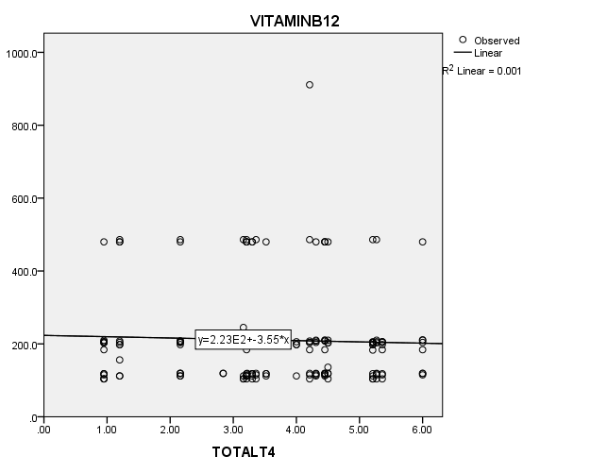**Table 6:** Total T4 was observed negatively associated with Vitamin B12 (r=-0.038 p= 0.616) and ferritin (r=-0.012 p= 0.879) but both are not significant. There was no correlation found between Total T4 and folate (r=0.062 p= 0.415).

**FIG.7: SCATTER DIAGRAM SHOWING ASSOCIATION BETWEEN TOTAL T4****AND VITAMIN B12 IN HYPOTHYROID GROUP**

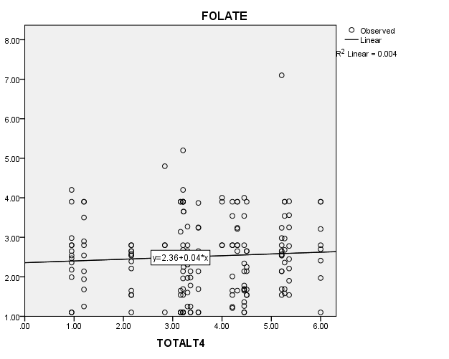

**FIG.8: SCATTER DIAGRAM SHOWING ASSOCIATION BETWEEN TOTAL T4 AND FOLATE IN HYPOTHYROID GROUP**

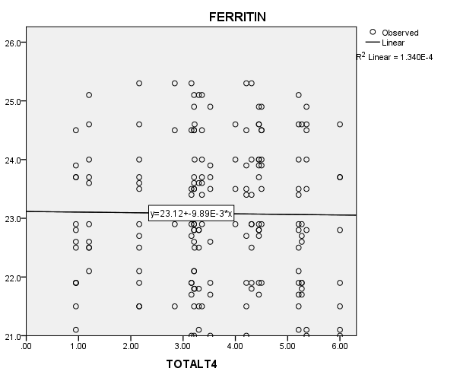

**FIG.9: SCATTER DIAGRAM SHOWING ASSOCIATION BETWEEN TOTAL T4****AND FERRITIN IN HYPOTHYROID GROUP**

**DISCUSSION**

Thyroid hormones are critical for normal growth of our body and are supposed as one of the very essential required hormonal factors in regulation of the basic metabolic rate of effective organs like liver, heart, kidney and brain. As in hypothyroidism, TSH levels remain higher and total T3 and total T4 levels are at lower level; in the present study, serum TSH levels were significantly higher and total T3 and total T4 were lower in the hypothyroid patients as compared to the normal individuals.

Abnormality in the thyroid function may also cause due to iron deficiency anaemia, decreasing the plasma and T4 levels, reducing the peripheral conversion of T4 to T3 and an increase in the TSH (13). B-12 deficiency in hypothyroid patients in India was reported as 10% (14). In the present study, Vitamin B12 was observed significantly (p<0.0001)lower in hypothyroid patients (210.45±129.30) in comparison to normal individuals (483.93±264.74). Another study, conducted in Turkey, reported Vitamin B12 deficiency as 25.6% among 100 patients with subclinical hypothyroidism and 18.6% among 100 patients with overt hypothyroidism (15). Hypothyroidism is a disease causing metabolic disturbance. Hemato-poietic system is the primary one among these affected systems and anemia is the most important one. So, alteration in the thyroid parameters may cause anaemic condition.

Present study states low level of folate (2.51±0.99) in hypothyroidism as compared to normal (6.67±0.83). Folic acid is a vitamin with impaired intestinal absorption, may cause macrocytic anemia in hypothyroidism (16). Vitamin B12 maintains normal folate metabolism. Its deficiency may also lead to the decrease in folate level. Methyl tetra-hydrofolate remain un-utilized by the cells and hence methyl tetrahydrofolate is not being converted to tetra hydrofolate and hence causes folic acid deficiency.

Our study also observed a significant correlation between ferritin and hypothyroidism. Low level of ferritin (23.08±1.18) was observed in hypothyroidism in comparision to normal individuals (63.43±3.30). Another study also reported iron deficiency in a significant portion of patients with primary hypothyroidism (17). Ferritin is an iron storage protein found in almost all of the body tissues. Serum ferritin levels have been reported to be altered in patients with thyroid disease (18). Low iron, or more specifically, low ferritin, is one of the most overlooked causes of low thyroid function (19). Recently, it has been reported that the serum level of ferritin is high in hyperthyroidism and low in hypothyroidism, and changes in the serum concentrations reflect thyroid function (20). Thyroidperoxidase (TPO) is a membrane-bound glycosylated hemoprotein that has a key role in the biosynthesis of thyroid hormones. It initiates the first two steps in thyroid hormone synthesis. For the synthesis of thyroid hormones, thyroidperoxidase requires iron. Iron deficiency lowers thyroid peroxidase (TPO) activity and alters the thyroid hormone synthesis. Other study reveals that administration of T3 to hypothyroid individuals generates a significant increase in amount of serum ferritin. Lot of awareness is still required at physician level in developing countries like India for optimum management of hypothyroid patients (21).

**CONCLUSION**

This study reveals that females are more prone to hypothyroidism than males. Hypothyroid patients were observed to have lower levels of serum Vitamin B12, Folate and Ferritin in comparision to normal individuals. Low levels of these parameters interprets that it exhibits a strong relationship with hypothyroidism. Thyroid hormones have a metabolic control all over the hormonal system. This can be the reason to the alteration in the haematopoietic system and may lead to anaemic condition. So, early detection of parameters like vitamin B12, Folate, Ferritin and other haematological tests should be done in hypothyroidism.

**Funding:** None

**Authors Contribution**

The entire authors have contributed equally. All authors have agreed approval for the final version to be published and have approved to be accountable for all aspects of the work.

**Conflicts of Interests:** Declared None

**REFERENCES**

1. Guerrero A, Pamplona R, Postero-Otin M, López-Torres M. Effect of thyroid status on lipid composition and peroxidation in the mouse liver.Free Rad Biol Med. 1999; 26(1-2): 73-80.
2. Lingidi JL, Mohapatra E, Zephy D, Kumari S. Serum Lipids and Oxidative Stress in Hyporthyrodism. Journal of Advance Researches in Biological Sciences 2013; 5 (1): 63-66.
3. Antonijević N., Nesović M., Trbojević B., Milosević R. (1999) Med. Pregl., 52(3-5), 136-140.
4. Christ-Crain M., Meier C., Huber P., Zulewski H., Staub J.J., Müller B. (2003) Hormones, 2, 237-242.
5. Mclean E, Benoist B, Allen LH. Review of the magnitude of folate and vitamin B12 deficiencies worldwide. Food Nutr Bull. 2008; 29(2):38-51.
6. Snow CF. Laboratory diagnosis of vitamin B12 deficiency. Arch Inter Medicine 1999; 159; 1289-98.
7. Green R, Kinsella LJ. Current concepts in diagnosis of cobalamin deficiency. Neurol 1995; 45:435-40.
8. Sims E.G. (1983) J. Natl. Med. Assoc., 75(4), 429-431.
9. Carmel R. Discussion: Causes of vitamin B12 and folate deficiencies. Food Nutr Bull. 2008; 29(2 Suppl):S35-S37.
10. Zhuo JM, Pratico D, Acceleration of brain amyloidosis in an Alzheimer's disease mouse model by a folate, vitamin B6 and B12-deficient diet, Exp Gerontol, 45 (3), 2010, 195-201.
11. Beydoun MA, Fanelli Kuczmarski MT, Beydoun HA, Shroff MR, Mason MA, Evans MK, Zonderman AB, The sex-specific role of plasma folate in mediating the association of dietary quality with depressive symptoms, J Nutr, 2010; 140 (2), 338-347.
12. Takamatsu J, Majima M, Miki K, Kuma K, Mozai T. Serum ferritin as a marker of thyroid hormone action on peripheral tissues. J Clin Endocrinol Metabol 1985; 61(4):672–6.
13. Hess SY, Zimmermann MB, Arnold M, Langhans W, Hurrell RF. Iron deficiency anemia reduces thyroid peroxidase activity in rats. J Nutrition. 2002; 132(7):1951-5.
14. Das C, Sahana PK, Sengupta N, Giri D, Roy M, Mukhopadhyay P. Etiology of anemia in primary hypothyroid subjects in a tertiary care center in eastern india. Indian J Encorinol Metab. 2012; 16:S361-3.
15. Mehmet E, Aybike K, Ganidagli S, Mustafa K. Characteristics of anemia in subclinical and overt hypothyroid patients. Endocr J. 2012; 59:213-20. doi: 10.1507/endocrj.EJ11-0096.
16. Sims EG. J Natl Med Assoc 1983 75(4): 429-31.
17. Banday TH, Bhat SB, Bhat SB, Shah N, Bashir S. To study prevalence of incipient iron deficiency in primary hypothyroidism. Int J Res Med Sci. 2014; 2(2):472–5.
18. Zwirska-Korczala, K., Buntner, B., Sobieraj, H., Ostrowska, Z., Kniazewski, B. And Swietochowska, E."Serum ferritin, iron and transferrin in women with thyrotoxic

graves' disease before and after methimazole treatment" Acta Physiol., 41,7, 163-168

(1990).

1. Barb. Thyroid Hormone Requires Iron, Cortisol, Selenium, Iodine [Internet]. Tired Thyroid. [cited 2015 Jul 12]. Available from <http://www.tiredthyroid.com/cofactors.html>
2. Sakata, S., Nagai, K., Maekawa, H., Kimata, Y., Komaki, T., Nakamura, S. and Miura, K. "Serum ferritin concentration in subacute thyroiditis" Metabolism, 1991; 40, 7, 683- 688.
3. Surana V, Aggarwal S, Khandelwal D, Singla R, Bhattacharya S, Chittawar S, et al. A 2016 clinical practice pattern in the management of primary hypothyroidism among doctors from different clinical specialties in New Delhi. Indian J Endocrinol Metab. 2017; 21:165–77.