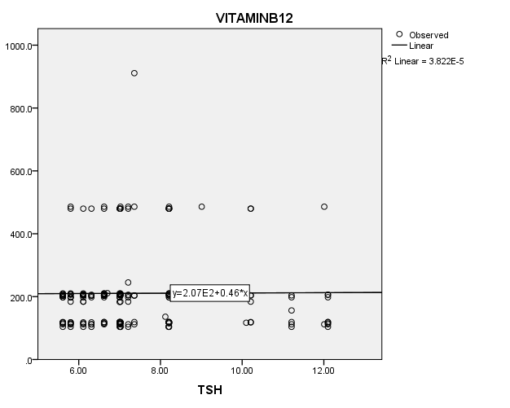**FIG. 1: SCATTER DIAGRAM SHOWING ASSOCIATION BETWEEN TSH AND VITAMIN B12 IN HYPOTHYROID GROUP**

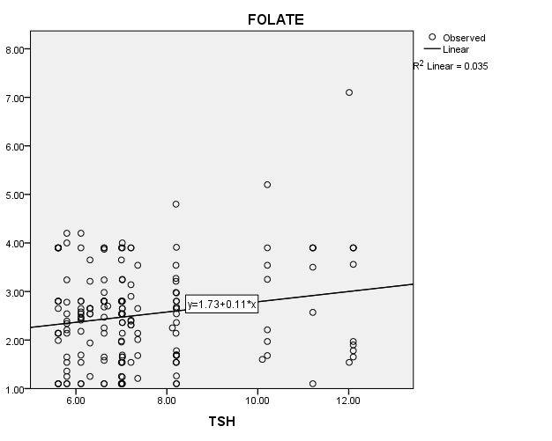

**FIG. 2: SCATTER DIAGRAM SHOWING ASSOCIATION BETWEEN TSH AND FOLATE IN HYPOTHYROID GROUP**

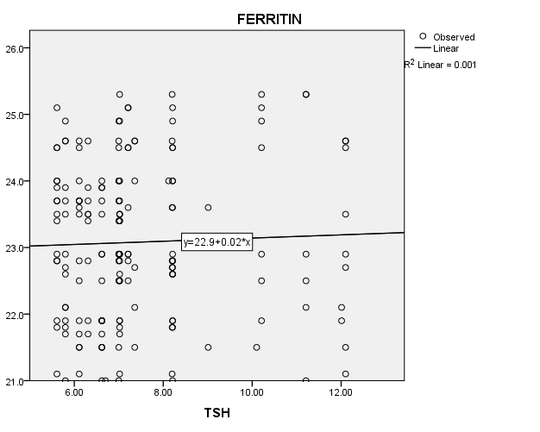

**FIG. 3: SCATTER DIAGRAM SHOWING ASSOCIATION BETWEEN TSH AND** **FERRITIN IN HYPOTHYROID GROUP**

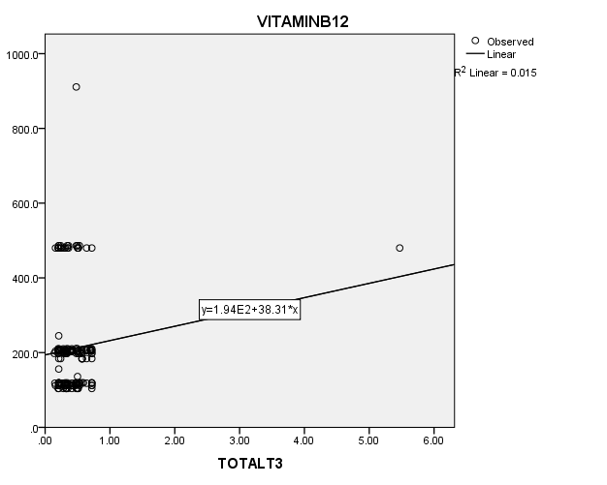

**FIG. 4: SCATTER DIAGRAM SHOWING ASSOCIATION BETWEEN TOTAL T3****AND VITAMIN B12 IN HYPOTHYROID GROUP**

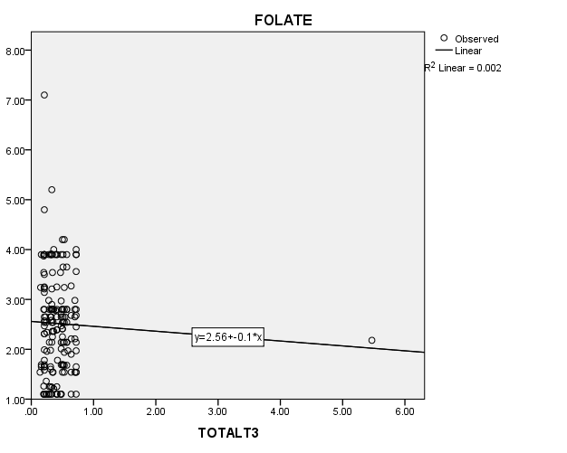

**FIG. 5: SCATTER DIAGRAM SHOWING ASSOCIATION BETWEEN TOTAL T3 AND FOLATE IN HYPOTHYROID GROUP**

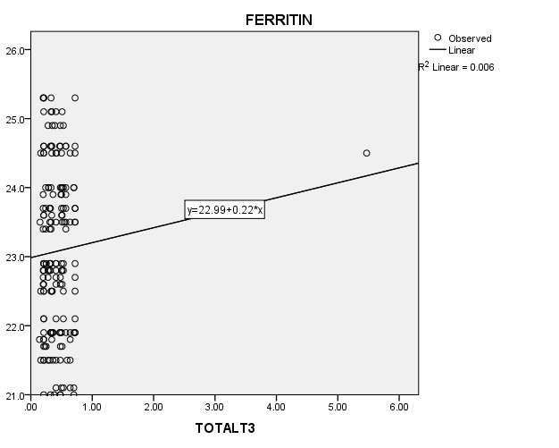

**FIG. 6: SCATTER DIAGRAM SHOWING ASSOCIATION BETWEEN TOTAL** **T3 AND FERRITIN IN HYPOTHYROID GROUP**

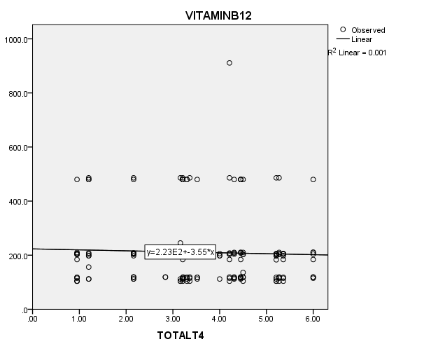

**FIG.7: SCATTER DIAGRAM SHOWING ASSOCIATION BETWEEN TOTAL T4****AND VITAMIN B12 IN HYPOTHYROID GROUP**

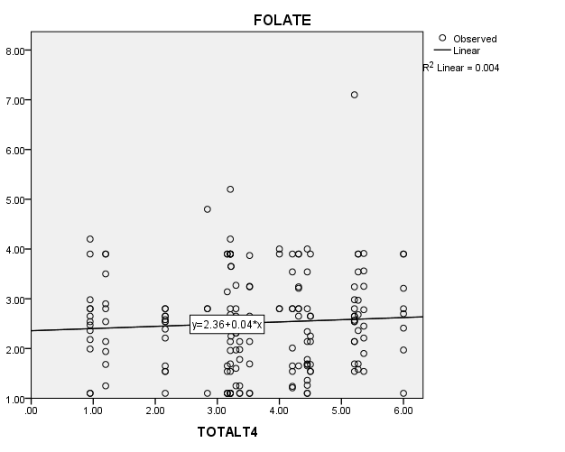

**FIG.8: SCATTER DIAGRAM SHOWING ASSOCIATION BETWEEN TOTAL T4 AND FOLATE IN HYPOTHYROID GROUP**

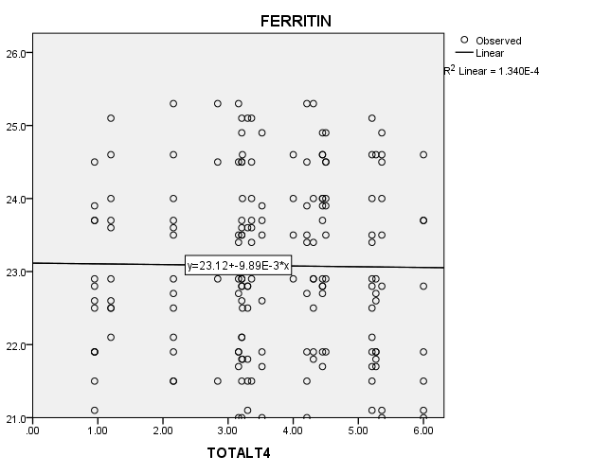

**FIG.9: SCATTER DIAGRAM SHOWING ASSOCIATION BETWEEN TOTAL T4****AND FERRITIN IN HYPOTHYROID GROUP**