Dear Editor,

This is to confirm that the article entitled **“Preterm labor management: A narrative review**” submitted to the *Indian Journal of Medical Ethics* is original and has been co-authored by the undersigned. All authors have participated in the work sufficiently to meet the ICMJE guidelines for authorship. All have read and approved the manuscript.

The submission is not under consideration for publication in any other journal.

We give consent to **Ms. Madhusmita Nayak** to act as the author for correspondence.

Details of sponsorship or relevant competing interests, financial or otherwise: -**None**

We have read the terms and conditions of authorship of IJME and accept them.

**Contact details (mailing address, institutional and personal email ids) and current affiliations of all co-authors:**

Ms. Madhusmita Nayak

(first author cum correspondence author)

M sc Nursing Tutor, SUM Nursing college, Siksha O’ Anusandhan University, Bhubaneswar, Odisha, India

Mail ID- [madhusmitanayak@soa.ac.in](mailto:madhusmitanayak@soa.ac.in)

Mob- 8763519041

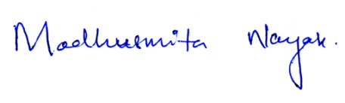**Names and signatures of all authors:**

Madhusmita Nayak