Bangalore

10 October 2018

Dear Editor,

This is to confirm that the article entitled “Healing Touch” submitted to the Indian Journal of Medical Ethics is original and has been co-authored by the undersigned.

I have participated in the work sufficiently to meet the ICMJE guidelines for authorship. All have read and approved the manuscript. The submission is not under consideration for publication in any other journal.

I give consent to to act as the author for correspondence.

Details of sponsorship or relevant competing interests, financial or otherwise: None.

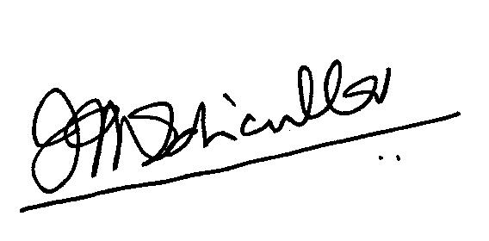 I have read the terms and conditions of authorship of IJME and accepted them