**The dilemmas in Medical Practice and Suggestions from a questionnaire-based study**

**Abstract:**

History has shown that humans are indeed capable of causing not only good but also harm to their fellow beings which is not justified. Following ethical guidelines in practice and research is very important to sustain the mutual trust. Dilemmas exist at multiple levels, doctors, patient’s, dilemmas unique to the nature of the science, moral and ethical. We conducted a questionnaire based study of young medicos that "*why they became medicos and their accountability to Nation*", it revealed a mixed impression indicating the need for more role models in this noblest profession. Knowledge in to ethical aspects of clinical practice and research are very important as it makes the process smooth for the patients and researchers. Medicine and its practice remains the noblest opportunity to use ones *janma* and take care to do it with commitment. “Grow into your ideals so that life cannot rob you of them. “Albert Schweitzer.

Text:

**Introduction:**

The word Ethics is synonymous with moral philosophy, systematising, defending and recommending concepts of right and wrong behaviour. As we know “to err is human” therefore there is the risk of behavioural aberrations which can cause harm or make someone suffer from harm. Hence even in the BC's ethical code for medical practice has been laid. Siddha code existed from 30th century BC and Charaka Samhitha code from 10th century BC. Later in 4th century BC, Hippocrates oath was formed and in second century AD, the Babylonian law code (1).

Medical ethics can be categorised into; (i) Clinical ethics which is service related code of conduct, of service provider with the patient. (ii) Research ethics which demands enquiry into the role of vested interests on the investigator due to commercialised research funding, methods to supervise & monitor complications and complete freedom of right to information of the volunteer, about the research protocol, in which he is in. This need was realised after Nazi experiments in 1945(2), human radiation experiments in 1944(3), Tuskegee study of syphilis in 1972 (4), Jewish chronic diseases hospital study of 1963(5), and Tapeworm related studies in prisoners of war (6). This was highlighted in the landmark article, of US abuses by Henry Beecher, 1966 in New England Journal of Medicine titled "*Ethics and clinical research special article*" (7)

In the year 1948, UN adopted the Universal Declaration of Human Rights, followed by Declaration of Helsinki, 1964 and then Law of Federal protection of human research participants, 1974, followed by Belmonte report on Ethical principles and guidelines for the protection of human research subjects, both biomedical and behavioural research, April 1979. Later it was followed by FDA regulations in 1980 and the council for International Organisation of Medical Sciences in1982. Common rule was framed in 1990, an advisory committee for human radiation experiments was formed in 1994, National Bioethics advisory commission, 1995 and protection of human research participants in 2000. (8,9,10,11)

**Principles of Bioethics**

1. Beneficence and no maleficence – which insists on ‘do good and do no harm’.
2. Autonomic principles – which insists on respect for people, which includes conflicts between autonomy and beneficence, informed consent, protection of vulnerable people, privacy and confidentiality.
3. Justice, which ensures equitable selection, equal distribution of burden and benefit.

**Ethics in public health**

This involves balances between collective benefits vs individual interests, social justice and conflicts within and between communities. (12). Harm principle – exercising powers over an individual, against his will, to prevent harm to others (13).

Medical profession is unique, which needs very high degree of mutual trust, to be maintained. India has ethical guidelines for biomedical research on human participants, formulated in 1980, revised in 2000 and 2006(14). Good clinical practice guidelines for clinical trials, on pharmaceutical products in India- 2001(15), Guidelines for Stem Cell research and therapy – 2007(16), approved new drugs, clinical trials and control over quality of important drugs is maintained by the regulatory bodies – CDSCO, DCG 1. Ethical guidelines allow doctors, care providers, families and patients to work towards a common goal of maintaining trust and avoiding conflict (17).

Communication forms an important way to avoid conflict and lack of communication seems to be the cause for most ethical contradictions. Communication break between the health care team and family members can lead to disagreements. Effective hospital accreditation needs ethical committees which are constituted by medical professionals of academic institutions, general practioners, philosophers and clergy. Regarding ‘telling the truth’, there are several cultural biases in revealing serious illness to patients, however WMA international code for medical ethics discourages both deception and exaggeration (18). Medical professionals should not encourage conflict of interest to influence judgement (19).

Fee splitting and payment of commission to attract referrals is unethical (20). Drug company inducement of prescription pattern with gifts, sponsoring CMEs is unethical (21). American Medical Association recommends against medical professionals treating themselves and close family members (22) Medical license can be cancelled for personal misconduct with patients (23).

**Concept of medical futility**

What should be done, when there is no chance for survival and patients insist on advanced care? In this aspect, there are guidelines for some diseases and selected situations. We can use advanced directives like living will, durable powers of attorney, 'do not resuscitate' instructions by the patient. Substituted judgement is the concept of family member giving consent for treatment if the patient cannot.

Baby doe law – establishes state protection for a disabled child’s right to life when they want to withhold treatment, ensuring that it is protected even against the wishes of parents or guardians, (24).

**Dilemmas in the minds of patients, medical professionals – reasons and possible solutions**

A medical person needs to constantly update Knowledge, have Concern, Commitment and the ability to love all, who comes, with Purity and contract with god. Are we needed in this era is a question to be answered? But there is philosophy in the art of healing. Man is a part of nature and has to remain so, imagine a situation where machines and computers treating us? Therefore, medicine is much more than a science. The committed doctor is a friend, philosopher, guide and dictator, the patient looks up to; and no machine or technology can replace this role. Control over the practice of medicine should come from within us and we should not permit it to happen from outside, it will hurt the sentiments of medicine. Medicine is more of an art than science and Physician is not a person who deals with malfunctioning organs but someone who deals with a distressed fellow human being. As per Charaka, this is a profession motivated by Compassion for Living Beings. Physician who regards Compassion for Living Beings as Highest Religion fulfils his Mission and Obtains Happiness (25). To be a physician is incomparable bliss we know for sure. Compassion, service, altruism, values and trustworthiness are the qualifications. Compassion is a deep awareness of the sufferings of another, coupled with the wish to relieve it. Service is striving for excellence, dedicated to serve. Altruism is highest commitment to service and trust worth is the cornerstone. Currently the burning question is How to understand the unrest of the society and still set noble goals? How to reset values in the ailing medical professionals?

The art of healing evolved from philosophy ‘who is man”?

Evolved as the speciality evaluating the patient as a whole, the body and soul listening with clinical instinct. Extra special perceptive ability to sense, an attribute which no machine can duplicate and when art and science joins, healing is achieved. But Medicine now is more a contract yet maintaining personal values. We became doctors voluntarily, an opportunity to define our worth and make a difference. But the role of patient is involuntary. The patient therefore is in uncertainty and fear. It is a privilege to be a doctor, with obligation to community and nation. Medicine is a societal service to humanity, so do not opt out in any excuse.

**The doctor’s dilemmas:**

Patients are in hurry and demand investigations, Want quick results, Care givers have no time, when all is over complain about cost. Fear of consumer protection act & court compensation is always there and do not know whether the Obligation of a doctor is legal or moral?. While peers are settled, doctor is not. Risking life with infections, burn out, missed meals, sleeping in hospital beds, Good deeds forgotten, mistakes blown up, Long dependency for basic needs. With Unexpected challenges which topple the balance, a sincere doctor Lives in the midst of turmoil and at the end of the journey 'alone'. Administrative hassles, finance and excessive regulations are another source of stress. Under assault in all fronts such as Filling forms than treating patients, Verbal duels with people who do not understand, Burn out are more difficult, less rewarding?.

**Dilemmas unique to the science of medicine:**

Medicine, a science with many probabilities and possibilities. Human body is not a lab and does not produce the same result always. Diseases vary in their cause and complication. Evidence base medicine will need to be refined by experience.

**Dilemmas in the mind of patients:**

Malpractice, unnecessary interventions, stealing organs, exaggerated expenses is a common phenomenon. Both public and institutions promote Straight approach to super speciality. Treatment judged by concrete walls and intensive cares. There is Industrialization of medicine with Communication gaps and misunderstanding.

**Educational dilemmas:**

Large number of medical professionals with purchased valueless degrees are not even trainable. Entry criteria is money, not by aptitude, ability or efficiency. Expectations therefore are returns not quality care. Role models have become extinct.

**Fundamental problems at all levels**:

The problem Lies within the society as a whole. Need and greed for money is ever increasing. People do not try to know facts before making allegations. More equal and less equal doctors are categorized by what yard stick? Can medicine be learned from internet? Team support is not available always. Environment, where patient is the most important person, does it exist? Where is the society, which tries to preserve the empathy in the physician? A Perceptual set to receive the warmth of the doctor given to the patient and family just by an unspoken touch is no more there in the right oriented society. Society which understands a doctor who connects to the deep meaning of the profession is extinct. There is pressure from Non-medical employer & business managers, pharmaceutical company, government regulations, Technology forcing the doctor to look at the elephant through microscope are all areas of concern. Physicians are powerless to change the system. Therefore, the right thinking medical professional feels loss of meaning in his profession. But the paradox is Medicine achieved little in spite of technology because medicine has strayed from its path. Mechanization of medicine has submerged the art and robbed its humanism. Machine patient relationship is more than the doctor patient relationship. Yet medicine is learnt at beside and technology cannot help cement a doctor patient relationship. The greatest stress is not lack of sleep or time. But it comes from believing in one set of values and finding that you are trapped in to living by another set. Opportunity to practice medicine the way it is worthy is often not there. The beginning and the end are same irrespective of material possessions. The path matters, what better opportunity? *Deivam manushya roopena*. Therefore, try not to identify with our lower self the material and physical one. The once enviable doctor /patient relationship now includes 3rd parties. The doctor is at assault from several sides Internal assault because of the impossibility of knowing everything. Real world does not support inner dedication of the doctor and therefore Doctor is left with moments of terrible nervous tension. The Protocol driven cook book system makes doctor a technician. A deep sense of betrayal fills the heart of the burnt-out physician at the end of his/her life. Wondering what went wrong? Need no gratitude but spare ingratitude is the cry mostly. A sincere doctor has always deficient in the aspect of material success. But as per ancient Indian system the criteria for medical selection is deva guna, asura gana and very little material needs as these three Anna dhanam, chikitsha Dhanam and Vidhya Dhanam has to be given with no material expectations.

**Increasing patient side violence:**

More equal patients and less equal doctors or vice versa (all are equal for the true doctor). Finer qualities of life and living are considered as weakness and therefore who possess such qualities become soft targets. Hope or dread which path will medicine follow? (Ethical or legal). Unrealistic expectations of patients, forgetting that the medical professional has also many limitations and bound by what is believed to be right at that point of time and nothing more. Good doctors with willingness for hard work are beaten and arrested only to understand later it is the contaminated poor-quality drugs supplied was the culprit as in the case of tubectomy camp. Even in the yester years, when George cotzias was experimenting on patient volunteer's to locate the part of the plant in which has active component which can improves Parkinson’s was beaten and his retina got detached. Wise persons use unsuspecting physicians for their personal revenge against their family members and the doctor need to know lot more than medicine to deal with these issues. Society needs to be educated, Educate the role of erratic lifestyles over years cannot be reset in a day. Media should work on truth not glamorous news. Work together for better health care delivery. Employer of the doctor should protect a well-meaning physician. Society should permit the healer within physician to grow and not be scarred for life. The art of medicine remains all pervasive even when the science fails or has reached its utmost limits. Ability to spot and appreciate the signs which no gadget can is attained by the intuitive feel of the doctor understanding the patient suffering and attempting to remove it, because a patient is much more than his disease. Miracles and spontaneous healing are everyday occurrence if only we have the sense to perceive it.

**Questionnaire based study:**

WHY I CHOSE TO BECOME A DOCTOR -

"If you treat a disease, you may win sometimes and lose sometimes; but when you treat a patient, you always win, no matter what the outcomes".This quote is from the movie Patch Adams.

'Medicine can rarely cure and sometimes control but always console'. Being able to offer a supporting shoulder to a fellow human being in distress is what makes medicine, one of the noblest professions.

An online survey conducted with young medicos revealed the fallowing.

100 participants aged 20 to 30 (undergraduate medical students, interns, residents and those who have finished residency) in the cities of Pune and Bangalore, from both government and private institutions. Persons more than 30 years and from alternate branches of medicine were not included.

Methodology- Participants had to fill a 10 point questionnaire, designed by us which were communicated to them using various social media.

Following is the question and answer summary

1. Did you complete or are you pursuing medical education from a private or government institution?



Figure 1 Indiactes Government, Priavte and Grey area for MIxed.

1. If someone in your close family is a doctor, was it instrumental in your decision to pursue this profession?
2. The intellectual rigour required in the field of medicine appeals to you (on a scale of 0-10).

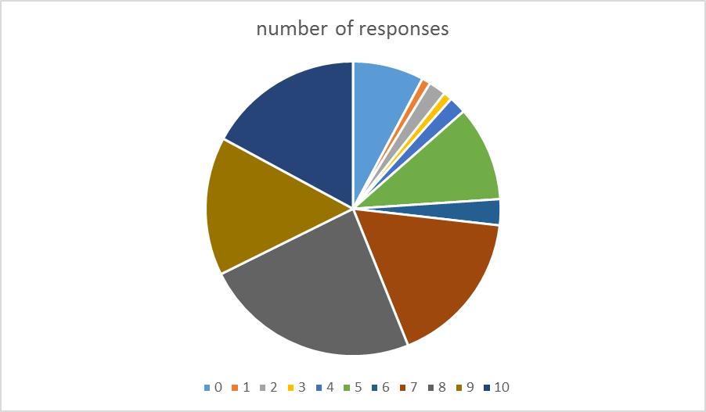

1. The high social status of doctors in India was important to you while choosing this profession. (on a scale of 0-10).

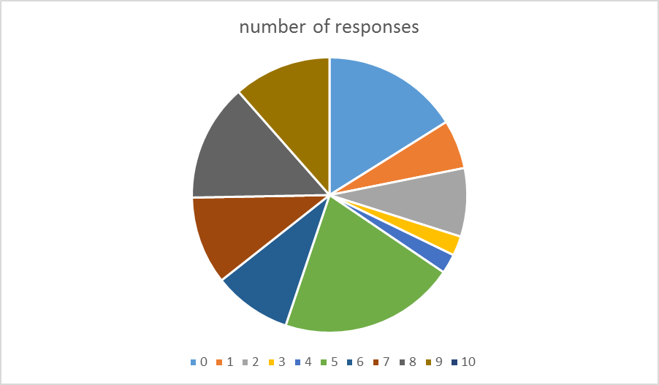

1. The potential for high income was important in your decision in choosing medicine as a profession. (on a scale of 0-10).

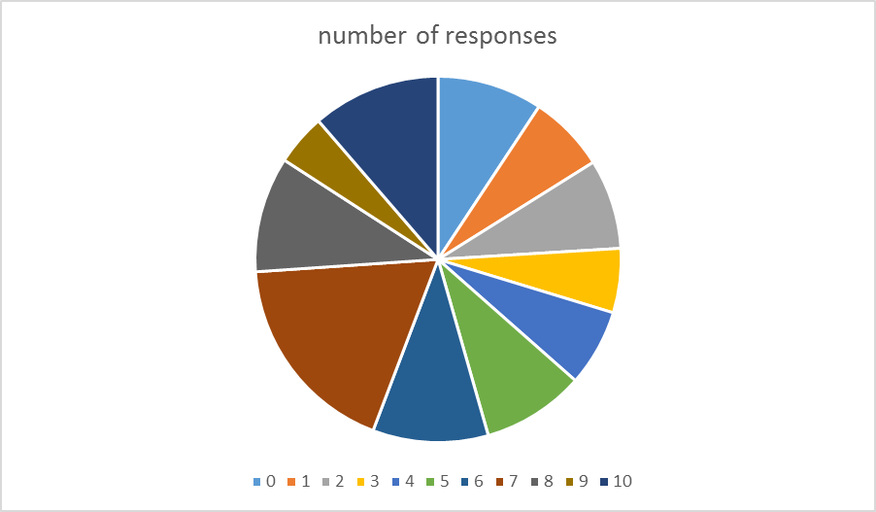

1. The opportunity you get to serve the society is an attractive aspect of your work. (on a scale of 0-10).

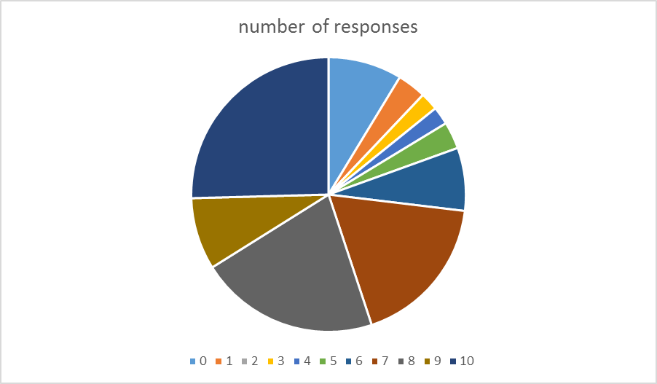

7. What frustrates you most in your career in medicine?

a. entrance preparation b. long working hours in residency c. not enough time for family and extracurricular activities d. having to deal with violence from patient attenders e. lack of infrastructure and resources in your hospital f. comparing professional achievements with friends in other professions g. health risk to self, due to hospital environment .h. Investment of time and money for completion of education Others (please specify)

8. What in your opinion sets the medical profession apart from others?

a. doctors work responsibility is not limited to office/clinic .b. The gratitude that patients show towards doctors is unlike seen in any other customer service profession .c. A doctor’s actions directly affect human life and death. Other professions only have an indirect impact .d. Doctors enjoy significantly higher social status than other professions.

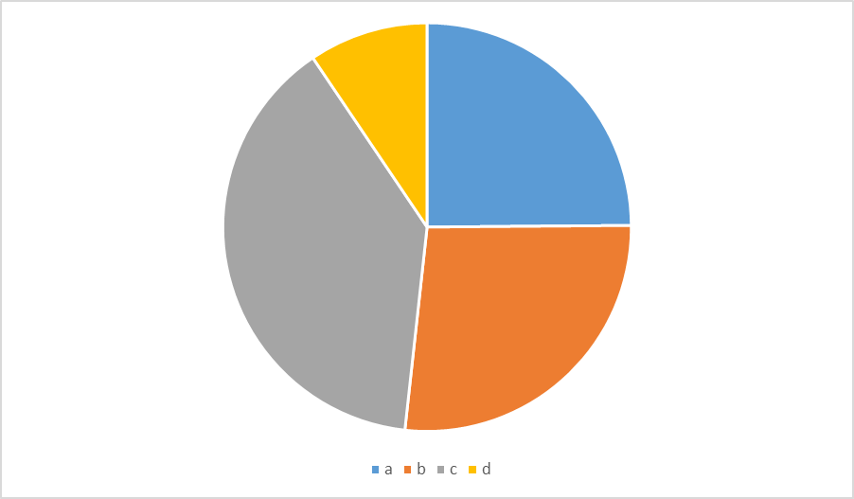

9. Which of the following career options are you most likely to choose in the intermediate to long term?

a. Start your own private practice in a city b. Join corporate hospital c. Takeover family owned clinic or hospital. d. Work at a government health centre in rural areas. e. Study and work as a doctor abroad. f. Pursue a career in nonmedical fields. Others (please specify)

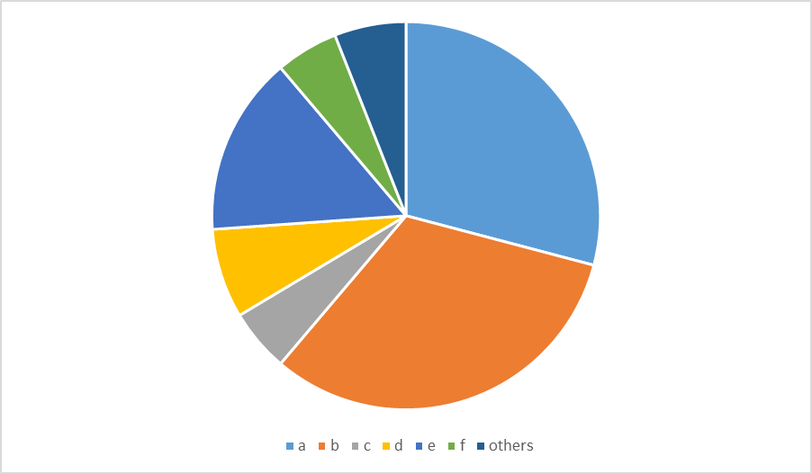

10. On a scale of 0 to 10, how likely are you to recommend pursuing a career in medicine to someone else?

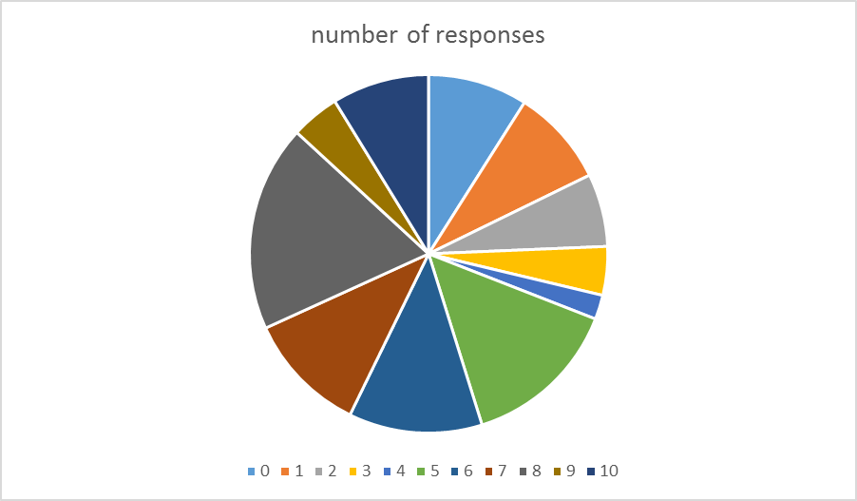

**Results and conclusion:**

Majority of students were from government institutions. Major concern expressed was regarding violence from patients and caregivers. Second cause was lack of infrastructure in the institutions, not enough time for family & Extracurricular activities and long working hours. The Majority expressed their opinion that this profession is attractive as it directly influences the life of a fellow being, and the unmatchable pleasure which comes when patients express their gratitude. The most preferred long term choice was to join corporate hospital, start own practice and join government hospital in that order. The other factors expressed are intellectual challenges, an opportunity for social service, income, social status and would recommend this profession to others too.

**My accountability to my Nation a questionnaire based study:**

Aim: To understand more about why young doctors chose medicine as a career and their view of the positive and negative aspects of this profession.

Inclusion criteria-It included 76 participants aged 20 to 30 (undergraduate medical students, interns, residents and those who have finished residency in the Allopathic system) in cities of Rajasthan and Bangalore from both government and private institutions

Methodology- Participants had to fill an 8-point questionnaire designed by us which was communicated to them using various social media.

Questions

1. A very poor patient who is in dire need of treatment ends up at your clinic with no money. What would you do?

You would refuse treatment?

You would give him primary care free of charge and refer him to a government hospital?

You would see to it that he gets the full treatment at your clinic free of cost?

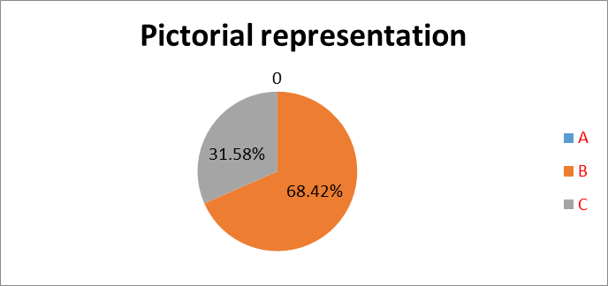

1. You have had a hectic 24 hour duty, just as you are about to leave after the completion of your duty, an old patient of yours happens to meet you and starts discussing about issues related to his medical condition. What would you do?

You would ask him to come next day as you are off duty?

You would ask him to consult the doctor currently on duty?

You would listen to him entirely and advise appropriately?

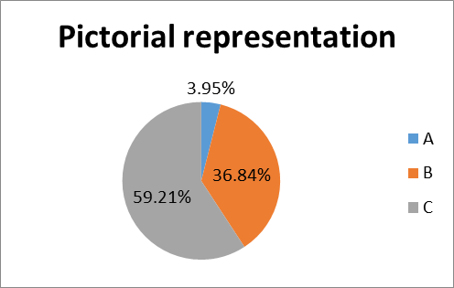

1. You are a student who has completed his entire medical education on scholarship in India. After completion you get a lucrative offer to work in a foreign hospital abroad. Would you take the opportunity?

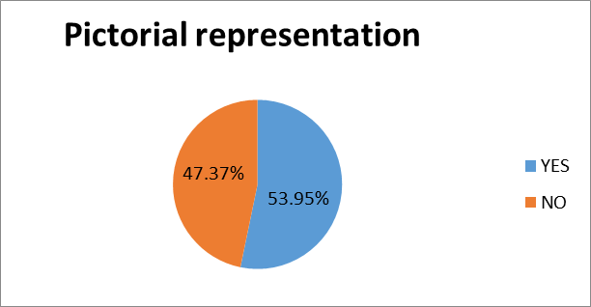

1. On a scale of 1 to 10, how often do you explain the procedure, the risks and outcomes of the procedure you are about to do on the patient.

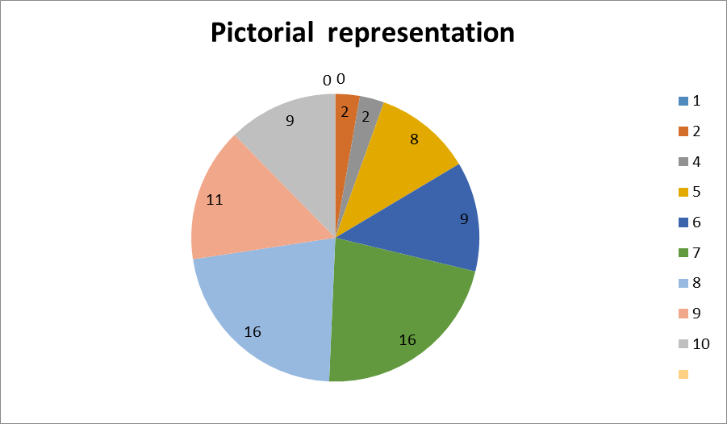

1. You are in the midst of a family gathering, when a friend of your relative not known to you walks up to you to have a casual chat about a medical condition he has. What would you do?

You would ask him to come to your clinic the next day

You would take time and advice him appropriately

You would say you don't want to be bothered currently and enjoy the gathering

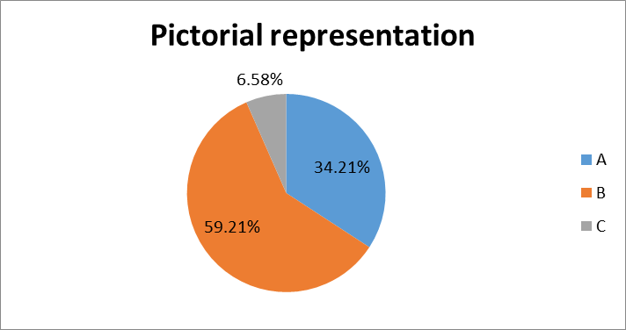

1. .Do you agree that gifts or perks from pharmaceutical companies may influence your medical judgement?

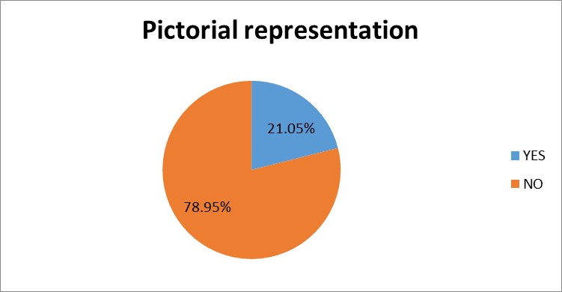

1. If a fellow doctors family (not known to you) comes to you in your clinic for a consultation, would you charge them for the consultation?

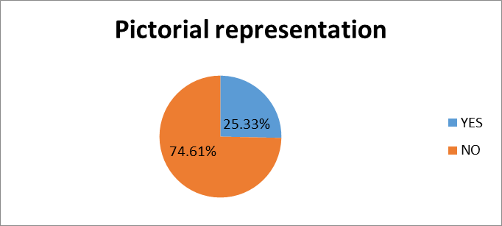

8. Do you think Medical Ethics as a separate subject should be included in the medical curriculum for undergraduate students?

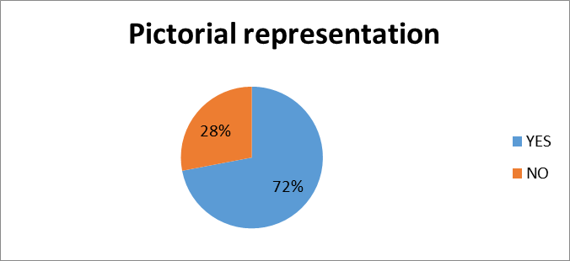

The survey has shown a clear trend as to the mind set of young medicos today. The most encouraging being a majority of them wishing to have medical ethics as a curriculum subject for undergraduates and also seem interested in service above everything else.

**Conclusion and key message:**

We should not hide mistakes as they enhance trust of patients and improves skills in doctor. Mechanization and commercialization of medical practice has adulterated the way medicine was practiced when; there were no non-medical personals dictating the medical profession. But now Physician finds it difficult to remain, an island in a valueless world. Healthy interaction and interrelation is a reciprocal affair and then only a physician will take risks to save life. But, Still the noblest profession in the world. We love strangers automatically. Be truthful to yourself always. It is most important to understand that patient -doctor; student-teacher is not different but only different faces of the same individual’s life. The study conducted in a mixed group of medicos reflects the need for role models as the young person's seem to be not well informed about the unique opportunity provided to them to the extend needed. There is definite need for including medical ethics in the curriculum as well as role models. Do not permit yourself to be purchased or sold for anything. Believe in the Great Unknown. “Grow into your ideals so that life cannot rob you of them. “Albert Schweitzer (1875–1965)—Physician, philosopher. We have moral obligations, forget the legal.

**References:**

1. Kaufman R. A practical definition of ethics for truly strategic planning in higher education. New Directions for Higher Education. 2008 Jun 1;2008(142):9-15.

2. Spitz V. Doctors from hell: The horrific account of Nazi experiments on humans. Sentient Publications; 2005.

3. Vessey JC. Secrecy and Openness: The Study of American Human Radiation Experiments, 1945-1995 (Doctoral dissertation, Harvard University).

4. Brandt AM. Racism and research: the case of the Tuskegee Syphilis Study. Hastings center report. 1978 Dec 1;8(6):21-9.

5. Arras JD. The Jewish chronic disease hospital case. The Oxford textbook of clinical research ethics. 2008 Mar 21:73-9.

6. Gunn SW. Dictionary of disaster medicine and humanitarian relief. Springer Science & Business Media; 2012 Sep 14.

7. Beecher HK. Ethics and clinical research. Bulletin of the World Health Organization. 2001;79:367-72.

8. Assembly UG. Universal declaration of human rights. UN General Assembly. 1948 Dec 10

9. General Assembly of the World Medical Association. World Medical Association Declaration of Helsinki: ethical principles for medical research involving human subjects. The Journal of the American College of Dentists. 2014;81(3):14..

10. Levine C, Faden R, Grady C, Hammerschmidt D, Eckenwiler L, Sugarman J. The limitations of “vulnerability” as a protection for human research participants. The American Journal of Bioethics. 2004 Aug 1;4(3):44-9.

11. McIntosh S, Sierra E, Dozier A, Diaz S, Quiñones Z, Primack A, Chadwick G, OSSIP‐KLEIN DJ. Ethical review issues in collaborative research between US and low–middle income country partners: A case example. Bioethics. 2008 Oct 1;22(8):414-22.

12. Upshur RE. Principles for the justification of public health intervention. Canadian Journal of Public Health/Revue Canadienne de Sante'e Publique. 2002 Mar 1:101-3.

13. Diekema D. Parental refusals of medical treatment: the harm principle as threshold for state intervention. Theoretical medicine and bioethics. 2004 Jul 1;25(4):243-64.

14. Bhattacharya SK, Sur D. Ethical guidelines for biomedical research on human participants. Indian Journal of Medical Research. 2007 Dec 1;126(6):587-9.

15. Maiti R, Raghavendra M. Clinical trials in India. Pharmacological Research. 2007 Jul 1;56(1):1-0.

16. Patra PK, Sleeboom-Faulkner M. Bionetworking: experimental stem cell therapy and patient recruitment in India. Anthropology & Medicine. 2009 Aug 1;16(2):147-63.

17. Weise MV. Medical ethics made easy. Professional case management. 2016 Mar 1;21(2):88-94.

18. Rubenstein L, London L. The UDHR and the limits of medical ethics: the case of South Africa. Health and Human Rights. 1998 Jan 1:160-75.

19. Bekelman JE, Li Y, Gross CP. Scope and impact of financial conflicts of interest in biomedical research: a systematic review. Jama. 2003 Jan 22;289(4):454-65.

20. Berlin L, Berlin JW. Leasing imaging facilities to referring physicians: fee shifting or fee splitting?. Radiology. 2005 Jan;234(1):44-8.

21. Blake RL, Early EK. Patients' attitudes about gifts to physicians from pharmaceutical companies. The Journal of the American Board of Family Practice. 1995 Nov 1;8(6):457-64.

22. Clark M, Moreland N, Greaves I, Greaves N, Jolley D. Putting personalisation and integration into practice in primary care. Journal of Integrated Care. 2013 Mar 29;21(2):105-20.

23. Appel JM. MAY PHYSICIANS DATE THEIR PATIENTS'RELATIVES?. Rhode Island Medical Journal. 2004 May 1;87(5):159.

24. Rosenberg M. Baby Doe Law. In2014 AAP National Conference and Exhibition 2014 Oct 11. American Academy of Pediatrics.

25. Tan SY. Medical professionalism: our badge and our pledge. Singapore medical journal. 2000 Jul;41(7):312-6.