# Factors influencing the informed consent: a survey from Pakistani patients.

Dr. Nargis Khan*. Dr. Gul Hassan Sethar**

*Assistant Professor Department Of Medicine Dow University Of Health Sciences Karachi.

**Currently Working At Al-Amiri Hospital Kuwait.

Correspondence Address: [drsethar@hotmail.com](mailto:drsethar@hotmail.com).

Residential address: A-618, Block H, North Nazim Abad Karachi.

Phone: 00923332395018, 0096599613621

**ABSTRACT**

**Introduction:** Consent is an important tool in improving the ethical relationship between the patient and the physician. Informed consent (IC) not only protects the patients from unnecessary interventions but also protect the doctors from any litigation. There is an evidence exists in the literature that while taking IC most of the subjects rights have been ignored. In western world IC is fully developed with its all aspects regarding the valid consent according to the principle of autonomy but unfortunately in developing countries especially in Pakistan informed consent is not well taken according to its perspective. Therefore we conducted a study on questionnaire based survey to see whether informed consent is taken according to its standards.

**Study design:** Questionnaire based descriptive &cross sectional survey.

**Statistical analysis:** The data was analyzed using SPSS version 23

**Place & duration of study:** The study was conducted in public sector hospitals of Karachi. Duration of study was October 2017 to august 2018.

**Results:** A total of 587 subjects with a mean age 43 years & 340 (57.9%) were male & 247(42.1) were females. 51.7% respondents had education level of < 10 years. 51.1% & 48.9 % subjects underwent medical related & surgical related procedures respectively. 426 (72.6%) of patients were aware of IC and 318 (54.2%) responded affirmative to significance IC. 407 (69.3%) subjects were discussed treatment options before the procedure, 349 (59.5%) were informed about the complications and 294 (50.1%) were discussed the risk & benefits, 281 (47.9%) of the patients were satisfied with the information related to procedure, while 288 (49.1%) subjects understood the information. 356 (60.6%) said that the language was not appropriate for comprehension, 200 (34.1%) of patients identified language, 185 (31.5%) considered culture and 202 (34.4%) thought both language and culture were the barriers for IC. 368 (62.7%) of the subjects self-signed the IC, 219 (37.3%) IC was signed by a family member. Only minority of patients 199 (33.9%) felt that the consent was free and fair while 388 (66.1%) felt the decision was influenced, 233 (39.7%) felt the decision was influenced by doctor whereas 155 (26.4%) said family member.

**Conclusion:** The survey showed that there is a much need of improvement for the legally & ethically valid IC. Education, language, culture are the major factors which plays clear role for the understanding of IC. Higher the education better understanding of the IC. Majority of the patient showed that IC was not free & fair & language & culture was a major barrier for IC. Survey also showed that there is need of improving communication skills of health care professionals.

**Key words:** Informed Consent, voluntariness of informed consent, comprehension of informed consent.

**INTRODUCTION:** Consent is an important tool in improving the ethical relationship between the patient and the physician. Informed consent has been labeled with different names like a shield or umbrella which serve to protect the patients from unnecessary interventions and also help keep patients shape their lives as they desire. In this way, informed consent also serves to protect the Healthcare Professionals (HCPs) from any litigation.1

Hippocratic writings (4- 5 B.C.), Percival’s medical ethics (1803), First code of ethics (1846-1847) of American Medical Association (AMA), as well as historically significant didactic writings on medical ethics in the eighteenth and nineteenth centuries all present a disappointing history from the perspective of IC. Thomas Percival’s Historic Medical Ethics (1803) struggled with the issue of truth telling.2

Nuremberg code in its first point clearly mentions that for any human subject it is extremely essential that voluntary consent should be obtained before any procedure and surgery.3 The Nuremberg Code (1947), the Declaration of Helsinki (1964), and the Belmont Report (1979) all these reports/codes gave specific importance to autonomy and informed consent. 4

Evidence exists in records that the consent obtained does not appear to have been meaningful by contemporary standards of informed consent because most of the patient's rights have been ignored. It was common in the past for research to be conducted on slaves and servants without consent. In 1950s and 1960s, there occurred a little change regarding the disclosure of necessary information in obtaining consent. This development required a new term, and so informed was tacked onto consent which created the term of informed consent.2

Informed consent is nothing but authorization by our self for any intervention according to his/her own will and permission.5 Informed consent is the process by which a fully informed patient can opt for his/her choices about the health care decisions. It is the ethical duty of the physician to involve the patient in health care decisions and moreover it is the legal and ethical right of the patient to be involved in treatment plan decisions. In western world informed consent is fully developed with its all aspects regarding the valid consent but unfortunately in developing countries especially in Pakistan informed consent is not well taken according to its perspective. Therefore we conducted a study on questionnaire based survey to see whether informed consent is taken according to its standards.

**Methodology:** A descriptive, cross- sectional study was conducted. This research was based on questionnaire survey from 587 patients from different hospitals of Karachi. The questionnaire was in English & Urdu with close ended answers. Patients were helped if they need further explanation of the question.

**Questionnaire:** A questionnaire was developed based on 12 questions. These questions were developed in three categories. First category was for the assessment of awareness & significance of IC. Second category was to assess the elements of IC & third category was for the assessment of administrative part of IC.

**Study population:** Patients were enrolled if their age was >18 years and admitted to hospital, who have undergone any surgery or medical procedures like pleural, ascetic tap, lumbar puncture, etc. Patients <18 years, critically ill or unconscious were excluded.

**Place & duration of study:** The study was conducted in different hospitals of Karachi including civil hospital Karachi, Abbassi Shaheed hospital, Dow University hospital Ojha Campus. Duration of study was October 2017 to august 2018.

**Study design:** Questionnaire based observational &cross sectional survey.

**Statistical analysis:** Completed questionnaires were coded and spreadsheets were created for data entry. The data was analyzed using SPSS version 23 (SPSS Inc., Chicago, IL, USA).

**RESULTS:**

A total of 587 subjects aging from 19 to 74 years with a mean age 43 years participated in the survey. Out of 587 patients, 340 (57.9%) were male & 247(42.1) were females. Demographic data showed that majority of the respondents had education level of < 10 years (51.7%) and were males (57.9%). Regarding procedure types 51.1 % procedures were medical related conditions & 48.9 % were surgical related procedures. Details are shown in table no: 1

Table 1: Gender & education levels & procedure types of participants

|  |  |  |  |
| --- | --- | --- | --- |
| **Variable** | | **Frequency** | **Percent** |
| Gender | Male | 340 | 57.9 |
| Female | 247 | 42.1 |
| Education | Primary | 84 | 14.3 |
| Secondary | 133 | 22.7 |
| Matric And Above(>10 years) | 284 | 48.4 |
| Unable To Read Or Write | 86 | 14.7 |
| Procedure type | Pleural tap | 132 | 22.5 |
| Ascetic tap | 168 | 28.6 |
| Hernia, gall bladder & laparotomy | 169 | 28.8 |
| Orthopedic surgery | 118 | 20.1 |

Regarding questions assessing the knowledge about IC and its importance; 426 (72.6%) of patients said yes to a question whether they were aware of IC and 318 (54.2%) responded affirmative to a question on their knowledge about the importance of IC. Details are shown in Table no: 2.

**Table 2: Category 1:** Importance and awareness of Informed consent:

|  |  |  |  |
| --- | --- | --- | --- |
| Variable | Response | Frequency | Percentage |
| Do you aware of informed consent? | Yes | 426 | 72.6 |
| No | 161 | 27.4 |
| Do you know the significance of informed consent | Yes | 318 | 54.2 |
| No | 269 | 45.8 |

Regarding category two questions for the assessment of the elements of IC which comprises of alternate treatment options, complications, risks & benefits of procedure, language understanding, satisfaction from information given at the time of process of IC.

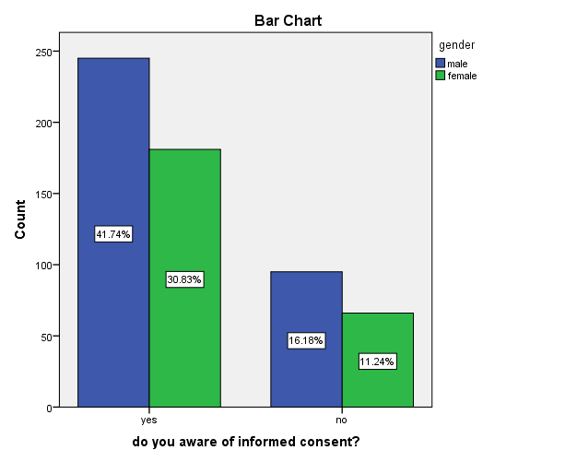

Responses to questions related to elements of IC, 407 (69.3%) subjects answered yes when asked if the HCP discussed the treatment options before the procedure, 349 (59.5%) said that the doctor informed them about the potential complications of the procedure and 294 (50.1%) said the doctor did discuss the risk & benefits. To a set of questions assessing how do patients feel about IC, only 281 (47.9%) of the patients said that they were satisfied with the information provided to them, while 288 (49.1%) said that they understood the details provided. Majority of patients 356 (60.6%) thought that the language used was not appropriate for comprehension considering their education level. 200 (34.1%) of patients identified language as a main barrier for IC, whereas 185 (31.5%) considered culture and 202 (34.4%) thought both language and culture are the barriers for IC.

**Table 3: Category 2:** Elements of informed consent.

|  |  |  |  |
| --- | --- | --- | --- |
| Variable | Response | Frequency | Percentage |
| Did doctor discussed with you treatment options before procedure? | Yes | 407 | 69.3 |
| No | 180 | 30.7 |
| Did your doctor discussed with you complications of procedure before consent? | Yes | 349 | 59.5 |
| No | 238 | 40.5 |
| Did your doctor mentioned risks & benefits of procedure? | Yes | 294 | 50.1 |
| No | 293 | 49.9 |
| Are you satisfied with information given to you? | Yes | 281 | 47.9 |
| No | 306 | 52.1 |
| Did you understand information given to you? | Yes | 288 | 49.1 |
| No | 299 | 50.9 |
| Does language used was appropriate according to your education capacity? | Yes | 231 | 39.4 |
| No | 356 | 60.6 |

**Do you aware of informed consent? * education Crosstabulation**

|  |  |  |  |  |  |  |
| --- | --- | --- | --- | --- | --- | --- |
| Variable | | Education | | | | Total |
| Primary | secondary | matric and above | unable to read or write |
| do you aware of informed consent? | Yes | 62 | 93 | 249 | 22 | 426 |
| No | 22 | 40 | 35 | 64 | 161 |
| Total | | 84 | 133 | 284 | 86 | 587 |

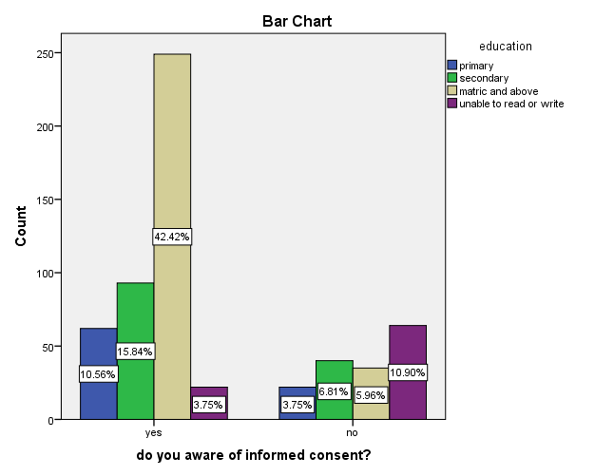

|  |  |  |  |  |  |  |
| --- | --- | --- | --- | --- | --- | --- |
| **do you know the significance of informed consent * education Crosstabulation** | | | | | | |
|  | | Education | | | | Total |
| Primary | secondary | matric and above | unable to read or write |
| do you know the significance of informed consent | Yes | 31 | 85 | 171 | 31 | 318 |
| No | 53 | 48 | 113 | 55 | 269 |
| Total | | 84 | 133 | 284 | 86 | 587 |
|  | | | | | | |

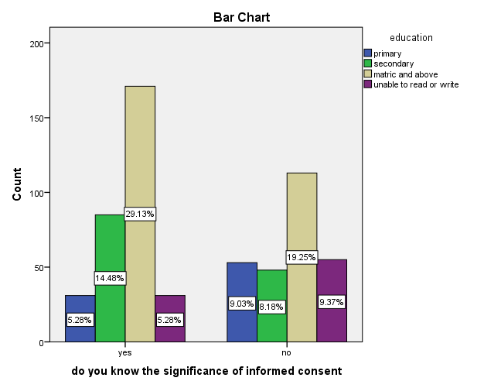

|  |  |  |  |  |
| --- | --- | --- | --- | --- |
| **do you know the significance of informed consent * gender Crosstabulation** | | | | |
|  | | Gender | | Total |
| Male | Female |
| do you know the significance of informed consent | Yes | 252 | 66 | 318 |
| No | 88 | 181 | 269 |
| Total | | 340 | 247 | 587 |

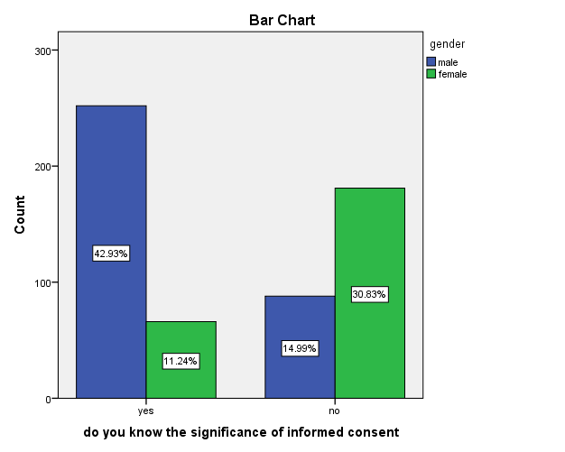

**do you aware of informed consent? * gender Crosstabulation**

|  |  |  |  |  |
| --- | --- | --- | --- | --- |
|  | | Gender | | Total |
| Male | Female |
| do you aware of informed consent? | Yes | 245 | 181 | 426 |
| No | 95 | 66 | 161 |
| Total | | 340 | 247 | 587 |

Regarding the assessment of administrative part of IC, which were assessing the signing of IC, barriers of IC, influence on the consent. 368 (62.7%) of the subjects signed the informed consent themselves while 219 (37.3%) said that the IC was signed by a family member.

Only minority of patients 199 (33.9%) felt that the consent was free and fair while 388 (66.1%) felt the decision was influenced. 233 (39.7%) felt the decision was influenced by doctor whereas 155 (26.4%) said family member. Details are shown in table 4.

**Table 4: Category 3:**  The administrative part of IC

|  |  |  |  |
| --- | --- | --- | --- |
| Variable | Response | Frequency | Percent |
| What are the barriers of informed consent? | Language | 200 | 34.1 |
| Cultural | 185 | 31.5 |
| Both | 202 | 34.4 |
| Who signed the consent? | Self | 368 | 62.7 |
| Family | 219 | 37.3 |
| Did consent was free and fair or influenced by someone? | Free & fair | 199 | 33.9 |
| Influenced | 388 | 66.1 |
| Who influenced consent? | Doctor | 233 | 39.7 |
| Family | 155 | 26.4 |
| Not applicable | 199 | 33.9 |

**Discussion:** it has been well established in western world that informed consent is mandatory for any procedure/surgery or participation of human subject in the research studies. Therefore sharing medical information with patients is a basic moral responsibility of physicians. Informed consent has central role in clinical and research ethics. Patients have full right to make decisions about their medical conditions and have the right to be given all available information relevant to such decisions. To obtain consent is not a discrete event; rather, it is a process that should be applied in all aspects of the physician-patient relationship. 6

Majority of the patients (72.6%) were aware about IC but nearly half of the patients (45.8%) doesn’t know the significance IC. It alerts us that there is lot of need to educate the public. When we analyzed the significance of informed consent with the education of the patient with cross tabulation & chi-square test the results showed that higher the education better understanding of the significance of IC & it was statistically significant (P value 0.001)

Majority of the patients (60.6%) were not satisfied about the language which was used to explain IC according to education level & more than half (52.1%) were not satisfied about the adequacy of information and half of the patient (50.9%) didn’t understand the information. In another study 40.5% patients understood the information which tell us the majority of the subjects were not fully informed.7 These findings alert us that much is needed to educate the HCP for using the communication skills according to the education level of the patients. There are some studies; reviews and meta-analysis that have proved that obtaining informed consent is the basic building block for the successful doctor-patient relationship, good communication has a positive impact on emotional, physical and palliative health of the patient.8 Provision of the information about condition produces a good effect on health and significantly reduces negative feelings, distress and pain.9 it greatly increases patient's satisfaction and compliance with the treatment.8 Moreover it is also mandatory for HCPs to consider education level, intelligence & belief of individuals while communicating the patients.10

Majority of the subjects (69.3%) were discussed about the complications of procedure but nearly half (49.9%) of the subjects were not discussed about the risks & benefits of procedure. In other studies (48%) were informed about complications which means 52% were not informed about complications of the procedure 7 & these findings were also reported by another study in which 51.1 & 56.9% subjects & relatives were not informed for the complications respectively. 11 In another study conducted at south Africa, in which 89.3% HCPs provided benefits of the procedure, 81% were informed about treatment options & 95% HCPs discussed the risks of the procedures to subjects.12 These findings are warning us that there is still need of improvements in such regards.

Pakistan is a multi-linguistic country & multi-cultural country; though Urdu is the national language but still lot of population doesn’t know the national language. Language & culture plays a great role for the IC. In this survey major barriers related to IC were language, cultural & both (34.1%), (31.5%) & (34.4%) respectively. In one study 87.5% HCPs said language was the major barriers of IC.12 Responses related to signing of the consent; 368 (62.7%) said self & 219(37.3%) said family. Our results showed improvements in self-signing of consent as compare to 29% & 52% as reported by previous studies respectively.13,14 As compare to western society, our society is culturally different; therefore we need to address not only language but also cultural reasons which are also major barriers for the IC.

Whether the IC was free and fair or influenced by someone? Majority of the patients 388(66.1%) said that IC was influenced & (39.7%) said HCPs, (26.4%) said family influenced for the IC. In previous study: 56% subjects said the informed consent was influenced by doctor7 & in another study 32.9% showed that consent was influenced by family & friends.11 For a legally & ethically valid IC; It is necessary that IC must be free & fair & there shouldn’t be any influence either from family or from HCP. In the ethics, informed consent is deeply rooted with the ethical principle of autonomy. It is the patient's right to make autonomous decision without any coercion. It keeps away the physician to carry out any unwanted and experimental intervention. The physician who did not obtain consent and started medical intervention will be considered as battery15 and treating a patient on the basis of inadequate informed consent will be considered as medical negligence.16 A valid consent can be evaluated by country rules which are described in constitution of their country. A good example is from Canadian health care act which defines the important elements of valid consent, procedure to determine the capacity of the patient, if patient found incapacitated then there is a defined procedure that who can give consent on behalf of the patient. 17 It has been well recognized in the literature that it is the physician's commitment to obtain valid consent before starting any intervention.18

The basic target of informed consent is to provide opportunity to patients to actively participate in medical decisions. For adequate, ethically and legally complete informed consent need detailed information of the procedure/intervention, benefits & risk of the procedure, alternatives of the intervention, understanding of the patient information and acceptance & authorization of the procedure. 19

Informed consent will be considered valid when it is given by individual who actively participate in discussion, information given in lay man's language, completely understands the decision .It must be given voluntarily by competent individual & free from coercion. There are two different senses of informed consent. In the first sense informed consent can be analyzed on account of autonomy because it is the person's autonomous choice. In the second sense, informed consent should be measured in relation to social rules. If social rules are applied in consent process then it becomes an agreement rather than informed consent. In this sense informed consent loses its meaningful status but serve as only legally effective consent without being necessarily autonomous.8

In other words Informed Consent has five essential elements which include disclosure, comprehension, voluntariness, competence and consent.8, Disclosure includesreasonable and relevant information by the physician/researcher to the subjects which includes its nature, purpose, risks and benefits & available alternatives & understanding of information.20 For a legally legitimate informed consent; there are basically three approaches which include reasonable physician standard, reasonable patient standard& subjective standard. Of these three approaches reasonable patient standard approach has patient centered approach but drawback of this approach is that subjects cannot interpret technical information. Subjective standard is also reasonable but it might confuse the subjects. Therefore for a legitimate informed consent must fulfill all the essential elements.19

While taking consent Capacity of the patient must be fulfilled & competent patient have complete right to refuse treatment even if the treatment is life-saving.19 Consent should be Voluntary which refers subjects must decide freely. There shouldn’t be literal coercion, undue inducement & no choice situation. To obtain a valid consent patient should be given opportunities for to ask questions and concerns. Clinician must actively involve the patients in the consent process.15

**Conclusion:** The survey showed that there is a much need of improvement for the legally & ethically valid IC. Education, language, culture & female gender are the major factors & plays clear role for the understanding of IC & moreover it needs improvement of the communication skills of the HCP. Higher the education better understanding of the IC. Majority of the patient showed that IC was not free & fair & language & culture was a major barrier for IC.

**Limitation:** This study was mainly carried out at public sector hospital, where majority of the patients were from remote areas of the state & it doesn’t reflect the education level of natives of the city.

# REFERENCES

1. Making healthcare decisions: the ethical and legal implications of informed consent in the patient-practitioner relationship. President’s commission for the study of ethical problems in medicine and biomedical research and behavioral research. Volume one (Washington D.C: 1982), 41-51
2. Beauchamp T.L. "Informed Consent" In Veatch R.M. (ed) *Medical Ethics* (London: Jones and Bartlett 1997): 185-206.
3. Jonsen A.R. "The Ethics Of Research With Human Subjects". In Jonsen A.R. Veatch R.M. Walters L. (ed) *Source Book In Bioethics*. Washington D.C: Georgetown University Press; 1998, 11-12
4. Beauchamp T.L. "Informed Consent" In Veatch R.M.(ed) *Medical Ethics* (London: Jones and Bartlett 1997)*, 194.*
5. Beauchamp T.L. Faden R.R. "Informed Consent: II. Meaning And Elements Of Informed Consent." In Reich WT (ed) *Encyclopedia of Bioethics*. vol 3.(New York: Simon & Schuster Macmillan 1995), 1240.
6. Lidz C.W. Appelbaum P.S. Meisel A. Two Models Of Implementing Informed Consent.*Arch Intern Med*1988; 148:1385-9.
7. Amir M, Rabbani MZ, Parvez MB. Informed consent in elective surgical procedures: What do the patients think? J Pak Med Assoc 2009; 59: 679-82.
8. Beauchamp T.L. Childress J.F. *Principles Of Biomedical Ethics* (New York: Oxford University Press 2009), 99-148
9. Suls J. Wan C.K." Effects Of Sensory And Procedural Information On Coping With Stressful Medical Procedures And Pain: A Meta -Analysis."*J Consult Clin Psychol*1989; 57:372-9.
10. Tekola F, Bull SJ, Farsides B, Newport MJ, Adeyemo A, Rotimi CN, et al. Tailoring Consent to context: Designing an appropriate consent process for a biomedical study in a low income setting. PLoS Negl Trop Dis 2009, 7: e482.
11. Jahan F, Roshan R, Nanji K,Sajwani U,Warsani S, Jaffer S. Factors affecting the process of obtaining informed consent to surgery among patients and relatives in a developing country: results from Pakistan. East Mediterr Health J. 2014; 20 (9): 569-77.
12. Chima SC. Evaluating the quality of informed consent and contemporary clinical practices by medical doctors in South Africa: An empirical study. BMC Medical Ethics 2013, 14 (Suppl 1):S3
13. Khan RI. Informed consent and some of its problems in Pakistan. J Pak Med Assoc 2008; 58: 82-4
14. Zafar S, Malik RH, Sami AN, Avais AR, Avais A, Malik FN. The awareness of informed consent; among medical students & the current consent practices at a tertiary care hospital. Ann Pak Inst Med Sci 2011; 7 (4): 176-179.
15. Malette v. Shulman  67 Dom Law Rep 1990 Mar 30; 67: 321-39. (Ont CA) 328-338
16. Reibl v. Hughes [1980] 2 SCR: 880.
17. Health Care Consent Act, SO 1996, c 2
18. Informed Decision-Making [Policy Summary]. *CMAJ*1986; 135:1208A
19. Edwards K.A. Informed Consent <http://depts.washington.edu/bioethx/topics/consent.html> Accessed in October 2018.
20. Weijer C, Grimshaw JM, Eccles MP, McRae AD, White A, Brehaut JC, et al.; Ottawa Ethics of Cluster Randomized Trials Consensus Group. The Ottawa Statement on the Ethical Design and Conduct of Cluster Randomized Trials. PLoS Med. 2012; 9(11): e1001346.
21. Tam NT, Huy NT, Thoa LTB, Long NP, Trang NTH, Hirayamad CK, Karbwangb J. Participants’ understanding of informed consent in clinical trials over three decades: systematic review and meta-analysis. *Bull World Health Organ* 2015;93:186–198H