Dear Editor,

This is to confirm that the article entitled “***Aged Care Ethical Values: A Content Analysis of the Literature***” submitted to the Indian Journal of Medical Ethics is original and has been co-authored by the undersigned. All authors have participated in the work sufficiently to meet the ICMJE guidelines for authorship. All have read and approved the manuscript .The submission is not under consideration for publication in any other journal.

We give consent to Dr ***Farahnaz Mohammdi shahboulaghi*** to act as the author for correspondence.

Details of sponsorship or relevant competing interests, financial or otherwise:

**None**

We have read the terms and conditions of authorship of IJME and accept them. Contact details (mailing ad dress, emailid ) and affiliation of all authors:

Reza Hosseinabadi: Iranian Research Center on Aging, Department of Aging, University of Social Welfare and Rehabilitation Sciences, Tehran, Iran. Mailing addresses: **kodakyar Ave., daneshjo Blvd.,Evin,Post code: : 1985713834, Tehran, Iran. Email** addresse: [Reza_hosseinabadi@yahoo.com](mailto:Reza_hosseinabadi@yahoo.com)



Yadollah Abolfathi Momtaz: Iranian Research Center on Aging, Department of Aging, University of Social Welfare and Rehabilitation Sciences, Tehran, Iran. Mailing addresses: **kodakyar Ave., daneshjo Blvd.,Evin,Post code: : 1985713834, Tehran, Iran. Email** address: [yabolfathi@gmail.com](mailto:yabolfathi@gmail.com)

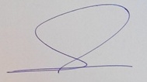

Farahnaz Mohammdi shahboulaghi: Social Determinants of Health Research Center, Nursing Department, University of Social Welfare and Rehabilitation Sciences, Tehran, Iran. Mailing addresses: **kodakyar Ave., daneshjo Blvd.,Evin,Post code: : 1985713834, Tehran, Iran. Email** addresse: [mohammadifarahnaz@gmail.com](mailto:mohammadifarahnaz@gmail.com)

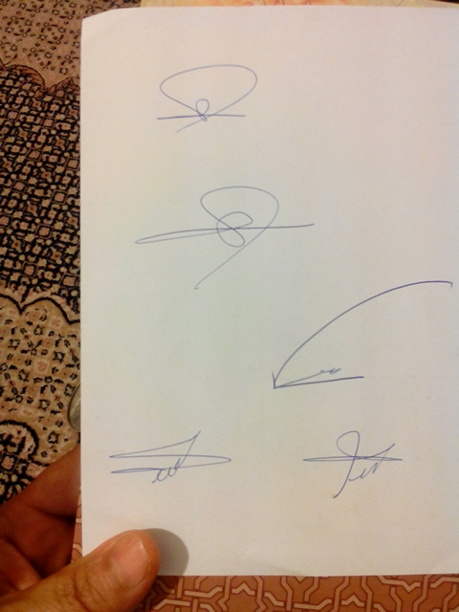

Abbas Abbaszadeh: School of Nursing and Midwifery, Shahid Beheshti University of Medical Sciences, Tehran, Iran. Email address: [aabaszadeh@hotmail.com](mailto:aabaszadeh@hotmail.com)



Ahmad ali Akbari Kamrani: Iranian Research Center on Aging, Department of Aging, University of Social Welfare and Rehabilitation Sciences, Tehran, Iran. Mailing addresses: **kodakyar Ave., daneshjo Blvd.,Evin,Post code: : 1985713834, Tehran, Iran. Email** addresse: akbarikamrani@gmail.com



Signatures of all authors: