**Googling symptoms – Making you a Cyberchondriac? -A questionnaire survey**

**ABSTRACT**

**Background**

Google processes over 40,000 searches every second on an average to 3.5 billion searches per day worldwide. Roughly 1% of searches are related to medical symptom queries. Health content on the web may provide information but may lead people from mild symptoms to scary and unlikely conditions which can cause unnecessary anxiety and stress. The aim of this study was to assess the practice of googling symptoms and its effect on them.

**Materials and methods:**

An online questionnaire with structured questions regarding practice towards googling symptoms and its effect was posted on the home page of 350 frequent online users aged between 20 -40. 306 responses were received and evaluated. The survey data were calculated as percentage and depicted as graphs.

**Results**

The data showed 71.2% googled their symptoms and 47.2% thought they had the worst probable diagnosis and 48.8% started worrying about it. With the rise in android systems and smart phones and easy availability of the internet now , there is an increase in number of people who google their symptoms before meeting the doctor and get more anxious and stressed.

**Conclusion**

In the present generation, all feel important to educate themselves but without further investigation it’s better to leave the experts do their job. Its better to google after diagnoses by the doctor or else it will lead us from a few symptoms to a sea of diseases where we will tend to relate ourselves and get more anxious.

**Introduction**

Google is an American multinational technology company that specializes in Internet-related services and products, which include online advertising technologies, search engine, cloud computing, software, and hardware(1). Google was invented in 1998 by [Larry Page](https://en.wikipedia.org/wiki/Larry_Page) and [Sergey Brin](https://en.wikipedia.org/wiki/Sergey_Brin) while they were Ph.D. students at [Stanford University](https://en.wikipedia.org/wiki/Stanford_University), [California](https://en.wikipedia.org/wiki/California)(2)**.**

For all ages Internet is a source of information for anything and everything . But what concerns us is googling for medical information which may get a person at risk for life. The Web is becoming increasingly popular for gaining information on medical or health issues. Indeed, according to a Pew Internet report, 80% of American Web users look for health information online(3). Women are more likely to search for health information online  for themselves, their children and family members.(4) Previous research has focused on parents who seek health information online for their children(5). Bernhardt and Felter found that women as parents are among the highest information-seekers who use the Web to confirm beliefs or get a “second opinion”(6).

The search engines started as a tool of awareness but now is being overexploited and used for self diagnosis. In India access to the internet was not like it is now.. Now due to lots of commercialism and competition between net resources be it the rate, daily packs or the speed of internet and the handy devices like smart phones, tablets and laptops it is accessible to majority of the people. Moreover, lot of open access journals are also available but the credibility of the information is questionable.

To date, many studies worldwide have focused on benefit of the internet as a tool for doctors, smartphones and internet preferences of patients, the internet versus doctor’s source of information and many more. Information retrieval is easier now than ever before. Since the rise of modern search engines, social networks, and ubiquitous access through devices such as smartphones and tablet or laptop computers, information is available at people’s fingertips almost any time of the day(7) .Hence their eagerness to know about their health condition has also increased. The exaggerated reaction and response to what they see, itself adds to an anxiety disorder. The thought of doing this survey arose following numerous questions from my friends and relatives after googling symptoms of their child’s condition and becoming anxious. They would calm down after consulting over phone. It was the time to find out the number of people falling prey to internet information and create awareness of its effects.. This study was done to assess and evaluate the practice of googling symptoms and the consequences taking them closer to cyberchondriasis.

**Materials and methods**

An online questionnaire with 3 sections consisting of 20 questions were sent to the home page of 350 online users aged between 20-40(mean age 35). This age group was chosen since they were frequent online users. The first section involved 3 questions regarding pre –googling , what they do when ill and whether they google symptoms. If the answer was no to googling symptoms, the page will direct you to the fourth section which asks for the gender and ends with an awareness along with a gratitude note for patiently filling the questionnaire. If the answer was yes it would go to the second section which was about googling and the third section about its after effects, where the participants had to fill 17 questions regarding practice of googling symptoms, whether the diagnosis was correct, the reason for googling and the time of googling with few questions regarding the search strategy and effects of googling. Finally the gender, awareness note and piece of gratitude for filling the survey form. Once the subject filled the questionnaire, the response was recorded. Totally 306 completed responses were received. Among those only 219 googled their symptoms and hence were eligible for going to the next section . The data received was evaluated and expressed as percentage. The survey was conducted from June 2018 to November 2018.

**Results:**

The questions were divided into 3 sections. First based on the first step they take when noticing symptoms. Majority of people (71.6% ) googled their symptoms. Among those 72.6% had the correct diagnosis.76% met the doctor to confirm it.92.2% felt clinical examination was important for their diagnosis. 82.6% googled before meeting the doctor.84.9% googled to have an idea of their present condition and 24.2% googled to communicate sensibly with the doctor. Majority (61.6%)read the articles on the first page of their search and only 27.9% read all the articles of their search.53% are satisfied with if the results were normal and 32% got more anxious and 22.8 % more stressed.47.5% thought they had the worst probable diagnosis and 48.4% started worrying about it. 17.8% joined health care forums for seeking medical advice and 29.7% were less stressed on doing so.94.5% agreed the doctor diagnoses better. The graphs from 1a to 1c represent pre -googling, figures 2a-2j about googling and figures 3a- 3g on post googling.

**Discussion**

Google search engine has become the hub for information . Google processes over 40,000searches every second on an average to 3.5 billion searches per day worldwide. Roughly 1% of searches are related to medical symptom queries. Based on analysis of Eysenbach approximately 4.5% of all searches on the web might be health-related.(8) Although health-related queries constitute a relatively small fraction of web-searches, the absolute numbers are still impressive: Google reports 150 Million searches per day on all regional partner sites combined, which means that about 6.75 Million health related searches per day in Google alone are being conducted. In comparison, in 1996 NLM reported 7 Million searches in the MEDLARS (Medline) systemper year*.*In the medicinal field , it is used by both the doctors and the patients.(8)

Questions based on Pre-Googling:

This section was just to know what the users do when they notice medical symptoms and when they meet the doctor 20.6% leave it to resolve naturally, 35% google their symptoms, 20.6% self medicate, 38.9 % meet the doctor and 20.3% did all of the above . On questioning when you must meet a doctor once you notice symptoms, 7.5% chose on the same day, 39.9% after 1 or 2 days, 34% if self medication does not work and if condition gets severe 33.7%.

Googling:

In this survey , 71.6% googled symptoms with majority of the diagnosis being correct . According to [comScore](https://en.wikipedia.org/wiki/ComScore) market research from November 2009, [Google Search](https://en.wikipedia.org/wiki/Google_Search) is the dominant search engine in the United States market, with a [market share](https://en.wikipedia.org/wiki/Market_share) of 65.6%(9).Google [indexes](https://en.wikipedia.org/wiki/Search_engine_indexing) billions of web pages to allow users to search for the information they desire through the use of keywords and [operators](https://en.wikipedia.org/wiki/Operator_(computer_programming)) (10) Christiansen et al was a case report of a 43-year-old woman who diagnosed herself with Erythropoietic photoporphyria after googling photosensitivity. Genetic testing revealed a formerly undescribed mutation, c. 1096-3C>G in combination with the polymorphism, c.333-48T>C (11)

In a study done by Tang et al to determine how often searching with Google (the most popular search engine on the world wide web) leads doctors to the correct diagnosis Google searches revealed the correct diagnosis in 15 (58%, 95% confidence interval 38% to 77%) cases.(12)

76% met the doctor to confirm it since they felt clinical examination is important for their diagnosis. Practitioners sometimes call it ‘‘Doctor Google’’(13). There are at least three problems with giving such patients what they google. First, what the patient wants may not be the best for the patient. Second, even if the treatment does not harm the patient, it may waste medical resources because it is not indicated. Third, it intrudes on the doctor’s autonomy and quality of professional life—someone with no medical training is telling the doctor how to practice medicine. (14)

Hypochondriasis is a symptom which usually develop during adulthood, includes a long-term and intense fear of having a serious condition and worry that minor symptoms indicate something serious. A person may frequently visit or switch doctors(15). Cyberchondria' is the online equivalent of hypochondria and maybe even more harmful because of the glut of sometimes dubious material that is available at the click of a mouse.The frequency of googling was more before meeting the doctor . The reason why they googled was, to have an idea of the present condition and feel sensible while communicating with the doctor with a few to have a emotional connect with people experiencing the same. Sabelefsky et al in his study stated: that higher education level of parents , a young age of the children and acute diseases predisposed to internet use for consultation(16).

It was seen that 61.6% read only the articles that were displayed in the first page of search and the next majority read articles with more introduction. Very few looked at the last page of search.61.6% knew there was a filter effect by google in showing the results. On basis of using other forums like symptom checker websites , majority didn’t have an idea about it. Biasing” or directing your search by adding the name of an online clinical knowledge base can lead you to quality information more quickly; you avoid sifting through dozens of unknown journals, personal webpages, blogs, or discussion forums containing your search terms. He has even tried that by typing “pigmented lesion+buccal” into Google one will get 55 000 hits with a vast array of very different material. However, typing pigmented lesion +buccal +emedicine” provides only 106 hits (17) .

Post Googling

 48.4% start worrying and become more anxious. Can Mark Twain's remark “Be careful about reading health books. You may die of a misprint” be applied to Google?(18).

Googling may be correct but at times can mislead and the internet is a world where within minutes, a muscle twitch becomes [ALS](https://money.usnews.com/money/blogs/the-best-life/2013/06/06/living-with-als-medical-gains-cant-come-fast-enough), cough into lung cancer, a [migraine](https://health.usnews.com/health-products/top-rec-migraine-headache-products-91) morphs into a brain tumor – and a mole into [Melanoma](https://health.usnews.com/health-news/health-wellness/articles/2013/08/10/melanoma-prevention-warning-signs-and-treatment).

A very few join health care forums and seek advice from fellow people in the forum. One thing must be understood that each one’s body behaves differently to a similar condition.94.5% felt that the doctor diagnoses better. Now even doctors google for diagnosis. Several information specialists point out that doctors might be well advised to use librarians' training and skills to conduct complex searches, rather than try to do it themselves. That Google is forming partnerships with libraries is seen as a step in the right direction(19).

Others remind us that Google is not set up as a diagnostic decision support system—although it can be a useful aid to differential diagnosis once a diagnosis has been made—and especially that Google is not a content provider(19).

No World Wide Web page provided information assessed as being written in plain English. A minority of web pages were assessed as high quality. A single World Wide Web page provided accurate information: evidentlycochrane.net. Available information was, in general, skewed toward the diagnosis of endometriosis. There were 16 credible World Wide Web pages, however the content limitations were infrequently discussed. No World Wide Web page scored highly across all 4 domains(20).

Darren R Hargrave et al. in his study stated that patients and family prefer the healthcare professional as the primary source of information but the health care team does not meet their needs. He evaluated the quality of information obtained and found only 2 sites were rated good or excellent across all five tumour types information(21)

While the internet can be a great information resource, it is always best to see a doctor when ill. Not only can a medical professional put a persons mind at rest, they can also check out all the symptoms and tell person what is the actual diagnosis. This has been proved in my KAP survey.

**Conclusion**

It’s important to educate ourselves but better to leave the experts do their job. It is better to google after diagnoses by the doctor or else we will have a few symptoms but a sea of diseases where we will tend to relate ourselves and get more anxious. For the sake of efficiency, it would be best if we brought our list of symptoms to the doctor’s office rather than online diagnosis. A physical examination- something the internet cannot do greatly increases the doctor’s chances of pinpointing the illness. The best bet is to think of online search as just one tool in your arsenal.

REFERENCES

1. Rivas, Teresa. “Ranking The Big Four Tech Stocks: Google Is No. 1, Apple Comes In Last”. www.barrons.com. Retrieved 2018-12-27.

2. https://en.wikipedia.org/w/index.php?title=Google&oldid=829346031.

3. Fox S, Duggan M. Health Online 2013. Internet and American Life Project. 2013. [Accessed May 23, 2017]. Available at: http://pewinternet.org/Reports/2013/Health-online.aspx.

4. Chu, J. T., Wang, M. P., Shen, C., Viswanath, K., Lam, T. H., & Chan, S. (2017). How, When and Why People Seek Health Information Online: Qualitative Study in Hong Kong. Interactive journal of medical research, 6(2), e24.

5. Walsh, Anne M et al. “Use of online health information to manage children’s health care: a prospective study investigating parental decisions” BMC health services research vol. 15 131. 2 Apr. 2015.

6. Bernhardt JM, Felter EM.Online pediatric information seeking among mothers of young children: results from a qualitative study using focus groups.J Med Internet Res. 2004 Mar 1;6(1):e7.

7. Tonsaker, Tabitha et al. “Health information on the Internet: gold mine or minefield?” Canadian family physician Medecin de famille canadien vol. 60,5 (2014): 407-8.

8. Eysenbach G.The impact of the Internet on cancer outcomes.CA Cancer J Clin. 2003 Nov-Dec;53(6):356-71.

9. “comScore Releases November 2009 U.S. Search Engine Rankings”. December 16, 2006. In.

10. Arrington, Michael (July 25, 2008). “Google’s Misleading Blog Post: The Size Of The Web And The Size Of Their Index Are Very Different”. TechCrunch. AOL.

11. Christiansen AL, Brusgaard K, Hertz JM, Bygum A.A patient diagnosed herself with erythropoietic protoporphyria after googling photosensitivity.Ugeskr Laeger. 2015 Jul 20;177(30).

12. Tang H, Ng JH.Googling for a diagnosis--use of Google as a diagnostic aid: internet based study.BMJ. 2006 Dec 2;333(7579):1143-5.

13. Loudon, I. “Why are (male) surgeons still addressed as Mr?” BMJ (Clinical research ed.) vol. 321,7276 (2000): 1589-91.

14. Davis, J. K. (2017). Dr. Google and Premature Consent: Patients Who Trust the Internet More Than They Trust Their Provider. HEC Forum, 30(3), 253–265.

15. hypochondria_en_IN.pdf [Internet]. [cited 2018 Mar 10]. Available from: https://www.gstatic.com/healthricherkp/pdf/hypochondria_en_IN.pdf

16. Sebelefsky C ,Voitl J ,Karner D, Klein F , Voitl P ,Bock A. Internet use of parents before attending ageneral pediatric outpatient clinic:does it change their information level and assessment of acute diseases.BMC Peadiatric.2016 Aug 18;16:129.

17. Mark Taubert.Use of Google as a diagnostic aid.Bias your search.BMJ. 2006 Dec 16; 333(7581): 1270.

18. Reinhard Wentz.Use of Google as a diagnostic aid Is Google like 10 000 monkeys?BMJ. 2006 Dec 16; 333(7581): 1270.

19. Birte Twisselmann.Use of Google as a diagnostic aid .Summary of other responses.BMJ. 2006 Dec 16; 333(7581): 1270–1271.

20. Hirsch M, Aggarwal S, Barker C, Davis CJ, Duffy JMN.Googling endometriosis: a systematic review of information available on the Internet.Am J Obstet Gynecol. 2017 May;216(5):451-458.e1.

21. Hargrave DR, Hargrave UA ,Bouffet E. Quality of health information on the internet in pediatric neuro oncology.Neuro oncol.2006 Apr:8(2): 175-82.

Table 1: Pre googling

|  |  |
| --- | --- |
| Questions | Response in percentage(%) |
| **When I have certain medical problem / symptoms , I** |  |
| Leave it to resolve naturally | 20.6 |
| Google your symptoms | 35 |
| Self medicate | 20.6 |
| Meet the doctor | 38.9 |
| All of the above | 20.3 |
| **I think I must meet a doctor once I notice symptoms** |  |
| On the same day | 7.5 |
| After 1 or 2 days | 39.9 |
| If self medication does not work | 34 |
| If condition quite severe | 33.7 |
| **I have googled my medical symptoms** | 71.6 |

Table 2: Googling

|  |  |
| --- | --- |
| **The diagnosis was correct** | 72.6 |
| **I met the doctor to confirm it** | 76 |
| **I think clinical examination is important for diagnosis** | 92.2 |
| **My frequency of googling is more** |  |
| Before meeting the doctor | 82.6 |
| When at reception are waiting for your turn at the doctors clinic | 6.8 |
| After doctor has diagnosed | 32 |
| **I google** |  |
| To have an idea of your present condition | 84.9 |
| To feel sensible while communicating with the doctor | 24.2 |
| For self medication | 9.6 |
| To get support and emotional connection with people experiencing the same | 21 |
| **The articles that I search for regarding my query are** |  |
| Ones on the first page | 61.6 |
| Ones that are highlighted | 28.3 |
| Articles with more introduction | 30.1 |
| Ones even in back pages | 6.4 |
| **I read all the articles of my search** | 28.3 |
| **I know there is a filter effect by google for my search** | 61.6 |
| **I think google shows the same result for all of them with the same symptom search** | 51.1 |
| **I use symptom checker websites** | 17.4 |

Table 3 :Post Googling

|  |  |
| --- | --- |
| **My reaction after I google symptoms?** |  |
| Get more anxious | 32 |
| Get more stresssed | 22.8 |
| Get satisfied with the search if normal | 53 |
| Satisfied even if it's exaggerated | 18.3 |
| Self medicate | 6.8 |
| **I think I may have even the worst probable diagnosis** | 47.5 |
| **I start worrying about it** | 48.4 |
| **I join health care forums / facebook pages / twitter sites** | 17.8 |
| **I seek advice from fellow people in the forum** | 15.5 |
| **It reduces my stress** | 29.7 |
| **I feel doctor diagnoses better** | 94.5 |

Figure 1a:

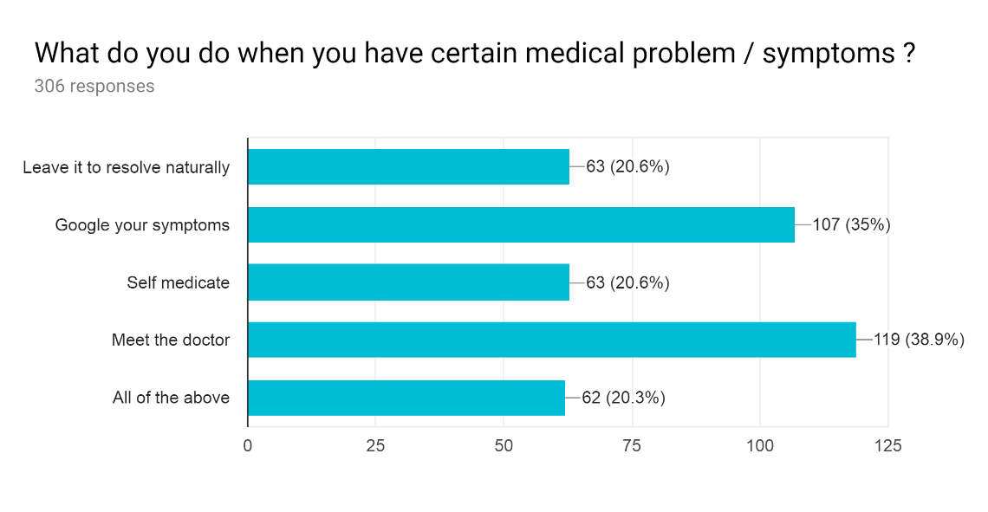

Figure 1b

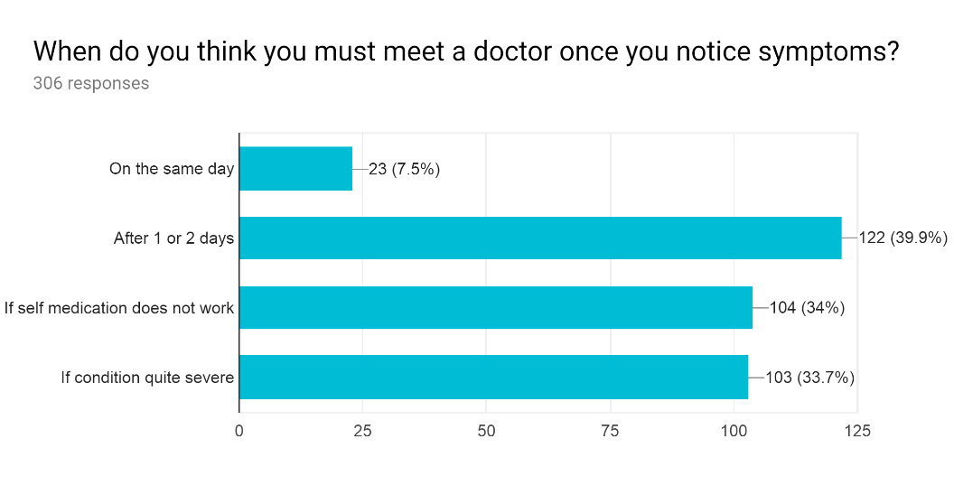

Figure 1c

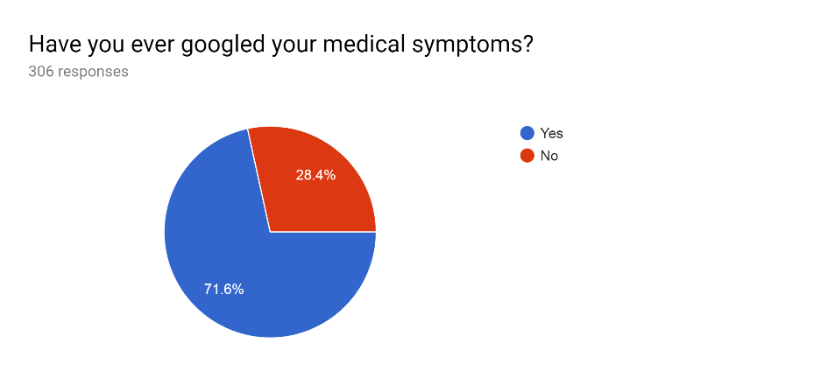

Figure 2a

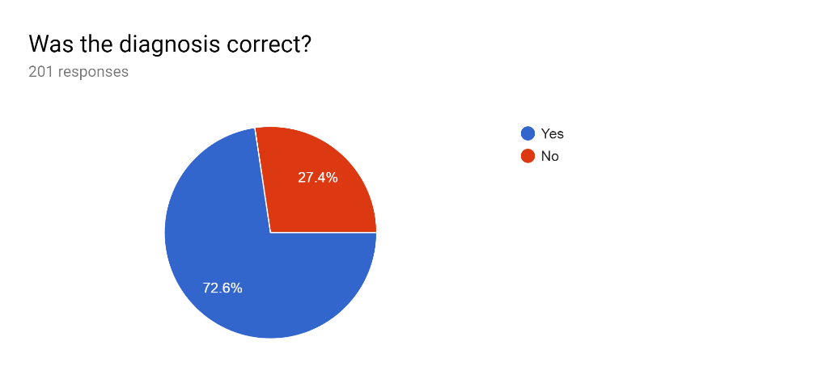

Figure 2 b

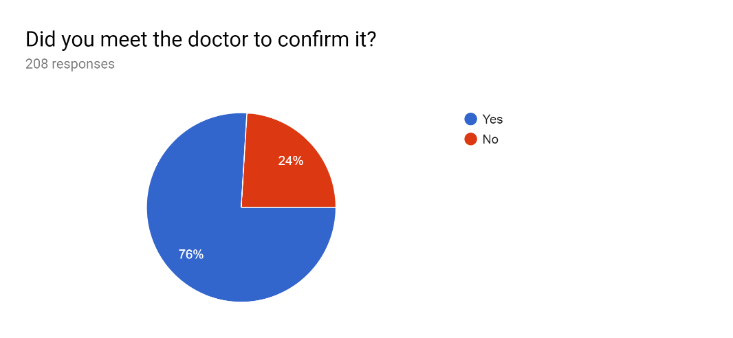

Figure 2 c

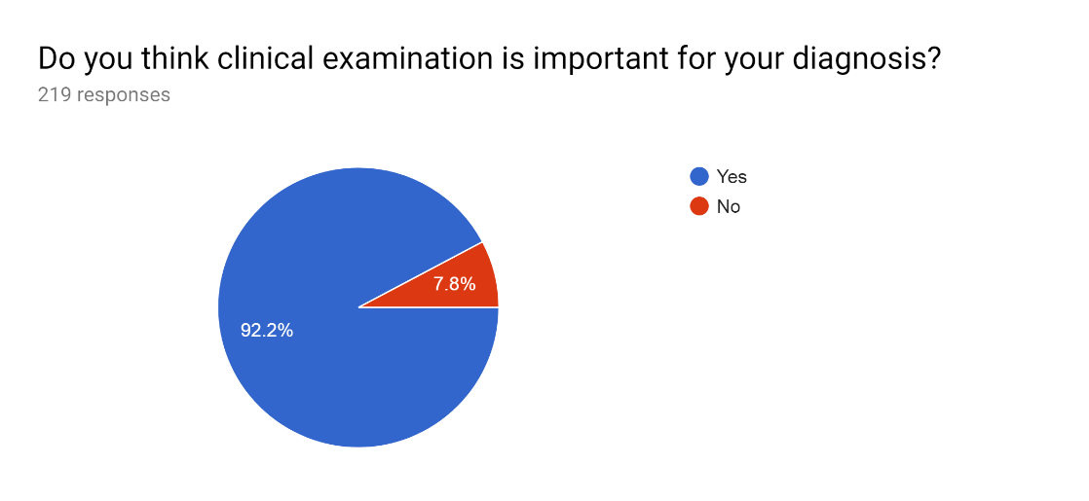

Figure 2 d

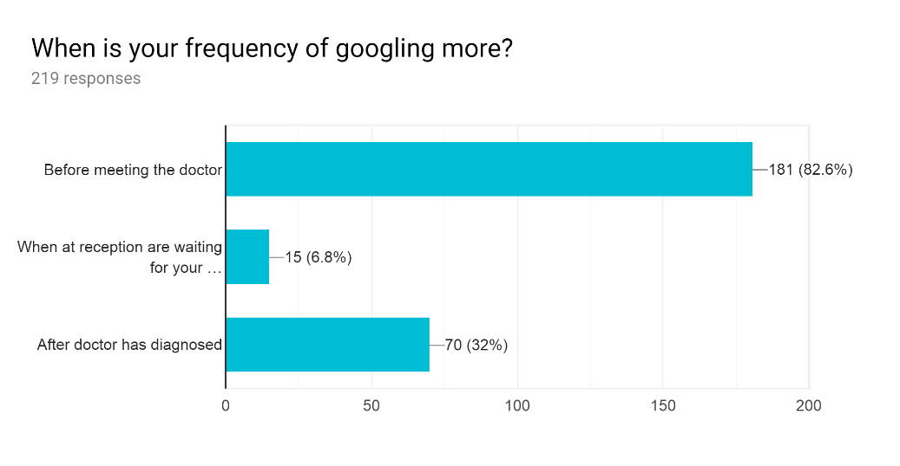

Figure 2 e

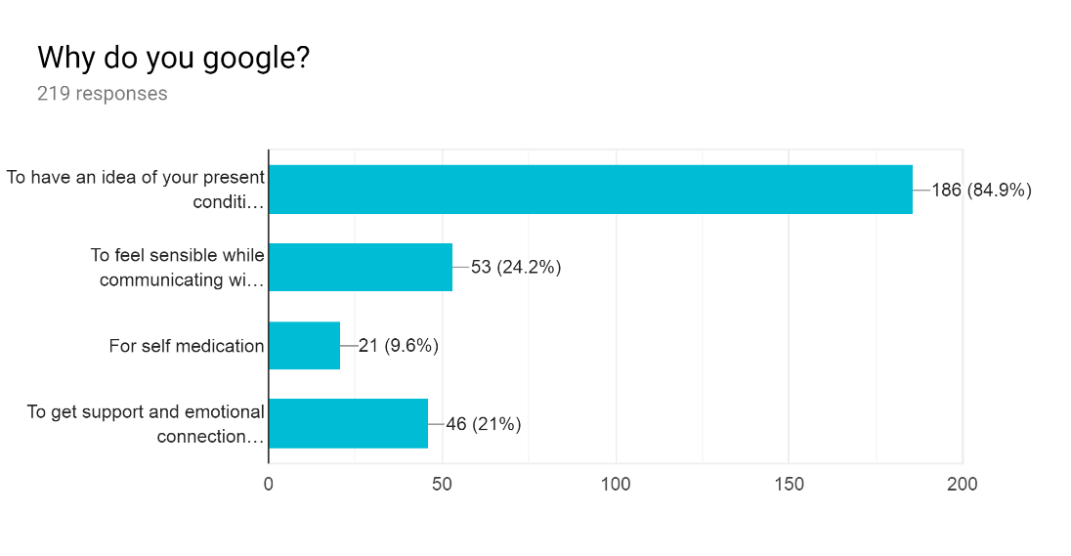

Figure 2 f

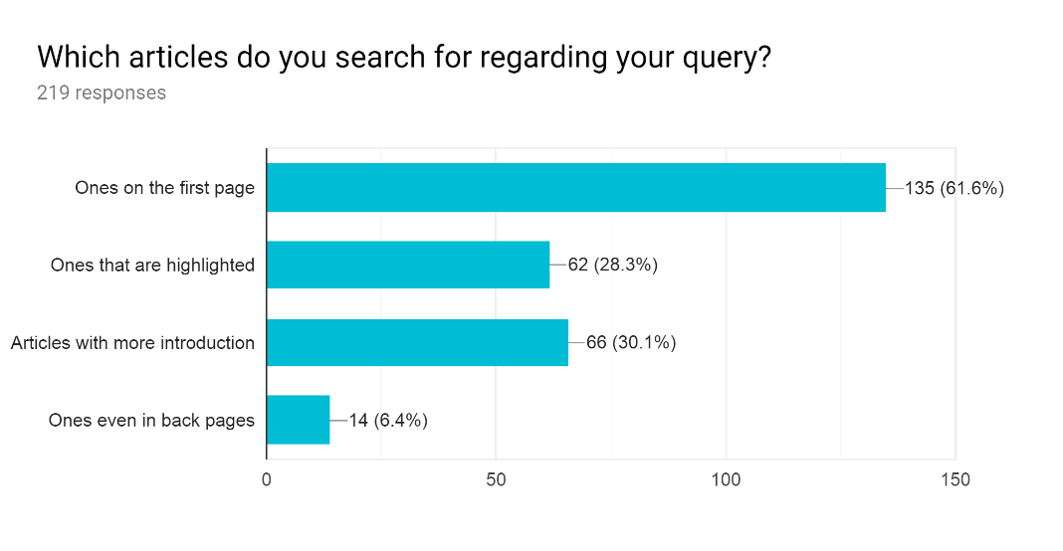

Figure 2 g

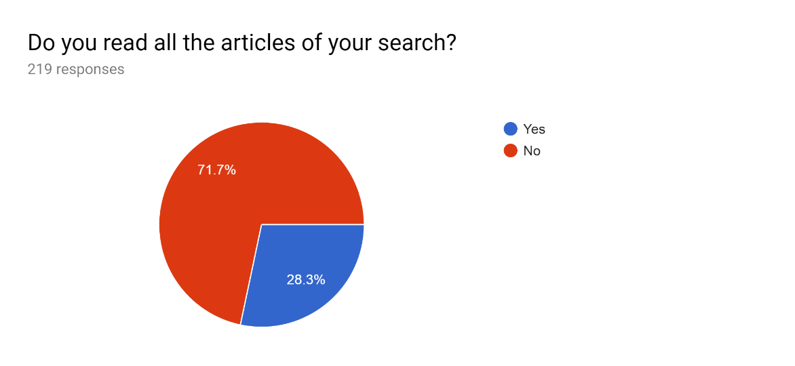

Figure 2 h

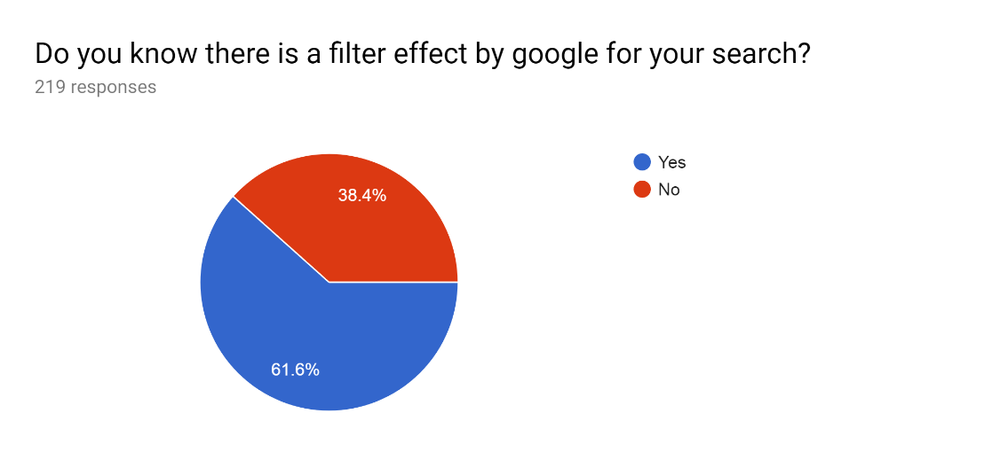

Figure 2 i

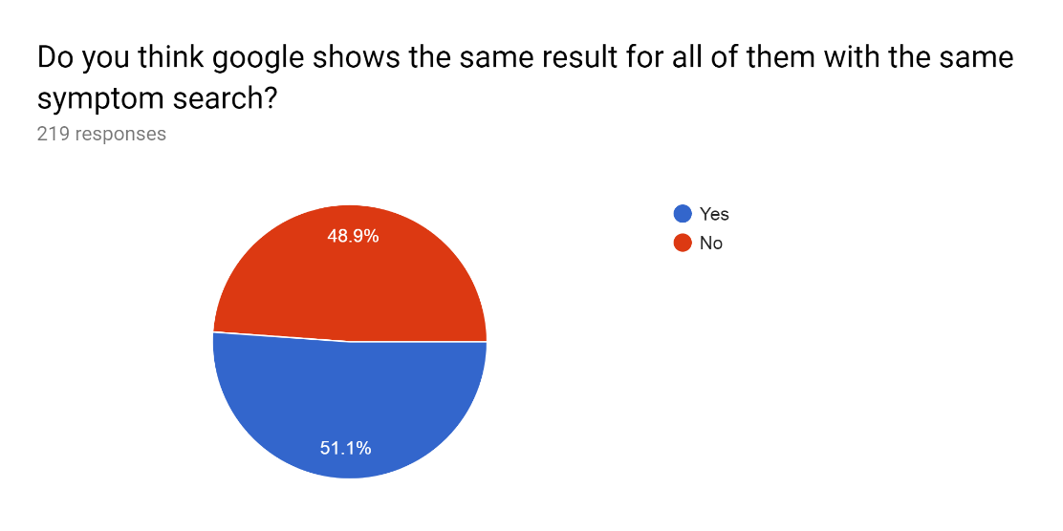

Figure 2 j

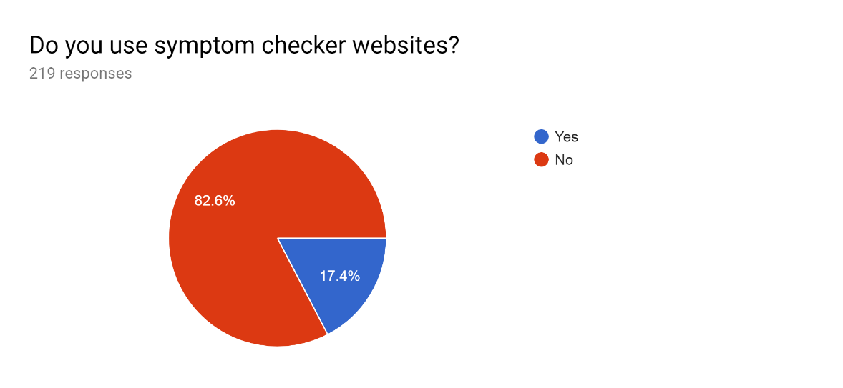

Figure 3a

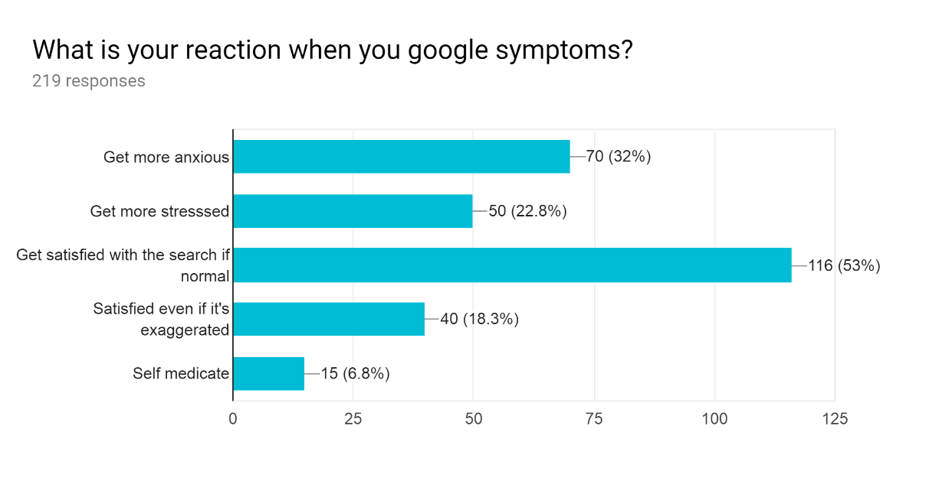

Figure 3b

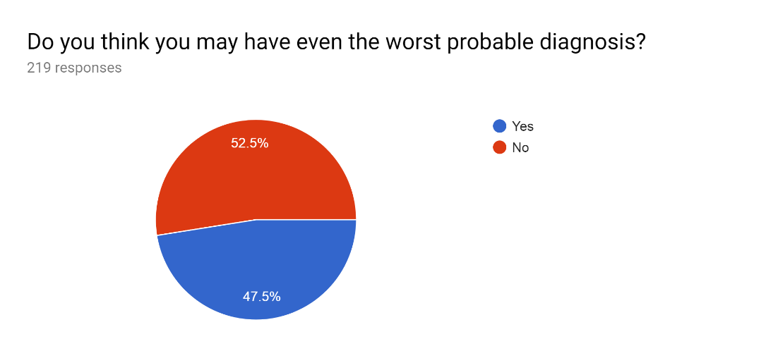

Figure 3c

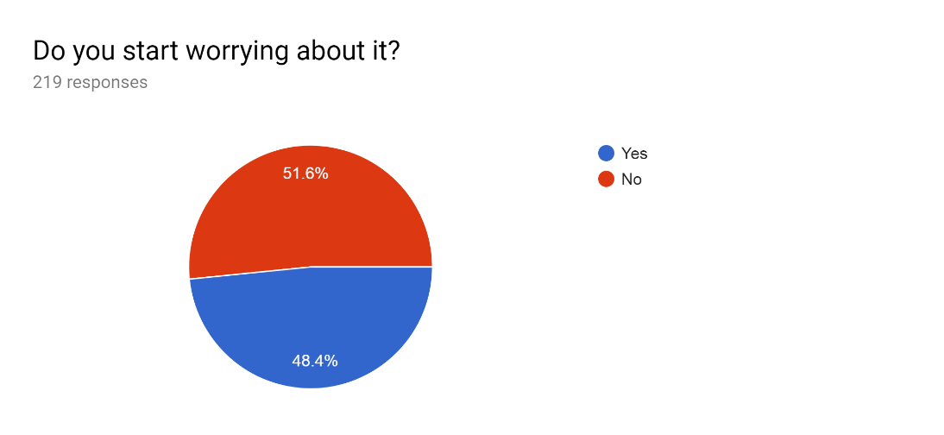

Figure 3d

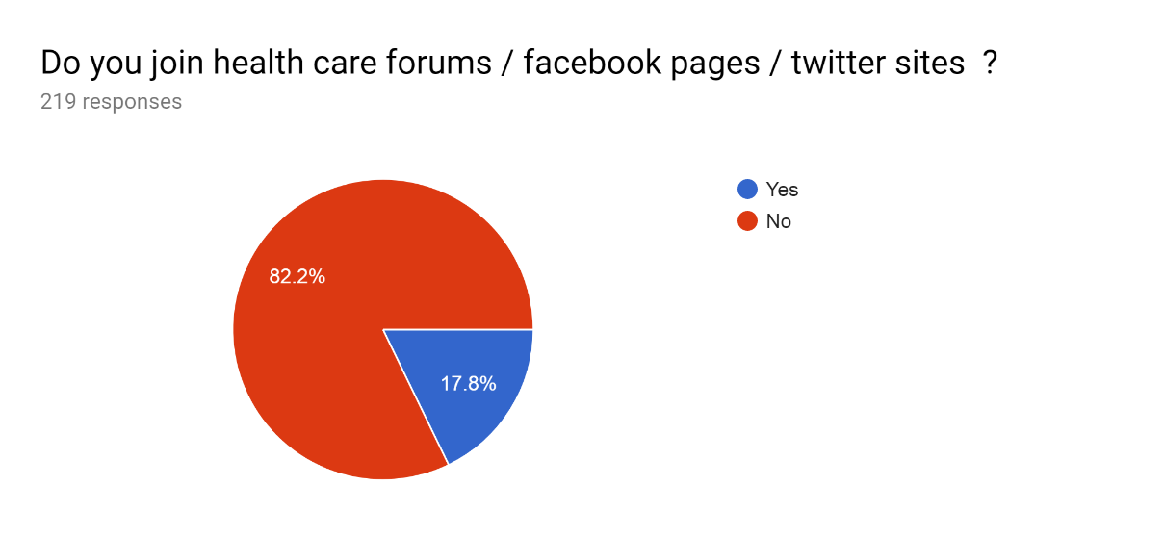

Figure 3e

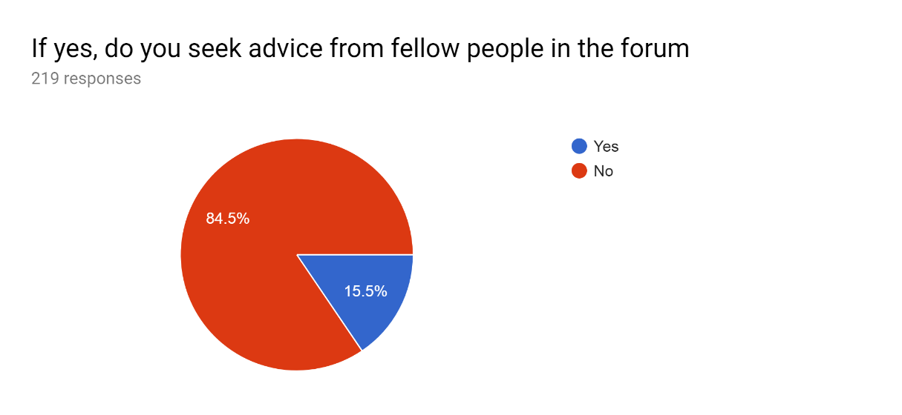

Figure 3f

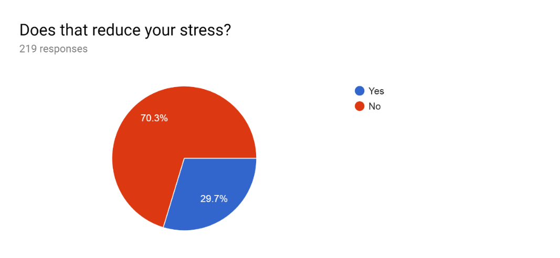

Figure 3g

