Figer et al Perceptions about participation in clinical research 190219

Figure 1:

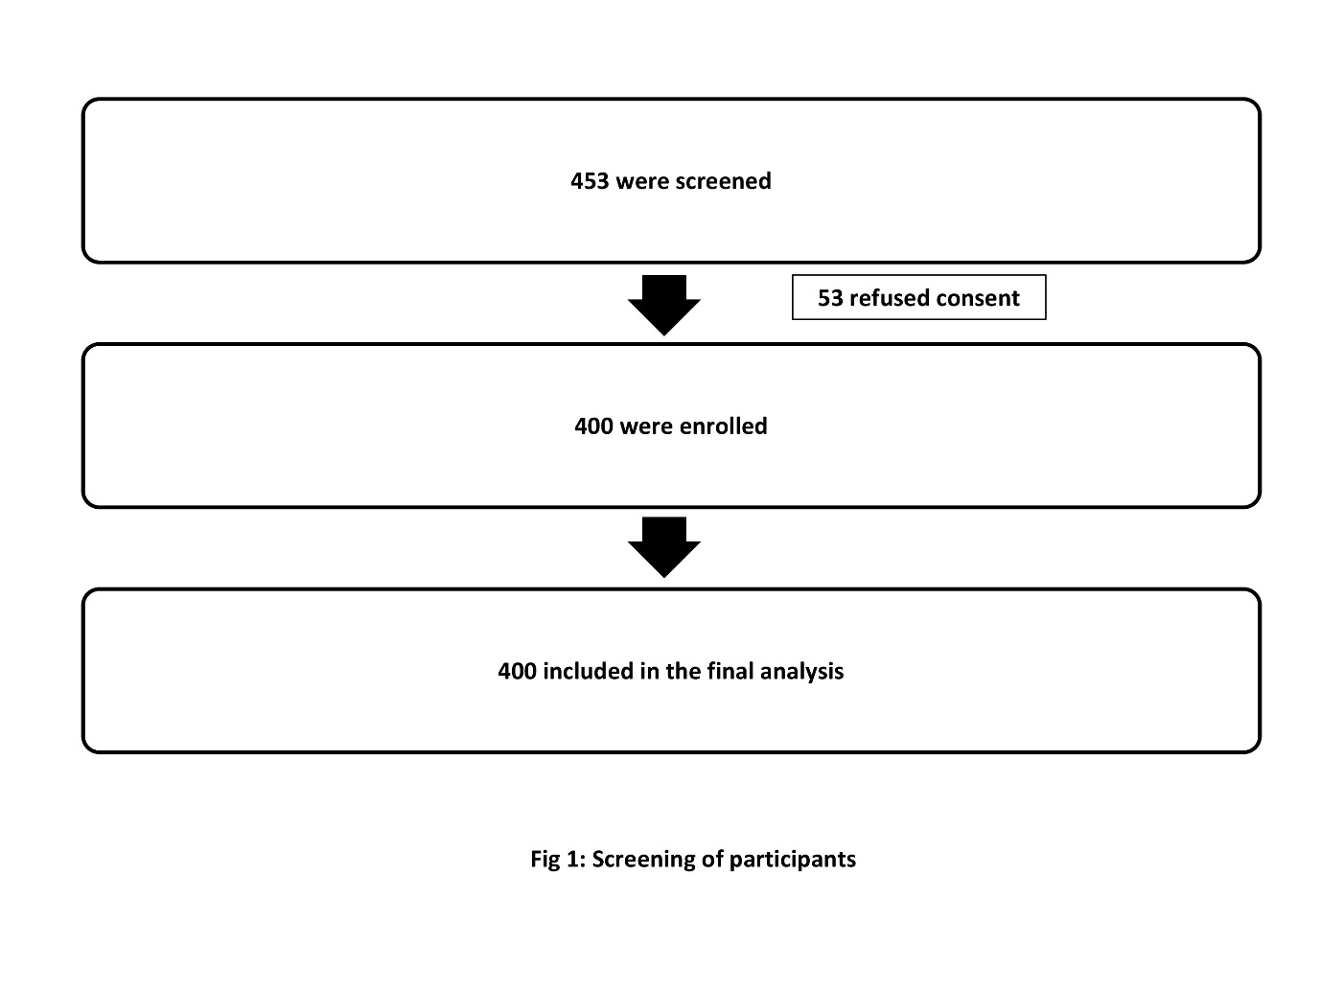

**Figure 2:**

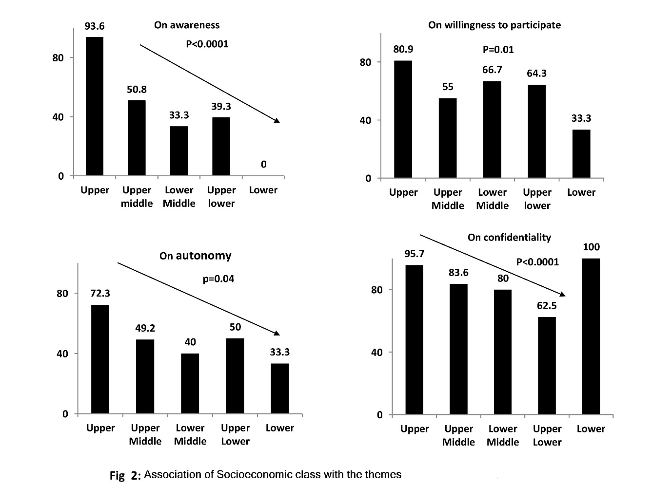

**Figure 3:**

