Autoimmunity: an in-sight narrative

Abstract

*Chronic (autoimmune) inflammatory conditions mirror dis-ease at many levels, each of which involves blurring of the self from the non-self. While medicine captures the inflammatory angle involving the immune system, this article presents perspectives on other players in this dis-ease: lifestyle, mental and emotional states and sociocultural settings that are gathered from the author’s own journey with autoimmunity.*

## The *itis* spectrum

Let us begin with my medical history. The first symptoms appeared when I was a toddler. By the end of teens, the entire spectrum was out in the open, recorded in big, fat case-files, hospital-wise and specialist-wise. To keep it simple, I have used an illustration to summarize my case files. (Figure 1)

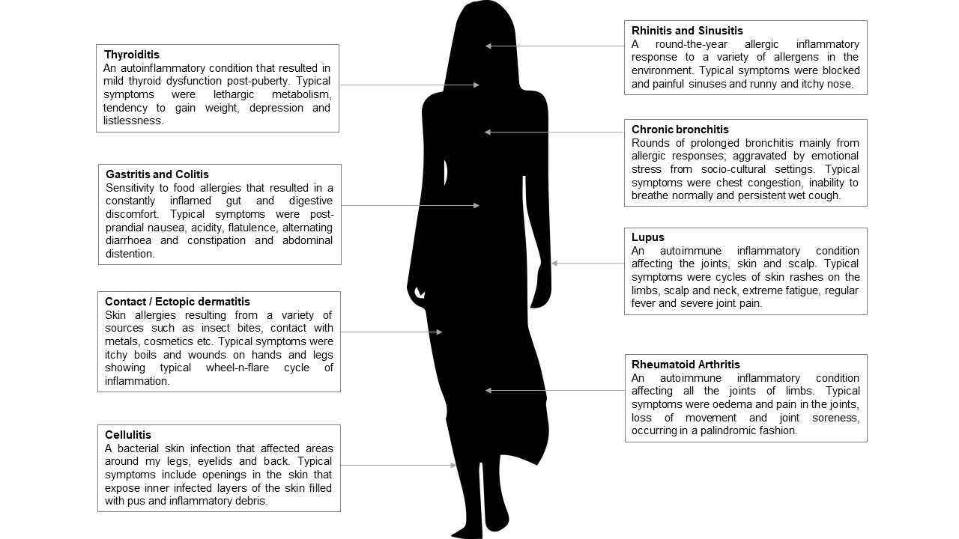

Figure 1: The *itis* spectrum. [Image source](https://pixabay.com/illustrations/silhouette-woman-walking-1603286/). *Itis* is the suffix used in medical language to indicate an inflammatory condition. I choose to call my medical history the *itis* spectrum.

Some temporary non-*itis* conditions include vasovagal syncope, a life-threatening *Helicobacter pylori* infection causing ulcers and polyps in the gut, Gilbert’s syndrome, polycystic ovarian syndrome - to name a few. Some conditions were visitors, others stayed but all of them left their *mark on my being*. As I grew up into a teenager, my definition of *freedom* was a day spent without burning, itching and pain. That simple!

## Dis-eased lifestyle

Even before I learnt to speak, I was battling irresistible urges to scratch the omnipresent boils and rashes on my skin. If I scratched, they bled. Being a child, I would watch the *outcome*; not sure why it is happening, but curious to know if it would happen *every time*, the itchy urge only adding to my scientific experimentation! This initially annoyed and then, began to worry people around me. After much deliberation came the solution to this *behavioral problem*! Reprimanding and name-calling. The *shaming* would stop the act (and then, maybe, heal the sores as well!). Of course, the strategy worked. The name-calling stopped the *digging* (as onlookers perceived it - a little one ploughing her wounds *needlessly*), only in public though. I quickly learnt to subdue the itch and burn as part of acceptable social behavior and mastered at doing it *privately*. The pain ensuing from inflammations in almost every body part set me up to fear everything, escape all activities, avoid social gatherings and coil up within. Arthritis never allowed for games, exercises and outings with friends. To compensate for the *lack of acceptance* I felt, I binged on processed food items like biscuits, sweets, fried snacks, horlicks / bournvita / boost, chocolates etc. at an alarming rate. Fruits and vegetables were a no-no (as with any other kid). And if reprimanded, I either threw a tantrum or purposefully, did more of the emotional binging. Being finicky and carefree with food was my way of getting back at *them*, not realizing then that I was feeding myself the raw materials for an *inflammatory mayhem*.

**Till I *believed* that the food I eat has no relation to the pain I suffer, I was under the grip of inflammations. When I began to carefully *watch my plate* is when I began to heal.**

I do not recall any instance of medical counsel, during my prolonged search for anti-inflammatory solutions inside urban multi-specialty hospitals, on food and inflammation. The admonition came after all the damage was done, from a gynecologist who was not in a hurry to prescribe tests or pills for my hormonal maladies. To know about the strong relation between malnourishment, the gut lining and inflammation was empowering. As I set out to experiment with diets came the next question - *What is the correct diet for a person with chronic malnourishment AND genetic predisposition to allergies and inflammation?* Ayurvedic texts gave insights. That system of medicine provides a compositional classification of living things, including sources of the food. *Choosing a source of food that aligns with your own body composition gives you the right nutrition without the danger of inflammation*, was my lesson. I now realize that eating wholesome healthy food is more expensive in this country than binging processed, pro-inflammatory food! With the growth of packaged / fast-food / street-food culture in urban spaces, inflammatory diseases are here to stay. Unless, we are ready to take nutritional awareness to another level - nutritional therapy *over* drug therapy.

## Dis-eased personality

At first, I and the diagnoses were separate. I *had* the condition. Every time I visited a specialist with a new condition, I started off by describing how I *felt* but soon moved to the what and how of the *case* (because that is what doctors wanted to know). New pills and syrups got added to the existing bucket of medicines. Some homeopathic pills too; to sweeten the tongue that had turned metallic from the medication. But as the disease list grew, and doctors became increasingly clueless on how to treat me, I *became* the condition. *She is arthritic; she is a case of chronic dermatitis; she is ____ condition*. The transition was seamless, both for me and my healthcare provider. As a teenager struggling to cope with a day’s routine, I *accepted* this identity, for that is the only way of *living* I had ever known.

**Till I *believed* the conditions to be *me*, my *only* identity, I was under the grip of inflammations. When I began to look for an identity *beyond* the conditions is when I began to heal.**

The common approach used by specialists when talking to patients with chronic genetic diseases is one of the following - *Nothing can be done to cure it, but it can be managed with drugs and diagnostics (which are quite expensive themselves).* OR *There are advanced treatments, but they are expensive and without an assurance of a sure cure.* Hearing this repeatedly from healthcare providers can take the will to live out of a patient with such diseases. The patient goes from the state of denial to determined compliance to desperate search for *better* symptom management to, finally, a quiet submission to morbidities of the disease. It is essential to delineate, right from the start of the treatment, the *patient’s identity* from the *disease manifestations*. The patient may not always be able to do this himself/herself, given the pain, confusion and/or despondency that the patient faces. Family and friends also may not be equipped or knowledgeable enough to meet this need. Hence, it is important for specialists to work closely with mental health counselors or patient support groups when treating patients with chronic genetic diseases. The body and mind work in a *synergistic way* to help us live a healthy and meaningful life; one out of this pair cannot be ignored when looking to cure (or manage) a disease affecting the other.

## Dis-eased socio-cultural settings

I was born the third girl child to a conservative Tamil brahmin family. The pressure on me to ‘perform’ existed even before I was conceived; this child *should* be a boy. The parents were under immense pressure to gift themselves and the extended family a boy; their education didn’t empower them to face the social admonition for not having a son. And, despite all the prayers and astrological predictions, out I came, a baby girl! (I was informed later that) disappointment and denial loomed. Taunts followed. But parents quietly accepted the responsibility of parenting three girl children. Since, I was the *last hope*, I was also the first to be blamed by the extended family. I responded. With a firm resolve, I started believing that even if I am not born a son, but I can *be* a son to my parents. I observed and moved around with boys of my age to understand how they think, act and be a son to their parents. I picked up clues on *being a son* from the social environment around me and made active attempts to incorporate those aspects into my living; somewhere down the line, unknown to me, I was overpowered by the urge to suppress everything that was *feminine* in me. When adolescence hit, I was a confused person; not happy to be a female and not designed to be a male.

**Till I *believed* that being a son to my parents was important to retain my relevance in their lives, I was under the grip of inflammations. When I began to resolve my family role and gender identity, welcoming the feminine in me, is when I began to heal**.

The relation between emotional stress and inflammation is now well established by medical research. And yet, this important factor is not considered when taking *patient history* for chronic inflammatory diseases. More often than not, the person with a chronic disease also has a *story* of social discrimination, abuse or identity crisis faced in loneliness, away from the gaze of family and loved ones. These patterns of mental stress (and the resulting imagined, baseless or wrongful social isolation) can often feed and accelerate inflammatory processes over time. The relation between the two - source of stress and pattern of inflammation - cannot be undermined. My own healing started only when I clearly identified the ‘trigger/feed’ mental (emotional) patterns that preceded massive inflammatory cycles and took firm steps to arrest as well as reverse them.

## Dis-ease to ease

For the first 16 years of my life, I went through the phases of denial, anger, frustration, resistance and submission to the diseases I had. The only salvage - I never quit asking questions - to myself and my healthcare providers. At age 17, I decided to pursue biochemistry so that I could *understand* and *participate* in finding a cure for some, if not all, of the diseases. Finding information in this digital age is not very difficult. Fighting your own biases and those imposed by family and society is. And, that was my biggest roadblock. I found myself constantly battling biases related to modern medical beliefs, conventional social practices, traditional systems of medicine, spirituality, yoga and pranayama, lifestyle choices, unconventional career choices (where I am not a superwoman!) etc. To date, I keep asking myself - *Are you making a well-informed and empowered choice or just complying to a borrowed belief?* This one question has prevented me from falling into the *I-am-helpless-because-I-have-a-genetic-disease* trap. I believe that this approach helped me find ways to a healthy living by digging through the knowledge repositories offered by medical science, traditional medicine, psychology and spirituality and most importantly, by listening carefully to the *language* of my own body.

In all honesty, I have just begun to put the pieces of the puzzle together from the answers I find to questions like — what is a genetic disease? how do epigenetic factors influence disease progress? what is the role of nutrition, mental health, spiritual pursuits and societal factors in modulating disease onset / progression / regression? What is my role in my own healing? — in a way that is meaningful and beneficial to me. Up ahead, lies the task of leading a healthy life, sustainably and joyfully, and sharing my learnings in a responsible way. I have my hands full, so no complaints!

I am often asked how I feel being a *survivor* of debilitating inflammatory diseases or what my approach to *fighting* the diseases was. To confess, my approach is of a learner. My journey with inflammatory diseases taught me many a lesson, some of which I have shared here. This does not imply that I am a sagely girl fighting the assaults of my immune system on my being with quiet calmness and resilience; that is far from the truth. But the fact remains that I *choose* to give the student in me the upper hand always, which helps me cut through *biases* coming in the way of my *healing*. I dared to question and learn amidst pain and inner chaos, and continue to do so.

## Acknowledgments

While the health solutions came from personal choices, making these choices needed support. And I did get plenty of support. My parents – mother, who never let me accept defeat even when the body was crumbling under the inflammatory burden, and father, who shouldered the financial burden of a very expensive medical journey. My husband – who loves me for what I am and gracefully accepts the scars from diseases I had before we met. My doctors – who empower me by being honest with their answers. My friends – who fuel my intellectual pursuits and kept me motivated to *learn more*. My students – who refine my questioning skills by asking their questions fearlessly. And above all, my spiritual guide and guru – who lives as the voice of conscience inside me, prompting me to be loving and compassionate in my ways, towards self and others, always.

## Some empowering resources

Here are some resources that broadened my understanding of things.

1. Myers A. *The Autoimmune Solution: prevent and reverse the full spectrum of inflammatory symptoms and diseases.* (2017) HarperCollins Publishers, New York. ISBN 978-0-06-234748-0
2. Enders G. *Gut: the inside story of our body’s most under-rated organ.* (2015) Speaking Tiger Publishing Pvt. Ltd., New Delhi. ISBN 978-93-85288-61-6
3. Campbell T.C. *Whole: Rethinking the Science of Nutrition.* (2014) BenBella Books, Inc. Dallas, Texas. Epub ISBN 978-1-937856-25-0. Hardback ISBN 978-1-937856-24-3
4. Sapolsky R. *Behave: The Biology of Humans at Our Best and Worst* (2017) VINTAGE, London. Epub ISBN 978-1-44-812978-2 version 1.0
5. Svoboda R. *Prakriti: Your Ayurvedic Constitution.* (1988) Motilal Banarasidass Publishers Pvt. Ltd., Delhi. ISBN 978-81-208-1840-8
6. Frawley D. *Ayurvedic Healing: A Comprehensive Guide.* (1997) Motilal Banarasidass Publishers Pvt. Ltd., Delhi. ISBN 978-81-208-1003-1
7. Giri J. and Jain P. *Sukham Ayu: Cooking at Home with Ayurvedic Insights.* (2016) Wisdom Tree, New Delhi. ISBN 978-81-8328-312-0
8. Judith A. *Chakras: Seven Keys to Awakening and Healing the Energy Body.* (2016) Hay House (India) Publishers Pvt. Ltd. ISBN 978-93-85827-21-1
9. Goleman D. and Davidson R.J. *The Science of Meditation: how to change your brain, mind and body.* (2017) Penguin Life, UK. ISBN 978-0-24-197569-5
10. Pasukanna R. *Fingers as Doctor: 108 Sutras of Mudra Science.* (2014) Kanna Foundation.
11. Sri Sathya Sai Baba. *The Vahinis*. A series of 16 books on spiritual living. Sri Sathya Sai Books and Publication Trust, Prasanthi Nilayam (India). The e-format can be accessed [here](http://www.sssbpt.info/english/vahinis.html).
12. Swami Venkatesananda. *The Yoga Sutras of Patanjali.* (2008) Motilal Banarasidass Publishers Pvt. Ltd., Delhi. ISBN 978-81-208-3351-7
13. Gibran K. *The Prophet.* (1991) Pan Books, London. ISBN 978-0-330-31972-0
14. Manson M. *The Subtle Art of Not Giving A F*ck: A Counterintuitive Approach to Living a Good Life*.(2016) HarperCollins Publishers. Epub ISBN 978-0-06-245773-8 Version 04042018
15. Tevelow J. W. *The Connection Algorithm: Take Risks, Defy the Status Quo, and Live Your Passions.* (2015) Self-published by author. ISBN 978-0-692-39176-1
16. Dover D. *The Minimalist Mindset*. (2018) Intriguing Ideas Press, USA. Epub ISBN 978-0-9986467-1-8 Version 2.4(D)