**CERTAIN INVESTIGATION AND DEVELOPMENT OF CONVENTIONAL WHEELCHAIR TO IMPROVE THE LIFE OF A SEVERELY DISABLED PERSON WITH MULTIPLE SCLEROSIS**

**P.Revathi1, G.Prasanna Kumar2,K.Prashanthi2, N.Thoufeek Raja2**

**1Assistant Professor**

**2UG scholar**

**Department of Electronics and Instrumentation, Kongu Engineering College, Perundurai-638060, Tamil Nadu, India**

**E-mail:kprash10997@gmail.com, msgtorevathi@gmail.com**

**Abstract:** The implementation of robotic wheel chair explores how technology can be assistive for individuals to communicate with the environment. It leads to more self-reliant and independent life.This paper discussed about a project based on servo gripper attached to one end of the metal arm and angle is accomplished by using servo motor.The lead screw arrangement is used for smooth functioning of metal arm ,which is driven by gear motor.Joy stick is used to achieve the movement of metal rod in both left and right direction,so that the object(tumbler) can be picked by using servo gripper in both directions respectively.A gear motor at the bottom enables the entire setup to move in left and right directions depending upon the movement of the joystick.This design was implemented to make multiple sclerosis patient to feel more comfortable because it is very safe and easy technology which does not meet any complicated algorithm or programs to perform the task.

**Keywords**: Multiple Sclerosis, Servo Gripper, Joy stick, Lead screw arrangement, Microcontroller

**INTRODUCTION**

Multiple sclerosis (MS)[2] is a potentially disabling disease of the brain and spinal cord (central nervous system)[5].In MS, the immune system attacks the protective sheath (myelin) that covers nerve fibers and causes communication problems between brain and the rest of the body[1]. Eventually, the disease can cause the nerves themselves to deteriorate or become permanently damaged[6].Signs and symptoms of MS vary widely and depend on the amount of nerve damage and which nerves are affected[5]. Some people with severe MS may lose the ability to walk independently, while others may experience long periods of remission without any new symptoms.[6]

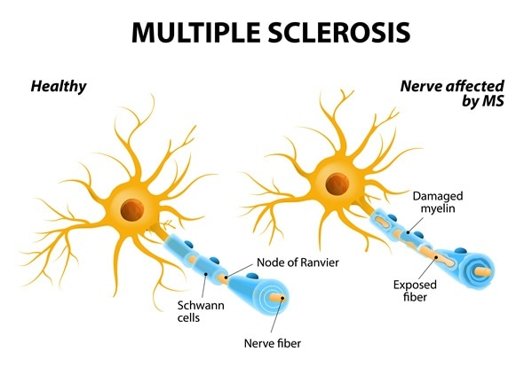

**Figure 1 Demylinated sheath of MS patient**

Servo gripper, one of the most common appliances for lifting applications[8]. This paper is all about to support the multiple sclerosis[2] patient to survive independently. This project consists of three sections: mechanical, electrical and control section. All control actions are carried out by microcontroller.

The objective of this project is to make the multiple sclerosis patient to survive independently. The outcome of the paper is to reduce the manual work and to make the patient to hold the cup without any human effort[12].

**PROPOSED METHODOLOGY**

The proposed model consists of lead screw arrangement which is fitted with wheel chair.The holding and lifting applications is provided by using servo gripper.The lead screw arrangement is used for the constant movement of the arm to achieve upward and downward movement.The lead screw is driven by gear motor which is powered by battery(12v). Joystick is used inorder to rotate the arm towards left and right directions which can be accomplished by using gear motor,which is fixed at the bottom The control action is provided by PIC16F877A microcontroller to the gripper, gear motor, limit switches, joystick and servo motor.

**BLOCK DIAGRAM OF THE PROPOSED SYSTEM**

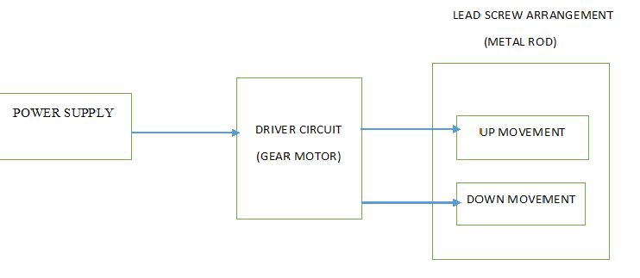

**Figure 2 Block Diagram for leadscrew**

The Figure 2 shows the block diagram for lead screw arrangement.The power supply from battery is fed to the driver circuit, inorder to drive the gear motor which is fixed with lead screw.As a result lead screw movement takes place.The lead screw makes the rod to move up and down at constant speed.

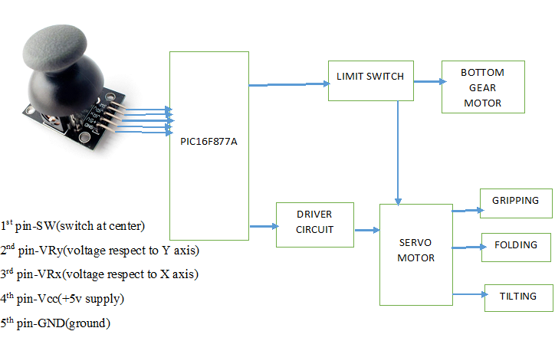

**Figure 3 Block Diagram using joystick**

The Figure 3 shows the block diagram using joystick.The Joystick is interfaced with pic16F877A microcontroller.Limit switches are used to move the rod arrangement within the allowable limits and movement of the entire model towards left and right direction for gripping the object.The bottom gear motor rotates the entire setup either towards left or right direction respectively.The gripping,folding and tilting action is accomplished by using servo motor which is interfaced with microcontroller by using driver circuit.

**PROCESS DESCRIPTION**

**MATERIAL REQUIREMENTS**

* The holding and lifting applications is provided by servo gripper(5v)
* Upward and downward movement is attained by lead screw arrangement.
* Metal rod movement is carried out by means of gear motor
* Limit switches are used to move the metal rod within the range.

**DESIGN LAYOUT**

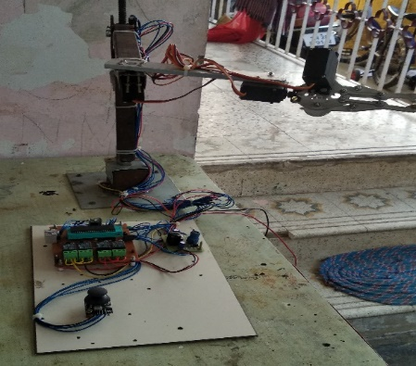

**Figure 4 Design Layout**

The whole arrangement comprises of wheel chair to which metal rod is attached to one arm .At the end of metal rod servo gripper is welded for holding applications.On the other arm joy stick is used for arm movement in left and right directions.Lead screw arrangement is used to achieve arm movement at constant rate.

**CONTROLLER CIRCUIT DESCRIPTION**

The joystick is interfaced with the PIC16F877A microcontroller.The VRx pin is connected to 2nd pin(analog 0) and VRy pin is connected to 3rd pin(analog 0).The limit switches are connected from RB0 to RB6 to limit the rod movement and movement of the model towards left and right direction which is accomplished by gear motor.The gear motor which is fixed with leadscrew is powered by battery.MOSFET is used along with bottom gear motor inorder to control its speed.The servo motor which is used for folding,gripping and tilting actions are interfaced with the microcontroller through driver circuit

**CONTROLLER CIRCUIT DIAGRAM**

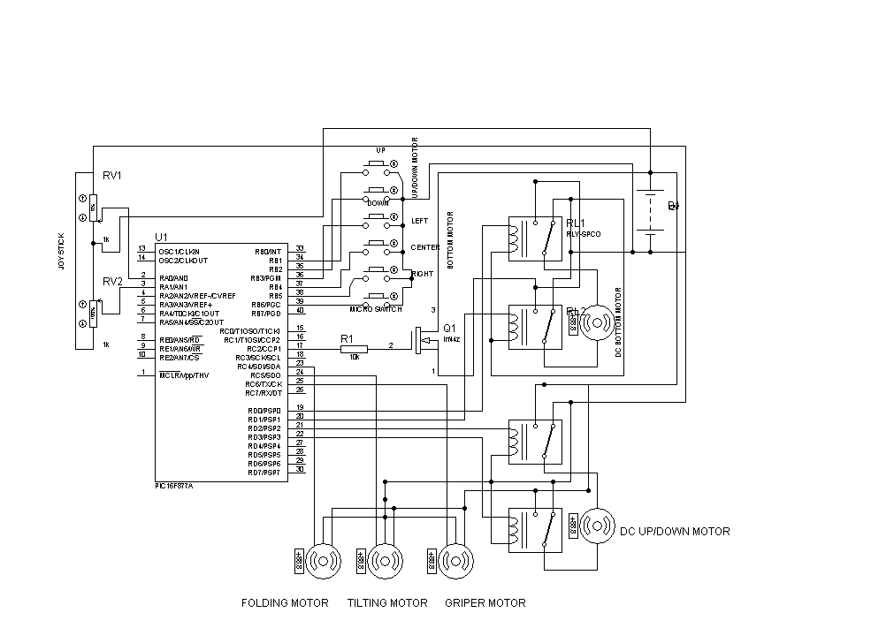

**Figure 5 Circuit Diagram**

**RESULTS AND DISCUSSION**

The holding movement is ensured through controlling the step by step rotation of the gripper.To achieve constant speed for arm movement lead screw arrangement is used.Joy stick is used inorder to lift the object(tumbler)in right and left directions.

**Table No.1. DESIGN ANALYSIS FOR MOVEMENT OF JOYSTICK**

|  |  |
| --- | --- |
| **MOVEMENT OF JOYSTICK** | **ACTION** |
| RIGHT SIDE | ROTATION OF GEAR MOTOR TOWARDS RIGHT |
| GRIPPING ACTION |
| ROTATION OF GRIPPER TOWARDS 45 DEGREE |
| LEFT SIDE | ROTATION OF GEAR MOTOR TOWARDS LEFT |
| GRIPPING ACTION |
| ROTATION OF GRIPPER TOWARDS 45 DEGREE |

**RECOMMENDATION TOWARDS IMPROVEMENT**

In this project the inability of multiple sclerosis patient to hold the object can be eliminated. In addition to this automation is done without any human intervention.

In future , application to support the patient during eating can be extended which will be very helpful for them to eat adequate amount of food without any human support.Wireless option in wheel chair can be done.By replacing servo gripper with robotic arm, more functional activities can be done like self activities of walking, taking food etc. By include more generalized programs,movement of wheel chair in different directions can be achieved.

**REFERENCES**

1. Ellison G, Myers LW, Mickey MR, et al. Clinicial experience with azathioprine: the pros. Neurology 1988;38(suppl 2):20-23.
2. Silberberg DH. Azathioprine in multiple sclerosis: the cons. Neurology 1988;38(suppl 2): 24-26.
3. The Multiple Sclerosis Study Group.Efficacy and toxicity of cyclosporine in chronic progressive multiple sclerosis: a randomized, double-blind, placebo-controlled clinicial trail. Ann Neurol 1990;27: 591-605.
4. Hauser SL, Dawson DM, Lehrich Jr, et al. Intensive immunosuppression in progress multiple sclerosis: a randomized, three-arm study of high-dose intravenous cyclophosphamide, plasma exchange and ACTH. N Engl J Med 1983;308: 173-180.
5. Likosky WH. Experience with cyclophosphamide in multiple sclerosis: the cons. Neurology 1988; 38(suppl 2): 14-18.
6. Currier RD, Haerer AF, Meydrech EF. Low dose oral methotrexate treatment of multiple sclerosis: a pilot study. J Neurol Neurosurg Psychiatry 1993; 56: 1217-1218.
7. Braee.M(1996): “A robot arm for a first course in control engineering”,vol .39, no. 1,pp. 40-45
8. Emin.A and Erdemir.G (2011): “Development of a web-based control and robotic applications laboratory for control engineering education”, vol. 40, no. 4, pp. 352–357
9. Inigo.R and Morton.J,(1991): “Simulations of the dynamics of an industrial robot”, vol.34, no.1,pp.89-99
10. Moya A.G and Barros A.B (2013) : “Practical course of embedded systems based on XUPV2P development boards”, vol.8. no.2,pp.64-70
11. Xabiel.G , Melendi.D, Cabrero.S, Blanco.R, García.R, and Rionda.A (2013) : “Three techniques for competitive lab activities based on project oriented learning in information and communication technologies”, vol. 8, no. 1, pp. 39–46.
12. Vasundhara G. POsugade., Komal K.shedge., Chaitali S. Tikhe., “Touch- Screen Based Wheelchair System”,International Journal of Engineering Research and Applications(IJERA) Vol.2,No.2, pp.1245-1248, March –April 2012.